MKTG1501
Marketing Concept:
- Consumer orientation
- Continuous marketing research
- All organisational activities and strategies are integrated
- Aims to convert satisfied customers to loyal customers

Inside-Out Approach: Selling Concept
- Focus on existing products and heavy selling
- Aim is to sell what company makes instead of making what customer wants

Outside-In Approach: Marketing Concept
- Focuses on the customer

Production Philosophy: consumers will favour products that are available and highly affordable. Management focuses on improving production and distribution efficiency.

Product Philosophy: holds that consumers favour products that offer the most quality, performance, and innovative features.

Selling Philosophy: holds that consumers will not buy enough of organisations products unless it undertakes large scale selling.

Strong Market-Orientated Culture is reflected by:
- Deep understanding of customers
- Awareness and knowledge of competitors
- Strong collaboration across all functions of the firm
- Leadership actions that focus on the customer

Customer Value: difference between the benefits the customer gains from owning and using a product and the cost of obtaining the product

- Customers are value maximisers
  - Will buy from firm they believe will provide them with highest customer delivered value
  - Customers will only consider the features that are important to them

Features: attributes of a product
Benefits: attributes you will use provides value for customer

Customer Satisfaction:
- Customer’s conscious evaluation of a product/service, or of the product/service itself
- Satisfaction judgements influenced by:
  - Past experiences
  - Information and promises made by marketing organisations
  - Company’s competitors or competing products
  - What seems like fair value

Customer Satisfaction:
- Extent to which a products perceived performance matches buyers’ expectations

Complex Mix Buyers Needs:
- Functional attributes: 37% level of influence on buyers’ satisfaction
- Psychological Attributes: 63% Level of influence on buyers satisfaction

Measuring Customer Satisfaction and Loyalty:
- Customer satisfaction and loyalty surveys
- Complaint and suggestion systems
- Mystery shopping and customer interviews
- Lost customer analysis

Totally satisfied customers are more likely to be loyal customers
BUT:
- The relationship between satisfaction and loyalty varies across industries and competitive situations
- Satisfaction alone does not achieve loyalty

5 Levels of Relationships that can be formed with customers have purchased a product:
- Basic: salesperson sells product but does not follow up at all
- Reactive: customer encouraged to call if they have a need after the sale
- Accountable: salesperson contacts customer after sale
- Proactive: sales person or others calls with helpful suggestions or information about new products
- Partnership: organisation and customer work continuously together

Relationship Ties:
- Financial Benefits: one method that can be used to assist in developing closer relationship level with consumers
- Social Benefits: company will focus on social bonds with customers by learning about customers’ needs and then individualising these and personalising products/services

Structural Ties:
- Structural ties refer to the links that an organisation may provide to a consumer to assist with its own business, such as software for inventory or orders.

Retention and Customer Profitability:
- Marketing is the art of attracting and keeping profitable customers
  - 20-40% of customers do not represent profitable sales
  - many new companies view marketing as an investment rather than an expense
    - resulted in better measures of return on marketing investment
Customer Lifetime Value:
- amount by which revenues from a given customer overtime will exceed company’s cost of attracting, selling and servicing that customer
Porter’s Five Forces:
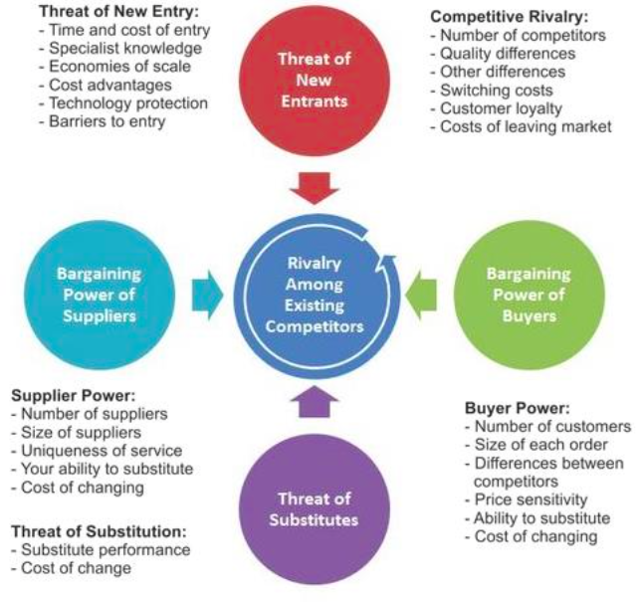

Competitive Strategies:
- Overall cost leadership- can offer lower price than competitors
- Differentiation- concentrate on highly differentiated products
- Focus- concentrate on a small piece of the market

Generic Value Chain

Competitive Positions:
- Market leader:
  - Largest market share
  - Lead others in price changes, new products and promotional spend
- Market Challenger:
  - Usually 2nd Biggest firm in market
  - Fighting hard to increase market share
- Market Follower:
  - Wants to hold market share without rocking the boat
- Market Niche:
  - Serves small segments not served by other firms

Lecture 3
Review Questions
Marketing management orientation in which organisations focus on its own internal capabilities, rather than on the desires of the marketplace, is called:
- Production Orientation

Customer Value is:
- The ratio of benefits to the sacrifice needed to obtain those benefits

A sales orientation:
- Is based on the idea that people will buy more goods/services if aggressive sales techniques are used

The difference between total customer value and total customer cost is called:
- Customer delivered value

______ is the process of planning and executing the conception, pricing, promotion and distribution of ideas, goods and services

To understand the concept of customer value, it is important to remember that:
- Customers are value-maximisers

When buying a new lawnmower, Cherry will form her product expectations based on:
- All of the above

Any actions that lead consumers to believe that they will receive more value from a product than they actually do are considered:
- Deceptive practices

In sales orientation, the customer, not the seller defines value:
- FALSE
A manager states to the organisation’s shareholders: “we are in the business of maximising the perceived value for our customers.” What management orientation is the organisation practicing:
- A marketing orientation

Strategic Planning:
- Most organisations operate according formal plans
- Process of developing and maintaining a strategic fit between organisation’s goals and capabilities in the light of changing marketing opportunities
- Relies on:
  - Clear company mission
  - Supporting objectives
  - Sounds business portfolio
  - Coordinated functional strategies
- Marketing strategy in plan:
  - Developing market position
  - Customer satisfaction
  - Focus on: customer value creation, maintenance and defence
- We want to find a balance between shareholder value and customer value added
- Steps in Strategic Planning
  - Corporate Level
    - Defining Company mission
      - Describing what the company wants to accomplish
    - Defining company objectives and goals
      - Strategy begins to be operationally defined
    - Designing business portfolio
      - Requires constant evaluation of current businesses in relation to the existing competitive position and the future goals of the company
  - Business Level
    - Planning, Marketing and Other Functional Strategies
    - Marketing Strategy and Planning
- Setting Company Missions and Objectives
  - Mission leads to a hierarchy of objectives
  - Marketing strategies are developed to support objectives
- Business Portfolio:
  - Guided by mission, objectives and strategy, management must now plan its business portfolio
    - Collection of businesses and products that make up the company
    - Most effective portfolio is one that best fits the company’s strengths and weaknesses to opportunities in the environment
    - A company needs to analyse its current business portfolio to decide which businesses should receive more, less or the same
    - Develop and identify growth strategies and products for the future
  - Portfolio analysis:
    - Tool that helps management identify and evaluate various businesses that make up that company
    - Strategic business unit of a firm determined on 2 important decisions:
      - Attractiveness of SBUs market
      - Strength of SBUs position

NEED TO KNOW
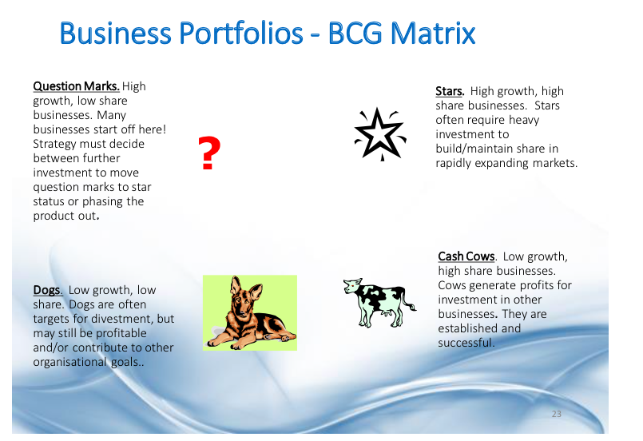

- Problems with BCG and GE (Boston Consulting Group and General Electrics) Planning
  - Difficult and time consuming
  - Costly
  - May be hard to define SBUs at times if highly fragmented and saturated markets
  - Focus on current market and limited for assessing future planning
  - Now done by cross functional teams and divisional managers (not centralised)
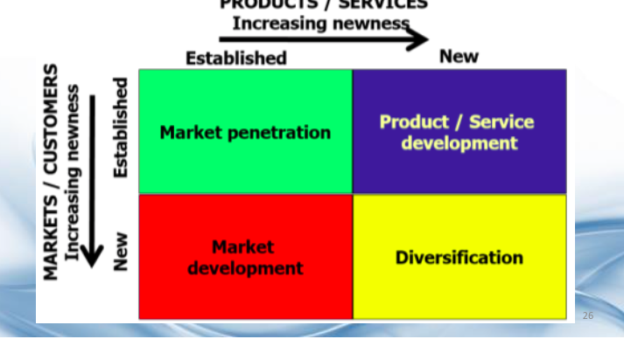

Marketing Strategies for Competitive Advantage:
- To be successful, a company must do a better job of satisfying target consumers than its competitors
- Marketing strategies must be geared to the needs of the customers and also take into account competitors
Branding is massive
Brand Familiarity = customer recognition and acceptance
5 levels that can be used for strategic planning:
- Rejection
- Non-rejection
- Brand recognition
- Brand Preference
- Brand Insistence

Lecture 4
- If prices of a product are dropped- it usually means market penetration
- Marketers undertake consumer research to learn about:
  - What consumers buy
  - Who buys
  - When they buy
  - Where they by
  - Most importantly: why they buy
- Central Question: How do consumers respond to the various marketing stimuli the marketing organisation might use?
- Model of Consumer Behaviour
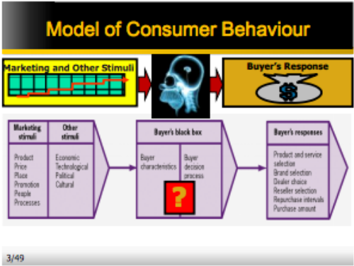

- Consumer purchases are strongly influenced by two groups of factors:
  - Internal characteristics that determine behaviour:
    - Psychological
    - Personal
  - External influences that represent environment in which individual behaviour takes place:
    - Cultural
    - Social
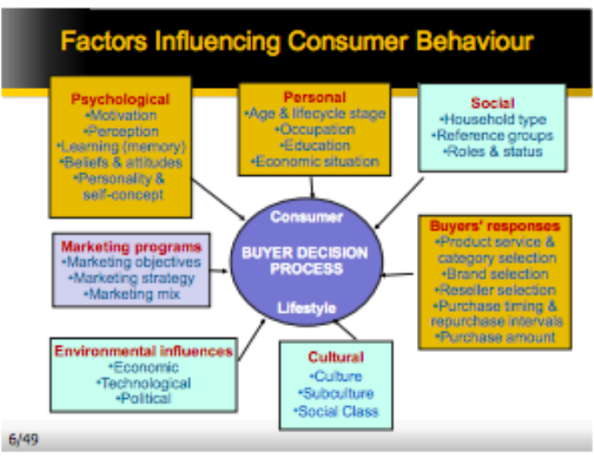

- Psychological Factors: motivation
  - Needs Gap Analysis- the gap between reality and what they want
  - A person has many needs at any given time
  - Theories: Abraham Maslow: explain why people are driven by particular needs at particular times
    - Why does one person spend much time and energy on personal safety and another on gaining the esteem of others?
      - Maslows Answer: human needs are arranged in a hierarchy, from the most pressing to the least pressing
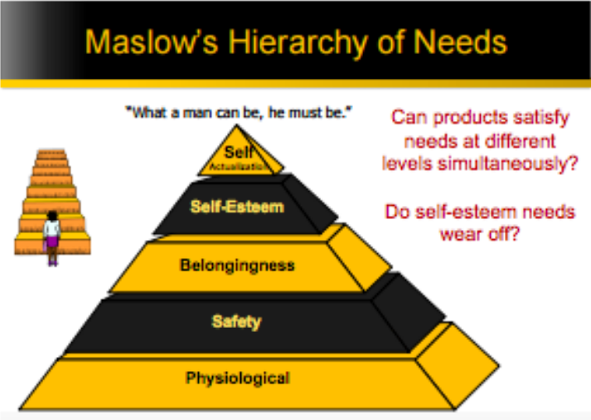

- Psychological factors- perception
  - Perceptual Processes:
    - Selective exposure: we select some input and not others thus only some info makes it into our awareness
    - Selective distortion: tendency of people to adapt information to personal meanings
    - Selective retention: people forget much of what they learn
  - Learning:
    - When people act, they learn.
    - Significance is that markets can build demand for a product by associating it with strong drives, using motivating cues and providing positive reinforcement
    - Classic Condition (Pavlov’s Dog):
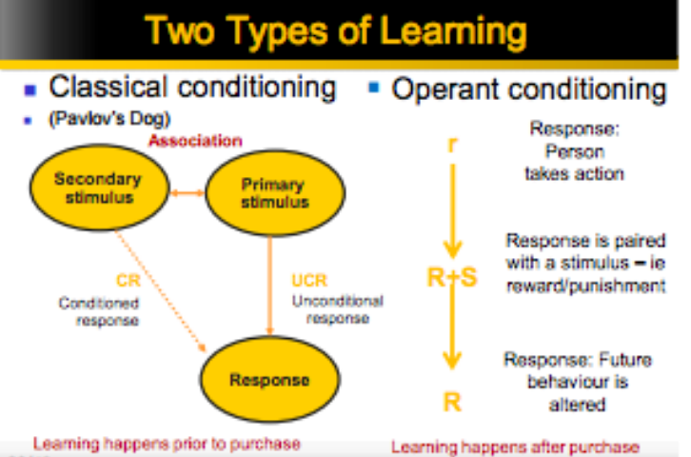

- Beliefs and Attitudes
  - Three components of attitudes:
    - Cognitive: beliefs and evaluations not influenced by emotion
    - Affective: emotional responses such as liking or dislike
    - Behavioural: intention to purchase or the purchase itself

    - Attitudes: enduring evaluation, feelings and behavioural tendencies towards an object or idea

- Personal Factors:
  - Age and lifecycle stage
  - Occupation
  - Education
  - Economic situation
  - Lifestyle
  - Personality and self concept
- Cultural Factors:
  - Exert the broadest and deepest influence on consumer behaviour
  - Role played by:
    - Culture: set of basic values, perceptions, wants and behaviours learned by a member of society form family and other important institutions
    - Subculture: a group of people with shared value systems based on common life experiences
    - Social class: relatively permanent and ordered divisions in a society, members share similar values, interest and behaviours
- Social Factors:
  - Consumers household type and reference groups, social roles and status
- Reference Groups:
  - Reference groups: groups that have direct/indirect influence on the person;;s attitudes/behaviour
- Membership groups:
  - Groups that have a direct influence on a person’s behaviour and to which a person belongs
- Aspirational Groups:
  - Groups which an individual wishes to belong to
- Opinion Leaders:
  - people who exert influence on others’ opinions and buying behaviour.

Consumer Buying Roles:
- Key Family Decision Roles
  - Initiation: person who first suggests the idea of buying a particular product/service
  - Influences: person whose views/advice carry some weight in making the final buying decision
  - Decider: the person who ultimately makes the buying decision
  - Buyer: the person who makes the actual purchase
  - User: the person who consumes the product/service
- E.G. UNI

Involvement in buying decisions
- Involvement: importance of the product for consumer
  - Perception of risk:
    - Financial
    - Social
- Buyer Decision Process
  - 1- Need recognition
  - 2- Information search
  - 3- Evaluation of Alternatives
  - 4- Purchase Decision
  - 5- Post-purchase behaviour
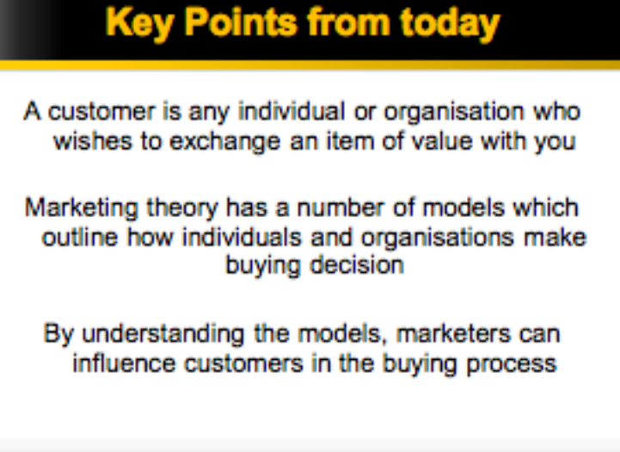

Lecture 5
Marketing Organisation’s Micro-Environment:
- marketing management has the task of attracting and building relationships with customers by creating customer value and satisfaction
- success will depend on other actors in the organisation’s micro-enviornment
  - 1- marketing organisation
  - 2- suppliers
    - provide resources needed by organisation to product its goods and services
    - Important link in the organisations’ overall customer ‘value delivery system’
    - Marketing managers must watch for:
      - Supply availability
      - Supply shortage/delays
      - Labour strikes
      - Price trends of supplies
        - These points can damage customer satisfaction in the long term
        - Rising supply costs may force price increases that can harm the organisation’s sales volume
  - 3- marketing intermediaries
    - help organisation to promote, sell and distribute its goods to final buyers
      - help an organisation to promote, sell and distribute its goods to final buyers
      - Resellers: distribution channel firms that help organisation find customers/make sales
      - Physical distribution firms: helps organisations stock and move goods from point of origin to destination
      - Marketing services agencies: marketing research companies, advertising agencies, media firms, export consulting agencies
      - Financial intermediaries: Include banks, credit organisations, insurance organisations and other businesses that help to finance transactions
  - 4- customers
    - end consumers, businesses, governments, etc.
    - every organisation
  - 5- Competitors
    - each marketer/firm should consider their own size and industry position compared with those of its competition
    - each organisation faces a wide range of competitors
    - to be successful, organisation must provide greater customer value and satisfaction than competitiors
    - Competitive Analysis:
      - Builds competitive advantage
      - Stages:
        - Identify current/potential competitors
        - Assess each key competitor
        - Assess each key competitor’s strengths and weaknesses to see why they are successful
        - Focus analysis on each key competitor’s marketing capabilities- what are they doing create that success?
        - Estimate each key competitor’s most likely strategies and responses under different environmental situations
  - 6- Publics
    - include groups that have an interest in or impact on the firm’s ability to achieve its goals
    - any group that has an actual/potential interest in, or impact on, an organisation’s ability to achieve objectives
    - Every organisation is involved with 7 types of publics:
      - Financial
      - Media
      - Government
      - Citizen-action
      - Local publics
      - General publics
      - Internal publics
- Macro-Environment of Marketing Organisation
  - Six major forces:
    - Demographic
      - Changing age structure of population
      - Changing household
      - Geographic shift in population
      - Better educated & more white-collar
      - Increased ethnic diversity
    - Economic
      - Factors that affect consumer-buying power and spending patterns
    - Natural
      - Government intervention
      - Shortage of raw materials
      - Energy costs
      - Increased pollution
    - Technological
      - Issues in technological environment
        - Fast pace of change
        - High R & D Budgets
        - Focus on minor improvements
        - Increased regulation
    - Political
      - Legislation
      - Enforcement
      - Greater concern for ethics
    - Cultural
      - Institutions and other forces that affect society’s basic values, perceptions, preferences, and behaviours
- How does an industry grow/shrink?
  - Growth comes from 3 sources:
    - More customers start buying products
    - Same number of customers buy in higher volume
    - Prices increase while volume stays steady
  - Shrinkage comes from similar sources:
    - Fewer customers continue buying
    - The same number of customers buy less
    - Prices decrease but volume doesn’t increase
- Macro-enviornmental analysis:
  - Look upto 5 years out
  - Identify aspects of the macro-environment that are likely to have a +ve and ---ve impact
- SWOT ANALYSIS- VERY IMPORTANT
- To a marketer, market is a set of all actual and potential buyers of a market
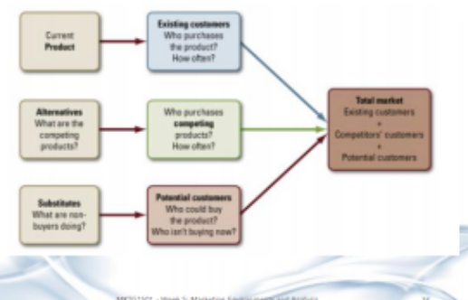

Lecture 6- Segmentation, Targeting & Positioning
- SWOT Analysis
  - Strengths and Weaknesses
    - Production costs
    - Marketing skills
    - Financial Resources
    - Company and/or brand image
    - Employee capabilities
    - Available Technology
  - Opportunities and Threats
    - Competitors activities/products
    - External environments
    - Consumer trends

- Target Marketing:
  - Market segmentation
    - Dividing market into distinct group of buyers with different needs, characteristics or behaviour who might require separate products/marketing mixes
  - Market targeting
    - Evaluating each market segment’s attractiveness and selecting on or more of the market segments to enter
  - Market positioning
    - Setting competitive position for the product and creating a detailed marketing mix
- Why segment?
  - Customers have different needs for the same product
  - Focus efforts on most profitable target markets
  - Better understand consumer differences and needs
  - Too expensive to customise product for each consumer
  - Identify opportunities/gaps in market
  - Help marketing mix development
  - Tailor promotional message
  - Allocate advertising budget better
- Bases for Segmentation:
  - Demographic
    - Age, education, religion, race, nationality, occupation, family size, family life cycle, gender, income
  - Behavioural
    - Divides buyers into groups based on their knowledge of the product, their attitude towards it, the way they use it and their responses to it
      - Occasions: grup consumers according to occasions when they get the idea to buy, actually make the purchase or use purchased item
      - Benefits sought: group buyers according to different benefits they seek from products
      - User status: group buyers into non-users, ex-users, potential users, first time users and regular users
      - Usage Rate;: group buyers into light-, medium- and heavy- user groups
      - Loyalty Status: divide buyers into group according to degree of loyalty
  - Geographic
    - Diving market into different geographical units such as:
      - Nations, regions, states, municipalities, cities or neighbourhoods
  - Psychographic
    - Buyers are divided into different groups based on socioeconomic status, lifestyle or personality characteristics

Market Targeting:
- Requirements for Effective Segmentation:
  - Measureable: degree to which size and purchasing power of segments can be measured. Certain segmentation variables are difficult to measure
  - Actionability: degree to which effective programs can be designed for attracting and serving the segments
  - Accessibility: degree to which segments can be reached and served
  - Substantiality: degree to which segments are large/profitable enough. A segment should be largest possible homogenous group worth going after with a tailored marketing program
- To evaluate market segments:
  - Market size and growth
  - Segment structural attractiveness
  - Company objectives
- Undifferentiated marketing:
  - All consumers have similar needs and only one product is offered
  - Tries to appeal to largest number of buyers
  - Major advantage in cost savings in production, promotion and distribution
- Concentrated Segmentation:
  - Focus on one segment only
  - Riskier
  - Good if limited resources
  - Niche marketing
- Multiple segmentation (differentiated):
  - Different mix for each segment
  - More expensive but more sales
  - Often for mature market
- Concentrated Segmentation
  - Focus on one segment only
  - Riskier
  - Good if limited resources
  - Niche marketing
- Multiple segmentation (differentiated)
  - Different mix for each segment
  - More expensive but more sales
  - Often for mature market

Market positioning:
- Positioning strategies
  - Users
  - Product class
  - Product attributes
  - Benefits offered
  - Usage occasions
  - Away from competitors
  - Against a competitor
- Perceptual map: based on SWOT analysis- decide on what basis are we going to enter the market.
- Identifying Possible Competitive advantage:
  - Areas for competitive differentiation:
    - Product
    - Service
    - Personnel
    - Image
- Selecting the right competitive advantage:
  - Important: difference delivers a high valued benefit to target buyers
  - Distinctive: competitors do not offer difference, or the company can offer it in a more distinctive way
  - Superior
  - Communicable
  - Pre-emptive
  - Affordable profitable
- Marketing mix must support positioning strategy
  - Tangible products:
    - Price
    - place
    - Product
    - promotion
  - Service products:
    - Process
    - Physical evidence
    - People

Lecture 7
- Levels of a product
  - Core product: problem solving product/core benefits that consumers are really buying when they obtain a product
  - Actual Product: brand name, activities and processes that combine to deliver core benefits
  - Augmented product: additional customer benefits built around the core and actual product
- Convenience goods: frequent purchases bought with minimal buying effort and little comparison shopping
  - Low price
  - Widespread distribution
  - Staples- impulse- emergency goods
- Shopping goods:
  - Less frequent purchases requiring more shopping effort and price, quality, and style comparisons
  - Higher prices than convenience goods
  - Selective distribution in fewer outlets
- Specialty goods
  - Strong brand preference and loyalty, requires special purchase effort, little brand comparisons and low price sensitivity
  - High price
  - Exclusive distribution
- Unsought goods:
  - Little product knowledge and awareness
  - Pricing varies
  - Distribution varies
- Basic Assumptions of Services:
  - There are a number of unique characteristics that separate services from tangible goods:
    - Intangible: services cannot be seen, touched or tasted
    - Variable: quality control and standardisation is difficult
    - Perishable: services cannot be stored over time; providers cannot use inventory to manage fluctuations in demand and supply
    - Synchronous delivery and consumption: services are produced and consumed at the same time, customers participate in service production
    - Lack of ownership:
- Expanded mix for services:
  - Product, price, place, promotion +
  - People: human actors who play a part in service delivery and this, influence buyer’s perceptions
  - Physical evidence: environment in which the service is delivered and where the firm and customer interact and any intangible components that facilitate performance or communication of the service
  - Process: actual procedures, mechanisms and flow of activities by which the service is delivered- the service delivery and operating systems
- Process: how a firm does things may be just as important as what it does
- Physical environment: design the servicescape and provide tangible evidence of service performances
  - Create and maintain physical appearances:
    - Buildings/landscaping
    - Interior design/furnishings
    - Vehicles/equipment
    - Staff grooming/clothing
    - Sounds and smells
    - Other tangibles
- People: interactions between customers and contact personnel strongly influence customer perceptions of service quality
  - Well-managed firms devote special care to selecting, training and motivating service employees
  - Other customers can also affect one’s satisfaction with a service
- What are customers buying: regardless of whether it is a physical product, intangible service or a mixture, customers are seeking out buy the bundle of attributes which best satisfy their needs
- Some attributes are at the core of the product/service they buy while others are supplementary
- Customer buy benefits not products
- Branding: name, term, sign, symbol, design or a combination of these, that identifies the maker/sellers of a product/service
- Labelling and packaging are different things
- Product attributes:
  - Quality
  - Features
  - Style design
- Product Life Cycle Strategies:
  - Product development: begins when the company develops a new product idea
    - Sales are zero
    - Investment costs are high
    - Profits are negative
  - Introduction:
    - Low sales
    - High cost per customer acquired
    - Negative profits
    - Innovators/early adopters targeted
    - Little competition
  - Growth
    - Rapidly rising sales
    - Rising profits
    - Early adopters/early majority targeted
    - Competition begins to decline
  - Maturity
    - Sales peak
    - Low cost per customer
    - High profits- starting to decline
    - Middle/late majority are targeted
    - Competition begins to decline

Lecture 8
Marketing communication:
- Sender: party sending message to another party
- Encoding: process of putting thought into symbolic form
- Message: set of symbols that sender transmits- the actual advertisement
- Media: communication channels through which message moves from sender to receiver
- Decoding: process by which receiver assigns mean to the symbols encoded by the sender- a consumer watches the ad and interprets the words and illustrations it contains

Integrated Marketing Communication Process:
- Identifying target audience
- Determining response sought
- Selecting a media
- Selecting a message
- Selecting a message source
- Collecting feedback
Produce a database of customers--- “ Register today, get a free …”
Developing IMC:
- Step 1: identify target audience

AIDA Model: Attention Interest Desire Action
- Attention:
  - Awareness: repetitive advertising- simple message
  - Knowledge: specific message- infomerical, website, brochure
- Interest:
  - Liking: create favourable attitudes- sampling, information, endorsement, humour
  - Preference: competitive ads, argumentative copy
- Desire:
  - Conviction: intention-to-purchase, sampling, information
- Action:
  - Purchase: point-of-purchase, last-chance offers, reinforcement; frequent flyers
Step 2: determining process sought

- Step 3: selecting a message:
  - Appeals:
    - Rational appeals: logical, the product will produce the desired benefits
    - Emotional appeals: generate negative or positive emotions to motivate
    - Moral appeals: appealing to your sense of right and wrong
  - Message structure: strongest points first or last
  - Message format
  - Push vs pull strategy
  - Media decision

Major Advertising Decisions:
- Media timing: schedule ads continuously or unevenly
- Reach: Percentage of target market exposed to advertisement during a given period
- Media vehicles: refer to specific media within each media type
- Media impact: impact medium has relative to the product
- Frequency: # of times an individual is exposed to the message

Step 4: selecting a media
- Personal communication channels
  - Channels through which two or more people communicate directly
- Non-personal communication channels
  - Media that carry messages without personal cotact or feedback

Nature of advertising:
- Direct marketing
- On line
- Public relations
- Sales promotion
- Advertising
- Personal selling

Promotional Mix Elements:
- Advertising: paid form of non-personal presentation of ideas, goods, or services by an identified sponsor
  - Increases sales during slow periods
  - Move old models
  - Explain product attributes and features
  - Reposition a brand
  - Make sales-force more productive
  - Increase awareness, interest and desire for a brand
- Public Relations/Publicity: non-personal stimulation of demand for goods, service or business units by generating commercially significant news about them in the mass media
- Sales Promotion: marketing activity other than personal selling, advertising and publicity
- Personal selling: oral presentation with one or more prospective purchasers for the purpose of making sales
- Direct marketing: communication that is directly aimed at specific customers

Types of Advertising:
- Product advertising: concerned with selling goods and services to consumers
- Institutional advertising
Major Advertising Media:
- Newspapers
  - Advantages: flexibility, timeliness, good local market coverage
  - Limitations: shrt life, poor reproduction quality
- Tele
  - Advantages: combines sight, sound and motion
  - Disadvantages: high absolute cost, high clutter, fleeting exposure
- Radio:
  - Advantages: mass use, high geographic and demographic selectivity
  - Limitations: audience presentation only, lower attention than TV
- Magazines
  - Advantages: high geographic and demographic selectivity, credibility and prestige
  - Disadvantages: long ad purchase lead times, some waste circulation
- Outdoor/cinema
  - Advantages: flexibility, high repeat exposure, low cost, low competition
  - Disadvantages: no audience selectivity
Types of Advertising:
- Informative approaches are those that attempt to provide consumers with objective information
- Persuasive approaches are those that attempt to persuade consumers that a particular brand is right for them
- Reminder approaches are those that aim to keep the brand-name well entrenched in the consumer’s mind
Consumer Markets: most important to least
- Advertising
- Sales promotion
- Direct and online
- Personal selling
- Public relations
B2B Markets: most important to least
- Personal selling
- Direct and online
- Sales promotion
- Advertising public relations

Step 5- Selecting a message sources
Step 6- collecting feedback

Promotion Budget:
- Methods for budgeting promotion
  - Affordable
  - Objective task
  - Competitive parity
  - Percentage of sales

Lecture 9
- Sales Promotion:
  - Act of influencing customer/consumer perception and behaviour to build market share and sales that reinforce brand image
  - Consists of incentive tools to simulate quicker/greater purchases
    - Samples
    - Redeemable coupons
    - Cash-back offers
    - Cent off deals or price packs
    - Premium offers
    - Advertising specialities
    - Patronage rewards
    - Point-of-purchase promotions
    - Contents and games of chance and skill
  - Purpose of Sales Promotion:
    - Attract new triers
    - Reward brand-loyal customers and retain them
    - Reduce time between purchases
    - Turn light users into medium/heavy users
    - Regain past purchasers who have ceased buying
  - Sales promotions decisions:
    - How will this impact on your brand?
      - E.g. build brand loyalty?
    - What are your secondary objectives?
      - Build brand awareness?
    - Is message consistent with other communication?
    - How do you promote this campaign?
    - Can you link this to PR opportunities?
    - How do you add urgency?
- Personal selling:
  - Salespeople involved in two-way personal communications with customers
    - Build long term relationships with customers
    - Explain benefits of product in more detail than other forms of promotion
- Role of the salesforce:
  - Salesforce is critical link between company and its customers
  - Find and develop new customers and communicate information about company’s offerings
  - Sell products, answer objections, negotiate prices and terms and close sales
  - Need to know how to satisfy customers
  - Produce profit for company
  - Understand sales data, measure market potential, gather market intelligence
  - Develop marketing strategies and plans
  - Market-orientated more effective than sales-orientated in the long run
- Independent Representatives v Company Reps
  - Independent:
    - Improved cash flow
    - Predictable sales experience
    - Provide greater territory exchange
    - Penetrate new markets faster
  - Company reps:
    - Sell only company product
    - Greater attachment to company
    - Greater control over activities
- Best salesperson has 4 key talents:
  - Intrinsic motivation
  - Disciplined work style
  - Ability to close a sale
  - Ability to build relationships with customers
- Customer relationship marketing: ‘The process of creating, maintaining and enhancing strong, value-laden relationships with customers and other stakeholders’.
- Direct marketing: Non-personal and personal communications between a marketer and its publics that usually have the aim of gaining a direct response, such as sales.
  - Oral, mailed or electronic

Lecture 10 Pricing for Value

Price: sum of values consumers exchange for the benefits of having/using product service
- What the customer is prepared to pay

Fixed costs: costs that do not vary with production/sales level
Variable costs: vary directly with level of production

Total costs: fixed + variable costs

Oligopolistic competition

Pure Monopoly

- Demand and supply:
  - Demand for a product and the price the consumer is willing to pay are fundamental determinants of price
- Inelastic Demand: price change cause smaller % changes in demand
- Elastic Demand: price changes cause larger % changes in demand

Value based pricing
Economic Value Pricing: for many industrial products, costs perceived by customers extend well beyond price charged

Going rate pricing: company bases its price largely on competitors’ prices, with less attention paid to its own costs or demand
- Smaller firms follow the leader, change their prices when market leader’s prices change, rather than when their own demand/cost changes

Sealed-Bid Tender: company bases its prices on how it thinks competitors will price rather than on its own costs/demands

Pricing strategies for existing products
- Above market
- Below market
- At market
Skimming Price strategy:
- Typically new products
- Where a high price is set, fewer sales but more profits for the organisation
- Usually firm sets a lower price later in order to capture more price sensitive segments of the market
- In this case, quality and image must match high price
- Important that costs of product are not too high

Penetration Price Strategy:
- Where low price is set in order to gain larger market share
- High volume results in lower costs for the business
- Good strategy in a price sensitive market
- Production and distribution costs fall within volume
- Strategy can be an effective way to create a barrier to entry for competitors

Captive product/servicing pricing:
- Pricing of products that must be used along with a main product, such as blades for a razor

By-product pricing: setting a price for by-products in order to make main product’s price more competitive

Product-bundle pricing: combining several products and offering bundle at reduced price
---
Product/service-line pricing: setting price steps between various prpoducts ina product line based on cost different between products, customer evaluation of different features and competitors’ prices

Discount pricing and allowances: cash discounts, quantitiy discounts, seasonal discounts

Segmented pricing: different prices for different customers, product forms, places or times

Psychological pricing: adjust price to communicate more effectively a product’s intended positioning- price is used to say something about the product

Promotional pricing: temporarily pricing products below list price and sometimes below cost to increase short run sales

Value pricing: offers just the right combination of quality and good service at a fair price

Geographic Pricing: deciding how to price to distant customers

International Pricing: adjust price to meet different conditions and expectations in different world markets
---

Product: attributes of the product influence its perceived value
- Brand equity, warranties, styling, durability, performance rating and quality of work

Place: needs to be considered to ensure final consumer gets product at expected price and intermediaries get adequate margins to continue distribution

Promotion: expenditure on advertising and other activities reinforces value of the product in the mind of consumer. Price must be consistent with promotional strategy and image

Lecture 11

Placement: getting right product in right place, at right time, in correct quantity to customer- subject to organisational objectives

Marketing Logistics Decisions Include:
- Cycle-time reductions
- Conversion operations location
- Purchasing decisions
- Manufacturing and operations process decisions
- Order processing and costs
- Warehouse number and costs
- Inventory levels and costs
- Inventory levels and cost
- Transport type and costs
- Restructure marketing channels

It affects:
- Sales: if product is not available the customer can’t buy it
- Profits and competitiveness: distribution is a big overhead for a lot of firms- squeezes margins
- Customer relationships and satisfaction: when customer wants it, where they want it and quantity
Factors influencing placement decisions:
- Speed: door to door delivery time
- Dependability: delivery on time
- Capability: ability to hand different products
- Cost availability: geographic area served
- Flexibility: willingness to transfer modes and alter timing

Marketing Channel Functions:
- Information: gathering/distributing marketing environment information
- Promotion: developing and spreading communication about an offer
- Contact: finding and communicating with potential buyers
- Matching: shaping and fitting offer to buyers’ needs
- Negotiating: reaching an agreement on price and other terms
- Physical distribution: transporting and storing goods
- Financing: acquiring and using funds to cover cost of channel work
- Risk-taking: assuming risks of carrying out channel work

Vertical Marketing Networks
- Corporate: greatest control
  - Combines successive stages of production and distribution under single ownership
- Contractual: middle control
  - Vertical marketing network in which independent firms at different levels of production and distribution, not through……..
  - Examples of Contractual VMN:
    - Wholesaler sponsored retailer: network of independent retailers that co-ordinate activities to compete against larger organisations
    - Retailer co-operatives: retailers organise a new jointly owned business. Buy products through the cooperative. Profits returned to cooperative.
    - Franchises:
      - Retailer: e.g. auto industry. Dealers are independent, but with agreed sales and service conditions
      - Wholesaler: e.g. coca cola sells license to bottle product to wholesalers in various countries
      - Services sponsored: e.g. car rentals: firm licenses a network of retailers
- Administered: least control
  - Coordinates successive stages of production and distribution, not through common ownership or contractual ties, but through size aand power of one of the parties

Distribution decisions:
- Warehouse locations
- Delivery methods
- Minimum order quantities
- Stocking levels

Identifying Major Alternatives:
- Exclusive distribution: giving of a limited number of dealers the exclusive right to distribute company’s products in the territories
  - Low competition
  - Low degree of market coverage
  - Customer prepared to exert effort
  - Low purchase frequency
  - Premium/prestige image
  - Price skimming/above market
  - High control
- Selective distribution: use of more than one but less than all intermediaries who are willing to carry company’s products
- Intensive distribution: stocking of the product in as many outlets as possible

Wholesaling: all activities involved in selling goods/services to those buying for resale or business sue:
- Merchant wholesalers: independently-owned business that takes title to the merchandise it handles
- Brokers and agents: broker brings buyers and sellers together and assists in negotiations
- Manufacturers sales branches: outlet of manufacturer

Classification of retailing:
- Retailing is all those activities involved in selling goods or service directly to final consumers for their personal, non-business use
- Amount of service: self service (supermarket), limited service (hardware), full service (upmarket stores)
- Product line sold: retaileers can be classified according to depth/breadth of product assortments:
  - Specialty store
  - Department store
  - Supermarket
  - Convenience
  - Mass merchant or hypermarket
  - Service business
- Relative price emphasis- retailers can also be classified according to their prices:
  - Discount store: standard merchandise at lower prices
  - Off-price retailers- new version of discount store- factory outlets
  - Catalogue or showroom: in US, not Australia but sell high mark-up
- Control of outlets
  - Corporate chain
  - Voluntary chain and retailer cooperative
  - Franchise organisation
  - Merchandising conglomerate
- Types of store cluster: stores cluster together to increase customer pulling power. Types of store clusters include central business district, regional shopping centre, community shopping centre, neighbourhood shopping and highway strip

Store Atmosphere:
- Atmospherics: things that we can design into environment to have an influence on customers
  - E.g. music colour, lighting, smell, layout of aisles, even floor coverings
- Often without conscious awareness of the customers

Lecture 12

- In order to produce superior value and satisfaction for customers, marketing managers need info about:
  - Customers
  - End-users
  - Resellers
  - Competitors
  - Government regulations
  - Other forces in marketplace
- Marketing Information System:
  - People, equipment and procedures to gather, sort, analyse, evaluate and distribute timely and accurate information to marketing decision markers
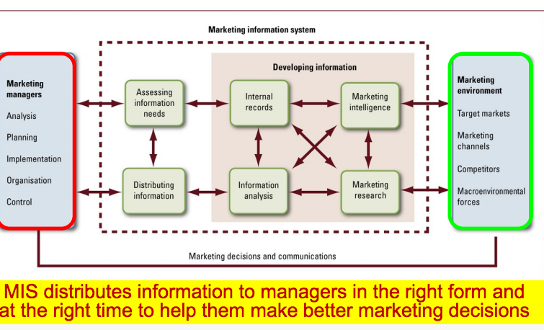

- Assessing Information Needs:
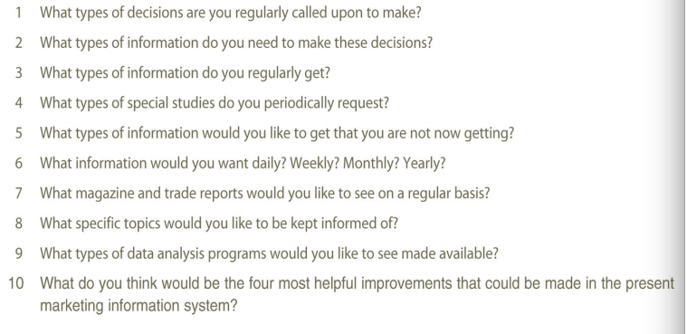
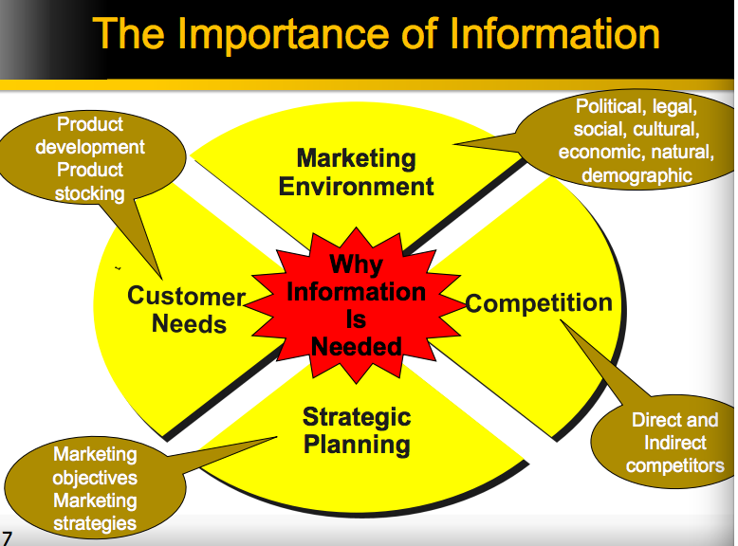
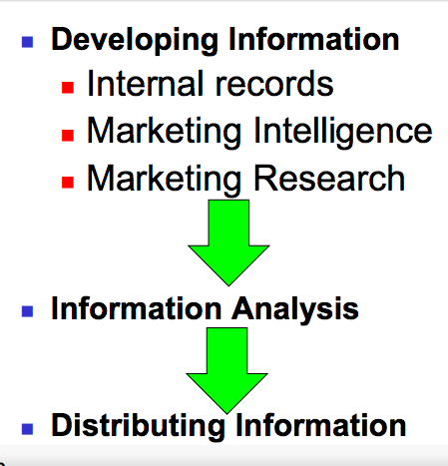
- Internal Records: info gathered from sources within company to evaluate marketing performance and to detect marketing problems and opportunities
- Marketing Intelligence: systematic collection and analysis of public available information about competitors and developments in the marketing environment
- Marketing Research: function that links consumer, customer and public to marketer through information used to:
  - Used to identify and define marketing opportunities and problems
  - To generate, refine and evaluate marketing actions
  - To monitor marketing performance
  - To improve understanding of marketing process
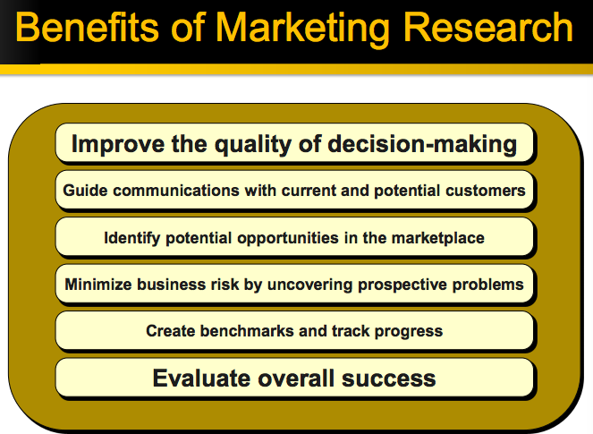
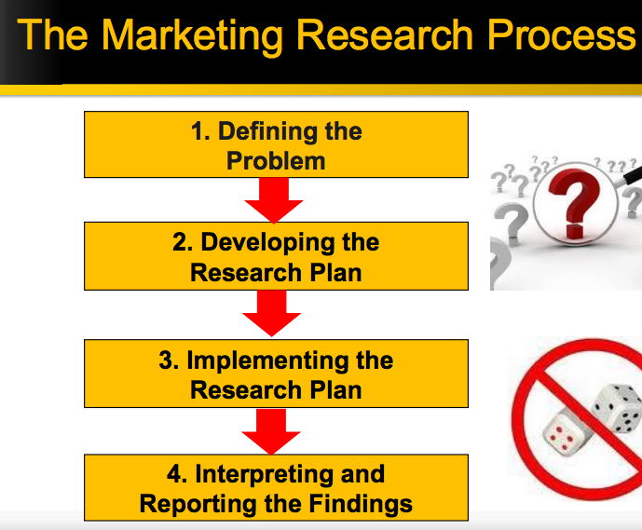

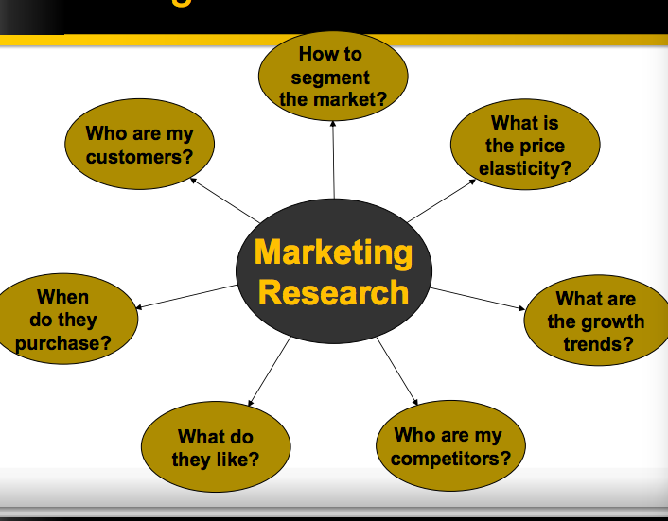

Developing Research Plan:
- Exploratory Research: marketing research to gather preliminary information that will help to define problems better and suggest hypotheses
- Descriptive research: marketing research to describe marketing problems, situations or markets better- such as market potential for a product or demographics and attitudes of consumers
- Causal Research: marketing research to test hypotheses about cause and effect relationships

- Secondary Data: consist of information that already exists
- Primary Data: consist of information collected for current research purpose
  - Researchers must take care to obtain primary data that is relevant, accurate, current and unbiased

- Observational research: gathering of primary data by observing relevant people, actions and situations
  - Mechanical: people metres, checkout scanners
  - Survey research: gathering of primary data by asking people questions about their knowledge, attitudes, preferences and buying behaviour
    - Structured
    - Unstructured
      - Direct approach
      - Indirect approach
  - Research Methods
    - Experimental Research: gathering of primary data by selecting matched groups of subjects, giving them different treatments, controlling unrelated factors and checking for differences in group responses
    - Focus group interviewing: consists of inviting 6-10 people to discuss a particular topic
  - Information Analysis: info gathered by company’s marketing intelligence and marketing research systems often require more analysis, and sometimes managers need help to apply information to marketing problems and decisiosn
    - Process may include advanced stats analysis
      - HELPS ANSWER QUESTION e.g.:
        - What are major variables affecting my sales and how important is each one?
        - What are best variables for segmenting my market?
        - If I raised price 10%, and increase advertising expenditure 20%, what would happen to sales?

Interpreting and Reporting Findings:
- Researcher must now interpret findings, draw conclusions and report them to management
- Researcher should present major findings that are useful for main decisions faced by management

Distributing Information:
- Info gathered through marketing intelligence and marketing research must be distributed to the right managers at the right time
- Done through a Distributed Marketing Information System
  - Internal and external info can be obtained, analysed and reported

Marketing Research in Small Businesses and Non-Profit
- Managers can conduct informal surveys
- Managers can obtain good marketing info simply by observing

KEY POINTS:
- Customer is an individual/organisation who wishes to exchange an item of value with you
- Marketing theory has a number of models which outline how individuals and organisations make buying decision
- By understanding the models, marketers can influence customers in buying process

Marketing Ethics:
- Ethics and social responsibility require a total corporate commitment and must be part of overall corporate culture
- Mangers need a set of principles that will help them work out issues such as moral importance of a situation and act in good conscience
- Such issues are decided by free market and legal system
- Companies should also have social conscience and apply high standards of ethics and morality regardless of ‘what the system allows.’

Criticisms of Marketing and marketers:
- High prices
- High costs of distribution
- High advertising and promotion costs
- Excessive gross profit margins
- Deceptive practices
- High-pressure selling
- Unsafe products
- Planned obsolescence

Socially responsible marketing:
- Sense of mission: principle of enlightened marketing that holds that the organisation should define its mission in broad social terms rather than narrow marketing or financial terms
- Maintaining social responsibility: enlightened marketing organisation makes marketing decisions by considering consumers’ wants and interests, the marketing organisation’s requirements and society’s long-run interests

Environmentalism: organised movement of concerned citizens, businesses and government agencies seeking to protect and improve people’s living environment

Competitive advantage of sustainability

Traditional Sellers’ Rights:
- Right to introduce any product in any size and style, provided it is not hazardous to personal health/safety
- Right to charge any price for the product provided no discrimination exists among similar kinds of buyers
- Right to spend any amount to promote the product, provided it is not defined as unfair competition
- Right to use any product message, provided it is not misleading or dishonest in content or execution
- Right to use any buying incentive schemes, provided they are not unfair or misleading

Traditional Buyers’ rights include:
- Right not to buy a product that offered for sale
- Right to expect product to be safe
- Right to expect product to perform as claimed

Consumer advocates call for following additional rights:
- Right to be well informed about important aspects of the product
- Right to be protected against questionable products and marketing practices
- Right to influence products and marketing practices in ways that will improve the quality of life

REVIEW
- SEVEN P’s
- 3 types of advertising appeals: emotional, moral, rational
- Marketers do:
  - Environmental scanning and analysis
  - Marketing research and analysis
  - Identifying needs of consumer
  - Segmentation, targeting, positioning
  - Design products
  - Set prices
  - Identify places to sell
  - Coordinate promotion
  - Manage relationships
- Marketing concept can be applied to all organisations including:
  - Non-profit
  - Government
  - Services
  - Business-to-business
- Core marketing concepts: products value, satisfaction and quality exchange, transactions and relationships markets needs, wants and demands
- Factors influencing consumer behaviour
  - Internal and External factors:
    - Psychological
      - Motivation
      - Perception
      - Learning
      - Beliefs and attitudes
      - Personality and self-concept
    - Personal
      - Age and lifecycle stage
      - Occupation
      - Education
      - Economic situation
    - Social
      - Household type
      - Reference groups
      - Roles and status
    - Buyers’ responses
    - Cultural
      - Culture
      - Subculture
      - Social class
    - Environmental influences
      - Economic
      - Technological
      - Political
    - Marketing programs
      - Marketing objectives
      - Marketing strategy
      - Marketing mix
- Buyer decision process:
  - Need recognition information search evaluation of alternatives purchase decision post-purchase behaviour
  - Process differs from high and low involvement goods/services
- Marketing Research Process

D
A
A
B
B
C
C
A
B
A
D
C
E
E
D
B
D
C

Extra Notes
Horizontal marketing system: distribution channel arrangement whereby two or more organisations at the same level join together for marketing purposes to capitalise on new opportunities

Strengths and weakness- internal factors
Threats and opportunities- external factors

