The Internal Environment

- Identify the firm’s resources
- Tangible resources
  - Financial
  - Organizational
  - Technological
  - Physical
- Intangible resources
  - Reputational
  - Human
  - Innovation

- Bundle the resources into capabilities

- Test to see if any capabilities represent a core competency (a source of sustainable competitive advantage). Use a VRIN to identify this. See below.

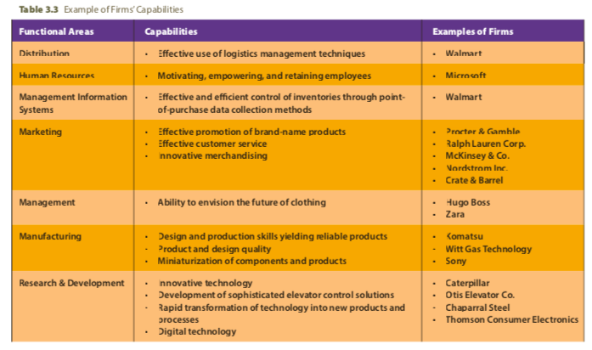

VRIN
- A sustainable competitive advantage exists only when competitors are unable to duplicate the benefits of a firm’s strategy or when they lack the resources to attempt imitation

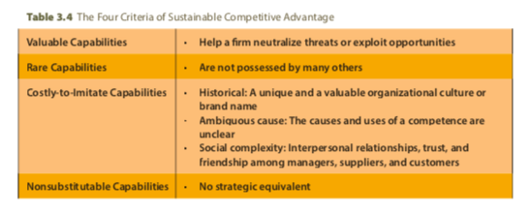
Competitive Dynamics

Market Commonality: the number of markets in which the firms compete against each other (state if low, medium or high)
- Geographic, product, customer segments

Resource Commonality: firms similarity in resources (state if low, medium or high)
- Tangible & intangible

Firms with high market commonality and highly similar resources are direct and mutually acknowledged competitors

Strategic and Tactical Actions / Responses
- Strategic action or strategic response:
  - Market-based move that involves a significant commitment of organisation resources and is difficult to implement and reverse
- Tactical action or tactical response:
  - Market-based move that is take to fine-tune a strategy; it involves fewer resources and is relatively easy to implement and reverse.

Likelihood of Attack
- There are three factors that fall under strategical and tactical actions to attack the competitor:
  - First-mover benefits
  - Organisational size
  - Quality
- First mover benefits:
  - Initial competitive actions in order to build or defend its competitive advantage or to improve its market position (innovative actions)
  - A first mover in a fast-cycle market can experience many times the valuation and revenue of the second mover
  - Additional to this increased likelihood of revenue, they are also likely to gain the loyalty of customers
  - General evidence suggests greater survival rates, however carries risk. Hard to estimate accurate returns that will be earned from introducing product innovation to marketplace.
  - Second mover: responds to first mover. More cautious than the first mover and studies the customers’ reactions. Also tries to find any mistakes the first mover made, so that it can avoid them. The most successful second movers are able to rapidly and meaningfully interpret market feedback to respond quickly yet successfully to the first mover’s successful innovation.
- Organisational size
  - Small firms are more likely than large companies to launch competitive actions and tend to do it more quickly
  - Small firms’ flexibility and nimbleness allow them to develop variety in their competitive actions
  - Large firms are likely to initiate more competitive actions with more strategic actions during a given period. When studying competitors in terms of organisational size, the firm should use a measurement such as total sale revenue etc.
- Quality
  - Customers may be interested in measuring the quality of a firm’s goods and services against a broad range of dimensions (product & service – see below)
  - Without quality, a firm’s products lack creditability, meaning customers don’t consider them as viable options.
  - Quality affects competitive rivalry. Poor quality can predict a decline in the competitor’s sales revenue until the quality issues are resolved

Slow, standard and fast cycle markets
- Slow cycle
  - Firm’s competitive advantage are shielded from imitation, commonly for long periods of time and where imitation is costly
  - Thus, competitive advantages are sustainable over longer periods in time
  - Building unique capability produces comp advantage and success in a slow market cycle. This type of advantage is difficult for competitors to understand
- Standard cycle
  - Markets in which the firm’s competitive advantages are partially shielded from imitation, and imitation is moderately costly
  - Competitive advantages are partially sustainable, but only when the firm is able to continuously upgrade the quality of its capabilities as a foundation for being able to stay ahead of competitors
  - Tends to serve many customers in what are typically highly competitive markets
  - Because the capabilities on which their competitive advantages are based are less specialised, imitation is faster and less costly that in slow cycle.
  - However, imitation is slower and more expensive than in fast cycle.
- Fast cycle
  - Firm’s capabilities that contribute to competitive advantage, are not shielded from imitation and where imitation is often rapid and inexpensive. Thus, competitive advantages aren’t sustainable.
  - Such high velocity environments place considerable pressures on top managers to quickly make strategic decisions that are also effective.
  - Reverse engineering and the rate of technology facilitate the rapid imitation that occurs in fast cycle markets.
  - Instead of concentrating on protecting, maintaining and extending competitive advantages, as in a slow-cycle market, companies competing in fast-cycle markets focus on learning how rapidly and continuously develop new competitive advantages that are superior to those they replaced
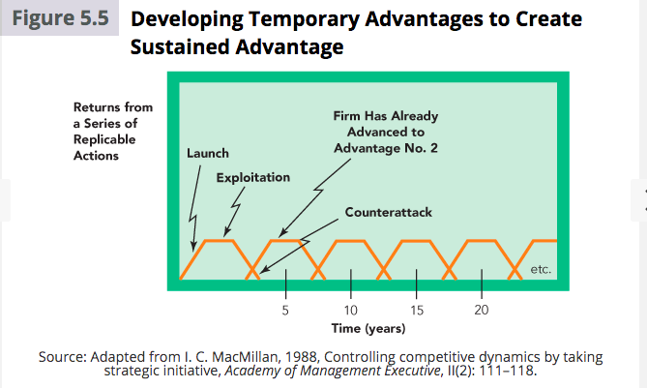
Business-Level Strategies

Business level strategies are an integrated and coordinated set of commitments and actions the firm uses to gain a competitive advantage by exploiting core competencies in specific product markets

In terms of customers, when selecting a business-level strategy the firm determines:
- Who will be served (market segmentation – demographic, socioeconomic, geographic, consumption patterns, perceptual factors etc.)
- What needs those target customers have that it will satisfy; and
- How those needs will be satisfied

Different types of business-level strategies
- Cost-leadership
  - Integrated set of actions taken to produce goods or services with features that are acceptable to customers at the lowest cost, relative to that of competitors
  - Rivalry with Existing Competitors: having the low cost position is valuable when dealing with rivals. Because of the cost leader’s advantageous position, rivals hesitate to compete on the basis of price, especially before evaluating the potential outcomes of such competition.
  - Bargaining Power of Buyers: powerful customers can force a cost leaser to reduce its prices, but not below the level at which the cost leader’s next-most-efficient industry competitor can earn average returns. Although powerful customers may be able to force the cost leader to reduce prices even below this level, they probably will not as prices that are low enough to prevent the next-most-efficient competitor from earning average returns would thus push them out of the market, leaving the original firm with less competition and an even stronger position. Customers would thus lose their power and pay higher prices.
  - Bargaining Power of Suppliers: cost leader generally operates with margins greater than those of competitors and often tries to increase its margins by driving costs lower. Higher gross margins relative to those of competitors allows for the cost leader to absorb its suppliers’ price increases while competitors may struggle. Additionally, a powerful cost leader may be able to force its suppliers to hold down their prices.
  - Potential Entrants: because of economies of scale enhance profit margins, they serve as a significant entry barrier to potential competitors. New entrants must be willing to accept less than average returns until they gain the experience required to approach the cost leader’s efficiency
  - Product Substitutes: cost leader also holds attractive position relative to product substitutes. A product substitute becomes a concern for the cost leader when its features and characteristics, in terms of cost and differentiation, are potentially attractive to the firm’s customers. To retain customers, cost leaders can often reduce prices.
  - Competitive Risks of the Cost Leadership Strategy: the cost leadership strategy is not risk free. One risk is that the processes used by the cost leader could become obsolete due to competitor’s strategies. A second risk is that too much focus on cost reduction may reduce customers’ perceptions of competitive levels of differentiation.
- Differentiation
  - Integrated set of actions taken to produce goods or services (at an acceptable cost) that customers perceive as being different in ways that are important to them.
  - Rivalry with Existing Competitors: reputations can sustain competitive advantage of a firm following a differentiation strategy. As a customer’s loyalty to a brand increases, customers’ sensitivity to price increases is reduced.
  - Bargaining Power of Buyers: the distinctiveness of differentiated goods reduces customers’ sensitivity to price increases. Customers are willing to accept a price increase when a product still satisfies their unique needs better than the competitor’s offerings.
  - Bargaining Power of Supplier: because the firm using a differentiation strategy charges a premium price, suppliers must provide high quality components, driving up the firm’s costs. High returns that the firm earns partially insulates it from the influence of high supplier costs, alternatively, the increased costs of suppliers can be oncharged to the customer.
  - Potential Entrants: customer loyalty and the need to overcome the uniqueness of a differentiated product create substantial barriers to potential entrants
  - Product Substitutes: companies without brand loyalty face a higher probability of their customers switching either to products who offer differentiated features that serve the same function for a lower price, or products that offer more features.
  - Competitive Risks of the Differentiated Strategy: customers may decide that the price differential between the differentiator’s product and the cost leader’s product is too large. Another risk is that the firms means of differentiation may cease to provide value for customers, and thus customers may switch to other products.
- Focus Strategies
  - An integrated set of actions taken to produce goods or services that serve the needs of a particular competitive segment
  - Either:
    - Particular buyer group
    - A different segment of a product line
    - A different geographic market
  - Focused Cost Leadership: particular competitive segment with a low cost differentiation focus.
  - Focused Differentiation Strategy: firms must be able to complete various primary value chain activities and support functions in a competitively superior manner to develop and sustain competitive advantage and earn above-average returns.
  - Competitive Risks of Focus Strategies: same general risks of cost leadership and differentiation on industry-wide basis. Also: competitor may be able to focus on a more narrowly defined competitive segment and therefore ‘out-focus’. The needs of customers within a narrow competitive segment may become similar to those of industry-wide customers as a whole over time. As a result, the advantages of a focus strategy are either reduced or eliminated over time.
- Integrated Cost Leadership / Differentiation Strategy
  - Involves engaging in primary value-chain activities and support functions that allow a firm to simultaneously pursue low cost and differentiation.
  - Firms that successfully use the integrated cost leadership / differentiation strategy usually adapt quickly to new technologies and rapid changes in their external environments
  - Can be achieved through:
    - Flexible manufacturing systems
    - Information networks
    - Top quality management systems (to increase customer satisfaction, cut costs or reduce the amount of time required to introduce innovative products to the marketplace)
  - Risks due to the difficulty to perform primary value-chain activities and support functions in ways that allow them to produce relatively inexpensive products with levels of differentiation that create value for the target customer. Moreover, to properly use this strategy across time, firms must be able to simultaneously reduce costs (as required by the cost leadership strategy) incurred to produce products while increasing product differentiation (required by the differentiation strategy).

Corporate Level Strategies

A corporate-level strategy specifies actions a firm takes to gain a competitive advantage by selecting and managing a group of different businesses competing in different product markets. Corporate-level strategies help companies to select new strategic positions - positions that are expected to increase the firm’s value.

The decision to pursue growth is not a risk-free choice for firms, effective firms carefully evaluate their growth options before committing resources.

Levels of Diversification

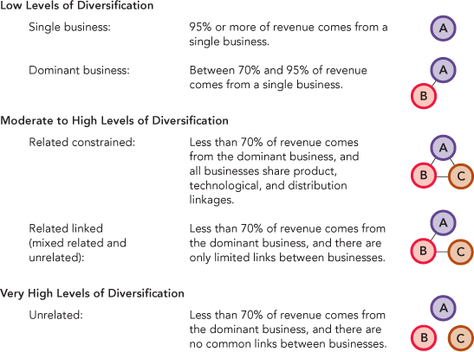

- Low Levels of Diversification:
  - Either uses a single or a dominant-business, corporate-level diversification strategy.
  - Firms that focus on one or very few businesses and markets can earn positive returns, because they develop capabilities useful for these markets and can provide superior service to their customers.
  - Fewer challenges in managing one or a very small set of businesses, allowing them to gain economies of scale and efficiently use their resources.
  - Companies may prefer this as they prefer the narrower focus a reputation (e.g. family name) is related closely to that of the business. Thus, they prefer to provide quality goods and services which a focused strategy better allows
- Moderate and High Levels of Diversification
  - Uses a related diversification corporate-level strategy.
  - When links between the diversified firm's businesses are rather direct, it is related constrained diversification strategy. These firms tend to share similar sourcing, throughput and output.
  - When links between the diversified firm's businesses share fewer resources and assets between them, they use a related linked diversification strategy. Concentrate on transferring knowledge and core competencies
- Very High Levels of Diversification
  - A highly diversified firm that has no relationships between its businesses follows an unrelated diversification strategy.
  - Commonly, firms using this strategy are called conglomerates. These businesses are not related to each other, and the firm makes no efforts to share activities or to transfer core competencies between or among them. This firm’s size and diversity suggest the challenge of successfully managing the unrelated diversification strategy

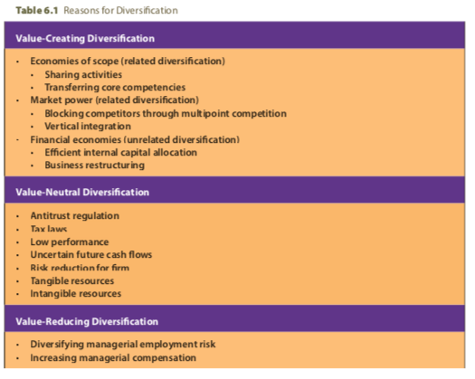

- Value-Reducing Diversification: Decisions to expand a firm’s portfolio of businesses to reduce managerial risk or increase top managers pay can have a negative effect on the firm’s value. Greater amounts of diversification reduce managerial risk in that if one of the businesses in a diversified firm fails, the top executive of that business does not risk total failure by the corporation
- Value-Neutral Diversification: desire to match and thereby neutralize a competitor’s market power (e.g., to neutralize another firm’s advantage by acquiring a similar distribution outlet)
- Value-Creating Diversification: Value is created either through related diversification or through unrelated diversification when the strategy allows a company’s businesses to increase revenues or reduce costs while implementing their business-level strategies
  - Related Constrained and Related Linked Diversification:
  - With the related diversification corporate-level strategy, the firm builds upon or extends its resources and capabilities to build a competitive advantage by creating value for customers. The company wants to develop and exploit economies of scope between its businesses. Economies of scope are cost savings a firm creates by successfully sharing resources and capabilities or transferring one or more corporate level core-competencies that were developed in one of its businesses to another of its businesses.
  - Tangible resources such as plant and equipment or other business-unit physical assets often must be shared
  - Less tangible resources such as manufacturing know-how and technological capabilities can also be shared. A 'know-how' for something, transferred between separate activities with no physical or tangible resource involved, is a transfer of a corporate-level core competence, not an operational sharing of activities

Operational Relatedness: Sharing Activities
- Firms can create operational relatedness by sharing either a primary activity (e.g., inventory delivery systems) or a support activity (e.g., purchasing practices)
- Firms more so using the related constrained diversification strategy share activities in order to create value
- Activity sharing is also risky because ties among a firm’s businesses create links between outcomes - can reduce activity sharing success. Additionally, activity sharing requires careful coordination
- Research has shown however that firms with closely related businesses have lower risk. These results suggest that gaining economies of scope by sharing activities across a firm's businesses may be important in reducing risk and in creating value.

Corporate Relatedness: Transferring of Core Competencies
- The firm's intangible resources, such as it know-how, become the foundation of core competencies.
- Corporate-level core competencies are complex sets of resources and capabilities that link different businesses, primarily through managerial and technological knowledge, experience and expertise.
- Firms seeking to create value through corporate relatedness use the related linked diversification strategy.

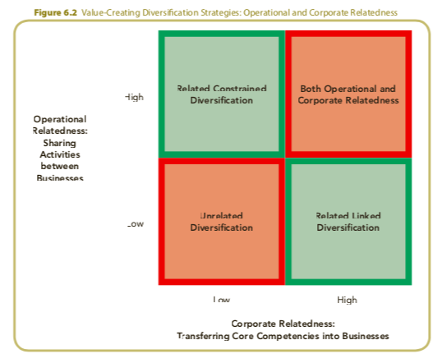

Merges and Acquisitions

Merger: strategy through which two firms agree to integrate their operations on a relatively coequal basis

Acquisition: strategy through which one firm buys a controlling or 100% interest in another firm with the intent of making the acquired firm a subsidiary business within its portfolio

Take-over: special type of acquisition where the target firm does not solicit the acquiring firm's bid; thus, takeovers are unfriendly acquisitions.

Reasons for Acquisitions:
- Increased Market Power
  - Market power exists when a firm is able to sell its goods and services above competitive levels or when the costs of its primary or support activities are lower than those of its competitors. Market power is usually derived from the size of a firm, quality of the resources it uses to compete, and its share of the market in which it competes
  - Therefore, most acquisitions that are designed to achieve greater market power entail buy a competitor, supplier, distributor or business in a highly related industry so a core competence can be used to gain competitive advantage. Horizontal acquisitions increase a firm’s market power by exploiting cost-based and revenue-based synergies
  - Horizontal acquisitions: acquisition of a company competing in the same industry
  - Vertical acquisitions: firm acquiring a supplier or distributor of one or more of its products.Through a vertical acquisition, the newly formed firm controls additional parts of the value chain - vertical acquisitions lead to increased market power
  - Related acquisitions: acquiring a firm in a higher related industry. Through a related acquisition, firms seek to create value through the synergy that can be generated by integrating some of their resources and capabilities
- Overcoming Entry Barriers
  - Facing the entry barriers that economies of scale and differentiated products create, a new entrant may find that acquiring an established company is more effective than entering the market as a competitor. In fact, the higher the barriers to market entry, the greater the probability that a firm will acquire an existing firm
  - Entry barriers: economies of scale in manufacturing or servicing their products, enduring relationships with customers often create loyalties which are difficult for new entrants to overcome, differentiated products
  - Cross Border Acquisitions: acquisitions made between companies with headquarters in different countries
- Cost of New Product Development and Increased Speed to Market
  - Acquisitions provide more predictable returns because the performance of the acquired firm's product can be assessed prior to completing the acquisition
  - Because an estimated 88% of innovations fail to achieve adequate returns, concerns exist in firms about their ability to achieve adequate returns from the capital they invest to develop and commercialize new products.
  - Potentially contributing to these less-than-desirable rates of return is the successful imitation of approximately 60 percent of innovations within four years after the patents are obtained. These types of outcomes may lead managers to perceive internal product development as a high-risk activity
- Lower Risk Compared to Developing New Products
  - The outcomes of an acquisition can be estimated more easily and accurately than the out- comes of an internal product development process; as such, managers may view acquisitions as less risky
  - However, may become a substitute for internal innovation
- Increased Diversification
  - It is difficult for companies to develop products that differ from their current lines for markets in which they lack experience. Acquisition strategies can be used to support both related and unrelated strategies
  - The more related the acquired firm is to the acquiring firm, the greater the probability will be that the firm will be successful. Thus, horizontal acquisitions and related acquisitions tends to contribute more to the firm’s strategic competitiveness
- Reshaping Firm's Competitive Scope
  - To reduce the negative effect of an intense rivalry on financial performance, firms may use acquisitions to lessen their product and/or market dependencies.
- Learning and Developing New Capabilities
  - Gain access to capabilities they lack. Research shows that firms can broaden their knowledge base and reduce inertia through acquisitions and that they increase the potential of their capabilities when they acquire diverse talent through cross-border acquisitions

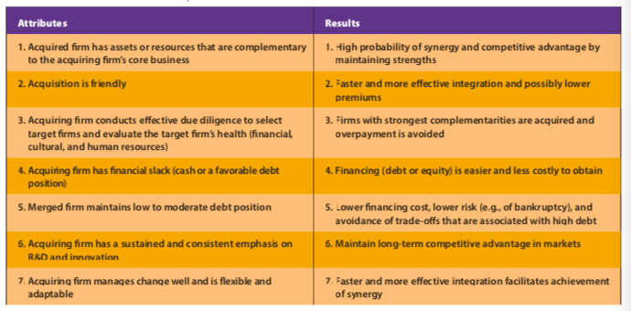

Risks Associated in Acquisitions:
- Integration difficulties
  - Meld two or more unique corporate cultures
  - Link different financial and control systems
  - Build effective working relationships (particularly when management styles differ)
  - Determine the leadership structure and those who will fill it for the integrated firm
- Inadequate evaluation of target
  - Due diligence is a process through which a potential acquirer evaluates a target firm for acquisition.
  - In an effective due diligence process, hundreds of items are examined in differing areas that would be necessary to successfully meld the two workforces.
  - Commonly, firms are willing to pay a premium to acquire a company they believe will increase their ability to earn above-average returns. When firms overestimate the value of synergies or value of future growth potential associated with the acquisition, the premium they paid may prove to be too large. Excessive premiums can have dilutive effects on the newly formed short-term and long-term earning potentials.
- Large or extraordinary debt
  - Firms using an acquisition strategy want to verify that their purchases do not create a debt load that overpowers their ability to remain solvent and vibrant as a competitor.
- Inability to achieve synergy
  - In response to building on complementary assets: Private synergy is created when combining and integrating the acquiring and acquired firms’ assets yield capabilities and core competencies that could not be developed by combining and integrating either firm’s assets with another company. Private synergy is possible when firms’ assets are complementary in unique ways; that is, the unique type of asset complementarity is not always possible simply by combining two companies’ sets of assets with each other.
- Too much diversification
  - The firm that becomes overdiversified will experience a decline in its performance and likely a decision to divest some of its units. Commonly, such divestments, which tend to reshape a firm’s competitive scope, are part of a firm’s restructuring strategy.
- Managers overly focused on acquisitions
  - Activities managers becomes involved in with acquisitions:
    - searching for viable acquisition candidates
    - completing effective due-diligence processes
    - preparing for negotiations
    - managing the integration process after completing the acquisition
  - Acquisitions can divert managerial attention from other matters that are necessary for long-term competitive success
  - Both theory and research suggest that managers can become overly involved in the process of making acquisitions

Corporate Governance

Corporate Governance: the set of mechanisms used to manage the relationships among stakeholders and to determine and control the strategic direction and performance of organisations.

Separation of Ownership and Managerial Control
- Agency Relationships (the power of institutional shareholders over a firm):
  - Agency relationship: exists when on party delegates decision-making responsibility to a second party for compensation. This separation can be problematic and can lead to managerial opportunism ..
- Agency Costs and Governance Mechanisms
  - Agency costs: sum of incentive costs, monitoring costs, enforcement costs, and individual financial losses incurred by principals because governance mechanisms cannot guarantee total compliance by the agent.
  - Managerial interests may prevail when governance mechanisms are weak
  - If however, the board of directors controls managerial autonomy, or if other strong governance mechanisms are used, the firm’s strategies should better reflect stakeholders and shareholders interests.

Ownership Concentration (three internal governance mechanisms of managerial decisions regarding firm’s strategies):
- Ownership concentration: defined by the number of large-block shareholders and the total percentage of the firm’s shares they hold
- Large block shareholders: typically own at least 5% of a company’s issued shares
- Ownership concentration as a governance mechanism has received considerable interest because large-block shareholders are increasingly active in their demands that firms adopt effective governance mechanisms to control managerial decisions so that they will best represent owners’ interests
- Institutional owners: financial institutions, such as mutual funds and pension funds, that control large-block shareholder positions.
- Institutional owners have the potential to be a powerful governance mechanism. Hold both the size and incentive to discipline ineffective top-level managers and they can significantly influence a firm’s choice of strategies and strategic decisions.

Board of Directors
- Group of elected individuals whose primary responsibility is to act in the owners’ best interests by formally monitoring and controlling the firm’s top-level managers
- Insiders, related outsiders, outsiders
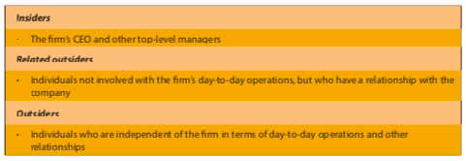

- The demand for greater accountability and improved performance is stimulating many boards to voluntarily make changes. To help create a more effective board of directors the following has been adapted:
  - Increases in the diversity of the backgrounds of board members
  - The strengthening of internal management and accounting control systems
  - Establishing and consistently using formal processes to evaluate board member’s performance
  - Modifying the compensation of directors, especially reducing or eliminating stock options as part of their package
  - Creating a ‘lead director’ role that has strong powers with regards to the board agenda and oversight of non-management board member activities

Executive compensation
- Governance mechanism that seeks to align the interests of managers and owners through salaries, bonuses and long-term incentives such as stock awards and options
- Long-term incentive plans are an increasingly important part of compensation packages for top-level managers. Theoretically, using long-term incentives facilitates the firm’s efforts (through the board of directors’ pay-related decisions) to avoid potential agency problems by linking managerial compensation the wealth of the common shareholders.
- Effectively designed long-term incentive plans have the potential to prevent large-block shareholders from pressing for changes in the composition of the board of directors and the top-management team because they assume that the plans will ensure that top-level managers will act in shareholders’ best interests
- Effectiveness / Issues of Executive Compensation:
  - Strategic decisions top-level managers make are complex and nonroutine, meaning that direct supervision is likely to be ineffective as a means of judging the quality of their decisions. The result is a tendency to link top-level managers’ compensation to outcomes the board can easily evaluate, such as the firm’s financial performance
  - The effects of top level managers’ decisions are stronger on the firm’s long term performance than its short term performance, making it difficult to assess the effects on a regular basis
  - A number of other factors affect a firm’s performance besides top-level managerial decisions and behaviour. Unpredictable changes in segments (economic, demographic, political) in the firm’s general environment make it difficult to separate the effects of the top-level managers decisions and the effects (both positive and negative) of changes in the firm’s external environment on the firm’s performance
  - Annual bonuses may provide incentives to pursue short-run objectives at the expense of the firm’s long-term interests.
  - Although long-term, performance-based incentives may reduce the temptation to underinvest in the short run, they increase executive exposure to risks associated with uncontrollable events, such as market fluctuations and industry decline.

Organisational Structure and Controls

Organisational Structure
- Specifies the firm’s formal reporting relationships, procedures, controls, and authority and decision-making processes.
- When effective organisational structure is achieved, it provides the organisation with a better opportunity to compete against rivals as well as implement strategies as a means of outperforming those competitors and maintaining/gaining competitive edge.
- Evidence suggests that performance declines when the firm’s strategy is not matched with the most appropriate structure and controls.

Different Types of Organisational Structure – Business Level
- Functional: consists of a CEO and limited corporate staff, with functional line managers in dominant organisational areas such as production, accounting, marketing, R & D, engineering and human resources
  - This structure allows for functional specialisation, thereby facilitating active sharing of knowledge within each functional area
  - However, can negatively impact communication and co-ordination among those representing different functions
  - For this reason, the CEO must verify the decisions and actions of the individual business’ functions promote the entire firm rather than one individual function
  - Supports implementing business-level strategies and some corporate-level strategies with low levels of diversification
- Divisional: consists of corporate office and operating divisions, each operating division representing a separate business or profit centre in which the top corporate officer delegates responsibilities for day-to-day operations and business unit strategy to division managers
  - With continuing growth and success, firms often consider greater levels of diversification. Successfully using a diversification strategy requires analysing greater amounts of data and information.
  - Trying to manage high levels of diversification through functional strategies creates serious coordination and control problems.
  - Enables corporate officers to more accurately monitor the performance of each business, which simplifies the problem of control
  - Facilitates comparisons between divisions, which improves resource allocation process
  - Stimulates managers poorly performing divisions to look for ways of improving performance
  - Active monitoring of performance increases the likelihood that decisions made by managers heading individual units will be in the stakeholders’ best interests
  - Used to support implementation of related and unrelated diversification

Business Level Strategies and the Functional Structure
- The functional structure is used to implement business-level strategies
- The cost leadership strategy requires a centralized functional structure—one in which manufacturing efficiency and process engineering are emphasized
- The differentiation strategy’s functional structure decentralizes implementation- related decisions, especially those concerned with marketing, to those involved with individual organizational functions.
- Focus strategies, often used in small firms, require a simple structure until such time that the firm diversifies in terms of products and/or markets.

Corporate Level Strategies and the Multidivisional Structure
- Unique combinations of different forms of the multidivisional structure are matched with different corporate-level diversification strategies to properly implement these strategies.
- The related constrained M-form corporate-level strategy, has a centralized corporate office and extensive integrating mechanisms. Divisional incentives are linked to overall corporate performance to foster cooperation among divisions.
- The related linked M-form structure establishes separate profit centres within the diversified firm. Each profit centre or SBU may have divisions offering similar products, but the SBUs are often unrelated to each other.
- The unrelated diversification M-form structure, is highly decentralized, lacks integrating mechanisms, and utilizes objective financial criteria to evaluate each unit’s performance.

Structural Elements to Consider
- When choosing an organisation structure, a firm should consider various structural elements that will help it to implement its strategy and accomplish its long term strategic objectives, including:
- Specialisation: the type and number of jobs required to complete the work of the firm (high specialisation = workers have few tasks in the job description; low specialisation = workers have relatively large number of tasks in job description)
- Centralisation: the degree to which decision-making authority is retained at high managerial levels (centralisation concentrates decision authority and responsibility to increase control; decentralisation devolves decision authority and responsibility to lower levels across organisation to allow flexibility and rapid responses)
- Formalisation: the degree to which formal rules and procedures govern work (high formalisation = rigid rules and procedures govern individual work for control and consistency; low formalisation = few rules and procedures to allow individual creativity and discretion)

Organisational Controls: guide the use of strategy, indicate how to compare actual results with expected results, and suggest corrective actions to take when the difference is unacceptable
- Strategic Controls: largely subjective criteria intended to verify that the firm is using appropriate strategies for the conditions in the external environment and the company’s competitive advantages
- Financial Controls: largely objective criteria used to measure the firm’s performance against previously established quantitative standards

Strategic Leadership

Effective strategic leadership is exercised through determining strategic direction and establishing balanced organisational controls. This is further achieved through effectively sustaining an effective organisational culture.

Determining Strategic Direction:
- Involves specifying the vision and the strategy or strategies to achieve the vision over time
- The strategic direction is framed within the context of the conditions (opportunities and threats) that leaders expect from their firm to face in roughly next three to five years
- The ideal long term strategic direction has two parts: a core ideology (to motivate employees) and an envisioned future (encourage employees to go beyond expectations of accomplishment and required significant change and progress to be realised)
- E.g. enter new international market or new suppliers to add to firm’s value chain etc.

Sustaining Effective Organisational Culture
- Because organisational culture influences how the firm conducts business and helps regulate and control employees behaviour, it can be a source of competitive advantage
- Organisational culture can be an increasingly important source of differentiation for firms to emphasise when pursing strategic competitiveness and above average returns
  - Entrepreneurial mind set: entrepreneurial opportunities are a vital source of growth and innovation. Key action for strategic leaders to take is to encourage and promote innovation by pursuing entrepreneurial opportunities
    - Five dimensions characterize a firm’s entrepreneurial mind-set: autonomy, innovativeness, risk taking, proactiveness, and competitive aggressiveness
  - Changing organisational culture and restructuring: identifying when change is needed. This can assist in implementing strategies. Reinforcing new culture requires effective communication and problem solving, along with selecting the right people and using appropriate reward systems. Evidence suggests that cultural changes only succeed when CEOs, other key top management team members and middle-level managers actively support the change.

Maintaining Balanced Organisational Controls:
- Controls are necessary to help ensure that firms achieve their desired outcomes. Most critically, controls provide the parameters for implementing strategies as well as the corrective actions to be taken when adjustments are required
- Financial controls focus on short-term financial outcomes
- Strategic controls focus on content of strategic actions rather than outcomes
- A balanced scorecard approach allows a firm to determine if they are achieving an appropriate balance when using strategic and financial controls as a means of positively influencing performance

