Table of Contents
Introduction to organisational behaviour and diversity 2
Attitudes and job satisfaction 8
Emotions and stress 12
Personality and values 16
Ethics and the ‘dark side’ of OB 21
Leadership 24
Perception and individual decision-making 27
Groups and teams 30
Powers and politics 34
Motivation 36
Organisational culture 39

Introduction to organisational behaviour and diversity

Importance of Interpersonal Skills

- Helps organisations to attract and keep high-performing employees.
- Positive social relationships are associated with lower stress levels at work and lower intentions to quit. So, having managers with good interpersonal skills is likely to make the workplace more pleasant.
- In today’s competitive and demanding workplace, managers cannot succeed on their technical skills alone they also need to have good people skills.

What do managers do?
They get things done through other people.

Management activities
- Make decisions.
- Allocate resources.
- Direct activities of others to attain goals.

Work in an organisation
- A consciously coordinate special unit composed of two or more people that functions on a relatively continuous basis to achieve a common goal or set of goals.
Three Different Approaches to Managerial Skills and Activities
Management Functions (Fayol)  - Planning  - Organising  - Leading  - Controlling | Management Roles (Mintzberg)  - Interpersonal roles  - Informational roles  - Decisional roles
Management Skills
- Technical skills (apply specialised knowledge)
- Human skills (work with people)
- Conceptual skills (analyse and diagnose complex situations)

Effective versus successful managerial activities

Four managerial activities:
- Traditional management
  - Decision making, planning and controlling.
- Communication
  - Exchanging routine information and processing paperwork.
- Human resource management
  - Motivating, disciplining, managing conflict, staffing and training.
- Networking
  - Socialising, politicking and interacting with others.

Allocation of activities by time

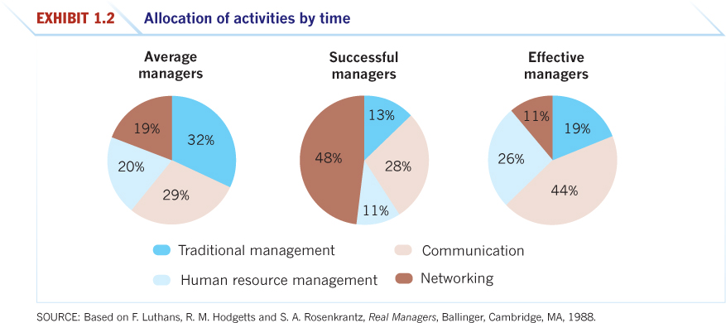

* As illustrated above successful managers will assign most of their time to networking i.e. forming connections with others (meeting other meeting, identifying people that are helpful to your career, creating and mentoring relationships, ensuring people view you as being successful i.e. making your successful endeavours visible to others, making clear to other people that you want those promotions). Additionally, to be an effective manager 44% of time is spent communicating with others providing further evidence that interpersonal skills are imperative in becoming a leader.

What is organisational behaviour?

- Organisational behaviour (OB) is a field of study that investigates the impact that individuals, groups and structure have on behaviour within organisations, for the purpose of improving an organisations effectiveness.
- OB studies three determinants of behaviour in organisations:
  - Individuals, groups and structure
- Applies knowledge gained about individuals, groups and the effect of structure on behaviour in order to make organisations work more effectively.

Intuition and systematic study

- Each of us is a student of behaviour. You have been ‘reading’ people almost all your life, watching their actions and trying to interpret what you see or to predict what people might do under different conditions.
- You can improve your predictive ability by supplementing intuition with a more systematic approach.
- Behaviour is generally predictable, and the systematic study of behaviour is a means to making reasonably accurate predictions.
- Systematic study allows us to look at relationships, attempting to attribute causes and effects, and basing our conclusions on scientific evidence—that is, on data gathered under controlled conditions and measured and interpreted in a reasonably rigorous manner.
  - Intuition is not always accurate and cannot be solely relied upon, it must be accompanied by systematic research.
  - Intuition needs to be complimented with systematic study i.e. research to reinforce presumptions.

Evidence-based management

- Evidence-based management (EBM) complements systematic study by basing managerial decisions on the best available scientific evidence or data.
- Use evidence as much as possible to inform your intuition and experience.
- There are no absolutes in OB.
  - It the idea that managers can learn more about their employees and understand more about their experiences if they listen to them e.g. this may involve going out on the shop floor and actively engaging with employees (i.e. face-to-face contact or management by walking around).
  - As a result, researchers found that this type of management was not as effective as it was initially thought. Only worked effectively in cases where managers followed up on employee concerns. Further, listening needed to be followed up by action.
- The trick, of course, is to know when to go with your gut. – Jack Welch.

* Important that you understand this concept and keep it at the forefront of your mind throughout this course.

Disciplines that contribute to OB

- Psychology
  - Helps us to understand individual-level behaviours and characteristics, including personality, decision-making, stress, and perception, etc.
- Social Psychology
  - Contributes to measuring, understanding and changing attitudes; identifying communication patterns; building trust; group behaviour
- Sociology
  - Helps us understand organisational culture, formal organisation theory and structure, group behaviour
- Anthropology
  - Contributes to knowledge of organisational culture, organisational environments and differences between national cultures

Challenges and opportunities for OB

- Today’s challenges bring opportunities for managers to use OB concepts to address problems and work toward solutions:
- Responding to economic pressures
- Responding to globalisation
- Managing workforce diversity
- Improving customer service and people skills
  - For example, ad campaigns can sometimes be misinterpreted which can damage brands e.g. H&M.
- Working in networked organisations
- Enhancing employee well-being at work
- Improving ethical behaviour
  - Unethical practices conducted by the big 4 banks in Australia.

* Our world is characterised by constant change. In today’s organisations managers are confronted with both challenges and opportunities that they have never had to face before. In fact, there are challenges coming that future managers will have to grapple/acclimatise to e.g. artificial intelligence (driverless cars, robots performing work, etc. – learning how to respond to these changes).

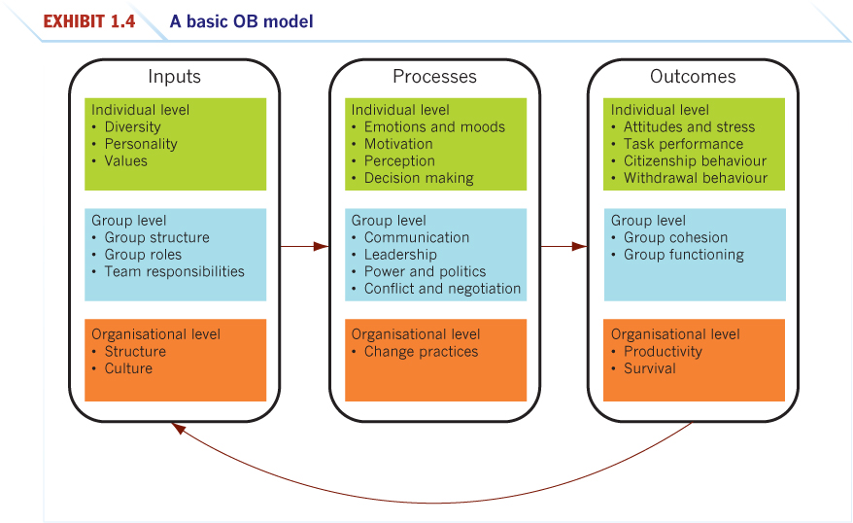
- A model is an abstraction of reality, a simplified representation of some real-world phenomenon.

- The OB model proposes three types of variables:
  - Inputs
  - Processes
  - Outcomes

- At three levels of analysis:
- Individual
- Group
- Organisational

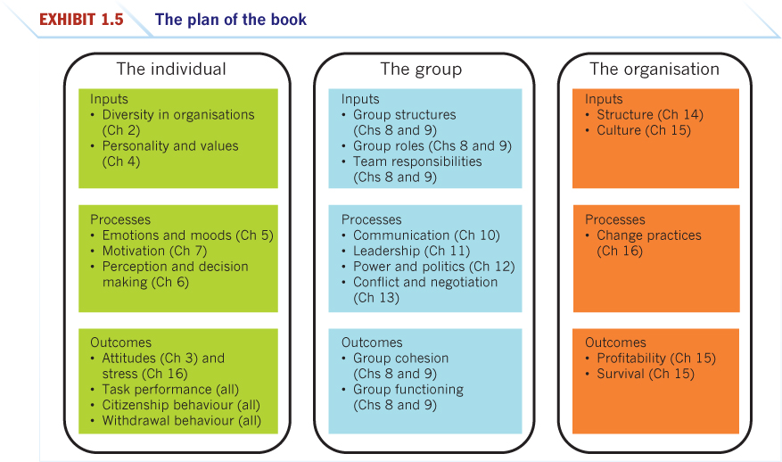
Coming attractions in OB

- Attitudes and stress
- Task performance
- Citizenship behaviours
- Withdrawal behaviour
- Group cohesion
- Group functioning
- Productivity
- Survival

Diversity in organisations

- Importance of diversity management
- Levels of diversity
- Biographical characteristics
- Ability
- Implementing diversity management strategies
- Effective diversity programs

Importance of diversity management

- Increasing diversity in organisations worldwide.
- Effective diversity management increases an organisation’s access to the widest possible pool of skills, abilities and ideas.
- Managers also need to recognise that differences between people can lead to miscommunication, misunderstanding and conflict.
- Individual characteristics, such as age, gender, race, ethnicity and abilities, can influence employee performance.
- Managers can develop awareness about these characteristics and manage a diverse workforce effectively.

Levels of diversity

- Demographics mostly reflect surface-level diversity, not thoughts and feelings, and this can lead employees to perceive one another through stereotypes and assumptions.
- Evidence has shown that as people get to know one another they become less concerned about demographic differences if they see themselves as sharing characteristics such as personality and values, which represent deep-level diversity.
- Individual differences in personality and culture shape preferences for rewards, communication styles, reactions to leaders, negotiation styles and many other aspects of behaviour in organisations.

Biographical characteristics

- Biographical characteristics, such as age, gender, race, disability, religion, length of service, are some of the most obvious ways employees differ.
- Although diversity does present many opportunities for organisations, effective diversity management also means working to eliminate unfair discrimination based on these characteristics.

Ability is an individual’s current capacity to perform the various tasks in a job. Overall, abilities are essentially made up of two sets of factors: intellectual and physical
- Everyone has strengths and weaknesses in terms of ability that make them relatively superior or inferior to others in performing certain tasks or activities.
- From management’s standpoint, the issue is not whether people differ in terms of their abilities; they clearly do. The issue is knowing how people differ in abilities and using that knowledge to increase the likelihood that an employee will perform the job well.

Implementing diversity management strategies
Diversity management makes everyone more aware of and sensitive to the needs and differences of others
- This definition highlights the fact that diversity programs include and are meant for everyone
- When seen as everyone’s business, diversity is much more likely to be successful than if we believe it helps only certain groups of employees

Effective diversity programs
Effective, comprehensive workforce programs encouraging diversity have three distinct components.
- First, they teach managers about the legal framework for equal employment opportunity and encourage fair treatment of all people regardless of their demographic characteristics.
- Second, they teach managers how a diverse workforce will be better able to serve a diverse market of customers and clients.
- Third, they foster personal development practices, bringing out the skills and abilities of all workers, and acknowledging how differences in perspective can be a valuable way to improve performance for everyone.

Discussion Questions

Organisational Behaviour

- What is the importance of interpersonal skills?
- What do managers do I terms of functions, roles and skills?
- What is organisational behaviour (OB)?
- Why is it important to complement intuition with systematic study?
- What are the major behavioral science disciplines that contribute to OB?
- Why are there few absolutes in OB?
- What are the challenges and opportunities for managers in using OB concepts?
- What are the three levels of analysis in this book’s OB model?

Diversity in the workplace

- Describe forms of workforce diversity.
- Identify the keep biographical characteristics and describe how they are relevant to OB.
- What are the relevant points of intellectual and physical abilities to OB?
- Describe how organisations manage diversity effectively.

Attitudes and job satisfaction

- What are the main components of attitude? Are these components related or unrelated?

Attitudes are evaluations employees make about objects, people or events.

The three components include:
    - Cognition – description of or belief in the ways things are. It is an option or beliefs segment of an attitude e.g. ‘My pay is poor’
    - Affect – the emotional feeling segment of an attitude e.g. ‘I’m angry over how little I’m paid.’
    - Behaviour – an intention to behave in a certain way towards someone or something e.g. ‘I’m going to find another job that pays better.’

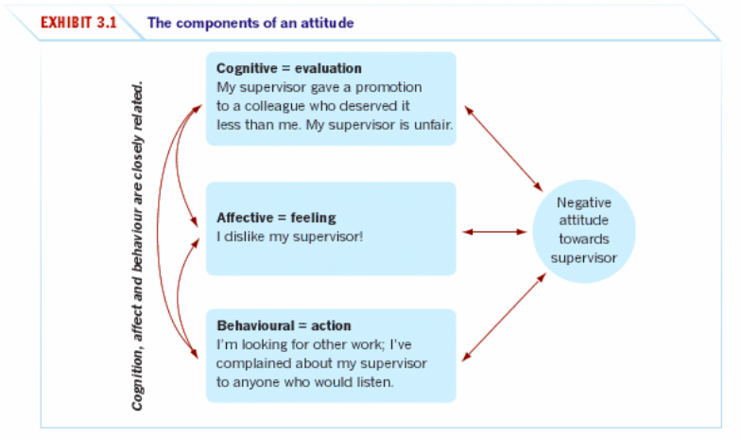

These components are closely related, and cognition and affect in particular are inseparable in many ways. For example, imagine you had a disagreement with a colleague and concluded that they had treated you harshly. You are likely to have feelings about the incident occurring virtually instantaneously with your thoughts about the incident. Thus, these two components are intertwined.

- Does behaviour always follow from attitude? Why or why not? Discuss the factors whether behaviour follows from attitudes.

Early research found that attitudes were casually related to our behaviour – that is, the attitude people hold determine what they do.

Leon Festinger, a researcher found that attitudes do follow behaviour. He proposed that cases of attitude following behaviour illustrate the effects of cognitive dissonance which is the incompatibility an individual might perceptive between two or more attitudes or between behaviour and attitudes e.g. when people change what they say so that it doesn’t contradict what they do (attitudes follow behaviour). He argued that any form of inconsistency between the two is uncomfortable and so individuals will attempt to reduce it. They will seek a stable state, with a minimum of dissonance.

It is undeniable that people seek consistency between their attitudes and behaviour. They will either alter the attitudes or the behaviour, or they develop a rationalisation or the discrepancy; an example can be smokers, they know that the behaviour poses serious health risks, instead they will brainwash or convince themselves of its benefits.

Of course, it is virtually impossible to avoid dissonance completely. The desire to reduce dissonance depends on moderating factors, including the importance of the elements creating it, the degree of influence we believe we have over them (when they believe they have the power to control it) and rewards of dissonance (high rewards accompanying high dissonance tend to reduce tension inherent in the dissonance).

While this was the vested approach taken by Festinger, not all researchers agreed. More recently, research has shown that attitudes predict future behaviour

The most important variable moderating the relationship between attitudes and behaviour:
- Importance of the attitude;
- Its correspondence to behaviour;
- Its accessibility;
- The presence of social pressures;
- Whether a personal has direct experience with the attitude.

* Cognitive dissonance somewhat corresponds to hypocriticalness in that it is when one’s attitude is inconsistent with their behaviour.

- What are the major job attitudes? In what ways are these attitudes alike? What is unique about each?

- Job satisfaction – a positive feeling about one’s job, resulting from an evaluation of its characteristics.
- Job involvement – the degree to which a person identifies with a job, actively participates in it and considers performance important to self-worth.
- Psychological empowerment: employee’s belief in the degree to which they affect their work environment, their work environment, their competence, the meaningfulness of their job and their perceived autonomy in their work.
- Job commitment – the degree to which an employee identifies with a particular organisation and its goals, and wishes to maintain membership in the organisation.
- Perceived organisational support (POS) – the degree to which employees believe an organisation value their contribution and cares about their well-being.
- Employee engagement – an individual involvement and satisfaction with, and enthusiasm for, the work he or she does.

- How do we measure job satisfaction?

There are two approaches to measuring job satisfaction;
- Asking question of ‘All things considered, how satisfied are you with your job?’ with respondents circling a number scale between 1and 5 with 1 being highly satisfied and 5 being highly dissatisfied.
- The summation of job facets – it identifies key elements in a job such as the nature of the work, supervision, present pay, promotion, opportunities and relationships with colleagues. Respondents are then asked to rate these on a standardised scale, and researchers add the ratings to create an overall job satisfaction score.

- What causes job satisfaction? For most people, is pay or the work itself more important?

- Liking the work you do and the people you work with.
- A job that provides activities of interest e.g. training, variety, independence and control.
- Strong correlation between people enjoying the social environment of their workplace and high job satisfaction.
- Also, other factors can include:
  - Interdependence;
  - Feedback; (closely related to recognition)
  - Social support;
  - Interaction with colleagues outside of the work environment.

Highly compensated employees recorded average satisfaction levels no higher than those that were paid much less. For example, one researcher even found no significant difference when he compared the overall well-being of the richest people on the Forbes 400 list with that of Massai herdsmen in East Africa.

For majority of people the job itself is much more important than what it pays.

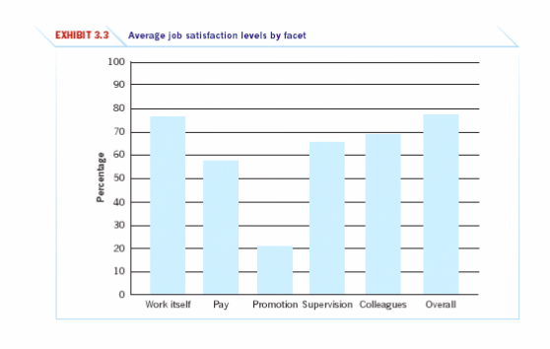

- What outcomes does job satisfaction influence? What implications does this have for management?

- Exit: dissatisfaction expressed through behaviour directed towards leaving the organisation, including looking for a new position as well as resigning.
- Voice: the voice response includes actively and constructively attempting to improve conditions, including suggesting improvements, discussing problems with superiors and undertaking some forms of union activity.
- Loyalty: the loyalty response means passively but optimistically waiting for conditions to improve, including speaking up for the organisation in the face of external criticism and trusting the organisation and its management to ‘do the right thing.’
- Neglect: the neglect response passively allows conditions to worsen and includes chronic absenteeism or lateness, reduced effort and increased error rate.

Often managers will overestimate how satisfied employees are with their jobs, so they don’t think that there is much of a problem when there is. One study consisted of 262 employers, with 86% of senior managers believing that their organisation treated its employees well, however only 55% of employees agreed.
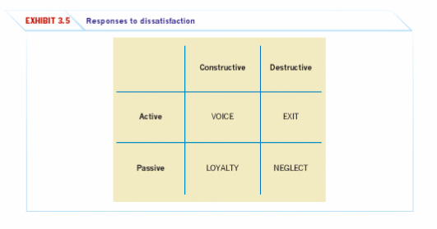

Emotions and stress

- What is the difference between emotions and moods? What the basic emotions and moods?

Affect is a generic term that covers a broad range of feelings people experience, including both emotions and moods. Emotions are intense feelings directed at someone or something. Moods are less intense feelings than emotions and often (though not always) arise without a specific event acting as a stimulus.

Emotions are reactions to a person (seeing a friend at work may make you feel glad) or an event (dealing with a rude client may make you feel frustrated).

Basic emotions

Basic emotions can include anger, contempt, enthusiasm, envy, fear, frustration, disappointment, embarrassment, disgust, happiness, hate, hope, jealously, joy, love, pride, surprise, and sadness.

Many researchers agree on six essentially universal emotions – anger, fear, sadness, happiness, disgust and surprise. Some even plot them along a continuum: happiness – surprise – fear – sadness – anger – disgust. The closer the two emotions are to each other on this continuum, the more likely people will confuse them, for example: we sometimes mistake happiness for surprise but rarely ever do we confuse happiness and disgust.

Basic moods

One way to classify emotions is to determine whether their effect is positive or negative. Positive emotions such as joy and gratitude express a favourable evaluation or feeling. Negative emotions such as anger or guilt express the opposite. Emotions cannot be neutral as for them to be neutral they are non-emotional. A positive affect is a mood dimension that consists of specific positive emptions such as excitement, self-assurance and cheerfulness at the high end and boredom, sluggishness and tiredness at the low end. Negative affect is a mood dimension that consists of emotions such as nervousness, stress and anxiety at the high end and relaxation, tranquillity and poise at the low end.

- Are emotions rational? What functions do they serve?

‘Where we have strong emotions, we’re liable to fool ourselves’
– Carl Sagan

These observations suggest rationality and emotion are in conflict and that if you exhibit emotion you are likely to act irrationally. There is the view that by displaying emotions such as sadness to the point of crying is so toxic to a career that we should leave the room rather than allow others to witness it. This is suggestive of emotions and its ability to make one appear weak, brittle or irrational. However, recent research has shown that emotions are imperative to rational thinking – there has been such evidence of a link/correlation for a long time.

Functions of emotions [p. cxliii]

Emotions provide valuable insights into how workplace hassles and uplifting events influence employee performance and satisfaction. Additionally, employees and managers should ignore emotions or the events that cause them, even when thy appear minor, because they accumulate.

- What are the sources of emotions and moods?

- Personality – moods and emotions have a trait component: most people have built-in tenancies to experience certain moods and emotions more frequently than others do. People also experience the same emotions with different intensity; affect intensity refers to individual differences in the strength with which individual’s experience emotions.
- Time of the day – people’s moods will vary according to the time of day e.g. if someone is not a morning person and feel better as the day goes on, their mood will vary and get better throughout the day.
- Day of the week – are people in their best moods on the weekend?
- Weather – sun or rain?
- Illusory correlation: tendency of people to associate two events when in reality there is no connection.
- Stress – stressful daily events will have a negative impact on mood (e.g. nasty email, impending deadline, loss of a big sale, reprimand from the boss).
- Social activities – do you tend to be the happiest when out with friends?
- Sleep – research has found that lack of sleep can lead to greater feelings of fatigue, anger and hostility.
- Exercise – can enhance peoples positive mood.
- Age – research has found that negative emotions are much more predominant in younger people.
- Gender – women tend to be more emotional than men and display more frequent expressions of both positive and negative emotions, except anger.

- What impact does emotional labour have on employees?

- Emotional labour is a situation in which an employee expresses organisationally desired emotions during interpersonal transactions at work.
- Every employee expends physical and mental labour by putting body and mind, respectively, into the job. But jobs also require emotional labour, an employees expression of organisationally desired emotions during interpersonal transactions at work. The true challenges arises when employees have to project one emotion while feeling another. This disparity is emotional dissonance, and it can take a heavy toll. Bottled up feelings of frustration, anger and resentment can eventually lead to emotional exhaustion and burnout. Emotional dissonance is similar to cognitive dissonance except in that the former concerns feelings rather than thinking.

- What is affective events theory? What are its applications?

Affective events theory is a model that suggests workplace events cause emotional reactions on the part of employee, which then influence workplace attitudes and behaviours.

Applications
The tests is as follows:
- An emotional episode is actually a series of emotional experiences, precipitated by a single event and containing elements of both emotions and mood cycles.
- Current emotions influence job satisfaction at any given time, along with the history of emotions surrounding the event.
- Emotion-driven behaviours are typically short in duration and of high variability.
- Because emotions, even positive ones, tend to be incompatible with behaviours required to do a job, they typically have a negative influence on job performance.

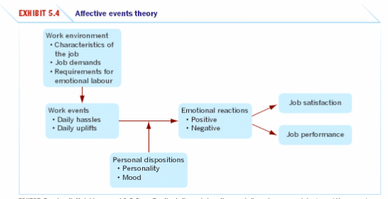

- What is the evidence for and against the existence of emotional intelligence? [p. cliiii]

Emotional intelligence (EI) is the ability to detect and to manage emotional cues and information.

FOR emotional intelligence | AGAINST emotional intelligence
- Intuitive appeal  - Predicts criteria that matter  - Biologically based | - Researchers don’t agree on a set definition.  - It can’t be measured.  - It is nothing but personality with a different label.

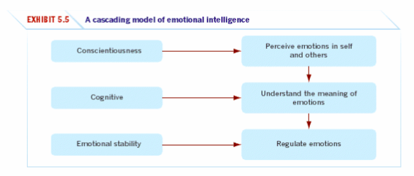

- What are some strategies for emotion regulation and their likely effects? [p. cliii]

The central idea behind emotion regulation is to identify and modify the emotions you feel.

One of the strategies includes surface acting or rather ‘putting on a face’ appropriate to the given situation. A recent study has shown perhaps due to the price of expressing false feelings, individuals who vary their surface-acting response may have lower job satisfaction and higher levels of work withdrawal than those who consistently use surface-acting.
Deep acting is another strategy which is less psychologically costly than surface-acting due to employees actually trying to experience the emotion.

These strategies are undertaken for the purpose of showing appropriate emotions which mitigate the effects of the consequences of actual emotions, such as emotional exhaustion and workplace withdrawal.

- How do you apply concepts about emotions and moods to specific OB issues?

- Selection
- employees should use EI when hiring employees especially for jobs that demand a high degree of social interaction.
- Decision making
- moods and emotions have important effects on decision making.
- positive moods and emotions = sound decisions (more likely to use heuristics i.e. rule of thumb)
- Creativity
- Motivation
- Leadership
- Negotiation
- Customer service
- Job attitudes
- Deviant workplace behaviours
- Safety and injury at work
- How managers can influence moods

Personality and values

- What is personality? How do we typically measure it? What factors determine personality?

Personality
Personality can be defined as the sum of total ways in which an individual reacts to an interacts with others. Most commonly measured in terms of traits that a person exhibits.

Gordon Allport defined personality to be:

‘the dynamic organisation within the individual of those psycho-physical systems that determine his unique adjustments to his environment’.

Personality factors
Personality is the result of both heredity and environmental factors. Research has tended to favour heredity over that of environmental.

Heredity factors are determined at conception, some may include:
- Physical stature
- Facial features
- Gender
- Temperament
- Muscle composition and reflexes
- Energy level
- Biological rhythms.
The heredity argument is mostly founded on the explanation that an individual’s personality is determined by their molecule structure of their genes, located in the chromosomes.

- What is the Myers-Briggs Type Indicator (MBTI) and what does it measure?

Myer-Briggs Types Indicator (MBTI) is a personality test that taps four characteristics and classifies people into one set of 16 personality types. It’s a 100-question personality tests that asks people how they usually feel or act in particular situations. On the basis of their answers, individuals will be their classified as introverted or extraverted (E or I), sensing or intuitive (S or N), thinking or feeling (T or F) and judging or perceiving (J or P).

Extraverted versus introverted – extraverted individuals are outgoing, sociable and assertive. Introverts are quiet and shy.

Sensing versus intuitive – sensing types are practical and prefer routine and order, they focus on details. Intuitives rely on unconscious processes and look at the ‘big picture’.

Thinking versus feeling – thinking types use reason and logic to handle problems. Feeling types rely on their personal values and emotions.
Judging versus perceiving – judging types want control and prefer their world to be ordered and structured. Perceiving types are flexible and spontaneous.

- What are the Big Five personality traits and how do they predict work behaviour?

- Extraversion – dimension captures our comfort level with relationships. Extraverts tend to be gregarious, assertive and sociable. Introverts tend to be reserved, timid and quiet.
- Agreeableness – dimension refers to an individual’s propensity to defer to others. Highly agreeable people are cooperative, warm and trusting. People who score low on agreeableness are cold, disagreeable and antagonistic.
- Conscientiousness – dimension is a measure of reliability. A highly conscientious person is responsible, organised, dependable and persistent. Those who score low on this dimension are easily distracted, disorganised and unreliable.
- Emotional stability – dimension often labelled by its converse, neuroticism – taps a person’s ability to withstand stress. People with positive emotional stability tend to be calm, self-confident and secure. Those with high negative scores tend to be nervous, anxious, depressed and insecure.
- Openness to experience – dimension addresses a range of interest and a fascination with novelty. Extremely open people are creative, curious and artistically sensitive. Those at the other end of the openness category are conventional and find comfort in the familiar.

- How does the situation or environment affect the degree to which personality predicts behaviour? (how does the environment impact personality which corresponds with behaviour?)

- Situation-strength theory proposes that the way personality translates into behaviour depends on the strength of the situation; strength refers to the degree to which norms, cues or standards dictate appropriate behaviour.
- Strong situations will apply pressure to exhibit the ‘right’ behaviour; it will make clear the right and discourage from the wrong.
- Conversely, weak situations ‘anything goes’ which allows us to be freer when expressing out personality through behaviour.

Four elements
- Clarity – degree to which cues about work duties and responsibilities are available and clear.
- Consistency – cues regarding work duties and responsibilities are compatible with one another.
- Constraints – individual freedoms to decide or act is limited by forces outside their control.
- Consequences – degree to which decisions or actions have important implications for the organisation or its members, clients, supplies, and so on.

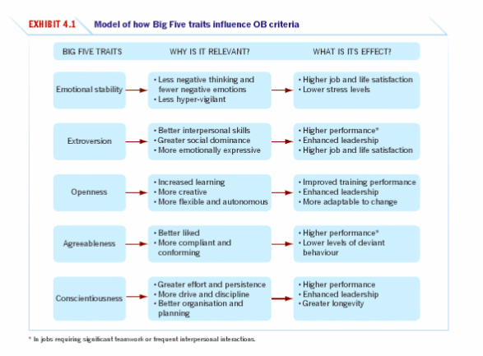
* Big five traits are what we call ‘socially desirable’ meaning we would be glad to score high on them.

- What are values, why are they important and what is the difference between terminal and instrumental values?

- Values represent basic convictions that a ‘a specific mode of conduct or end-state of existence is personally or socially preferable to an opposite or a convene mode of conduct or end-state of existence’. Values have two components; firstly, the content attributes say that mode of conduct or end-state of existence is important) and secondly, intensity specifies just how important.
- Terminal – desirable end-states of existence; the goals a personal would like to achieve during his or her lifetime.
- Instrumental – preferable modes of behaviour or means of achieving one’s terminal values.

- Do values differ across generations? How do they differ?

- Baby boomers: a large cohort born after WWII when veterans returned to their families and times were good. Boomers entered the workforce from the mid 1960s to the mid 1980s.
Values: brought with them a ‘hippie ethic’ and distrust of authority; place great deal of emphasis on achievement and material success; hard workers that want to enjoy the fruits of their labour; they are pragmatists that believe that ends can justify means; boomers see their employers as vehicles for their careers; terminal values such as accomplishment and social recognition rank high.

- Xers (Generation Xers): shaped by globalisation, two-career parents, MTV, IADS and computers.
Values: flexibility, life options and the achievement of job satisfaction; family and relationships are very important to this cohort; sceptical, particularly of authority; also enjoy team-orientated work, in each of balance in their lives, less willing to make personal sacrifices for the sake of their employer in comparisons with previous generations; rate true friendship, happiness and pleasure very highly.
- Millennials (netters, nexters, generation Yers, Generation Nexters): grew up during prosperous times.
Values: high expectations and seek meaning in their work; life goals more orientated with becoming rich and famous; also see themselves socially responsible; first generation more likely to take technology for granted, tend to be questioning, electronically networked and entrepreneurial; can be described as ‘entitled’ and ‘needy’; can clash with other generations in relation to attire and communication; value frequent and candid feedback.

- What are the differences between person-job fit and person-organisation fit?

Personality-job-fit theory identifies six personality types and proposes that the fit between personality type and occupational environment determines satisfaction and turnover.

Six personality types:
- Realistic: physical activities that require skill, strength and coordination.
- Investigative: activities that involve thinking, organising and understanding.
- Social: activities that involve helping and developing others.
- Conventional: rule-regulated, orderly and unambiguous activities.
- Enterprising: verbal activities in which there are opportunities to influence others and attain power.
- Artistic: ambiguous and unsystematic activities that allow creative expression.

- Person-job fit: matching job requirements with personality characteristics. The theory argues that satisfaction is highest and turnover is lowest when personality and occupation is in agreement.
- Person-organisation fit: matching people to organisations as well as jobs. This theory argues that people are attracted to and selected by organisations that match their values, and they leave organisations that are not compatible with their personalities.

- Do values differ across cultures? How do they differ?

Hofstede’s Framework for Assessing Cultures
- Power distance: the degree to which people in a country accept that power in institutions and organisations is distributed unequally.
- Individualism versus collectivism: individualism being the degree to which people prefer to act as individuals rather than as members of groups and believe in individual rights.
Whereas collectivism places an emphasis on those that expect others in groups of which they are a part to look after them and protect them.
- Masculinity versus femininity: masculinity being the degree to which the culture favours traditional masculine roles such as achievement, power and control as opposed to viewing men and women as equals. A high masculinity rating indicates that the culture has separate roles for men and women, with men dominating the society. A high femininity rating means the culture sees little differentiation between male and female and treats women as the equal of men in all respects.
- Uncertainty avoidance: the degree to which people in a country prefer structured over unstructured situations defines their uncertainty avoidance. Cultures that score high on uncertainty avoidance are more likely to have people that have an increased level of anxiety about uncertainty and ambiguity and use laws and controls to reduce uncertainty. Contrast this with cultures that score low on uncertainty avoidance are more accepting of ambiguity, are less rule-orientated, take more risks and are more open to accepting change.
- Long-term versus short-term orientation: measures society’s devotion to traditional values. People in a culture with long-term orientation look to the future and value thrift, persistence and tradition. In the short-term orientation; people value the here and now, they accept change more readily and don’t see commitments as impediments to change.

Values do differ across different cultures, take Malaysia for instance who has a higher power distance when compared to every other country (p. 94).

Ethics and the ‘dark side’ of OB

- What are ethics and morals?

Ethics is a code of moral principles that sets standard as to what is good or bad, or right to wrong in one’s conduct and thereby guides the behaviour of a person or group.

Morals often used interchangeably with ethics, refers to the fundamental beliefs and right and wrong that are used to guide individual decisions.

- Why do managers need to be aware of business ethics?

- Negative consequences of deviance
  - Implications for individuals and organisations
- Employee commitment
  - A recent survey revealed that 79% of employees agree that ethics is an important consideration in continuing to work for their organisation.
- Increased profits
  - Evidence indicates that companies that are perceived to have a high degree of ethical behaviour and integrity have a higher average total return to shareholders than those that do not.
- Customer satisfaction
  - Socially responsible behaviours will help to develop lasting, productive relationships with stakeholders.
- Investor loyalty
  - Investors are attracted to companies which demonstrate socially responsible practices and recognise that an ethical culture can underpin efficiency and profits.

- What are the philosophical approaches to ethical decision making?

- Utilitarianism
- Categorical imperative
- Cultural relativism
- Enlightened self-interest
- Legalism
- Light-of-day

- What is the person-situation interactionist model?
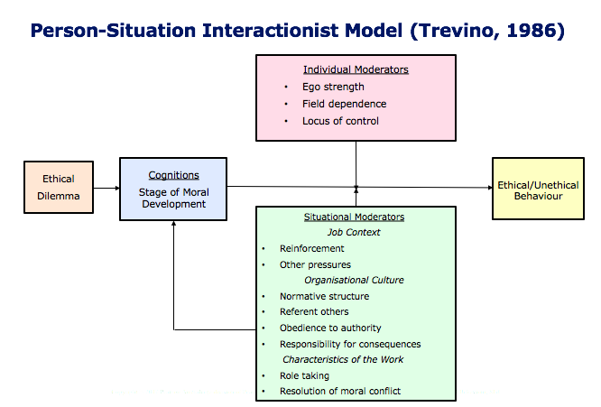

- What is workplace deviance?

Workplace deviance is voluntary behaviour of organisational members that violates significant organisational norms and in doing so threatens the well-being of an organisation, its members or both. Typically involves unethical behaviour but not always.

Types of workplace deviance
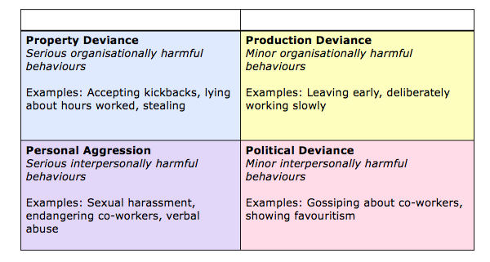

- How to reduce unethical behaviour in organisations?
- Background screening prior o employment
  - Reference checks, situational interviews, personality testing
- Formal ethics programs
  - Policies and procedures for preventing and reducing deviance, including a code of conduct.
  - An ethics officer who develops coordinates and evaluates ethics polices; provides ethics training and investigates complaints of misconduct.
  - Formal ethics training at all levels of the organisation.
  - Telephone hotline for the reporting of wrongdoing.
- Explain the personal and organisational costs of engaging in deviance
  - Emphasise harm to employees, consumers and wider stakeholders.
- Provide mechanisms for employees to voice concerns and address these swiftly and appropriately
  - Make sure that employees have a means to report episodes of observed or experienced deviance, and apply punishments appropriately.
- Treat employees with dignity and respect
  - Ensure that employees feel valued and respected, increase job autonomy where possible, mange interpersonal conflict effectively, reduce perceptions of powerlessness and frustration.

- What are the employee responses to workplace deviance?

- Exit
- Voice
- Loyalty
- Neglect
- Organisational silence
- Whistle-blowing – the disclosure by organisation members of illegal, immoral or illegitimate practices under the control of their employers, to persons or organisations that may be able to effect action.
  - Factors closely associated to whistle-blowing include age, tenure (‘term’), salary and education.
  - Employees with moderate levels of organisational commitment are mostly likely to blow the whistle.

Leadership

- Are leadership and management different from one another? If so, how?

Leadership is the ability to influence a group towards the achievement of a vision or set of goals.
The source of influence may be formal, such that it is provided by managerial rank in an organisation. Not all leaders are managers, nor are all manager’s leaders. Non-sanctioned leadership is the ability to influence that arises outside the formal structure which is often more important than formal influence. Organisations need strong leadership and strong management for optimal effectiveness. Leaders are needed to challenge the status quo, create visions of the future and inspire organisational members to want to achieve the visions. Managers are needed to formulate detailed plans, create efficient organisational structures and oversee day-to-day operations.

- What is the difference between trait and behavioural theories of leadership? Are the theories valid?

Trait theories of leadership focus on personal qualities and characteristics that differentiate leaders from non-leaders.

- Like being around people;
- Assert themselves (extraverted);
- Disciplined;
- Keep commitments they make (conscientious); and
- Creative and flexible (open).

Behavioural theories of leadership focus on theories proposing that specific behaviours differentiate leaders from non-leaders.

- Initiating structure: extent to which a leader is likely to define and structure his or her role and those of employees in the search for goal attainment. It is behaviour that attempts to organise work, work relationships and goals.
- Consideration: extent to which a person’s job relationships are characterised by mutual trust, respect for employee’s ideas and regards for their feelings.

Two behavioural dimensions:
- Employee-orientated leaders: a leader who emphasises interpersonal relations, takes a personal interest in the needs of employees and accepts individual differences between members.
- Production-orientated leaders: a leader who emphasises technical or task aspects of the job.

- What is Fielders contingency model? Has it been supported in research?

This model proposes that effective group performance depends on the proper match between the leader’s style of interacting with subordinates and the degree to which the situation gives the leader control and influence.
Fiedler assumes that an individual’s leadership style is fixed. This means if a situations requires a task-orientated leader and the person in the leadership position is relationship-orientated, either the situation has to be modified or the leader has to be replaced to achieve optimal effectiveness.

Fielders three contingency or situational dimensions:
- Leader-member relations is the degree of confidence, trust and respect members have in their leader.
- Task structure is the degree to which the job assignment and procedurised (that is, structured or unstructured).
- Position power is the degree of influence a leader has over power variables such as hiring, firing, discipline, promotions and salary increases.

Studies testing the overall validity of the model find considerable evidence tom support substantial parts of it. If we only use the three categories instead of the original eight there is ample evidence to support Fielders conclusions.

- How do charismatic and transformational leadership compare and contrast? Are they valid? (7j)

Charismatic leadership theory is a leadership theory where followers make attributions of heroic or extraordinary leadership abilities when they observe certain behaviours.

Transformational leadership are leaders who inspire followers to transcend their self-interests for the good of the organisation and can have an extraordinary effect on their followers.

Transactional leadership are leaders who guide their followers towards established goals by clarifying role and task requirements.

- What is authentic leadership? Why do ethics and trust matter to leadership?

Authentic leadership are leaders who know who they are, know what they believe in and value, and act on those values and beliefs openly and candidly. Their followers would consider them to be ethical people. Key components include being genuine, values driven, lead from experience and ‘walk the talk’.

Ethical leadership is when leaders treat their followers with fairness, especially by providing honest, frequent and accurate information are seen as more effective. Leaders rated as highly ethical tend to have followers who engage in more organisational citizenship behaviours and who are more willing to bring problems to the leader’s attention. Ethical leadership has also been shown to reduce interpersonal conflicts. Key components include humility, honesty, empathy and accountability.

Followers who trust a leader are willing to be venerable to the leader’s actions, confident that their rights and interests will not be abused. People are unlikely to look up to or follow someone they perceive as dishonest or likely to take advantage of them.

- How is mentoring valuable to leadership? What are the keys to effective mentoring?

A mentor is a senior employee who sponsors and supports less-experienced employees, a protégés.

Leaders often take responsibility for developing future leaders. Their role as mentors helps preserve and develop organisational culture and knowledge over time.

They present ideas clearly, listen well and emphasise with protégés problems.

- Do you agree that there are situations in which leadership is not necessary? Why or why not?

Challenges to the leadership construct

Attribution theory of leadership
- Leadership is merely an attribution that people make about other individuals.

Substitutes for and neutralisers of leadership
- One theory of leadership suggests that, in many situations, leader’s actions are irrelevant.
- Experience and training are among the substitutes that can replace the need for a leaders support or ability to create structure.

Online leadership
- Today’s mangers and their employees are increasingly linked by networks rather than geographic proximity.

- How can organisations select and develop effective leaders?

Selecting leaders begins by revising the knowledge, skills and abilities needed to do the job effectively. Personality tests can also help to identify traits associated with leadership.

Training leaders place emphasis on leadership development. They might teach implementation skills, content themes critical to effective visions, trust building and mentoring, situational analysis skills and leadership skills.

Perception and individual decision-making

- What is perception, and what factors influence it?

Perception is a process by which individuals organise and interpret sensory impressions in order to give meaning to their environment.

Factors in the perceiver | Factors in the situation | Factors in the target
- Attitudes  - Motives  - Interests  - Experience  - Expectations | - Time  - Work setting  - Social setting | - Novelty  - Motion  - Sounds  - Size  - Background  - Proximity  - Similarity

- What is attribution theory? What are the three determinants of attribution? What are its implications for explaining organisational behaviour?

Attribution theory is when individuals observe behaviour, they attempt to determine whether it is internally or externally caused.

Three determinants:
- Distinctiveness: shows different behaviours in different situations.
- Consensus: response is the same as others to same situation.
- Consistency: responds in the same way over time.

Observation → interpretation → attribution of cause

Implications
- Fundamental attribution error: tendency to underestimate the influence of external factors and overestimate the influence of internal factors when making judgments about the behaviour of others e.g. in general we tend to blame the person first, not the situation.
- Self-serving bias: tendency for individuals to attribute their own successes to internal factors while putting the blame for failures on external factors e.g. individuals and organisational also tend to attribute their own success to internal factors such as ability or effort, while putting the blame for failure on external factors such as bad luck or unproductive co-workers.

- What is the link between perception and decision making? How does one affect the other?

Perception of the decision maker
- Problem: a perceived discrepancy between the current state of affairs and a desired state.
- Decisions: choices made from among alternatives developed from data perceived as relevant.

↓ = OUTCOME

- What is the rational model of decision making? How is it different from bounded rationality and intuition?

Three approaches to decision making:
- Rational decision-making model: describes how individuals should behave in order to maximise some outcome. It relies on a number of assumptions; including that the decision maker: has complete information, can identify all the relevant options in an unbiased manner and chooses the option with the highest utility.
- Bounded rationality: a process of making decisions by constructing simplified models that extract the essential features from problems without capturing all their complexity.
- Intuitive decision-making: an unconscious process created out of distilled (‘refined’) experience.

Rational decision-making model
- Define the problem
- Identify the decision criteria
- Allocate weights to the criteria
- Develop the alternatives
- Evaluate the alternatives
- Select the best alternatives

- How do individual differences, organisational constraints and cultural influence decision making?

These are the factors that influence how people make decisions and the degree to which they are susceptible to errors and biases.

Individual differences include characteristics such as personality, gender, mental ability, cultural differences

Organisational constraints include performance evaluation, rewards systems, formal regulations, system-imposed time constraints, historical precedents.

- Are unethical decisions more a function of an individual decision maker or the decision makers work environment? Explain.

Three ethical decisions criteria
- Utilitarianism: decisions are made solely on the basis of their outcomes, ideally to provide the greatest good for the greatest number.
- Rights: protecting the basic rights of individuals such as the right to privacy, free speech and due process.
- Justice: an equitable distribution of benefits and costs.
- What is creativity, and what is the three-stage model of creativity?

The rational decision making model also requires creativity which is the ability to produce novel and useful ideas; ideas that are different from what has been done before but that are appropriate to the problem presented. This allows the decision maker to assess and understand the problem and see problems that others can’t see.

Creative behaviour
- Problem formulation: identify the problem or opportunity that requires a solution as yet unknown.
- Information gathering: individuals collect as much information as possible.
- Idea generation: develop possible solutions to a problem from relevant information and knowledge.
- Idea evaluation: evaluate potential solutions to identify the best one.

Groups and teams

- Define group. What are the different types of groups?

A group is two or more individuals, interacting and interdependent who have come together to achieve a common goal.

Types of groups:
- Formal group: a designated work group defined by an organisations structure.
- Informal group: a group that is neither formally structured nor organisationally determined; such a group appears in response to the need for social contact.

- What are the five stages of group development?

- Do role requirements change in different situations? If so, how?

Roles are a set of expected behaviour patterns attributed to someone occupying a given position in a social unit. It is important to set clear role expectations in groups to manage role conflict.

- How do group norms and status influence an individual’s behaviour?

Norms are acceptable standards of behaviour within a group that are shared by the group’s members.

Classes of norms:
- Performance norms
- Appearance norms
- Social arrangement norms
- Resource allocation norms

- How do status and size differences affect group performance?

Status is a socially defined position or rank give to groups or group members by others. According to the status characteristic theory status will derive from one of three ways;
- The power a person wields over others.
- A person’s ability to contribute to a groups goals.
- An individual’s personal characteristics.

Research indicates that size influences group behaviour in that groups with a dozen or more members are good for gaining diverse input. Smaller groups of about seven members are better at doing something productive with that input. If the goal is fact-finding, larger groups should be more effective.

- How can cohesiveness and diversity support group effectiveness?

Cohesiveness is the degree to which group members are attracted to each other and are motivated to stay in the group.

Diversity is the extent to which group members are similar to, or different from one another.

The impact of diversity of groups is mixed, it is difficult to be in a diverse group in the short-term. However, if members can weather their differences over-time, diversity may help them to be more open-minded and creative and to do better.

- What are the strengths and weaknesses of group (versus individual) decision making?

Strengths | Weaknesses
- Generate more complete information and knowledge.  - Offers increased diversity of views.  - Increased acceptance of a solution. | - Time-consuming  - Conformity pressures  - Discussions can be dominated by one or a few members.  - Decisions suffer from ambiguous responsibility.

- How do you explain the growing popularity of teams in organisations?

As organisations have restructured themselves to compete more effectively and efficiently, they have turned to teams as a better way to use employee talents.

- What is the difference between a group and a team?

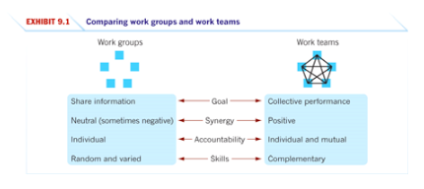
- What are the main types of teams?
- Problem-solving: groups of 5 to 12 employees from the same apartment who meet for a few hours each week to discuss ways of improving quality, efficiency and the work environment.
- Self-managed: groups of 10 to 15 employees who take on responsibilities of their former supervisors.
- Cross-functional: employees from about the same hierarchical level, but from different work areas, who come together to accomplish a task.
- Virtual: use computer technology to tie together physically dispersed members in order to achieve a common goal.
- Multi-team system: a collection of two or more interdependent teams that share a superordinate goal; a team of teams.

- What conditions or context factors determine whether teams are effective?

The team effectiveness model makes two assumptions:
- Teams differ in form and structure
- Teamwork is preferable to individual work

Three key components of effective teams:
- The resources and other contextual influence that make teams effective.
- The team’s composition.
- The process variables within the team that influence effectiveness.

Context | Composition | Process
- Adequate resources  - Leadership and structure  - Climate of trust  - Performance evaluation and rewards systems | - Abilities of members  - Personality of members  - Allocation of roles  - Diversity of members  - Size of teams  - Member preferences | - Common plan and purpose  - Specific goals  - Team efficacy  - Mental models  - Conflict levels  - Social loafing

- How can organisations create team players?

- Selection: hiring team players
  - When hiring members, be sure that candidates can fulfil their team roles as well their technical requirements.
- Training: creating team players
  - Training specialists conduct exercises that allow employees to experience the satisfaction that teamwork can provide.
  - Workshops help employees to improve their problem-solving, communication, negotiation, conflict-management and coaching skills.
- Rewarding: providing incentives to be a good team player
  - An organisations reward system needs to be reworked to encourage cooperative efforts rather than competitive ones.

- When is work performed by individuals preferred over work performed by teams?
As teamwork takes more time, and often more resources than individual work; it is necessary to ask three key questions when determining if a situation requires a team:
    - Can the work be done better by more than one person?
    - Does the work create a common purpose or set of goals for the people in the group that is more than the aggregate of individual goals?
    - Are the members of the group interdependent?

Powers and politics

- How would you define power? How is it different from leadership?

Power is the capacity that an individual has in influencing the behaviour of another so that they act in accordance with their wishes.

- What are the five bases of power?

Formal power | Personal power
Coercive: a power base that is dependent on fear. | Expert: influence based on special skills or knowledge.
Reward: compliance achieved based on the ability to distribute rewards that others view as valuable. | Referent: influence based on identification with a person who has desirable resources or personal traits.
Legitimate: the power a person receives as a result of his or her position in the formal hierarchy of an organisation.

- What is the role of dependency in power relationships?

Dependency is B’s relationship to A when A possesses something that B requires. The greater B’s dependency on A, the greater the power A has over B.

Dependency increases when resources are:
- Important
- Scarce
- Non-substitutable

- What are the nine power or influence tactics?

- Legitimacy: relying on your authority position or saying that a request accords with organisational policies or rules.
- Rational persuasion: presenting logical arguments and factual evidence to demonstrate that a request is reasonable.
- Inspirational appeals: developing emotional commitment by appealing to a targets values, needs, hopes, and aspirations.
- Consultation: increasing the targets support by involving them in deciding how you will accomplish your plan.
- Exchange: rewarding a target with benefits or favours in exchange for following a request.
- Personal appeals: asking for compliance based on friendship or loyalty.
- Ingratiation: using flattery, praise or friendly behaviour prior to making a request.
- Pressure: using warnings, repeated demands and threats.
- Coalitions: enlisting the aid or support of others to persuade the target to agree.

- In what way is sexual harassment about the abuse of power?

Sexual harassment is any unwanted activity of a sexual nature that affects an individual’s employment and creates a hostile work environment. It can damage the well-being of the individual, work group and organisation.

- How do politics work in organisations?

Political behaviour are activities that are not required as part of one’s formal role in the organisation, but that influence, or attempt to influence, the distribution of advantages or disadvantages within the organisation. Examples: without holding key information, joining a coalition, whistle-blowing, spreading rumours, etc.

- What are the causes and consequences of political behaviour?

Recent research and observation have identified a number of factors that appear to encourage political behaviour:
- Individual factors
  - Personality traits: high self-monitors, internal locus of control, Machiavellian (‘cunning’) personality.
- Organisational factors
  - The organisations resources are declining
  - The existing pattern of resources are changing
  - There are clear opportunities for promotions
  - The culture is characterised by low trust, high pressure, role ambiguity, zero-sum reward allocation, etc.

- How can one determine whether a political action is ethical?

Important questions to consider:
- What is the utility of engaging in the behaviour?
- Does the utility balance out any harm done by the action?
- Does the action conform to standards od equity and justice?

When faced with an ethical dilemma regrading organisational politics, consider whether playing politics is worth the risk, and whether others might be harmed in the process.

Motivation

- Define motivation. What are the three key elements of motivation?

Motivation is the processes that account for an individual’s intensity, direction and persistence of effort towards attaining a goal.

- Intensity: how hard a person tries.
- Direction: high intensity effort is unlikely to lead to favourable job-performance outcomes unless the effort is channelled in a direction that befits the organisation.
- Persistence: measures how long a person can maintain effort. Motivated individuals stay with a task long enough to achieve their goal.

- What are the early theories of motivation? How well have they been supported by research?

Maslow’s hierarchy of needs: a hierarchy of 5 needs in which, as each need is substantially satisfied, the next need becomes dominant.

- Physiological
- Safety
- Social
- Esteem
- Self-actualisation

Theory X and Theory Y:
- Theory X: the assumption that employees dislike work, are lazy, and must be coerced to perform.
- Theory Y: the assumption that employees like work, are creative, seek responsibility, and can exercise self-direction.

Herzberg’s two-factor theory (‘Motivator-Hygiene Theory’): theory that relates intrinsic factors to job satisfaction and associates extrinsic factors with dissatisfaction.

- What are the similarities and differences between self-determination theory and goal-setting theory?

Self-determination: a theory that states that allocating extrinsic rewards for behaviour that had been previously intrinsically rewarding tends to decrease the overall level of motivation if the rewards are seen as controlling.

Goal-setting theory: a theory that specific and difficult goals, with feedback, lead to higher performance.

- What are the key principles of self-efficacy theory, reinforcement theory, equity theory and expectancy theory?

- Self-efficacy: refers to an individual’s belief that he or she is capable of performing a task. The higher your self-efficacy, the more confident you are in your ability to succeed.
- Reinforcement theory: is a counterpoint to goal-setting. It ignores the inner state of the individual and concentrates solely on what happens when he or she takes some action.
- Equity theory: employees perceive what they get from a job situation (salary levels, pay increases, recognition) in relationship to what they put into its (effort, experience, education, competence) and then compare their outcome-input ratio with that of relevant others. If we perceive our ratio to be equal to that of the relevant others with whom we compare ourselves, a state of equity exists; we perceive that our situation is fair and justice prevails.
- Expectancy theory: argues that the strength of a tendency to act in a certain way depends on the strength of our expectation of a given outcome and the attractiveness of that outcome.

- What is the job characteristics model? How does it motivate employees?

Job characteristics | Definition
Skills variety | Degree to which a job requires a verity of difference activities (how many different skills are used in a given day, week, month?)
Task identity | Degree to which a job requires completion of a whole and identifiable piece of work (from beginning to end)
Task significance | Degree to which the job has a substantial impact on the lives or work of other people.
Autonomy | Degree to which the job provides substantial freedom an discretion to the individual in scheduling the work and in determining the procedures to be used in carrying it out.
Feedback | Degree to which carrying out the work activities required by a job results in the individual obtaining direct and clear information about the effectiveness of his or her performance.

- What are the three major ways that jobs can be redesigned? In your view, in what situations would one of the methods be favoured over the others?

Job design is the way in which a job is structured which can act to increase or decrease effort.

Jobs can be redesigned through:
- Job rotation: the periodic shifting of an employee from one task to another.
- Job enrichment: the vertical expansion of jobs, which increases the degree to which the workers controls the planning, execution and evaluation of the work.

- How can employee involvement measures motivate employees?

Employee involvement is a participative process that uses employees input to increase their commitment to the success of an organisation.

There are two main types:
- Participative management: a process in which subordinates share a significant degree of decision-making power with their immediate superiors.
- Representative participation: a system in which workers participate in organisational decision making through a small group of representative employees.

- How can the different types of variable-pay programs increase employee motivation?

Variable-pay program bases a portion of pay on an individual or organisational measure of performance.

Variable pay program | Description
Price-rate pay plan | A pay plan in which employees are paid a fixed sum for each unit of production completed.
Merit-based pay plan | A pay plan based on performance appraisal ratings.
Bonus | A pay plan that rewards employees for recent performance rather than for historical performance.
Profit-sharing plan | An organisation-wide program that distributes compensation based on some established formula designed around a company’s profitability.

- How can flexible benefits motivate employees?

Flexible benefits allows each employee to put together a benefit package individually tailored to his or her own needs and situation.

- What are the motivational benefits of intrinsic rewards?

- Behaviour is encouraged
- Public and private recognition
- Performance management tool
- Susceptible to political manipulation
- Criteria may not be self-evident

Organisational culture

- What is organisational culture and what are its common characteristics?

Organisational culture is a system of shared meaning held by members that distinguishes the organisation from other organisations.

There are seven primary characteristics that capture the essence of an organisations culture:
- Innovation and risk taking: employees are encouraged to be innovative and take risks.
- Attention to detail: employees are expected to exhibit precision, analysis and attention to detail.
- Outcome orientation: management focuses on results r outcomes rather than on the techniques and processes used to achieve them.
- People orientation: management decisions take into consideration the effect of outcomes on people within the organisation.
- Team orientation: activities are organised around teams rather than individuals.
- Aggressiveness: people are aggressive and competitive rather than easy-going.
- Stability: organisational activities emphasise maintaining the status quo in contrast to growth.

- Do organisations have uniform cultures?

- Dominant culture: a culture that expresses the core values that are shared by a majority of the organisations members.
- Sub-cultures: mini-cultures within an organisation, typically defined by department designations and geographical separation.
- Core values: the primary or dominant values that are accepted throughout the organisation.

- What factors create and sustain an organisations culture?

Culture creation occur in three ways:
- Founders hire and keep only employees who think and feel the same way they do.
- Founders indoctrinate and socialise these employees to their way of thinking and feeling.
- The founders own behaviour act as a role model that encourages employees to identify with them and thereby internalise their beliefs, values and assumptions.

There are three forces that play a particular role in sustaining a culture:
- Selection practices
- Top management
- Socialisation methods

- How is culture transmitted to employees?

- Stories: contain a narrative of events about the organisations founders, rule breaking, rags-to-riches successes, reductions in the workforce, relocation of employees, reactions to past mistakes and organisational coping. These stories anchor the present in the past and explain and legitimise current practices.
- Rituals: repetitive sequences of activities that express and reinforce the key values of the organisation, which goals are most important, which people are important and which people are expendable.
- Symbols: convey to employees who is important, the degree of egalitarianism that top management desires and the kinds of behaviour that are appropriate, such as risk-taking, conservative, authoritarian, participative, individualistic or social.
- Language: acronyms and jargon, that once assimilated, act as a common denominator to unite members of a given culture or subculture.

- How can an ethical culture be created?

Managers can have an effect on the ethical behaviour of employees by adhering to the following principles:
- Be a visible role model: employees will look to the actions of top management as a benchmark for appropriate behaviour.
- Communicate ethical expectations: minimise ethical ambiguities by creating and disseminating an organisational code of ethics.
- Provide ethical training: set up seminars, workshops and similar ethical-training programs to reinforce the organisations standards of conduct, clarify what practices are and are not permissible and address potential ethical dilemmas.
- Visibly reward ethical acts and punish unethical ones: evaluate how decisions measure up against the organisations code of ethics.
- Provides protective mechanisms: provides formal mechanisms so employees can discuss ethical dilemmas and report unethical behaviour without fear of reprimand.

- What are the characteristics of a spiritual culture?

Workplace spirituality is the recognition that people have an inner life that nourishes and is nourished by meaningful work that takes place in the context of the community. People seek to find meaning and purpose in their work.

- Strong sense of purpose
- Trust and respect
- Benevolence
- Open-mindedness

For example, in your upcoming essay you will discuss the impact of your chosen problem on employee productivity, turnover, absenteeism, job satisfaction, etc. These are the types of outcomes that we are attempting to address and improve.
This is all about identifying individual’s strengths and using them to gain an advantage e.g. people with autism.
Ensuring individuals who identify as having a disability of some sort are given equitable access to opportunities i.e. in the selection process.
Refers to what we can see i.e. the exterior.
An example: Oliver asserts that Australian cars are inferior to all other cars and that he wouldn’t buy anything else other than a German car. His father then purchases a Holden for him, he then retracts his former statement and relents that Australian cars aren’t so bad after all (example of wherein behaviour has influenced attitude).
The quality of being well meaning; kindness.

