LAWS3100 Notes
Income Tax Law
Vimal Singh

Lecture 1: Taxation in Australia
Basics
- What is tax?
  - Tax is a contribution levied on persons, property or business in support of government.
  - A compulsory exaction of money by a public authority for public purposes, enforceable by law.
  - The process of raising money for the purposes of government by means of contributions from individual persons.

Peculiarities of our Australian income tax system?
- Adam Smith’s cannons of taxation: Economic tax administration, Convenience or ease of use, Equity, Certainty
- Lack of tax policy
- Ongoing reviews of our tax system
- Private and public tax ruling system
- Fringe benefits are taxed in hands of employer, not employee
  - Everywhere else in the world FB employees are taxed, not employers.
- Deductions available for employees for work expenses they incur
  - Drycleaning, Charity donations etc…
- Franking credits available for shareholders who receive dividends
  - Only Australia + NZ have Franking credits.
- The consequences of using discretionary family trusts to operate businesses
- Negative Gearing
  - Not unique to Australia, but still fucking weird.

Income Tax
- 12-month liability, e.g. 1 July 2018 to 30 June 2019
- Liability determined after 30 June 2019 -> PAYG System
- Tax Based on Taxable Income
- Income Tax = Taxable Income x Tax Rate – Tax Offsets
  - Not Everyone receives Tax Offsets
- Taxable Income = Assessable Income - Deductions
- Assessable Income = Ordinary Income + Statutory Income
  - Ordinary Income comes from
    - Income from Employment
    - Income from Business
    - Income from Property
- Deductions = General Deductions (Not capital) + Specific Deductions
  - General Deductions comes from
    - Expenses to earn: Income from Employment
    - Expenses to earn: Income from Business
    - Expenses to earn: Income from Property
- Everyone MUST KEEP a record of their accounting profit
- Everyone

Who administers the Federal Tax System
Understanding Different Taxpayers and their Income
EXAMPLE: Pty Ltd company with 1 Shareholder and 1 Director
Companies
- Accounting Records
- Profit before Tax + Depreciation (Dep. Can’t be taxed, so needs to be added back)
  - These two will be used to work out Taxable income (Covered in Lecture/Topic 2)
- Profit After tax, will then be used to pay dividends or reinvested back into the company.
- Salary Expense
Individuals
- Dividends + Franking Credits
  - An individual can only receive money from a company legally from Dividends.
- Salary
  - Can be employed by THE businesses, in the form of a Salary and be taxed on a PAYG basis
- Loans
  - Anti Avoidance Provisions Prevents individuals from taking loans from the business to avoid paying tax. If done, it is then treated as a dividend and will not receive FC (which act as Tax Offsets)

- Sole traders cannot take salaries as they are the business
  - Partnerships have a TFN to track profit allocations

In-Class Question 1
How many tax returns will Bill lodge if he gets the following:
- How many tax returns will Bill lodge if he gets the following:
- A salary from his fulltime employment at UQ
- Rent from an investment property he owns jointly with his wife
- Dividends from shares he owns in the Bank of Queensland
- A distribution from a discretionary trust, paid to him as a beneficiary
- Income from his home-grown vegetable stall at the Redcliffe market that operates every last Saturday of the month
- Business income from a consultancy business called Bill’s Consultancy

Taxes Payable on taxable income
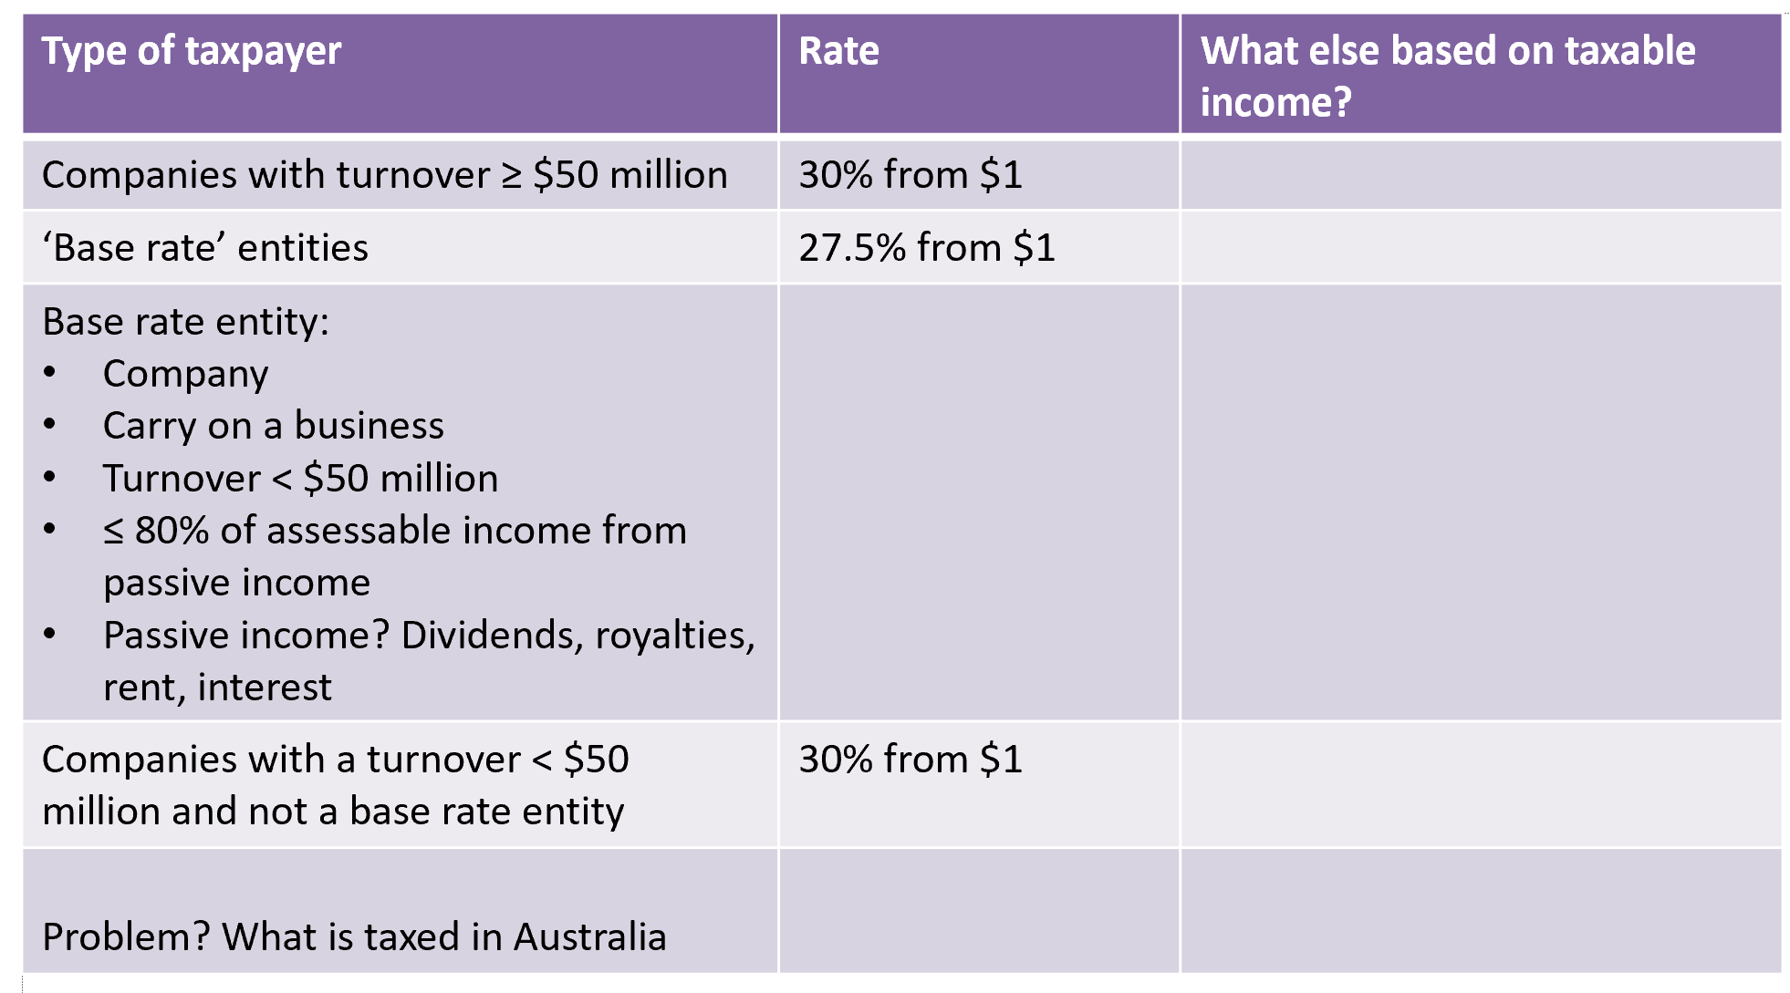

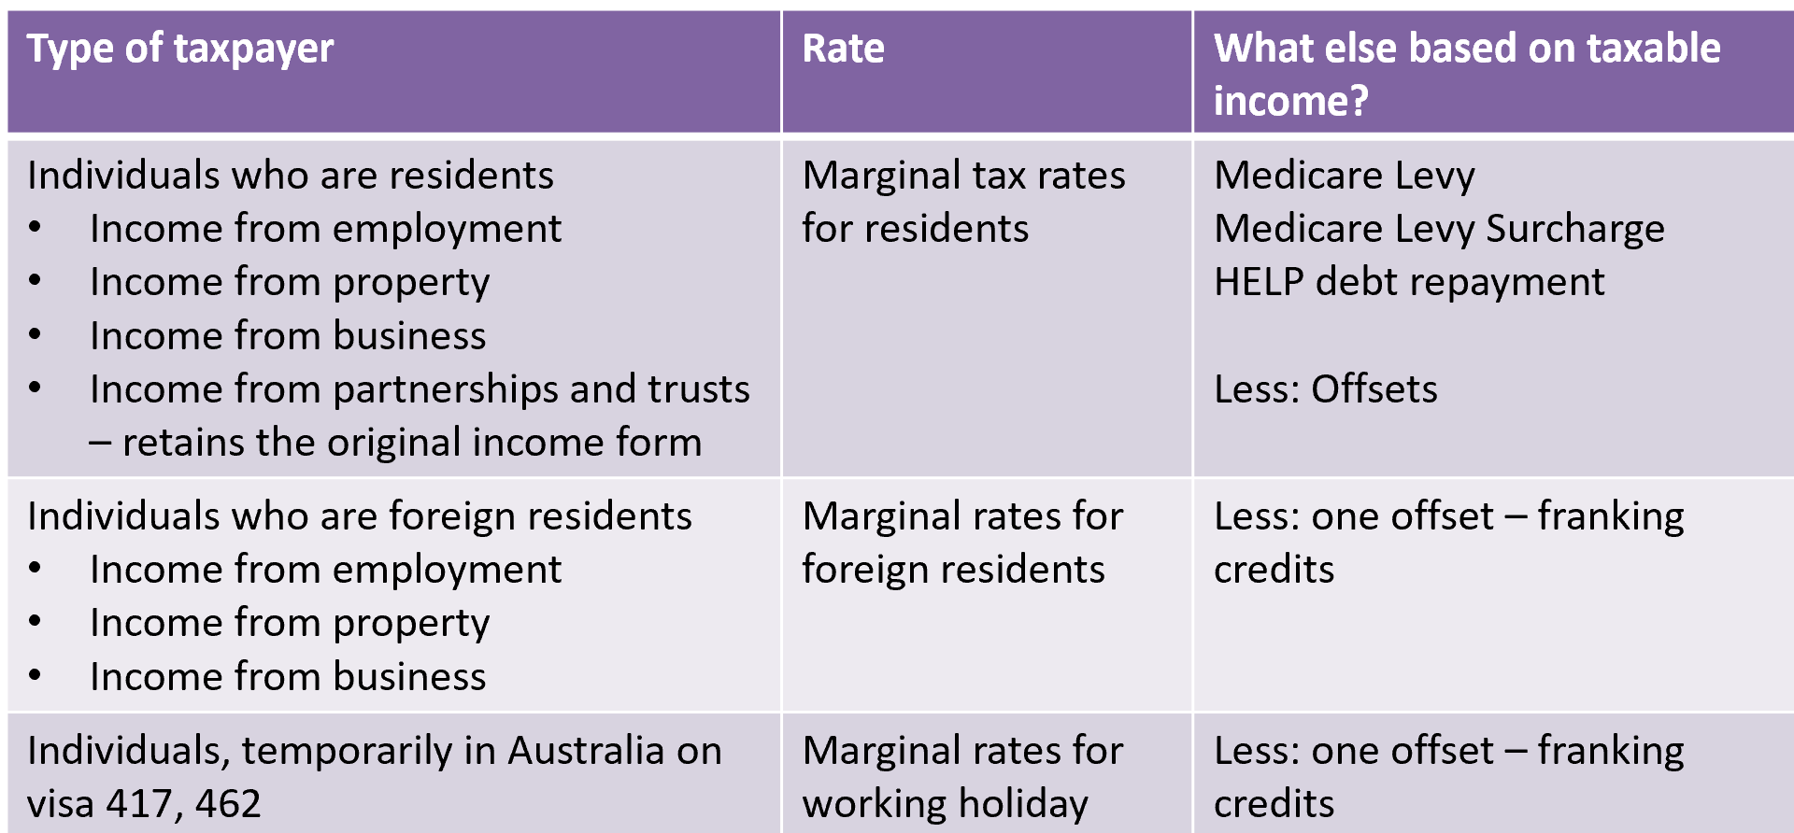

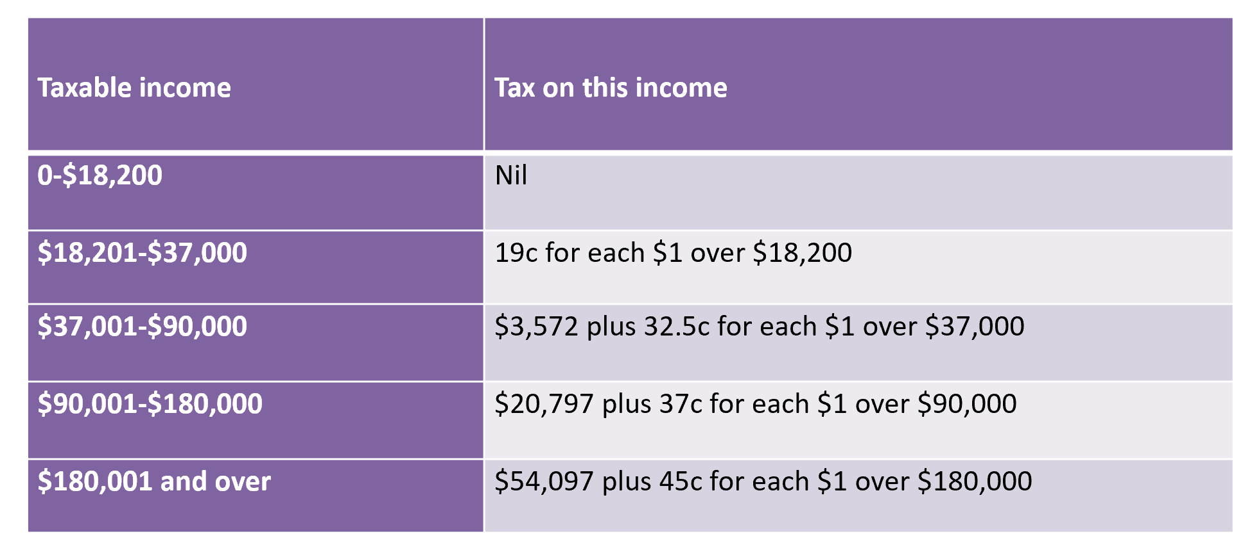
Income Tax Rate for Resident Individuals

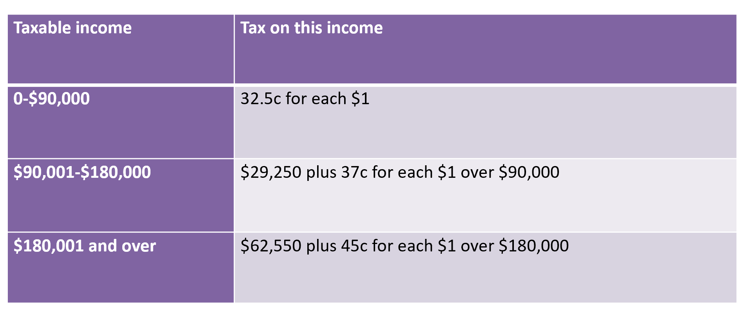
Income Tax Rates for Foreign Resident Individuals

SBEs (Small Business Entities)
- Focus of government economic policy
- Usually a presumption of ‘carrying on a business’
- Incorporated and unincorporated SBEs
- Range of tax concessions, turnover driven – You have to identify, this is a question
- Notable Concessions
  - CGT concessions, < $2 million turnover | Topic 6
  - SBE accelerated asset write offs, < $10 million turnover | Topic 4
  - Unincorporated Small Business Income Tax Offset, < $5 million | Topic 1
Medicare Levy
- Funds access to Medicare benefits
- On top of basic tax payable | Remitted via PAYG
- = Taxable income * 2%
- Exceptions:
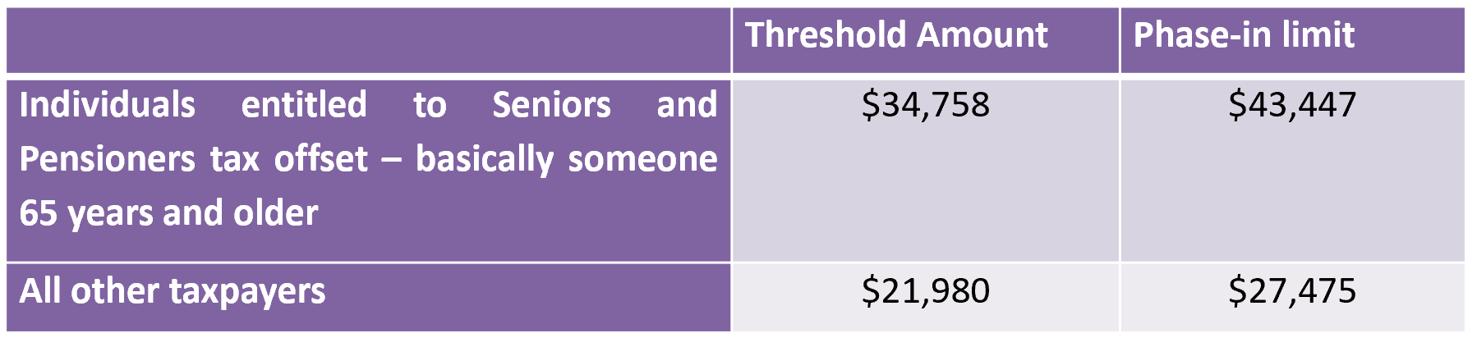
- If taxable income > threshold but < phase in limit, the Medicare Levy = 10% of excess above threshold.

Medicare Levy Surcharge
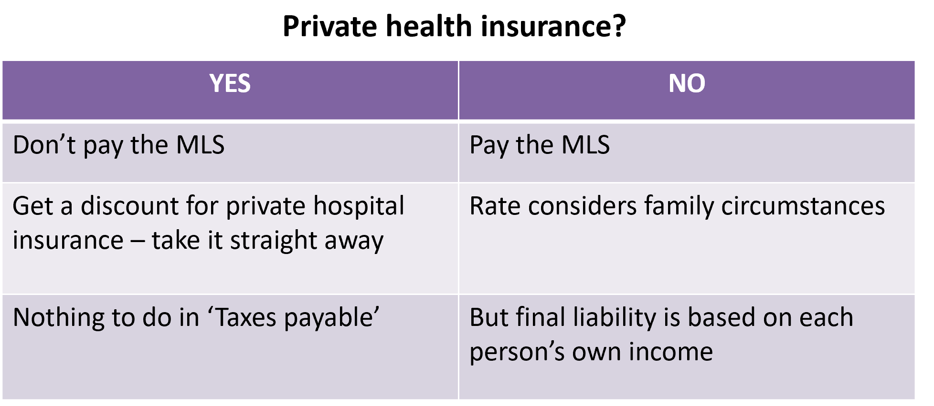

- MLS only applies once you earn $90,000 or more.
- Better to apply when you’re younger to private insurance due to getting a lower premium as opposed to applying later and getting a higher one.

Medicare Levy Surcharge Calculation
- Step 1: Determine the ‘Income for surcharge purposes’
- Taxable Income
- + Net Financial Investment Loss
- + Net Rental Property Loss
- + Reportable Fringe Benefits
- + Reportable Superannuation contributions
- + Exempt foreign employment income
- MUST write out all the elements of formula in words
  - If the taxpayer has a spouse, determine the ‘Income for surcharge purposes’ for the taxpayer and their spouse

Lecture 6: Trading Stock
What is Trading Stock?
- Requires ‘carrying on a business’
- Section 70-10: ‘Anything produced, manufactured, or acquired that is held for the purposes of manufacture, sale or exchange in the ordinary course of business and livestock’ – Must be the primary purpose.
- Contrast trading stock and capital assets
- That which is attributed to it by legal and commercial people for accounting and other purposes

- Land?
- Shares?
- Spare parts used to repair the taxpayer’s capital assets?
- Items available for rent or hire?
- Consumable?

- Includes shares in the hands of a share trader

- Includes Goods-in-transit shipped ‘CFI’
  - All States Frozen Foods vs FCT
- Spare Parts and supplies used by a business performing repair work for customers/clients

- Packaging materials
  - Trading stock if it is closely associated with the core goods
  - Packaging for a carton of beer (YES)
  - Plastic bags provided at checkout (NO)
- Raw Materials = trading stock
- Work in progress end of the year
  - Manufacturing (YES)
  - Professional Services Business aka lawyers, accountants e.g. (NO)

Trading Stock | Tax Treatment
- Sales of trading stock are assessable under s6-5
- The cost of acquiring trading stock is deductible under s8-1
- Section 70-40 | the closing value for one year becomes the opening value for the next year
- Section 70-35 (2) | where the value of closing stocks exceeds opening stock the difference is included in assessable income
- Section 70-35 (3) | where the value of opening stock exceeds closing stock the difference is included as an allowable deduction
Valuation of Opening Trading Stock
- Section 70-40 | value of opening stock = Closing stock from previous income year
- What if you start a business in the current year?

Valuation of Closing Trading Stock
- Section 70-45 | Elect to value each item of trading stock on hand at the end of an income year at:
  - Its cost price; or
  - Its market selling value; or
  - Its replacement value
- Can use a different method for valuing different items
- But value chosen -> Opening stock value in the next year
  - ALWAYS choose lowest
  - If that means closing > opening -> Smaller Income
  - If that means opening > closing -> Larger deduction

- Cost price:
  - Absorption costing in a manufacturing business (YES)
  - Standard costing in a manufacturing business (YES)
  - LIFO (NO)
  - Direct Costing (NO)
- Market selling value:
  - Usual price charged to ‘usual’ customers
- Replacement value:
  - At end of income year
Or lower if stock is obsolete

Valuation of Obsolete Trading Stock
- Obsolescence
- Going out of use, going out of date, becoming unfashionable or becoming outmoded (i.e. becoming obsolete)
- Is out of use, out of date, unfashionable or outmoded (obsolete stock)
- Provided adequate documentation supporting the calculation, fair and reasonable value of obsolete stock | TR 93/23

When to claim a deduction for trading stock purchases?
INCOME TAX ASSESSMENT ACT 1997 - SECT 70-15
In which income year do you deduct an outgoing for trading stock?
(1) This section tells you in which income year to deduct under section 8-1 (about general deductions) an outgoing incurred in connection with acquiring an item of * trading stock. (The outgoing must be deductible under that section.)
(2) If the item becomes part of your * trading stock on hand before or during the income year in which you incur the outgoing, deduct it in that income year.
(3) Otherwise, deduct the outgoing in the first income year:
a. during which the item becomes part of your * trading stock on hand; or
b. for which an amount is included in your assessable income in connection with the disposal of that item.

When to claim a deduction for trading stock purchases?
- When trading stock is ‘on hand’
  - Legal ownership isn’t a pre-requisite
  - Physical possession isn’t a pre-requisite
    - All States Frozen Foods Pty Ltd
  - When the taxpayer has ‘dispositive power’
- When an amount is included in assessable income in connection with the disposal of the trading stock – Tax Accounting, Topic 2

The Relationship between Trading Stock and Capital Gains Tax Event K4
- Section 70-30 | Starts holding as trading stock an item which they already own but does not hold as trading stock
  - Capital asset becomes trading stock.

- Calculate GST
  - Proceeds, choose;
    - Cost or
    - Market Value
- Acquisition cost for stock, deduction s 8-1, value proceeds for Capital Gains Tax (CGT)

Trading Stock Lost or Destroyed
- Deduction s 8-1 when purchased
- Now, not included in closing stock
- Therefore, no additional deduction needed
- Amounts received as compensation for lost or destroyed stock | Assessable Income | S 6-5, if not ordinary income -> s 70-115

Lecture 6 – Trading Stock Study Notes Section:
- Division 70 of ITAA97 contains most of the provisions related to trading stock. The division contains a large number of sections that each deal with a particular aspect of trading stock.
  - To show you understand answer, you must provide sufficient explanation next to answer (using same definitions/terminology) as in the legislation
  - Not required to state specific section numbers. However, Div 70 must be added to answer to indicate you are using the special provisions for trading stock.

Common definitions or descriptions you should use in answers
- 3 Options:
  - Cost Price
  - Market selling value
  - Replacement value
    - Add the value to each. Explain why you select whichever method
- State value of opening stock (OS) = to value of closing stock (CS) from previous income year
- State whether you are using market value or market selling value
- When trading stock is disposed of on terms other than usual market value or when gifted consider the following:
  - Disposal was made outside of the ordinary course of business
    - If yes, Assessable income includes the market value of the stock
      - Answer would read as “Stock disposed outside the ordinary course of business, include market value into assessable income”
        - Example of this is sell stock to family members at reduced price (which is different to what is charged to public), or when you give willingly trading stock to family members and charge nothing

- When a business stops holding trading stock as an item available for sale, but continues to own it.
  - Answer = “Stop holding the item as trading stock, Include cost into assessable income”
    - Examples of such are: trading stock is now used as a capital item, or business owner is a sole proprietor/partner and use trading stock for personal use. (butcher using meat to cook meals for himself personally)

- ONLY PUT ‘Div 70’ no need to specify section numbers (however must use one of the above answers to clarify answer)

Trading Stock | Trading Stock VS Capital Assets
- The purchase of a trading stock is a deduction s8-1
  - Strong distinction between TS and

Lecture 7 & 8: CGT
All other notes are found in book,
E1 – Acquisition Cost
- Money Paid
- + market value of other property given to acquire the asset
- - Compensation for part of asset
- - Capital allowances claimed
E2 – Incidental Costs (a lot of marks here in the exam)
- A definitive list of incidental costs
- Remuneration for services
  - If you pay a tax agent to help with affairs, can be placed into E2 element 1, only if not claimed as a tax deduction. If you’ve never claimed this previous cost before, you can include under E1.
  - Any services that are associated with selling you can include under E1 (photographing things for transfer)
- Costs of the transfer
- Stamp duty or similar duty -> Transfer duties/Duties
- The costs of advertising to find a seller, or to find a buyer
  - For people who you pay to look for houses and shit
- Costs of obtaining a valuation or apportionment
- Search fees relating to a CGT asset
  - If you pay someone to look up relevant property requirements are met (like pool safety certificate) you can claim under here
- Cost of a conveyancing kit
  - For conveyancing lawyers
- Borrowing expenses
  - When you’re unable to claim a deduction (if you don’t rent it out, it’s just a family home) you can claim under E2 Element 8
E3- Non-Capital Costs of Ownership
- Nature of non capital costs
- Examples
  - Interest
  - Repairs, maintenance
  - Insurance
  - Rates and land taxes
- Only applies if asset was acquired after 20/08/1991
- No E3 for collectables or personal use assets
  - (this is like, art, fridge, microwave)
- Cannot index third element
- Can’t include if already claimed under s8-1
- This is for Land/Building, for holiday homes. Because it is not rented and just a family holiday home and no deduction was made, claim can be made under E3
E4 – Capital costs of enhancement
- Costs to increase value of asset
  - But reduced by value of capital allowances claimed
- Examples include
  - Extensions or major renovations to a property
  - Non-deductible initial repairs
  - Landscaping works
  - Swimming pools
  - Driveways
  - Solar Panels
  - Air-conditioning – ducted

E5 – Costs of defending title (this is an easy one, it’s given in the exam)
- Costs to establish, preserve or defend the taxpayer’s title to the example
- Example
  - Legal and court costs associated with contesting a land resumption (government takes land) order by a government agency or department

What is not included in the cost base
- E1 and E4: Expenditure claimed as capital allowances: Div 40, Div 43, Div 328
- E2, E3, E5 Expenditure claimed as deduction
- Expenditure that has been recouped, unless the recoupment has been included in assessable income
- Cannot include any amounts prevented from being a deduction under Division 26, e.g.
  - S 26-54 cost of illegal activities
  - S 26-5 penalties
- Law remains the law, if you can’t claim a deduction for any reason, you can’t claim a capital allowance either

Step 1 – Have you made a capital gain or loss?
- What events attract CGT?
- What is a CGT Asset?
- Does an exception or exemption apply?
- Can there be a roll-over?

Step 1 Q1 – What events attract CGT? (A1 will definitely be in the exam)
- A1 Disposal of asset
- C1 Loss or destruction of an asset
- C2 Loss, cancellation, surrender or similar ending of an intangible asset
- C3 Capital gains by companies that issue options to acquire shares
- D1 capital gains bringing a contractual or other right into existence
- D2 Capital gain from granting an option
- K4 Gain or loss when a capital asset becomes trading stock – topic 5
- K7 Gain or loss on disposal of asset that first returned a balancing adjustment – Topic 4

A1 – Disposal of an asset
Change of ownership occurs from you to another entity
- Timing
  - Entering into a contract
  - Or if no contract -> change of ownership occurs
- Selling your family home – timing? Unconidtional
- Gift assets to others?
  - A1 event
  - No cash changes hand
  - Proceeds -> Step 2, proceeds modification = MV (market value)
C1 – Loss or destruction of an asset
Asset Destroyed -> C1
- Timing:
  - Compensation first received, or
  - If no compensation -> Loss is discovered/destruction occurred
Part of asset destroyed -> NOT C1
- Receive no compensation
- Receive compensation and do nothing
- Receive compensation, use the compensation

D1 – Creating contractual or other rights
Create a contractual right -> Applies to most contracts
- Timing, enter into contract
- Other party often has event C2
- D1, usually a gain
- ‘Ignore D1’ if it results in another CGT Event -> Combine D1 with other event
Examples
- Enter into contract to sell property and then sell the property?
- Agree to option terms, received money?
- Entering into restraint of trade agreement, receive payment
- Entering into a restrictive covenant, receive money
- Receiving payment for withdrawing an objection to a proposed development
D2 – Granting an Option
You grant, renew, extend option:
- Timing, when that happens
Options on personal use assets and collectibles
  - Takes on form of those assets, may be disregarded
D2, always a gain:
- Receive money for writing (agreeing to) the option
- Other party, holder/grantee, then decides what happens next
  - Option not exercised -> D2 for grantor and C2 for Grantee
  - Grantor sells an asset -> Call option
  - Grantor buys an asset -> Put option

C2 – Cancellation, surrender & similar endings
Intangible CGT asset ends:
- Redeemed or cancelled, released, discharged or satisfied, expiring, abandoned, surrendered or forfeited, exercised.
- Option contract is not exercised
- Contractual right ends -> Restrictive covenant period ends
- Contractual rights ends -> Restraint of trade period ends
- Option is excercised -> Asset sold or purchased, treat C2 with Disposal or purchase of asset
Timing problem:
- Outcome known later, pay money now
- But C2 timing = When entered into contract -> Re-open tax return
Options – relationship between the two parties
Holder paid for the option:
- Exercises, buys underlying asset -> Call option
- Grantor, Event A1 -> Roll D2 into A1 -> Add D2 Gain to proceeds
- Grantee, no CGT event -> Establish cost base of asset -> Roll C2 loss into cost base -> Add to purchase price

Holder paid for the option:
- Exercises sell underlying asset -> Put option
- Grantor has no CGT event -> Establishes cost base of asset -> Roll D2 into cost base -> Reduce cost base with D2 Gain
- Grantee has event A1 -> Roll C2 loss into cost base -> Add to purchase price

ANY C OR D EVENT, THE 50% INDIVIDUAL CONCESSION DOES NOT APPY

Step 1 Question 2 | Classifying CGT Assets
- Section 108-5 | A CGT asset is any kind of property
  - Land and buildings
  - Shares
  - Options
  - Rights to enforce a contractual obligation
  - Foreign Currency
  - Goodwill
  - Interest in a partnership
  - Part of a CGT Asset

DISREGARD GAINS AND LOSSES IF ASSET WAS ACQUIRED BEFORE 20/09/1985 (This is a PRE CGT-ASSET)

Priority classification
- Check if it is a collectible if not, check if personal use asset if not, then CGT Asset

Collectables
Personal use and enjoyment
- Companies can never have collectibles
- Artwork = Painting, sculpture, drawing, engraving etc
- Jewellery
- Coin, medallion, postage stamp
- Rare folio, book
- Antique => 100 years at disposal
- Collectables often fit into the same rules as Personal use asset, however as collectables rule is stronger, follow them with that item
Personal Use Assets
Personal use and enjoyment
- Never a collectable
- Never land and buildings
- Example:
  - Gifting, if you have a ring willed down to you by a grandparent and give it to your fiancé, no disposal. However if you buy an engagement ring and then give it to your partner, then you have a CGT disposal
CGT Assets
- Special rule for land acquired before 20/09/1985 but building built on it after that date
  - Split into 2 Assets
- Overrides common law
- Land, pre-CGT
- Building gain or loss

Special Rules – Always write down (WILL BE ON THE FINAL EXAM)
Collectables:
- Acquired for =< $500 (E1) -> Disregard gain or loss
- Capital losses, only use @ capital gains from collectables | Ring-fenced
- Cost base never includes non-capital costs of ownership (E3)
- When usually sold as set, can’t split set to get E1 <=$500
- Option to acquire or sell collectable = collectable
Personal use asset:
- Acquired for <= $10,000 (E1) -> Disregard capital gain
- Capital losses -> always disregard
- Cost base never includes non-capital costs of ownership (E3)
- When usually sold as set, can’t split to get E1 <= $10,000
- Option to acquire or sell personal use asset = personal use asset
Step 1 Question 3 | Does an exception or exemption apply to the CGT event?
- Pre CGT-Asset
  - Acquired before 20/09/1985
    - Disregard gains and losses
- Collectable
  - E1 <= $500
    - Disregard gains and losses
- Personal use asset
  - Capital Loss
    - Disregard Loss
- Personal use asset
  - E1 <= $10,000
    - Disregard Gains
- Asset produces exempt income
    - Disregard gains and losses
- Gambling, games and competitions
    - Disregard gains and losses
- Early stage investment in innovation companies
  - Sells after 12 months, and before 10 years
    - Disregard gains and losses
- Car, motor cycle or similar vehicle
    - Disregard gains and losses
- Decoration for valour or bravery
  - Did not pay for it or give an asset in exchange
    - Disregard gains and losses
- Compensation
  - Wrong suffered personally or in an occupation
    - Disregard Gains and losses

- Main Residence Death, CGT of Small Business Entities
  - COMPLEX RULES

Main Residence
- Dwelling
  - Individually, mainly residential accommodation: house, unit, caravan, houseboat, mobile home
    - If spouse has another house, PICK ONE.
- Exemption
  - Disregard gains or losses
- Move from one to another
  - Can treat both as main residence for 6 months
    - Provided old main residence was main residence for continuous period of 3 months in last 12 months, and not used to produce assessable income in the last 12 months
- Absent from home, not earning assessable income
  - Still main residence
    - Indefinitely, as long as no another main residence
- Absent from home, earning assessable income
  - Still main residence
    - For maximum of 6 years
- Buys property, renovate or build or repair
  - Still main residence
    - For maximum of 4 years if took that time to move in, as long as no other main residence
- Claimed occupancy costs
  - Will have capital gains or capital loss
    - Income producing % of capital gain or capital loss

Cost Base of assets from deceased estates
- CST Asset
  - Cost Base Beneficiary = Cost Base Deceased
- PRE CGT-Asset
  - Cost Base Beneficiary = Market Value at date of death
- Main Residence
  - Cost Base Beneficiary =Market Value at date of death

CGT SBE Concessions
CGT SBE:
- Individual, partnership, company, trust
- Carry on a business, turnover < $2mil, or
- Net value of assts, in CGT SBE and related entities <$6mil
Type of asset sold to get the concession? Active asset
- Used in carrying on a business
- Link with Div 40, 328
- Intangible asset inherently connected to business e.g. goodwill
- Interest in partnership
What if the asset sold is a share in a CGT SBE company, or an interest in a trust that is a CGT SBE?
- Three additional requirements
- Draft legislation to make this stricter

CGT SBE Concessions – Shares or trust interest
What if the asset sold is a share in a CGT SBE company, or an interest in a trust that is a CGT SBE?
- Requirement 1: A CGT concession stakeholder wants to claim the concessions
  - A significant individual in the company or trust = controls at least 20% of the shares or has at least 20% interest in the trust = their small business participation percentage
  - OR the spouse of a significant individual, irrespective of their %
- Requirement 2: CGT concession stakeholders must have a small business participation percentage in the entity at lease 90% before CGT Event
- Requirement 3: Market value of the active assets of the company or trust must be more than 80% or more of the market value of all the asset sof the company of trust.

CGT SBE Concessions
- The 15-year asset exemption
  - Total capital gain exempts if,
    - Tax payer = continuous ownership at least 15 years + > 55 years and retire or permanently incapacitated
- The 50% active asset reduction
  - 50% general discount? -> Apply
  - Then 50% active asset reduction
  - Effect = 25% of original gain left
- The retirement exemption
  - Lifetime limit = $500,000
  - Use it and < 55 years -> pay part of this concession used into a superannuation fund
- The asset roll-over
  - Rollover relief -> Deduct gain from cost base of new asset
Application of these concessions is a complex area of law.

Step 1 Q4 | Can there be a rollover?
- Same Asset Rollovers | Table in s112-150
  - Taxpayer losing ownership fo asset ignores CGT
  - Acquirer gets history of asset with the asset
  - No CGT event now
  - E.g. asset transfer on breakdown of a marriage.
- Replacement asset rollovers | Table in s112-115
- Deduct Capital gain from cost base of new asset
- No CGT event now
Lecture 9: Partnerships and Trusts
Sole Trader
- Requires an ABN/TFN to conduct business
- They trade in their own name
- They are NOT a separate legal entity
- Ignore internal transactions from a tax perspective.
- Deductions for payments to relatives is restricted by s26-35
  - Relative to position based on the basis of equality (for jobs)
- Soletraders can deduct max of $25k to super s290-150
Company
- Requires an ABN/TFN to conduct business
- They are a SEPARATE legal entity
- Taxed at 30% or 27.5%
- Companies pay tax on their taxable income
- TO take money out of the company (because it’s a separate legal entity)
  - Employee salary (Taxed as an individual)
  - Being paid dividends (taxed as an indivudal)
  - Private company ‘loans’ -> 2005, anti-avoidance, loans must be paid before the end of the year.
    - Might fall foul Deemed dividend provisions. Div. 7A
      - If no agreement
      - Smaller than 7 years
      - Interest lower than 5.2%
    - If you don’t pay it back in the year, it becomes a deemed dividend -> which is like literally salary
Joint asset ownerships
- Not carrying on a business, we focus on individuals – just holding assets
- Joint tenants/Tenants in common
- Form of partnership only in tax law, separate calculation of net profit or loss from ownership
- Include share of net profit or loss in assessable income, based on ownership, can’t be varied by agreement
- Streamable dividends, franking credits, profits, losses to owners
- NO drawings (internal transaction) only net profit.
- Taxed on net profit from owning assets together.
Partnerships of Max 20 members
- Carry on a business
- not a separate entity (no limited liability, if there is debt, partners pay for it)
- Effective to split income
- ABN, TFN and registered for GST if turnover is >$75,000
- Calculate net profit or loss from partnership -> usual income tax law then split amongst partners
- Some partners can be paid salaries, and also take a cut of the profits from the partnership
  - Priority drawings (getting paid a salary) is not deductible
- Partnerships do not have CGT
- Stream 100% of dividends and franking credits

Trusts
- “control everything, but own nothing”
- Not a legal entity, arrangement, trust deed, -> TFN
- Trustee has ownship of assets, deal with assets, discretion to make payments to beneficiaries
- Appointer = real power -> Appoint + Remove Trustee
- Rule against perpetuities
  - Trusts can only last for a max of 80 years
- Assets return income -> 100% taxed
- Dividends, Capital gains -> have special rules or can be streamed
- Other income + Business income, accrual basis -> ABN, TFN, GST if turnover is $75,000
- Who pays tax?
  - Beneficiary presently entitled (kids, grandchildren)
  - Default beneficiary
  - Trustee, at flat rate of 47%

Business structures and income tax law
Partnerships:
- Common law definition (general law partnership), carry on a business
- Joint ownership of property, income tax definition
  - Joint tenants
  - Tenants in common
  - Study notes page 4-5, FCT v McDonald
    - Very important, here is the calculation for joint tenants WILL BE ON THE EXAM (calc for net rental profit)

Trusts:
- Discretionary trusts holding passive assets
- Discretionary trusts with business income

‘Usual’ income tax law applies first in partnerships and trusts
- Interest, s6-5
- Business income s6-5
- Deductions s8-1
- Capital allowances Div 40, 43, 328
- Specific deductions Div 25
- Denied deductions Div 26
- Dividend, s44, Gross up, s 207-20 + franking credits
Special Rules
Partnerships:
- Ignore partner salaries, other internal transactions
- Ignore partner drawings
- CGT not in partnerships
  - New partner -> old partner’s share of assets reduce, CGT disposal for them
  - Partner leaves -> remaining partner’s share of assets increase
- Distributions affected by tax losses
- If partnership runs at a loss, loss can be allocated to the partners (good way to save tax).
Trusts
- Streaming dividends
- Streaming capital gains
  - Never goes to a company (generally) because 50% general discount for individual is void
- Allocating remaining income
  - Trust income does not equal taxable income
  - Loss positions
- Special tax rates apply

Partnerships
- Lifecycle
  - Formation/new Partner
  - Business carrying on
  - Partner leaves

Formation/New Partner
- Special rules for
  - Trading stock
  - Assets, Div 40, 328
  - No impact on taxable income (not really done in this subject)
- Other assets -> affects partners
  - Disposal of part of asset, A1 event
  - Decrease in % interest
  - See study notes
  - AND INCREase in %interest establishes cost base for new partner
Partner leaves
- Variation or dissolution?
- Special rules for:
  - Trading stock, WIP
  - Assets, div 40, 328
  - No impact on taxable income (still not covere din this course)
- Disposal of part of asset, A1
- Drecrease in % interest
- See study notes
- And increase in % interest, establishes cost base for remaining partners
Taxation of partnership business
S92 ITAA36:
- Include partner’s share of net income or partnership loss in assessable income

S90 ITAA36:
- Net Income = assessable income – deductions
- Partnership loss = deductions – assessable income
- Partner salaries, Re Scott v FCT -> Drawings IMPORTANT COURT CASE, PROVES DRAWINGS ARE NOT SALARIES
- Loans From partners, Leonard v FCT
  - Even if you get a loan from the partnership to yourself, theres a deduction in the partnership yes, but it all went to you, making you fully liable for it.
- Superannuation contributions for partners, not employees, voluntary contributions -> drawings -> s291-20 deduction @ partner, max $25,000 p.y. -> deduct, 290-150
- Other partner benefits, expenses paid (like fuel and shit) = drawings
  - Drawings are advances of profit, varies partner interests, ignore for income tax
- Priority access to profits (cash)
- Superannuation contributions? Same as salary, no case law -> s290-150 aprtner deduction
- Interest paid on capital/advance on profit? Sam as sacary, but use FCT v Beville
- Other interest paid on funds borrowed? Leonard v FCT, FCT v Roberts and Smith deductible in partnership, s 8-1
- CGT -> Only in partner taxable income (not individual income)
- Tax offsets -> at partner level
  - Franking credits
  - Unincorporated Small business income tax offset
- Distributions of net income can be made to a minor
  - Potentially subject to Division 6AA penalty tax regime
    - DIV 6AA | Part III ITAA 36 – Higher rates of tax on certain income of minors who are Australian residents
    - A minor is a person under the age of 18 years
  - DIV 6AA does not apply to income derived by excepted persons
    - Minor engaged in full time occupation
    - Minor is in receipt of certain government allowances
    - If Minor is disabled or orphaned
Div 6AA penalty tax regime
- A minor may not be an excepted person , but ordinary tax rates apply to certain types of income that they receive:
  - Employment income
  - Assessable government pensions or payments
  - Super fund benefits
  - Income from deceased estate
  - Income from their own business
  - Income from a partnership in which they are an active partner
  - Compensation payments
- Currently penalty rates on income are
  - 0-416 – nil
  - 417-1307- 66%
  - 1308+ 45%
- Minor cannot use the low income tax offset to reduce any Div 6AA tax liability
- If asked in the exam whts a good strategy if you have a big family trust, focus on this to mitigate some of the costs

Trusts
Disadvantages/Risks of discretionary trusts
- May be costly
- Trust deed must be well drafted
- Problems with trust control
- Beneficiaries do not understand how the trust works, do not understand the law of trusts
- Everyone agreed on succession planning?
- Losses from trust operations cannot be distributed to beneficiaries and are locked in the trust
- Complex trust loss rules apply
- Any income retained taxed at top marginal rate of 47%
- Rule against perpetuities (vests after 80 years, except in South Australia)
- Difficult to satisfy the controlling individual test for CGT to get SBE concessions
- Can’t restructure out of a trust using roll-over relief for SBEs
- Beneficiaries do not have a transferable interest
- Beneficiaries can’t access cash or assets on their terms
- Complexity of unwinding assets in Family Trust Election
- Complexity of including new investors in businesses included in a Family Trust Election, results in Family Trust Distributions Tax
- Political risk
- Tax law about trusts is uncertain
Trusts – Discretionary Trusts
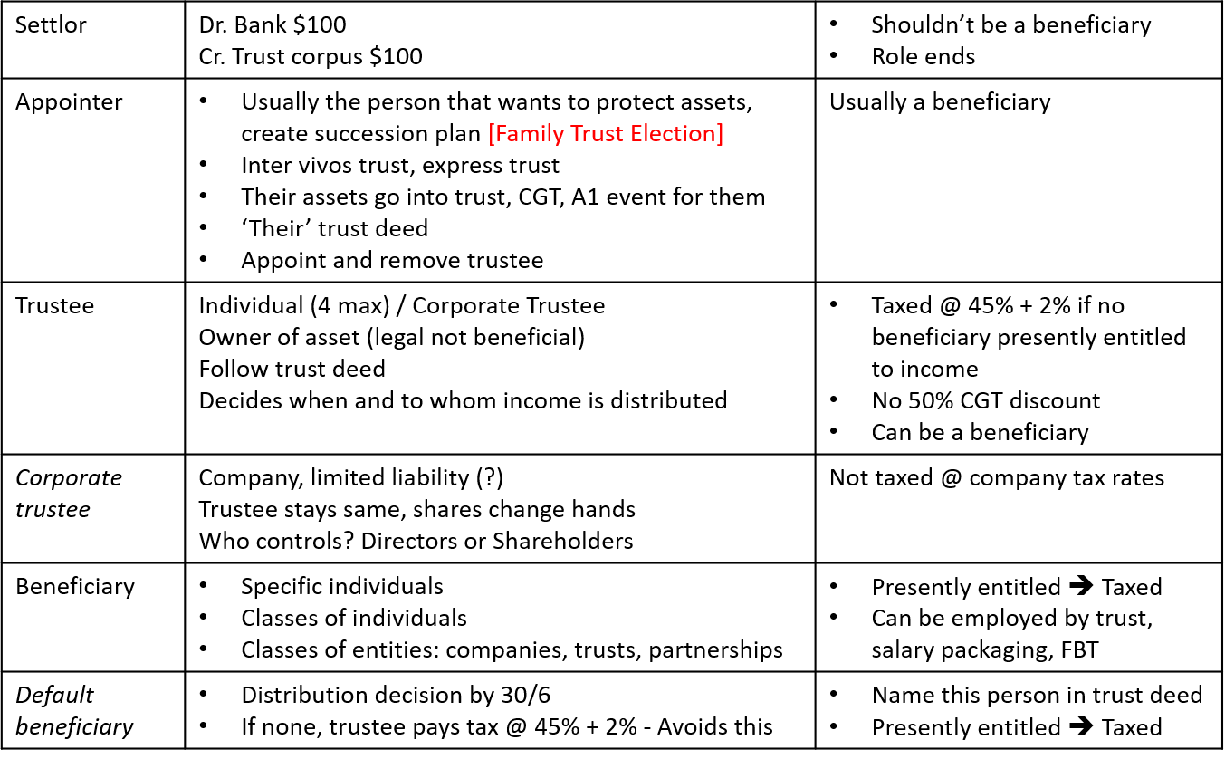
Tax rates applicable to trust income
- Beneficiary, presently entitled and not under a legal disability | s 97 ITAA36
  - Individual, marginal tax rates Franking credit, unincorporated SBE tax offset
  - Company, 30% (or 27.5%) Franking credits
- Beneficiary, presently entitled and under a legal disability | s 98 ITAA36 | Trustee pays this
  - under 18 years of age, OR mental incapacity, OR in bankruptcy
  - Marginal tax rates (and 6AA) Franking credit, unincorporated SBE tax offset
- No beneficiary is presently entitled | s 99A or s 99 ITAA36
  - s 99A 47% (45% + 2% ML) trustee pays this
  - s 90 Marginal tax rates, trust created by will or s 99A unreasonable
Presently Entitled
- Immediate and present right to call for trust income and receive payment
- The result of trustee discretion (decision)
- Doesn’t have to be paid
- Can be unpaid present entitlement
- Distributions not physically paid by the trust to a private company beneficiary, deemed dividends, Div 7A
- Payment received, not necessarily equal to amount included in taxable income
  - Entitled to trust income
  - But taxed on net income

Trust Income v Net Income
Trust income:
- Defined in trust deed, based on the law of trusts
- Modern trust deeds, closer to tax concept of net income
- But usually based on accounting principles
  - Income flows to beneficiaries
  - Capital receipts and capital gains, usually added to trust corpus
Net income:
- Assessable income – Deductions
- Includes net capital gain
- Includes franking credits
- Defined in s 95(1) ITAA36

What do we tax?
- S 97 ITAA36 – Include into the assessable income of a beneficiary who is presently entitled, a share of the income of a trust estate
  - Not a share of net income
When could trust income and net income be different?
- Dividends
- Non deductible expenses
- Capital allowances
- Capital gains
- Amendment to the trust’s net income by the ATO and additional net trust income must be distributed, which will be subject to tax

Principle we use to deal with these differences?
- FCT v Bamford | Proportionate view
  - Includes in the assessable income of a beneficiary the same proportion of the net income of a trust
  - As the proportion of trust income to which the beneficiary is presently entitled

- Trust income = $60,000
  - Under the trust deed:
    - Beneficiary A is entitled to 20% of distributable income
    - Beneficiary B is entitled to 10% of distributable income
    - Beneficiary C is entitled to the remaining 70%

- If net income = $90,000
  - A includes 20% of $90,000 = $18,000 as assessable income
  - B includes 10% of $90,000 = $9,000 as assessable income
  - C includes 70% of $90,000 = $63,000 as assessable income

Does this work if ATO increase net income?
Why would ATO increase net income?
  - including additional assessable income, or
  - disallowing deductions

What happens if ATO amends net income from $90,000 to $200,000?
  - A includes extra 20% of $110,000 = $22,000 as assessable income
  - B includes extra 10% of $110,000 = $11,000 as assessable income
  - C includes extra 70% of $110,000 = $77,000 as assessable income
5 Key Rules: Any of these 5 will appear on the final exam 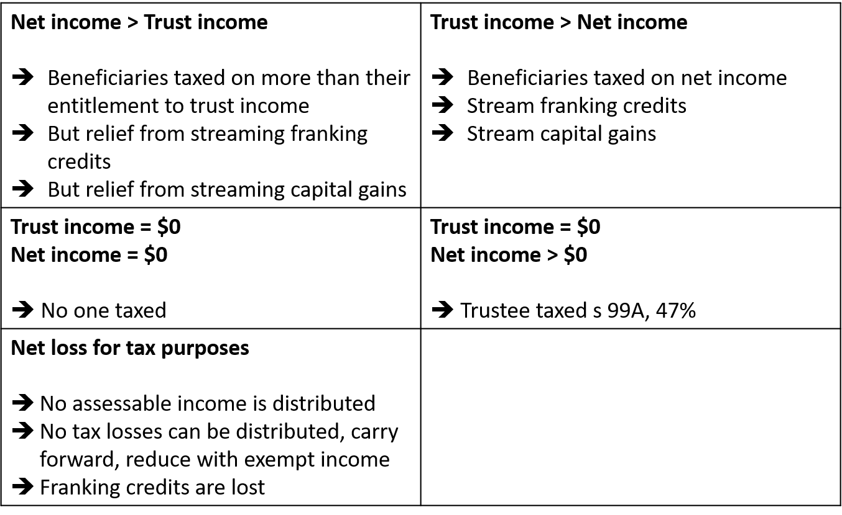
Net Income
- Assessable Income – Deductions -> Usual rules
- Dividends and Franking Credits | Div 207-B ITAA97
  - Included in assessable income
  - Stream to particular beneficiary
  - Modified approach to allocate distribution
- This is due to the fact that franking credits are only given to the owner
- Capital gains | Div 115-C ITAA97
  - Net capital gain in assessable income
  - -> Stream particular capital gain to particular beneficiary
  - Modified approach to allocated distribution
  - Do not stream CG to company because you don’t get the 50% general discount
Example – Trusts
Dividends in net income of trust:
- S 44, dividends = assessable income
- S207-20, gross up = assessable income
- Franking credits = tax offset
- Stream dividends and franking credits specifically to beneficiary
- Show franking credits separately
Net capital gain in net income of trust:
- Proceeds less cost base
- = capital gain
- Less capital losses from other CGT events
- Total
- x 50 % general discount
- x 50% active asset reduction for SBEs
- Usually the net capital gain = 50% of (proceeds – cost base)
- Stream to beneficiary? LAWS3101, Stream gain before discounts and losses

Example: Discretionary Trust
James Urban set up the Urban Family Discretionary Trust in 2010. He originally transferred a number of assets to the trust. On 1 July 2018, these were the assets of the trust: Shares in BHP Billiton, Shares in Westpac, the assets of a business that operates as a restaurant. The trustee of the Urban Family Discretionary Trust is Urban Trustee Pty Ltd. James owns all of the shares in this corporate trustee.
Urban Trustee Pty Ltd operates the restaurant on behalf of the trust. The accounting records reveal that trust income for the current year is as follows:
Restaurant income $100,000
Less: Ongoing expenses to operate the restaurant $ 40,000
Less: Accounting depreciation on a large oven $ 10,000
Plus: Dividends received from BHP Billiton $ 7,000
Trust income $ 57,000

The oven was purchased on 1 July 2018 for $30,000. The restaurant qualifies as a small business entity.
Answer:
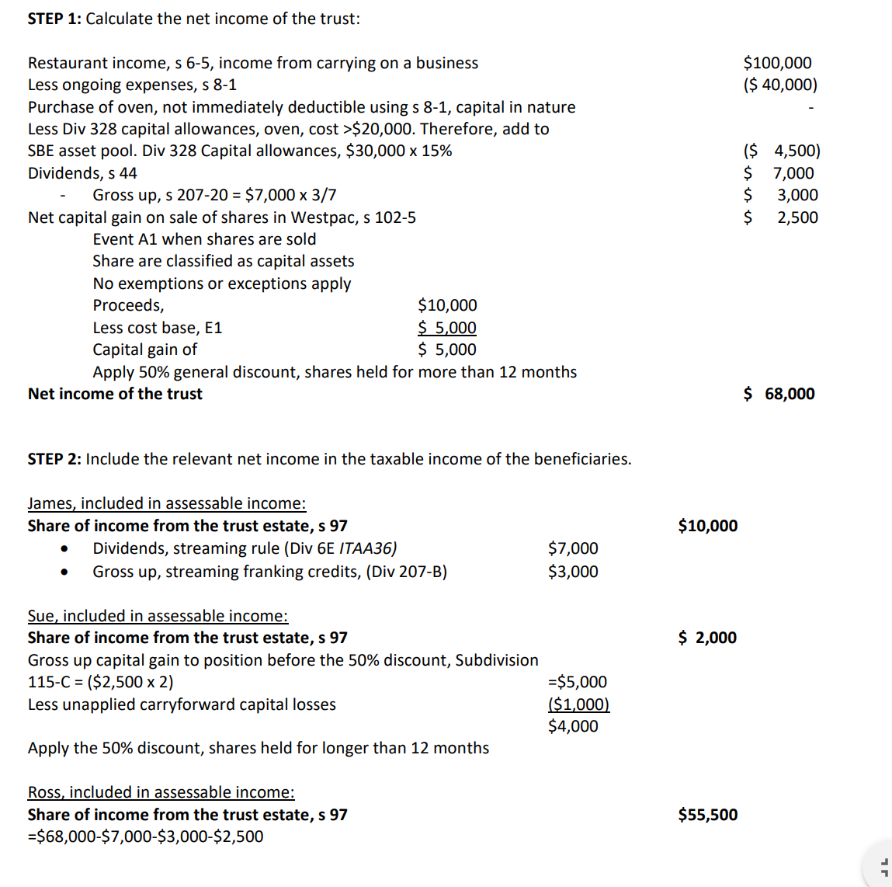

Topic 8 – GST (Week 11)
LAST TWO TOPICS, STUDY NOTES ARE VERY IMPORTANT
What is GST?
- A 10% goods and services tax (GST) Introduced on 1 July 2000
- GST replaced wholesale sales tax
- GST is an indirect, broad-based consumption tax
  - Similar taxation systems occur in around the world, often labelled as VAT (Value added tax)
- There are other forms of indirect taxations such as Excise, Luxury Car Tax and the Wine Equalisation Tax. NOT EXAMINABLE

Exam Questions
- No references to section numbers
- No case law
- Provide reasons for answers
- Show calculations
- Calculations and short discussion questions – topic 8 case study
- Abbreviate ITC (input tax credits)

The ‘politics’ and global effects of GST
- Allocated GST to states
- Aligning Australia’s GST with our trade partners
- Downloads imported services
- GST on low value imports
- ‘Tampon tax’
- Fighting high electricity prices
Enterprises must register for GST
- Registration turnover threshold, annual turnover of $75k or more
- $150,000 for non-profit bodies
- May also register if:
  - Annual turnover is < threshold
  - Intend to carry on an enterprise in the future
    - (this means taxi drivers/ubers)
What then?
- Sells goods or services
  - Includes GST in price, keep a record, remit GST to ATO later
- Buy goods and services and pays GST to the suppliers,
  - Claim back the GST paid, called ITC from the ATO
- How? Summarise all these GST transactions on the BAS
- IF GST received from sales of goods and services > GST ITC,
  - GST is payable, pay the net amount to the ATO
- IF GST received from sales of goods and services < GST ITC,
  - GST is refundable, get the net amount from the ATO in cash

Accounting for GST | Business Activity Statements – BAS
- S 31-10:
  - The entity must lodge the activity statement within:
    - 21 Days after the end of the tax period (monthly)
    - 28 Days after the end of the tax period (Quarterly).
- S 31-25
  - If the annual turnover of the entity is $20 mil or more, the entity must electronically lodge the activity statement
  - S 33-10 Must also pay GST electronically
- Copy of BAS in reference materials folder
- Use accruals basis, unless apply for cash basis with turnover less than $10 mil

Requirements to include GST in supply of goods and services? Probably examinable
- Registered fore GST
- Issue a valid tax invoice
- Must make taxable supplies

Definition of ‘Taxable Supply’
- Supply of goods and services | s 9-10 GSTA
- Consideration = Cash or Anything of value | S 9-15 GSTA
- In the course of furtherance of an Enterprise | S 9-20 GSTA
- Connected with indirect tax zone | s 9-25 GSTA
  - Delivered or made available to recipient in Australia
  - Goods removed from Australia
  - Supply of Australian land
  - Supply done in Australia
  - Through an enterprise carried on in Australia
  - Recipient of supply is an Australian Consumer
- Registered entity, to extend the supply is not GST free or input-taxed
What to write down under exam conditions?
- The usual? (usual business activity, like myer selling clothes (DO NOT WRITE IN EXAM, just say it’s a taxable supply)
- AN element missing? Or different?
- Exports? Imports to Australian consumer?
Taxable Supply
- Is made for a GST inclusive price
- Technical perspective -> GST is 10% of value of taxable supply
- Value of taxable supply = Price x 100/110 (or divide 11)
- Calculate GST = GST Inclusive price x 10/110
- Your sales on credit for a GST period is $100,000
  - Dr Debtors $100,000
    - CR sales ($100,000 /11) $90,909
    - CR GST Output ($100,000 /11) $9,091

Requirements to Claim back ITC?
- Creditable acquisition:
  - Registered as an entity
    - Need to be registered for GST to claim ITC
  - Makes an acquisition (tangible, intangible)
  - For a consideration
  - Hold a valid tax invoice
  - Creditable purpose (or part creditable purpose) – Relates to carrying on an enterprise, not input taxed supplies, business purpose.
    - Can only claim ITC if its for principle carrying on of business
What to write under exam conditions?
- The usual?
  - If normal, just focus on what they can’t claim on, the exceptions
- Can’t claim loss or outgoing as a deduction for Income tax? Div 26, Div 32
- Private use?

How will you know the enterprises holds a valid tax invoice?
- Question says all amounts include GST
- Question provides additional info:
  - Large Australian company
  - Leading Australian retailer
  - Nationwide company
  - Large equipment supplier
  - Why? These suppliers will be registered for gST
- Someone not in business
  - Can’t register for GST, can’t charge GST.
  - IF THEY ARE NOT A BUSINESS, CANNOT CHARGE GST. SO DO NOT CALC FOR IT

What does not have GST included in the price?
- Anything purchased from a non-GST registered source
- GST free supplies use this exact terminology in the exam
- Input-taxed supplies use this exact terminology in the exam

GST FREE v Input-taxed -> Strong focus on who provides which
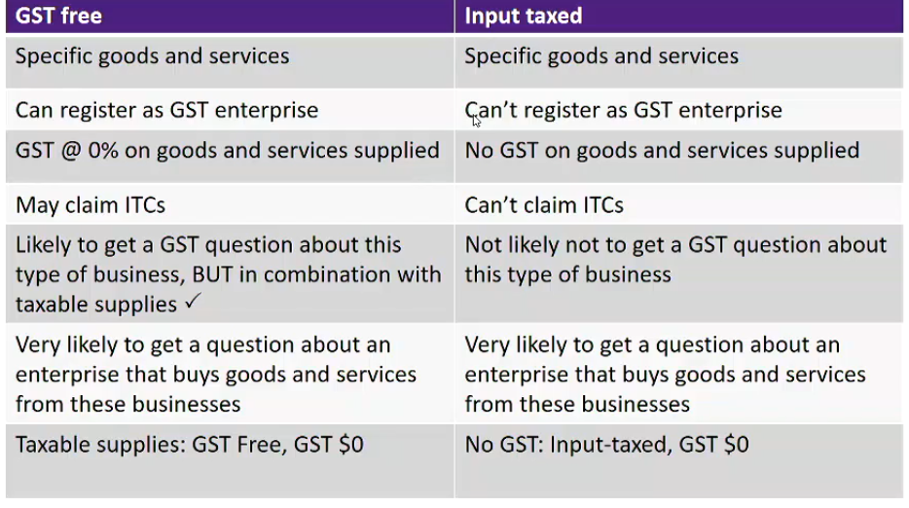
YOU WILL NOT BE ASKED A GST QUESTION ABOUT INPUT TAXED BUSINESSES
If you do get a business that procure some of their goods and services from an input taxed supplier, you need to say “this is input taxed therefore gst = 0” very few items will relate to input tax but remember that terminology when stated.
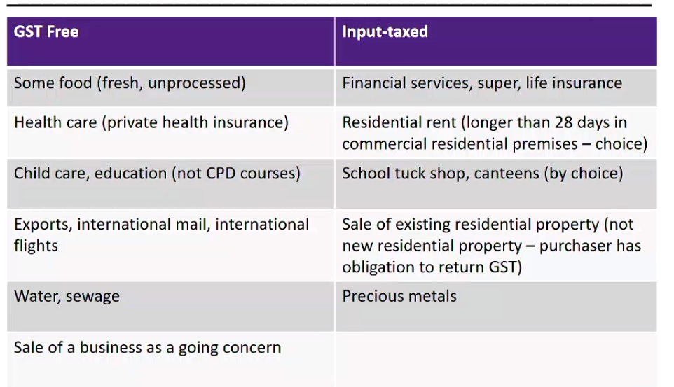
GST-free regulation driven
- GST food guide – example
  - Uncooked chicken nuggets -> gst free
  - Meat pie (frozen) -> taxable
  - Milk -> gst free
  - Flavouried milk -> taxable
  - Drinkign chocolate to flavour milk -> GST free
  - Breafkast cereal -> Gst free
  - Breakfast bars -> taxable

Gst free
- Water – not gst free if:
  - In containers less than 100 litres and
    - Artificially carbonated
    - Additives
    - Consumed on premises
Input-Taxed
Financial Services
- Opening, keeping, operating, maintaining and closing of cheque, debit card, deposit and savings accounts for accounts holders
- Cashing cheques and payments orders
- Electronic funds transfers
- Supply of credit cards
- A mortgage over land, premises or chattel
- Various types of contracts of insurance
- Providing Foreign currency

Insurance
- Life insurance is input-taxed
  - Premiums can’;t include gst
  - Payouts can’t include GST
- Private patient hospital insurance is GST-free
  - GST in premiums at 0%
- Other insurance policies:
  - Stock theft, damage to assets, public liability insurance, natural disasters
  - GST included in premiums
  - If insured is registered for GST, claim back input tax credits
- Low gross-up factor are seen in exams -> related to FBT and paying for employees insurance

Taxable importation of G & S
- Taxable importation = goods/services are imported, entered for home consumption (use in Australia)
  - GST is payable on taxable importation:
    - Payable by the importer – Liability to pay GST
    - Regardless of whether GST – registered or carrying on an enterprise
    - But, GST registered entity can claim back ITCs if all requirements are met for creditable importation
- Value of GST = 10% x (Customs duty value of goods + insurance + freight + transport to AU)
  - Exceptions:
    - GST Free goods (like fruit0
    - Non-deductible expenses
    - Low value goods to non-Australian consumer, <$1,000
- In exam you will probs see the above formula, multiple by 10% not 11

- New rules for importation of intangible goods and low value goods
- But, GST applicable if made to an Australian consumer

Special rules for supplier’s to ‘Australian consumers’ (not business to business):
- Intangible supplies
- Low value goods
Liability for GST is imposed on overseas supplier
Intangible supplies:
- Consultancy, professional services
- Digitial services, Electronic distribution platforms
- Made to Australian consumer, then supplier registers for GST in Australia
- Charge GST, remit to ATO
Low value items:
- <$1000, but not tobacco or alcohol, usually no GST
- But, GST applicable if made to an Australian consumer

Taxable importation of Goods and Services
- Rio tinto imports a machine for use in one of its mines -> Taxable importation = creditable acquisition -> claim ITCS
- Mary imports clothes from a supplier in the UK that cost $140 -> made to Australian consumer -> Pay gst to supplier -> can’t claim ITCS
- Arnold imports fruit -> made to Australian consumer -> but gst free -> no gst
GST Adjustments
- Adjustments for changes in business circumstances
  - Claim additional ITCs
  - ‘Return’ ITCs over-claimed
  - ‘Get back’ GST on sales
  - Increase or decrease in non-taxable use
- Examples
  - Bad debts
  - Change in the extent of the entity’s creditable purpose, more or less private usage
  - Paying back a customer for defective products sold

Car Limit
- Limits ITC Claimed back on acquisition
- $57,581
- EXAMPLE
  - If you purchase a car, and its more than $57,581, we also cap the GST. If you purchase a vehicle that’s a car and its more than 250k the gst will be on the 250k, but the ITC is capped by the $57,581.
  - Purchase car for $250k, will take 250k/11 = GST that you paid
  - ITC will be $57,581/11 = ITC can claim back
    - $5,235 is the max you’ll ever be able to claim back on a car

Topic 9 – Fringe Benefit Tax (week 12 + 13)
study notes will help with this
What is FBT?
- Tax paid by an employer on employee fringe benefits
- Employer-employee issue -> Working out how you will be paid
- Cost-to-company – negotiation process – Combination cash, fringe benefits

FBT, using ‘cost-to-company leaves employer and employee in the same position:
- Whether the employee gets the non-cash benefits directly from the employer OR
- Whether the employee receives the equivalent cash salary and uses that to buy the non-cash benefits themselves
- Assuming the top marginal tax rate applies
- Employer will never pay full wage + Fringe benefits
- Employers often limit who gets the fringe benefit, because its very expensy to set up
Example’s of these structuring are page 1-9 of study notes

What is FBT?
- A benefit
- Provided to an employee or an associate of an employee
- In respect of the employee’s employment
- Paid by either:
  - Employer
  - Associate of the employer
  - 3rd party | e.g. leasing a car
- FBT Rate = 47%
- FBT years from 1 April 2018 to 31 March 2019
- FBT focuses on value of private use
  - Reimbursement, paying back the employee for specific expense
  - Non-cash -> being assets, service uses of assets use of facilities
  - Paying expenses for employee

FBT pulls together Income tax law, FBT and GST
- WATCH FOR DATES, all dates fit within income tax year. So be careful because FBT dates are different
- Analyse tradeoff, would you rather get taxted highly for FB or just paid yourself and then you just buy it

In FBT questions:
- Salary or wages
allowances
- Exempt fringe benefits
  - ‘Excluded from the definition of fringe benefits, no FBT payable’
  - S 136 (1) FBTAA
  - Cite specific section numbers -> Topic 9 study notes
In taxable income questions for employee:
- Fringe benefits exempt from income tax, s 23L ITAA36
In taxable income questions for employer:
- FBT, Deductible, s8-1
- Cost of providing FBT -> s8-1 or Div 40/328
If your employer is giving you something, and you don’t have to give proof then it is an allowance is you have to prove it with a receipt it is a fringe benefit

6 Step process
- Identify the fringe benefit category
- Does an exemption apply to the FB
- What is the taxable value of the FB if it is not exempt?
- Is there any possibility of reducing the taxable value?
- Gross up the final table value to work out taxable amount?
- Add the grossed up taxable amounts and multiple by the FBT rate of 47%

STEP 1-4 MUST BE REPEATED FOR EACH SEPARATE FRINGE BENEFIT
Step 6, gross up all of them, then just total them. Once you have a total, it’s easier to just multiply that by 47%

LOOK AT THE FUCKING STUDY NOTES YOU DUMB FUCKING BITCH
THERE ARE A FEW SECTIONS THAT NEED TO BE REFERENCED IN FBT, CAN BE FOUND IN STUDY NOTES

- Can only use fringe benefit, if it gives you a private benefit.
Step 1 – Identify the fringe benefit category
13 Categories focused on
- Car fringe benefits | Div 2
  - Car as defined
    - Low capacity of less than 1 tonne, and carries less than 9 passengers
  - Access to vehicle owned by employer, or leased by employer
  - Even if you rarely actually use it privately
  - Even if employer’s logo is on it
  - Even if parked in garage, or at airport
  - Value private use
  - Usually for execs and travelling sales people

- Loan fringe benefits | Div 4
  - Borrow money from employer at <5.20% (only FBT if less than 5.2%)

- Expense payment fringe benefits | Div 5
  - Employee or associate pays gets reimbursed
  - Employer pays an expense on behalf of an employee
  - Examples:
    - School fees, GST free, all private
    - Gym fees, GST, all private
    - phone bill, GST, could have combination private and business, target private use
    - Petrol with your own car, GST, could have combination private and business, target private use
  - THIS IS GOOD IF YOUR EMPLOYER IS THE GOVERNMENT (they’re not fucking taxing themselves are they ya bloody dumbass)

- Property fringe benefits | Div 11
  - An employer provides an employee with property
  - An employer provides goods to an employee free of charge
  - An employer provides goods to an employee at a discount
  - AN employee consumes goods on the employer’s premises
  - An employer pays for entertainments costs (food and drinks) off the business premises (rather than reimbursing the employee, which will result in an expense payment fringe benefit) -> Meal at a restaurant

- Residual fringe benefits | Div 12
  - Anything not captured in other categories
  - Use of employer’s assets
  - Providing a service to the employee at no/low cost
  - Use of a vehicle not a car
  - Priority access to child care services
  - Using an employer’s gym facilities
  - Waiver of loan establishment fees
    - Subject to GST, it is not input-taxed

- Meal entertainment fringe benefits | Div 9A
  - Usually, food is not deductible, however it can be fringe benefited (this is use for senior partners, who take clients out to lunch).
  - Entertainment by way of food or drink
  - Accommodation or travel in connection with entertainment by way of food or drink
  - A reimbursement of expenses incurred by an employee in relation to the above expense AND Employer elects to classify as meal entertainment fringe benefit using DIV 9A
  - EXAM QUESTION WILL STATE IF PERSON HAS ELECTED DIV 9A
  - Think like, really lavish meals and shit
Step 2 – Does an exemption to the fringe benefit? Specific Categories
- Car FB
  - Very Few – PoTL 2019
- Loan FB
  - If terms of loan = to public
- Expense payment FB
  - ‘No private use declaration’
- Property FB
  - To Employee, consumed on employer’s premises on working day, even if a social event
- Residual FB (mostly big ticket items, smaller tings are ignored)
  - Yes, several. E.g. – study notes
  - Use of toilets at work
  - Vending machines at work
  - Private use of employer’s equipment at work
- Meal entertainment – no bitch

Work-related items -> item given to employee, or use of an item, or reimbursed:
- S 58X
- Used primarily for work purposes (chiefly, principally)
- Categories:
  - Portable electronic device (mobile phone, laptop)
  - Item of computer software
  - Protective clothing required for employment
  - Briefcase
  - Tools of trade
- One item of each type per employee per FBT year – SBE exception (<$10mil)
- Employee is unable to claim a deduction for any depreciation on an FBT exempt item
- Employer can claim a deduction, s 8-1 or capital allowances
- Was the main purpose work? If so, then its all good. They don’t have to LWAYS use it for work.
Membership fees and subscriptions,
- s58Y
  - airline aiport lounges membership (only if they travel)
  - professional or trade journals subscriptions

Single-trip taxi travel
- s 58Z
- basically, if you have to work late because of work, work can play for a taxi and you can get an exception

Emergency Assistance
- if there is like a tornado, fire, flood, if work steps in to help, you don’t have to pay the tax.

Step 2 | is the fringe benefit wholly exempt?
Yes -> No FBT. AN exempt fringe benfit is not a fringe benefit FBTAA, s136(1), definition for fringe benefit, para (g)
NO -> Need to determine taxable value of the relevant FB
- different rules for each category
- summary, essential

Car Fringe Benefits Value
- Taxable value, using either:
  - Statutory formula method
  - Cost Basis (Operating cost method)
    - They need to be keeping a logbook and very strict records
- Employer can choose whichever method yields the lowest taxable value
- Must specifically elect to use the operating cost method
Car Fringe Benefits -> Statutory Formula
- Taxable value = A x B (C / D) – E

- A = Base value of the car. Includes:
    - Purchase cost
    - Dealer delivery charges
    - GST, LCT
    - Deduct trade in values or amounts paid by employee
  - Excludes: registration, insurance, extended warranty costs
  - IF car is leased, base value = Market value of car at start of lease
  - Can reduce base value by one third after four years
- B = the statutory fraction = 20%
- The number of days in FBT year when car was available for private use by employee(s)
- Number of days in the FBT year
- Employee contributions
  - This $ value, tax deduction for employee
  - Mix of private and business purposes, only deduct business related
Example:
- An employer purchases a car for $30,000 including GST on 1 October 2018, gives its use to an employee from that day. The employee pays fuel costs of $1,000 and provides their employer with the necessary declaration.
Taxable value:
= A x B x (C ÷ D) – E
= $30,000 x 20% x (182 ÷ 365) - $1,000
= $1,992
IF IN EXAM, WORTH LIKE 5/6 MARKS
Car Fringe benefits -> Cost Basis Method
- Taxable Value = (C x [100% -BP] ) – R
  - C = Total operating costs
  - BP = The percentage business use | Log Book
  - R = The employee contributions
- May provide a lower taxable value than Statutory Method if high level of business use
- Only use if specifically choose this method
- Total operating costs:
  - Actual costs, e.g. insurance, fuel, leasing costs
  - + If employer owns the car
    - Deemed depreciation
      - = 25% x depreciated value x # days available/365
      - Car limit doesn’t apply
      - Year 1 = Cost + GST + LCT + delivery charges, excludes registration and insurance
      - Year 2 = Use diminishing value
    - Deemed interest
      - Depreciated value beginning of year x 5.20% x # days available/365
Example:
Employer purchases a car on 1 January 2018 for $20,000 (GST incl.), and makes it available to an employee from that date. During the 2019 FBT year, fuel, insurance, registration and repairs costs total $6,000 (GST incl.). Employee keeps a logbook – uses car 70% for work purposes. Employee pays for $1,000 in fuel and provides employer with declaration. Taxable value 2019 FBT year?
The depreciated value at 1 April 2018:
= $20,000 – ($20,000 x 25% x 90/365)
= $20,000 - $1,233 = $18,767
Taxable value = [C x (100% - BP)] – R
= [($6,000 + ($18,767 x 25%) + ($18,767 x 5.20%)) x 30%] - $1,000
= [($6,000 + $4,692 + $976) x 30%] - $1,000
= $2,500

CAN ONLY USE THIS, IF EMPLYOER ELECTS THIS METHOD

Loan Fringe Benefit
- Shareholder and employee?
  - Deemed dividends, DIV 7A, not a fringe benefit if linked to shares
    - Shareholders CAN’T get fringe benefits.
- Practical implication of FBT legislation
  - Daily Balance
- Loan Balance x (5.20% - interest rate charged) x Days of loan/365

Expense Payment Fringe Benefits
- Employer reimburses or pays expenses of an employee or associate for example:
  - Home telephone
  - Train fares
  - Holidays
  - School fees
  - Road tools if associated with private use of work-related car -> travel to and from work
- Taxable value = usually the amount paid, unless an in-house expense payment fringe benefit
  - In house = goods and service usually provided by the employer
  - Taxable value of in-house = 75% of lowest price charged to public

Property Fringe Benefit
- Employer buys capital assets gives ownership to employee
- Employer buys goods, employee uses it up
- Employer buys food and drinks, employee uses it up
- Sells goods to employee at discount

- External property fringe benefit = price paid
- In-house property fringe benefit:
  - Manufactured, produced, processed or treated by the employer + employer sells to a manufacturer, wholesaler or retailer
    - Lowest arm’s length price at which property is sold
  - Manufactured, produced, processed or treated by the employer + employer usually sells products directly to the public
    - 75% of lowest arm’s length price at which the property is sold to public
  - Purchased by employer + ordinarily sold to the public, lesser of:
    - Cost of property
    - Selling price
- Go to Case study #1 about periwinkle, this combines prop fb in manufacturing environment, with another exemption

Employer provides food (and drink) to employees or associates of employees
- Residual fringe benefit value will be given in the exam
Three different fringe benefits may arise:
- Expense Payment Fringe Benefit = usually when reimbursing the employee
- Property Fringe Benefit = When employer pays directly (at/away from premises, irrespective of whether a party or not)
- Meal Entertainment Fringe Benefit = DIV 9A FBTAA
  - Must elect to use DIV9A
  - If chosen it applies to the whole of the relevant FBT year
  - Can impact on Minor Fringe Benefit Exemption and income tax deduction for providing fringe benefit
- If question says 9A, just treat as 9A, if it doesn’t pick either prop FB or 9A ( can never be both)
Meal Entertainment Fringe Benefit ATO TR97/17
- Why the food or drink is provided?
  - As refreshment (e.g. morning tea for employees) will not be entertainment
  - In a social situation (e.g. lunch at a restaurant) will be classified as entertainment
- What type of food or drink is provided?
  - Morning or afternoon tea, sandwiches or light meals are unlikely to constitute entertainment
  - While a three-course meal will constitute entertainment
- When is the food or drink provided?
  - Food or drink provided during work hours, during overtime or while an employee is travelling is less likely to be entertainment
- Where is the food or drink provided?
  - Provided at the employer’s premises is less likely to be entertainment
  - Provided at a hotel, restaurant or café are more likely to be classified as entertainment
Meal entertainment Fringe Benefit
- Employer chooses Div 9A
  - Business lunches and drinks and staff social functions such as Christmas parties, staff golf days and farewell functions
  - Tickets to sporting or theatrical events, sightseeing tours or holidays
  - Accommodation and travel in connection with entertaining clients and/or employees over a weekend at a tourist resort
Meal entertainment fringe benefit and income tax
- Most meal entertainment costs will not be deductible, s 32-5
- May be deductible if provided as fringe benefit, s 32-20
- Can’t be deductible if exempt fringe benefit
- Depends on how expenditure is treated for FBT purposes
- Study Div 32, ITAA97
- Summary of meal entertainment for FBT in Study Notes
Div 9A Meal Entertainment Fringe Benefit
Two Methods
- 50/50 split applies automatically
  - 50% of meal entertainment will be subject to FBT
  - But cannot apply the minor fringe benefit exemption
  - 50% of the cost will be deductible for Income Tax
  - FBT on meal entertainment will be deductible for Income Tax
  - Claim back input tax credits on 50% of cost
- 12 week register -> only applies if employer elects to use
- Used to obtain a higher % than 50% for employees present
- Or to access the minor fringe benefit exemption
- Employee’s cost of the meal will be deductible for Income Tax
- FBT on meal entertainment will be deductible for Income Tax

Example | Dinner at restaurant, cost at >$300
- If paid by employer:
  - Property fringe benefit
  - Not exempt, as not at employer’s premises
  - Taxable value for FBT = price paid
  - FBT and costs of dinner (less GST ITC claimed) = deductible, s 32-20
- If paid by employee and reimbursed by employer:
  - Expense payment fringe benefit
  - Not exempt
  - Taxable value for FBT = price paid
  - FBT and costs of dinner (less GST ITC claimed) = deductible, s 32-20
- Meal entertainment fringe benefit, employer elects Div 9A:
  - No register, use 50:50 method
  - Taxable value for FBT = 50% of price paid
  - Deductible is FBT and 50% of costs after GST claimed on 50%

Example | Dinner at restaurant, cost <$300, Infrequent
- If paid by employer:
  - Property fringe benefit
  - Minor fringe benefit, exempt fringe benefit, no FBT payable
  - $0 deductible for Income Tax due to s 32-5
  - Exemption in s32-20 does not apply. An exempt fringe benefit is not a fringe benefit
- If paid by employee and reimbursed by employer:
  - Expense payment fringe benefit
  - Minor fringe benefit, exempt fringe benefit, no FBT payable
  - $0 deductible for Income Tax due to s 32-5
  - Exemption in s32-20 does not apply. An exempt fringe benefit is not a fringe benefit
- Meal entertainment fringe benefit, employer elects Div 9A:
  - No register use 50:50 method, therefore minor fringe benefit rule doesn’t apply
  - Taxable value for FBT = 50% of price paid
  - Deductible is FBT and 50% of costs after GST claimed on 50%

Step 4 = Possible to reduce the Taxable Value?
Recipient’s contribution
- Usually assessable income to the employer
- Raise GST on the amount received, if registered for GST
- Does not apply to car fringe benefit
- Does not apply to loan fringe benefit

Otherwise deductible rule
- The employee could have claimed a tax deduction if they had incurred the cost themselves
- Only applies to one-time-only deductions -> not depreciation
- Does not apply to car fringe benefit
- Phone bill? Gym fees? Interest on loan?
  - If used item to produce assessable income, then you can use the deductible rule.
  - Cannot be used for Gym fees (because private and domestic in nature), unrelated to assessable income
  - Interest on loan, may be able to use deductible loan, -> if they used this loan to buy shares and get dividends they’d be getting assessable income, however if for private and domestic use cannot apply.

Minor benefits exemption of $300
- Section 58P | FBTAA
- Does not apply if in-house benefits exemption applies
- Does not apply to car fringe benefits
- Does not apply to loan fringe benefits
- Does not apply to 50:50 method for meal entertainment
- Consider each individual fringe benefit, per person basis
- Applies to infrequent and irregular (or when unreasonable to apply)
  - Expense payment benefits
  - Property benefits
  - Residual benefits
  - Meal entertainment benefits using register method
- Basically, if its less than $300 and its irregular, you can use this exemption

In house benefit exemption of $1000
- Similar goods and services to usually sold
- Available for each employee over full year
- First $1000 exempt
  - Does not apply to car fringe benefit
  - Does not apply to minor fringe benefit exemption
  - Does not apply to loan fringe benefit
- In an exam situation…
  - Consider the individual employee’s situation over whole year
  - Reduce value of in-house benefits by max of $1000
  - FBT case study

Step 5 = Gross up taxable value of each benefit
Literally just take the value, don’t question it bruh
- Gross up = multiply taxable value with a factor
- Links to GST
- Underlying benefit includes GST, Type 1¸use 2.0802
- Underlying benefit is GST free or input taxed, Type 2 use 1.8868
Example:
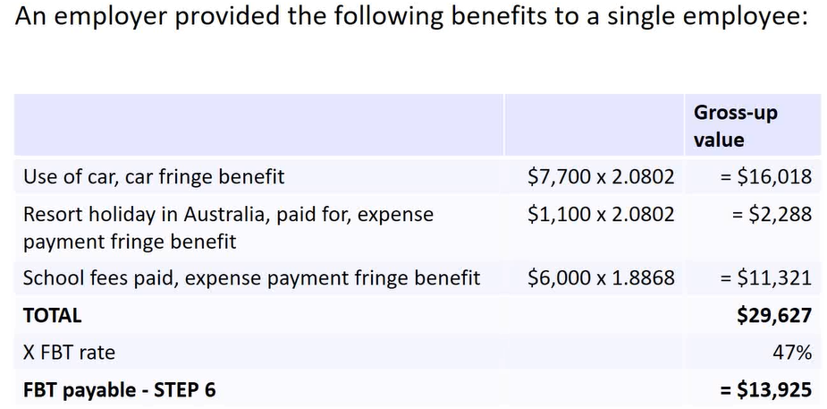

Link with income tax and GST
The net cost to the employer is:
- Type 1 = Actual cost of the benefit (s 8-1 or capital allowances) + FBT (s 8-1) – GST input tax credit
- Type 2 = Actual cost of the benefit (s 8-1 or capital allowances) + FBT (s 8-1)

Otherwise deductible rules example
Work entitlements of managing director of RM Willaims:
- Memberships fees to CA ANZ
  - Yes deductible, you can deduct it personally under s8-1 as its required for assessable income -> therefore otherwise deductible rule applies.
- Airport lounge
  - Yes deduction, it’s an exemption
- CPD seminiars, including accommodation
  - Yes deductible, its required for job
- 5 pairs of RM williams
  - No, its personal or domestic -> therefore you can claim FBT, it becomes a property fringe benefit. (because the company makes the shoes)
  - Wouldn’t be able to get out of it, from usual rules. But because RM William makes it, you can reduce it by the first $1000
  - CASE STUDY 1 – BATH TUB, LOOK AT (it explains this better)
- 4 return air tickets
  - No, its frequent yearly
- Car rental in Brisbane from longreach,
  - No that’s a fringe benefit
- Computer
  - Otherwise deductible, can’t be used
  - BUT 58X can, (this is used in step 2, not step 4)

- Think about ti this way, if you’re employing brilliant people and need to pay them for things that’ll help them work. It’s probably deductible under fbt

Link with income tax and gst
- Cost of providing FB, deductible, s8-1/capital allowances
- Excludes GST if able to claim back ITCs from deduction
- Can claim back ITCs even if employee originally paid
- Other expenses generally not deductibles becomes deductibles when provided as a fringe benefit include:
  - HELP repayments, 26-20
  - Relative’s travel expenses, s 26-30
  - Recreational club expenses, s 26-45
    - IF someone took out personally a golf membership, he wouldn’t get a deduction under, s26-45, for a business it would be a cost of employment which makes it a fringe benefit.
  - Leisure facility expenses, 26-50
  - Entertainment, Div 32
Any of the above, can be fringe benefited

- FBT taxable value = Include GST (unless GST free or input taxed) Income Tax deductions = Excludes GST if claimed back ITCs
- Employer reimburses employee for his telephone account of $440
  - FBT taxable value = $440
  - Gross up, Type 1 @ 2.0802
  - FBT Payable @47% = $430
- Deduction Income Tax, s 8-1
  - $400 ($440 x 10/110) + $430 of FBT
- Claim back GST input tax credits, $440 x 10/110 = $40
EVERY FBT CALCULATION INCLUDES, GST, CLAIM BACK ITC AT THE END IF IT DOESN’T
- Income tax question
- Purely fbt question
- GST question
All 3 questions open for final exam

Tute 9 1, calc taxable income all amoutns include gst look at this

FOR TRUSTS
IN THE EXAM, ONLY US ETHE 4 DIVISIONS LISTED IN STUDY NOTES, NO MORE NEEDED

FOR TRADING STOCK
When given two types of stock, do not total the CP, MSV and RV and then work out the trading stock, must be done for each individual stock item

READ POTL

in final exam
- For final exam, topic 3 you must state characteristic of s6-5
- no long ass questions about income (no whitfords or myers)

Date Table
Month | Days | Time to start of FY (from the 1st) | Time to FBT year (From the 1st)
Jan | 31 | 181 | 90
Feb | 28/29 | 150 | 59
Mar | 31 | 122 | 31
Apr | 30 | 91 | 0
May | 31 | 61 | 335
Jun | 30 | 30 | 304
Jul | 31 | 0 | 274
Aug | 31 | 334 | 243
Sept | 30 | 303 | 212
Oct | 31 | 273 | 182
Nov | 30 | 242 | 151
Dec | 31 | 212 | 121

To calc arbitrary dates, use this as a point of reference, then subtract (Date -1) from point in table.
- E.g. Aug 10 would be (10-1) = 9 days, therefore (334-9) = 325 days to FY.
FY 19-20 is a fucking leap year btw (so add 1 day to each of these if it’s a 19-20 q)

FBT Year runs from April 1 to March 31 (start is April 1)

