Week 1 Health Economics

Introduction

Readings: Economic Analysis in Health Care. John Wiley & Sons: Chapter 1.

Course Description

- Life, healthy living, longevity, ageing, death
- Descriptive and theoretical aspects and help you to look at health and health care issues through the distinctive lens of an economist.
- Central concern is the behaviour of economic agents (that includes you!) when confronted with scarcity
  - Choice and opportunity cost are central

- Focus on demand for and supply of healthcare, health insurance, equity and need, health and labour market, lifestyle behaviours, measurement of health outcomes, health economics of ageing and longevity, welfarist and non-welfarist foundations of economic evaluation.

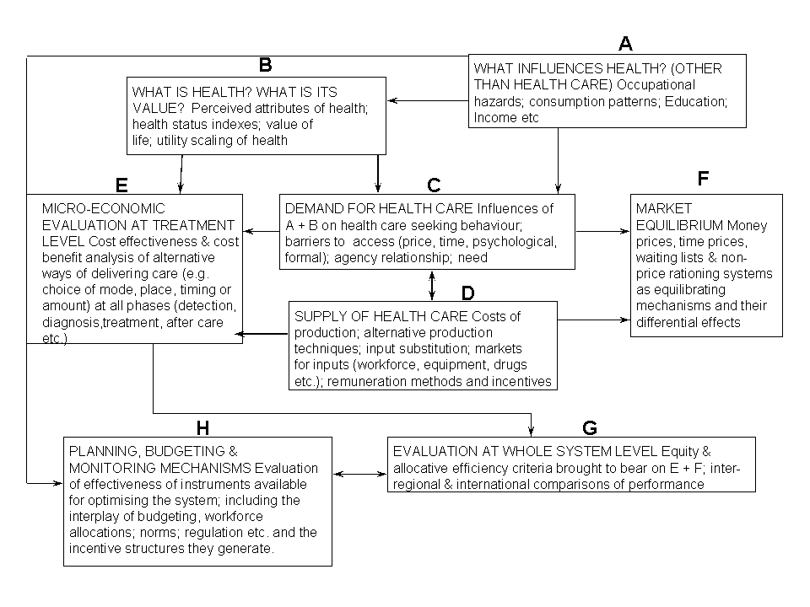
What is Health Economics?
Health Economics is concerned with the evaluation of the effectiveness of health care
- it is an application of economic theory to analyse decision making by individuals’/ health care providers/ government

In the market for health care there is asymmetry of information
- Doctors have a major influence on both the supply and demand
  - Greater information than consumers of health care/ services
- Supply does not equal demand 🡪 there is market failure
- Financing of health care services (insurance/ public funding etc)
  - Rand Study

Great demand for Health Economists
- Result of the continuing drive to reform health care systems /growing importance of economic evaluation in health policy.

Health care is an economic good
- Considers supply/ demand/ impact on health and employment etc
- Opportunity cost is central
  - Choices must be made on how much to produce/ how much it costs

Why is health economics different?

- Consumers cannot “shop around” as much
  - If there is particular services in your area that may be all you have access too

- Information in the market is not perfect
  - Asymmetry of information
  - One size does not fit all in regards to treatments

- Restricted entry to the industry
  - Regulations on who can and can’t enter into the industry

- Supplier induced demand
  - Arises from asymmetry of information
  - Knowledge difference between suppliers (doctors etc) and consumers

- Profit maximisation is not the sole goal
  - Ethical issues
  - Effectiveness issues

- No set fees
  - Rebate from governments
  - Makes valuation difficult

Choice and OC in allocation of Health Care Resources

Health economics questions and OC of possible solutions

Question 1. How much should we spend on health care as a country?  - Can range from 9% to 12% of GDP | Increase public spending on health care by increasing taxes/social insurance contribution. | OC A. Lower net incomes for consumers, so benefits of private consumption are foregone.  OC B. Higher taxes for firms either lowers profits, reducing incentives to invest and creating incentives to cut costs, including labour costs, OR results in increased prices where taxes can be passed on to consumers
Question 2. How much of health care is allocated to each region? | Increase share to total budget in one region | OC The health and other benefits foregone from reduced health care services in other areas.
Question 3. Which patients should get access to the treatments we have decided to fund? 🡪 | Ensure patients with particular characteristics eg. Those on long waitlists get access to services | OC Health and other benefits foregone as a result of those same services not being made available to other patients with different characteristics
Question 4. How much of our limited income as consumers should be spent on health related v non health related goods & services | Spend more of our income on health related goods and services | OC Utility foregone from our consumption of other goods & services

Arrow (1963) Study

Beginning of Health economics theory

Focused on the concept of Uncertainty
- Apart from asymmetry of information there is also uncertainty as to our health condition in the future
- Cannot predict our date of death

How do we then allocate resources in light of this uncertainty
- Insurance markets could address this?

Demand for Health Care

Consumer choice theory – using indifference curves to value QoL
- Using utility functions to understand patient choice

Demand functions – determinants of demand for health care/insurance
- D=D(P,I,N,Pc,Ps,T,S)
  - Prices/ Income/ “non price” (access/waiting lists) / price of compliments / price of substitutes/ time / state of your health
  - This is not totally appropriate for health estimations due to all the uncertainty

Grossman model
- Variant of the Human capital model
- Basis of health economics thinking

Needs/ wants/ demands of patients
- Asymmetry of information – supplier induced demand

Efficiency and Equity

Criteria used to judge the use of resources:

- Efficiency: allocation of scare resources to maximise achievement of aims
- Equity: are resources evenly distributed (poor v rich)
  - Effectiveness and ethics are also important considerations

Assessment:

Write a 1500 word report on a topic from lecture 2-7. Precise topics/questions to be handed out in Lecture 2 and on Blackboard thereafter.

Please address:
1. Write a title at top of page, include page numbers 5 marks
2. Keep report to 1500 words only – but ensure key concepts are included 5 marks
3. What is the question? 10 marks “this essay will”
4. Is there a theoretical framework? 40 marks
5. Give 3 examples

10 marks for presentation, including diagrams and references where appropriate.

Total marks 100

Please provide one paragraph for each of the points 3-5 above and provide a diagram where necessary or a diagram suitable to explain the answer.

Short Answer Structure:

Total answer to be no more than 250 words.
Examples of grading (for final exam purposes):

1. What is the question/issue? 10 marks
2. Describe any theoretical framework 30 marks
3. Discuss any relevant arguments 40 marks
4. Present discussion clearly (with diagram if necessary) 20 marks

Questions for Tutorial

- How does health economics depart from traditional economics supply-demand framework?

This question seeks to answer why health economics is different to the traditional economics model.

Health economics differs to traditional economics because there is asymmetry of information and a high potential for supplier induced demand. The doctor may have more information than the patient and influence them to demand more care, beyond their needs. Health care needs are essential to for health economics model. Patients do not act like consumers, doctors do not act like firms. Uncertainty is the key concept here.

Discuss why this may be true/false –using evidence from literature.

- Explain the context of choice and opportunity cost in health care resource allocation. Discuss equity and efficiency in the context of health care.

Week 2 Demand for Healthcare

RAND Health Insurance Experiment

Consumer Choice Theory

Preferences and utility:
- Assumes rationality
- Utility, preferences and indifference curves are abstract so can they be used?
  - YES
Consumers always seek to maximise their utility
- use this to understand patient choice of hospital

Chose alternatives based on alternative characteristics
- length of waiting time/ how far to travel

Relative weight of characteristics in the utility function can be estimated statistically

1.1 Using Utility functions to understand patient choice

Observing the choice people make in a Discrete Choice Experiment (DCE)

Factors included length of time waiting for surgery, how far to travel, post surgical care (trade offs)

- preferences were for every additional hour of travel, patients require a two month reduction in waiting time
Choices were affected by patients own characteristics
- older or less educated select local hospital even with lower waiting times elsewhere

Results were then used to inform the introduction of hospital choice in the UK

BUT.. constrained by budgets and other factors

- constrained by budgets, max. utility subject to income

Health care is different:
- information is not perfect (asymmetry of information)
- uncertainty (we do not know when will need health care)

Demand is derived on the basis of person’s perception of their need to get better
- there are also unmet needs and no need

1.1.1 Barriers to Health Care

Barriers to use of health care are:

- Supply side
- availability of services to meet needs include
- Demand side
  - prices and income, affecting ability to access

1.2 Determinants of Demand

- Price
- Elasticity and Inelasticity
- Some health care may not be overly necessary (asymmetry of information is possible)
- Need some healthcare regardless of price
- Income
- Prices of other goods
- Tastes, life styles
- Age?

1.3 Estimating Demand Functions

D=f(P,I,N,Pc,Ps,T,S)

Price to consumer, income, non-price access costs (waiting time), price of complements, prices of substitutes, tastes and state of health

EXAMPLE Demand for Dentures

Dd=157505-10960xPd+2141xPo-4432xI+8867xA

- Demand for dentures is negatively related to their price
- Positively related to the price of other goods
- Income goes up, demand falls (inferior good)
  - Can afford better access to other healthcare
- As availability goes up demand increases
  - Potential indicator of supplier induced demand

2. RAND experiment

Manning, W., et al. (1987) Health insurance and demand for medical care; evidence from a randomized experiment. American Economic Review, 77(3), pp. 251-277.

How does cost sharing affect demand for medical services?

Families assigned to 1 of 14 different fee-for-service insurance plans or a prepaid group practice
- Randomized experiment
- Use of medical services (GP and Hospital) (not outpatient, or dental)
- Demand elasticities are > 0, price elasticity is -0.2 approx.
  - if you put the price up (extra amount the consumer has to pay) the demand for services will go down
  - not completely causal → other factors at play

3. Effect of ageing on the demand for health care

Does a higher population of older people lead to higher health costs?
- People now live longer, longevity is relevant
- End of life may now be shorter and therefore costs remain same or even lower?

Zweifel et al. (1999) predict that proximity to death explains higher health costs, rather than age per se
- Last 6-12 months of life are the most expensive

More important drivers of costs are improved quality of care, access to care, and new technology
- All these may be largely devoted to older people
- Age may be associated with higher costs, but is not actually the causal factor

3. Health Economics Frameworks

Modelling Choices about Health

3.1 Grossman’s Model

People Demand and produce health
- health/healthcare is a product that consumer demand BUT
- People are producers of their own health by engaging in health producing behaviours

This duality means that the Grossman model is both a consumption and investment model

3.1.1 Consumption Element

Demand for healthcare is derived demand
- depending on what level of health you want you will then demand a certain level of healthcare
  - If you have perfect health then you will demand little/no healthcare
  - Medium health level AND ARE HAPPY with this you will demand little/no healthcare
  - Low health level and want to improve means you will demand a high level of health care

Health is a basic commodity
- use time and market inputs to produce health

Health is not just a direct source of utility
- Effects ability to work and therefore time available to produce income
- Poor health reduces ability to earn and reduces happiness/quality of life
  - Both direct and indirect effects on utility
  - Differentiates it from other commodities that produce only DIRECT utility

3.1.2 Investment Element

Health is treated as a capital good (not just a consumer good)
- Health is a key component of the human capital model

A person has a stock of health, depreciates over time (age) and decreases when used in production and consumption of other commodities.
- Can be increased through investments of time, effort and knowledge in health promotion activities.

Linked to other human capital, since knowledge/learning can affect how efficiently they can produce health
- skills in turn depend on investments in education.

3.2 Grossman Model - Simplified Graphical Model

Consumption of health and other good BOTH derive utility
- Utility will be Maximised where U_{max} , H* (Health) and O* (Consumption) are chosen
- Requires purchase of M* healthcare inputs and X* non health care inputs

Diagram can be used to predict what effects changes in different elements have on commodities choices
- ie. increase or decrease in income causing budget line to shift
- improvement in health care technology would cause production function to change shape or position

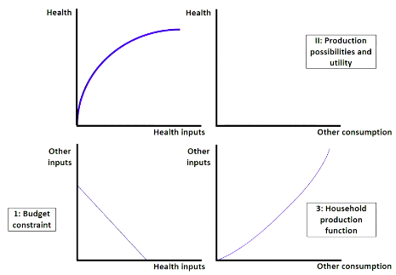
Utility is maximised where you have demanded a certain number of healthcare inputs to achieve a certain maximum level of health and you can use your money to buy other goods

1. you have an income and therefore a budget constraint and you can only buy a certain number of inputs/ health inputs

2. Health production function
- as health inputs increase so does your health
- DMR take effect here

3. Household production function → inverse of health production function

4. Production possibilities/ utility

3.2.1 Step 1 - Exclusively Other Inputs
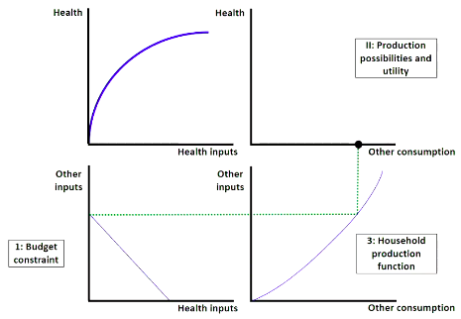

If you consume exclusively other inputs this will mean you are consuming ON the x axis (x*)

3.2.2 Step 2 - Exclusively Health Inputs
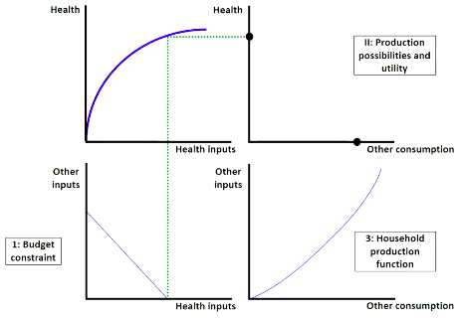

if you consume exclusively health inputs this will mean you consume on the Y axis (M*)

3.2.3 Step 3 - Mixed consumption of inputs
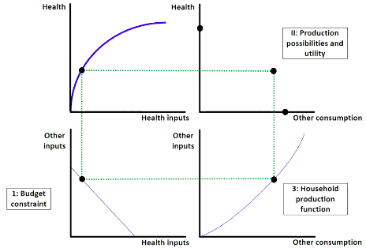

We can begin to derive the PPF if we look at mixed inputs of different amounts

3.2.4 Step 4 - Completed PPF and IC
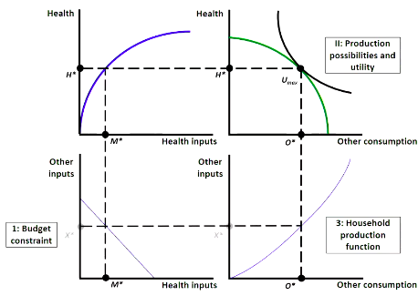
U_{Max} is where utility is maximised i.e where the IC hits the highest point of the PPF

At M* health inputs producing H* health - demand is derived because we want to achieve h* health and need to consume M* inputs todo so

X* inputs of other good for o* consumption

3.3 Simple Grossman Diagram
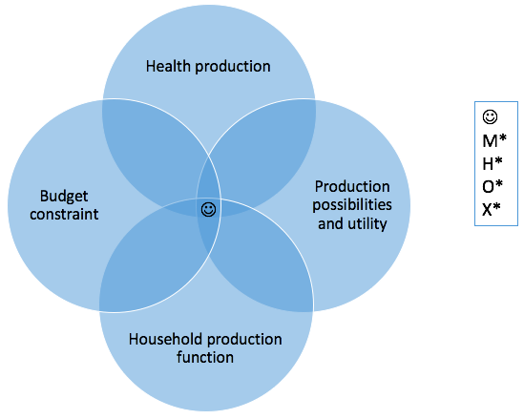

Want to consume where M* = H* = O*= X*

3.4 Grossman Investment in Health Care - Equations

Health Promotion activities - Buying health care, exercise, preventative methods
- assume that people are rational and will take these steps

U=U(H,O)

Health Stock: HSt=HSt-1 - dt+ It
- Health stock in the present time (2019) is related to health stock in the previous period 2018 and when you’re born you’re at health stock (HSt₀)
- Your health stock gradually depreciates and you will want to INVEST to return to the previous health stock Level

Investment: I_{t}= I(M_{t},T_{Ht},E_{t})
- Medical Care, Time and Education are all part of this investment

Consumption of Other Goods: O_{t}= O(X_{t},T_{ot},E_{t})
- Time, Education
  - In previous demand function we also have a time constraint as there is only 24 hours in a day to be able to engage in productive activities

Time Constraint: T_{t}=T_{Ht}+T_{ot}+T_{wt}+T_{St}

Income: P_{m}M+P_{x}X=T_{w}W
- the amount of time you put into work multiplied by your wage
- you will have a number of medical and other inputs depending on their respective prices

3.4.1 Where do you invest?

Invest where Marginal Cost = Marginal Benefit

People invest to the point where MB of investments (consumption benefit (utility from good health)+ investment benefit)= marginal costs incurred by the investment

- return on medical benefit is the wage we can then earn

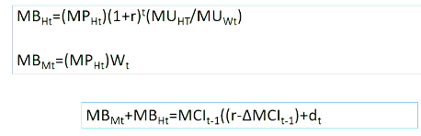

Problem: testing of this relies on setting MBM=0 or MBH=0

3.5 Grossman Predictions

Age - depreciates health capital
- depreciation rate increases as people get older
- When people get older depreciation rate accelerates and it gets harder and harder to invest in health to get it back to desirable health stock

With Marginal Efficiency of Capital (MEC₀) and equilibrium at C₀ and Hs₀ and then in the next period
- C₁ is higher due to depreciation and lower HS₁
- MEC → health depreciates with age and accelerates as you get older the ability to get to the desired level of health stock depends on the MEC

3.5.1 Marginal Efficiency of Health Capital - Graphically

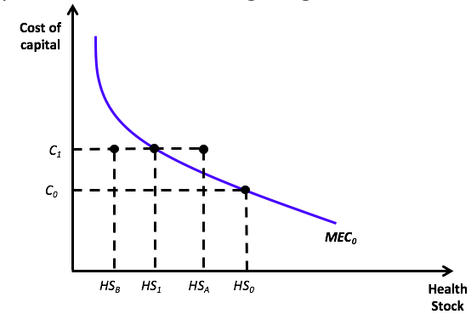
We start at health stock HS₀ and the Cost of Capital is C₀

Next year health goes down to HS₁ because of advancing age and depreciation rate of health stock → cost of looking after health goes up tp C₁

If you invest in your health care and reach HS_{A} → still at C1 but above the MEC₀ Curve
If you invest in your health care and reach HS_{B} → Is your health goes down to HS_{B} you may have to increase investment to C₂ (higher cost) to get to desired health stock level

- Demand for investment in health (and demand health care inputs) depends on the depreciation
- If HS0 goes to HSA, the actual stock would be higher then preferred HS1, so there would be no investment in health.
- But if it fell to HSB , investment would be necessary to raise it to HS1

3.5.2 Changes to MEC Curve

Effect of changes in W (wages)

- Raises the value of production of healthy days BUT OC of persons’ time also increases

But returns to health will increase
- MEC₀ shifts out to MEC₁ and HS₀ shifts to HS₂ (New optimum level)

3.6 Limitations to Grossman Model

Assumes consumers have perfect information and foresight about:
- their health and effect of health care on their health,
- Rate of depreciation of health
- effect of health care and consumption of other goods on their health
  - do people make well informed/ rational decisions about their time of death??

Uncertainty → timing of adverse events

3.6.1 Asymmetry of Information

Much uncertainty is one-sided
- Don’t know all of the technology
- Information is an economic good

Principal, agent = patient, doctor
- Doctor do not or cannot act as perfect agents
- leads to supplier induced demand

Only way to prove SID is to know how much patients would have demanded if they were as well informed as the doctor

4. Aggregate Demand

Use health care spending as a proxy for demand
- Most of the variation between countries is explained by country income
- Problematic because it is not the full demand - there are still unmet demand that aren’t captured in spending

Week 3 Supply of Healthcare

Conventional Supply Theory: Theory of Production

1.1 Firms, markets and industries in the healthcare sector

A firm is an economic unit that produces and sells goods
- eg medical equipment or service (dental care/ health insurance)

An Industry is a collection of firms that sell similar products
- pharmaceutical/ insurance/ hospital industries

Supply side of the market
- to analyse supply of healthcare we therefore need to develop a theory of the firm to explain how healthcare firms behave

1.2 Components of the healthcare industry

GP = “the gatekeeper” before you are referred to the Secondary/hospital sector

1.3 What is an “output”of healthcare

Health/improvement of health is the ultimate output
- often viewed that health is only produced by individuals (through the products they consumer), so output is the amount of healthcare provided (number of patients treated)
  - Intermediate good

Final output is then health
- Firms we are dealing with are either single and multi-product
  - single is GP services/ multiple producers multiple services/goods

1.4 Production Function

Firm production function - show relationships between inputs and outputs

Inputs are factors of production: labour/land/ raw materials/ capital

Example:

Labour (L)= doctors/nurses Capital (K)= equipment/hospital beds

Question: how can inputs be substituted? What is the efficiency of production, and how do we measure it?

1.4.1 Production Function Equation

Q = Q (x₁, x₂, x₃ ...xn, s, e)

- X are inputs
- Sigma is returns to scale (size of unit of production)
- E is managerial/ organisational efficiency
  - may be difficult to observe

Technical Efficiency: Maximum output that technology can produce with particular combination & quantity of outputs
- all about the products

1.4.2 Production Frontiers

Frontier for 2 outputs

Measure distance from frontier

Returns to scale - can bigger firms produce more?
- Bigger hospitals v smaller hospitals

In a week 1000 people will be treated (Q=1000)

Some tasks you may substitute doctors for nurses

Any point on the isoquant will be efficient

1.4.3 Technical Inefficiency

If we are producing at point A this will produce more than 1000 treatments which is beyond what is required → Is therefore inefficient

determining whether we reduce the number of doctors or nurses is a more difficult question

Radial distance measure to determine inefficiency/ technical efficiency

Start at origin point and measure through to where it intersects the isoquant → this will be the most efficient point

you can then measure the difference between the intersect point and the inefficient point and this will be the measure of inefficiency

1.5 Allocative (Cost) Efficiency

Produce output at the lowest possible cost
- cost efficient

For a given set of input prices, it is not possible to produce any more of a good/service without incurring greater costs
- Not possible to produce anymore without going outside the hospital budget

Technical efficiency is a requirement of allocative efficiency
- have got to achieve technical efficiency while being allocatively efficient

Q=1000 treatments as before

Now have introduced an isocost line (budget constraint) for the firm - can only produce only at the level where the isocost and production frontier intersect

2. Cost of Production

2.1 Costs and Production

Efficiency labelled as economic efficiency, cost-effectiveness or allocative efficiency

Minimising cost of production WHILE maximising output for a particular budget
- on your isocost line

2.2 Cost Functions

Relates quantity of output to cost (of that output)

C = C(Q, P_{x1}, p_{x2}, … P_{xn})

- Prices of the different goods

AC = C (Q)/ Q

- Average cost (add up all costs and then divided by the number of units)

Marginal Cost: MC = δC (Q) / δ(Q)
- the cost of an additional unit

2.2.1 AC v MC

Using AC may be misleading

- Measurement of cost savings from schemes that allow some patients to be treated in community rather than hospital admission (assuming that they are all the same value of treatment)
- tempting to conclude that avoiding admissions will reduce the cost by AC

  - BUT MC varies with level of output (the No. of admissions)
    - is HIGHER at lower output levels because this covers more severe patients who are more costly to treat
    - less severe patients can be treated in the community, so scheme will result in fewer cost savings than average cost suggests

Have to consider both MC and AC when looking at cost savings
- have you reduced the MARGINAL COSTS of the procedure/treatment type
- Average cost could be based of stay length

3. Market Structures
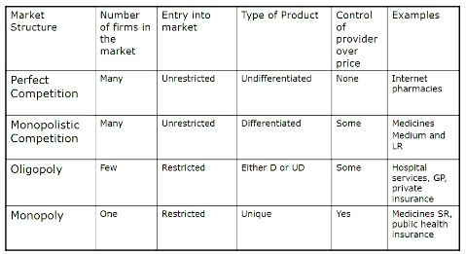

- Monopolistic Competition - start with a patent for a drug
  - in the LR other companies will begin to manufacture the drug once the patent expires
  - these will not carry the brand name of the first drug and will be generic

Monopoly
- medicare (public sector)

3.1 Perfect Competition

In perfect competition there are:
- a large number of sellers in the market
- freedom of entry/exit
- firms sell undifferentiated products
- perfect knowledge

Firms are price takers
- they have no control over price

Implication of these assumptions:
- In the LR firms will earn 0 profit

Example: Internet Pharmacies

3.2 Monopoly

Single seller of a product
- NO CLOSE SUBSTITUTES to good sold
- significant barriers to entry
  - high levels of expenditure required for R&D

Example: Market for medicines
- Pharmaceutical companies are granted with a patent which grants them monopoly power to produce the molecule
- This acts as a reward for the expenditure incurred in bringing the medicine to the market/ to encourage the future R&D

3.3 Monopolistic Competition

Many firms competing in the market
- no barrier to entry/exit
- each firm sells a differentiated product from its competitors

Example: Market for medicine when patent has expired (LR)
- can produce generic copies of the medicine

3.4 Oligopoly

Oligopoly occurs when:
- few firms in an industry
- entry to new firms is restricted

Firms are mutually dependent - firms may collude in order to limit competition among themselves
- collusion may be formal or informal

Due to interdependence, non-collusive oligopolists are required to devise strategies that take into account the impact of their actions on the behaviour of rivals

Example - hospitals acting collusively to increase their revenue

Game theory is an approach that can be used to examine the optimal strategy of a firm
- depending on its views about how its rivals will behave

4. Profit maximisation alternatives in the healthcare industry

- Growth Maximisation
  - Growing sales (quantity)
  - treat more people
    - if there is a large waiting lists want to increase provision of services
  - Growth of the economy

- Behavioural theories
- Recognise that health care firms are complex organisational units with multiple goals/ decision making units
  - also Charities

- Utility maximisation, where utility is a function of the quality/quantity of care provided
  - Hospital wants to increase the value (utility) to patients

- Maximising net income per physician

4.1 Utility Maximising

Max quantity/quality of services subject to a budget constraint

Q= patients treated, days treated
- technically efficient

Quality = expertise of staff, perceived quality of care, re-admissions, length of stay, adverse events (hospital acquired infection)

To perform a complete efficiency analysis would have to follow the care pathway of the patient
- i.e do the leave hospital early but then have to go to the GP 3-4 times after

5. Market Equilibrium?
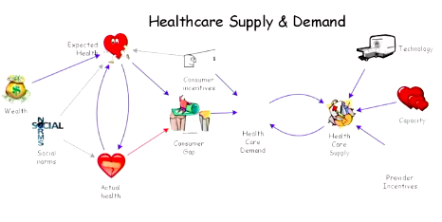

Week 4 Market Failure in Healthcare

Market Economics

Market forces determine what and how much is produced and who consumes it
- this will create a stable equilibrium that maximises welfare

Supply (S): Role of Producers
- Minimise cost of production to maximise profits
- Continue producing until MR=MC
  - Upwards sloping curve

Demand(D): Role of Consumers
- Based on (only) willingness and ability to pay
- Continue purchasing until MB=P
  - Downwards sloping

Market equilibrium achieved through independent S and D
- Even if there is a shock to the system, the invisible hand will return the market back to an equilibrium state
  - If the price of the good increases, consumers will stop demanding ,there will be excess supply, and the price will drop again
- In this equilibrium the people who are willing to pay the price/value the goods the most will get the goods and this will produce the optimal outcome

1.1 Market Economics: Assumptions

- No uncertainty
  - There is uncertainty in healthcare market
    - Uncertainty in Need: unsure when we’re going to be ill and therefore purchase healthcare and satisfaction depends on consumer having an illness
      - don’t demand healthcare per se dependent on us being sick
    - Uncertainty in Income: unsure of the outcome we will get from healthcare/treatment or what side effects will be
      - No guarantees/ warranties in healthcare
  - Normal responses to uncertainty in the form of uncertainty do not apply in the same way in the health market → healthcare insurance is in relation to uncertainty about COST
- No externalities
  - Benefits and costs of healthcare extend beyond the individual consumer of the healthcare
    - Physical externality: reducing risks to health of others
      - One person having health reduces the risks for others → Vaccines
      - If we leave the purchase of vaccines to individuals there may be free riding
      - MB of service for individual does not equal MSB for society
    - Caring externality: My value of access to health care for others
      - value of knowing other people have access to care when they need it
  - How should the government intervene? Subside the costs to increase utilisation to where MB = MSB

- Freedom of entry into the market for both producers and consumers
  - Healthcare poses a risk of harm to public
  - Risk that if we have an open market providers may mislead consumers on their knowledge

  - Consumer cannot judge the quality of service .. and in advance
    - We as individuals we cannot judge how well a doctor is doing as healthcare isn’t a perfect science
    - when we are sick, we have to ask for someone to help us and can;t judge in advance if that is going to be a quality service
      - With other goods, if we have a poor experience we still won’t die

- Perfect information about g+s on offer
  - very rare that we have perfect information in a market setting
  - always working within the constraint of imperfect information and what that means in terms of optimal incomes
  - what is the consumer actually demanding in health care?
    - change to their health status/ demand for change in risk of falling sick

- Acceptable distribution of wealth/income

In other markets, who will get the good depends on ability/willingness to pay
- whoever is willing to pay the most will get the good
- willing to pay more because they will get more utility/enjoyment from the good
Inverse Care Law (Tudor Hart 1971)
- The availability of good medical care tends to vary inversely with the need for it in the population served
- if you go to the poorest parts of the community the availability/access to health care is less than richer parts of the community
  - If you’re sick this is likely to have an impact on your income

- Consumer ability to pay is inversely correlated with the need for care
- Providers locate where demand (not need) for services is greatest
  - providers would tend to locate in richer areas as to sell the most services
  - Distribution of providers (before public health system) was swayed toward richer areas

- Healthcare services will not be used for greatest needs/health gains
  - Due to the distribution of providers skewed towards richer areas where the demand not the need for health care is greatest there provision of services will not be serving the greatest need of the population
  - Will be serving the needs that have the greatest ability and willingness to pay

Market will again be failing if we want to get the resources to places where they are going to have the greatest impact
- best determinant of where we build new hospitals are in marginal constituencies

- Objective to maximise individual utility and therefore social welfare

Does a healthcare system maximise individual utility?
- do we even want it to?
- Ultimately want to achieve and improvement in health with a healthcare system
- fundamental difference in providing utility and improving the health of the population
  - Health care contributes to individual utility through impact on health
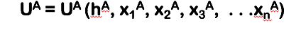

- Maximising individual utility involves trade offs between health and other goods
  - generally don’t want to consume health care as we are generally sick/ it is not enjoyable to consume healthcare
- The health care system is concerned with improving health
- Objective: use resources allocated to health care to maximise the impact on health of the population (maximise health gain)
  - whatever we chose to spend on health care want to ensure they are being used in the most effective way = most impact on the healthcare
  - expert on marginal utility of health gain is the individual
- Patient compliance requires that health care required to maximise health (system objective) also maximises individual utility
  - if it’s not maximising individual utility why would a patient adhere to the treatment
  - activities you must do for health care have an opportunity cost, this OC may not maximise utility

1.1.1 Market Response to Uncertainty

Insurance → Buying certainty in ‘out-of-pocket’ costs NOT health.

Incomplete coverage

Exclusions and the price of risk reduction

How easy is it to get insurance?

Based on pre-existing conditions diseases etc

Insurer will not want to take the risk

Age due to the increased risks of getting sick

(B) Adverse selection

Adverse selection will undermine the market and prevent it from reaching the optimal solution

Insurance based on risk pooling among similar risks
- If several people join a scheme, premiums will go towards potential pay out of person who will claim
- to reduce premiums want to be part of a low risk group (healthy) people

In attempt to address the idea of adverse selection
- An individual will know more about the likelihood of them claiming on insurance than the provider will
- If you’re paying on the mean risk value but you’re going to claim above the mean risk value then the insurance provider will lose out
  - the market response will be price discrimination
    - Based on a number of characteristics including lifestyle (smoker/alcohol/exercise)
    - Attempting to overcome adverse selection by collecting as much information as possible on the individual’s risks to health

(C) Moral hazard

Behavioural impact of insurance adversely affects the market
- Because you have health insurance you increase your risk of an adverse event happening
- If you are uninsured you will be more cautious

Does this apply in a healthcare context?
- No, as insurance does not cover HEALTH rather the costs associated with seeking HEALTHCARE
  - Not going to willining cause damage/take risks associated with healthcare
- Death is the ultimate adverse effect

MAY APPLY in:
- If you have health insurance you may be incentivised to seek more/ more frequently attend health care as the cost is reduced
- This will be another aspect of market failure

How do we deal with Moral Hazard?
- Co-payments still have to pay part of the claim to dissuade consumers from using the service

1.1.2 Market Response to Externalities

(A) Internalise Externalities

Taxes and subsidies

(B) Taxes and Subsidies

Own and cross price, and income elasticities of demand
  - Need to know price elasticities to know the effects/outcomes of your policy OR may have an adverse outcome

How do we set these Taxes/Subsidies?

Response to changes will be determined by the elasticities of demand/income

Externality of Smoking is dealt with by large taxes

Purpose is to discourage people from smoking due to price increases

Generating revenue for the government

Less likely to live to old age where the bulk of money is spent

Smoking has increased amongst poorer people and they will therefore pay the majority of the taxes related to smoking
Are you wanting to change behaviour OR to raise revenue

Willingness and ability to pay to avoid behaviour change
- If want to reduce the use of a system add a cost to the service
  - If you introduce a fee willingness/ability to pay will determine who stops using the service

(C) Regulation

Effective enforcement
- how easy is it to enforce the change in behaviour to deal fully with the externalities in the market
- Difficult to achieve through regulation

1.1.3 Free entry of providers

Limited entry to the market
- have to have certain qualifications to become a doctor

Regulate who can provide health care through the use of
- licensure and title protection
  - if you don’t have certain qualifications it is illegal to call yourself a medical doctor

This achieves restricting entry to market to only qualified providers
- does not guarantee that they will perform well BUT know they have gone through appropriate training

Market cannot respond to changes in demand in short term
- due to the very long process associated with becoming a qualified MD
- have to plan workforce for a long time in advance
- Can entice doctors from overseas to come work in your country
  - Not instantaneous due to immigration procedures etc
- Ensure other healthcare professionals are being fully utilised

1.1.4 Perfect Information: Consumers

- Nature of consumer demand

Consumer A, demands a change in health (h) or the risks to health
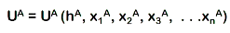

impact of marginal change in health on consumer’s utility
- Determined by consumer’s utility function (nothing else)
    - how much value will the consumer gain from the increase in health
- Normative/subjective (but uncertain)
  - no one can advise you on your utility function

(B) Provider Knowledge

Do not have perfect information on how to health the desired health status

Provider has “expert” knowledge of health production function:
- if does not have perfect knowledge at least has better knowledge than the consumer
determined by a whole raft of factors AND healthcare

Asymmetry of information: Provider advice consumer on health care required for health change

= Impact of marginal change in healthcare on health, positive/objective (BUT uncertain)
- prognosis with and without the treatment based on their knowledge

Health care demand derived by provider from consumer demand for health change
- based on the information you take to the provider about your desired levels of health

(C) Product and activity of production identical

The provider is providing healthcare and it is health are you are coming to improve your health

Provider: In an ideal works is acting as agent of consumer
- Behaviour governed by concern for consumer’s welfare (and nothing else) for market to function

Provider, P, is also earning income producing health care
- dU^{P}/dhc^{A} > 0.
  - Utility of the provider goes up with the increased consumption of healthcare by the consumer
  - This creates a problem due to a conflict of interest
- Goes beyond advising on dh^{A}/dhc^{A} (how healthcare will increase the individuals health) and advises on dU^{A}/dh^{A} (increase in provider’s utility)

No independent demand for health care
- Provider influences demand for his/her own service
- Conflict of interest

EXAMPLE: Fluoride Toothpaste

Addition of fluoride to toothpaste reduced the incidence of cavities in childrens’ teeth
- Need for dental treatment (‘fillings’) reduced
- Fewer dentists required to care for children’s teeth

Dentists recommended (and delivered) orthodontics for children
- Increased demand for orthodontics helped maintain workloads and incomes in face of declining needs for (and earnings from) treatment

(D) Health Care Income-Expenditure Identity

these things move together → different ways of explaining the same thing

Quantity of care provided (Q) x Average Price of Care to funder(P) ≡ Total expenditure on health care ≡ People with income from health care (the whole industry) (N) x Average Income (Y)

- have to think of healthcare expenditure as a partially inflated balloon
- if you reduce average cost of health care will have to reduce the number of people earning an income or the incomes of those people

1.1.5 Does Health Maximise Individual Utility?

EXAMPLE:

Smoking Cessation Programs

Offer extra years at end of life (increased life expectancy)

- Impact on healthcare on health/Change in health from a change in healthcare
  - advice/ health promotion

This will then offer improvements in utility as health is in the utility function of people
- BUT marginal utility of health is subjective/ based on preferences on the margin
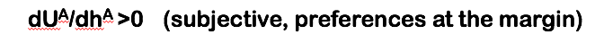

Extra life years in wealth v extra life years in poverty
- Is living longer actually better?
- Do people actual maximise health

Can do more harm (reductions in U^{A}) than good (improvements in U^{A})
- not offering the same marginal utility gain
- May reduce utility of the individual more than they are improving the utility of the individual
- if we are going to be successful in changing behaviour have to design/ evaluate programs specific to the context to the people we are trying to change

2. The Healthcare Market

All elements of market failure in health care common to other markets

Markets respond to elements (e.g., insurance, taxes/subsidies)
- BUT these responses do not correct for market failure in health care
  - can’t rely on them to fully correct

Combination of elements of market failure and ineffectiveness of market responses makes health care different
- No case where these failures and the responses to the failures do not work

Generates the need for government intervention in health care
- if we’re happy for healthcare to maximise individual utility based off the given income don’t have to worry about public intervention
- Balance of social values

3. Government Intervention into Health Care

Market fails to allocate resources and distribute services in accordance with system objectives

Government intervention required to achieve health care system objectives
- won’t happen spontaneously need to design other system

In absence of the market, nothing in place to ensure governments allocate resources and distribute services optimally (to people the need it most)

Risks replacing market failure by government failure
- if the government just intervenes and pays the bills
- will not be getting resources to those who need it most

Week 5 Healthcare Insurance and health care financing

Private Health.gov → how does private health insurance work?
- Medicare Levy - dependent on household income

Uncertainty and Healthcare Financing

Implication of uncertainty for decisions on how healthcare is to be funded

Due to health shocks people may be unable to afford if they did not predict the shocks
- sudden onset of a health condition

Solution - Insurance
- a contract between an insurance provider and the person who considers themselves to be at risk of ill health
- the agreed price is the premium, in exchange for the payout to the insured if they become ill

1.1 Healthcare Financing relationships
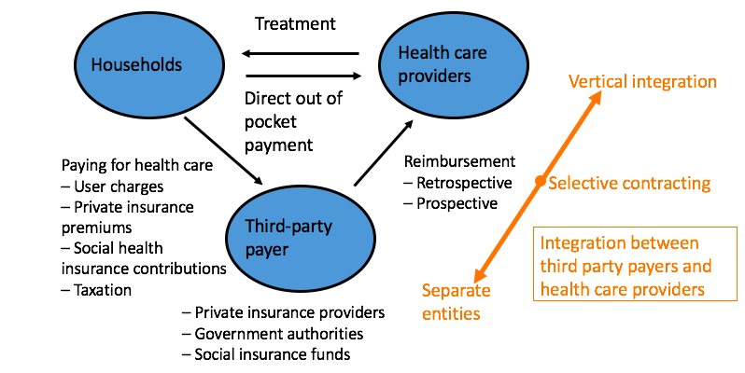
How will the households pay the 3rd party?
- user chargers
- insurance premiums
- social health insurance contributions (sickness fund)
- Taxation (medicare levy)

3rd Party Payer
- Private Insurance fund
- Government Authority (from taxation)
- Employer Based Insurance funds

How does the money go from 3rd Parties to Providers?

Reimbursement
- Prospective → making a contract saying will pay $X for X number of treatments
- Retrospective → backing backwards on what was paid

1.1.1 Integration

How do we manage the funds better by way of integration?

Selective Contracting -
If you integrate with providers, insurers will want to keep their costs down and will therefore insurer cheaper procedures

- Vertical Integration

More common in the US

In AUS BUPA are an insurer and provider

1.2 Private Health Care Uptake

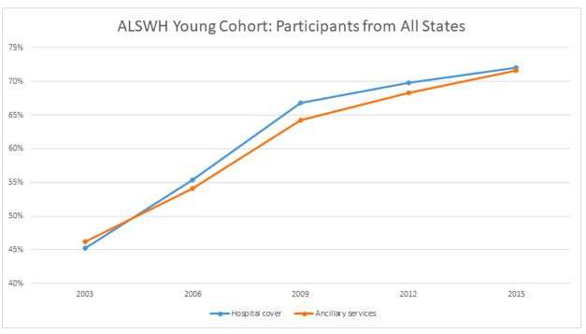
Official Stats for update of private health insurance in WA

WA has the highest uptake of private cover across all states

Of Women aged 18-23 70% are insured - self reported

National average is 44%

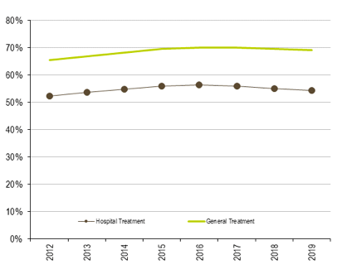

Hospital/ General treatment are high in WA

2. Risk and Demand for Health Insurance

If people stopped buying health insurance this would out excess strain on the public system
- this would generate equity issues if private health is only available to high income earners who then get extra services

The role of the health insurance will depend on the attitudes to risk
- Uncertainty exists when we do not know the state that will arise
- Risk exists when the probability of each state can be estimated
- Depends on the marginal utility of income

EXAMPLE:

A fair gamble exists when we play a game that offers 50% chance of winning $10 and a 50% chance of losing $10.

The expected value of the gamble is zero: (10 x 0.5) + (-10 x 0.5) =0

A risk averse person will not choose a fair gamble
- they may undertake risky behaviour but the gamble needs to be favourable enough to overcome their dislike of risk

Risk attitude arises because people like or dislike a risk.

- Risk aversion may occur due to specific disutility associated.
- Or a fair gamble in monetary terms, may not be fair gamble in utility terms.

2.1 Insurance and the DMU of Income
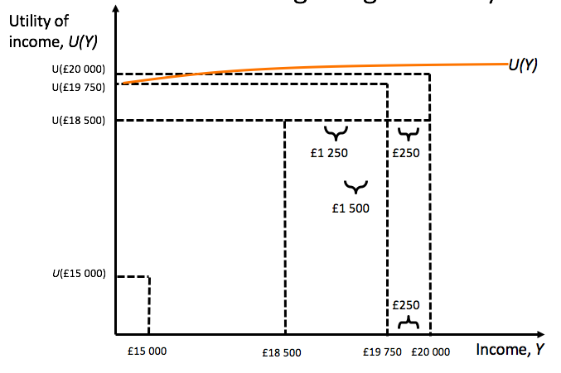

The amount of risk you will take depends on the marginal utility of income

2.2 Indifference curve approach to the demand for insurance
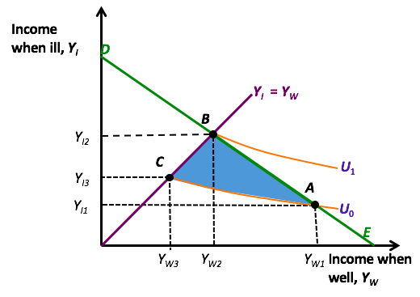

Risk in the demand for healthcare:
- Define what is risk
- the gambles that are involved
- whether the person is risk adverse or not
- Expected Value
- Marginal Utility of Income impacts the decision a person will make
- IC can be used

3. The market for health insurance and market failure (adverse selection and moral hazard)

When a person buys insurance the premium will not be based on their risk because they don’t really know it
- The insurer can/will pool the risks of all the individuals and then will decide on the premium

Total premium q=p(y2-y1)+F

P=probability of developing health condition = 0.05

Y2-y1 = Cost of treatment and wages lost = $5000

Expected loss= p *(y2-y1)

– this is the average payout expected from the insurer = 0.05 *(5000)=$250
- you will need to get at least $250 to cover loss in case of adverse event

F is the loading factor and is the administration costs and normal profit
- this further increases the price of the insurance
- will vary across insurers

Admin costs of contract $25
Admin costs of dealing with claim $600
Expected costs of dealing with claim are 0.05 * $600= $30
Markup of $150 on every contract

F =$25+$30+$150= $205

$205+$250=$455

Max premium willing to pay is $1500
- would be the case for someone with a health condition
- as their willingness to pay is far greater than the premium will buy insurance

3.1 Adverse Selection

This occurs when wrong people( from insurance provider’s POV) choose to buy the insurance, those with high risks.
- This will result in the insurer then will make a loss

Solutions= Raise the premiums?
- An increase in the price by increasing the premium will cause demand on average to go down

Adverse selection death spiral…the high risk people cannot afford to pay in advance. (Buchmueller and DiNardo, 2002)
- Adverse selection problem continues

Adverse selection arises due to asymmetry of information between insured and insurer

- People know their own risk (mostly) but the insurer only knows the population risk (low and high pooled)
- The insurer therefore bases their assessment of risk and premium, on the average risk
  - This is known as community rating
  - Then the low risk may not insure and the high risk will insure

3.2 Market Collapse?

If the insurer has low, medium and high risk in their population
- the Community rate for all leads to low risk dropping out

The new community rate for medium and high, leads to a new premium (otherside the insurer will face a loss)
- Then the new rate may lead to drop out of medium risk group

If only high risk are left, then the rate is for that group only, the market may then collapse if the probability of needing insurance is almost 1

3.3 How can we prevent adverse selection?

Experience rating: different premium for different risk groups
- This could lead to more expense to determine the risks (e.g. gene tests) and then this would increase the cost of insurance
  - pre-existing / family history in attempt to reduce asymmetry of information

- This could influence the insurers to ‘cherry pick’ and only provide insurance to the low risk

Make health insurance compulsory?
- Publicly provided health insurance but then low risk subsidise the payouts for the high risk, and is this equitable?
  - based off ability to pay not the actual need

3.4 Moral Hazard

Once insured, people are less careful to minimise the risks

- Then more claims lead to higher costs, which are then passed on to the insured via higher premiums.

This could affect accessibility for those on lower incomes.
- It could affect viability and again lead to market collapse.

Health care provider can also influence the size of the payout

Supplier induced demand
- health care providers may demand more health care for patients when they are insured

3.4.1 Moral Hazard and Price Elasticity
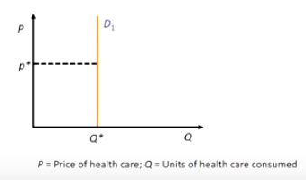
Demand for health insurance

Moral Hazard Increases the price for everyone-

if the price increases will this affect the demand for health insurance?

if the good is inelastic despite price changes the demand won’t change

Due to moral hazard the real price of healthcare for the individual has reduced because they have insurance
- price reduction from moral hazard
- demand for healthcare goods will depend on the elasticity of that good therefore moral hazard depends on the elasticity of the good

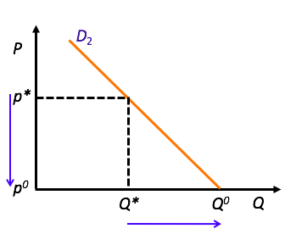
Case of elastic good- increase or decrease in price will affect the demand of the good

3.5 Mechanisms to reduce moral hazard

(A) Co-insurance

The co-insurance rate determines the amount of loss that has to be paid by the consumer
- “the co-payment”
- increases the price of healthcare/insurance to the consumer
- percentage of the payout

If we assume health care is price elastic, then demand for health care would fall
- can be difficult to decide the rate
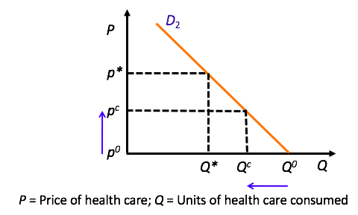

Price of healthcare increases from P0 to Pc, where healthcare is elastic this reduces the quantity demanded by the consumer

(B) Deductibles
- More common
The amount of money the insured pays regardless of co-insurance – known as an excess
- does not deter excess consumption but does raise revenue for the insurer
- fixed Rate
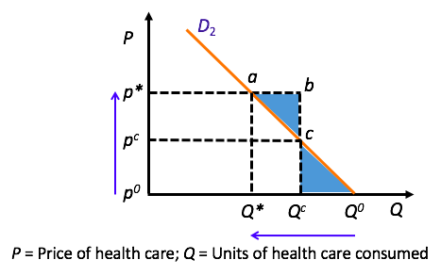

start at P* and Q* that will be set by the market

As a consumer you are willing to pay for Qc units of healthcare at price P* →

(C) No claim bonus

Less common in health insurance
- reduced premium in the next period sometimes results from this

4. Non-price Competition

Price is no longer a huge factor to some patients (with insurance) so health care providers may not minimise the costs

Patients more likely to choose on factors such as perceived quality
- Costs of such perceived quality may be passed to the insurer and health care costs would rise
- Contrary to standard economic theory – more competition leads to higher prices

But insurers have incentive to have cost-containment measures
- Insurers have the ability to restrict choice of health care provider
  - Integration

5. Incomplete Coverage

Low income earns may not afford health insurance

Leading to incomplete coverage for high risk groups such as people with ill health and older people

Typically health insurers exclude treatment for pre-existing conditions
- 12 month waiting periods

Cost containment could reduce incomplete coverage
- costs reduced and lower insurance premiums if passed on to consumers
- but private insurers are profit motivated and this may not work

Justification for tax based health systems and social insurance systems
- Incomplete coverage due to high premiums

6. Reimbursement

How are health care providers paid for services they provide?

6.1 Retrospective

Hospitals – paid after treatment

2 ways this will occur:

- Actual costs (depends on workload) incurred
- Fee-for-service (set fee for workload and service)
- that fee is set by competition or third party payer
- may be more than the actual cost

Leads to few incentives to keep costs low
- May increase length of stay or over use diagnostic tests
- This would have the effect of increasing the cost of healthcare

6.2 Prospective

More common

Payments agreed in advance and not directly related to the costs
- Size of payment only is agreed in advance
  - Payment by Results (PbR)

Incentive to reduce costs are greater but payers may need to monitor the quality and access
- get paid on treatment provided not success of treatment

Global budget or amount per case – DRG pricing
- diagnostic related group pricing (reference group pricing)
- DRG payments are based on average costs per case in a diagnostic group

7. Insurance Based Healthcare Financing

7.1 Key features of insurance-based health care financing systems (1)
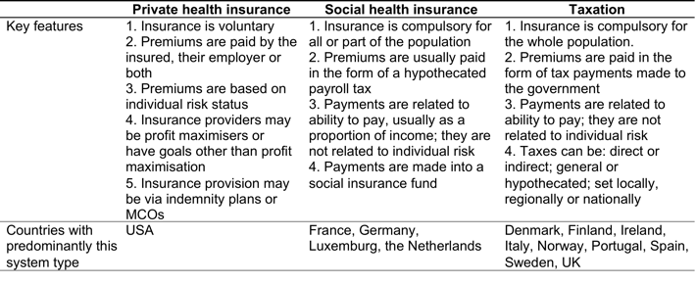

Social Insurance Fund v Taxation

- Whole population v some of the population
- Social insurance - small number of employees or local councils
- Everyone benefits from taxation

7.2 Key features of insurance-based health care financing systems (2)
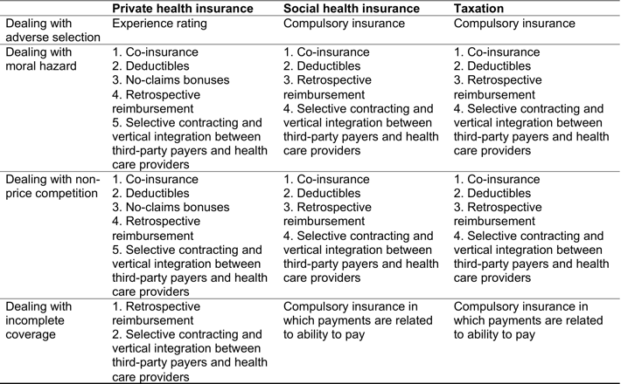
When we have incomplete coverage
- move from private health insurance to taxation based system

Australia has a 50% rate of supplemental insurance
- auxiliary/ extras are insured

Week 6 Risky Behaviours and Health Outcomes

The Health Economics of Bads

Consumer Choice

Society may encourage/ discourage desired/undesired choices
- consumption of alcohol, drugs, smoking, certain foods discouraged
If people are rational then utility will be maximised and there will be no reason for market failure and subsequent government intervention BUT THIS IS NOT THE CASE

Economic efficiency arguments for why smoking, or alcoholism is bad
- Externalities → smokers and drinkers may underestimate the probability of ill health due to their consumption
- then imperfect information provides an efficiency rationale for measures such as taxes, that would tend to try and reduce the occurrence of the behaviours
  - imperfect information regarding consequences of behaviour provides reason for government intervention

Interventions to reduce behaviours may depend on:

1. relationship of price to demand (elasticity)
- If demand is responsive to price imposing a tax will be an effective method of reducing consumption/ the behaviour

2. what is the relationship of product advertising to total consumption
- advertising can promote (alcohol ads) and reduce (smoking ads) the desired behaviours

Impact will result from these 2 relationships

Econometric studies of health production have found that smoking is a significant factor in mortality rates
- smoking is a negative input in healthcare production

Compare for example the trend in smoking and reduction in lung cancer diagnosis and deaths
- correlation between trend in smoking and reduction in lung cancer deaths

1.1 Is the consumer rational?

Is the consumer reasonably informed of the risks, and there are no side effects for others?
- then there may be no economic reasons for intervention

But… are people really rational?
- The behaviours and substances of alcohol and smoking are addictive
  - Rationality is not likely

This leads us to discuss models of addiction that originated from psychology and economics together:

- Imperfectly rational addiction models
  - addict has stable but inconsistent preferences in the short run
  - Want the bad good and want good health
  - preferences are inconsistent with each other

- Myopic addiction models
  - a variant of imperfectly rational addiction models
  - naïve as to the dangers of the substance → not connecting possibility of future poor health with the behaviours of now
    - may have a vague idea that it is bad for them but don’t know about the addictiveness of the good

- Rational addiction - is addiction a rational choice?
  - Becker and Murphy (1988) – where people include all information, past, present and future, rationally, into their utility calculations
  - Addiction itself may not be rational when considering all the life time factors
  - Satisfying current utility

Reinforcement- greater past consumption increases desire for present consumption (state dependence in the econometric models)

Tolerance – utility from a given consumption is lower where past consumption is greater…e.g. compare your first ever alcoholic drink with that of 1 unit after you have created a tolerance to alcohol

A larger addictive stock may then make future consumption more pleasurable too

A myopic, near sighted person looks at the reinforcement effect but a rational addict considers future consequences too

2. Addiction model

Reinforcement: greater past consumption increases desire for present consumption
- State dependence in the econometric models
- present consumption will be dictated by past consumption
- want to maintain the same utility level

Tolerance: utility from a given consumption is lower where past consumption is greater
- compare your first ever alcoholic drink with that of 1 unit after you have created a tolerance to alcohol
- “build up a tolerance” / addictive stock

A larger addictive stock may then make future consumption more pleasurable too

A myopic, near sighted person looks at the reinforcement effect but a rational addict considers future consequences too
- consumption now to equate that of the previous period
- wants to maximise utility right now

Under rational addiction, people are likely to discount the future heavily, since they do not care as much about potential adverse effects
- know there is future effects but do not care about them
- Addiction is more likely when effects of past consumption depreciates more rapidly
- Expected future price rises may dampen current consumption, similar to effects of current price rises
  - If there is an expected increase in the price may also influence the decisions of future consumption
- will try maximise utility across the life course

Economists will look for the steady state, and equilibrium
- Whereby the system will be maintained over time provided that current smoking add enough consumption to the addictive stock to replace depreciation of that stock during that time period
  - the steady state will be where a system is maintained overtime

2.1 Addiction Model and Policy Changes

2.1.1 Price Changes - Imposition of taxes

(A) Current Price Change

Price rises and smoking decreases at first (in the SR)

Initial decreases in smoking reduce addictive capital (reduces the stock of consumption)
- This stimulates further smoking decreases in the long run
  - Influences people to continue to stop smoking
- The long run response exceeds the short run response
  - Some addicts will quit and reduce consumption to zero

(B) Future Price Change

Future prices will also have an effect:
- more so for the rational person, not the myopic person

Both the price effect and probability of quitting are enhanced by permanent price increases i.e price will never decrease again

2.1.2 Restrictions on Advertising

Permanent restrictions on advertising (that would try to encourage smoking) would have more effect than temporary restrictions.

Temporary restriction may not be as effective
- if you bring back the advertising this will just bring people back into consumption patterns

Which is more effective out of price changes and advertising changes will be dependent on the type of good/ is subject to empirical analysis BUT is most likely going to be a price change
- may also have a more permanent effect

3. Rationale for Public Intervention

Externalities due to passive smoking

Economics offers two tools for intervention:
- Advertising
- Excise taxes
  - effective if demand is elastic

Complete prohibition is likely ineffective, but partial prohibition is likely to be effective
- too dictative

Increase of taxes is known to be more effective than advertising, even if price elasticities are small in absolute value, a substantial price hike can reduce consumption in large proportions

3.1 Sugar Tax

Sugar is bad for you and want to reduce the consumption of it

Studies have found in general that an increase in price will reduce consumption of the taxed good but it may not change health outcomes in the long run

A firms are profit maximising - will find another substitute good which may not be taxed to provide/ push to consumers
- i.e coke v iced coffee

4. Strulik (2018) Paper

Alternate to Grossman Model → Health Deficits Accumulation Model
- Amount of health conditions that you accumulate over the lifetime

Looks at life cycle addiction theory where consumption of addictive goods reduces health and longevity

Addiction model combined with health economics theory suggesting that:
- Consumption may reduce health and longevity
- Where some people control their addiction but some do not understand the consequences
  - Will then consider health deficits rather than maximising utility

The rational model did not take into account that people will not live forever and consumption could indeed affect mortality through addiction of their bad health behaviour
- Had an “infinite life” assumption
- Your mortality can be reduced VIA addiction
- may see that consumption increases over the life course BUT this did not reflect the data as these behaviours decrease with time

In the life cycle model, postponing consumption until older age may make sense:
- For hard drugs, but not for smoking, since most people stop consumption in young to middle age and not many start smoking at older ages
- Less to worry about in the next period of life

4.1 Strulik’s Model

Strulik now defines:

- Sophisticated addiction (rational addiction)
- Naïve addiction
  - when people do not consider effects of addiction but do know the effects on health and longevity

The older people may stop their behaviour today as a result of expected price changes BUT the young may wait until after the price changes
- Due to the above conditions of sophisticated and naïve addiction
  - Older people will reduce consumption in anticipation of the price hike
  - Younger people will wait until price increase is enforced (based on income rather than potential addictive effect)

The model also provides motivation for a socio-economic gradient in health behaviour:
- Richer People wish to extend consumption over longer period of time as lifetime is endogenous (depends on the state of health) and permits a trade off for intertemporal consumption
- Poor People may not consider future period as important as the current and want to get more utility out of the current period

4.1.1 Integrating Addiction into the Model

Strulik integrates addiction into the health deficit accumulation model NOT the Grossman health capital model

Why?

Health capital is a latent variable but health deficits can be measured by a frailty index
- Utility depends on consumption of the bad goods and good goods, along with past consumption of the bad good (habits)
- How do we measure health? latent variable

Health investment can slow down the health deficits (bad health traits) accumulation and consumption of bads can increase the rate of accumulation
- People maximise lifetime utility by choosing lifetime optimal combinations of consumption of good and bads goods, along with health expenditure

4.2 Optimality Conditions MB = MC

- MU of 1 unit of any good is equal to MC (1 unit of foregone savings)
- MB of health expenditure (investment) is equal to MC

MB is the marginal impact on health deficits x the contribution of 1 less deficit

- Marginal utility gained from 1 unit of the bad good is equal to the MC

MC is a combination of costs through lower savings, health costs through quicker accumulation of deficits and utility cost due to increase in addiction stock
- Individuals will then respond to an increase in price of bad good, by reducing consumption of that good
  - lower savings a result of having to invest in health

Sophisticated addiction does not then align with observed life time patterns
- Individuals with sophisticated addiction know that consuming the bad good today will help build up addictive capital and will reduce future utility of that good via build up of tolerance
  - this doesn’t align with real life because this would imply

That before death, will consumption of large amounts lead to utility increases without affecting future utility
- individuals can consume large amounts just before they die

This is intuitive but does not align with observed behaviours
- older people may tend to smoke, drink less as they age

e.g. taking a stimulant or medication today to help reduce effects of depression, may result in addiction in the long term

EXAMPLE

A classic test for rational addiction:

Observe if an expected price increase now reduces current consumption
- the idea is to reduce the addictive stocks, the problem here is the infinite life assumption
- will not reduce consumption for the naively addicted people

In reality, life is finite:

Price elasticity is low, suppose a 10 fold increase in price for a 40 year old
- they may increase consumption in earlier ages, reduce consumption at that age, leading to no smoking by age 50
- this is not predicted by the rational addiction model

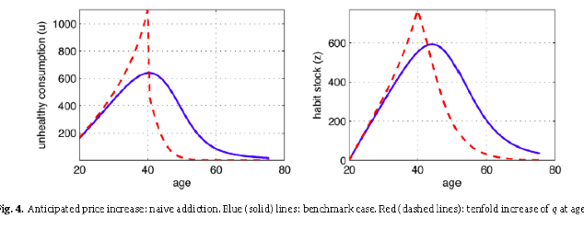
At Age 40 if you have a price increase the unhealthy consumption dramatically decreases and may even be at 0 rate by age 50 (for a rational person

Naive consumption = blue line

4.3 Socio Economic Effects
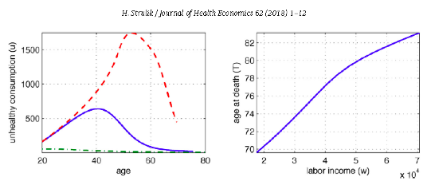

Blue is benchmark case/ reference person

4.4 What is the impact of income on addiction and health?

Model predicts that those with half the income of the reference person, will smoke more at middle age, spends $500 more a year on smoking and dies 6 years younger
- Smoke more and die younger

Individual with twice the income, spends only $20 and lives 6.5 years longer.

Why? Due to diminishing marginal utility of income.

There is a trade of between consuming now and later:

For those with high income, the marginal utility is low, so they are interested to increase life length – longevity.
- The rich also have high health expenditure, so reduce their accumulation of health deficits in the case where there is not a public health system

For poor, there is a high marginal utility from consuming today
- More satisfaction/utility from consuming today
  - So they will consume now, as they are less interested in the future

4.4.1 Differences in Life Expectancy

The Strulik model helps explain the socio-economic gradient in mortality.

Life expectancy difference between rich and poor in the US was recently found to be 14.6 years.

Large parts of the socio-economic gradient are moderated to health behaviour (in addition to income)
- Similarly previous authors found differences in health behaviour are to large extent explained by socio-economic status.

4.5 Comparative Cases

If the reference person was not addicted, they would live 1.8 years longer, spend 57% less on smoking, spend 23% less on health.

Heavy addiction leads to not much change in smoking, compared to the reference person, they also smoke more in later years, they die earlier even though they spend more on health

If the rate of addiction is higher, they smoke more, spend more on health and die earlier

When tolerance has increased, the naïve addicted know they suffer from tolerance, but do not know how it affects addiction, the utility loss from tolerance induces them to reduce longevity and so they will consume more when tolerance increases

But with sophisticated addiction, individuals respond strongly to increasing levels of tolerance and increase smoking steeply in old age

5. Intergenerational Transmission of Health (Obesity)

Intertemporal preferences in patience and self control linked to obesity of parents
- these preferences are then transmitted to children/spillover effects

Intertemporal preferences - if you are patient now and refrain from sugary foods v you have a more myopic view

5.1 Trade Off/ Opportunity Costs

Examples of myopic (here and now) traits in individuals:
The trade-off/opportunity cost of eating well compared to convenience food OR trading off that Netflix binge instead of exercise are

Inconsistent time preferences can occur when temptation arises
- Not showing the same time preferences (future health)

Preferences are time consistent under standard microeconomic theory - standard
- People maximise utility by making choices so that the present is more important

Standard exponential discount model: assumes future periods are discounted at a constant rate
- not realistic

Quasi hyperbolic discount model: allows people to be present bias (impatient) and future biased (self control)

These preferences are related to unhealthy behaviours

5.1.1 How do we measure time preferencing/ self-control?

Using US data…health outcome is self-reported BMI for adults and children based on their height and weight

-Time preferences were measured by using two survey questions on two hypothetical questions on preferences for dollars now or later

The time preference rate, consistent or inconsistent, was calculated

This was then related to their own obesity and child obesity using a probit model

Various covariates were included

5.1.2 Limitations

What if both time preference and child obesity were affected by parents obesity
- then there are unobservables and an IV approach may be warranted, e.g. proximity to fast foods
- The result remained unchanged however

Parents who are impatient are 7% pts more likely to be obese compared to patient; those who are present biased (self control) were 6% pts more likely to be obese

Children of inpatient parents were 5% more likely to be obese, 4% for the first child, and 7% for second and third child

5.2 Implications for Policy

Target interventions to parents

Limitation here though is that children‘s preferences are excluded

Target policies therefore that will improve parent’s time preference w.r.t health behaviours

This will have spillover effect to their children’s health

6. Thesis Paper

Downwards Spillover → Parents to Children
Horizontal Spillover → Between Spouses
Upwards Spillover → Children to Parents

Unhealthy Child could lead to:
- Reduced labour force participation (can’t work have to look after children)
- Worse parents’ health and wellbeing

Limitations of previous studies
- was limited to young children/children with disabilities

Need to identify causal effect of having unhealthy adult children on adult parent’s health

Prediction: Unhealthy child will have a great impact on parental health
- does the affect different between older mothers and older fathers
- utility maximisation model

Outcomes: Unhealthy adult children have a negative effect on mother’s mental health but not father’s mental health

Both fathers and mother of unhalth adult children are more likely to experience some chronic conditions

Mothers are more likely to experience arthritis, psychiatric problems, asthma, stroke, heart attack, heart diseases and lung diseases.

Fathers are more likely to be diagnosed with arthritis, asthma and diabetes and cancer

Policy implication - and intervention which improves adult children’s health could also improve older parental healths → public health insurance

Week 7 Equity in Health Care

Inequality, Equality; Inequity, Equity

Which concepts are positive?
- Part of economics that doesn’t involve any value judgements

Can verify or falsify a normative statement

Which concepts are normative?

Can’t be verified or falsified

- Do involve value judgements
- In order to make policy recommendations have to articulate clear assumptions regarding our model, definitions of “social welfare”

Utilitarian/ Benthamite
- Maximising welfare by maximizing the sum of utilities in society
- if we can make someone else better off and not make anyone else worse off then social welfare will increase as a result
  - Pareto Improvement

Kaldor- Hicks
- less restrictive
- If you can make people better off and the gainers can compensate the losers and still be better off there will be a welfare gain overall

All part of “welfare-economics”

Policy analysis ends up being mostly normative

What (if anything) do/does distinction imply
- For measurement?
- For policy?
  - Inequality, inequity, etc. in respect of what?

Inequality/ Equality
- This can be proven/falsified therefore concept of equality/inequality is a positive concept
- Properties that can be measured/ theory that can be tested

Inequity/ Equity
- Judgement of fairness
- Therefore is a normative judgement
- Can’t say whether something is fair/unfair in an objective sense

What sort of inequalities are we interested in?

How should we distribute health care (normative question)
- inversely according height
- allocate according to wealth
- According to another metric?

Should be allocating healthcare according to need not willingness/ability to pay

Health Care Premiums
- Insurers cannot charge different premiums for different people
- Will be paying a premium that is determined by the average payout on that healthcare
- If you are healthy you will then be paying an “actuarially unfair” premium
  - amount you pay per dollar that you get back on your insurance
- Low risks will pay much more than a dollar you pay out

Are concerned about equity and fairness in this case

1.1 Inequality and Equality

Positive concepts
- can be proven/ verified

Statement that “health care is (un)equally distributed, with respect to income” is empirically testable
- With further, detailed, specification

1.2 Equity and Inequity

Normative Concept
- Equity, like beauty, is in the eye of the beholder

The literature blurs these concepts
- Equity / equality and Inequality and inequity are often used interchangeably

2. Absolute Income Hypothesis

Does income have a causal effect on health?
- it is an important driver of health
- ceteris paribus higher incomes increase access to healthcare/ the necessary inputs

Does relative income matter?
- Does how much you earn, relative to someone else affect your healthcare?
  - Generally no

There are clear concerns about endogeneity here
- Endogeneity - there is a correlation between the error term and the covariant
- Get a biased and inconsistent estimator of the population
- Does income “cause” more health OR do health and health-related preferences “cause” more income (education, etc.)
- CF literature on education and health

Do higher levels of education cause higher health outcomes OR is the correlation due to lower rates of time preference (e.g.)?
- there is also the future discount rate of people

2.1 Absolute Income Hypothesis

The absolute income hypothesis: no role for income inequality per se
- not thinking about income equality for health
- Rules out that inequalities are due to the relative positioning in society should be about what you have
  - More absolute income the more needs you will be able to consume

Health inequalities depend on income/wealth as income/wealth determines access to (market) resources

Deaton (2003) - much of health economics literature rejects notion of health-income nexus except via purchase of health care

3. Relative Income Hypothesis

Income inequalities per se explain differences in health states?

There is a sociological literature on this topic
- Cf the “Whitehall” study (Marmot et al. 1991)
- Relative positions of public servants were correlated with their health status

Other possible links (Deaton 2003)
- Two-way relationship between income and health and education
  - as above
- Relationship between income and nutrition at low levels of income
  - “Sin Taxes” are likely to be regressive as they will hurt the poorest people more than they will hurt the rich
- Negative effects of inequality on the political process for delivery of public goods
  - The people less likely to vote in the US/UK are less likely to get the public goods and services there’s a negative relationship between income, propensity to vote and health outcomes

“A rising tide lifts all boats?”
- may not be correct if relative income and not absolute income is what determined health
  - incomes rise but gaps between income levels remain
- If absolute income is relevant then there will be diminishing marginal terms because at some point will not be able to do anything further to improve health/ increase life expectancy
- Once everyone reaches an absolute income level where where there is 0 MB from extra income spent on healthcare, if only relative income matters increasing absolute income is not going to make any difference

3.1 Deaton Study
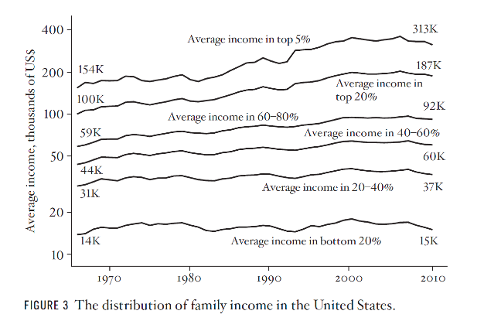
1966: Top 5% average income = 11 times average income in bottom 20%

2010? 21 times average income in the bottom 20%
- Top 20% have experienced a doubling in income
- Increasing income inequality

Deaton updates a famous graph by Piketty and Saez (2003)
- The authors noted that using household survey data are not very useful for examining high incomes
  - there are too few people to show up regularly in nationwide representative surveys.

They extended the work of Kuznets who worked with income data from tax records
- The data go back to 1913 (introduction of income tax in the US)

3.2 Updated Graph
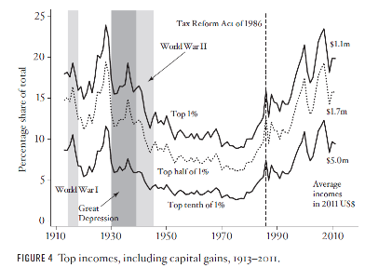

Top 1% earned about 25% of income prior to the great depression
- during WWII were hit with higher taxes

From 1970’s onwards reach pre-war levels
- Top 10th of 1% earning 8% of all income in the US

4. Inequalities as a Consequence of Ill-Health

Deaton (2003) emphasises the importance of health care financing mechanisms and health inequality
- This is similar to the child health and health inequality arguments we consider later
  - Health of poorer children is worse than that of children from wealthier backgrounds
  - As the children get older this gap widens and inequalities increase
- Where poor health—if not completely insurable against income effects—begets lower income
- Creates a feedback mechanism may contribute to worse health
  - this become and intergenerational transfer of poverty

Ill-Health can be a poverty trap for low income

4.1 Pen’s Parade

- Take average height of population
- Then take average income of the population
- use the height as a barometer for wealth inequality
  - I.e poorest person is 1mm tall
  - Richest person is 3000m tall
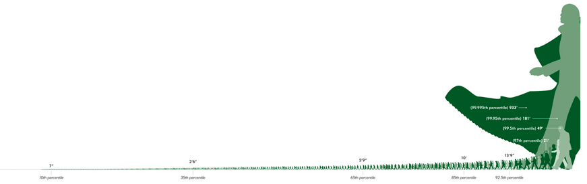

5. Income, Life Expectancy and Evaluation of Life

5.1 Preston Curve

Old Concept

Preston (1975) noted the relationship between income and health
- Exists internationally
- Exists intra-nationally too.

CF other early measures reported in Atkinson’s book on Economics of Inequality
- e.g., Pen’s parade.

5.1.1 Life Expectancy v Income Per Capita
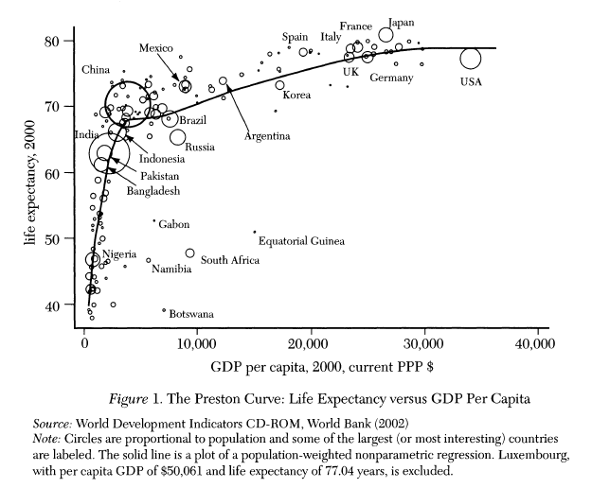

GDP per capita v life expectancy
- size of the population represented by the size of the bubble

Small changes in income at the lower level have drastic increases in life expectancy

As income per capita increases, the marginal increases in income per capital have less of an effect of life expectancy
- Diminishing marginal returns from income increases on life expectancy
- Decline in the rate of increase

Early gains are a result of small changes
- clean water/ sanitation that make a large difference, this tappers off after some time and the things required to make further increases to life expectancy are far more structural/ harder to achieve

Demographic Kink
- point at which where child mortality is very low
- see the affects due to improvement in adult health further down the track

5.1.2 Updated 2013 Data
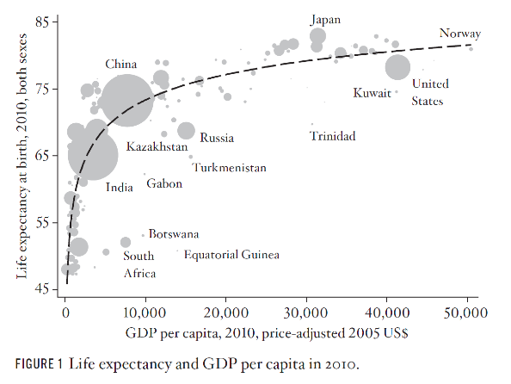

5.1.3 Average Life Evaluation
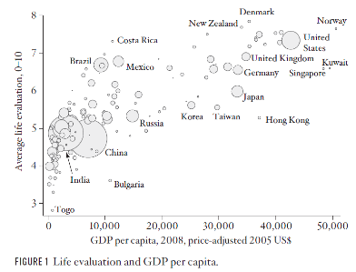

Can’t say happiness and satisfaction of life are not the same thing

Similar trend to life expectancy v per capita GDP

2008 Data

5.1.4 Log-Data Transformation of Life Evaluation
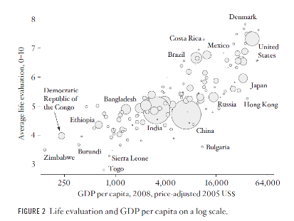
GDP is on a log scale

The flattening among rich countries
disappears.

The countries (poor and rich) now
lie on an essentially straight line.

Equal percentage changes in income
produce equal absolute changes in
life evaluation.

On average, moving from one country i,to another with 4(GDPi), gives rise to a one point change on the 0-10 scale
- consistency found across the spectrum

Absolute income does seem to impact in this case
- when income quadruples there is a 1 point increase in life evaluation scale

5. Income and Mortality

5.1 Income Inequality and Mortality
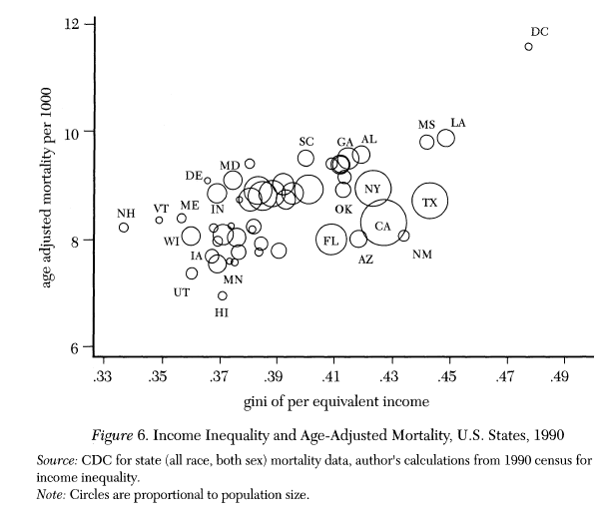

Not a clear link between income inequality in a US state and mortality by age

No clear relationship between mortality and equality

5.1.1 Income and Mortality (US)

Low income means that you have an increased chance of dying at age 50 as a white male

May be a result of riskier jobs etc

6. Income and Health-Related Inputs
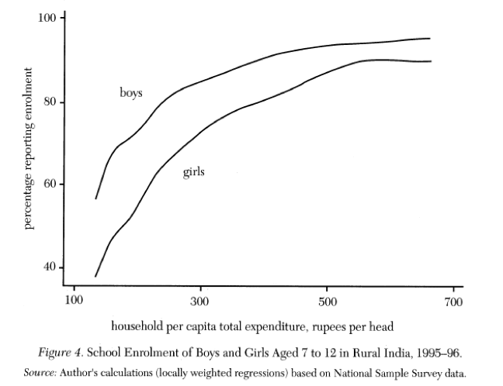

Data for India → for school enrollments for rural india

the higher the household income the greater the enrolment for children in general and girls

Gap closes between boy and girl enrolment rates and income increases

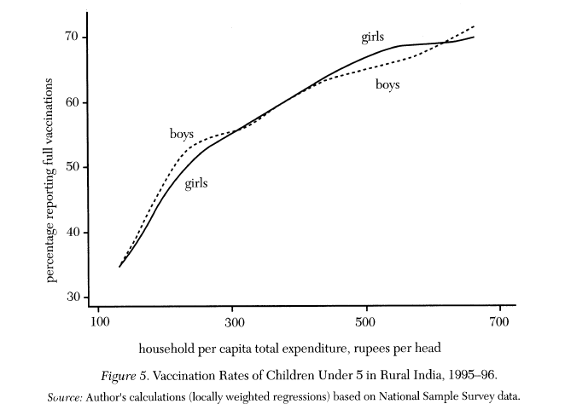
6.1 Household Income and Vaccination Rates

Household spending can be used to infer relative levels of household income rather than self reported data

6.2 Direct Relationship between Income and Health

Strong evidence of effects based on (mal)nutrition
- Even in developed countries (Austria, Denmark, Australia), evidence of mortality penalty for month of birth 50 years later
- why month of birth may matter for low income families
  - Lack of access to seasonal vegetables, fruits
  - Fetal development “womb with a view” hypothesis
    - Things that happen in utero have long term health impacts
    - See Deaton (2003) for review of extensive evidence

7. Relative Income, Health (and Happiness)

Easterlin (1975)
- Happiness is independent of income (in the long run)
  - Health may also conform to this pattern

How might relative income matter to health/happiness i.e what causal pathways exist?
- Increased access to material goods
  - If you’re relatively more wealthy in a country (even though not absolutely more wealth in a world wide context) may be able to live in a nice part of the country/ city
  - “healthier” environs, for example

- Perhaps “rank”, rather than absolute measures is important?
  - feelings of power that may contribute to feelings of stress/ anxiety
  - cf literature on power as a “positional good”

- If rank per se is responsible, standard redistributional policies may be ineffective

7.1 Evidence

7.1.1 Within countries and states

- Individual income and individual health are related

7.1.2 Between countries and states

Average income and average health are only weakly related
- BUT average health and income inequality are (negatively) related.

7.2 Relative Inequality and Reference Groups

If relative income inequality matters, an immediate question concerns the relevant reference group

To whom do I compare my own income?
- Everyone in society?
- Neighbours?
- Social or religious circles?
- Other economists?

7.2.1 Reference Groups

Whitehall study (Marmot et al.) – reference group part of the design
- Individual civil servants assumed to compare their incomes to that of their civil service colleagues
  - Not sure if this is what people actually do?
  - More likely to compare colleagues or other social groups
- One way of dealing with this uncertainty is to recognise that reference groups are typically cannot be identified
  - Have to make assumptions in place of this uncertainty

7.2.2 Between - and within group inequality and the income- health gradient

Suppose that there are two groups (Deaton 2003)
- Economists
- Doctors

And that
- these groups peer-reference incomes
- And that their health is affected by income inequality within the reference group
  - only compare themselves to others in their groups
- But that we can’t identify the groups empirically

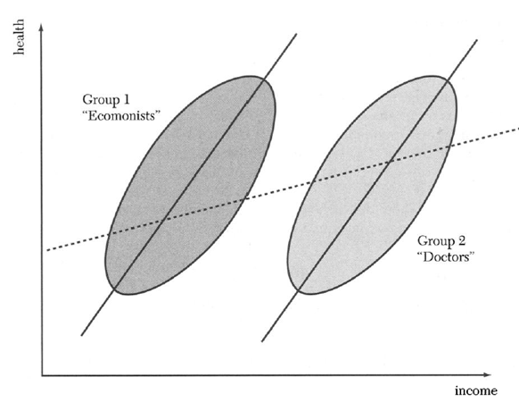

Top of oval is wealthiest people in the group
- Don’t observe the reference group i.e the oval area

Doctors have a higher income than economists in general

Doctors and economists have the same average health

The only effect on health is, by construction, relative income - average health of doctors and economists is the same and the only thing that matters is the internal relevant health

The true relationship between income inequality and health is given by the two solid lines

When the reference groups are not identified, we observe (what appears to be) absolute income inequality
- But the relationship is attenuated (dotted line)
- Looks flatter than it actually is

What do we really observe (i.e from the outside world/absolute income) v what is the relative income (observed within a group by the individuals in a group) effect on health
- does this relative income then consistent with the absolute income hypothesis

The degree of inequality that is observed depends on the ratio of within-group income inequality to between-group income inequality

- Moving the two groups further apart will further (flatten) attenuate the measured inequality

- Holding between-group inequality in income fixed, but increasing within-group inequality will steepen the observed gradient.

7.2.2 Stories or Evidence?

Deaton (2003, 2013) provides an extensive discussion of:
- Data problems
- Problems with attempts to replicate the findings of some studies of the relationship between income and inequality.

He concludes (2003, p.150) that:
- The stories about income inequality affecting health are stronger than the evidence

- Why is this the case?

There is a strong appeal to the stories of income inequality affecting health

Further, there is strong appeal of the following “ideas”
- Before the epidemiological transition income affects mortality
  - Graph where there is a steep increase in life expectancy when income rises before kink/ plateau
  - When child mortality is mostly eradicated
- After child mortality is eradicated, income inequality affects health/
- In poor countries higher incomes protect against malnutrition, disease, etc.
- In high-income countries, degree of income inequality an indicator of the latent quality of social institutions.

- Evidence

As Deaton (2003) points out, this literature has exploded in recent years and is highly cited.

As he also points out, there are strong measurement problems yet to be resolved and the stories are still more convincing than the evidence

8. Recent Evidence in Health Economics

In health economics, many studies have examined measures of distribution of:
- Indicators of health
- healthcare
- health care financing

Often these studies use summary measures to compare distribution over time for a particular country
- A lot of these things don’t have a “natural” explanation

8.1 Health Policy and Horizontal Inequities of health-care utilisation in Australia

Other side of Lorenz curve can be used to measure things such as ill health
- Look at proportion of illness compared to proportion of healthcare spending

Vertical Equity
- Notion that if person A earns more than person B then person A should pay more tax
- If you need more healthcare you should receive more healthcare
  - Doesn’t specific scale / degree to which should pay/receive more

Horizontal Inequity/Inequality
- The same should be treated the same
- 2 people with the same need should receive the same levels of income
  - people with different needs receive different levels of healthcare

8.2 Methods

Look at individual healthcare consumption

Gain measures of healthcare services used at individual level
- Also gain demographic measures
- self reported health status measures
- level of education/marriage

Then calculate standardised healthcare utilization
- use to estimate healthcare needs

Then calculate horizontal equity measures
- concentration measures of medical services distribution

8.3 Results

There is a large literature on health inequalities
- Single indices can only tell us so much...
- A good understanding of health inequalities requires measures across a range of variables (some of which are latent)
- The related social determinants of health literature also makes an important contribution to the topic

Week 8 REVIEW

Framework: theoretical set up
- the theory behind the concepts
- Financing moral hazard, adverse selection, risk

Once people are insured they may be less careful to minimise risk, this may increase the number of claims and therefore a higher cost. This may then lead to a higher price.

This will then reduce the demand for health insurance if it is an elastic good

Effect on elastic and inelastic healthcare will be different
- Even if the price of chemotherapy increases if you require treatment you will still maintain your consumption

Deductibles - does not reduce excess consumption but does raise revenues for the insurer

Week 9 Health and Labour Market Outcomes

Background

Impact of health on the decision to work/ not work
- working conditions can lead to bad health (reverse causality issue)

1.1 OCED Video

OECD: those with mild or moderate mental illness (anxiety, depression, are twice as likely to be unemployed (30% v 15%) than those who are not unemployed

Cost of mental health are high but policy makers are slow to react
- 1- 4 people from ages 14-64 suffer from mental illness
- twice as likely to be unemployed

Total cost of mental health is 3.5% of GDP in Europe

1.2 Measuring the impact of health on labour market outcomes

What is the impact of poor health on supply of labour (work)?
- Does work lead to poor health too? (reverse causality)
  - Labour Demand comes from employers side
- Important for productivity issues as well

If so, casual estimates are difficult to derive:

- Measurement error in self-reported survey responses to health
- People often overestimate their health
- People with actual same levels of health may self-report to be different levels of health
- Hospital Data may be more reliable than self-reported data

- Unobserved effects: individual carry traits that make them more likely to be both in poor health and not work
- time preference (prefer leisure now, prefer unhealthy behaviours)
  - timing of when you want to perform the health good
- may prefer unhealthy behaviours
  - unobserved heterogeneity

- Reverse causality: work conditions can affect health and health can affect ability to work

These are standard issues across many issues in health economics

1.3 Measurement Error

Is the impact of health on work affected by the measurement of health?
- Objective v Subjective (own) health measurement

There is measurement error in all data related to health

1.4 Reverse Causality

Work and Ill Health
- if your take sick leave this means you have ill health and this affects your working hours
- there are some working conditions that leads to ill health
- Decisions about work also relate to amount of work rather than just yes work and no work
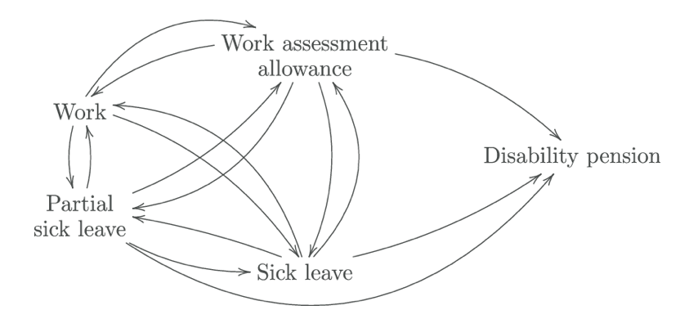

Presenteeism
- When you are physically at work but are not being productive
- Harder to measure than absenteeism

1.5 Unobserved Heterogeneity

- Relationship about the decision to work is the utility maximisation
  - Trade off between leisure and consumption
  - More leisure means less labour hours
  - an individual may have an unobserved characteristic that leads them to be unhealthy and less likely to work

1.6 Relevancy of these issues

1.6.1 Days away from work sick

(Self-reported) Statistics on the number of days lost per person
- 7.3 days in Australia in 2014
- 2.4 days in Korea
- 24.4 days in Lithuania

Reasons for differences
- Due to financial incentives available to people in each country
  - disability/ health insurance

1.6.2 Compensated absence from work

Insurance available to people across countries
- Days that are compensated by the government for people who are off sick

Chile = 7 days
France = 8.3
Ireland = 11.7

Countries where rates are going say may be because government has become more stringent in assessing who is eligible / who is being fraudulent

- taken from household surveys/ administrative surveys

2. Micro-Theory applied to labour/work decisions and health

2.1 Theory

Individuals utility is dependent on consumption and leisure

Standard micro-economic theory
- U=U(C,L)
- People maximise utility subject to their budget constraint (wages, unearned income, assets)

SIMPLISTIC VERSION

Max U(C,L) subject to:
- A=(WH-C)+A
  - Assets = (wage rate x hours of work - consumption) + assets
  - Budget constraint

Solve model to get optimal leisure as function of W, H, A
- will find out from this how many hours of work they will actually do
- Health is a factor of this

Decision to work or not is derived from the utility maximisation framework
- can then look at the impact of health on this framework

2.2 Theoretically How does disability/poor health impact on work decision?

Disability or poor health could influence any parameter in the model
- education levels/ work etc

- Supply Side: Could reduce tasks, increase costs of working, increase financial incentives not to work (if there is a disability allowance)
  - if you have poor health will reduce ability / productivity to work

- Demand Side: employers more reluctant to hire
  - Discrimination
  - Can consider the number of vacancies as to give and idea of demand for work
  - Legislation can often protect/ prohibit discrimination
    - Australia has such laws

3. Literature

- Bartel and Taubman (1979) looked at effects of poor health on hours worked per week US

- Madden and Walker (1999) found poor health reduces numbers of hours worked UK

- Kidd, Sloane and Ferko (2000) found substantial wage and employment differences between disabled and non-disabled

- Gannon (2005) looked at dynamic aspects

3.1 Empirical Analysis

- Affect of previous disability on the ability to work
- State dependence - if you didn’t work in the previous period

y = the work decision
b₁= whether you worked in the previous year (dynamic issue)
b₂= current disability/ poor health impact on decision to work
b₃ = previous disability/poor health can impact decision to work (lagged effect)
a = unobserved effect variable = is a constant and doesn't change every year based on the individual

Looked at the effect of retiring and the impact on the mental health of the person
- age/gender etc were observed
- also considered the unobserved effects

3.2 Dynamics of Work and Poor Health/Disability

How would previous disability/poor health impact on current work?
- Would it affect chances of work because you previously could not work?
  - State Dependence

Would your chances of work increase once you get better?
- Exit workforce from ill health but are you likely to re-enter if you improve – not explored here though in this paper

3.3 Data

y in the equation (outcome data)
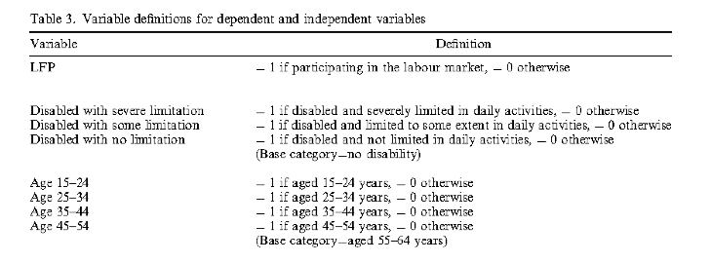

3.4 Dynamics (Gannon)

People who had previous disability less likely to work in current year even if recovered

Reason is that they did not work previously due to illness/disability

Hence they were less likely to work in the next year (state dependence)
- Mechanism of state dependence
- Not necessarily obvious
- Has significant policy implications

3.5 Data Summary

Work Decision (Labour Force participation decision)
- 86.6% of Men in the Data set were working
- 51.9% of women in the data set were working

Severe Limitation (disability)
- 2.6% of Men
- 1.6% of Momen

No Limitation
- 81.5% of Men
- 85% of Women

Of people who had a disability in the first period - 72% of people had a disability in the second period

3.6 Main Results

The more severely limited a person is due to disability/ poor health they are less likely to be working in that period

The more limited they were the previous year, the less likely they are to be in work the next year
- Does not control for unobserved effects

When you introduce the unobserved effects will observe the causal relationship
- Shows that the initial effects were overestimated (measurement error/ heterogeneity)

3.7 Discussion of Results

Compared to all other findings, the parameter estimates for currently disabled men with severe or some limitations, suggest that:
- approximately 40–50% of the base effect is due to unobserved individual effects/state dependence.

For women, we find that the original estimates of severe and some limitations are overestimated by about 5–10%.

3.8 Critique

In this paper, we cannot determine the nature of these unobserved characteristics, but further knowledge on these effects are necessary for integration of disabled people into the labour force. Additional information on how participation affects future disability will also prove useful, in that we may be able to establish how past occupational injuries from past participation affect current disability and participation, and people with these disabilities may re-join the labour force.

- The incentive effects of disability benefits may also play a role here
  - Do people mis-report their disability to get the disability benefits
  - 5-10% mis-representing

3.9 Limitations

In particular, if the reporting of disability in the survey is prone to measurement error, we cannot estimate the true effect of disability on participation. This may help to explain the substantial contribution of unobserved individual effects, but without extending the model to allow for measurement error in reporting behaviour, results on the effect of disability on participation are not conclusive.

- unobserved effects measured implicity in the model

3.10 Policy Recommendations

- Train people to get back to work quickly
- Remove barriers to participation
- Enforce legislation
- Effective monitoring of disability payments

4. Atalay, Barrett and Staneva (2019)

Effect of retirement on cognition

Establishing a causal effect of retirement on cognition is empirically challenging since the retirement decision is not random
- Poor mental health may directly induce retirement, and unobserved individual heterogeneity
- Time-varying confounding factors can affect both the retirement decision and cognitive capacity

The previous literature tends to be conclusive in finding a negative retirement effect on cognition

4.1 Contribution

Uses HILDA from Australia

Presents results for men/women separately
- Labour force participation of women is different to men
- women tend to work part-time more often then men

Investigates Mechanisms such as mental exercise behaviours, time use and social behaviours during transition into retirement
- Measures the effect of retiring on ability to do cognitive tasks
- if you do all the above things likely to have better cognitive ability after retirement

4.2 Findings

The causal short-run effect of retirement for women is modest and retirement is not associated with either a significant decline in working memory nor speed of information processing.

MEN:
- Find significant short-run effects on both word reading and working memory along with a negative effect of retirement duration

Examining the possible mechanisms through which retirement may influence individual’s cognitive performance they find that with the transition into retirement:

Women: are more likely to spend their time in reading, club membership, household and volunteer activities.

They do not observe any significant changes for men which could help explain the gender differences in cognitive functioning associated with the transition into retirement.

4.3 Instrumental variable approach
Based on the assumption that the eligibility thresholds cannot in themselves affect cognitive outcomes, but can influence retirement decisions they utilise these eligibility thresholds for both women and men in their instrumental variable approach.

- Cognitive ability can also affect decision to retire from work
  - IV approach - a variable that predicts whether you’re going to retire that does not affect your ability to do cognitive tasks
    - Eligibility requirements (age) for Retirement

Eligibility Age and how this has changed over the years
- retirement age has increased
- i.e access to the pension

Comparison of statistics of people in work and those who are retired

Is there a difference and if there is a difference need to factor in age
- There is nothing that is statistically significant

4.4 Policy Implications

Pay attention to transition into retirement

By postponing retirement, and working longer, may only postpone the problem

A more extensive transition program is recommended, programs for social engagement

4.5 Critique

The paper does not specify it’s own limitations

Measurement error included implicitly only (under the IV approach)
- (but this is sufficient if measurement is random)

There is not enough data to look at the long term effect?
- Although the long term effect is likely to follow the short term effect?

Week 10 Measurement of Health Outcomes

Monetary value of health care benefits

We are interested in the measurement of output
- This is usually straightforward

How should the output of a health care intervention be measured?
- Number of treatments?
- Improved health? (measure of quantity)
- How are improvements in health to be valued?
  - Market for health care is unusual, means the market is unlikely to generate information about the value of health services and treatments
- Any person that receives healthcare will receive a benefit
  - benefit to overall wellbeing/health/utility
  - Can also put a monetary value on this benefit (for cost-benefit analysis)

Firstly, we will consider the monetary valuation of health care benefits.

1.1 Methods used for Monetary Valuation Theory
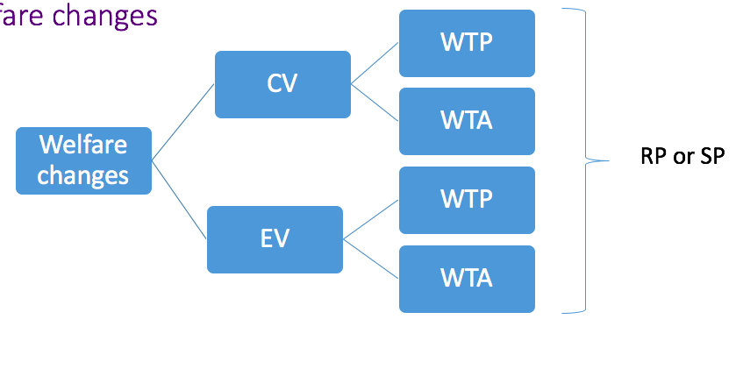
When we want to determine an monetary benefit from a healthcare intervention

Want to look at welfare changes
- Contingent Valuation
  - if you get a health improvement how do we pay for this
- Equivalent Variation
  - treatment may not be available and will stay at the same level of health
  - what’s the amount you’re willing to accept/pay to stay a constant level of health and not deteriorate further

Willingness to Pay
- about of money you’re willing to pay as a society as public OR as an individual that is then aggregated up to the public for this to happen

Willingness to Accept
- how much you’re willing to accept as compensation to stay constant/ for treatment to not happen

Does this then amount to a revealed preference or a stated preference

Revealed Preference
- Based on data retrospectively
- Data set has already been provided
  - Amount that has been revealed already

Stated Preference
- Survey’s collecting this data generally stated in a hypothetical manner i.e “what is your willingness to pay moving forward”

Equivalent Variation (EV), Contingent Valuation (CV), Willingness to Pay (WTP) and Willingness to Accept (WTA) are the usual ways to measure welfare changes in economics with unit of money

These are the basis of the benefit side of CBA, to give estimates of changes in consumer surplus
- Difference between what people pay and are willing to pay

Revealed preference and stated preference approaches can be used to measure the monetary value of health care benefits.

1.2 Stated and Revealed Preferences

- Revealed preference (RP):
- Valuation of goods and services that can be inferred from real choices made in the everyday world
- Choices reveal people’s preferences

- Stated preference (SP):

- More theoretical Contingent Valuation Methods- measurement of value is contingent on the description of a hypothetical market
  - Hypothetical choices are considered via willingness to pay methods.

- The theoretical basis is psychological

- For the values derived by contingent valuation methods to be deemed reliable:
  - The respondents must understand the situation presented to them, they must find it plausible and meaningful; AND
  - The sample of people questioned should be representative of the sample of everyone who may be affected by the intervention
- Problems: if the environment a decision is made in affects the outcome, SP techniques may not reflect true valuations
  - For example, if respondent believes they will have to pay for the good in the future, this may reflect their answers.

1.3 Willingness to Pay
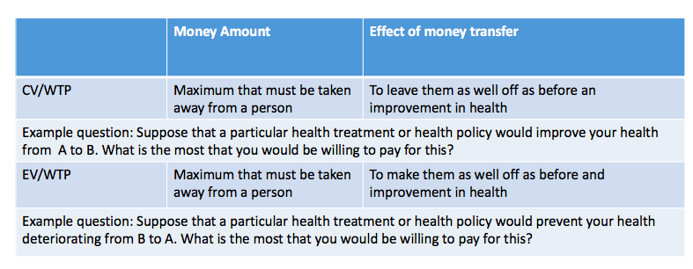

The willingness to pay is the maximum amount of money that is taken away from an individual for a service or a good
- Want to be left as well as before the improvement in health

EXAMPLE

Contingent Value Willingness to Pay
- Genetic test that will improve diagnosis
- New Vaccination

Equivalent Valuation Willingness to Pay
- have a specific disease, how much are you willing to pay to stay at the same level of health

1.3.1 Example of WTP Study

O'Shea E; Gannon B; Kennelly B. (2008) Eliciting preferences for resource allocation in mental health care in Ireland. Health Policy 88(2-3): 359-370

Over 400 randomly chosen respondents were asked to consider expansions in three health care programmes:
- A pain-relieving treatment programme for cancer patients
- Community care services for older people and
- community-based services for mental health

Respondents were first asked to rank the three programmes and then they were asked to state how much, if anything, they would be willing to pay for an expansion in each programme.

This paper investigates the use of willingness-to-pay in a broad priority-setting context by allowing members of the public to set priorities amongst alternative uses of health care resources in these three settings.

People were willing to pay the most for the cancer services and the least for mental health services
- what is the cause?
  - People are more effected by the cancer rather than the mental health
  - Circular? Government spends more on the cancer treatment and therefore in the eyes of the media/ public it is a more worthwhile venture to spend money on

1.3.2 Methods to record WTP

- Open ended responses/Continuous responses
  - Any figure that the respondent comes up with

- Payment scale
  - value between 0 - X

- Closed ended/discrete choice
  - number of boxes and go up in specific increments

- Conjoint analysis
  - 2 choices that have conditions attached to them
  - trading off all the different decisions

1.3.3 Potential Problems with WTP

- Poor correlation between hypothetical and real WTP
- Discrepancy between rankings and WTP
- Ordering effects
  - Ordering of preferences can affect the outcome of the rankings/WTP
- Amount and type of information provided
- Ability to pay
  - Can relate WTP to income which may affect ability to pay etc

1.4 Willingness to Accept

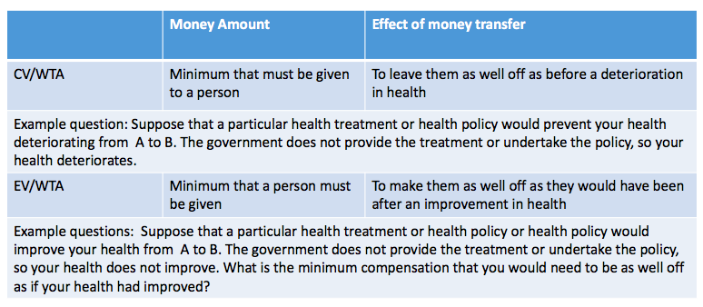

Minimum that must be given to an individual
- How much is an individual willing to accept for knowing that there is an available treatment BUT you are not getting it

Will find divergence between WTP and WTA for same procedure
- need to ensure that the wording is done correctly

1.5 Conjoint Analysis

Originated in market research

- Views goods as having specific attributes and it is people’s preferences for those goods that determine overall preference

EXAMPLE: dental care, with positive and negative attributes

Scenario 1 with pain relief but inability to eat, pain free treatment and cost €300

Scenario 2 with some pain relief, improved ability to eat, some pain in treatment, cost €100

Offer choice between pairs of scenarios
- Trade off monetary effect to pain effect

Use discrete response models to get valuation of different attributes for whole group
- If cost included can estimate WTP
- Measure utility related to scenario 1 and scenario 2

1.5.1 Example of Discrete Choice Experiment to value Informal Care

Mentzakis, E., Ryan, M. and P. McNamee (2011) “Using discrete choice experiments to value informal care tasks: exploring preference heterogeneity”, Health Economics 20(8):930-944

- Assesses value of informal care

- Asks respondents about WTA

3. Measuring health outcomes using health status indicators

In the previous section we considered the monetary measurement of benefit of a health care intervention as the additional health care produced.

Now we are going to concentrate on the measurement of benefit as the health loss or health gain generated by a health care intervention
- utility value of healthcare benefit

The measurement of health benefit is often preferred to the monetary valuation of the health care intervention.

Need an indicator of health status
- The concept of health-related quality of life (HRQOL) has dominated health indicators of the kind used in economic evaluation.

3.1 Generating a health status indicator:

Indicators for measuring HRQOL benefits that are based on questionnaires or interview schedules are called instruments.

The criteria for judging the usefulness of a HRQOL instrument is mainly based on its psychometric properties
- The instrumental is assessed by reliability, validity, responsiveness and feasibility.

A HRQOL indicator must provide an unambiguous measure of health. It must be possible to compare the outcomes of different possible uses of scare resources
- It should be able to be interpreted in terms of value.

Instruments can either be generic:
- EQ-5D
- HUI (Health Utilities index)
- SF-36

Or, instruments can be disease-, condition-, treatment- or domain-specific
- how do we obtain one measure that measures everything

3.2 Instruments and Profiles

If the instrument consists of a set of dimensions that have different levels, it is known as a profile.

Profile based health states instruments do not make any comparisons between the different dimensions of health
- The EQ-5D contains five dimensions (mobility, self-care, usual activities, pain and discomfort, anxiety and depression), each dimension is rated by three levels.

Profiles may not be able to say whether one health outcome is better than another.

If the instrument produces a single number representing the overall level of health, it is an index.
- This allows unambiguous judgement about whether one state is better than another
- Could mask important details of health state changes

3.2.1 EQ-5D Form

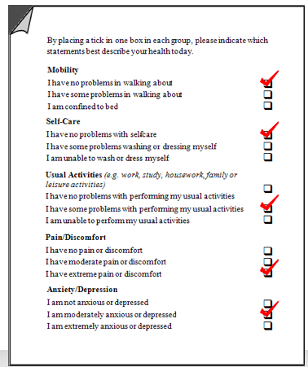
Can compare the before and after treatment responses of patients to discover whether treatments have improved health

Now at 5 levels compared to 3

4. Non Monetary Valuation of Health States

We now have a health state indicator- we now need to ensure it implies values.

A number of methods have arisen for attaching non-monetary valuation to health states:
- Visual analogue scales
- The standard gamble
  - Expected probability
- The time-trade-off

4.1 Visual Analogue Scale

Also called a rating scale

A scale that provides anchor points against which respondents rate a health state(s)
- Anchor points from 0-100

The scale has to cover the entire spectrum of feasible states
- Typically the anchor points are labelled “best imaginable health” and “worst imaginable health state”

Respondents are typically given two or more different health states to consider and are asked to indicate how good or bad a health state is by placing it on the scale.

Place health states on the line such that the relative distance between locations reflects the difference between states

Respondents asked to indicate how good or bad a health state is, in their opinion.

For example, the may be asked to value health states as described by the EQ-5D

4.1.1 Advantages/ Disadvantages of Visual Analogue Scale

Advantages | Disadvantages
- Ease of use  - Good response rates | - No notion of opportunity cost (given one state only and asked for the value of that state)  - Context bias  - End point aversion & end point bias  - People normally will pick closer to the middle of the scale

4.2 Standard Gamble

Based on expected utility theory
- How economists believe decisions are made when there is uncertainty

If outcomes A and B may occur with some probability p and (1-p), respectively, the expected utility of the lottery will be

p*(utility of A) + (1-p)*(utility of B)

SG embodies the notion of sacrifice between health and risk

Individuals are asked to choose between:
- A certain outcome for t years (the health state to be valued) and
- An uncertain prospect (one of which is better and one is worse – typically full health for t years and death)

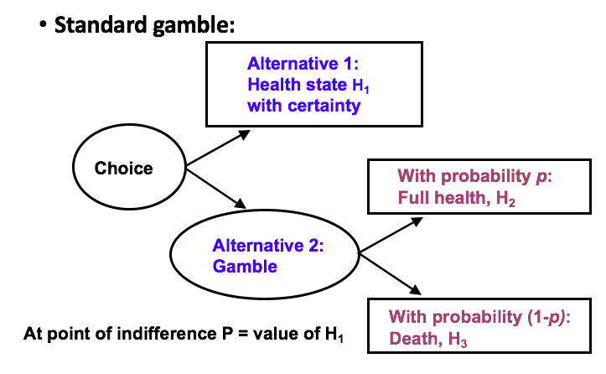

Alternative 1: know you will be healthy

4.2.1 Advantages/ Disadvantages of Standard Gamble

Advantages | Disadvantages
- Based on choice and sacrifice  - Involves uncertainty (risk) and is therefore more realistic for medical decision making  - Addresses the quantity/quality trade-off (opportunity cost)  - do you want 2 years of good quality life or 10 years of bad quality | - Probability can be difficult for respondents to understand

4.3 Time Trade Off (TTO)

Embodies the notion of tradeoff/ sacrifice between quality of life and length of life

Individuals choose between two certain options:
- Full length of life (LOLB) in the health state to be valued (QOLB)
- A shorter period (LOLA) in full health (QOLA).

LOLA typically starts small and is increased until the individual is indifferent between the two choices.

The “full length of life” must be realistic for the individual

4.3.1 TTO method for a chronic state preferred to death

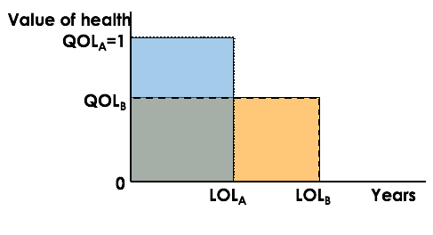

Taking the value under the curve

If the respondent is indifferent between health profile A and health profile B, then the QALY gains from A = QALY gains from B

LOLA*QOLA= LOLB*QOLB

If we want to value health state B then:
QOLB= LOLA/ LOLB

4.3.1 Advantages/ Disadvantages of Standard Gamble

Advantages | Disadvantages
- Possibly easier to understand than probabilities  - Based on choice  - Addresses the quantity/quality trade-off | - Assumes utility of life years is linear  - No account taken of risk

5. Generic multi-attribute utility scales

EQ-5D scale is a Generic multi-attribute utility scale

Health status indicators which can be expressed in terms of utility values have been favoured by economists.

Important type of health indicator is one which is based on a multi-attribute utility function.
- Eg. SF-6D, EQ-5D

Utility is derived from a range of health state ‘attributes’ or ‘dimensions’ (Ai)
- TTO, SG, VAS on current or experienced patients can be used to value multi-attribute index measures of health states.

The utility function attached to a multi-attribute health indicator must describe:
- The impact each attribute has on utility when all other attributes are held constant.
- The impact of the interaction of each attribute with each other attribute on utility.
- Below w_{i} are the conditional utilities or weightings of the impact of each attribute on utility.
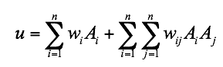

5.1 EQ-5D indicator

EQ-5D is one of the most widely reported multi-attribute index measure of health status in both clinical and economic studies

Its availability in more than 120 language versions reflects the adoption of EQ-5D on a global basis

Generally, the EQ-5D is the preferred measure of HRQL in adults

Regression methods have been used to derive values for the conditional utilities / weights:
- 45 of 243 states valued by survey undertaken. Respondents asked to value 12 states by VAS and TTO.
- Used a regression analysis to estimate a scoring algorithm which predicts values for the weights and can therefore be used to value all 243 states.
- A tariff of values exits for each of the 243 EQ-5D states.

5.1.1 EQ-5D EXAMPLE

Health state 11223:

- No problems walking
- No problems with self-care
- Some problems with performing usual activities
- Moderate pain or discomfort
- Extremely anxious or depressed

Value = 0.255 [derived from the regression]

6. MCQ Examples

No | Question
1 | A key characteristic of multidimensional measures of health benefits is that they: | (a) Are based on scores from a number of health dimensions  (b) Are based on one dimension of health.  (c) Are based on QALYs.
2 | The difference between generic and disease specific health instruments is that | (a) Generic instruments are limited to a specific therapeutic area.  (b) Generic instruments can only be used for the older population.  (c) Generic instruments can be used in any therapeutic area
3 | Which one of these is the most widely used generic health status survey? | a. SF-36.  b. FS-36.  c. SF-63.  d. FS-63.
4 | QALYs measure:  - quality adjusted life year  - what instrument do you need (EQ-5D) allows you to measure across the population | a. Length of life and quality of life.  b. Quality of life only.  c. Length of life only.
5 | Which of these methods uses probabilities in deriving utility weights for health states? | a. VAS.  b. TTO.  c. SG.
6 | Which one of these involves uncertainty? | a. VAS.  b. TTO.  c. SG.
7 | Which one of these does not take into account the notion of ‘opportunity cost’? | a. VAS.  b. TTO.  c. SG.
8 | Which of these converts health benefits into a monetary valuation? | a. WTP.  b. TTO.  c. VAS.
9 | Which of the following is a multi-dimensional measure? | a. Case of flu avoided.  b. Symptom free week.  c. EQ-5D.

Week 11 Health economics of ageing and longevity, and health shocks

Important questions in the ageing economy

Does expenditure increase with age or end-of-life?

How do certain conditions and comorbidities affect health care use and overall health?
- Presence of one or more additional conditions co-occurring with

How does health impact on retirement decisions or retirement impact on health?

Australian Government Expenditure on Aged Care
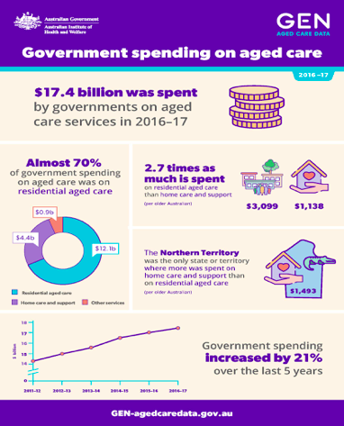

There has been an increase in the amount the government spends on aged care in the past 5 years

Residential aged care i.e looking after people was a huge portion (70%) of total spending on aged care

Increases in Life Expectancy

Life expectancy has been steadily increasing since the 1880’s with average life expectancy for both men and women exceeding 80 years

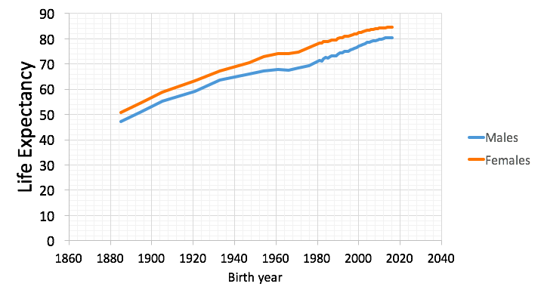

3.1 Factors that Impact Life Expectancy

Geographical location can greatly affect your life expectancy

Population Structure

Since the 1970’s the composition of Australians is becoming increasingly older with the number of people in the middle of their lives exceeding younger people
- creates issues due to increased demand on publicly provided services such as aged care/ healthcare

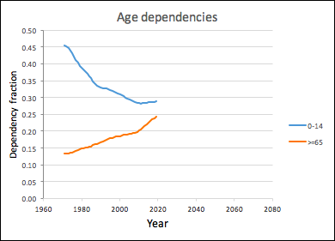
4.1 Age Dependency Ratios

Dependency Ratios:

Population under 15/(15-64)

Population 65+/(15-64)

Currently the total is 0.53

Dependency Ratio is the number of people not in the workforce compared to those who are
- will the increasing needs of those who are older/retired be able to be met by the decreasing proportion of people who are in the workforce

4.2 Predicted Overtake

it is predicted that in 2066 the number of people dependent on the working population will exceed the number of people working

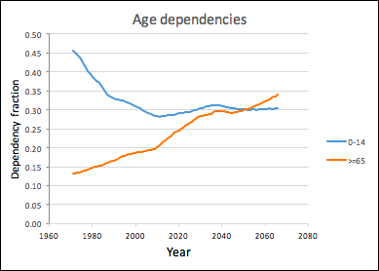

4. Economic Theory: Grossman Model

(Galama T and A Kapetyn (2011) Grossman’s missing health threshold. Journal of Health Economics, 30:1044-1056.)

- People demand and produce health

- Consumption and investment model

- Demand for health care is a derived demand

- Health is a basic commodity – use time and market inputs to produce health

- Health is not just a direct source of utility – also needed to affect ability to work, and therefore time available to produce income
- Poor health reduces ability to earn and reduces happiness/quality of life

4.1 Grossman Model II

Health is treated as a capital good (not just a consumer good)

- Health is a key component of the human capital model

A person has a stock of health, depreciates over time (age) and decreases when used in production and consumption of other commodities
- Can be increased through investments of time, effort and knowledge in health promotion activities.

Linked to other human capital, since knowledge/learning can affect how efficiently they can produce health
- Skills in turn depend on investments in education

Demand for health care is a derived demand

Health is a basic commodity – use time and market inputs to produce health

Health is not just a direct source of utility – also needed to affect ability to work, and therefore time available to produce income
- Poor health reduces ability to earn and reduces happiness/quality of life

Consumption of health and other (both derive utility)

Utility is maximised where U_{max}, H* health and O* consumption are chosen

- Requires the purchase of M* health care inputs and X* non health care inputs

This model can then be used to predict what effects changes in different elements (e.g. budget) have on commodities choice

Change in income would cause budget line to shift
- Improvement in health care technology would cause production function to change shape or position

4.2 Grossman Model Investment in Healthcare

People invest to the point where MB of investments (consumption benefit + investment benefit), are equal to, marginal costs incurred by the investment.

4.3 Grossman Predictions

Age depreciates health capital
- Rate of depreciation increases as people get older

Demand for investment in health (and demand health care inputs) depends on the depreciation

If the actual stock would be higher than preferred, there would be no investment in health.

But if it fell too low, investment would be necessary to raise it to preferred levels where possible

4.4 Grossman: Limitations

Assumes consumers have perfect information and foresight about:
- their health, and
- effect of health care on their health,
- rate of depreciation of health,
- the effect of health care and consumption of other goods on their health

Do people make well informed decisions and rational decisions about time of death?!
- Uncertainty – timing of adverse events
  - (See Lugo and Gannon, 2017)

Demand for health care as one gets older is ambiguous
- Wages increase with longer work experience and could offset depreciation where the rate increases as one gets older…hence we need to empirically test the hypothesis.
  - Micro derivatives are all available in Galama and Kapteyn

5. How can we use health economics and data to answer these questions?

- Administrative data

- Cohort studies

- Longitudinal data

5.1 Longitudinal data - following individuals over time

- HILDA (Household Income and Labour Dynamics in Australia)
- HRS (Health and Retirement Survey, US)
- SHARE (Survey of Health Ageing and Retirement in Europe)
- CHARLS (Chinese Health and Retirement Longitudinal Study)
- TILDA (The Irish Longitudinal Study on Ageing)
- ELSA (The English Longitudinal Study on Ageing)
- ALSWH (Australian Longitudinal Study of Women's Health)
- 45 and Up (NSW)

5.2 Empirical issues

Unobserved heterogeneity, individual traits that increase probability of worse health and increased use of health services
- Ability, time preference (prefer better health now or later)

Health and health care use
- Health or retirement, which comes first – reverse causality.

6. Age and end of life: health care resource expenditure

The relationship between health care expenditure (HCE) and age was tested empirically by Zweifel et al. (1999)

- Previous cross section analysis found that HCE did increase with age

Zweifel tested the hypothesis that HCE increased with closeness to death, if so, ageing is not the main cost driver per se
- Focus on last 2 and 5 years of life

Per capita HCE is driven by time to death and demographic change will not have a large impact on aggregate health expenditure over the life time

BUT Seshami and Gray (2004) questioned the methodology

They find age is important, but still not as large a driver as last year of life (thus confirming the Zweifel findings)

They also used different data and replicated the Zweifel model, and found no age or proximity to death effects

The paper/topic demonstrates the importance of sound theoretical foundations, along with appropriate econometrics methodology, to test the hypotheses generated and to fit the data accurately.

Figure 3: average cost by patient age and sex in last quarter of life (Zweifel)
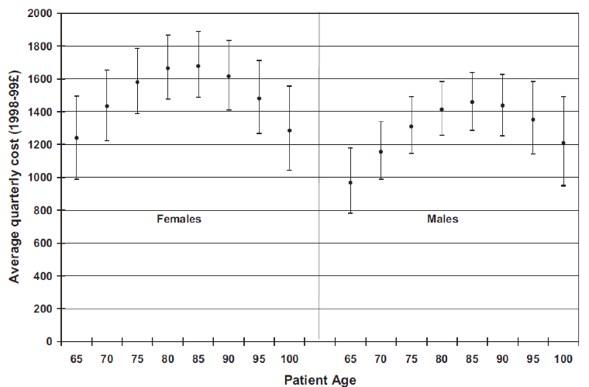

Figure 4: Predicted average quarterly cost by time to death
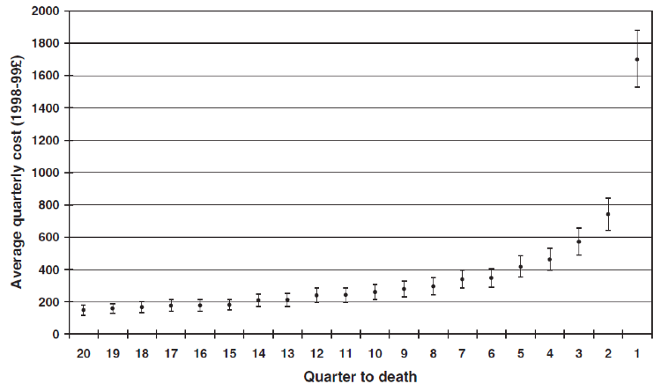

6.1 Who pays for end of life health care expenditure?

Fischer et al. (2018) – issue of rationality tested

WTP for terminal care is high
- Does this justify novel therapies costing $100,000 per QALY

He put forward theory of valuation of life under imminent threat of death
- If WTP>MC then there is no rationale for government not to fund the treatment

Tested using a discrete choice experiment
- Elicit Individual and Societal WTP (S>I due to altruism and it being a public good)

Therefore much support for hypothesis that there is societal WTP for end of life
- Limitations are that true preferences are not revealed

7. Falls in Health Stock and Health Care Utilisation
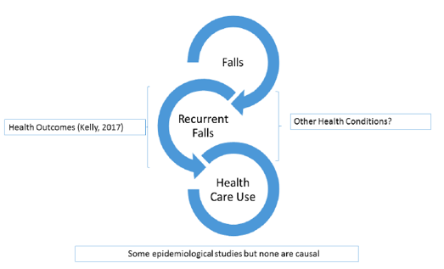

Marginal effect of falls on health: predicted probability of being in good health, 15% points lower for those who fell compared to those who did not fall

Falls are a negative input into the health production function

Of those who fall, 70% more likely to die by the next year

Decrease in daily living and more depression

Now there are many falls prevention programmes and projects
- http://www.preventit.eu/index.php/about-preventit/

7.1 Overview of new research on falls….and health care use

Analyse the association between falls in older people and healthcare utilisation, for community living dwellers
- Findings show high use of health care services

- Focus on direct effects of fall consequences, captured by analysing health care utilisation

“Overall, we find this association varies from at least 0.6 more GP contacts, up to 1.8 more MP contacts and 2.7 more hospital nights”

7.2 Why Falls

Approx. 1 out of every 10 people in our sample have fallen!

- Falls are often not a once off health shock and can be recurring along with persistent effects from first shock

- Health costs are large and more information is needed on extent of repeated falls on health care use

7.3 What knowledge is required yet?

Kelly, 2017: only direct costs have been estimated and so they look at indirect effects on physical and mental health outcomes

We now look at isolating the effect of falls, aim to get a more precise measure of falls effects
- Previous cost literature potentially overestimate this effect

We differentiate falls and recurrent falls: which has largest impact on health care use
- important policy consequences for interventions

7.4 Why longitudinal data (SHARE)?

Benefits: Isolate effects from other health conditions, follow up data allows us to look at repeated falls also

- Several countries although we do not separate by country

Limitations: Only community dwellers, so not full health care use… but still important in terms of learning for living at home strategies

7.4.1 Data: SHARE

SHARE - 5 years of data so far

Health care use Variables
- Medical professional (MP) contact
- General practitioner (GP) contact
- Hospital nights

Explanatory _𝑉𝑎𝑟𝑖𝑎𝑏𝑙𝑒𝑠__ (Andersen Model of Health Services)
- Fall
- Predisposing factors (e.g. age, sex, education)
- Enabling factors (e.g. income)
- Need factors: (e.g. health conditions and impairments)
- Health Behaviours (e.g. exercise, smoking, medication)
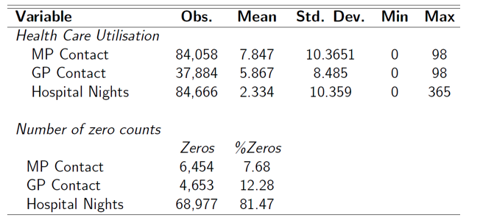

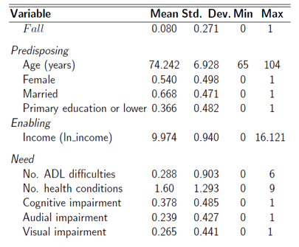

7.5 Acuteness of Care & Repeated Falls

The more acute the care-type (hospital), the more impacted by falls
- Recurring Falls result in more GP use (central point of contact, prevention, prescriptions)
- Repeated falls result in more intense health care use
- Aligns with epidemiological literature, e.g. repeated fallers and consequences, e.g. fracture hip and require more health care

Looking at immediate past falls has the same effect

7.6 Fall Prevention Schemes

Exercise
- Balance-based, e.g. Tai Chi
- Cardiovascular exercise also recommended

Home modification
- Railings on flights of stairs

Behaviour modification
- Prescription glasses
- Appropriate footwear

7.7 Summary

Overall, falls are associated with increased health care utilization
- At least 0.6 more GP contacts
- Up to 1.8 more MP contacts
- 2.7 more hospital nights

Trends:
- Acuteness of care
- Fall recurrence
- GP as central point-of-contact

Reinforces the need for fall prevention schemes

8. Health care use and cognitive decline

Lugo-Palacios and Gannon (2017) 7
- Uses SHARE 2004-13

Impact of cognitive impairment and sensory impairment on health care utilisation

Applies Negative Binomial count and Finite Mixture econometric models

- CI leads to more hospitalistions
- SI lead to more hospital nights for lower users of HC

Both impact together on doctor and GP visits

9. Retirement and Health

Impact of changes in health (shocks) on changes in labour market state (retirement) (Disney et al. 2006)

Used British Household Panel survey 1991-98
- Transitions into retirement were positively associated with lagged and current shocks to health

- Better health reduces probability of leaving workforce

Are improvement in health symmetric with deteriorations in health: No!
- The impact of improvements is dampened compared to the effect of worse health

Biro and Elek (2018) How does retirement affect health care expenditures? Evidence from a change in the retirement age
- Effect of retirement on health expenditure (outpatient, inpatient, pharma)
- Is raising the retirement age really saving money?

- Proportion with positive expenditure decrease by 3,1.4 and 1.3 percentage points in SR - and intensive margin is not significant

Argument for extending retirement, more in work and using health care due to sick leave incentives; but does this translate to better health after retirement and at older age??

Does this cost more to pay sick leave (extend retirement age) than to pay pension etc. and/or reduced health care costs later on??

Week 12 - Welfare economics and introduction to Economic Evaluation

What is welfare economics?

Welfare economics – analysis of social desirability of any set of arrangements
- Allocation of resources, in terms of utility obtained by individuals
- Maximise utility for individuals and aggregate it up for the whole societal welfare function

Set of rules (value judgements) to achieve logical ranking of alternative states that we can choose from (e.g. Health care resources)
- what money should be spent on healthcare will be based on these rankings

Measured by individuals evaluation of their utility

1.1 Theoretical concepts

Welfare analysis: individuals will act as to maximise utility

Where no market exists a CBA may be used to ensure welfare maximisation

Pareto optimality: pareto improvement occurs if at least one individual is made better off and no other individual made worse off

BUT CBA is neutral to distributional equity
- Would require information on interpersonal comparison
- But pareto principle is not concerned with WHO is better off
- Does not address equity

Ability to look at equity is a common issue throughout economic valuation

1.2 Pareto Analysis - key points

How do we aggregate each utility
- What trade offs are acceptable?

Pareto principle used in welfare economics
- Based on consumer choice theory where each person can rank bundles of goods

Paretian analysis seeks to aggregate these individual preferences to produce social welfare ordering
- A complete and consistent ranking of all possible states

Weak pareto improvement: increase utility of all

Strong pareto improvement: does not decrease utility of anyone

Pareto optimal: increase in one person’s utility can only be achieved by reducing utility of at least one other

- But cannot compare non-optimal with optimal/neutral to equity
  - Does not say who is better off

1.3 Compensation Tests

How are these improvements in utility measured?
- Have to have a proxy for utility → Money is used

Gains by some, losses by others, possibility of monetary transfers between them to compensate losers

Hicks/Kaldor criteria: benefit defined as maximum amount to be taken away from an individual such that they are as well off

Decision makers cannot observe or compare individual utilities
- Money used as a proxy – two money measures of changes in utility are CV and EV

CV and EV can be aggregated to determine whether a policy has a positive or negative effect on social welfare

1.3.1 Methods to Measure Welfare Changes

Estimates of consumer surplus - difference between what people pay and are willing to pay

- Compensating Variation

- Equivalent Variation

But implies all have same marginal utility of income
- Not beneficial tool from an equitable perspective
  - Richer people will have a lower marginal utility
  - Poorer people will have a higher marginal utility at the same income amount

- Important for interpretation of CBA results and recommendations

Critiques on this method of valuation as it is a hypothetical/contingent valuation method

1.3.2 Discrete choice – conjoint analysis

Hypothetical Measure
- BUT prefered method
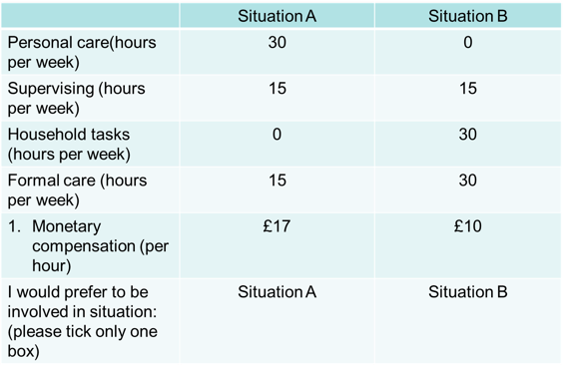

Decision between 2 specific/ discrete choices
- WTA Study
- How much are they willing to accept

2. Criticisms of Welfarism

- The underlying paradigm of rational choice and utility maximising behaviour is irrelevant to health and health care behaviours
- Externalities/ Uncertainty exists in the healthcare spectrum

- Welfarism assumes social welfare is determined only by utility from commodities
- Grossman model introduces health as an investment good

- Welfarism’s basis in individualism excludes community values

- Utility is flawed as a measure of individual wellbeing

2.1 Extra-welfarism

People differ with respect how they assess their own well-being and utility
- May not always be accurate/ sufficient

Their assessments also rely on their:
- Functioning (what a person can be)
- Capability (freedom to make choices)

So these two terms should be included when comparing social states….Extra-welfarism - (Sen (1985))

Health care is viewed as means to an end, depending on ‘Needs’ (Culyer, 1991)
- Have to predict future health needs in the population

Health is included as extra, not just a source of utility
- But Needs are important to make decisions on how to allocate scarce resources

Value judgements and effects on economic analysis must be clearly stated to decision makers
- ‘Economics can never replace morals or ethics’ (Fuchs 1998)

3. Practical Methods

3.1 What are the principles derived from theory that guide practice?

Generally we call this cost-benefit analysis (CBA)
- Weighing up advantages and disadvantages, comparing benefits with costs
- Comparing like with like

Costs measure value of scarce resources used in terms of opportunity costs, which are the benefits that could otherwise be obtained with those resources

CBA is simply a comparison of benefits of one use of scarce resources with those from another

3.2 Cost-Benefit Analysis

Cost-benefit analysis involves constructing an inventory of all costs and benefits of an alternative, whatever they are and whoever incurs them
- This forms a balance sheet in which they are weighed up against each other

This is only possible if all costs and benefits are measured in the same unit
- The obvious one is money as the measure of value most used in modern economies.

A theoretical basis for this can be found in welfare economics theory

3.3 Cost-Effectiveness Analysis

CBA may not always be practical due to the amount of information needed

Cost-effectiveness analysis (CEA) is a partial form of cost-benefit analysis
- The rationale for CEA is that while costs are usually measured in terms of money, it may be much more difficult to measure benefits that way.
- More difficult to measure the benefits
  - Shorter hospital visits/ no admission to hospital as measurement of effect

In health economics, cost-effectiveness analysis tries to identify where more health benefit can be produced at the same cost or a lower cost can be achieved for the same health benefit

A theoretical basis for this can be found in the theory of production efficiency
- Inputs (resources of capital and labour used)
- Outputs (units of measure, e.g. hospital admissions avoided)

3.3.1 Cost utility analysis

A more sophisticated version of CEA
- Effect is measured in terms of ‘healthy years’ (utility)

Healthy years: are represented by a multi-dimensional utility based measure which combines life years gained with some judgement on the quality of those life years
- Number of years and the quality of those years (EQ-5D Measurement)
  - Quality Adjusted Life Year (QLAY)

Comparisons are made in terms of Incremental Cost Effectiveness Ratios (ICER)
- change of the cost over the change in the output

Results of the Cost Utility Analysis are compared with a threshold ICER
- ICER < Threshold (tend to be funded)
- ICER > Threshold (tend not to be funded)
  - No threshold in Australia but other countries use 50,000 and this used in Aus as a comparison
  - If an ICER comes in under the threshold then it will be a fundabale activity
  - If it is over the threshold, it does not deem it unfundable, just that further considerations (such as equity) need to be considered

4. What Technique?
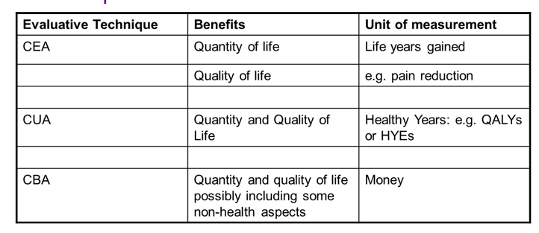

- Cost Utility Analysis: when want to look at quality and quantity of life
- Cost Benefit Analysis: Issue is that would have to find monetary value for the effect (difficult)
- Cost Effectiveness Analysis: can look at numbers (life years gained/hospital nights reduced) which can be easy to use units, quality of life would again cause issues of measuring utility

Which technique is most appropriate is determined by the question to be addressed

There are two types of questions:
- Questions of allocative efficiency
  - in relation to cost including cost of inputs
- Questions of technical efficiency
  - About the inputs and outputs and about how much you can produce given the inputs

4.1 Efficiency

Allocative efficiency is concerned with whether to allocate resources to a programme or whether to allocate more or less resources to it.
- YES/NO TO FUNDS
- Are funds directed to activities which will produce the greatest gains?

Technical efficiency is concerned with how best to deliver a programme, or achieve a given objective
- HOW BEST TO SPEND THE FUNDS GIVEN THE OBJECTIVE
- ensuring that you can produce the effect

4.2 Examples

- Allocative Efficiency:
(whether or not we will fund the surgery)

Surgery for tonsillectomy versus outpatient clinic for asthma

CBA
- Do these interventions generate Benefits > Costs
- Which has the highest Benefit: Cost Ratio

CUA
- By the specification of a threshold cost per QALY value are the effects > costs

- Technical efficiency:

(Delivery of program - looking at the inputs and outputs and producing what you can)

Day surgery vs inpatient surgery for tonsillectomy;
Local vs hospital based clinics for asthmatics
- Primary Concern of CUA

5. Discounting

see Medical Services Advisory Committee (MSAC), Pharmaceutical Benefit Advisory Committee (PBAC)

Which would you prefer:
- $1000 now vs. $ 1000 in 12 months time?
- Generally have a time preference for now rather than later

The discount rate is used to convert all costs and benefits to ‘present values’, so that they can be compared over time
- value of the value of the money will be less due to inflation in the future
- Used in both CBA and CUA

The recommended discount rate in Department of Health: An annual rate of 5% for both costs and benefits
- higher than the UK (3.5%)

6. Efficiency v Equity

Economic evaluation should pay heed to efficiency and equity but in practice efficiency gets more attention
- In private markets efficiency is left to market forces
- In public sector, market forces are weak

Economic evaluation is therefore mainly concerned with measuring efficiency in public sector, where there are no markets to generate information such as prices or profits, to allow us to judge efficiency

- Public sector will have different goals, perhaps maximise health and account for equity
- Economic evaluation should therefore take these goals into account ( in theory)

7. Applied Welfare Economics

…. necessary to identify all costs as marginal social costs…

….. using the Paretian Approach, takes society as a whole into account

…… aim of CBA is to provide information to help improve pareto efficiency

…..Partial efficiency is dealt with by different type of economic evaluation known as cost-effectiveness analysis (CEA)

8. Summary

CBA seeks to answer whether or not an output is worth the cost
- CBA asks whether we should do something

CEA seeks to answer among two alternatives, which provides most output for a given cost, or lowest cost for given output
- CEA asks what is best way to do things

9. Theory and measurement

Production and cost functions relate inputs to outputs and define efficiency aspects of relationship
- Economic evaluation attempts to quantify these

If inputs and outputs measured in physical units – technical efficiency

If inputs valued and outputs physical units – cost function – allocative efficiency, CEA

If both inputs and outputs valued – overall allocative (economic) efficiency, CBA

This links theory and measurement

9.1 Applying economic evaluation to health care programmes

Drummond (1980) initiated programme of research and many aspects of concepts concerning efficiency and economic evaluation of health care interventions have been since modified

Classified existing economic evaluations and aimed to improve reporting standards

Main task is what should be measured and how in terms of costs and benefits

So therefore techniques such as CBA and CEA are defined by measurement rather than economic theory
- Less guidance from theory as a result more of a focus on measurement

9.2 Looking back at equity

Economic evaluation can account for equity in distribution, BUT value judgements are required as to what the appropriate equity concept should be.
- But theory and methods for addressing this issue within practice of economic evaluation are underdeveloped

