Ricardian Model
Labour is the only factor of production
- Differences in labour productivity arise from different Technology
  - This gives rise to Comparative Advantage
  - Comparative advantage forms the basis of trade for countries
    - High productivity or low wages give countries a cost advantage.
    - Constant returns to scale

- Trade benefits all countries due to the relative price of the exported good rising

2. Specific Factors Model
- Three factors of production: labor (L), capital (K) and land (T for terrain)
  - Labor is a mobile factor that can move between sectors

The production possibilities frontier is curved
- DIMINISHING MARGINAL RETURNS to labor in each sector cause the opportunity cost to rise when an economy produces more of a good.
- Opportunity cost of cloth in terms of food is the slope of the production possibilities frontier
  - The slope becomes steeper as an economy produces more cloth.
  - More cloth you produce the higher the OC

2.1 Trade
- Opening up to trade increases the relative price of cloth in an economy whose relative supply of cloth is larger than for the world as a whole.

- It imports an amount of food equal to the relative price of cloth times the amount of cloth exported: D_{F} - Q_{F} = (P_{c} /P_{F} ) x (Q_{c} - D_{c})

TRADE AFFECTS RELATIVE PRICES THEREFORE FACTOR PRICES CHANGE
- Trade benefits the factor that is specific to the export sector BUT hurts the factor that is specific to the import-competing sectors → owner of the exported sector input benefit
- Without redistribution there are winners and losers
- Trade has ambiguous effects on mobile factors (labour)
  - Will move to the sector with the higher wages

Income distribution effects arise for two reasons:
  - Factors of production cannot move costlessly and quickly from one industry to another (Some are rigid)
  - Changes in an economy’s output mix have differential effects on the demand for different factors of production.

Labour migrates (moving factor of production) to countries with higher labor productivity and higher real wages, where labor is scarce.
  - Real wages fall due to immigration and rise due to emigration.
  - World output increases.

3. Two-Factor HO Model
- No factor specificity → mobility/substitution of factors (only 2 factors)
  - Curved PPF
- FACTOR ENDOWMENT DETERMINES TRADE
  - Countries are assumed to have the same technology will be different based on natural endowment
- Predicts a convergence of relative prices with trade

**little empirical evidence to support theory
- Ignores transport costs/barriers to trade
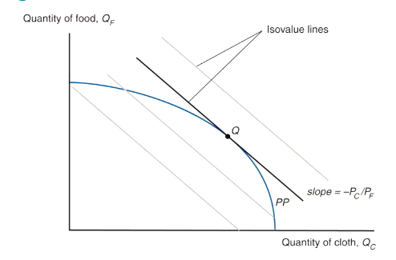

Economy produces at the point that maximizes the value of production given the prices it faces
- this is the point on the highest possible isovalue line.

3.1 Stolper-Samuelson theorem - Factor Prices/Good Prices
If the relative price of a good increases, then the real wage or rental rate of the factor used intensively in the production of that good increases, while the real wage or rental rate of the other factor decreases.

3.2 Rybczynski theorem - Resources/ Output
Theorem: If you hold output prices constant as the amount of a factor of production increases, then the supply of the good that uses this factor intensively increases and the supply of the other good decreases

3.3 Heckscher-Ohlin theorem
The country that is abundant in a factor exports the good whose production is intensive in that factor

Generalizes to a correlation:
- Countries tend to export goods whose production is intensive in factors with which the countries are abundantly endowed.

- Owners of a country’s abundant factors gain from trade, but owners of a country’s scarce factors lose

Leontief Paradox: The data collecting when trying to observe the HO model shows that US exports were much less capital intensive than US imports DESPITE the US being the most capital abundant country in the world.
→ when pattern of trades does not match the factor endowments
- Confirmed on international scale

Missing Trade

But because factor prices are not equalised across countries, the predicted volume of trade is much larger than actually occurs

The reason for this “missing trade” appears to be the assumption of identical technology among countries
- Technology affects the productivity of workers and therefore the value of labour services
- A country with high technology and a high value of labour services would not necessarily import a lot from a country with low technology and a low value of labour services

3.4 Skilled v Unskilled Labour

According to the model, wages of unskilled workers should increase in unskilled labour abundant countries relative to wages of skilled labour but in some cases the reverse has occurred
- Wages of skilled labour have increased more rapidly in mexico than wages of unskilled labour
- But compared to the US/Canada, Mexico is suppose to be abundant in unskilled workers

Regardless of the country’s composition of skilled to unskilled labour, and increase in skill-biased technological change will see and increase the employment of skilled labour
- new/better machines (capital) that displace unskilled workers but still require skilled workers
- Technology increases in both sectors could explain why there is growing inequality

4. Standard Trade Model
Standard trade model is a general model that includes Ricardian, specific factors, and Heckscher-Ohlin models as special cases.
- NO TRANSPORT COSTS

- Two goods, food (F) and cloth (C)
- Each countryʼs PPF is a smooth curve.
- Allows for differences in technology
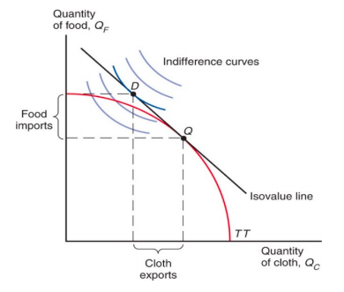
- Different PPFs
The economy produces at point Q, where the production possibility frontier is tangent to the highest possible isovalue line.

It consumes at point D, where that isovalue line is tangent to the highest possible indifference curve.
- Maximizes consumer welfare before trade
After trade can consume at a level that was not previously obtainable (Above the PPF)

The economy produces more cloth than it consumes and therefore exports cloth; correspondingly, it consumes more food than it produces and therefore imports food.

The standard model predicts that:
- An import tariff by the home country can increase domestic welfare at the expense of the foreign country
- An export subsidy by the home country reduces domestic welfare to the benefit for the foreign country

Intertemporal Trade

- Home is biased towards current consumption is therefore a LENDER
  - Home lends to Foreign by consuming less than it produces now → home able to consume more than it produces in the future when foreign pay back the loan
The price of future consumption relative to current consumption is 1/(1+r)
- 1 unit of current consumption is worth 1 + r of future consumption
  - So 1 unit of future consumption is worth (1/1+r) units of current consumption

Again the interest rate will be between the interest rates of the 2 countries BEFORE trade

5. External Economies of Scale

Increasing returns to scale or economies of scale:
- This means that when inputs to an industry increase at a certain rate, output increases at a faster rate
- With trade, a country can take advantage of economies of scale to produce more efficiently than if it tried to produce everything for itself

External economies of scale occur when cost per unit of output depends on the size of the industry
  - “Hubs” → smaller firms located in the same geographical area
  - An industry where economies of scale are purely external will typically consist of many small firms and be perfectly competitive

External economies many exist for a few reasons:
1. Specialised equipment or services may be needed for the industry, but are only supplied by other firms if the industry is large and concentrated
2. Labour Pooling a large and concentrated industry may attract a pool of workers, reducing employee search and hiring costs for each firm
3. Knowledge Spillovers workers from different firms may more easily share ideas that benefit each firm when a large and concentrated industry exists

Forwards-falling supply curve:
When there are external economies of scale, the average cost of producing a good falls as the quantity produced rises.
- Industry WIDE AC curve

5.1 Trade

Trade leads to prices that are lower than the prices in either country before trade (in both countries)

The Chinese button industry will expand while the US button industry Shrinks
- As the price is higher in the US will decide to buy cheaper Chinese goods, this means that the output that China produces will increase and prices will continue to drop
- The incentive to buy chinese buttons will keep increasing
- Conversely, the prices of US buttons will increase and the volume of production of buttons in the US continues to drop
  - This is disgreading any transport costs/ imperfections in trade
  - force leading to specialisation
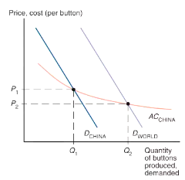

If external economies exist, however, the pattern of trade could be due to historical accidents:
- Countries that start as large producers in certain industries tend to remain large producers even if another country could potentially produce more cheaply
- IF COUNTRY HAS HEAD START THIS MAY TRUMP ACTUAL CA IN PRODUCTION OF GOOD

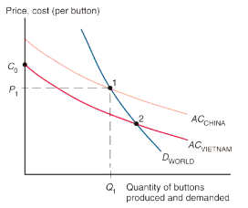

Affect on Welfare
Trade based on external economies has an ambiguous effect on national welfare
- There will be gains to the world economy by concentrating production of industries with external economies
- It’s possible that a country is worse off with trade than it would have been without trade
  - A country may be better off if it produces everything for its domestic market rather than paying for imports
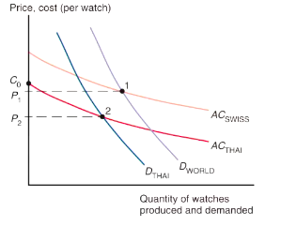

If thailand were to block all trade in watches, it would be able to supply its domestic market (D_{THAI}) at lower price P₂

The learning curve shows that unit cost is lower the greater the cumulative output of a country’s industry to date

External economies may also be important for interregional trade within a country
- Many financial firms located in NY provide financial services for consumers throughout the US

6. Monopolistic Competition (Internal economies of Scale)

Internal economies of scale occur when the cost per unit of output depends on the size of a firm
Big corporation with a concentration of production within the firm have cost advantage over small firms
  - Could lead to efficiency gain/monopoly → industry to become imperfectly competitive

Internal economies of scale imply that a firm’s average costs of production decreases the more output it produces

In imperfect competition, firms are aware that they can influence the prices of their products and that they can sell more only by reducing their prices

6.1 Monopolistic Pricing Production Decisions
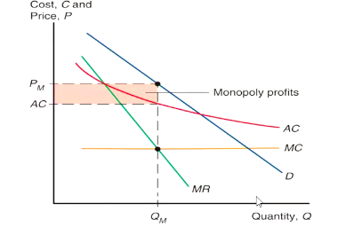

A monopolistic firm chooses an output at which MR (increase in revenue from selling an additional units) EQUALS MC (Cost of producing an additional unit)

This profit-maximising output is shown as Q_{M}; the price at which this output is demanded is P_{M}

The monopoly’s profits are equal to the area of the shaded rectangle, the difference between price and average cost times the amount of output sold

Average Cost: AC = C/Q = F/Q + c

In the long run, a monopolistically competitive firm will produce where average cost equals price

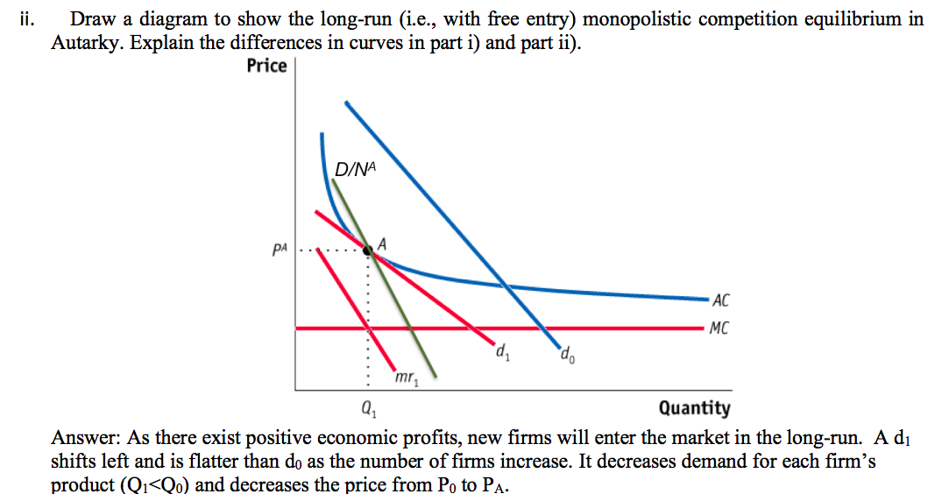

6.1 Monopolistic Competition Function

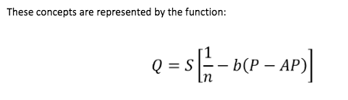

- Q is an individual firm’s sales
- S is the total sales of the industry
- N is the number of firms in the industry
- B is a constant term representing the responsiveness of a firm's sales to its price
- P is the price charged by the firm itself
- AP is the average price charged by its competitors

6.2 Equilibrium in a Monopolistically Competitive Market
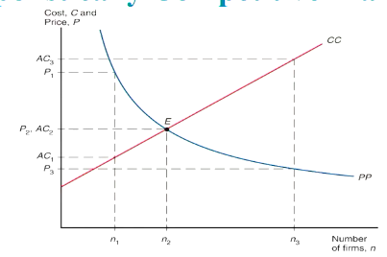
The number of firms in a monopolistically competitive market, and the prices they charge, are determined by 2 relationships.

On one side, the more firms there are, the more intensely they compete and reduce the industry price.
- Represented by the PP

On the other side, the more firms there are, the less each from sells and therefore the higher the industry’s AC is.
- Represented by the CC

If price exceeds the AC (PP Curve above the CC curve) the industry will be making profits and additional firms will enter the industry.

If the price is less than AC, the industry will be incurring losses and firms will leave the industry

Symmetry Assumption:
Assume that firms are symmetric → all firms face the same demand function and have the same cost function
- Thus all firms should charge the same price and have equal share of the market Q = S/n
- AC should depend on the size of the market and the number of firms
    - AC = C/Q = F/Q + c = n* F/s + c

6.3 Trade

Because trade increases market size, trade is predicted to decrease AC in an industry described by monopolistic competition
- Industry sales increase with trade leading to decreased AC → AC = n*F/S + c

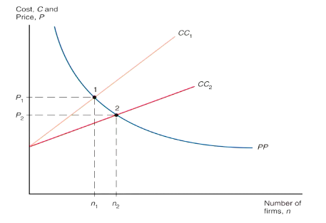

An increase in the size of the market allows each firm (other things equal) to produce more and thus have lower AC.

In the LR there will be no incentive to enter/exit the industry

6.4 Significance of Intra-Industry trade

Intra-Industry trade = two way exchanges of similar goods (not identical goods)

Increased competition tends to hurt the worst-performing firms - they are forced to exit

6.5 Trade Costs and Export Decisions

Trade costs add two important predictions to our model of monopolistic competition and trade:
- Why only a subset of firms export and why exporters are relatively larger and more productive (lower marginal costs)
- Only large firms can afford the additional costs that come with exporting

- Firms 1 and 2 both operate in their domestic (Home) market.
- Only firm 1 chooses to export to the Foreign market. It is not profitable for firm 2 to export given the trade cost t

6.6 Dumping

Price Discrimination and dumping may occur only if:
- Imperfect competition exists: firms are able to influence market prices
- Markets are segmented so that goods are not easily bought in one market and resold in another

7. Multinationals and Outsourcing

FDI = investment in which a firm in one country directly controls or owns a subsidiary in another country

If a foreign company invests at least 10% of the stock in a subsidiary, the two firms are typically classified as a multinational corporation
- 10% or more of ownership in stock is deemed to be sufficient for direct control of business operations

Greenfield FDI = when a company builds a new production facility abroad
- Has tended to be more stable

Brownfield FDI (cross-border mergers and acquisitions) = when a domestic firm buys a controlling stake in a foreign firm
- Cross-border mergers/acquisitions tend to occur in surges
Developed countries receive the largest portion of inward FDI BUT is increasing
- Much more volatile than FDI going to developing/transitional economies

- Horizontal FDI - Affiliate replicates the production process (that parent firm undertakes in its domestic facilities) elsewhere in the world
  - Done to exploit advantages in selling/producing locally
  - Dominated by flows between developed countries
    - Both multinational parent/affiliates are usually located in developed countries

Main reason for horizontal FDI is to locate production near firm’s large customer base
- Trade/transport costs pay more important role than production cost differences for thee FDI decisions

2. Vertical FDI - production chain is broken up/ parts of the production process are transferred to the affiliate location
  - Mainly driven by production cost differences between countries (for parts of production that can be performed at another location)
    - Vertical FDI is growing fast/ is the cause of large increase in FDI flows to developing countries

Trade off exists in FDI

- High trade costs associated with exporting create an incentive to locate production near customers BUT
- Increasing returns to scale in production = want to concentrate production in fewer locations
  - Trade off between which option you choose

The horizontal FDI decision involves a trade-off between the per-unit export cost t and the fixed cost F of setting up and additional production facility
If t(Q) > F, costs more to pay trade costs on t on Q units sold abroad than to pay fixed cost F to build a plant abroad.

The vertical FDI decision also involves a trade-off between cost savings and the fixed cost F of setting up a new facility

Foreign outsourcing/offshoring occurs when a firm contracts with an independent firm to produce in the foreign location
- In addition to choosing location of production also must decide whether to keep production internalised or by separate firms
  - Internalisation occurs when is more profitable to conduct transactions/production within a single organisation

16. Summary

- Internal economies of scale imply that more production at the firm level causes average costs to fall.
- With monopolistic competition, each firm can raise prices somewhat above those on competing products due to product differentiation but must compete with other firms whose prices are believed to be unaffected by each firm’s actions.
- Monopolistic competition allows for gains from trade through lower costs and prices, as well as through wider consumer choice.
- Monopolistic competition predicts intra-industry trade, and does not predict changes in income distribution within a country.
- Location of firms under monopolistic competition is unpredictable, but countries with similar relative factors are predicted to engage in intra-industry trade.
- . Dumping may be a profitable strategy when a firm faces little competition in its domestic market and faces heavy competition in foreign markets.
- Multinationals are typically larger and more productive than exporters, which in turn are larger and more efficient than firms that sell only to the domestic market.
- Multinational corporations undertake foreign direct investment when proximity is more important than concentrating production in one location.
  - Firms produce where it is most cost-effective — abroad if the scale is large enough. They replicate entire production process abroad or locate stages in different countries.
  - Firms also decide whether to keep transactions within the firm or contract with another firm

Effects of a Tariff (Large Country)
Home producers do not have to reduce their prices to remain competitive and will face the same price as the increased price for imported goods.
- This increase in price reduces domestic demand for the good AND increases the supply of the good by domestic producers → this reduces the Import demand

- Increasing the price of the good that a tariff has been imposed on

The country is large enough that it can affect international prices

- The import tariff will reduce the amount of money foriegn producers can get for the good and there will be a reduction in production, simultaneously as there is a reduction in the price of the good more foerign consumers will demand it
- reducing the price of the good the tariff has been imposed on

5. Effects of a Tariff in a Small Country
When a country is “small,” it has no effect on the foreign (world) price because its demand is an insignificant part of world demand for the good.
- The foreign price does not fall, but remains at P_{w}
- The price in the home market rises by the full amount of the tariff to P_{T} = P_{w} + t
- No benefit to home country consumers by imposing the tariff

8.2 Effect of Subsidy
An export subsidy damages national welfare
- While a tariff could increases welfare → overall welfare under a subsidy decreases

Import quota = restriction on the quantity of a good that may be imported
- A binding import quota will push up the price of the import because the quantity demanded will exceed the quantity supplied by Home producers and from imports.
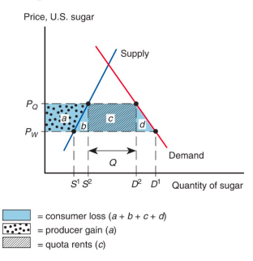

Stolper-Samuelson Theory: If the relative price of software decreases, the production of software becomes less profitable. Thus, the economy reduces the production of software and increases the production of clothing as shown in the diagram above. The software industry releases both labour and capital and the clothing industry absorbs labour and capital from the software industry. Clothing is relatively labour intensive while software is relatively capital intensive. Thus, there is excess demand for labour and excess supply of capital. As a result, the wage rate rises and the rental rate drops. Because the price of clothing didn’t change and the price of software decreased, the real return of workers increases. Since the decrease in the rental rate is greater than the decrease in the price of software, the real return of capital owners falls

