Week 1 Introduction

What is Public Economics/ Finance

Public Economics studies the role of government in the economy

Questions:
- How do government policies affect economic outcomes?
- How to design policies maximizing social welfare?
- How are public policies set?

1.1 Perfectly Competitive Markets

In perfectly competitive markets
- No single firm will have economic power
- They will be price takers
- There is no negative externalities

The market will fail when one of the above assumptions is not met
- Will fail when there is externalities
  - I.e pollution

1.2 Externalities

When people produce or consume goods the harm/side effect they create is called and externality
- Can be positive or negative
- What role does the government have in fixing/encouraging these externalities to improve public welfare

2. Government in the Economy

- Government regulates economic activities
  - Correct/promote market failures
    - Positive/negative externalities
  - Protection: In a competitive market, some firms may want to exploit human weakness/irrationality
    - Placement of candy bars at checkouts at supermarkets
    - Gambling
    - Banking royal commission
- Macroeconomic stability
  - Monetary policy
    - RBA manipulates interest → reducing interest rate to try and stimulate the economy/ promote GDP growth
      - Lower interest rate = reduces mortgages payments therefore increasing disposable income therefore increasing spending
  - Fiscal policy
- Expenditure
  - Public goods
  - Redistribution

- High government spending as a proportion of GDP does not indicate that public welfare is increased
  - May not be spending money effectively/efficiently

- Taxation
  - Efficiency
  - Equity

2.1 Australain Government Expenditure

- Largest portion of government spending is on social security and welfare
  - Provides social insurance and redistribution
  - Even if there is no market failure will want to spend money on social security

Social Insurance
- Is a transfer between taxpayers/ citizens
  - Taxes provide the funding for social insurance

2.2 Top 1% Income Share
- Rising inequality has led to investigation into the wealth of the top 1%

Proportion of income that 1% hold in Australia is around 10%
- Much lower than that of the US
- But there has been a great increase in the past 30 years (5-10%)

2.2.1 Differences in Pay across sectors

Wage of one hedge fund manager would pay for 8690 Kindergarten teachers

3. Inequality & Social Mobility

Perfect equality in a market economy may not be feasible or even viable
- There is often a tradeoff between equality and efficiency

Good social mobility people have similar opportunities to achieve economic well being
- Want equal opportunity not equal outcome

Government Primarily funds expenditure through income taxes
- Progressive tax system

3.1 Progressive Tax rates internationally (2004-2008)

Different countries have different top marginal tax rates

There is a correlation between the higher marginal tax rates leading to reduced 1% share of income

4. Political Economy

Economists must not only know their economic models, but also understand politics, interests,
conflicts, passions – the essence of collective life.
– Alejandro Foxley

Public policies are made through political processes.
- Optimal policies need not necessarily implemented.

Political Economy studies the interaction of politics and economics:
- effects of politics on economic outcomes
- collective choices of heterogeneous interests

4.1 Differing Political Opinions

3 major parties in Australia have vastly different opinions on Taxation and Spending (i.e Health Care)
- Different parties in power mean there would be very different policy outcomes

4.1.1 Brexit
- Economists suggest that it is not economically sensible to leave the EU

4.2 Economic Policy Uncertainty
- Data taken from newspaper articles

Week 2 - Externalities

What are externalities?

Why do externalities cause market failure?

How to deal with the market failures due to externalities?

Remedies for Externalities:
- Private bargaining
- Corrective taxation
- Cap and Trade

What are Externalities?

Externalities arise whenever the actions of one party directly affects the welfare of another party, yet the first party neither bears the costs nor receives the benefits of doing so.
- Activity can be consumption or production

“directly” - means that it is not because the first party’s actions affect the market price

1.1 Positive and Negative Externalities

Negative Externalities - Activity negatively affects another

Positive Externalities - Activity positively affects another

EXAMPLES

Traveling by cars imposes several kinds of negative externalities on other by:
- Adding to congestion + increases travel time/delays of other
- Increases the risk of hitting someone else
- Contributing to air pollution

Use of fossil fuels imposes negative externalities on everyone by contributing to global warming

Vaccination/ preventative measures against contagious diseases have positive externalities because they reduce risks of transmitting diseases to others

1.2 Measuring Externalities

1.2.1 Air Pollution on House Value

- People value air quality and where you live has a great impact on this
  - Difficult to just ask someone how much “clean air” is worth to them
- If people clause clean air, the air quality in a local area should be capitalised into house prices
  - Revealed Preference rather than stated preference

Air Pollution regulations are often controversial due to the lack of empirical evidence on their costs and benefits

Chay and Greenstone (2005) - investigate the effects of the Clean Air Amendments on local air quality and housing markets

Total Suspended particulates (TSP) - small particles that are suspended in the air
- Compared Attainment counties and nonattainment counties
  - Attainment counties had lower levels of particulates

Attainment v Non-Attainment Counties
- Non-attainment counties had far worse air pollution
- Attainment counties were not subjected to more stringent requirements/regulations

Clean Air Act Amendments of 1970
- Far more stringent regulations on polluters in nonattainment counties

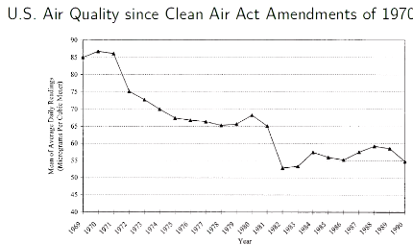

Act appeared to work and TSP amounts decreased

- How do we know the regulations worked?

- Maybe the pollution was trending downwards anyway
- Maybe it was because of something else

What if there was no clean air regulation?

Fundamental challenge in causal inference:
- We don’t observe the counterfactual

Methods for causal inference:
- Randomised control experiment
  - Not always possible in economics
- Natural experiments + econometric analysis
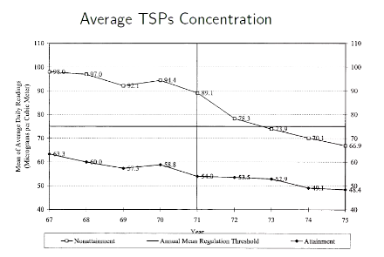

B) Findings

Related to house value in attainment counties
- House value of nonattainment counties increases by 2%

1 ug/m³ reduction in TSPS results in 0.2%- 0.4% increase in mean housing values

TSP nonattainment designations lead to:
- Improved air quality
- $45 billion aggregate gain for homeowners

1.2.2 Traffic Congestion and Infant Health

Motor vehicles are a major source of air pollution:
- 50% of Carbon Monoxide (CO)
- 34% of Nitrogen Dioxide (NO₂)
- 29% of Hydrocarbon emissions
- 10% of fine particulate matter (PM) emissions

Australia has the highest per capita carbon emissions among developed countries
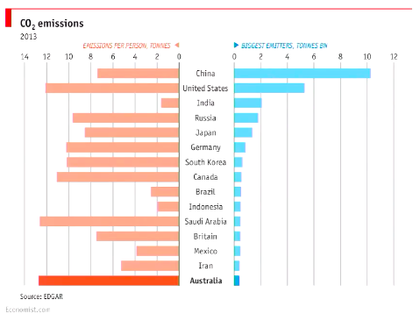

Places with traffic congestion have high concentration of polluted air
- Pregnant women and their babies are particularly vulnerable
- Does traffic congestion weaken the health of newborns?

- Just compare newborns in places with traffic congestion with those in places without?
- Difficult to isolate all confounding factors and pin down causality
- For example,omitted socio-economic status of mothers may induce spurious correlation
  - Better air quality is associated with higher housing prices
  - Low income earners may live in areas with more traffic congestion
  - Infants born to mothers with low socio-economic status may have poor health due to inadequate nutrition and health care duration during pregnancy
  - Positive correlation between traffic congestion and poor health of newborns EVEN if no causality exists

Cannot do actual scientific experiments because it not ethical/ feasible

B) A Natural Experiment - Introduction of Automatic Toll Passes

Electronic toll collection systems replaced old-fashioned toll collections that created bottle necks for traffic
- Introduction of electronic systems reduced both traffic congestion and vehicle emissions near highway toll places

Among mothers within 2km of a toll station the introduction of electronic tags reduced
- Prematurity by 10.8%
- Low birth weight by 11.8%
  - Relative to mothers 2-10km from toll station)

1.2.3 The Accident Externality from Driving

One’s driving increases the risks of others being involved in accidents, either due to their faults or not
- Very cautious drivers could still increase the others’ costs of driving due to high accident risks, simply because there would be more cars on the road to potentially hit
- But after an accident, one only pays the damages according to the apportionment of liabilities

When a person decides whether to drive or not, they do not include the social costs of increasing accident probabilities
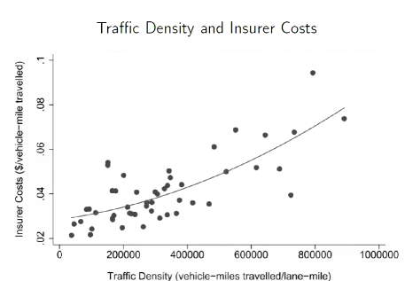

Found there is a positive relationship between traffic density and increased insurer cost

THUS the social costs of making traffic denser are not internalised in decision making
- Can we mount an argument that having more cars on the road slows down the traffic to the extent that it reduces accidents?
  - In that case, although driving has negative externalities on traffic congestion/delay it may have positive externalities on accidents
  - Since insurance companies pay out money to cover damages from accidents, the insurer costs would partially capture the accident externalities
    - DATA DOES NOT SUPPORT THIS CONCLUSION

1.3 Encouraging Positive Externalities

Tourists enhancing the experience of other tourists by dressing up at historical sites
- Encourage this by providing free entry if in traditional dress

2. Remedies for Externalities

2.1 Private Bargaining (Coase Theorem)

Property rights are clearly assigned, parties could bargain to internalise all costs and benefits, achieving social optimum
- Coasian Solutions
- For efficiency, it does not matter which side the rights are given to
- Works for both positive and negative externalities

2.1.1 How does Coasian Bargaining work?

- Scenario
A textile factory can produce a ton of fabric to profit $200 and pollute the river next to it

A fisherman fishing in an unpolluted river can gain $500 but only $200 in a polluted river

The socially optimal outcome is no fabric production and no pollution:
- Maximising total benefit

No Fabric & No Pollution | $500
Produce & Pollute | $200 +$200 = $400

BUT if the rights to use the river are unclear (or for other reasons there is no bargaining) the textile factory ignores the externalities of its production
B) Coasian Bargaining

Suppose the fisherman has the right to use the river
- No fabric production and no pollution

Suppose the factory has the right to use the river
- The fisherman could bargain with the factory to pay them between $200 and $300 (as their total benefit will be $500) not to pollute
- The Factory would accept as this is a better payment that would only yield $200 normally

In either case the socially optimal outcome is achieved (No production/ No pollution)

IF private bargaining is feasible and there is a clear assignment of property rights there is potential to bargain to achieve the socially optimal level

2.1.2 Limitations of Coasian Solutions

Private bargaining may not be practical if:

- The costs of bargaining are high
- No point to bargain if gains is not enough to compensate the bargaining costs
- Eg legal fees, time etc

- The harmed parties cannot identify who caused the damages
- Unsure who to bargain with
- Same for benefited parties (positive externalities)

- Too many parties are involved
- Problems with coordination
- People have incentives to free ride

2.2 Other Private Solutions

2.2.1 Mergers

To internalise the otherwise external costs/benefits the affected firms could merge with the firms generating the externalities

The merged firms earn higher profits by setting the “socially” efficient production level

2.2.2 Social Conventions

Social norms assign implicit property rights
- Inexpensive BUT takes time

2.2.3 Class Action lawsuits

A large group of harmed individuals are collectively represented by one or a few members of the group
- The threat of class action suits help with some coordination problems but not all

2.3 Corrective Tax or Subsidies

Recall that surpluses are maximised in the market equilibrium:
- Market is efficient if there are no externalities

- MC = MB
- Without externalities: Private MC = Private MB → Social MC = Social MB
- WITH externalities Private MC =Private MB ⇏ Social MC = Social MB

2.3.1 Restoring Efficiency

With positive production externalities, impose a subsidy on production so that:

Private MC = Social MC

With negative production externalities, impose a tax (Pigouvian tax) on production so that

Private MC = Social MC

EXAMPLE

Demand: P = 100 - Q

Supply: MC = P = 30 (constant)

One unit of production generates a negative externality: Ext -20

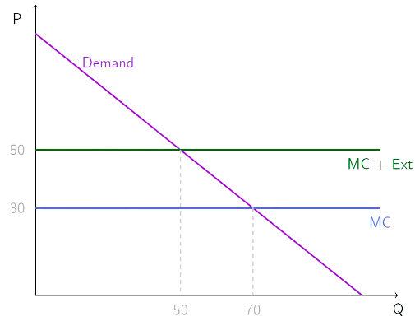

Initially producing where Q = 70. The Market does not clear at this point as some people are not willing to pay 30 for a unit of goods.

However, as there is the added cost of the negative externality which is NOT captured in the price of the good, the social cost is 50 per unit

The socially optimal Q is where the Social MC equals demand - less than than private MC level

Surplus
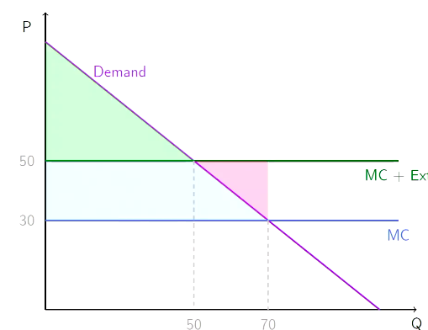

There is no producer surplus because the price is equal to the cost

The consumer surplus is triangle above the MC and below the demand curve

Pink Blue + Triangle is the externality when producing at privately optimal level

Social Surplus = Consumer Surplus - Total Externality

2.3.2 Limitations of Corrective Taxes and Subsidies

To implement corrective taxes/subsidies and achieve social optimum, the government needs information about externalities, which may depend on the production level

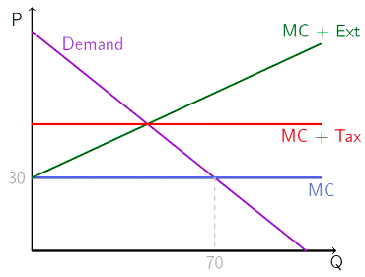
If the externalities is increasing → with each unit increase the unit of externalities produced also increases (Green Line)

To impose a tax will need to determine the socially optimal level and then determine the tax amount accordingly
- Emission Fees

Corrective taxes weaken the incentives for the polluters to produce
- But what we really want is for the producers to just reduce pollution

What if for the same level of production some firms pollute less than others?
- If firms can choose/invest in greener production technologies
- Facing uniform corrective tax on outputs, polluters have no incentives to opt for greener production processes

IF PRACTICAL - may be better to charge an emission fee rather than tax output

B) Cap and Trade

Instead of imposing taxes or fees, government can issue permits to pollute
- Unused permits can be sold to other polluters needing more permits

Trading prices of pollution permits are more responsive to inflation than fixed fee emissions
- But depending on the situation - cap and trade may or may not be more responsive to uncertainties of pollution reduction costs and benefits

Cap-and Trade is transfer between firms, while emission fee is a transfer from polluters to the government

C) Australia’s Carbon Pricing Scheme

Enacted by the Gillard Government in 2012
- Scheduled to transition into cap-and-trade scheme in 2015

But first with fixed emission fees (i.e carbon tax)
- Effective july 1st 2012
- $23.00 per tonne of CO2
- Applicable for entities which emit over 25,000 tonnes of CO2 per year
- Excludes transport/agricultural sectors
- Revenue raised was used to reduce income tax by lifting tax free threshold

Scheme repealed in 2014

D) Command- and- Control Regulation

EXAMPLES

- Corporate average fuel economy standard for all new passenger vehicles
- Mandating all new power plants to install “scrubbers” to remove particulates and reduce emissions

Less Flexible

BUT could be better if it is very hard/ costly for the government to monitor emissions

3. Difference-in-Differences

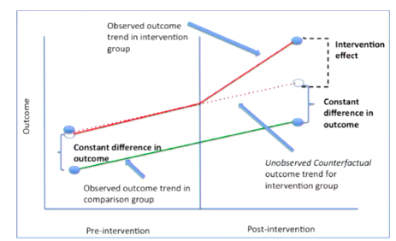
The Idea: Look at a comparison group that is likely to have a parallel trend of outcome in the absence of the intervention

Obama Age Comparison
- Michelle and Barack before presidency look the same age
- After presidency compare how they have aged
  - Michelle is the control group in this instance
  - Being the president is the intervention

Is the assumption holds this gives us more credible evidence that there is a change as a result of the intervention as there was a measurable and notable change from the control group on the intervention group

Week 3 - Public Goods

Public Good: Non-excludable/ non-rivalrous in consumption

Non-Rival: one individual’s consumption of a good does not affect another’s opportunity to consume the good

Non-Excludable: Individuals cannot deny each other the opportunity to consume a good

Pure Public Goods | Impure Public Goods
Goods that are perfectly non-rival in consumption and non-excludable | Goods that are non-rival in consumption and non-excludable to some extent (but not fully)  Example: Great Wall of China  - Party excludable: admission fees  - Partially rival: crowdless

Types of Goods

 | Rival | Non-Rival
Excludable | Private Good | Club Good (Impure Public Good)
 | Ice cream | Wifi-internet
Non-Excludable | Common Resource | Public Good
 | Tuna stock | Asteroid defense

1.1 Impure Public Goods
Club goods and common resources are impure public goods

Impure public goods include public goods with possible congestion, such as:
- Sidewalks
- Beaches
- Public-wifi
- Classroom access

1.2 Tragedy of the Commons

Typical example of market failure

Common Pool resources - collectively people will not want to over-extract the resources BUT individually given that what other people are doing may find it beneficial to extract more

Resources that can be used by everyone will be depleted more so than the privately owned ones
- This is because the short term self interests of people using the pasture made them consumed too many resources
- In the LR everyone lost

1.2.1 Over-Fishing

Regulating Fishery:
- Large number of small-scale fishing vessels
- Vast ocean, hard to patrol

In the high-seas / internationally territory, no single government has the right to extract resources, and as a result a lot of fishing stock is overfished
- About 29% is overfished

- China’s Seasonal Fishing Bans

For sustainable fisheries, China prohibits commercial fishing in its exclusive economic zones for several months per year
- Attempt to rectify market failure

Is this actually effective?
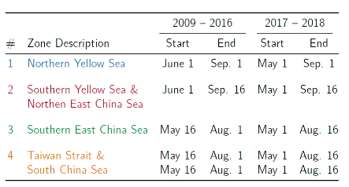

(B) Suomi National Polar-Orbiting Partnership Satellite

Hishan’s Paper

- New generation weather satellite launched October 2011
- Polar Orbiting (pass through the same place twice a day)
- Better Sensors
  - Use to make Automatic Boat Identification System

Using this tech can see the change in the number of boats in the exclusion zones during seasonal bans → suggests that the ban DOES work
- Fishing ban is command and control policy
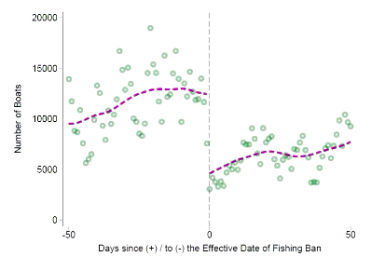

Decrease in the number of boats after seasonal ban is in place

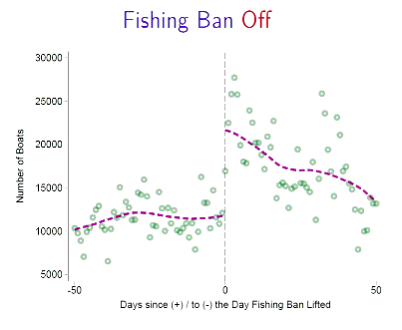

Increase again in the number of boats once the ban is lifted

1.3 Public Goods

Public goods are NOT equal to goods provided by the government
- Markets can provide some public goods
  - E.g fireworks provided by individuals
- Non-profit organisations could provide some public goods
  - Museums ran by charities

- The government could provide some private goods
  - e.g childcare as done in Sweden/ Norway

One could think of public good as a case of extreme positive externality
- When someone’s consumption affects other people in a positive way this is a positive externality

2. Optimal Provision of Private Goods

Market generally does not produce the optimal level
- Produces an EFFICIENT level of consumption

2 (Private) Goods:
- Ice cream (ic) with price P_{ic}
- Cookies (c) with price P_{c} = 1
  - (Numeraire good whose price is normalised to 1)

Two individuals Ben (B) and Jerry (J) demand different quantities of the goods at the same market prices

Marginal Rate of Substitution (MRS): The number of cookies the consumer is willing to give up for one ice-cream cone
- This is the MRS in cookies

Each consumer will have their own MRS
- Ben = MRS^{B}
- Jerry = MRS^{J}

2.1 Utility Maximisation
The utility (or happiness) of an individual depends on their consumption of:
- Icecream
- Cookie

But for both Icecream and Cookie MORE is better
- BUT there is a budget constraint
- More ice cream means less cookies and vice versa
  - Trade off between ice cream and cookie exists
An individual’s problem is to choose a bundle of icecream/ cookie to MAXIMISE utility

2.1.1 Indifference Curves
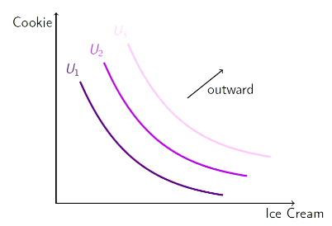

To represent how Icecream/ cookie affect utility in a graph we use indifference curves

Each curve represents a different level of utility and the higher the curve the better off (happier) the consumer will be

U₃ > U₂ > U₁
- More outwards indifference curves indicate higher level of utility

Along the indifference curve the utility is the same, thus an individual is different among any point on the curve (No different between a point A and a point B)
- Each point represents a different combination of cookies/icecream

Downwards sloping curve because MORE consumption is better
- Low consumption of one thing is compensated by high consumption of another thing

2.1.2 Marginal Rate of Substitution

MRS - the number of cookies the consumer is willing to give up for one icecream cone
- maintain utility level
- Also the (absolute slope) of an indifference curve

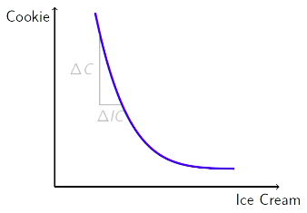

- MRS = | Slope of IC |

Optimal Consumption of Private Goods
- Optimal consumption = relative price
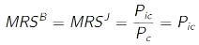

There is diminishing marginal utility for the goods
- The more icecream you consume the less utility you get from the additional units of consumption
- This is why the IC has a convex shape
  - Initially you are willing to give up alot of cookies for the first scoop of icecream, but as you move further along the curve and have more and more icecream you are less willing to give up cookies because you are gaining less utility from the icecream

When the price of cookies is right your MRS is high also

2.2 Profit Maximising Condition
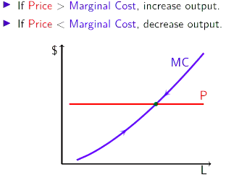

Optimally (profit maximising) on the supply side - MC_{ic} = P_{ic}

MC is not the same as the AC
- cost of producing one extra unit
- Is upwards sloping because the cost of producing one extra unit is increasing due to diminishing marginal returns
  - Will produce a level of output where price is equal to marginal cost

2.3 Optimal Provision of Private Goods

MRS
- Absolute slope of the indifference curve

2.3.1 Optimal consumption of private goods

- Price must be equal to the MRS

2.3.2 Optimality on the supply side

MC_{ic} = P_{ic}

2.3.3 In Equilibrium

MRS^{B} = MRS^{J} = MC_{IC}

2.4 Private Goods Market
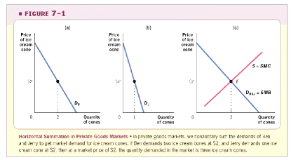
- Add individual demand curves together to get “Market Demand”
Private Sector Provision: MRS = MC for each individual
- No externalities etc we have an efficient outcome
  - More expensive to produce more than the social benefit provided

3. Optimal Provision of Public Goods

Replace private good ice-cream (ic) by a public good missile (m)

Now the MRS for Ben and Jerry are:
- MRS^{B} : number of cookies BEN is willing to give up for one missile
- MRS^{J}: number of cookies JERRY is willing to give up for one missile

The society is willing to give up MRS^{B} + MRS^{J} cookies for one missile
- As the missile is a public good, Ben’s consumption/enjoyment of the public good doesn’t exclude Jerry’s consumption/enjoyment of the public good
- All together the society is willing to give up the total amount of MRS of all those benefiting from the public good
  - Compare to private good where one icecream goes to Ben or Jerry

3.1 Optimal Provision of Public Goods

Socially optimal provision for the public goods requires:

MRS^{B} + MRS^{J} = MC_{m}

- This is the social benefit of one extra missile

3.1.1 Samuelson Rule

Provision of Public Goods is optimal when the MC is set equal to the sum of the MRSs, rather than being set equal to each individual MRS

3.1.2 Public Good Market (Vertical Summation)
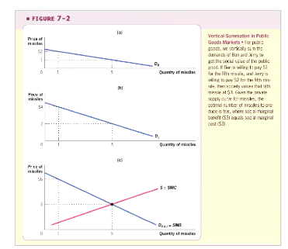

We when aggregate social benefit curve, we are doing vertical summation (add individual demand up vertically)

Ben is willing to pay $2 for one unit of missile

Jerry is willing to pay $4 for one unit of missile

- All together they are willing to pay $6 for one unit of missile

Socially optimal level will be where D = MC
- social benefit for one extra unit is equal to the cost of one extra unit

5. Private Sector Under-Provision

Private sector provision:
MRS = MC for each individual
- If individuals are paying for the good in the market will reach a point where MRS = MC
- This will dictate how consumers pay
- They will consider their own benefit and what they’re willing to give up

It means Σ MRS^{i} > MC - socially sub-optimal

- Sum of each individual MRS is greater than the MC - more that people are willing to give up and more benefit that could be derived

Diminishing Marginal Utility from consuming a good implies under-provision
- First unit of public good has great utility, people are willing to give up a lot for it,
- As you the utility decreases the MRS to give up cookie decreases

If you leave it to the market how much public good we should have there will generally be an under provision of public goods

5.1 Free Rider Problem

When an investment has a personal cost, but a common benefit, individuals will under-invest
- If a person is not capturing all the benefit they will under invest
- If you’re only getting part of the benefit you will not want to pay the same amount as you would when you’re capturing the whole benefit

Because of the free rider problem, the private market under-supplied public goods
- Since Ben’s consumption of missiles also benefits Jerry, Jerry may not want to pay (and vice versa)

Another way to see it:

Private provision of a public good creates a positive externality since everyone else benefits
- Markets will tend to produce less than the socially optimal level

5.1.1 Free Rider Problem in Practice

Radio and Television Programming

WNYC has audience of approx 1 million people BUT only 7.5% of listeners support station financially (free riding)

The UK uses a non-market solution
- BBC charges an annual licencing fee to anyone who owns and operates a TV
  - Worked very well in the past BUT NOW can stream/ watch online

Public Broadcasting System (PBS) is largely supported by the US federal/ state governments
- Study that it is beneficial to education especially economically disadvantaged children

5.2 Private Provision with Free Riding

The free riding problem does not lead to a complete absence of private provision of public goods

Private provision works better when:

- Some individuals care more than others:
Private provision is particularly likely to surmount the free riding problem when individuals are not identical, and when some individuals have an especially high demand for the public good.
- Incentive of individuals is not identical

- Altruism

When individuals value the benefit/costs to others in making their consumption choices
- In reality not everyone is selfish/only cares about their own benefit

- Warm Glow

Individuals care not only about the total amount of the public good but also their particular contributions
- They may not care about the end result this may have different policy results

5.3 Lab Experiments on Free Riding

Subjects (often students) are brought to the lab where they sit through a computer team game and get paid based on the game outcomes

EXAMPLE:

(Marwell & Ames)
- 10 repetitions for each game
- In eachgame, groups of 5 people, each with 10 tokens to allocate between cash and public good
- If take token in cash get $1 in cash for yourself (private good)
- If contribute to common good, each of all five players get ($0.5)

Nash Equilibrium: get everything in cash ($10 each)

Socially optimal equilibrium: Contribute everything to public good ($25 each)

In the lab subject contribute about 50% to public good, but public good contribution falls as the game is repeated

Explanation: people are willing to cooperate at first but get upset and retaliate if others take advantage of them

5.4 Crowding Out of Private Contribution (by Government Provision)

Government could provide the public goods using tax revenue/ mandate individuals to contribute
- Correct market failure

If only the level of public goods and the level of private consumption matter, government provision of public goods may crowd out voluntary contribution

If the crowd out is one-to-one total level of public good provided would not change
- However, government mandated contributions will have an effect as soon as private contributions fall to zero since individuals cannot contribute negative amount and undo government position

5.4.1 Empirical Evidence on Crowd-Out

Two Strands of Empirical Literature
- Fields of studies
- Lab experiments

Lab experiments show imperfect crow-out in public good games (where you compare situation with no mandated public goods, contributions and mandated public good contributions)

Lab Experiments are a great device to test economic theories but they might not capture important motives for giving
- Warm glow/prestige/solicitation from fundraisers

- Hungerman (2005)

Studies crowd-out of church-provided welfare (soup-kitchens etc) by government welfare
- One aspect of the 1996 Clinton welfare reform act
  - Reduced/eliminated welfare for non-citizens
- Difference-in-difference strategy
  - Compare churches in high non-citizen areas with churches in low non-citizen areas before/after the 1996 reform
- Estimates suggests that total church expenditure in a state increase by 40 cents when welfare spending is cut by $1

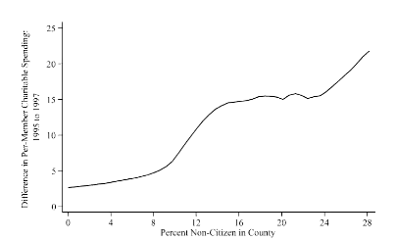

There is some crowd out

Different counties have different percentage of non-citizen residents - in those counties there is an increase in Church spending AFTER the welfare reformed
- Suggests that there is some crowd out if the government provides public goods

Not a 1:1 crowd out → some people are contributing

5.4.2 Charitable Giving

Charitable giving is one form of private provision of public good
- Big in the US 2% of national income given to charities
  - Tax implications
- Related to Americans, Europen people tend to donate more time than money

Charitable giving funds
- Religious activities
- Education
- Human services
- Health
- Arts
Various causes (environmental, animal protection etc)

Encouraged by government → charitable giving often can be deducted from income for income tax purposes

- Reasons for Giving
- Warm glow (name on building)
- Reciprocity (alumni)
- Social pressure (churches)
- Altruism (poverty relief)

Those effects are not captures in basic economic model

Charities have big fun-raising operations to induce people to give based on those psychological effects

(B) Reciprocity

Evidence from randomised field experiment

Falk (2007) conducted a field experiment to investigate the relevance of reciprocity in charitable giving
- In collaboration with a charitable organization, Falk sent 10,000 Christmas solicitation letters for funding children in Bangladesh to potential donors in Switzerland
- Potential donors are randomised into 3 groups
  - Control Group: No gift
  - Treatment 1: a small gift= 1 postcard + 1 envelope
  - Treatment 2: a large gift = 4 postcards + 4 envelopes

Results (Likelihood of giving)

Control Group: No gift → 12% (would give)
Treatment 1: a small gift → 14% would give
Treatment 2: a large gift → 21% would give

- A 75% increase related to the control group

- Large Gift was very effective (Contribution amounts increased with gift size)

(C) Social Pressure

DellaVinga-List-Malmendier (2012) design a door-to-door fund raising randomised experiment

Addresses were randomised into 3 groups
  - Control Group: No advance warning of fund-raiser visit
  - Treatment 1: flyer at doorknob informs about timing
    - 9-25% less likely to open door for fundraising
  - Treatment 2: same as treatment 1 BUT can tick Do Not Disturb
    - A number of people opt out and unconditional giving is 28%-42% lower

Social pressure is an important determinant of door-to-door giving and door-to-door fundraising campaigns lower utility of potential donors

6. Costs and Benefits of Public Goods

Efficient use of public resources to provide public goods requires a cost-benefit analysis BUT
- Estimating the costs of providing a public good might be difficult
- Estimating the benefits of proving a public good might be even harder

6.1 Measuring Benefits of Public Goods

Preference revelation: Individuals may not be willing to tell the government their true valuation

Preference knowledge: Even if individuals are willing to be honest, they might not know what their valuation is because they have little experience in pricing public goods like highways/ epidemic prevention

Preference Aggregate: How can the government effectively put together the preferences of millions of citizens to decide on the value of a public good

These problems are addressed by the field of the political economy.

EXAMPLE Airport Link Tunnel

- Cost $4.8 billion to build and opened in 2012
- 135,00 trips per day was forecast
  - When its operator BrisConnects went into receivership in 2013 it was 47,802 trips per day

Week 9 Political Accountability

Education accounts for the 5th biggest allocation of government expenditure in Australia
- 7.3%
- As in the case in other advanced economies as well

Why should the Government be Involved in Education

Not obvious because education does not look like a public good:
- Returns to education seem largely private
  - Higher wage for individual
- Education is excludable
  - Have to pay for university courses etc
Shouldn’t we expect students to invest roughly the optimal amount in their own education?
- If education doesn’t seem like a public good suggesting it may be subject to the market which is generally optimal, why does the government get involved?

1.1 4 Motives for Government Intervention

- Externalities
- Productivity spillovers: someone working in an environment where other people are highly educated will mean overall there is increased productivity
  - An individual’s education will increase other people productivity
- Crime
- Citizenship

- Credit Market failures
- Students might not be able to borrow enough money in the credit markets to finance their education even if the returns are great
  - Education is an investment in human capital/yourself
- If the credit market worked well then each person would optimise and seek education as it increases earning potential
- As the credit markets fail creating underinvestment in education
- Family Failures
- Divergence between parent and child preferences
- Some parents may not take good care of their children

- Individual Optimisation Failures
- In a private goods market if individuals know what the costs/return of their education is, they can make the calculation and invest
- People may not have all the information
- Young people might not do what is in their long-run interest due to self-control problems or lack of information
These motives may give governments reason to intervene in the market and assist in providing education

1.1.1 Externalities of Education on Crime and Voting
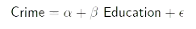
- Crime is costly to society and requires governments to spend money to maintain civil law/order
- Costs victims of crime lost

Observational studies simply comparing the educated v. uneducated likely get a biased estimate because propensity to crime (ε) is negatively correlated with education
- Highly educated people on average commit less crimes
- Unsure if this means education CAUSES less crime
  - May be that they instead growth up in a higher income family/ more educated family/ family that can afford a good lawyer

Lochner v Moretti (2004) use variation from state compulsory attendance laws:
- State T increases compulsory attendance from 9 to 10 years at time t
  - Students have to attend school for at least 10 years of education
- State C does not
  - Differential timing in adoption of compulsory attendance laws creates a natural experiment that induces differences in individuals education levels

Results:
- Shows that an extra year of schooling reduces incarceration rates significantly:
  - 0.1 percentage reduction for white males relative to mean of 1% incarcerated
  - 0.3 percentage reduction for black males relative to a mean of 3% incarcerated

Suggests education has huge impact on crime rates

Gap in schooling between whites/black accounts for more than 1/4 difference in crime rates

Social return to education exceeds private return by 25% based purely on reduction in crime
- Individuals don’t capture full benefit of education

Using the same strategy, Moretti, Mulligan & Oreopoulos (2003) find positive effects of education on likelihood of voting- in advanced economy/democracy
- High participation rate in political process is good becuase allows country to make more informed decisions
- Improve legitimacy of the government

1.1.2 Productivity Spillovers

Productivity externalities exist if the human capital acquired through education not only makes the educated workers more productive but also makes people who work with the educated workers more productive
- Human capital summarising the set of skills/knowledge etc that make the worker more productive
- Usually the primary way of getting human capital is by way of education

- Workers may under-invest in education if they do not capture all the benefits of their education
  - Generally, people make the decision to invest in their own human capital based on the extent that the education will be beneficial to them/improve their life outcome etcs
  - If there are productivity spillovers and an individual’s education can benefit their co-workers the individual may not invest enough as they do not capture the full benefit
- On-the-job training may make up some under-investment, specifically for job-specific or firm-specific investment in human capital
  - The individual firm may have some incentive to mitigate the market failure by providing the training
  - Because the firms can capture this additional benefit
- But firms are unlikely to make up the under-investment in general skills, which workers could carry with them as they move from one employer to another

- Evidence of Productivity Spillovers

- No strong data in the form of evidence yet in the form of causality experience
  - There is some subjective evidence however
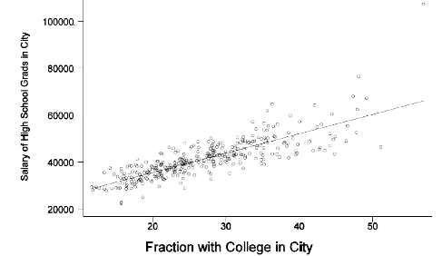

Enrico Moretti - fraction of college graduates to salary of high school students

The Salary of high school graduates is higher when there is a greater proportion of college graduates in the city

Suggests that there is productivity some spillover happening

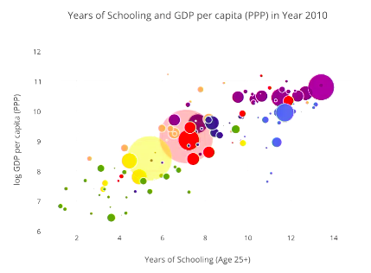
(B) Years of Schooling and GDP per capita

There is a positive correlation between years of schooling and higher GDP per capita in an economy

Size of the bubble indicates size of population

Provides some subjective evidence that a more educated labour force increases economic productivity and wealth

1.2 Family Failures - Divergences between Parent & Child Preferences

Another reason for government intervention is the potential divergence between parent and child preferences
- Not saying that parents don’t want the best for their child, but rather that parents may not know/ be able todo what is best for their child OR may disagree with what their child think is best for themselves
- With preferences it is hard to tell whether people are being honest with regard to the truth

Hard to find direct evidence

Duflo (2003) shows evidence that grandmothers spend more than grandfathers on female grandchildren
- Pension reform in 1992 in South Africa (developing country) gave all Blacks (65+) a minimum pension when household income is low
  - Previously only white south africans could get the pension under Apartheid
  - Payment would go to grandmother rather than grandfather

Pension availability improves the weight for height Z-score of female grandchildren (nutrition improves) when a grandmother gets the pension
- But not when a grandfather gets the pension
- Grandmothers transfer a greater amount of resources to granddaughters

Parents preferences matter for kids outcomes

1.3 Borrowing Constraints - Effects of Loans

Even if we forget about the externalities (productivity spillover/ reduction in crime)
- The market may still fail
- Young people tend not to have large amounts of savings and education can be quiet expensive (especially higher education)

If the individual is optimising and choose optimal level of education, may have to borrow money to afford the education
- BUT the credit market may not work well

If there are no borrowing constraints (and individuals are rational) current resources should not matter for education decisions:
- Invest ineducation only if: presented discounted value of benefits > costs

- Will invest up to a point where Future benefits are equal to the costs

Human capital/ skill coming from education is not tangible
- When taking out a mortgage you have the house as collateral and bank can recover their investment
- In the case of human capital the bank cannot do this
  - As future capital is hard to use as collateral the ability to borrow for education is limited

Empirical evidence shows that availability of loans do matter suggesting that borrowing constraints are an issue
- To what extent is this the case?
- If people are limited in their ability to borrow against future earnings to invest in their future education then the availability of government loans could make a big difference in the education decision

Solis (2013) studies the effects of guaranteed loan on college attendance in Chile
- Again naive comparison of students with and without guaranteed loans are problematic

In Chile, guaranteed loan is available if test score of student is above threshold, which is 475
- This policy may gives us a kind of natural experiment using Regression Discontinuity (RD) Design:
  - Takes advantage of the as if randomisation of students with test scores close to the cutoff
  - Comparison of scores close to the threshold would be similar students
  - By chance some students have achieved a higher score - the randomness provides some local randomisation
  - If someone has a guaranteed loan may provide a discrete increase
- Does discontinuity in load availability translate into discontinuity in college attendance?
  - yes
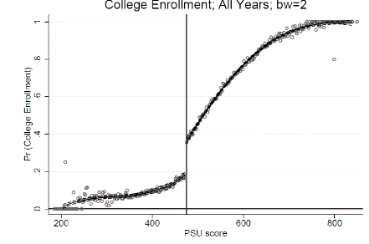

- To the left of the threshold, will not get loan, to the right of the threshold will get a loan

There is a sharp increase in the probability of a student going to university

Provides compelling evidence that the availability of student loans causes a lot of students to attend university

- In a world without credit constraints, people can borrow to invest in their future there will not be this sort of discontinuity

- The fact that we see this sort of discontinuity suggests that the private market doesn’t function like we would want it to
  - Alot of students have borrowing constraints, they cannot borrow money if they want to invest in their education

1.4 Individual optimization Failures

1.4.1 High School

Even if we forget about externality people may not be optimising their choices

Rational education decision should be based on comparing returns to education (higher wage later in life) v cost of education (tuition and time)
- Requires that young individuals know the return to education
- Also a lot of randomness

Jansen (2010) shows that simply presenting information about rate of return to education changes behaviour
- Survey data
- Randomised field experiments

From survey data for eight-grade boys in the Domincan Republic:
- Jansen (2010) finds that the boys’s perceived returns to secondary school are extremely low, despite high measured returns
- It is based off these perceptions that people make decisions

Then carried out randomised field experiment
- Students at randomly selected schools were split into 2 groups
- One group given information on the higher measured returns others not given any information
- Those given the information on the increases completed on average 0.20 more years of school over the next 4 years when compared to the group that received no information

1.4.2 University

High-achieving US students (top 2% of SAT scores) from disadvantaged backgrounds apply to weaker colleges more than other high-achieving US students (Hoxby & Avery, 2012)

Even though top schools offer generous financial aid to talented students from disadvantaged backgrounds

High achieving students still had a large optimizational failure

Mechanism:
- Poor talented kids in “nowhere” schools do not get good advice from family/local counselors
- End up going to localcollege (often paying more than they would at top college)
- Informational failure prevents poor but talented kids to exploit their potential

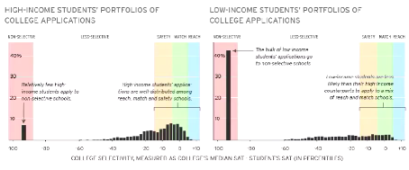

- The percentage of “poor” students applying to “non-selective schools” is much greater than richer students

Result:

Did randomised experiment providing personalized mailing info to talented students
- Relevant suggested applications, net cost calculator
- Significant effects on number and quality of applications

Students had better information on their educational options

2. Public Funding for Higher Education

With all these market failures/ positive externalities it is not a surprise that governments invest in public education
- Different countries have different levels of fees for education

2.1 Public Support for Tertiary Education
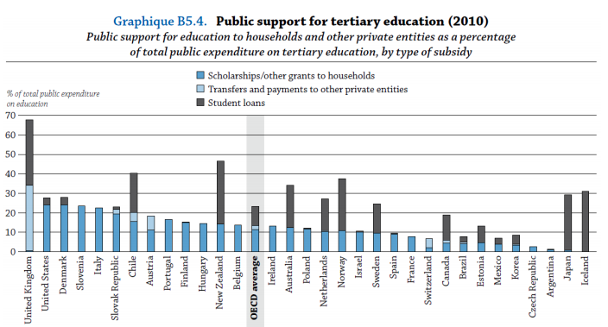

- Direct Subsidies to university count for smaller proportion of contributions in UK/US
- Government Provides the loan and only pays back if they achieve a certain income level (AUS)

Governments around the world recognise there is a market failure and that they should intervene and provide funding BUT there are different ways to do it

3. Social Insurance

3.1 Social Insurance Programs

Social Insurance Programs are government interventions in the provision of insurance against adverse effects

Examples
- Health insurance (Medicare. Pharmaceutical Allowance)
- Retirement insurance (Age Pension)
- Disability Insurance (Disability Support Pension)
- Unemployment insurance (Newstart Allowance)

Contrast with welfare which are usually means-tested transfers

Social Insurance is the biggest and most rapidly growing part of government expenditure today
- Social security/welfare is 34% (and Largest) portion of Australian Government expenditure

3.2 What is Insurance

Insurance Premiums:
Money that is paid to an insurer so that an individual will be insured against adverse events.

Examples of private insurance
- Health insurance
- Auto insurance
- Life insurance
- Casualty and property insurance

3.2.1 Expected Utility Model

One reason to buy insurance is that people are risk adverse
- They have a concave utility function
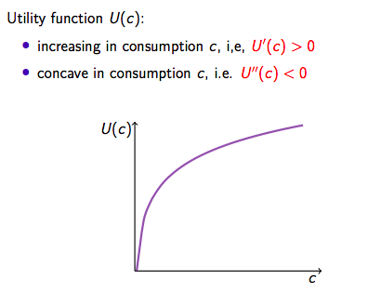

Utility depends on consumption alone
- Utility function of the consumption level

Properties:
1. Increasing in consumption - more consumption equals more utility which is better → Always has a positive slope

2. Function is concave - meaning that it increases at a decreasing rate as we have more consumption (DMR)

Individuals maximise expected utility defined as the weighted sum of utilities across states of the world, where the weights are the probabilities of each state occurring

Suppose an individual has income Y:
- If there is no adverse event, she consumes all of her income Y:
  - If there IS an adverse event, she loses L and only consumes what is left Y-L

Let q be the probability of an adverse event, then the expected utility is:
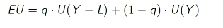

Expected Utility is the utility when the adverse event occurs x the probability of that event plus the utility from no adverse event occurring and the probability of it not occurring

3.3 Actuarially Fair Insurance

Actuarially Fair Insurance

Where Insurance premium = Insurer’s Expected Payout
- On average the insurer doesn’t make money

Examples of Private Insurance
- Health insurance
- Auto insurance
- Life insurance
- Casualty and property insurance

Suppose there is an actuarially fair full insurance contract:
- Always pay premium p
- Receive payout L only if Adverse event happens
  - Where L is sufficient to cover the full cost of the adverse event

Actuarially fair means that: P = qL (Premium = to the expected payout)

3.3.1 Insurance or Not?

Would the individual bet better off buying insurance?

To illustrate, let:

- Probability of Adverse event = q= ½
- Income = Y =25
- Cover = L=16
- Utility of consumption= U(c) = √ c

Actuarially fair: p =qL = 8

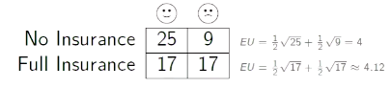

- The EU of insurance is greater than no insurance so it is better to insure than not

3.4 Gains from Insurance

Thus, having full insurance increases expected utility
- A concave utility function means diminishing marginal utility
- Marginal Utility is the extra amount of utility one gets (or loses) if one increases (or reduces) a small unit of consumption

Marginal Utility is low when the consumption level is high
- Due to DMU an individual would like to smooth consumption across states

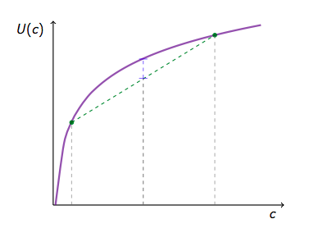
The utility from a certain amount of consumption at the expected consumption level is higher than expected utility of uncertain consumption:
A

B

2 Scenarios - One is a low consumption situation (adverse event has occurred and you have to spend money on it) and the other is a high consumption situation (no adverse event)
- Probability of event happening is ½
- EU would be the weighted sum of these 2 utility levels and would be at A
- Utility from the expected consumption (B)
  - What happens if the consumer consumes the average consumption

Being certain about consumption gives you more utility than being unsure

3.4.1 Full Insurance or Partial Insurance

In the previous example, there is full insurance
- Consumption is the same in both states
- And equals to Y -qL

Generally don’t have full insurance

If the insurance contract is partial insurance, the insurer pays out part of the loss when an adverse event happens: pL, where 0 < p < 1

For the same argument for income smoothing, the individual would like full insurance (p= 1) to maximise expected utility
- If they have full insurance they are certain to consume the average consumption
- If they have partial insurance they will consume at a worse point than if there is certainty

3.5 Heterogeneous Risk across Individuals

Suppose the adverse event is sickness
- There are two types of individuals (probably they will require payout from insurance)
  - Healthy q_{H} = 0.1
  - Sickly q_{s} = 0.5

3.5.1 Symmetry Information

Both Insurance Companies and individuals can observe health and sickly types (for example by age)
- Then insurance companies offer different policies to different types of people
- Both get full insurance
- But if Y < q_{s}L → sickly person cannot afford insurance and dies or starves if sick

3.5.2 Asymmetry Information

In reality neither insurance companies or individuals will have perfect information
- Only individuals can observe their own health and sickly types → insurance companies cannot

If insurance companies continue to offer the same two policies:
- p_{s} = q_{s}L for the sickly
- p_{H} = q_{H}L for the healthy
  - In both scenarios have full cover as premiums are equal to payout

Then everyone wants to buy the health insurance which is cheaper i.e even sickly people will buy the cheaper “healthy” insurance
- Insurance companies will make losses as the expected payout would be higher than the premiums paid
- Cannot be an equilibrium

3.5.3 Two Equilibrium Possibilities

(A) Pooling Equilibrium
- Insurance companies offer a contract based on average risk
- Good deal for sickly, mediocre deal for health but better than no insurance

(B) Separating Equilibrium

Insurance companies offer two contracts:
- one expensive contract with full insurance for the sickly,
- one cheap contract with partial insurance for the healthy
  - Each type self-select into its contract

Outcome not efficient as healthy as under-insured

3.5.4 Adverse Selection

Whole market may collapse as a result of the market failure:
- Asymmetry of information

When individuals know more about their risk level than the insurer and hence individuals with higher risk are more likely to purchase insurance.

EXAMPLE: people with high risk of getting into a car accident more likely to buy car insurance than people with low risk of getting involved in accidents.

With adverse selection, market of health insurance can unravel (“death spiral”):
Health insurance is offered at average fair price, bad deal for low risk people and hence only high risk people buy it ⇒ insurers make losses ⇒ insurers raise the price further ⇒ only very high risk people buy it ⇒ insurers make losses again ⇒ no insurance contract is offered at all even though everybody wants full actuarially fair insurance

3.5.5 How does the Government Address Adverse Selection?

The government can address adverse selection and improve market efficiency BUT this involves redistribution

Natural solution is to impose a mandate
- Everybody is required to purchase insurance
  - If price is the same for everybody, the low risk people end up subsidizing the high risks
  - From a social perspective, being high risk (e.g. having a
  - sickly constitution) is rarely consequence of individual
  - choices.

From a social perspective, being high risk (e.g. having a sickly constitution) is rarely a consequence of individual choices.
  - Society might want to compensate individuals for this

Explains why all OECD countries (except the US until Obamacare) have adopted universal health insurance

- Obamacare

- forbids insurers from charging based on pre-existing conditions
- mandates that everybody needs to get insurance
- subsidizes health insurance for low income families

Individuals may not appropriately insure themselves against risks if the government does not force them to do so (myopia, lack of information, self-control problems)
- If individuals understand their own failures, they will support social insurance (e.g., Medicare Health Insurance for elderly is very popular)
- If individuals really want to be myopic, they will oppose government social insurance (paternalism)

Administrative Costs
- The administrative costs for Medicare (U.S.) are less than 2% of claims paid.
- Administrative costs for private insurance average about 12% of claims paid.

3.6 Moral Hazard

Adverse actions taken by insured individuals in response to insurance against adverse outcomes

EXAMPLE: If you receive unemployment benefits replacing lost wages, you may not search as much for a new job
- Insurance reduces incentives to remedy adverse events
- Because the individual is not paying the full cost of the bad thing when it happens, they may not take action to ensure it will not happen

Moral Hazard exists with both private and social insurance as long as insurer cannot perfectly monitor the person insured
- Insurers do not offer perfect insurance

The existence of moral hazard problems creates the central trade-off of social insurance:
- insurance is desirable for consumption smoothing (increasing expected utility) but insurance can create moral hazard

3.6.1 Moral Hazard is Multi-Dimensional

Reduced precaution against entering the adverse state
- (example: auto insurance)

Increased odds of staying in the adverse state
-(example: unemployment insurance)

Increased expenditures when in the adverse state
- (example: health insurance)

4. Optimal Social Insurance

Optimal social insurance trades-off two considerations:

- How hard it is to observe whether the adverse event has happened
- How easy it is to change behavior in get into or stay in the adverse event

Optimal social insurance systems should partially, but not completely, insure individuals against adverse events.

5. Conclusions

Asymmetric information in insurance markets has two important implications:

- It can cause adverse selection in private insurance provision hence the need for social insurance
- It can cause moral hazard (as insurer cannot perfectly monitor behavior), hence the need to limit generosity of insurance

The ironic feature of asymmetric information is, therefore, that it simultaneously motivates and undercuts the rationale for government intervention through social insurance
- Some scope for the government to intervene but it is not by way of full insurance

Week 5 Equity & Redistribution

Income Inequality

Large increases in income inequality
- Especially in the top 5% and 1% of income earners

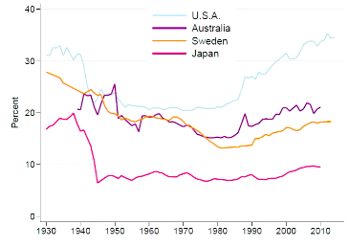
1.1 Top 5%

Share of total income against the top 5% of income earners have over the decades

Top 5% of income earners in the US in 2012 had ~35% of total income in the US
- Substantial increase since 1980’s in US

1.2 Top 1%
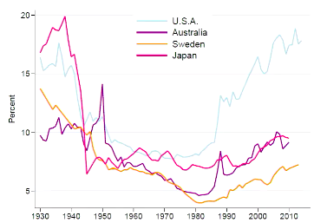

Top 1% of income earns share of total income has sky-rocketed

1.3 Wealth inequality in the US

WEALTH share rather than income share
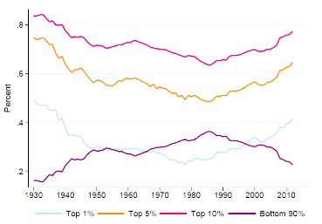

Top 5% hold more than 60% of the wealth in the US

Widening growth in the income/wealth inequality is that at different parts of the income distribution there are different growth rates in the income

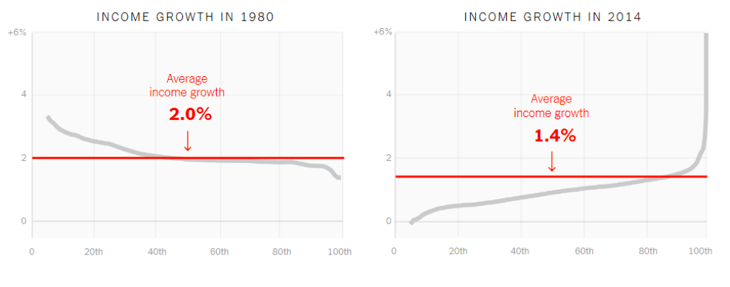

- 100th percentile = top income earners
- Since the 80’s the average growth rate has slowed
  - Income at the end of the distribution have higher than average growth and was growing faster than high income earners
- In 2014, average growth rate has declined BUT low income earners are growing at lower than the average rate and higher income owners are growing at above average rates

1.4 Australia Income Inequality
Issue of income inequality is US is particularly pronounced but also occurs in other countries
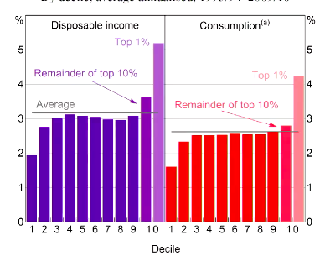

Splits population into 10 groups based in income level

Bottom 10% have much lower growth rate of disposable income between 1993-2010
- The rest close to average

10% have much higher rate of disposable income growth rate
- Top 1% even higher again

Same trend in consumption

1.5 Income inequality in the OECD

Measured by GINI Coefficient
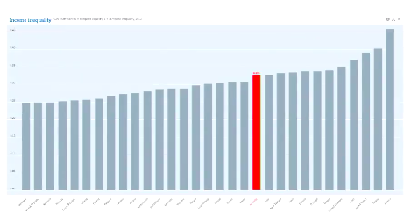

Australian GINI = 0.326
- Relatively high but not very high when compared to Mexico etc

1.5.1 What is the Gini Coefficient

Can be depicted graphically using the Lorenz Curve
- The Lorenz curve depicts the cumulative income shares against population share

The curvature of the Lorenz Curve depicts the level of inequality
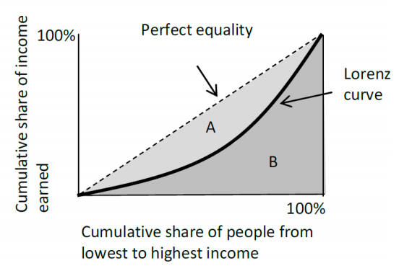

Perfect Equality
If all individuals (or households) had the same income (perfect equality) then the curve would lie along the 45 Degree ray from the origin

The gini coefficient is the ratio of the area enclosed by the Lorenz Curve and the perfect equality line (A) to the total area below the perfect equality line (A +B)

It ranges from 0 (perfect equality) to 1 (perfect inequality)

1.6 Lorenz Curve of Income and Wealth in Australia
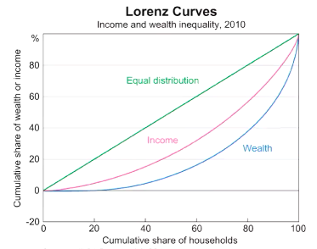

Green line indicates perfect equality

Wealth has a higher Gini Coefficient in Australia

Income has a lower Gini Coefficient

1.6.1 Gini Coefficients in Brisbane
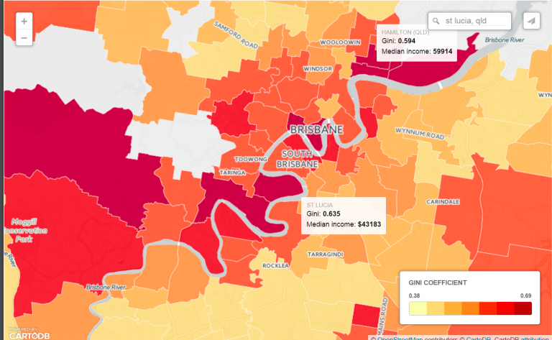

Darker areas indicate higher income inequality within different suburbs

This has different policy implications

1.7 Distribution of Disposable Income in Australia

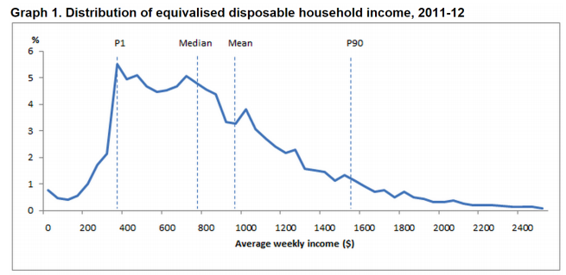
Average weekly income ~$1000 per week which is HIGHER than the median income

This is because we have a right skewed distribution (long tail on the right)

Meaning a small number of people have much higher income compared to the more concentrated lower end

Makes more sense to use MEDIAN INCOME rather than AVERAGE
- As average incomes can be skewed by a small number of very high income owner
- May not be representative

1.8 Alternatives to Gini

Can look at ratio of 90th percentile and 10th percentile income
- See how spread out the income is

1.8.1 Ratio of 90th Percentile income to 10th percentile income
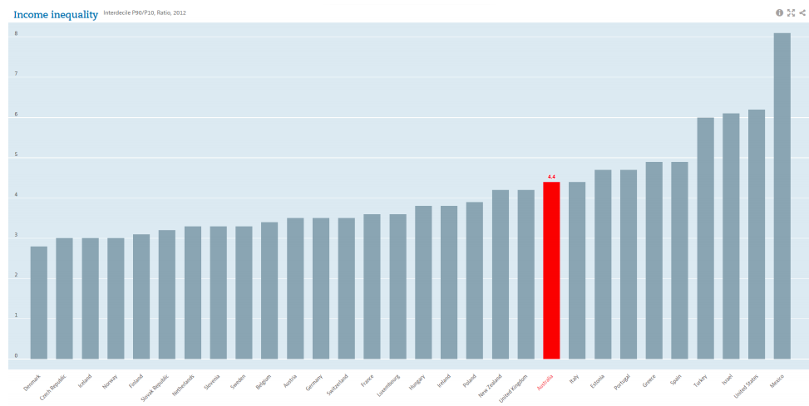

Australia = 4.4

90th percentile in AUS has income that is 4.4 times greater than the 10th percentile

1.8.2 Ratio of 90th Percentile income median income
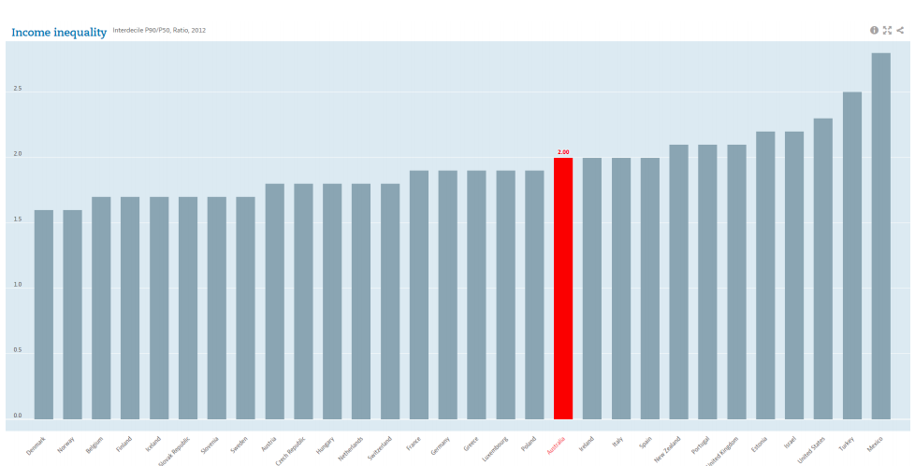

Australia = 2.0

90th percentile in AUS has income that is 2.0 times greater than the median

1.8.3 Ratios of Median Income to 10 Percentile Income
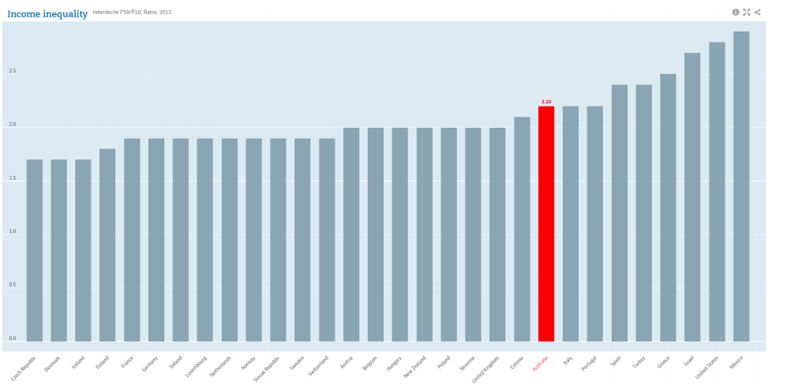

Australia = 2.2

Median income in AUS has 2.2 times greater than the 10th percentile

1.9 Variation of Income Inequality by geographical location

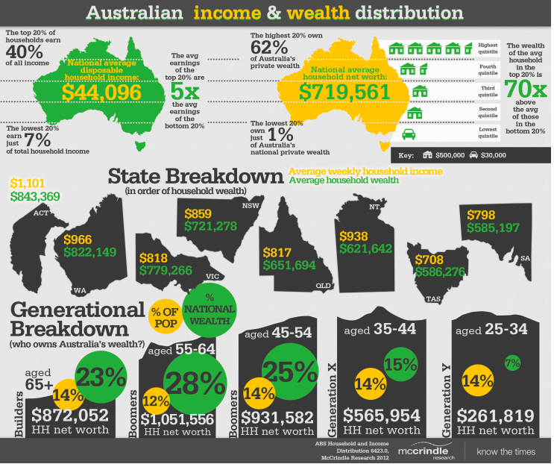

2. Rationales for Government Intervention

- Market Failures
  - Government intervention can help if there are market failures.
- Redistribution
  - Free market generates inequality
    - Market outcomes can be efficient without being fair/equal
  - Public cares about economic disparity
  - Government taxes and spending can reduce inequality

2.1 Redistribution

Even with no market failures, free market outcome might generate substantial inequality.

Economic inequality matters for social welfare:
- Diminishing marginal utility
- Inequality may hinder social mobility
- Inequality produces social problems such as crimes/ conflicts etc.
- Concentration of wealth may lead to concentration of political power, jeopardizing the democratic processes and the long-term prospects of an inclusive society.
- Public cares about inequality because people evaluate their economic well-being relative to others, not in absolute terms.

2.2 Methods of Redistribution

Government uses taxes and expenditure (transfers). to redistribute

2.2.1 Taxes

- Progressive: Average tax rate INCREASES with income
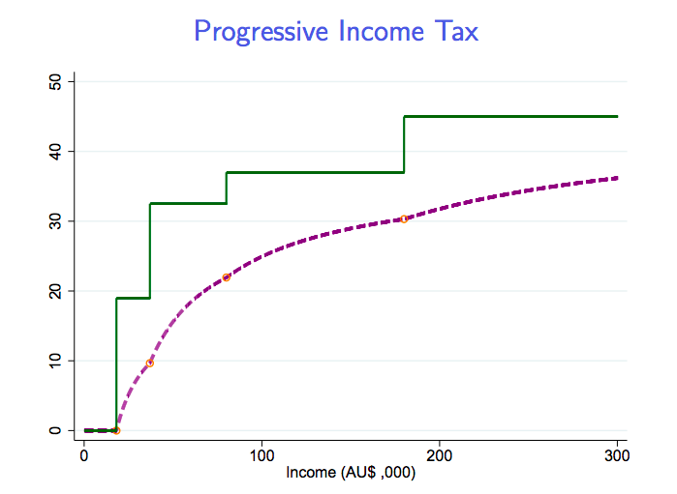
- Higher income people pay a higher share of their income as tax

Green line in the MARGINAL TAX RATE
- Not all the income that you earn is taxed at the highest rate, the part of your income that meets the threshold is taxed at that certain rates

Average Tax Rate = Tax Paid/ Income

Purple line = average tax rate
- Amount of tax people pay on their income increases with their income
- Proportional: Average tax rate UNCHANGED as income changes
- Regressive: Average tax rate DECREASE with income

2.2.2 Public Expenditure

- Poverty alleviation programs
- Means-tested transfer programs
- Access to public goods and services
- Universal health care
- Mandate purchases of private health insurance for high income individuals

3. Libertarian View

Any distributive patterns would be fine as long as people acquire their holdings voluntarily in the markets

Taxation infringes liberty and self-ownership
- Besides enforcing property rights, government should not do much on the ground of equity or even efficiency

Libertarians advocate:
- Laissez faire style of capitalism → happy to leave the market to do what it will and happy with the outcome regardless
- Where there is no redistribution by government

Critiques
- The functioning of markets rely on social infrastructure such as peace, enforcement of contracts etc
- In the modern days, property rights are enforced by the state, which benefits wealthy people most
  - We will not base our discussion on the libertarian view

4. Social Welfare Function

How should we think about redistribution if we acknowledge that there is some role the government can play in effecting the income distribution within society

Useful to use the social welfare function
- Allows the aggregation of individual wellbeing into a measure of social well being
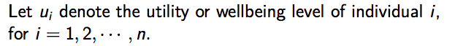

A Social Welfare Function (SWF) represents how individuals utilities are aggregated to social welfare = SW = f (u₁, u₂ …, u_{n})

4.1 Utilitarian Social Welfare Function

EXAMPLE:
Let n = 3

A Utilitarian SWF is: SW_{U} = u₁ + u₂ + u₃

Principle: “greatest happiness for the greatest numbers”
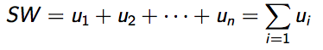
Mathematically:

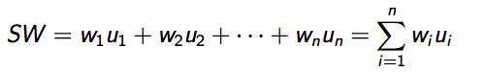
- Social welfare is the SUM of all individual welfare

More Generally:

- Where w_{i} is a weight assigned to individual i

4.2 Utilitarian Argument for Redistribution

Diminishing Marginal Utility
- $10 means more to a starving person (P) than to Gina Rinehart (R)
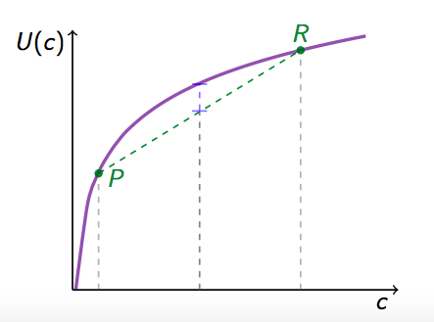
Thus redistributing income from rich to poor increases total (hence average) utilities

The average utility of these 2 people would be the mid point off the curve BUT if both of them have the average level of consumption (mid point ON the curve)

THEN the average utility is higher
→ improves aggregate/ total utility by transferring income from the rich to the poor

5. Rawlsian SWF

John Rawls: A Theory of Justice (1971)

- Thought experiment: behind “the veil of ignorance”
  - People don’t know about their ability/ social class/ family they are born into/ earning potential/intellect
  - What kind of society/social arrangement would rational people agree upon?
- Solution that Rawls came up with is:
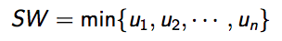
  - rights to equal basic liberties but inequality of outcomes of the social arrangement are justified only to the extent that it benefits the worst off members of the society.

Mathematically, social welfare is represented by:

Optimality: Maximin
- Social welfare is determined by the worse off person

EXAMPLE
Suppose a society consists of three individuals: A, B & C

- Two policy alternatives are being considered:
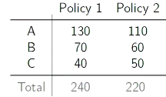

Individual A has the highest utility regardless of the policy

If we add up the utility Policy 1 will gie highest aggregate policy

BUT Policy 2 C is better off than other case

When considering the difference policies the different social welfare functions will disagree which policy should be implemented:

Normative Social Preferences:
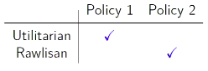

Utilitarian: Aggregate in Policy 1 is higher

Rawlsian: The worst off person, is best off under policy 2

6. Efficiency v Equity Tradeoff

Suppose the total income is invariant to redistributive taxes.
- Total income does not change when redistributive taxes are imposed

Then, perfect equality of incomes would maximize both Utilitarian SWF and Rawlsian SWF

- Redistributive Gains for Utilitarian SWF

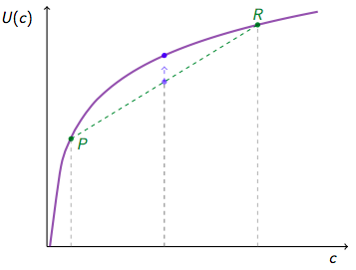

If there is inequality in a society then redistribution from the rich to the poor will increase average utility and this will make society better off
- If the income aggregate income is invariant to a redistributive tax

- Redistributive Gains for Utilitarian SWF
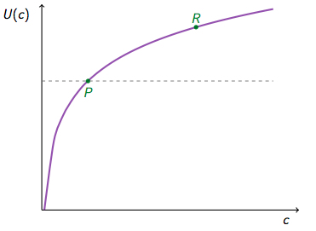

As overall wellbeing will be determined by the worse off person

Redistribution from rich to poor will increase average welfare making society better off overall

HOWEVER and transfers may provide disincentives for work, saving/investment and production
- If people’s income is taxed 100% or at a high rate then the will work less as to not incur the higher tax rate

The size of the economic pie is not invariant to distribute policies
Thus, The Efficiency- Equity Trade Off

- Size of economic pie vs distribution of the economic pie
  - Would like to have more equally distributed income/ wealth and live in a society that is more egalitarian
  - On the other hand perfect equality may not be the best thing in terms of efficiency as people may lose the incentive to work hard
- Policies maximizing social welfare usually do not entail perfect equality of economic outcomes.

6.1 Dead Weight Loss of a Tax

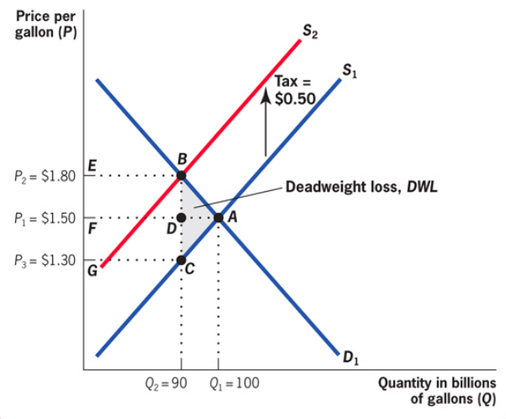

When a tax is imposed, the supply curve shifts from S₁ to S₂ and the equilibrium quantity in the market falls from Q₁ to Q₂ creating a Dead Weight Loss (DWL) triangle BAC
- Taxes move the market away from the efficient outcome

- The DWL arises because there trades (Q₁ - Q₂) for which SMB (Demand Curve) exceeds the SMC (Supply Curve) that are not made
  - Total producer and consumer surplus has decreased

Pivgovian (corrective) taxes are not enough for basic provision of public goods/ services
- However, some distortion in one part of the economy may provide benefits in another area

6.2 Optimal Policy

What distribution of income/ consumption is desirable?
- How should one aggregate individual welfare into social welfare?
- A normative question: question: Utilitarian, Rawlsian etc.
- Optimal trade-off between equity and efficiency requires solid understanding of positive questions.
  - There can be disagreement between perfectly reasonable people

To what extent does taxation reduce efficiency?
- Labor supply elasticity?
  - How responsive are people to a policy where their after tax wage is higher?
- Tax avoidance?
  - Socially wasteful behaviours such as tax avoidance
- Deadweight loss?
- Externalities?
- Dampen creative economic activities or rent-seeking?

Is there a Pareto improving policy?
- Some people get better off without making anyone else worse off

6.3 Horizontal Equity

Vertical Equity
- Distribution of economic resources among people with different incomes/earning abilities

While designing distributive policies we might also want to uphold the principle of horizontal equity

Horizontal Equity
- Requires people with similar income/ability to generate income to bare similar tax burden/ have similar economic outcomes

EXAMPLE

2 persons have similar incomes and level but differ in their consumption tastes
- Person A prefers consuming goods such as Big TVS and nice Sofa
- Person B prefers consuming services like dining out/ watching movies in the cinema
In the absence of other economic justifications, should goods and services be taxed differently?
- Should not tax people differently just because they have different tastes

Should income tax be levied at an individual level or at the household level?
- Australia: Individual level
- US: household level (marital status)

Household incomes may better capture the amount of economic resources available to the household
- BUT taxing household incomes instead of individual incomes may have both efficiency costs and be horizontally unequal

6. Redistribution

Government uses taxes and transfer to redistribute
- To what extent could the government reduce inequality?

Gini Coefficients of Market and Disposable Income
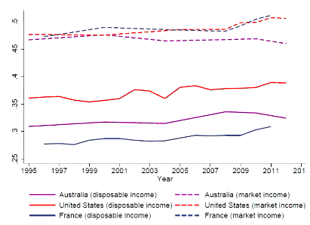

Market income = income your employer is paying you before tax
- Gini Coefficient is pretty high

When considering Disposable Income however (after tax income/ transfers from government )
- Gini coefficient is much lower

Shows that to some extent government taxation/ transfer reduce income inequality (especially in France)

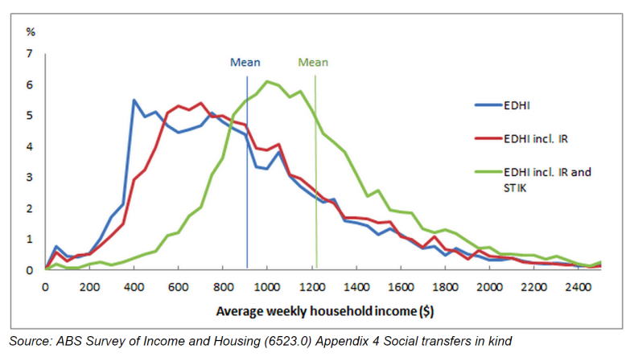
Distribution of Disposable Income in Australia

Disposable income = blue line
Disposable income + Public housing = red line
Disposable income + Public housing + transfers in kind = green line

Become more and more compressed and less right skewed
- The resources allocated by governments means that distribution of income becomes more equal

Marginal Tax rates in 1970’s
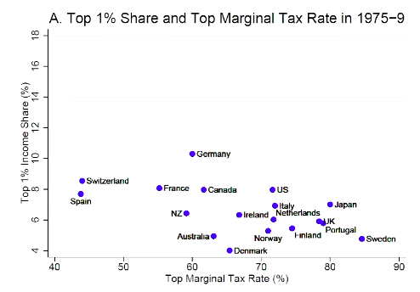

Marginal tax rates in the 70’s for top income owners were much higher than they are today

- Australia’s current top marginal tax rate is 45% compared to >60% in 70
- Negative relationship between top marginal tax rate and top 1% income share

Marginal tax rate 2004-08
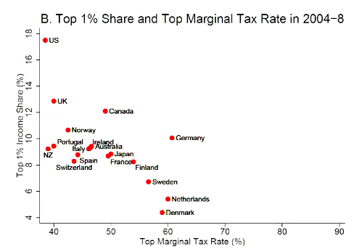

More recently

As the Top marginal tax rate has decreased, the top 1% income share has increased

There is still a negative relationship between higher tax rate and lowe 1% income share

Change in top Marginal tax Rate v Change in top 1% Income Share

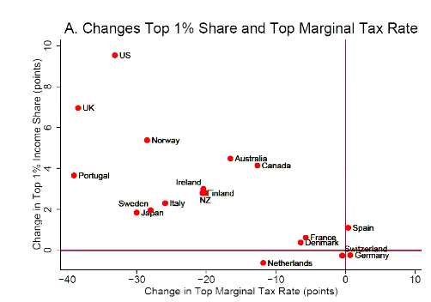

Largest decreases in marginal tax rate share have led to the largest increases in top 1% income share

Some people may move to countries where the tax rate is lower

7.1 War on Poverty

In the 1960’s US president announced a war on “poverty”
Major Initiatives
- The Economic Opportunity Act of 1964 (created Job Corp)
- Food Stamp Act of 1964
- Elementary and Secondary Education Act of 1965
- Social Security Act of 1965 (created Medicare and Medicaid)
- Head Start Program

Poverty Among elders (65+) fell from 28.5% in 1966 to 10% in 2013

7.2 Poverty in the US
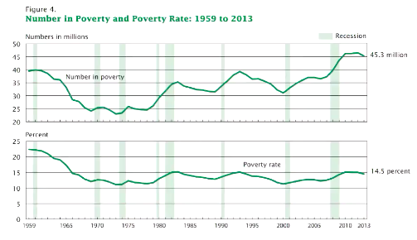

Percentage of people in poverty dropped a great deal following the initiatives

8. Equal Opportunity

Shouldn’t one be more concerned about the equality of opportunity instead of equality of economic outcomes?

EXAMPLE

Suppose individual A and B have the same ability and equal opportunity.
- A prefers working for long hours and high income;
- B prefers more leisure and a less materialistic life style.
- Since B has low income by choice, why should income be redistributed from A to B?

Shouldn’t inequality of outcomes be justified as long as people have equal opportunities
- Point is valid BUT from a public policy perspective equality of economic circumstances and equality of opportunities are closely linked

8.1 Food Stamps and Life Outcomes

Food Stamp Program: food vouchers for low income households in the US

- Infants whose mothers had access to the Food Stamp Programs during pregnancies had greater birth weight.
  - Impacts are particularly large for African American mothers
  - Greater increase of birth weights in the low end of the birth weights distribution

Access to food stamps in early childhood also have long-run benefits on adult health and economic outcomes:
- Significant reduction in the incidence of “metabolic syndrome” (obesity, high blood pressure, and diabetes)
- Increase in economic self-sufficiency for women

9. Social Mobility

Perfectly mobile society would have no effect on your income earning potential/ opportunities
- Minorities have a lessor chance of making it from the bottom quintile to the top quintile

9.1 Upward Mobility

Probability that a child born to parents in the bottom fifth of the income distribution reaches the top fifth:
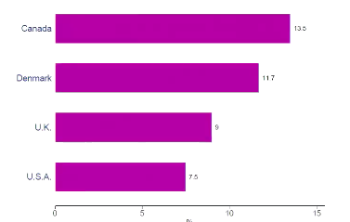

In US only 7.5% of us children born to parents in the lowest income percentage have the chance of moving to the top percentile

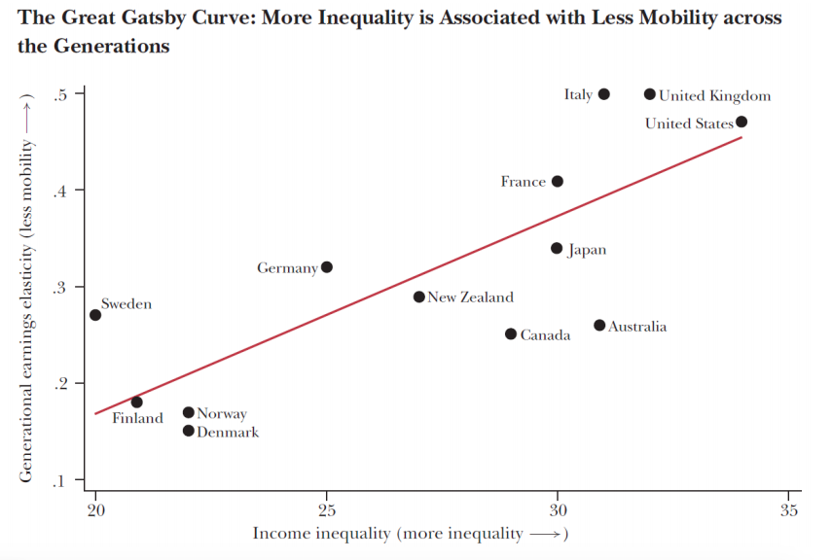

The more unequal the society the less the social mobility

The more elgaritain the society the more socially mobile the economy

9.2 Equity and Efficiency Trade-Off

Not all policies involve equity-efficiency trade-off

EXAMPLE
- Basic social safety net
- Public assistance for disadvantaged children
- Policies that promote social mobility could improve efficiency as well as equity

Rigorous analysis and empirically grounded research could inform and lead to smart policies

An area in which big data have great promises

Week 6 Voting and Election

Suppose there is a party with 85 members and they need to select their leader among three candidates: B, M, and D

- If a member prefers candidate X to Candidate Y denote: X > Y
Suppose there are 4 Groups of Members, each of which has a preference ranking over the three candidates:
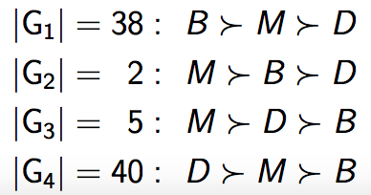

Suppose who gets the most votes would be elected and all members vote truthfully their most preferred candidate
- Candidate D would win

BUT But for the majority of the members (G1, G2, and G3) they prefer M to D

1.1 Two Round Voting

But suppose in the first round, we have B v M the winner of which would compete against D
- Candidate M would win (G2, G3, G4 all prefer M to B)
- Here Candidate D is not a so-called Condorcet Winner
  - Regardless of which other candidate you go against you will win

1.2 Direct Democracy

In a direct democracy, citizens vote directly on policies
- Let P_{i} denote policy for i = 1,2,3

If a citizen prefers policy 1 to policy 2 = P₁ > P₂

Suppose the society has 3 Citizens A, B and C:

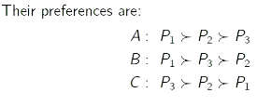
Under Majority rule → Policy 1 would be chosen
- Most preferred by citizen A and B

1.2.1 Condocent Winner

P₁ is called Condorcet winner because it wins against each of other alternatives
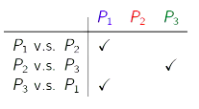

Which Candidate is a Condorcet Winner?
- Morrison will be the condorcet winner
- He would win against any other alternative

1.2.2 Does a Condocet Winner always exist?

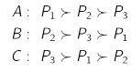
Suppose the preferences instead are:

P₁ will Win against P₂
P₂ will win against P₃
P₃ will win against P₁

This means that in no case will there be a Condocet Winner
- No one policy will be such that it wins against all others

The Paradox of Voting
- Coexistence of coherent individual preferences and a collectively incoherent choice by majority rule

2. Another Hypothetical Party Room

Suppose there is a party with 85 members, who select their leader among three candidates: B, M, and D.
- Suppose there are 5 groups of members, each of which has a preference ranking over the three candidates:
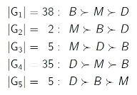

Is there a Condocet Winner?

Yes M is the Condocet winner

3. Democractic Ideas: Liberty and & Equality

Method: Popular Participation in Government

- Individual self-realization and self-respect requires collectively control of physical and social environment.

- Voting enables free and equal participation in the political life of the community.
- Voting is a necessary, but not sufficient, condition of democracy.
- Voting needs numerous institutions like political parties and free speech to be organized into genuine social choice.

3.1 Two Interpretations of Voting

3.1.1 Populist Interpretation

- Embodying the will of the people in the action of officials to obtain liberty and hence self-determination
  - Vox Populi, Vox Dei
  - Whatever they chose is the will of the people
- Collective choice of the person/policy on a pedestal

3.1.2 Liberal Interpretation

The function of voting is to control officials and no more
- Concerned about the “tyranny of the majority”
- Concerned that the majority can make the wrong choice/ choose harsher laws on a minority
- Just because it is the will of the majority does not mean it is right
  - Function of an election is not to make the “right” choice

This has become the dominant interpretation
- Democracy is not just voting (rule of law/ free speech)

3.2 Representative Democracy
- May be some cases where we have a direct democracy i.e citizens choose the laws directly (think postal vote)
- GENERALLY however will be representative who is elected by citizens to represent them
  - Liberal interpretation → provides way to control representative as can vote out a politician

Two basic frameworks to study electoral competition:

- Hotelling-Downs
- Citizen-Candidate Framework

3.2.1 Hotelling-Downs

A large number of voters populate a polity
- Each of them have an ideal policy between 0 and 1.
- Denote a voter by her ideal position i ∈ [0, 1]
- Voters are uniformly distributed over [0, 1]
  - Evenly distributed
  - At 0.5 the population will be evenly split

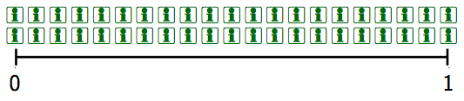

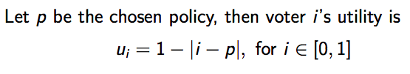

- Single Peaked Preferences
U_{i} = 1 - | i - p | for i = 0.5
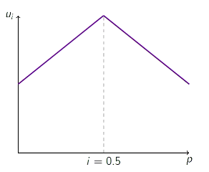
If I have an ideal policy of 0.5, then my utility graph will resemble this

If the policy is equal to 0.5 then this will be where utility is highest

People will have different preferences and this will be reflected in different peaks

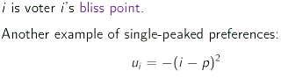
Hotelling-Downs model is a spatial model
- Examples of policy “space”:
  - Where to locate a public good (eg park/school)
- Ideological: left v right wing
- Tax rate and level of spending on public education

EXAMPLE

Two Candidates: A & B

Payoff to a Candidate: V = 1 if win the office / 0 if lose the office

Each candidate proposes a policy platform
- a be the policy proposed by Candidate A
- b be the policy proposed by Candidate B
  - This will be the range of 0 to 1
Voters vote for either candidate A or Candidate B

Majority Rule:
- The candidate with the highest share of votes wins.
- In case of a tie, a coin-flip decides the winner (i.e. each has a 50-50 chance)

The proposed policy of the winner will be implemented

Questions
- What policies would be proposed?
  - Extremes/ in the middle
- Which policy would be implemented?

Game Theory

Actually, the Hotelling-Downs model describes a game.
- Candidates are players.
- Each candidate’s strategy is to choose a policy position.
  - a and b
- A candidate’ goal is to win the election.
- What would be the equilibrium outcome?

Nash Equilibrium
- Each player’s strategy maximizes his/her payoff given others’ strategies.
  - Neither player would be able to get a better outcome if they unilaterally move from that policy profile

Electoral Competition drives policy convergence
- The Nash Equilibrium is such that both candidates both propose a policy that is equal to half and there will be a tile
- Nash Equilibrium = a = b = ½
- A coin flip will decide the winner, but regardless of who wins, p= ½ in equilibrium
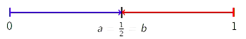

Why would both candidates choose a position in the middle?

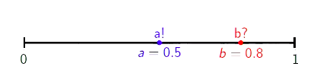
In the case where they do not choose a point in the middle, then one of the candidates can move and this will improve their chances of winning
- As it is a single pick policy they would prefer a policy that is closer to the idea position
- The closer the policy is to the ideal position the better the chance of winning

If Candidate A moves to the middle candidate A would win for sure
- Voters to the left of 0.5 would choose candidate A and people between 0.5 and 0.8 half of them will choose candidate A
  - Candidate will have 0.65 of the vote

Policy p =½ is a Condorcet winner
- No one can be better off if they deviate from p=0.5
- Picking the position most preferred by the median voter is a (weakly) dominant strategy

Median Voter Theory
The outcome most preferred by the median voter will be selected under a majority rule voting system
- 0.5 is the policy most prefered by a voter with either preference/ ideal position

(B) Voters Not Uniformly Distributed

Suppose voters are not uniformly distributed over [0,1] but the distribution remains symmetrical so that the median voter is still most prefer p=0.5
- Most people have a moderate ideology, not stuck at either end of the distribution
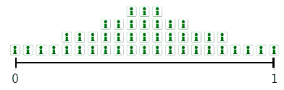

Even in this case the median voter theorem still holds yielding a=b=½

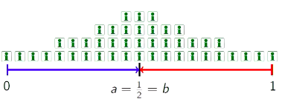

Suppose voters are not uniformly distributed over [0,1]
- Will have a skewed preference
- Position of the median voter is no longer in the middle (p=½)

Instead median voter is located at p_{m}=0.3
- MEDIAN VOTER THEOREM STILL HOLDS
- Candidates still have an incentive to propose a policy that is most preferred by the median voter

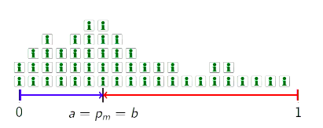

(C) A simple political Model of Public Finance

A large number of voters populate a polity

Voter i has an income y (indexed by income, not by policy preference)
- Y_{i} is uniformly distributed over [0,1] where 1 is the highest income
- Let’s normalise the population to one, then aggregate/ average pre-tax income as y = ½

Government imposes a flat tax τ and transforms the tax revenue into public goods:
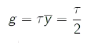

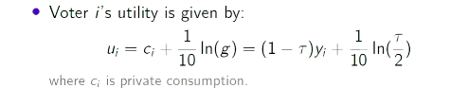

- People value public goods but private consumption will vary
  - This can be based on the fact that people have different levels of income and have different utility levels from public goods
  - Everyone has the same public goods

Two parties each propose a tax rate to compete for election
- Applying the median voter theorem the tax rate most preferred by the median voter will be implemented

What is the tax rate most prefered by voter i?

One that maximises voter i’s utility;

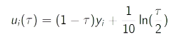
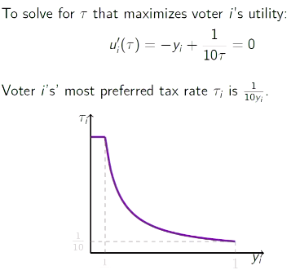

When the voter’s income is high, their preference is for a lower tax rate
- Can get more private consumption
When their income is low they’re preference is for a higher tax rate
- And higher public expenditure
- As the sacrifice they have of private consumption is lower

There is a negative relationship between most preferred tax rate and y_{i}

Since the median voter has an income of y_{m} = ½ the equilibrium tax rate is ⅕

(D) Assumptions of the Hotelling-Downs Model

- Single-dimensional policy space
  - Picking a policy in one dimension (left v right) not always the case in reality
- Voter participation
  - Don’t have high voter participation as it is not compulsory
- Two-party
- Sincerely voting
  - May vote in a way that is not your first preference i.e voting strategically
- Politician credibility
  - Whatever they propose would be the policy that they implement
  - Very little of the time does a politician keep their election promises

If we cannot assume there is credibility (i.e do exactly what they say they’re going to do”)
- The hotelling-downs model may breakdown
- For this reason people move away from model
- There is some force that makes candidates not take the middle position

- Political ideology

3.2.2 Citizen-Candidate Framework

If we cannot assume there is credibility (i.e do exactly what they say they’re going to do”)
- The hotelling-downs model may breakdown
- For this reason people move away from model
- There is some force that makes candidates not take the middle position

Use the Citizen-Candidate Framework

Politicians cannot commit to policy platforms
- The identity and hence preference and ideology of a politician affect policies
  - Part of the reason candidates run for office is to have the position but most importantly see a certain kind of policy implemented

As a voter, will want to pay attention to the life experiences of a candidate and what sort of policies they may implement

Week 8 Distributive Politics

How governments tax and spend affects the well-being of different populations differently
- Different sorts of public spending may benefit different income or social groups
- Some people bear the burden of a tax more than others.
- How progressive a tax system should be

Distributive Politics concerns with the allocation of government resources

Politician’s Motivation and Behaviours

Two views:

- Make policy to get (re-)elected
- Politicians are office-seeking and they vote according to their economic interests.
- The Hotelling-Down model reflects this view.
- Then, politicians would be responsive to both constituent and special interest pressure to increase their re-election prospects
  - Lobbyists persuade politicians to change their policy

- Get elected to make policy:
- Politicians have their own ideology and policy preferences
  - Got elected to push their own personal agenda
- The Citizen-Candidate framework reflects this view.
- Then, politicians mainly vote their own ideological preferences.

1.1 The Political Economy of U.S. Mortgage Default Crisis

How did members of U.S. Congress vote in the two significant bills during the U.S. mortgage default crisis in 2008?
- American Housing Rescue and Foreclosure Prevention Act (AHRFPA)
- Emergency Economic Stabilization Act (EESA)

Why these bills?
- Economic and historic significance $ 1 trillion +
- Winners from the legislation are clear
  - Can identify what people benefit from the passing of the legislation
- The bills violate the conservative principle of limited intervention in private markets

Paper looked at how did members of the US congress vote in this bill?

1.1.1 US Home Prices
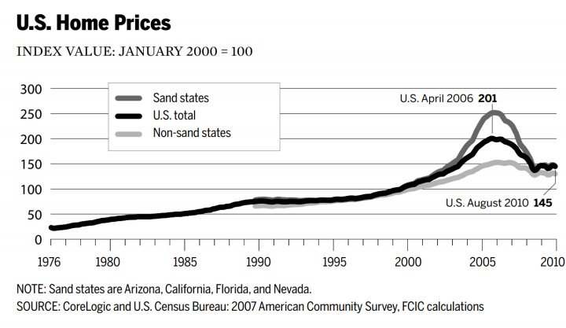

- US housing prices are closely linked to financial markets
  - In 2006 there was a huge increase in house prices
    - Increases were particularly pronounced in the “Sand States”
    - California, Arizona, Naveda, Florida (good weather locations)
  - Increased by more than 100%

- What drove house price increase?

Loose lending standards/ credit from banks / financial institutions
- Lending with low interest rates

Often mortgages brokers gave out loan to people that could not really pay them back
- Could just state income rather than proving it
- NINJA Loans

1.1.2 Mortgage Delinquencies by Loan Type
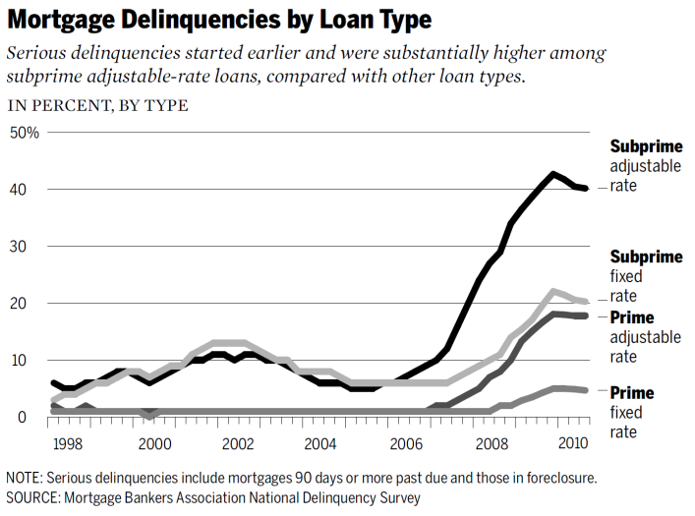

People are borrowing money to buy more houses
- Subprime borrowers were the majority

Prime Borrower: Borrowers who are employed and have a good credit history/ have routinely paid back their loans

Subprime: Didn’t have job/ good credit history/history of paying back loans

Mortgage Brokers - weren’t loaning their own money were just selling the products of other
- Didn’t care if you were paying back loan

Initial interest only periods - repayment of the principal was not due until a later time
- Fine while the value of the house continued to increase
- BUT house prices began to drop and people started defaulting on their loans

Delinquencies (Default or Late Payment) of mortgages skyrocket around this time
- 40% of subprime mortgages defaulted

1.1.3 Mortgage Delinquencies by Region

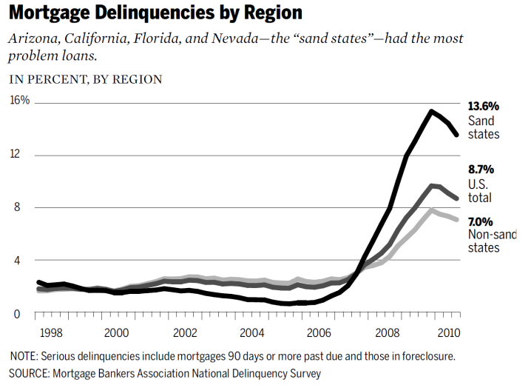

- Sand State defaults were especially high, housing prices had increased the most in these regions

1.2 Two Bills

1.2.1 American Housing Rescue and Foreclosure Prevention Act

- The bill provides up to $300 billion in Federal Housing Administration insurance for renegotiated mortgages and unlimited support for Freddie Mac and Fannie Mae.
- Expected winners = households that are in or close to default on their mortgages
- Constituent interests are promoted by this bill

1.2.2 Emergency Economic Stabilization Act (EESA)

The bill allows the Treasury Department to recapitalize banks through direct purchase of new equity and severely distressed mortgage backed securities up to $700 billion.
- Beneficiaries= financial industry
- Special interests - lobby congress/ state governments

1.3 Background on US Political Institutions

House representatives are elected from single-winner districts under first-past-the-post (plurality) rule
- Who ever has the most votes, wins

Two major parties: Democrats & Republican
- Center left and center right

Party discipline in how party members votes is very weak
- US whole party will vote the same way (increasingly so)
- Institutional features mean that members are free to vote as they like

At that time, the Republicans had the presidency (George W. Bush)
- The Democrats had a majority in both Senate and the House of Representatives.

1.3.1 Voting on Bills

- American Housing Recovery and Foreclosure Prevention Act

On the second vote of the bill:

All democrats voted for the bill BUT majority of the republicans voted for not passing the bill as it goes against their ideology of not interfering with the market

- Emergency Economic Stabilization Act (EESA)

Similar Pattern arises
- Voting to bail out the banks

On the second vote of the bill:

Democrats - Did not ike the bill but thought it was necessary and majority voted yes

Republicans - Do not like the idea of government intervening and majority voted no

- When No Vote narrowly won, the US stock market dropped by 8.8%
  - One of the largest decreases in the history of the stock market

Some legislators receive huge donations from the finance industry

1.4 Result of Study

Research looked at how parliamentarians voted:

1.4.1 Voting In favour of household relief

Found that if a legislator’s district had a higher mortgage default rate then they are much more likely to vote in favour of the first legislation that transferred resources to the housing markets/ household

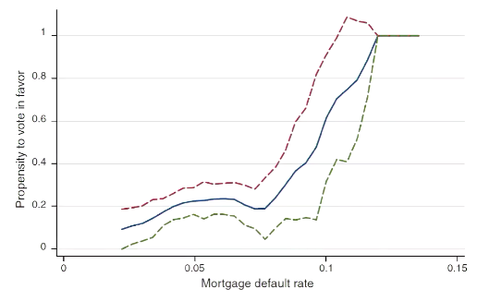

Suggests that to some extent that the legislation behaves in a way that is in the interests of their constituents

Legislators that had a large number of households who were in default of their mortgage in their district tend to vote in favour of the first legislation

1.4.2 Voting In favour of Financial Sector relief

How much money has the legislation received form the financial industry?
- Positive relationship exists between donations received and likelihood to vote in favor of the act that transfers resources to the financial services industry
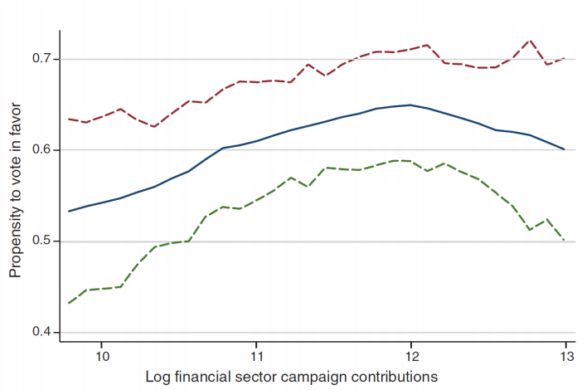

These 2 findings suggest that politicians make policy to get elected and vote in a way that would be favoured by their constituents as well as special donors who contribute to their campaign

1.4.3 Support of Ideology Position

Voted within general party ideology positions
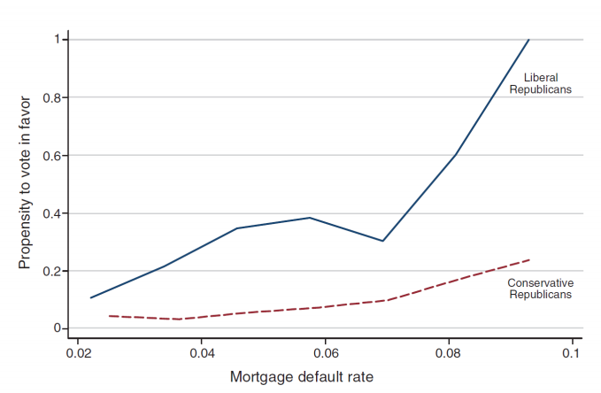
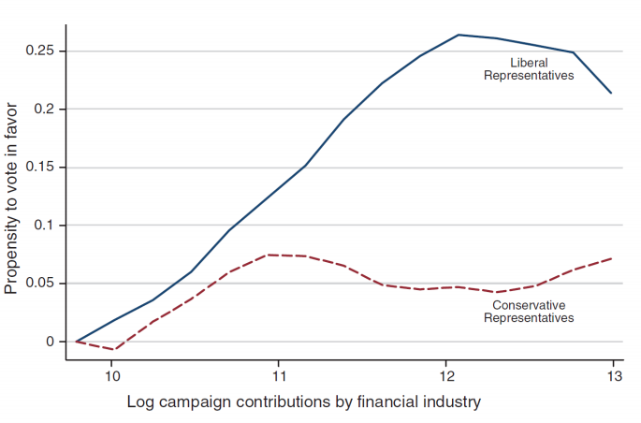

1.5 Remarks

- The mortgage default rates were uncorrelated with the ideology measures (DW-Nominate score) of Republican representatives, allowing one to disentangle constituent interests and ideology of the representatives.
  - Allow us to see that both variable play a significant role in how legislated voted in relation to these specific pieces of legislation

- The relationship between mortgage default rates and voting for the foreclosure prevention bill is stronger in competitive districts
  - In competitive districts, the marginal victory between candidates and the runner up are smaller
  - Small swing in sentiment or popularity of a candidate may they do not get re-elected
    - Constituent interests matter more in competitive districts

- It seems that Republicans are more responsive to the mortgage default rates in the Reblican leaning electorates

2. Political Rights

The fact that politicians are responsive to electoral incentives and constituency pressure suggests that the right to vote is important for the allocation of public spending
- If there is a group of people that do not have the right to vote, a politician may not care about that group of people

Evidence from the de facto black enfranchisement in the American South following the Voting Rights Act of 1965 (Cascio & Washington, 2014)
- I.e not only the legal right to vote but the de facto right to vote

2.1 History of Black Voting Rights in the South

American Civil War (1861 – 1865)
- Ended slavery

Reconstruction Era (1865 - 1877)
- The 14th and 15th Amendments to the U.S. Constitution give blacks citizenship and the right to vote
Era of Jim Crow (1877 – 1965)
- De facto disenfranchisement of black in the South
- Even though legally black people had the right to vote, there was a lot of restriction and intimidation they were de facto disenfranchised

Civil Right Movement (1954 – 1968)
- The Voting Right Act of 1965

2.1.1 Disenfranchisement of Blacks in American South

Jim Crow Laws:
- They mandated racial segregation in public facilities such as school, public transportation and etc

Blacks were de facto disenfranchised through:
- Literacy test
- Poll tax
- Moral character tests
- Discriminatory implementation of tests and administration of voter registration
- Intimidation and violence threads

The Voting Right Act of 1965:
- Prohibit poll taxes, literacy tests, and other discriminatory practices preventing minorities to vote.

2.1.2 Effect of Voting Act
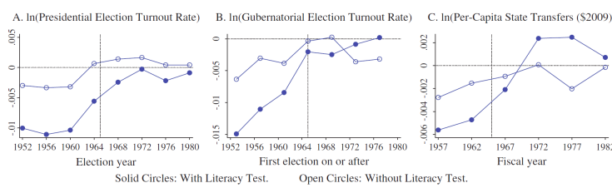
In some counties have a larger black population - as a result turn out when these literacy requirements were in place were very low
- In 1965 when the Act was brought in there was a large increase in voter participation rates

Public Spending from the government was much lower than other counties
- But with the passing of the Act, and gaining the right to vote, there was substantial increases in transfers from the state government

The defacto right to vote matters hugely for allocation of government spending

3. Electoral Incentives and Government Spending

Electoral incentives matter for allocation of funding/ to specific groups different groups having the ability/right to participate in the political process (namely vote) matter a great deal

3.1 Australia

Evidence is not as strong as elsewhere
- Not a bad thing there are other mechanisms to ensure public spending is based off needs rather than political incentive
- Maybe other factors such as the maturity of the democracy etc

- Sport grants to marginal constituencies in 1991 and 1993 (Denemark, 2000)

- Discretionary fundings and grants to electorates held by the governing coalition during the 2001–2004 cycle (Leigh, 2008)

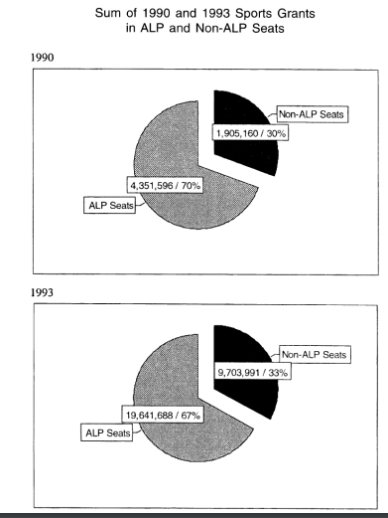

Looked at a Program that gave grants to build sport facilities/ support sport participation in local communities

Over the 2 years measures the ALP was in power and made the decisions on how to allocate those grants

70% of the grants went to locations with a Labor representative

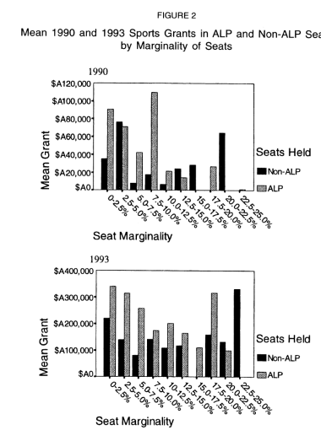

Some evidence (not very strong) that marginal seats got more funding than safe seats

Further larger amounts of funding in 1990 went to non-cabinet member seats

Opposite was true in 1993

3.2 US
- Pork barrel spending on levees

4. Democracy & Prosperity

One argument for democracy is that, by providing equal political rights to a broad segment of the society, democratic institutions promote shared prosperity and inclusive long-run growth.

Some evidence:
- Women’s suffrage in the U.S. in early 20th century induced large increases in local public health spending and lowered infant mortality (Miller, 2008).
- There is some evidence that democracy lowers infant mortality in Africa (Kudamatsu, 2012)
- A voting technology, which effectively enfranchised less educated people in Brazil, shifted government spending toward health care and increased infant health for less educated mothers.

4.1 Women’s Sufferage

New Zealand was the first country to give women the vote
- Australia was the second country
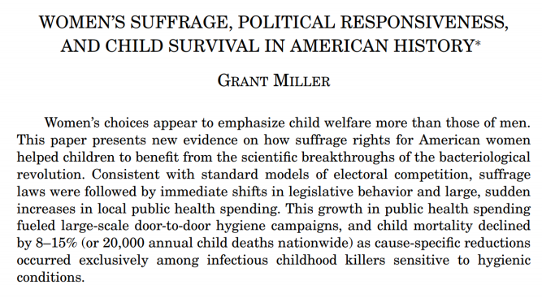
In the US
- Different states moved at different rates to give women the right to vote
- Created differential change
  - This creates a natural experiment to explore the causal rights on public Policy

Women’s choice appeared to emphasise child welfare over what men’s would
- There was immediate change once women could vote
- Increase in public health spending
- As a result there was a decrease in child mortality
  - 20,000 child death were reduced nation wide per year

Giving a broad range of people right to vote can cause a shift in public policy that promotes overall welfare improvements

4.2 Voting Technology - Brazil

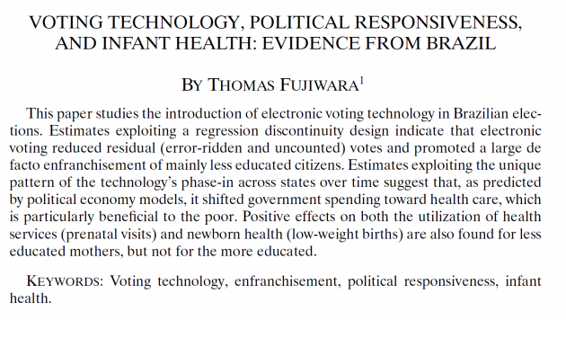
- Increased the effective voting rights of the poor through implementation of voting technology
  - Number of challenges faced by developing countries who are trying to implement democracy/ democratic processes
  - Eg a non-negligible portion of the population may be uneducated and not be literate which creates a barrier to effective voting
    - Large number of errors in ballots that would render vote invalid
    - Introduced electronic voting process
    - Reduced the error in voting and make their political voice stronger in political process

Greater spending on health care is especially beneficial for the poor
- With greater programs/ resources that the poor may utilise such as pre/post-natal visits child mortality decreased dramatically
- Also reduced low birthrate (indicator of child health)

5. Political Distortion on Public Spending

There is also an upside of politicians being incentivised by citizens is that we don’t have a dictatorship/ absolute authority

The electoral incentives may not align with the best allocation of resources
- Political incentive can distort public spending and may not be good for society in terms of equity/efficiency

If we have a impartial/ benevolent policy maker would be better to provide the decision process to this person

Example

Suppose a Country has 3 regions L, M, R

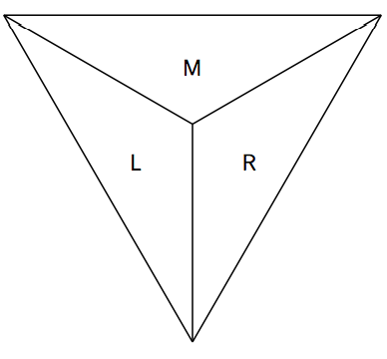

There is $10 million in the budget to be spent on one of the districts to maintain infrastructure

Left Region:

Suppose that the infrastructure in region L crumbling while the infrastructure in regions M and R are very good.

The economic conditions among the three regions are otherwise similar. Thus, the efficient allocation of the infrastructure spending should be in region L.

However, suppose that each region is an electoral district and elects one representative to the parliament.

Partisan leaning:
Region L : safe electorate for Party L
Region R : safe electorate for Party R
Region M : swing electorate

Party R is the incumbent government and would like to win the election next year.

Voters in swing electorate M could be “persuaded” by public spending in their district.

What would an office-seeking incumbent party do to maximize re-election chance?
- They would invest in region M so they are happy and vote for the incumbent so they regain office
- The political incentive distorts the efficient allocation of resources

5.1 Pork Barrel Politics

A politicians elected from a small geographic area may have incentives to target his/her electorate with public pending in exchange of political support
- This area may not need the spending the most BUT may give them a political advantage
- For example, levees along the lower portion of the Mississippi River banks

The electoral incentives therefore may induce inefficient allocation of public spending

5.1.1. Pork Barrel Spending on Levees

The Congress appropriates funds for the U.S. Army Corps of Engineers to build flood walls along the Mississippi River.

Powerful members of the Congress could influence the allocation of spendings on flood prevention.
- The flood walls on the Mississippi side were 3 feet higher than those on the Louisiana side.

- Similarly, the levees on the Indiana side of the Wabash River were higher than those on the Illinois side.

5.1.2 Evidence from Other Countries

Bangladesh
- Greater access to electricity and basic health infrastructure for governing coalition’s constituencies (Hahn et al, 2017)

Colombia
- The composition of public spending becomes more voter-friendly in election years. (Drazen & Eslava, 2010)

India
- More central-to-state transfers for state with partisan alignment with the central government (Arulampalam et al., 2009)
Japan
- Extra representative in the national parliament, extra municipal public expenditure (Yuan, 2014)

6. Special Interests

May be able to/want to influence policy for different reasons

6.1 Interest Groups

Individuals or organizations with shared interests or concerns attempt to influence public policy by forming associations

Examples:
- Group of Eight (Australia)
- Universities Australia
- Australia Bankers’ Association
- Queensland Farmers Federation
- Australian Chamber of Commerce and Industry
- Motion Picture Distributors Association of Australia
- Motion Picture Association of America
- National Rifle Association (U.S.)

6.1.1 Positive Views

- A form of political participation
- Allowing information transmission from the society to politicians
- Allowing expression of preference intensity
  - In a one person, one vote system doesn’t allow people to express how strongly they feel about a legislation or policy
  - Allows them to express the intensity of their beliefs

6.1.2 Negative Views
- Some groups are better posited to carry out collective actions than others
  - Can organise themselves better
- Small groups with concentrated interests are more likely to overcome the free-rider problem
  - Everyone benefits from a general interest and therefore less likely to donate/invest time in the interest group because everyone else, regardless of contribution will benefit from their lobbying interests → free rider problem
  - This problem is not as likely to exist where there is a small/ focused group as they will gain most of the benefit
- Special interests groups bias policy-making and divert resources from provision of public goods with diverse benefits to target a small segment of political influentials.
  - NRA is an example

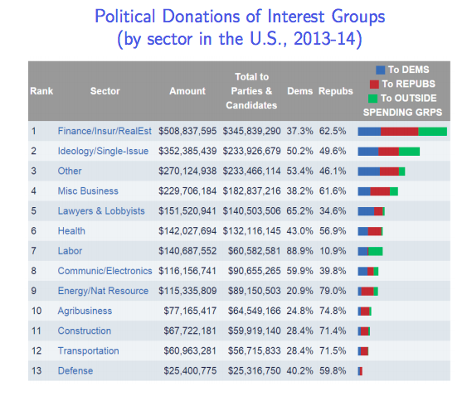

Interest groups can influence politicians through financial donations

Will often contribute to both sides of politics

Australian data is not readily available and laws are not that transparent

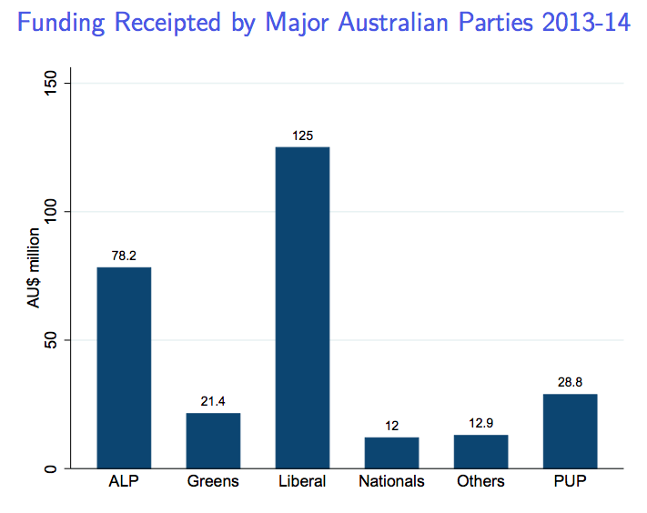

6.2 Campaign Contributions

- Donors
- Qui pro quo
  - Donors give something to politicians and politicians return the favour
  - Generally NOT LEGAL in most developed countries (if explicit)
- Help electing those donors’ like

- Buying (future) access
- Politicians
- Spend money to increase chances of election
  - advertisements/ promotion
- War chests scare off potential challengers
- Campaign expenditure, e.g. political ads, staffers salaries, logistics, etc.

6.3 Revolving Door Lobbyists
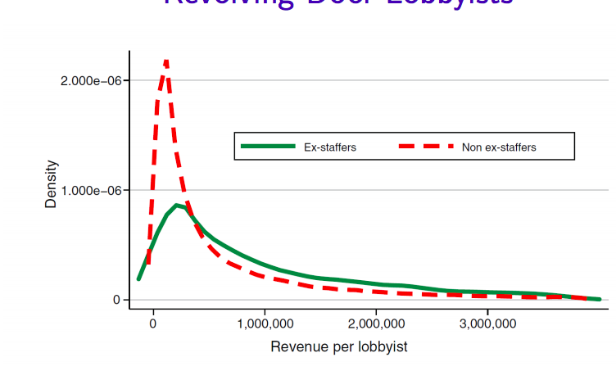

Lobbyists who are ex-staffer and therefore have a connection with the policy maker
- Earn higher revenue than those who aren’t connected
- Having the connection is quiet important for the success of a lobbyist

6.3.1 How do connected legislators Leave Congress?
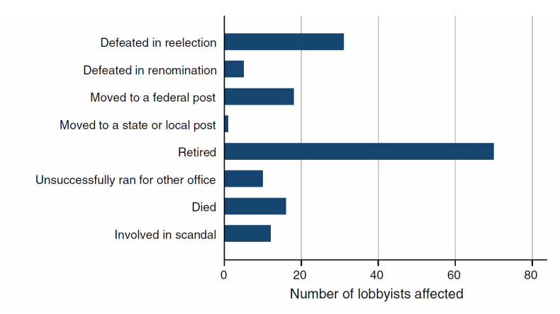

Most people leave before they retire

6.3.2 Affects of retirement of connections on lobbyist Profit

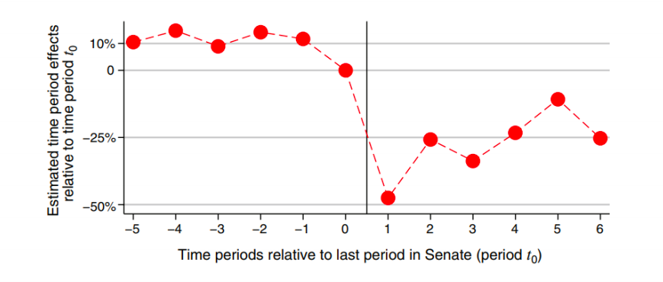

Time period immediately after they’re connection leaves senate revenue drops dramatically

Week 9 Political Accountability

What is Accountability?

The obligation of a decision-maker (or body) to be responsive to the needs and wishes of people affected by his, her or its decisions.

We will want our policy makers to be account so they are acting in the best \interests of their citizens

Political Accountability

Accountability achieved by political processes such as elections, oversight by an elected government, or consultation with affected citizens.

Questions

To what extent political processes such as elections could achieve political accountability? How?

Review of Game Theory: Prisoner’s Dilemma

What will give the most benefit to the players over all?
- Cooperation will lead to the lowest prison sentence

If they have no idea what the other party is doing
- Then there are gains to be made regardless of what the other person does if they betray (defect/ don’t cooperate)

If there is repetition in the game then this will give the chance to learn behavior and cooperate through making deals

Can have simultaneous (both actors move at the same time) or sequential (move at different times) games

1.1 A Simple Dynamic Game

Imagine that a not-so-benevolent government considers whether to increase tax to fund the building of golf clubs exclusively for their ministers.
- May have ulterior/ self serving motives

The strategy interaction is that citizens may react to the government decision
- Sequential game where Government moves first

Players: Government & Citizens

Strategies:
- Government: Status Quo or Tax Hike
- Citizens: Protest or Not Protest

Payoffs
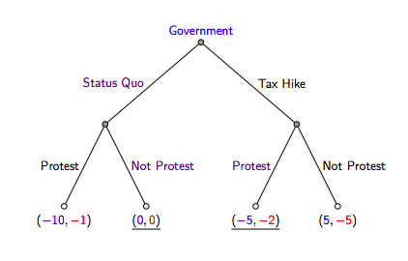
Government Moves First (Dynamic Game)

- Once government decides to make their move citizens will then respond

- Depending on citizen response will change outcome/ pay off for each party
  - Government Payoff is Blue, Citizen Payoff is Red

Game Theory Predicts:

Sub-Game Perfect Equilibrium
- Use backward induction to solve the game

Sub-Game 1 - Status Quo:
- Pay off for Citizens is greater if they Do Not Protest
- Pay Off = 0

Sub-Game 2 - After Tax Hike:
- Pay off for Citizens is greater if they DO Protest
- Pay off = -2

As the government knows how a rational citizen will act, the can predict their expected payoff from both actions
- The government knows they will face either a 0 or -5 payoff and will therefore KEEP the status quo
- Potential threat of protesting will prevent government from making a decision

1.1.1 Principal - Agent Problem

- Can arise where the incentives of two parties in a transaction are not aligned

I.e Mechanic and customer
- Asymmetry of information regarding needs

Issues do not just arise from potentially getting ripped off BUT ALSO the likelihood of getting ripped off means that the transaction is less likely to happen in the first place
- This could be inefficient

Politics is not exempt from Principal- Agent Problem

A Political Agency Model

2.1 Background

Political Agency Problems
- Moral Hazard
  - Agent may not have the incentive to behaviour on behalf of the principal
- Adverse Selection
  - Arises from asymmetry of information

Principal may be in a disadvantaged position as a result of these 2 affects

In a democracy the primary means for citizens to hold the government/ representative account is through elections
- To what extent do elections help with the political agency problem?

Set-Up
- 2 periods
- 2 states of the world
- 2 policy alternatives
- 2 types of politicians
- Homogeneous voters

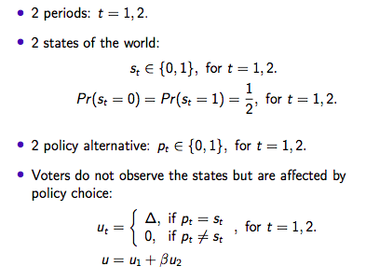
2.2 Model

0 means keep the budget as is
1 means increase the budget

Politician will make a decision in t=1 and t=2

Voters therefore do not which policy will be better
If the policy equals (is appropriate for/ picks the right policy) the state then the voter will have some positive utility
- If the policy does not equal the state then the utility will be 0

Total Utility:
- Utility from this time periods and then the discounted utility from the future period
  - People do not value the future as strongly

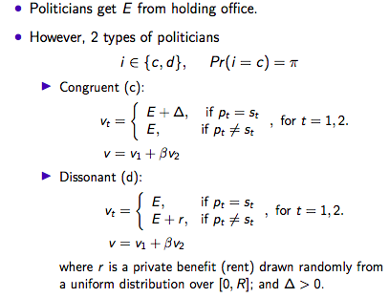
E is some positive number
- Can be the salary or prestige etc from holding office that the politician gets

There are 2 types of politicians

- Congruent/ good
Civil minded and policy preferences are inline with that of citizens

The utility to politicians is E from holding office and extra utility from choosing the right policy. If they don’t select the right policy then they do not get the extra utility

- Dissonant/ bad
Policy choices don’t align with that of citizens

If they make the wrong policy decision then they will get some personal benefit (r)
- Rent is random will be some positive rent from 0 to R

Total Utility:
- Utility from this time period and then the discounted utility from the future period

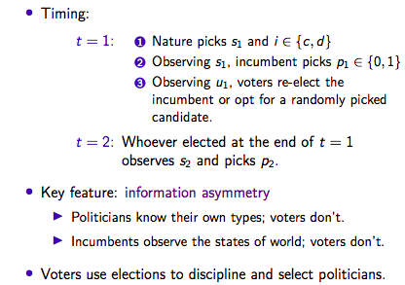

Initial Time Period

- Initial State is radom
- Knowing the state the politician will pick the policy {0 or 1}
- Voters will observe their utility as a result of the policy selected by the politician and then will either reflect or vote for another candidate

Secondary Time Period
- The second period is not random, will be a result of previous policy but regardless will be observed and then pick a policy accordingly

3. Solving the Political Agency Model

3.1 Perfect Bayesian Equilibrium
- Similar to the concept of Nash Equilibrium

In each period, each type of politician behaves optimally given the re-election rule
- In period 1, voters vote optimally to given their belief about the politician’s type
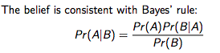

Has to be rational in some sense
- Conditional probability of event A happening given event B already happening

Solving it Backwards
- What would a politician do in period 2?
- How should voters vote?
- How would a politician behave in period 1?
- Impose equilibrium conditions.

3.2 Example Cont.

In period 2, both types of politicians will choose the policy they prefer most
- i.e. the short-term optimal action based on their utility functions
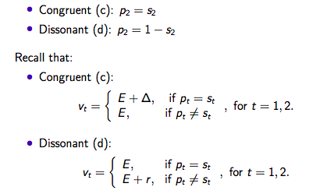

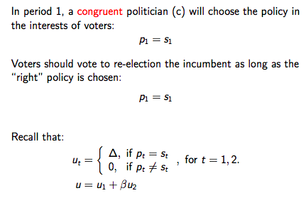
CONGRUENT POLITICIAN

For a congruent politician

P₁ = P₂

DISSONANT POLITICIAN
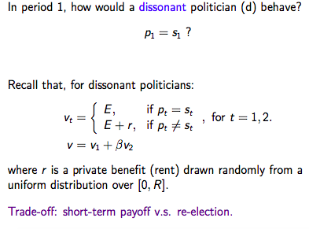
Will the BAD politician chose the right policy?

Will have a lower utility in the first period if they pick the right policy
- This is because picking the right policy would lead to re-election in the second period

There is no re-election after the second period so the bad politician can do as they please and implement the policy that is in their self interest

As politicians face re-election and can’t just select whatever policy they want, this may force them to act in the best interests of their constituents

3.3 Equilibrium of the Political Agency Model
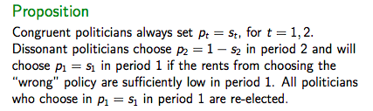

To some extent, elections discipline politicians.
- Even dissonant politicians choose the right policy sometimes

To some extent, elections also help to select better politicians

3.3.1 Re-Election of Dissonants

When a “wrong” policy is chosen, voters know that the politician is dissonant for sure
- Thus, voters should vote out the incumbent whenever a “wrong” policy has been implemented

But why is rational for voters to vote for re-election when the right policy is enacted even if the politician may still be dissonant?
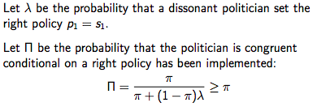

2 scenarios in which the right policy will be voted for:
- We have in fact chosen a good politician
  - Probability = π (given by the model)
- A dissonant politician choosing a good policy ( is seeking re-election )
  - Probability = 1- π (入)
  - 入 is the probability that a bad politician chooses a good policy regardless
    - This will occur when the private rent gained from picking the wrong policy is low

Conditional probability:

The probability that a politician is a good one based on the right policy being picked given by the ratio
- Denominator in this case is given by the total probability of the right policy being picked
  - Numerator is the probability of a good politician being picked

П = probability that a good politician has been selected based off the fact that the right policy has been selected

3.3.2 Why Would a bad Politician choose a good policy in the first period

If the private rents in the first period are sufficiently low (close to 0), pretending to be a good politician is the better choice
- You are more likely to get re-elected

This will maximize the total discounted payoff:
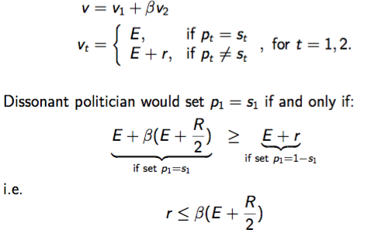
What is sufficiently low?

Compare pay off from getting re-elected to the pay off from doing whatever in the first period

E = pay off from being in office

Total payoff from pretending to be a good politician and getting reelected

Private rent pay off (no re-election)
- r

Expected Private Benefits from pretending to be a good politician (getting re-elected):

- Ego rent (e) + private benefits from rents in the second period (random/unknown) BUT do know that its uniformly distributed between 0 and R
  - On average it is then likely to be half of R

As this is in the second period/ in the future will be discounted (β)

A dissonant politician will chose the right policy in period 1 if the discounted expected pay-off from re-election is greater than the rents in the first period

3.3.3 Calculation of Private rents

Private rents are random number
- This can give us a probability ( 入)
  - 入 probability that private rent is lower than or equal to expected payoff from re-election
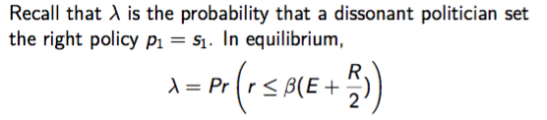

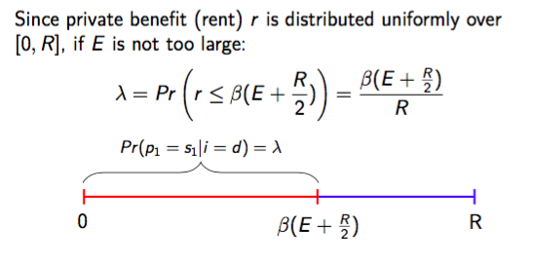

- If the Ego rent (E) is not too large, the cut off will be the half way point between 0 and R
  - (入) Probability will be the length of the expected pay off divided by the length of the whole interval R
  - The probability that r is smaller than the cut off (expected payout in the second period) for a bad politician being reelected

入 captures the extent to which politicians are disciplined by elections
- Even if they politician is bad will still behave like they are a good politician in the first period

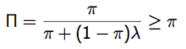
Recall П is the probability that the politician is congruent (good) conditional on a right policy being implemented

Since implementing the right policy leads to re-election, П captures the extent of political selection for period 2
- Denominator - 入 is less than 1 meaning that the whole denominator is less than 1

As long as 入 is less than 1, the conditional probability is going to be greater than the unconditional probability in equilibrium
- The number in an equilibrium covers the political selection in period 2
- Even if voter have no idea in the first period whether the politician is a good one or a bad one in this game to some extent can selection a better politician on average
  - In the second period the probability of picking a good politician is higher than in the first period

3.4 Comparative Statistics: β

Can use the model to understand how changes the parameters affect the equilibrium outcome/ agency problem

- 入 captures the extent to which politicians are disciplined
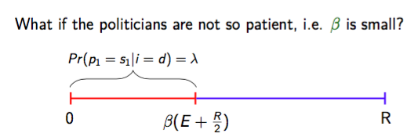

If politicians discount the future more
- Β drops from 0.8 to 0.4
- 入 will then decrease

If politicians are less patient and therefore value future pay off less they are more likely to disregard reflection and seek private rents in their first term

3.5 Comparative Statistics: E

- 入 captures the extent to which politicians are disciplined

If Ego rents (benefit of holding office) increases (increased prestige/ pensions etc)
- The cut off (expected value of a bad politician voting for a good policy) will increase
- If the expected pay-off for re-election is higher the private rent in the first period would need to be higher to make them forget about re-election

Increasing the benefit of holding office would increase the incentive to be a “good politician”
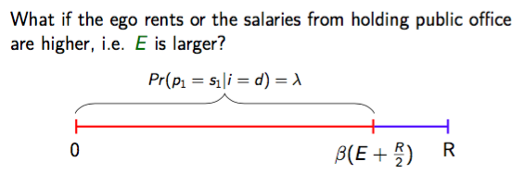

3.5 Policy Application

Does offering higher salaries to office holders (changing the incentives) reduce corruption or promote good governance?

From this model the answer seems to be yes:
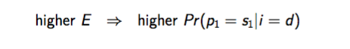
The intuition is that greater salaries for public officer holders makes it a greater loss from corruption → namely choosing policy against the interests of voters in this model, as compared to corruption rents r.

3.5.1 Policy Caveat

But it assumes that the share of (good) congruent politicians in the candidate pool π is unchanged

In reality, higher salaries may attract candidates who are money-driven more than candidates who care for public interests
- Increase in salary means that people who will become dissonant politicians are more likely to enter the pool

Evidence:
- Prior to 2009, each members of European Parliament (MEPs) received the same salary as the members of the lower house of her home country’s national parliament, which means that MEPs’ salaries could differ by as much as a factor of ten.
- In 2009, EU equalized the salaries of all MEPs.
- Fisman et al. (2015) find that increasing salaries raises the fraction of MEP’s who run for re-election.
- But it also draws in more MEP with lower quality as proxied by college quality.

3.6 Comparative Statistics: R
- Increase the pool/ number of opportunities from which private benefits can be drawn
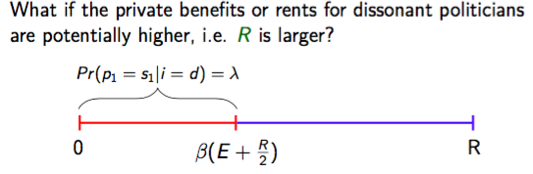
  - This decreases 入 (likelihood of politicians behaving) and electoral discipline will go down

3.7 Summary

Due to information asymmetry, voters as the principal need to deal with a moral hazard problem and an adverse selection problem in delegating policy-making to politicians, i.e. the agents.
- Voters use election to discipline and select politicians.
- But successes are only partial.

The stylized model here abstracts from many important political institutions such as:
- Parties
- Electoral rules
- Check and balance
  - In the US Legislative Branch (Congress) / Executive Branch (White House) / Judicial (Supreme Court)
    - Sometimes party controlling legislative branch doesn’t control executive
  - Separation from Legislative and Executive Branch is not as strong in Aus/UK
- Special interests groups

3.7.1 Gerrymandering

US has a majority system
- Doesn't matter how many votes you received its how many seats you won

Gerrymandering is where electoral boundaries are drawn to your benefit

- Redrawing the Boundaries of Electoral Districts/Divisions

Redistricting in the U.S:
- Rules and administration vary by states.
- Partisan bodies control the redistricting in most states.

Redistribution in Australia:
- Relatively independent agency: Australian Electoral Commission

Less of an issue in Australia, due to better institutions

4. US Favorability of Russia

Democrats/ Republicans have generally viewed Russia in the same way
- In recent years the favourability has departed significantly with the Republicans favouring Russia more the Democrats
- Republicans even like Putin more than the leader of the democratic party

5. Electoral Institutions

- Majoritarian
- Many small districts
- Each district elects one representative
- Government is formed by the party (or parties) winning the majority of seats/districts

Lower house of AUS/UK/ US

In Australian 2019 Election
- LNP won 77 seats and ALP won 68
  - Majority of seats won them the election
  - 13 districts with multiple seats in each

- Proportional Representation
- A few large districts.
- Parliamentary seats are allocated to parties proportional to their vote shares

Upper House Aus (Senate)
Norway:
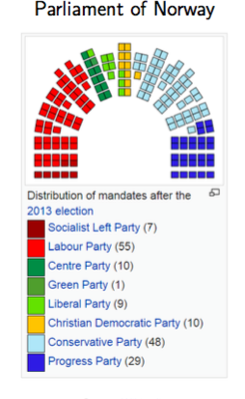

5.1 Majoritarian v.s. Proportional

Majoritarian | Proportional
- Good at holding individual politicians accountable (voting politicians individually)  - Susceptible to pork barrel politics (swing states)  - Tendency toward two-party system | - Greater representation of minority interests  - Tendency toward multi-party system  - Public transfers to social groups rather than geographic areas

Week 10 Media and Public Policy

Media & Public Policy

In Ancient Times transmitting information was difficult and expensive
- Much easier these days

Mass media could provide information at low cost.

Provision of information and knowledge is a public good:
- Non-rival
  - One person having the information doesn’t reduce the value for other people
- Non-excludable

A well-functioning democracy requires an electorate well informed of:
- Public policy
- Economic environment
- Political process

Media plays an important role in the political process/ policy making/ political accountability
- Is susceptible to media bias however

2. Media & Political Accountability

2.1 Political Agency Model
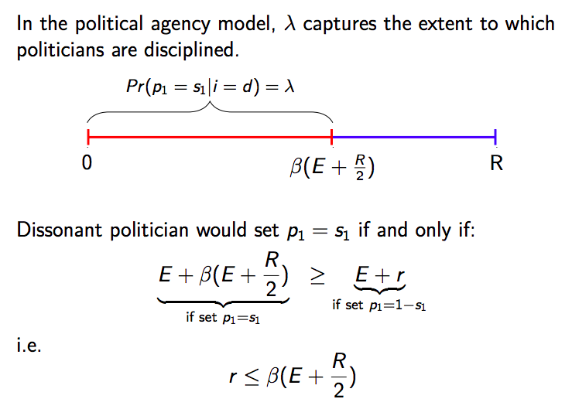

Even the bad politicians nay behave some times
- How often is dependent on private rent and ego rents
- 入 represents likelihood of bad politician making the right policy choice
  - This will change based on a number of factors (E, R and future discount rate)

2.2 Information and Accountability

Voters do not observe the states but are affected by the policy choice:

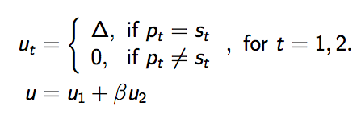

How do we change the model to introduce the role of media?

If a good policy choice is made in the first period then voters will gain some positive utility
- If a bad policy is made then the utility will be negative

In reality however voters do not always observe the policy impacts immediately
- Very complex issue with alot of stakeholders
  - State of australian economy - dependent on international/domestic/consumption markets

Voter may only observe some of the impacts of a policy OR make not observe the impacts immediately
- How is the political agent model affected if voters don’t observe the policy impacts immediately?

What if voters in the model only observe the impacts of policy some of the time?

2.3 Political Accountability with Less Information
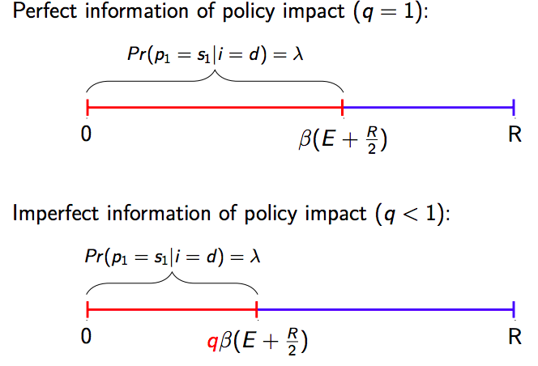
Probability q

Where voters always observe the impacts/utility from policy q =1

If voters have imperfect information about policy (q < 1)

The probability that voters observe the policy impact is q i.e sometimes they will no observe policy impacts

This has the effect of reducing the cut off level (of private rent)l and therefore decreases the likelihood that a dissonant (bad) politician will pick the right policy in the first period

Suppose voters only observe the policy impact (u1) before the election with probability q,
- where 0 ≤ q < 1

If they do not observe the policy impact, they vote randomly and only re-elect the incumbent with 50% probability

In the face of imperfect competition:
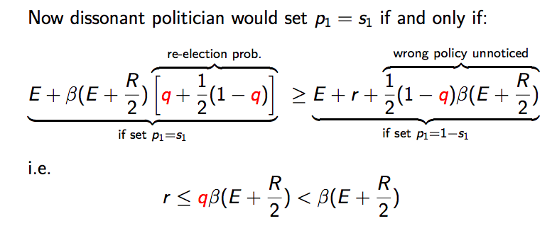

A bad politician will only do the right thing if the expected pay off of doing the right thing is higher than hit and run (private benefit and run)

Re-Election of the Incumbent:
- With probability q voters will observe the policy change and re-elect
- With probability 1-q they voters do not observe the policy impact AND will flip a coin (50:50) to decide who to vote for i.e vote incumbent back in

This is the threshold for private rent above which bad politicians would pick the right policy
- If q is a number between 0 and 1, then the threshold is going to be lower than in the case of perfect competition
  - If people are not going to find out that you are a bad politician, there is less incentive to do the right thing
  - The probability of re-election from good behaviour becomes smaller

If a country has a good media that has been doing its job and informing people then the value of q will be large and close to 1
- If media is captured by politicians or lack independence/ focuses on news that has not consequence in political discourse then q will be low

3. Government Responsiveness

3.1 Evidence from India

Elections provide incentives for government to be responsive to the needs of citizens
- Having a more informed and politically active electorate strengthens political accountability

Mass media is crucial in providing the public information required to hold their government accountable
- Besley and Burgess (2002) study how state governments in India respond falls in food production and crop flood damage.

In states where newspaper circulation is higher and electoral accountability greater (higher turnout and greater political competition)
- Governments are more responsive to economic shocks and food shortage via public food distribution and calamity relief expenditure.
- Are also more likely to be active in the political process which will require politicians to be better at their job

3.2 Press Coverage and Political Accountability

Synder & Strömberg (2010) study the impact of press coverage on citizen knowledge, politicians’ actions and policy.

- Voters living in area where the press covers their U.S. House representative less are less likely to recall their representative’s name and less able to describe and rate him/her.
- Congressmen who are less covered by the local press work less for their constituencies: they are less likely to
  - to stand witness before congressional hearings;
  - serve on constituency-oriented committees; and
  - to vote against the party line (greater leeway to vote in the US)

- Federal spending is lower in areas with exogenously lower press coverage of congressmen / congresswomen

Newspaper distributions can often coincide with congressional district lines in the US
- High congruence -newspaper readers closely follows district lines
- Low congruence - newspaper readers does not follow district lines

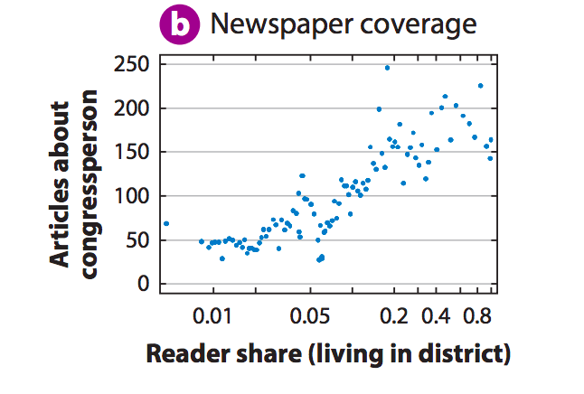

The number of articles newspaper m wrote about representative from district d is strongly increasing in the share of this paper’s readers that live in district d, as denoted by readershare

More readers living in one district means theres an increase in the number of articles written about them

Complications can also arise
- Some times districts have more than 1 news paper

Define Congruence_{d} as the average ReaderShare_{md} weighted by market share over the M newspapers in district d
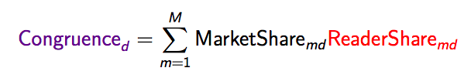

Where Marketshare_{mc} is newspaper m’s share in district d

Then, Congruence_{d} is a proxy for how actively the average newspaper read n district d covers congressional district d

High Congruence:

Congruence_{d} =Marketshare_{AD}Readershare_{Ad} = 1

Low Congruence:

2 Newspapers (A & B) both with a half market share
- Half of newspaper A’s readers live in the district
- Half of Newspaper B’s readers live in the district
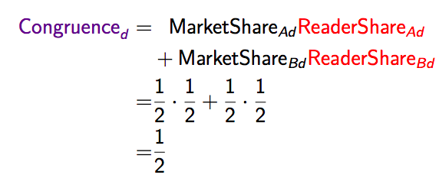

A higher congruence means that more time will be spent covering the politician
- More likely that voters will read about representative

4. How to Subvert Democracy: Montesinos in Peru

In the 1990s, Peru was run, in the name of President Alberto Fujimori, by its secret-police chief, Vladimiro Montesinos Torres.

In the course of exercising power, Montesinos methodically bribed judges, politicians, and the news media.
- Montesinos kept meticulous records of his transactions:
  - written bribery receipts
  - contracts detailing bribery receivers’ obligations
  - videotape of negotiations and transaction

The Fujimori government fell when one of Montesinos’s videotapes was leaked and broadcast on television.

- McMillan and Zoido (2004) study the bribery records

Many Many democratic institutions provide checks and balances that underpin democracy:
- a constitution
- regular elections
- independent judicial
- opposition parties
- a presidential term limit
- a free press

Peru has a full set of these BUT as revealed by Montesinos’s bribes, the most forceful one seems to be the free press:
- The typical bribe paid to a television-channel owner was about 100 times larger than that paid to a politician, which was somewhat larger than that paid to a judge.
- One single television channel’s bribe was five times larger than the total of the opposition politicians’ bribes.

5. Bias in Media

Bias in the media can have a large consequence
- But the extent will depend on those bias (demand or supply side bias)

5.1 Media Concentration
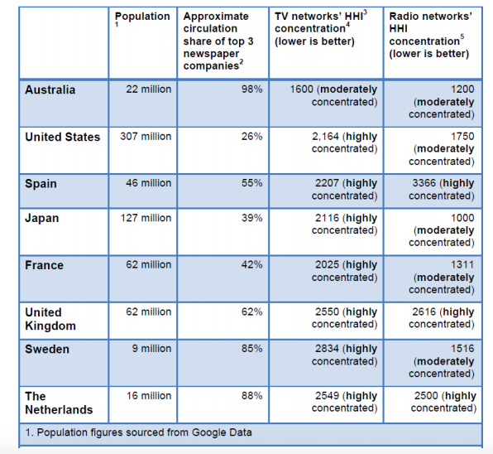

5.2 Print Media Concentration
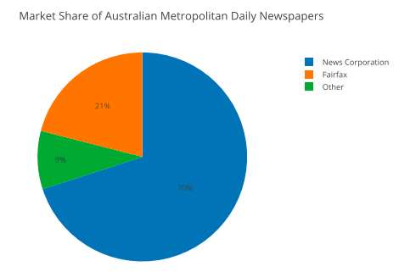

5.3 Large Media Corporations in Australia

Large control of news means that they have a greater ability to influence the news they put out

5.3.1 News Corp Australia

A subsidiary of News Corporation owned by Rupert Murdoch

Newspapers:
- The Australian (national)
- Daily Telegraph (Sydney)
- Herald Sun (Melbourne)
The Advertiser (Adelaide)
- The Courier-Mail (Brisbane)
- The Mercury (Hobart)
- Northern Territory News (Darwin)
- The Cairns Post
- The Gold Coast Bulletin
- Geelong Advertiser

5.3.2 Fairfax Media

In 2012, Gina Rinehart, the wealthiest person in Australia, acquired a shareholding of 19%, becoming the largest shareholder:

Newspapers:
- Australian Financial Review (national)
- Sydney Morning Herald (Sydney)
- The Age (Melbourne)
- Canberra Time (Canberra)
- Brisbane Times (Brisbane)

5.4 Demand-Driven Media Bias

The consumers of news, i.e. the audience, have different beliefs and ideological leaning.
- They might be inclined to consume news that are in line with their beliefs.

Media biases results as profit-maximizing media companies cater to their audience’s prior beliefs
- (Gentzkow & Shapiro, 2006)

Gentzkow & Shapiro (2010) measure media bias using textual analysis and find that the bias of U.S. newspapers is significantly correlated with the ideology of their readers

5.4.1 Methodology
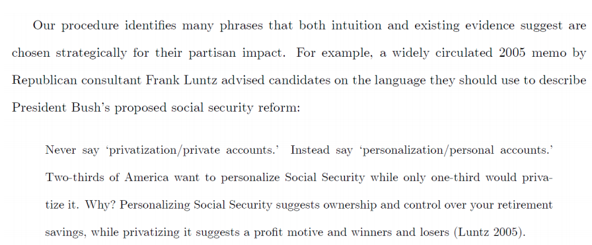

5.4.2 Slant of Wording
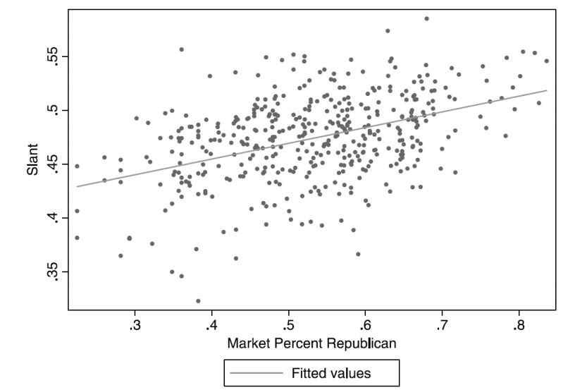

Depending on the wording used by the newspaper they can determine if they are biased towards the left or the right

Strong correlation between the share of people in a newspaper market who are republican and the words used in the newspaper (more towards republican wording)

Provides evidence that some of the biases in media are demand driven

Not necessarily a causal relationship

If there is 100% demand driven media biased, do not need to worry about concentration of newspapers

5.5 Supply of Media Bias

Does media bias affect voting?

- Rational expectation theories: voters filter out bias in reporting without being persuaded on average
  - If voters are really rational/calculating/ have all the information they need they are unlikely to be affected by biased and won’t be affected/ persuaded
- Behavioural theories: voters are subject to media persuasion
  - They subconsciously adopt a positions if they consume a lot of biased media

To answer this question, DellaVigna & Kaplan (2007) investigate whether and how the introduction of conservative Fox News channel affect voting behavior in the U.S.

5.6 The Fox News Effect

Rupert Murdoch introduced Fox News, a 24-hour cable news channel, in 1996.

The political coverage of Fox News is to the right of the coverage of other main television news: ABC, CBS, NCB and CNN.
- The news coverage of Fox News is also estimated to be to the right of the average U.S. elected official.

By the year 2000, Fox News had become available to about one third of the population in the 28 sample states of DellaVigna & Kaplan (2007).

By exploiting the timing of the entry of the Fox News channel in local cable markets, DellaVigna & Kaplan (2007) find:

- a significant effect of the introduction of Fox News on the vote share in Presidential election between 1996 and 2000;
- Republicans gained 0.4 to 0.7 percentage points in the towns that broadcast Fox News;
- Fox News also affect voter turnout and the Republican vote share in the Senate;
- 3 to 28 percent of Fox News’ viewers were convinced to vote Republican.

Potentially the supply side media bias does have impact on political discourse and how people vote
- 2000 election large indicator
- What should a democracy's media policy be as a result

5.7 Modern Day

Rise of social media has seen an increase in fake news
- Cost of creating news is far less than traditional media

No longer have to set up a network and build a brand
- Can spread information/misinformation much easier

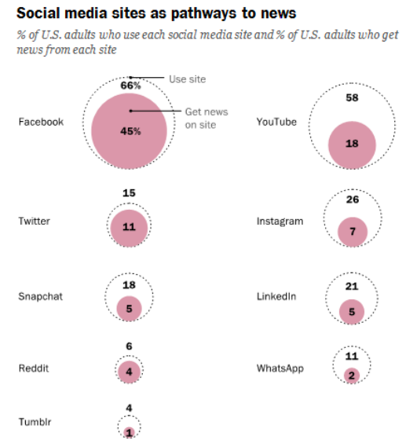

Week 11 Political Economy & Finance

What do Economists Do?

Economics is about trying to understand and tackle social problems.

- To do that, economists study how incentives and beliefs affect the behaviors of individuals, firms, organizations, etc., and how they interact with each other under different policies and institutions.
- Nowadays, a lot of cutting-edge economic studies are like detective work.
- Understanding behavior that agents would prefer to conceal has become a central component of the modern economic research.

- In this lecture, we will discuss several empirical studies where economists use data from financial markets for their detective work.

“FORENSIC ECONOMICS”
- Tries to uncover hidden behaviour
- Some studies have tried to uncover teachers cheating in exams / violation of UN sanctions

1.1 Why is Forensic Economics Important?

There are alot of behaviours that are important but are not easy to look at
- Things like corruption
  - Australia is not perceived to be corrupt

2. Corruption

It is important to study corruption as it is highly correlated to human development
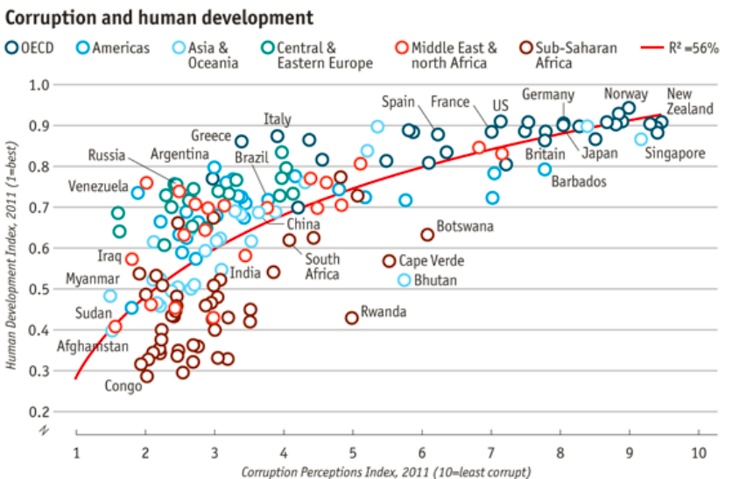

Higher the Index the lower the perceived corruption

The higher the Index score the higher the human development (includes education/heath/ income)

2.1 Corruption and Rent-Seeking

At a cost to the society, public office could be used by a powerful few to enrich themselves.
- Profitable investment may not happen due to the risk of being extorted by government officials.
  - The Invisible Hand and the Grabbing Hand
  - If there is little political accountability in the government this may lead to the government trying to extract resources from their efficient use (grabbing hand)

In a corrupt society, it may be more profitable to seek opportunities in securing favorable regulation or contracts from the government (rent-seeking) than to engage in productive economic activities such as:
- produce goods and services valued by consumers;
- research and innovate

These activities do not benefit society / improve the wellbeing of the people who live in those countries

People do not publicise their corrupt behaviors, can therefore be difficult to observe and measure the impacts of the behaviour

2.2 Corruption in Chinese Privatisations

Hoping to raise revenues and improve operating efficiency of state-owned assets, many countries, including China, carried out privatization of state-owned assets.

Anecdotally, there has been corruption, self-dealing, and heavily discounted sales of state assets to politically connected individuals and firms.

Fisman & Wang (2014) document evidence of corruption in Chinese state asset sales.
- In particular, they look at how the underpricing of state-owned assets correlates with deal attributes linking to misgovernance and corruption.

2.2.1 Background of Privatisation

Beginning in the early 1990s, many state-owned enterprises (SOEs) were partially privatized

The governments sold shares of SOEs to the general public, which created many publicly traded firms where governments still held substantial stakes.

More than two-third of outstanding shares were not permitted to trade in the stock market.
- These “non-tradable” shares allows control by the governments
- But blocks of “non-tradable” shares could be brought and sold through negotiation between their owners and specific firms and individuals

2.2.2 Negotiated Transfers

“Non-tradable” shares were owned by:
- Central, provincial, or local governments directly
- SOEs
- private parties

Rent-seeking potentials in “negotiated transfers”:
- The prices of share transfers were negotiated by managers of the SOEs, which owned the “non-tradable” shares
- These managers could be bribed (or give out favors) and set a low selling price, which costs the SOEs

2.2.3 Disguised SOE Shares

Negotiated transfers required regulatory approval as they were shares in state owned enterprises

Directly state-owned shares and SOE shares received greater scrutiny
- To avoid scrutiny, disguise SOE shares as privately owned shares

Reportedly private sellers are often ultimately owned by SOEs

Smoking guns:
- Did disguised sellers under-price their shares more than face-value SOEs?
- If there is some sort of corruption going on, the manager of the state owner enterprise would lower the sale price, to get the sale passed through and avoid scrutiny may pretend to not be selling shares in the SOE

Sample (n): 2121 deals involving 649 firms

2.2.4 Under Pricing
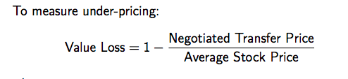

Where:

Negotiated Transfer Price = the transfer price of non-tradable shares between the seller and the buyer

Average Stock Price = the average stock price of the corresponding tradeable share in the month prior to the deal

If the negotiated transfer price is close to that of the average stock price the value loss would be close to 0
- If the manager is corrupt and is selling the goods at a very low price then the value loss would be much higher
- Does not immediately imply that manager is corrupt however

If we compare the the ratio for different transactions

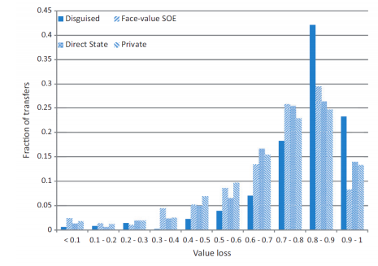

A lot of the disguised transactions have 70-80% value loss

Meaning there is a large discount on the share prices

Why would they disguise the owner of the shares? To allow it to get approved and also benefit from the bribes eyc

A regulation mandating greater disclosure of ownership chain was proposed in 2001 and enacted in 2002
- The share of deals with disguised SOE sellers drop after the regulation
- Harder to pretend the enterprise is not a state owner enterprise

Operating performance as measured by Return-on-Asset improves after transfers of face-value SOE shares but not transfers by disguised SOE sellers
- Consistent with other studies in this context - efficiently is generally increased
- Generally speaking the buyer of a SOE would be able to increase the efficiency of the firm
- There are also benefits from seller to the buyer offering the highest price who is also the person who is likely to be able to increase the efficiency of the firm the most
- If there is bribery going on it is not likely the buyer/bidder is the one who will increase efficiency the most

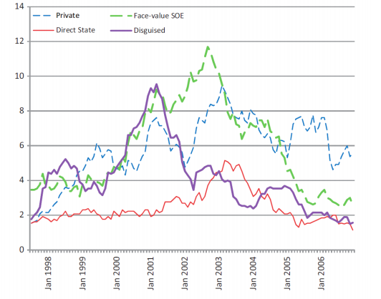

2.3 Value of Political Connections

Do political elites and firms benefit from rent-seeking?

Empirical challenges:
- Those who benefit from rent-seeking are not eager to tell people about it.

If so, how?
- One channel= Political Connections

Moreover, how much do connected firms benefit from their political connections?

2.3.1 Estimating the Value of Political Connections

Fisman (2001): Indonesia under Suharto

Empirical Approach:
- Use stock market event study to gauge the “market value” of political connections to a dictator
- Use data from Indonesian stock markets

Background and Empirical Setting:
- Indonesia under Suharto
- Authoritarian with widespread corruptions

Transparency International estimated that the Suharto family amassed $15 - $35 billion over the years

2.3.2 Empirical Approach: Event Study

Use stock market event study to estimate the “market value” of political connections to Suharto
- When news about Suharto getting sick appears, how were the stock value of firms connected to the Suharto family relative to unconnected firms?

For example: Bimantara Citra was found by Suharto’s middle son with his friends and former schoolmates when he was 28 years old. Within a decade, Bimantara Citra became one of Indonesia’s largest companies, with businesses in hotels, telecommunications, chemicals and food.

“Whenever Mr. Suharto catches a cold, shares in Bimantara Citra catch pneumonia”
- Captures the depency of the firm to the health (and power of connections) to Suharto

2.3.3 Data and Estimation

Data on dates of 6 Suharto health shocks from News database

Data on connections to Suharto
- Indonesian consultancy rates each firm on scale of 1-5 of how close they are to Suharto
- Examples of "5" firms are those owned by Suhartos children, Suharto’s cronies from childhood, and his relatives

2.3.4 Suharto’s Health & Connected Firms’ Stock Value

The graph strongly suggests that politically dependent firms, on average, lost more value
during these episode than less-dependent firms.

If the overall market declined by 1 percent in reaction to news about Suharto’s health, we might expect a firm with Dependent Index = x to drop 0.28 percent more than a firm with Index = x − 1
- A lot of value and profit of the connected forms is derived from the connections not the inherent value of the firms
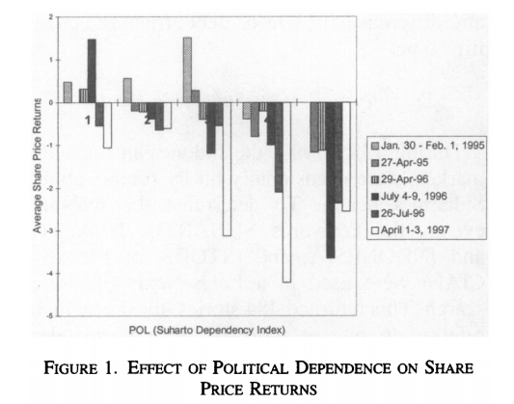

Figure 1 shows the share price returns for the six episodes, with the Suharto Dependency Index on the horizontal axis.

2.4 Mortality Cost of Political Connections in China

Political connections may bring favorable regulatory environment to firms

Fisman & Wang (2015) study how having senior managers who previously held high-level municipal government offices gives firms relatively loose workplace safety oversight and regulation.

Despite political connected firms have higher workplace fatality rates, they have lower chances of undergoing safety audits in years without fatalities.

Politically connected firms also have a lower chance of being fined for environmental violations

Political connected firms’ return on assets is 1 percentage higher than unconnected firms, which may be partially attributed their ability to circumvent regulation

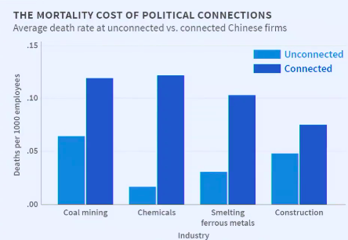
Death rates for connected firms are higher than those of non-connected firms

2.5 Corruption in Developed Countries/Democracies

Corruption does not only take place in developing countries, takes place in developed nations but may take different form

2.5.1 Campaign Contributions

- Politicians
- Spend Money to increase chances of election
- War chests scare off potential challengers
  - People may not be eager to challenge incumbents
- Campaign expenditure, e.g. political ads, staffers salaries, logistics, etc.

- Donors
- Qui pro quo
- Buying (future) access
- Help electing those donors’ like

(C) Revolving Door Lobbyists

Government officials who retire/no longer in government position move to the private sector and become lobbyists
- This is a conflict of interest
- Lobbying per say is not bad as it allows stakeholders voice their opinions

To what extent is the lobbying conveying useful information rather than just promoting private interests

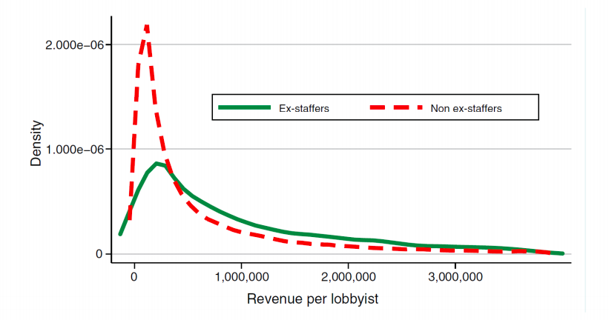

The proportion of lobbyists who are ex-staffers and are earning more than a million is much greater than those who are not ex staffers
- There is value from these political connections

The majority of lobbyists are retired politicians for both house of reps and the sentates

2.6 Value of Political Connections Cont.

- US

- Former Vice President Dick Chaney’s heart attack (Fisman et al., 2006)

- Political connections in turbulent times: Timothy Geithner as Treasury Secretary (Acemoglu et al., 2016)

- S&P 500 with board members connected to Republican gains in stock value upon the election of Bush in 2000 (Goldman et al., 2009)

- Pakistan

More bank loans to politically connected firms (Khwaja & Mian, 2005)

- Pooling other countries

- Announcements of political connections increase firm’s stock value (Faccio, 2006)
- Politically connected firms are more likely to get bailed out (Faccio et al., 2007)

3. Coups, Corproations and Classified Information

Does the public trust the Government?
- Sense of trust has been eroded over time

In the US there was the underlying sentiment that the policy/government has been controlled by the elite
- Undermining people’s faith in the government

3.1 Guatemala in the 1950s

Banana republic refers to a politically unstable country with an economy dependent upon the exportation of a limited-resource product, such as bananas or minerals.

The United Fruit Company (UFC) was an American corporation that traded in tropical fruit (primarily bananas), grown on Central and South American plantations, and sold in the United States and Europe.

By buying up land titles on the cheap from Guatemala’s corrupt elite, UFC owned over 40% of Guatemala’s land by 1950.
- UFC also owned all the banana processing plants, virtually all of the shipping ports, and most of the railroads in Guatemala.

3.2 Jacobo Árbenz Gúzman & Land Reform

In 1951, Jacobo Árbenz Gúzman became Guatemalas second democratically elected president.

Jacobo Árbenz’s policy platform centered around a comprehensive land reform and modernization plan.
In 1952, the Árbenz administration passed a agrarian reform bill that expropriated land from UFC and redistributed to poor peasants.

3.3 Friends in High Places

But UFC had friends in very high places:

- Cabot Brothers:
John Moors Cabot: Assistant Secretary of State for Inter-American Affairs
Thomas Dudley Cabot: UFC President, Department of State Director of Office of International Security Affairs

- Dulles Brothers formerly on the UFC board
Allen Dulles : Deputy CIA Director, later CIA Director
John Foster Dulles: Secretary of State

3.4 Declassified Top Secrets

A series of top secret meeting to plan on overthrowing Arbenz

- Operation PBSUCCESS approved by President Eisenhower on April 19th, 1954

- Thanks to Freedom of Information Act, declassified top secret documents became available to historians and the public.

3.5 1954 Guatemalan coup d’état

Backed by the U.S., Carlos Castillo Armas and his force 150 troop invaded Guatemala from Honduras and established military dictatorships.

The coup led to decades of instability and a series of military dictatorships.
- On the other hand, stock price of UFC went up
- Military Dictatorship was favourable to US and UFC

4. Background: The Cold War

During the Cold War, intelligence agencies of superpowers conducted covert operations in foreign countries.
- CIA
- MI6
- KGB

For the U.S., many of these operations had the expressed goal of replacing “unfriendly” regimes, which often are ones that had expropriated assets of multinational corporations.

Since these corporate assets were always returned after a successful regime change, these operations were potentially profitable to nationalized companies.

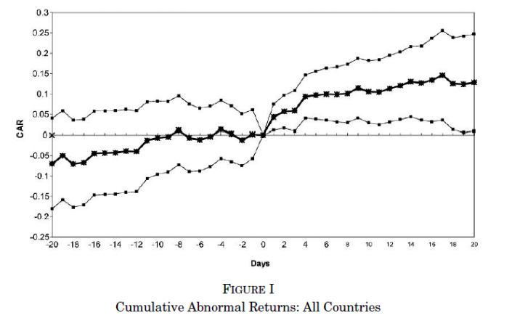
Time 0 is center point
- Look at affects of events on returns leading up to and after an event
- On average there is an increase on stock value on firms that stand to benefit from the coup

The paper found that there was an increase in the stock price of firms that were to gain from the coup after the coup and the return of their assets AND at the time the action was authorised
- HOWEVER the authorisation of the coups was TOP SECRET information known only by the government
- This means that there are those who were connected were gaining from the benefits of the firm

