ACCT3104 Notes
Management Accounting
Vimal Singh

Lecture 1: Costing Systems, allocation of indirect costs, PVV and inventory valuation methods.
Learning objectives:
- Explain what is and the role of managerial accounting.
- Explain costing systems, CVP analysis (cost-volume profit), allocation of indirect costs and PVV (production of volume variance).

MA and the Theory of the firm
- Where does the firm fit in? How can it be justified:
  - Intermediary between factor and product markets
  - Adds value transforming resources from one form to another (goods and services).
    - How do we know if this is happening?
      - Value of factor inputs compared with value of outputs.
- So what is the role of accounting information – particularly MA?
  - Help managers formulate strategy to create value,
    - Managers need to know how to set price and deal with costs of materials in order to utilise capacity and maximise operation capacity.

Simple Example – Value added by transforming resources
- (A) Sales price of one box of biscuits ($3.50) – (B) Total cost of resources consumed to produce and make one box of biscuits available ($3.00) = (C) Value Added ($0.50)
Management accounting
- “is a profession that involves partnering in management decision making, devising planning and performance measurement systems, and providing expertise in financial report and control to assist management in the formulation and implementation of an organisation’s strategy.”
Major differences between Financial & Management accounting
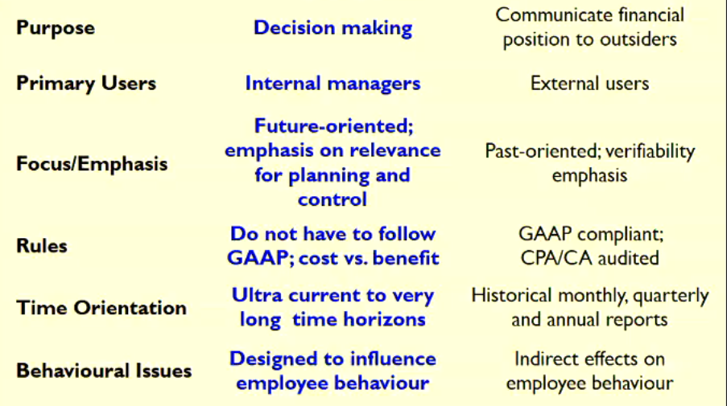

Purposes of cost information
- External reporting
  - Inventory valuation & COGS
- Internal Reporting
  - Decision making
    - Pricing
    - Product mix
    - Cost management (reduction/control)
    - Encourage desired ‘behaviours’
  - Performance measurement
Three key elements of making products
- Labour
- Materials
- Overhead
Absorption costing
- Fixed Manufacturing Overhead is applied to the cost inventory
Variable Costing (Used for management accounting)
- Fixed Manufacturing Overhead is applied as a period cost.
Actual Costing
- No variance
- However, can only be applied after the period (does not help management accountants, because it happens after)
Classification of Costs: Product (inventoriable) vs Period costs
- Product costs include direct material, labour and manufacturing overhead
  - (Applied to inventory, until such time as the sale occurs, then moved to COGS)
- Period costs are not included in product costs, they are expenses on the income statement.
Behaviour of Cost
- Variable
  - Total variable costs changes as activity level changes
  - variable cost per unit remains the same over wide ranges of activity
- Fixed
  - Total fixed cost remains the same
  - Goes down as you make more products

Variable costing – CVP analysis
- Shows how alternative actions can affect profit
- Focuses on the relationship between cost, volume and profit
- Enables us to:
- Determine the break-even level of production and
- Predict how change sin the level of production, selling price or costs will affect profit
- CVP is useful for planning and observing the sensitivity of profit to changes in costs and volume.

CVP Analysis
The Assumptions
- It is possible to divide costs into F & V elements
- VC are proportional to volume/activity
- FC are constant over the output range
- Sales price remain unchanged
- Expected levels of efficiency & productivity are unchanged
- Volume is the only factor affecting costs
- Only single product is produced or constant sales mix
- Production = Sales

C-V-P Methods
- Graphical Method
- Equation Method
- Contribution Margin Method
- Example: a manufacturer of kids toys sells each toy for $60. The following is the cost structure:
  - Total fixed costs = $300,000 (Mfg & Selling)
  - Variable costs per unit $45 = (Mfg & Selling)
- Calculate BEP where profit = 0.
Graph Method
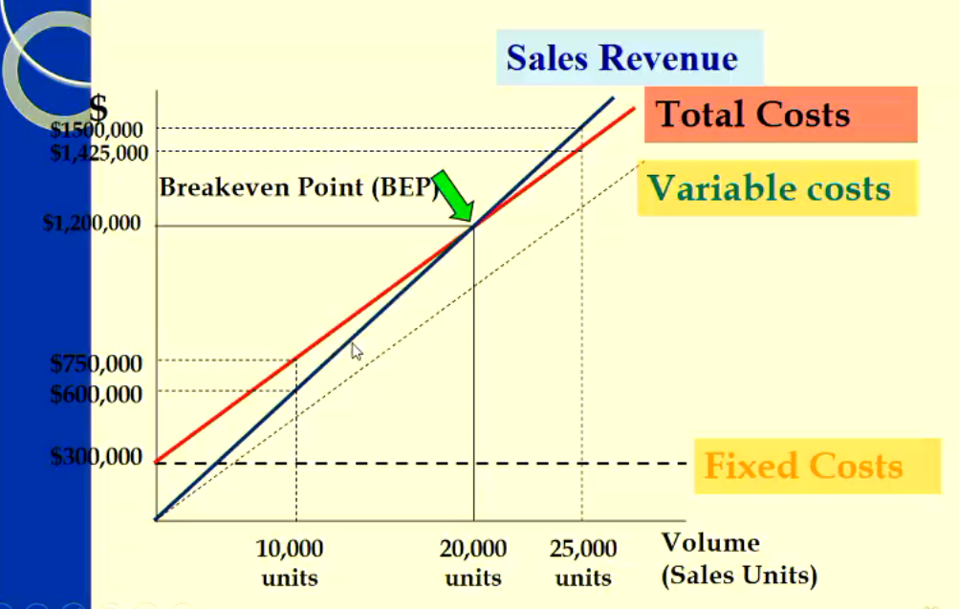

Equation Method
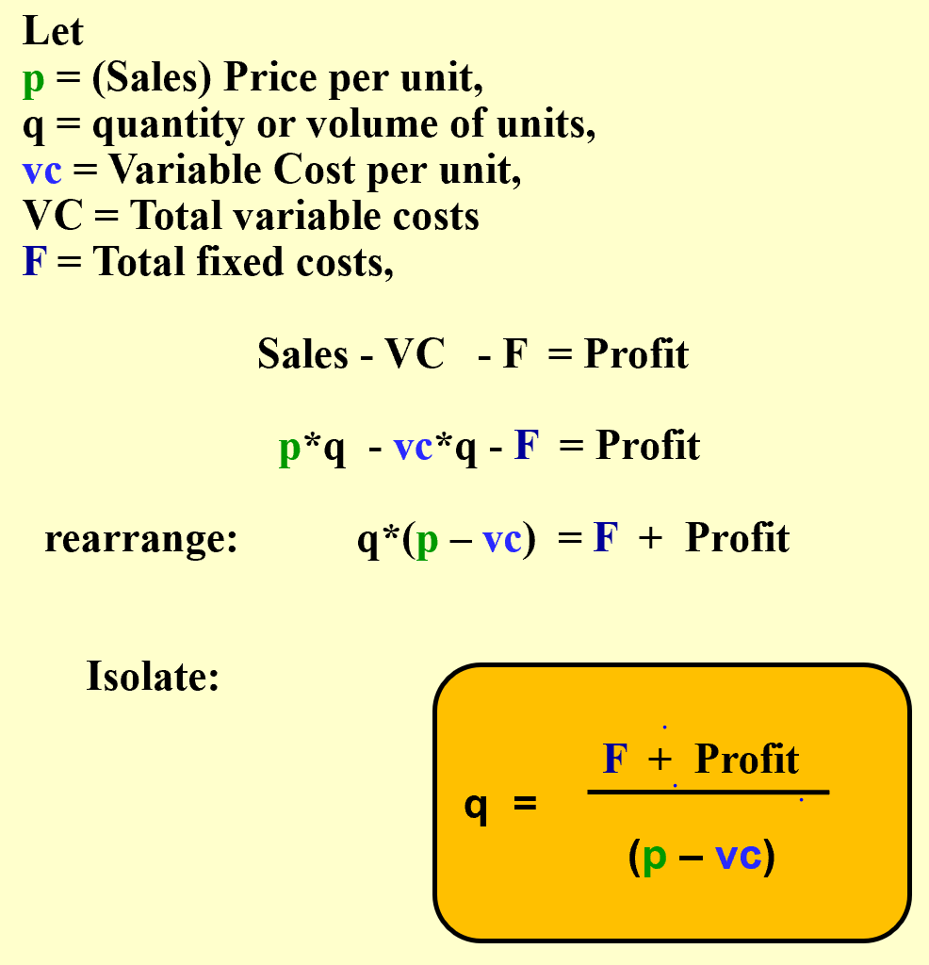
- Can be looked at in terms of price and quantity. (this diagram is quantity)
- 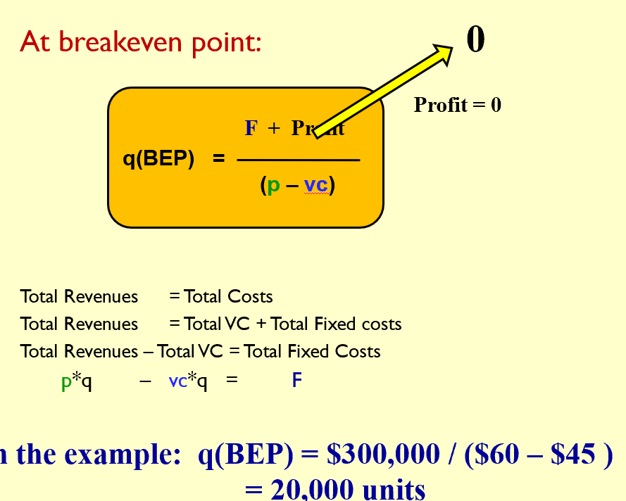

Absorption Costing – Manufacturing Cost Flows
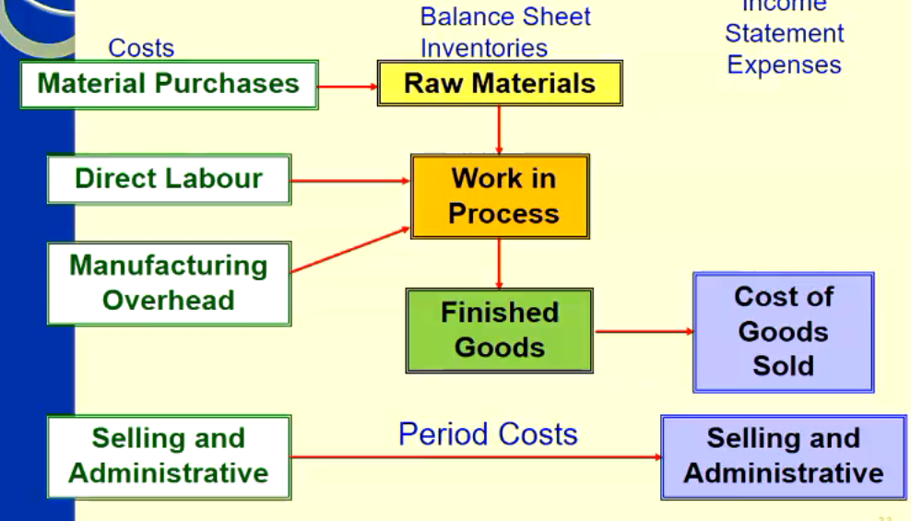
Record manufacturing costs
- What mafuc. Costs must be recorded?
  - All actual manufacturing costs?
- What manuf costs are recorded?
  - Depend on wthehre we use actual, normal or standard costing.

Tracing and Allocating Costs
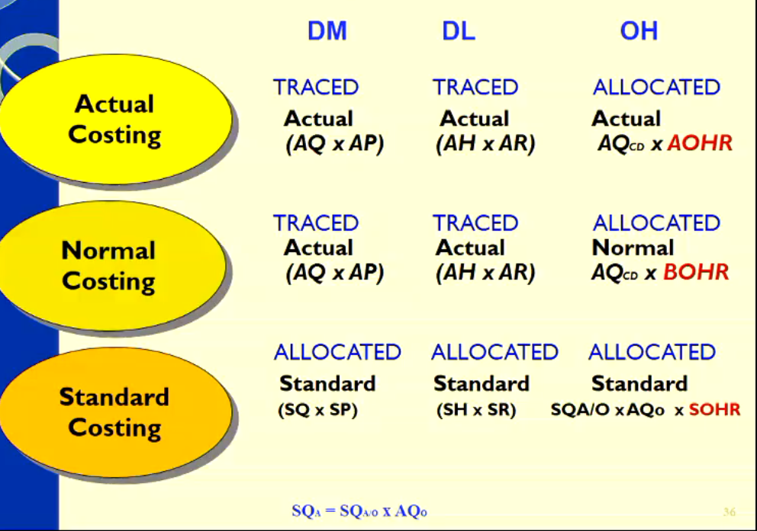
Example:
Budgeted Overhead = Budgeted Total OH costs for period / Budget quantity of allocated base for period
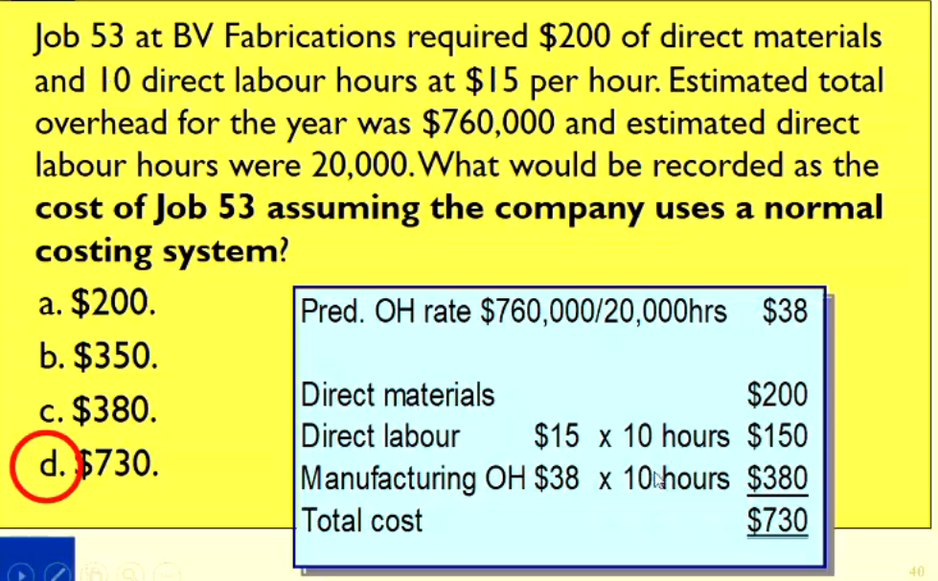

End of period adjustments
- Two approaches: proration or write off to COGS
  - Write off excess to COGS, just send everything to cogs.
    - Journal Entry:
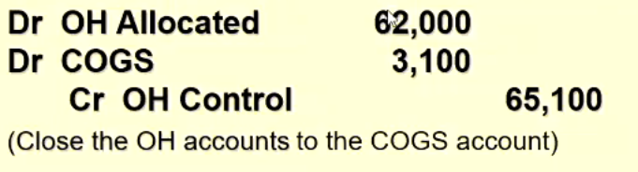
  - Proration approach – Proration of under/over allocated OH among ending WIP, FG and COGS Balances.
  - Basis to prorate under or over allocated OH
    - Total amount of manufacturing overhead allocated (before proration) in the accounts WIP, FG & COGS.
    - Ending balance (before proration) of the accounts WIP, FG & COGS.
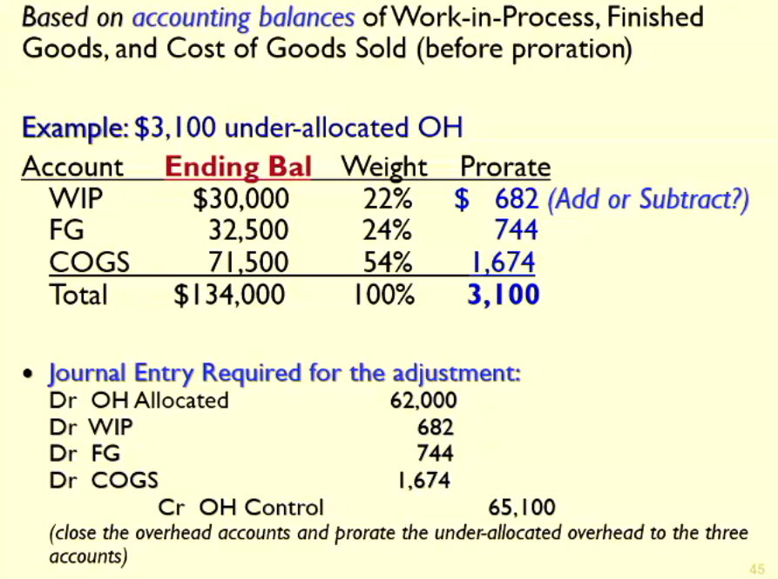
    - Example
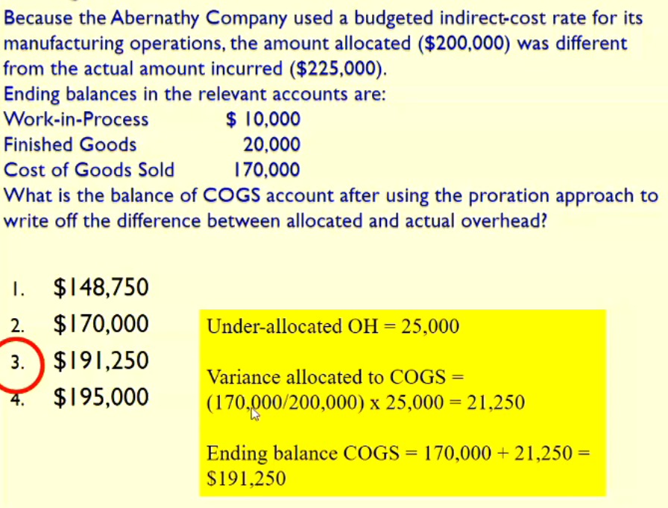
    - The Variance allocated divides by 200,000 because that is the sum of WIP, FG and COGS, NOT BECAUSE IT IS THE AMOUNT ALLOCATED
Normal Costing System
- OH Costs can be variable or fixed.
- VOH costs increase in total as output increases (e.g. electricity)
- VOH Allocated = AQ_{CD} X BVOHR
- Under/Over Allocated VOH = Spending Variance (U/F)

- FOH costs remain the same even though the volume of production increase or decrease (e.g. Rent).
- Flexible budget FOH = Static budget FOH = BFOH costs
- FOH Allocated = AQ_{CD} x BFOHR
- Under/Over allocated FOH = Spending Variance + PVV (U/F) difference between FOH Allocated and AFOH
- Spending Variance FOH costs = AFOH – BFOH
- PVV for FOH costs = BFOH – FOH allocated

In the Second Half of the Lecture, there is a completed example. Go back and revise.

Lecture 2: Absorption, Variable and Throughput Costing, Capacity decision. Break-even point

Learning Objectives
- Explain inventory costing methods: absorption, variable and throughput costing, and identify what distinguishes them.
- Compare income under Variable , Absorption and Throughput Costing and explain the difference.
- Describe and apply the different capacity concepts that can be used in Absorption Costing.
- Identify the key factors in choosing a capacity level to calculate and absorb the fixed manufacturing costs.
- Understand some issues in planning and control of capacity costs: downward demand spiral and break-even point.
Classification of Costing Systems:
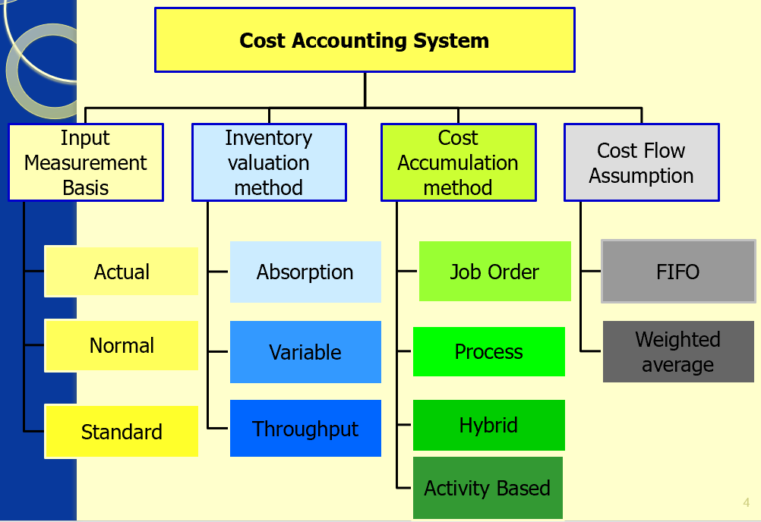

Inventory Valuation (Costing) methods
- Absorption – Variable – Throughput Costing
- The differences between absorption costing and variable costing methods are based on the treatment of fixed manufacturing overhead.
- The differences between variable costing and throughput costing (super-variable costing) methods are based on the definition of variable costs.

Inventory Valuation methods:
Variable vs Absorption costing:
- Under variable costing
- Under Variable Costing, fixed manufacturing overhead costs are excluded from inventoriable costs and are a cost of the period in which they are incurred.
- Under Absorption Costing, fixed manufacturing overhead costs are inventoriable (asset) and become expenses (COGS) only when a sale occurs.
- Required under AASB102
- Under both methods all non-manufacturing costs (such as research and development and marketing), whether variable or fixed, are recorded as expenses when incurred.
Variable Costing
- Inventory
  - Direct Materials
  - Direct labour
  - Variable overhead
- Expense
  - Fixed overhead
  - Variable selling & admin expenses
  - Fixed selling & admin expenses
Absorption Costing
- Inventory
  - Direct Materials
  - Direct labour
  - Variable overhead
  - Fixed overhead
- Expense
  - Variable selling & admin expenses
  - Fixed selling & admin expenses
Throughput costing
- Sometimes known as “super-variable” costing: only direct materials costs are included as inventoriable costs (e.g. the only “truly variable cost”)
- All other costs are period costs (including DL and VOH)
- Not widely Adopted
- Inventory
  - Direct Materials
- Expense
  - Fixed overhead
  - Variable selling & admin expenses
  - Fixed selling & admin expenses
  - Direct labour
  - Variable overhead
Inventory valuation (Costing) methods
- What is the difference between AC and VC
  - Treatment of fixed manufacturing oH
  - Absorption Costing requires “absorption” of all manufacturing costs into unit product cost
  - Variable costing (contribution format) emphasizes cost behaviour
- Income statement under AC and VC:
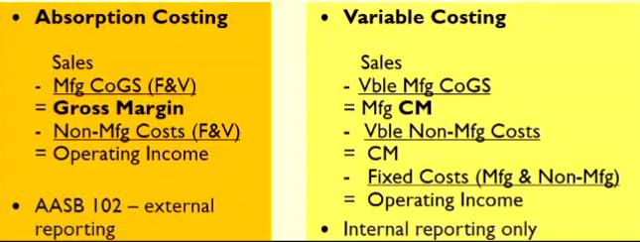

Comparing Income Statements
- Absorption v Variable Costing.
- Example:
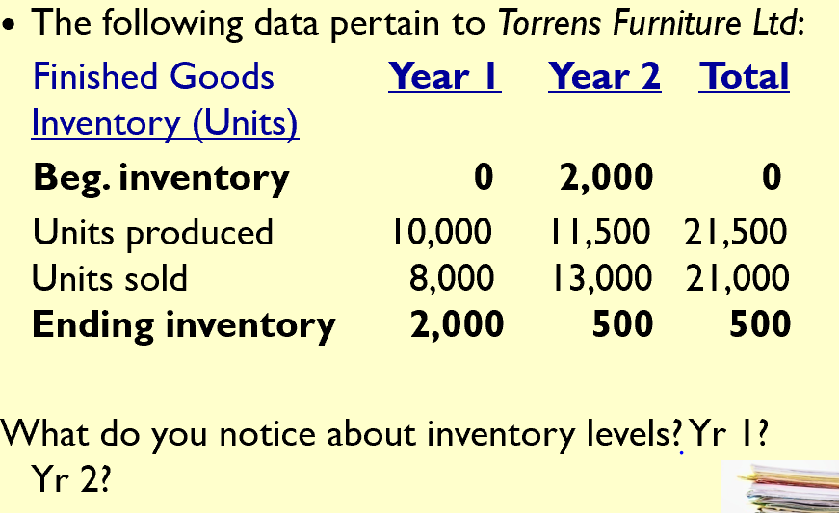
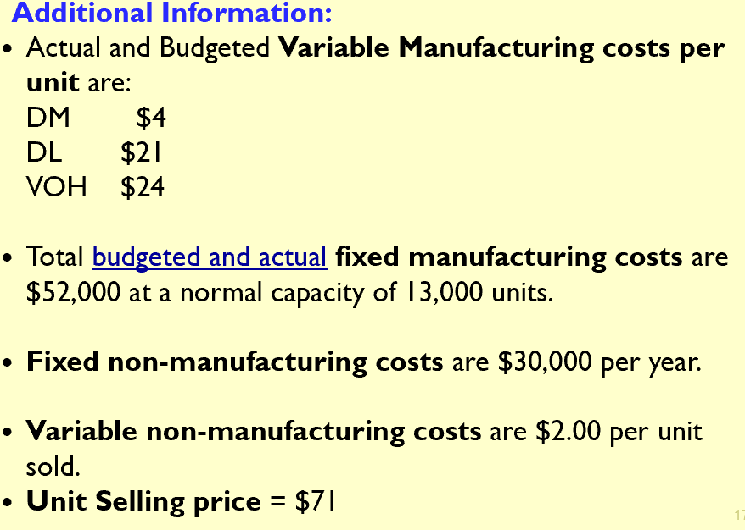

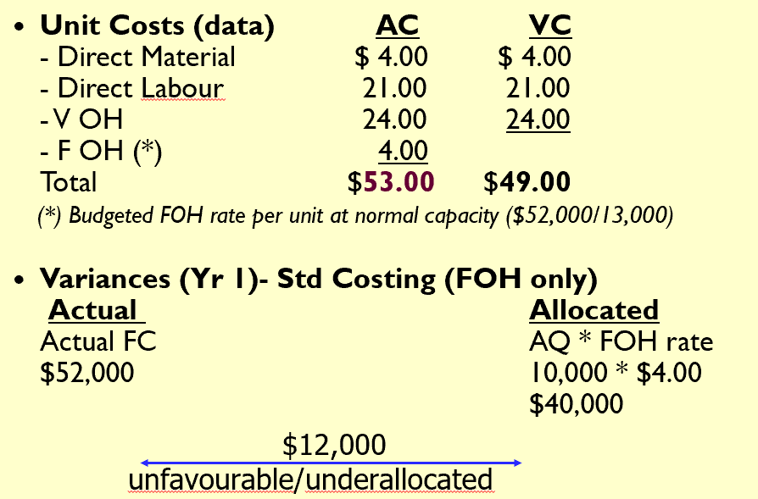
- Answer for Absorption

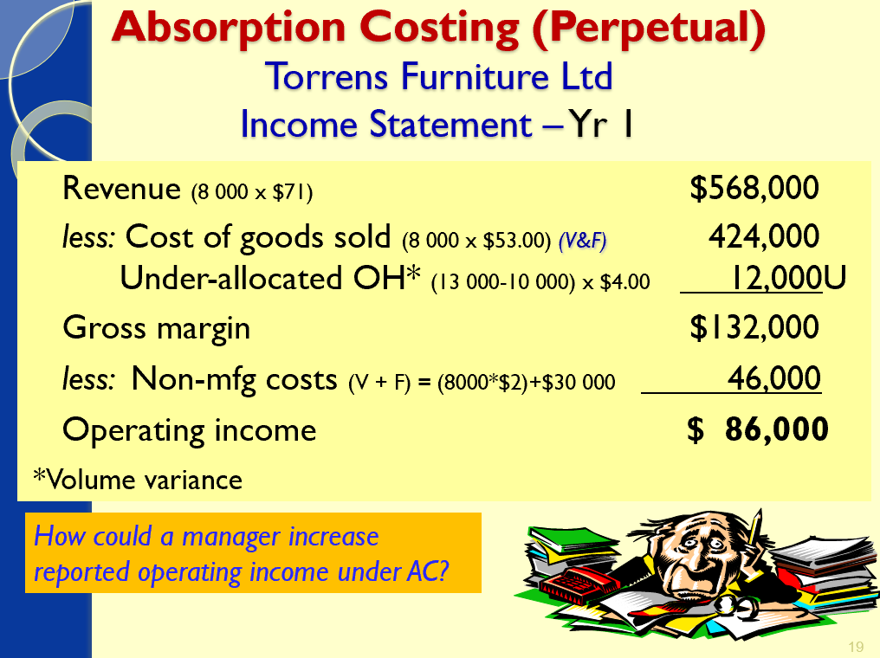

- Answer for Variable
- 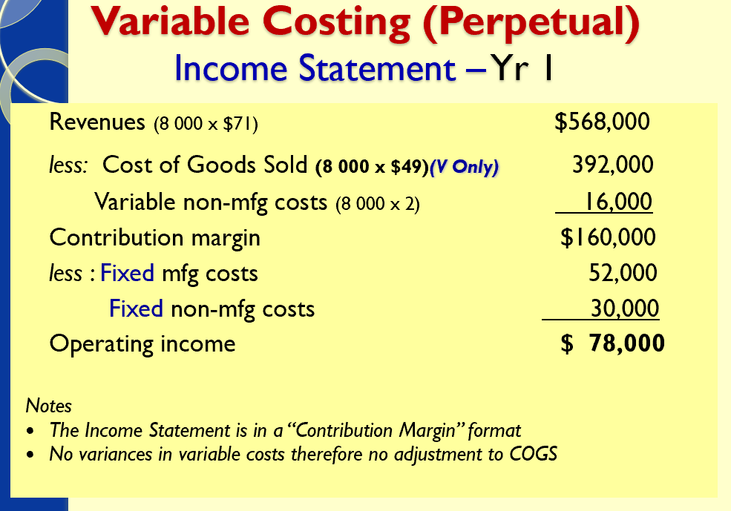
Comparison of Variable and Absorption Costing for year 1
- AC operating income: $86,000
- VC operating income: $78,000
- AC operating income is $8,000 higher. Why?

Production exceeded units sold in year 1:
- 10,000 – 8,000 = 2,000 unit increase in inventory
Value of increase in the inventory?
- Absorption costing: 2,000 × $53.00 = $106,000
- Variable costing: 2,000 × $49.00 = $98,000 Diff?
Higher cost of inv. & Lower COGS under AC: $8,000
Reconcilliation AC vs VC
- AC Op Income – VC Op Income = (EI – BI) x FOHR
- $86,000 - $78,000 = (2,000 – 0) x $4
- $8,000 = $8,000

Income statements – Absorption costing
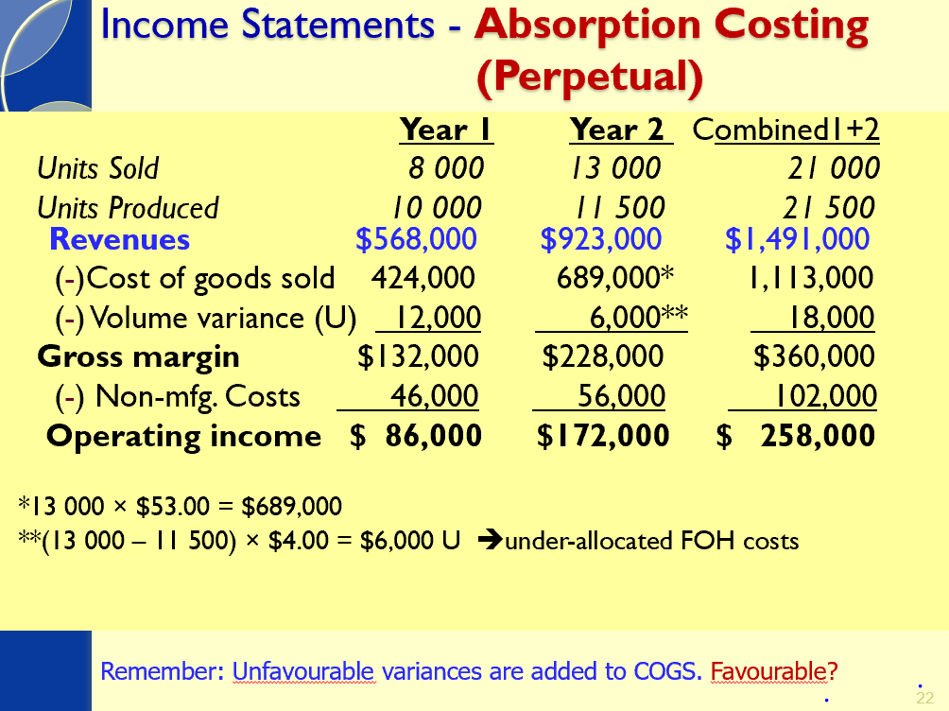
Income Statement – Variable Costing
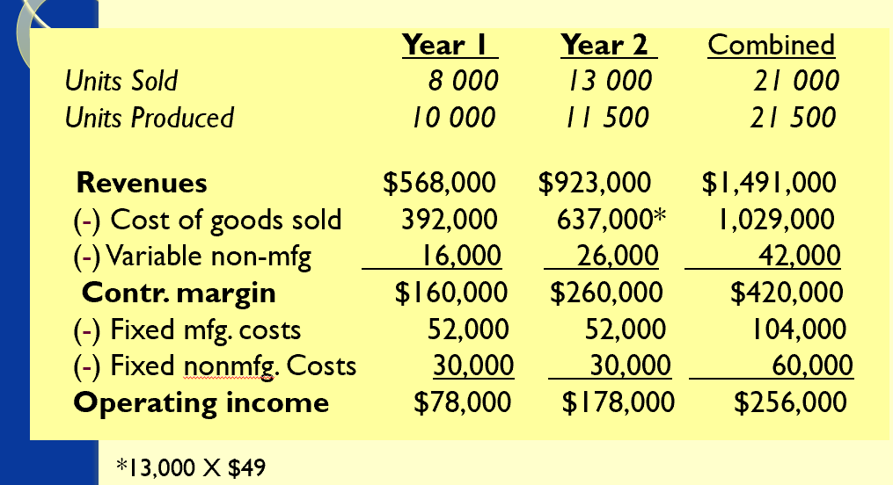

Comparison of Variable and Absorption costing Year 2
- AC operating income: $172,000
VC operating income: $178,000
- AC operating income is $6,000 lower. Why?

- Production is lower than units sold in Year 2.
- 11,500 – 13,000 = -1,500 unit decrease in inventory

- Value of decrease in the inventory?
Absorption costing: -1,500 × $53.00 = $(79,500)
Variable costing: -1,500 × $49.00 = $(73,500) Diff?
Lower cost of inv. & Higher COGS under AC: $6,000

- Reconciliation AC versus VC
AC Op Income – VC Op Income = (EI – BI) x FOHR
$172,000 - $178,000 = (500 – 2,000) x $4
$(6,000) = $(6,000)

General Rule: Useful when fixed OH rates Change
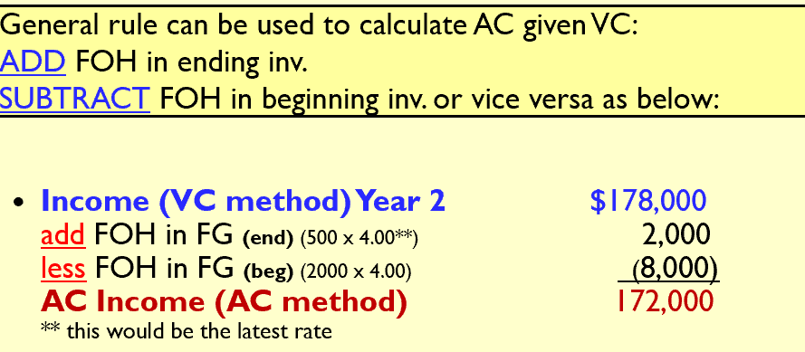

Summary
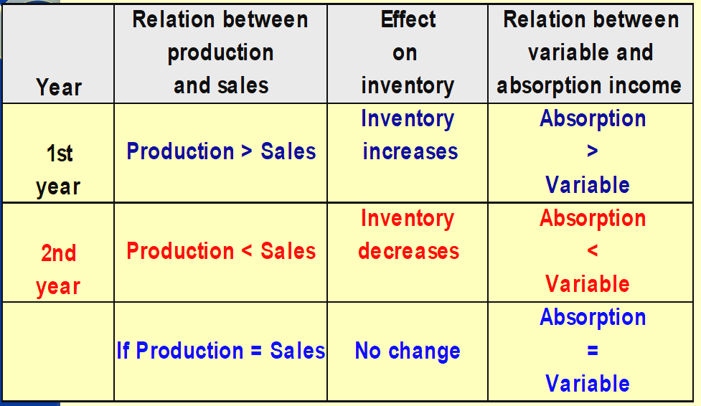
Example:
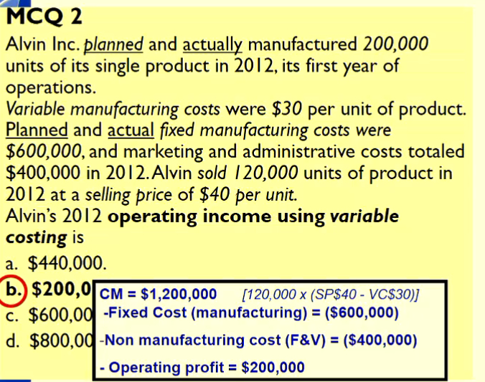
Example Answer if the qeustion was absorption costing not variable
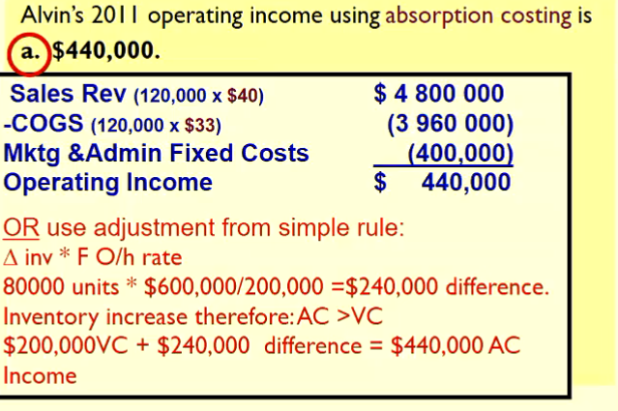

Advantages of VC vs AC
- It highlights the contribution margin and is compatible with techniques used for management decision-making, particularly short-term, e.g. CVP analysis.
- Classifying costs according to cost behaviour (as occurs in VC) is more useful for management decision-making.
- Eliminates Problems with allocation of Fixed OH and calculation of Fixed OH Rates etc.
- It avoids the problem of manipulation of production in order to increase profit. This is an important issue!
- BUT…. Not allowed AASB 102

Advantages of Absorption Costing
- AC “better reflects the cost of inventories” (AASB102).
- Inventories should carry a fixed cost component because both variable and fixed costs are necessary to produce the goods. The fixed overhead component of inventory represents a future economic benefit in the same way as the variable component – sale of inventory will generate revenue in future periods.
- AC satisfies the matching principle. It expenses costs related only to units sold.
- It avoids fictitious losses being reported, e.g. in firms with seasonal production activities.
Under VC if you “produce this period and sell next period” you can show a large loss in the period when you are producing because you expense all fixed overhead but have no revenue to match it with.
- As fixed costs of production increase….

Capacity concepts and analysis
- How do we budget for the size of the allocation base BQo?
- BFOHR = BOH Costs / BQo
- BQo depends on different concepts of capacity.
BQo = budgeted quantity of output or units produced
- The appropriate level of capacity is a strategic management decision
- Too much capacity? Incur costs of unused capacity
- Too little capacity? Demand may go unfilled
- The capacity level chosen will affect the budgeted fixed OH rate

Capacity levels:
- Supply side -> Available capcity
How much can I produce
- Theoretical capacity
- Practical capacity
- Demand side -> Customer demand
How much can I sell? How much should I produce?
- Normal capacity utilisation
- Master-budget capacity utilisation
Types of Capacity
Theoretical capacity
- The absolute maximum production capacity (output) at full efficiency all the time (365 days per year) e.g. no maintenance, no interruptions.
- Ideal target, … but … unattainable in the real world.
- Highest denominator level unrealistically small FOH costs/unit.

Practical Capacity
- The maximum output that could be realised if everything operates efficiently allowing for unavoidable interruptions.
- Theoretical capacity less planned down-time lower units/shift, lower days per year.
- This is the cost of supplying capacity (max units that can be produced) FOH costs / unit of supplying capacity.
- The cost of capacity can be divided into cost of capacity used and unused.
- Useful for managing unused capacity: leasing excess, new products, etc.
Normal Capacity
- The capacity that a firm uses to satisfy long-run average customer demand (computed over more than one year and includes seasonal, cyclical and trend factors).
Actual Capacity
- The actual production activity
Master budget Capacity
- The capacity that a firm expects to use to meet demand for the current budget period (year).
- Useful to evaluate marketing manager’s performance (master budget is the principal short-run planning and control tool).
- It can cause a downward demand spiral the continuous reduction in the demand for products when competitor prices are not met.

Key Factors in choosing a capacity level
- Managers must choose a different capacity level for different purposes including:
  - Product costing and capacity management
  - Pricing
  - Performance evaluation
  - External reporting & Tax requirements
- For external reporting, choice will affect size of PVV – and how this is disposed of will impact income.
- Theoretical capacity is rarely used – not ‘real’
- Practical capacity is frequently used – highlights cost of capacity acquired but not used and may direct manager’s attention towards more effective capacity management.
- Normal and master-budget capacity hide unused capacity (unused capacity costs are included in the FOH cost/unit).
- Master-budget capacity can lead to downward demand spiral.
Effect of capacity on Operating Income
- PVV = BFOH costs – FOH costs allocated
- PVV = BFOH costs - AQo x BFOH rate
- PVV = BFOH costs – AQo x (BFOH costs / Den-Level)
How PVV Is disposed at end of year?
- Adjusted allocation rate approach
- Proration approach
- Write off to COGS

Break Even Point

Lecture 3: Inventory Management, EOQ ( and JIT
Learning Objectives
- Be able to explain the importance of inventory management and supply chain management to organisational performance
- Explain the principles underlying traditional (conventional) inventory management
  - Be able to use the EOQ formula to calculate optimal order quantities and the re-order point
- Discuss the rationale and key features underlying JIT systems for purchasing and production
  - How do JIT systems operate?
  - Why do they succeed? What are the benefits of JIT systems in comparison with traditional?

Introduction: - Managing Inventory
- In ACCT3104 we will consider a number of topics including relevant costs that emphasise the need for relevant information for a number of different decisions that lead to improved organisational performance.
- Most organisations today are also focused on managing activities and costs across the supply chain of the business to improve performance, which can involve creating and managing close relationships with suppliers and customers.
- Management of inventory is a key consideration in dealing with suppliers and is a key consideration in improving organisational performance. We will consider two approaches for inventory management:
  - EOQ (Economic Order of Quantity) approach to determining optimum order quantities for inventory
  - JIT inventory management systems that allow businesses to manage inventory and production more effectively
Supply Chain of a business
- Supply chain management can involve creating close relationships with suppliers and customers, managing costs, measuring the performance of activities, suppliers and customers and, accelerating the time-to-market of new products
Managing Inventory
- Purchased material and components can make up a large proportion of cost of producing a product (>40%)
- Many organisation activities and cost are driven by the purchasing activity e.g.
  - Selecting a supplier
  - Communicating with supplier
  - Inspecting materials delivered
  - Storing Inventory
- Cost reductions do not equal, using suppliers with cheapest materials or components or ordering in the most effective quantities
- Cost reductions = reliable suppliers that can meet desired criteria (quality; on-time delivery, time…)

- Following criteria for selecting suppliers
  - Price
  - Quality
  - Delivery
  - Performance history
  - Capacity
  - Communication systems
  - Geographical location
- Can we as management accountants determine the relevant costs of alternative suppliers? How?
Traditional approach to inventory management
- Consider reasons why some organisations hold high levels of inventory?
  - Incase they run out.
- Economic Order Quantity (EOQ), as a traditional (conventional) approach, accepts inventory as necessary and focuses on ways to minimise inventory costs
  - Premise: managing inventories to increase net income requires effectively managing costs that fall into these five categories:
- Purchasing Costs
- Ordering Costs
- Carrying Costs
- Stockout Costs
- Quality Costs

Inventory Costs?
- Purchasing Costs
  - Costs of goods acquired including freight
  - Affected by quantity discounts (order size); payment terms
- Ordering costs
  - Costs of preparing, processing and paying purchase orders
  - Costs of receiving and inspecting the items included in the orders
  - When manufactured in-house, the ordering costs include cost of placing the world order and the costs of setting up the plant to produce the required inventory item
- Carrying costs
  - Costs of holding inventory (incremental)
  - Costs of storage and handling (e.g. rental, insurance, spoilage, obsolescence)
  - Opportunity cost of investment tied up in inventory.
- Stockout cost (shortage)
  - Costs of running out of inventory
  - Additional ordering (expediting) costs and associated freight costs
  - Opportunity costs – lost contribution margin on sale not made and future sales (due to customer ill-will)
- Quality costs
  - Costs of conformance/non-conformance
  - Prevention, appraisal, internal and external failure costs
- Shrinkage costs
  - Difference in count and quantity in records
  - Theft, embezzlement, breakage, misclassification, clerical errors
Other costs not considered
- A 7th: Cost of delivery failure – cost of expediting, additional labour to handle early/late delivery, downtime due to late delivery; lost CM from lost sales due to late delivery
- Note: many of these costs tend to be hidden within overhead costs in conventional accounting systems!

Just-In-Time (Systems)
- Popular since late 1970’s JIT inventory (purchasing) and JIT production management
- A philosophy – the simplification of the purchasing and production process by eliminating non-value-added activities
- A goal of JIT – to reduce or eliminate inventory at every stage of production from raw materials to finished goods (contrast with EOQ!)

JIT Purchasing
- Aim: purchase materials from suppliers only as they are needed for production or sales - to avoid costly inventory build-ups
- View compared to EOQ: “C” has been understated; “P” is decreasing
- Requirements?
  - Reduce number of suppliers
  - Enter long-term contracts
  - Specify quality standards in the contracts to reduce need to inspect
  - Use e-commerce applications to place orders electronically, to provide suppliers with online access to the organisation’s inventory files, and to pay suppliers invoices

- Relevant costs in JIT Purchasing
  - Purchasing Costs
  - Stockout Costs
  - Quality Costs
- Companies should use JIT purchasing only if activities throughout the supply chain are properly planned, coordinated and controlled.

Traditional System: Materials requirements planning (MRP)
- a “push-through” system that manufactures finished goods for inventory on the basis of demand forecasts
- MRP Inputs:
- MRP uses three information sources to determine the necessary outputs at each stage of production
1. Demand forecasts of final products
2. A bill of materials detailing the materials, components, and subassemblies for each final product
3. The quantities of materials, components, and product inventories to determine the necessary outputs at each stage of production
MRP Systems
- Take into account lead time to purchase materials and to manufacture components and finished products
- Set a master production schedule specifying quantities and timing of each item to be produced
- The output of each department is pushed through the production line whether it is needed or not
  - may result in an accumulation of inventory
- Management accountant must maintain accurate records of inventory and its costs

Therefore, Managing quality + time = JIT
- Objective of JIT is too
  - Purchase materials
  - Produce products
  - And deliver products
- Just when they are needed

JIT Production
- a “demand-pull” manufacturing system that manufactures each component in a production line as soon as and only when needed by the next step in the production line
- Key Features:
  - A pull method of coordinating production (demand triggers each step of the production process)
  - Simplified production processes (remove non-value added activities)
  - Purchase materials and manufacture in small lots (small batch sizes and low inventory levels)
  - Quick and inexpensive set-ups of production machinery (needed when batches are increased)
  - High quality levels for raw materials, components and finished products (if they are to arrive JIT they need to be right!)
- JIT Production GOALS
  - Meet customer demand in a timely way
  - With high quality products
  - At lowest possible costs

JIT and Enterprise Resource Planning Systems
- JIT production success hinges on the speed of information flows from customers manufacturers suppliers
- Systems like ERP are being used to improve information flows
- ERP is an integrated set of software modules covering accounting, distribution, manufacturing, purchasing, human resources, and other functions (eg., SAP, Peoplesoft, Oracle…)
- ERP gives managers, workers, customers and suppliers access to operating information
- ERP can be expensive, large, and unwieldy

Traditional approach to inventory management
Economic-Order-Quanity (EOQ) Decision Model
- simplest version – balances ordering and carrying costs only
- minimizes relevant total ordering costs and carrying costs
- Relevant total costs = Relevant ordering costs + Relevant carrying costs
- Once decision on order quantity is made, consider:
  - Reorder point when should an order be placed
  - Safety Stock To protect against stockout; inventory held at all times as a buffer
  - Cost of Prediction Error Results are only as good as the numbers that go in! (refer to your text for more on this)
- Is there a conflict between the EOQ model and the performance evaluation model?
- Recall – there are NO opportunity costs recorded in the accounting system and therefore it is not
- usually a part of the performance evaluation model!
  - Overcome this? Charge managers responsible for managing inventory with carrying costs that include a required return on investment.
EOQ – Assumptions
- 1. Fixed quantity is ordered and delivered at each reorder point
- Demand, ordering costs, and carrying costs are constant and known with certainty (on average one-half of inventory is in stock during the period)
- Purchase-order lead time is known with certainty
- Purchasing costs per unit is unaffected by quantity ordered (no quantity discounts)
- No stockouts occur; (stockout costs can be prohibitively high)
- Costs of quality (& shrinkage) considered only to extent that they affect ordering costs or carrying costs
EOQ Example
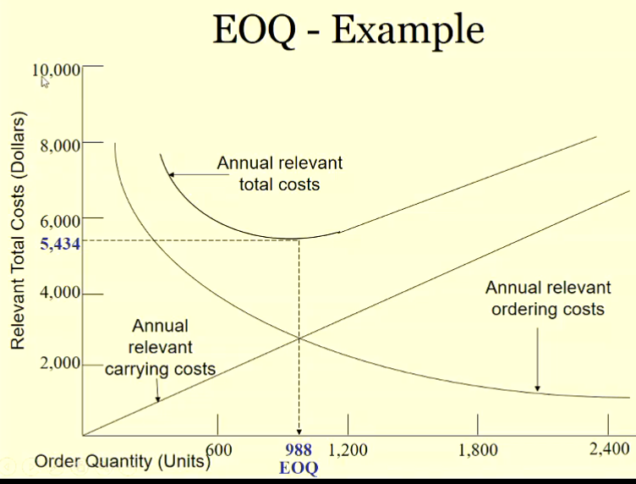

EOQ – Formula
EOQ = 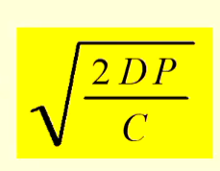
- D = known demand (in units) for a specified time period
(eg., annual)
- P = Relevant ordering costs per purchase order (cost of
placing and receiving an order)
- C = Relevant carrying cost of one unit in stock for the
specified time period in D (eg., one year)

Reorder Point
- Level of inventory on hand that triggers a new order
  - simplest to compute when both demand and purchase-order lead time are known with certainty

Safety Stock
- Inventory held at all time sregardless of quantity of inventory ordered using EOQ model
  - Buffer against unexpected increases in demand and purchase-order lead time are known with certainty

Go Back and look at Lecture Example for EOQ

Just – In – Time (Systems)
Objectives
- Meet customer demand in a timely way with high quality products at lowest possible costs.
- Purchase materials, produce products and deliver products just when they are needed.
- Reduce or eliminate inventory at every stage of production from raw materials to finished goods.
- JIT Managing quality + Time
JIT Purchasing
- Aim: purchase materials from suppliers only as they are needed for production or sales - to avoid costly inventory build-ups.
JIT Production (lean production)
- Aim: manufacture each component in a production line as soon as and only when needed by the next step in the production line.

A non-value added activity is an activity that does not add value to a product from the customer’s perspective – and therefore can be eliminated.

JIT Features
- Production in manufacturing cells (work cells) – materials move sequentially minimising handling costs
- Workers are hired and trained to be multi-skilled
- Defects are aggressively eliminated – with low inventory workers trace and solve problems quickly before moving to next station
- Set-up time is reduced + manufacturing cycle (lead) time is reduced production in smaller batches becomes more economical, reducing inventory levels and allows company to be more responsive to demand changes
- Suppliers selected on basis of ability to deliver quality materials in timely manner
Companies were initially attracted to JIT due to the lower carrying costs of inventory. However, they soon realized other benefits of lower inventories: emphasis on improving quality by eliminating the causes of rework, scrap, and waste along with lower manufacturing lead times.
Performance measures
- Personal observation
- Financial
  - Inventory turnover – expect to increase
- Non Financial
- Number of days inventory held – expected to decrease
- Units produced per hour – expect to increase
- % of defective units (reworked units) – expected to decrease
- Manufacturing cycle time – expect to decrease
- Setup time/ Total manfg time – expect to decrease
JIT Implementation? Cost v Benefit
The goal is to manage costs so tha thte savings associate dwith JIT exceed the cost of implementing JIT
Cost Savings:
- Inventory warehouse rent or cost
- Inventory managers and personelll
- Less warranty Cost
Implementation Costs:
- Employee retraining
- Technology improvement
- Exposure to work stoppage risks

Traditional Manufacturing vs JIT Manufacturing
Traditional Manufacturing
- Balance ordering and carrying costs
- Satisfy customer demands
- Avoid manufacturing shutdowns
- Take advantage of discounts
- Hedge against future price increases
JIT Manufacturing
- Drive order and carrying costs to zero
- Use due-date performance
- Total preventative maintenance
- Total quality control
- The Kanban system (“pull cards”)
Traditional materials-requirement-planning (MRP) systems forecast and plan purchases and inventory levels based on demand forecasts for finished goods, by working back from the demand for finished goods to calculate demand for each of the components required to produce the finished product. This approach often leads to stockpiles of inventory as a production department or workstation receives materials or components that they are not yet ready to begin work on or process. Management accountants can assist in effective inventory management by providing managers with accurate and timely information about inventory levels and the cost of carrying inventory.
In contrast, just-in-time (JIT) production systems are designed so that each component is produced just in time for it to be used by the next production department or workstation. An ideal just-in-time production system would produce the product just in time for it to be purchased by the customer, with inventory received at each production department or workstation just in time to be used by the production department or workstation. Effective JIT systems smooth the flow of goods and reduce inventory costs, while simultaneously improving product quality, reducing production costs, and increasing production efficiency (indirect outcomes dictated by the reduced margin for error that results from lower inventory levels).

Lecture 4: Decision Making and Relevant Information 1
Lecture Objectives:
- Use the 5 step decision making process to make decisions.
- Distinguish relevant from irrelevant information to make decisions.
- Analyse and evaluate a range of firm specific choices and make appropriate decisions based on the use of relevant costing principles.
- Explain the opportunity cost concept and why it is important for decision making.
- Evaluate the qualitative issues that relate to the decision(s).
- Understand the implications of management decisions using the decision model versus the performance-evaluation model used to evaluate the manager.

Decision Making Process
Decision Model
A decision model is a formal method for making a choice, often involving quantitative and qualitative analysis.
- Identify the problem and uncertainties
- Obtain information (relevant – both quantitative & qualitative)
- Make predictions about the future (for each alternative)
- Make decisions by choosing among alternatives (evaluate financial outcomes and weight with relevant qualitative factors)
- Implement the decision, evaluate performance and learn
Relevant Costs and Cost Concepts
Relevant Costs and Relevant Revenues
- Occur in the future (i.e. expected future costs and expected future revenues).
- Differ among the alternative courses of action.
- Avoidable (can be eliminated in whole or part by choosing one alternative over another).
Cost Concepts
- Historical Costs
  - Irrelevant to decision
  - Used for predicting future costs
- Sunk Costs
  - Costs already incurred in the past
  - Unavoidable -> irrelevant to decision
- Future costs that do not differ between alternatives
  - They will not matter -> irrelevant to decision
  - What if you take these into account? Will it affect your decision?

- Incremental cost
  - Additional total cost incurred for an activity
- Incremental revenue
  - Additional total revenue from an activity.
- Differential cost
  - Difference in total cost between two alternatives (net relevant costs).
- Differential revenue
  - Difference in total revenue between two alternatives
- Business function costs
  - The sum of all costs (variable and fixed) in a particular business of the value chain.
- Full costs of the product
  - The sum of all variable and fixed costs in all business functions of the value chain (R&D, design, production, marketing, distribution and customer service).
- Differential income
  - (net relevant income) is the difference in total operating income when choosing between two alternatives.
- Opportunity cost
  - The profit forgone by selecting one alternative over another (income sacrificed).
  - Not actual dollar outlays and not recorded in the firm’s accounts.
  - “what we give up from the road not taken”
- Avoidable cost
  - The cost that can be avoided if the company choose one alternative -> relevant
- Unavoidable cost
  - The cost that cannot be changed independently of the alternative chosen -> irrelevant
Identifying Relevant Costs
- Each decision must be considered on its own merits!
- In some cases, under different alternatives
  - Both revenues and costs vary
  - Only revenues or costs vary
- Variable costs may not change under different alternatives
- Fixed costs may change
- Unit cost data can mislead decision makers
  - Can include irrelevant costs
  - May differ at different output levels (when include fixed costs that do not differ at different output levels)

Decision Making and Relevant Costing
Decision making process
- To replace or do not replace equipment
- To insource or outsource an activity (make or buy)
- For choosing the product mix when resources are constrained/not constrained
  - Relaxing one or more constrained resources
- To accept, reject and price special orders.
- To keep or drop products, segments or whole business. To add or drop customers
- Decision Making and qualitative information.
- Decision model VS Performance evaluation model

Decision 1: Retain or Replace Equipment (relevance of past costs?)
- Decision? Continue using an asset or replace it.
- Consider all of the costs and benefits of the old equipment:
  - Book value of the current (old) asset is a sunk cost
    - Therefore irrelevant
  - Salvage value
    - Will occur if equipment is replaced
      - Therefore Relevant
  - Operating costs/benefits of old equipment?
    - What differs is relevant.
- This example demonstrated that sunk costs are irrelevant

Decision 2: Insource or outsource an activity (make or buy decisions)
- Produce a component par tor product internally or purchase from an outside supplier?
  - Insource vs Outsorce
- If there is opportunity to use the productive capacity for another purpose
  - Opp costs included in decision
  - Opportunity costs is the contribution to income that is foregone (rejected) by not using a limited resource in its next-best alternative use (increase opportunity cost -> Decrease profit)

Constrained Resources
- Constraint?
  - “anything that prevents a business achieving higher performance versus its goal toa dd value today and in the future”
  - Demand for resource > resource supplied
  - Creates opportunity cost (prevents further expansion)
  - Examples?
    - External Constraint
      - Market demand, material availability
    - Internal constraint
      - Machine hours, labour hours, internal policy
  - In presence of no constraints, the production (and sale) decision is simple:
    - Produce nothing where SP < VC
    - Produce and infinite amount where SP > VC (this doesn’t happen)
- If a firm possesses unlimited resources and the demand for each product being considered is unlimited, then the product mix decision is simple – produce an infinite number of each product. Unfortunately, every firm faces limited resources and limited demand for each product. These limitations are called constraints.
- External constraints are limiting factors imposed on the firm from external sources (such as market demand, material availability). In the external environment, limits include the economy, value chain limits, the market in general and specific markets, regulations and politics.
- Internal constraints are limiting factors found within the firm (such as machine and labour time availability). Internally this can mean strategic choices, personnel, equipment, space, materials, utility availability, and funds. Other constraints include an internal policy constraint.
- Although resources and demand may be limited, certain mixes may not meet all the demand or use all of the resources available to be used. Constraints whose limited resources are not fully used by the product mix are loose constraints. If, on the other hand, a product mix uses all of the limited resources of a constraint, then the constraint is a binding constraint.
- Remember, given that the firm has constraints, the manager needs select the product mix that maximises the total contribution margin. In addition, the manager should take an active role in managing the constraint itself. We will look at Management of Constrained Resources first.

Decision 3: Product Mix decision with Constraints
DO LECTURE EXAMPLE, AND PUT HERE

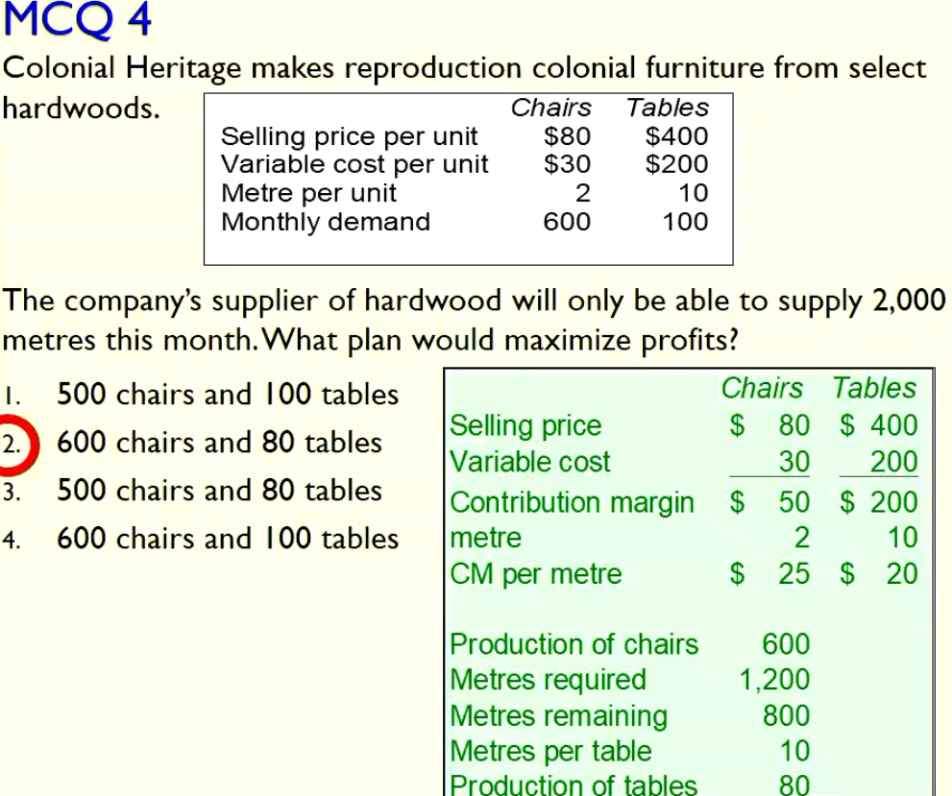

Managing constraints
- Produce only what can be sold
- At the bottleneck itself:
  - Improve the process
  - Add overtime or another shift
  - Hire new workers or acquired more machines
  - Subcontract production
- Eliminate waste.
- Streamline production process.
Optimizing when there are Multiple Constraints: Product Mix Analysis Tools (Not Examinble)
- Trial and Error
- Linear programming
  - Graph method
  - Simplex method. E.g. excel

Lecture 5: Decision Making + Relevant Information II
Decision 4: Accept or reject an order for a special price -> decisions that affect output level
- Opportunity to obtain additional business from a specific customer at a price concession
- Assumed:
  - Sales in other markets not affected by special order
  - If affected then lost sales (CM) include din making decision
- If no capacity constraint (op cost = 0) and no incremental fixed costs of the order
  - Only variable costs affected -> If SP > VC accept
- Decision Rule:
  - Accept if: Incremental revenue > Incremental costs
What if there is a capacity constraint?
Meaning? -> Demand > Supply
- Introduces “opportunity cost”
Qualitative issues -> you may upset existing customers and destroy your business model

Decision 5: Dropping (or adding) Product line, segments or Customers
- Questions:
  - Should we continue producing this apparently unprofitable product?
  - Should we close this apparently unprofitable divison?
  - Should we drop this apparently unprofitable customer?
- Relevant costs and benefits of adding or discontinuing a product line?
  - Issue: fixed costs previously allocated to discontinued product/division … that are not avoidable must be absorbed by other products/divisions
Following two approaches are how you work out step 5
Contribution Margin approach
- Decision rule: Drop the product line only if the fixed cost savings exceed lost contribution margin

Comparative income approach
- Answer can be found by comparing two income statements with the relevant changes and using the comparison to find net gain/loss
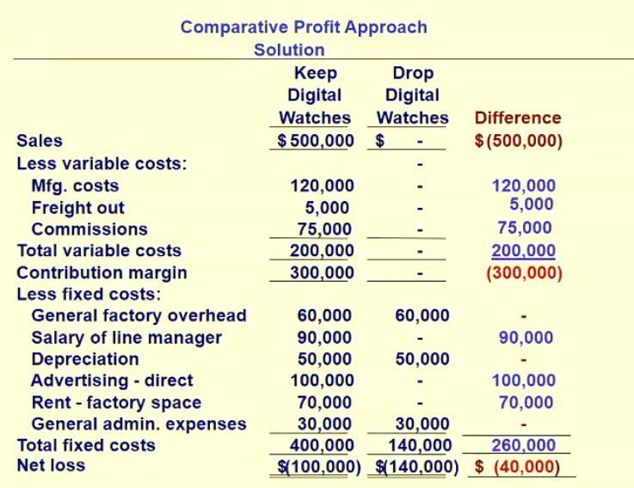

Qualitative Issues
- Quantitative relevant info vs Qualitative relevant info
Quantitative
  - Outcomes measure din numerical terms
  - Probable effect of decisions on
    - Financial info (costs,r evenues)
    - Non-financial (time,quality)
Qualitative relevant info
  - Outcomes that cannot be measured in numerical terms
  - Probable effects of decisions on
    - Employee Morale
    - Customer satisfactions
Some examples of qualitative issues:
- Decision to accept or reject one-time special order:
  - A loss on the special order may be accepted if the possibility of future long-term sales seem likely at a higher price
  - A profitable special order may be rejected because of the negative effect on customer relationships of not selling to existing customers:
- Decision to make or buy:
  - Factors to be considered for outsourcing decision: quality, delivery time, reliability of the supplier, dependability versus keep control, focus on areas of core competencies etc.
- Decisions to close down a division:
  - The role that the division’s product line plays relative to other product lines (e.g. attraction of customers to other product lines may be affected.)
  - Impact on the morale of employees of the remaining divisions may cause loss of talented employees that seek employment elsewhere.

Decision Model vs Performance Evaluation Model
- Issue? Possible conflict between these 2 models
- Example: consider the replace machine decision – would the manager replace if she/he was evaluated on the basis of ROI measured as:
  - ROI = Profit/Investment
  - Consider the investment to be measured on a net book value basis
- I have no idea what the fuck this means

Lecture 6: Pricing Decisions and Cost Management
Learning Objectives
- Understand the influences on pricing
- Understand the different dynamics involved in setting short-run prices as opposed to long-run prices
- Be able to apply target costing/pricing and understand the rationale for this approach and the use of value engineering
- Be able to apply cost-pus pricing and understand the rationale for this approach
- Appreciate the issues of life-cycle budgeting and costing.

Major Influences on Pricing Decisions
- Customer – Demand (value)
  - How much are they willing to pay?
    - Characteristics of the product
    - Quality
- Other: Political, Legal and Ethical Issues
  - Price discrimination …. Is the practice of charging some customers a higher price for the same product or service that is being charged to other customers
    - Business travellers’ demand for air travel is relatively insensitive to price (demand is price inelastic)
    - Pleasure travellers are more sensitive to price (demand is price-elastic)
    - The law generally prohibits companies from discriminating between their customers by setting different prices for the same product or service.
    - Also prohibited is collusion in price setting – firms in a particular industry agree to set their prices for a type of product at a certain level.
- Competitors – Substitute/alternatives
  - Price charged for alternative products?
  - Type of competition in the market?
    - Perfect → Price Taker
      - Management uses cost data to determine the most profitable product, choose output levels etc…
    - Imperfect → Price Maker (products are differentiated)
      - Management has some discretion in setting prices, and cost data may become relevant to set the price.
      - Relevant costs? All value chain business functions

- Costs – Affects supply
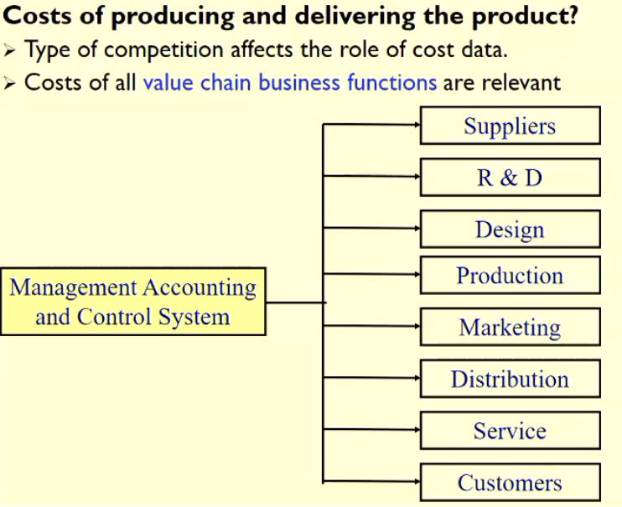

Need to understand the market environment: customers & competitors
Why is an understanding of customers and competitors important?
- Competition from lower cost producers means that prices cannot be increased (competitor analysis)
- Products (today) have shorter life cycles, leaving less time and opportunity to recover from pricing mistakes and lost market share
- Customers have become more knowledgeable and demand quality products at reasonable prices (customer analysis)
Peak-load pricing
- The practice of charging a higher price for the same product or service when demand approaches physical capacity limits
  - Telephone and telecommunications
  - Hotel rooms
  - Car rental
  - Electricity charges
Legal restrictions on Pricing
- The ACCC was formed in 1995, from a merger of the former trade practices commission and price surveillance authority
- AIM of ACCC? Promote competition in its regulation of prices and restrictive trade practices (and protect consumers)
- Prohibits conduct that
  - Allows corps. To take advantage of their market power to eliminate or substantially damage a competitor
  - Prevents entry of other corporations into the market
  - Deters or prevents other corporations from competing in a market

Predatory pricing
- A company engages in predatory pricing when it deliberately prices below its cost in an effort to drive out competitors (rather than to enlarge demand or meet competition).
- Predatory pricing occurs when:
- The predator company charges a price that is below an appropriate measure of its costs
- The predator company has a reasonable prospect of recovering int eh future the money It lost be pricing below cost
- Predatory pricing on the international market is called dumping
- Dumping occurs when a foreign company sells a product in Australia at a price below the (normal) market value, and its action causes (or threatens to cause) injury to an industry in Australia
- If dumping is proven, an anti-dumping duty can be imposed under Australian tariff laws. (Customs imposes a dumping duty)
Price Discrimination
When a company offers different prices, discounts, services or payment terms to different customers for the same goods or services. Purpose is to protect small purchasers from price discrimination that could be practised by a dominant supplier and also small suppliers who might otherwise be eliminated by the pricing behaviour of a large supplier
Resale price maintenance
Supplier dictates the minimum price at which goods or services are to be resold by a buyer to the retail or wholesale market
Price-fixing contracts (forbidden by the act)
Arrangements that result in the fixing, control or maintenance of prices of goods and services
Differences Affecting Pricing: Long run v Short run Pricing decisions
- Short run decision
  - Less than one year
  - Key issue: is there excess capacity
  - Relevant costs: all direct and indirect costs throughout the value chain will change in total (e.g additional fc)
  - Opportunistic
- Long run decision
  - One year or more
  - E.g Pricing a differentiated product in a major market
  - Relevant costs: Alll future fixed and variable costs
  - Strategic decision to build long term relationships with customers
  - Profit margin set to earn reasonable return on investment

Content for Lecture starts now, everything before was just pre-leccie material
Differences Affecting Pricing: Long Run vs Short Run Pricing Decisions
- Costs often irrelevant for short-run policy decisions, e.g. unavoidable fixed costs (fixed costs that cannot be changed), are generally relevant in the long run because costs can be altered in the long run
- Profit margins in long-run pricing decisions are often set to earn a reasonable return on investment
  - S-R ism roe opportunistic – prices are decreased when demand is weak and increased when demand is strong
- In the long-run ALL costs (full costs throughout the value chain) must be recovered
  - Fixed and variable
  - Manufacturing and non-manufacturing

Alternative Long-Run Pricing Approaches
- Market Based: price charged is based on what customers want and how competitors react
  - In a highly competitive market … price taker → must accept the price
  - Target pricing → estimated price for a product or service that potentials customers are willing to pay (customers perceived value), and gauge how competitors might react
  - → Target Costing
- Cost-Based: Price charged is based on what it cost to produce, coupled with the ability to recoup the costs and still achieve a required rate of return (less competitive markets)
- → Cost-plus pricing
Target Costing/Pricing
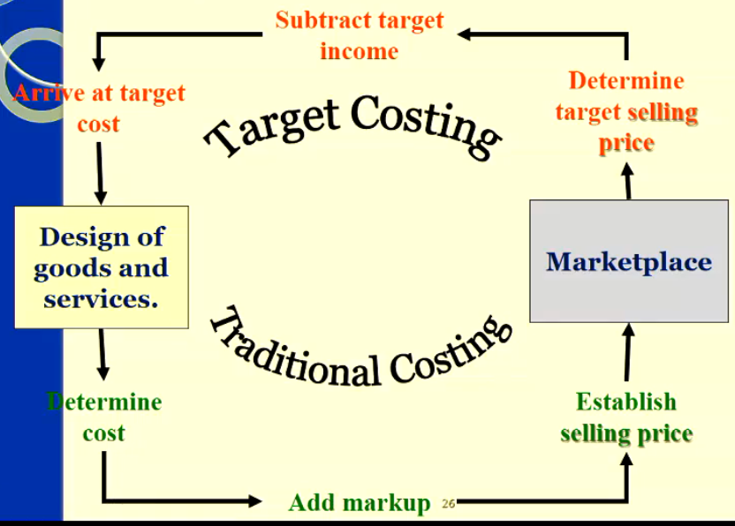

Five Steps in Developing Target Prices and Target Costs:
- Develop a product (design) that satisfied the needs of potential customers (find a need and fill it OR create the need)
- Choose a target price – based on research of competitor’s products and customers willingness to pay
- Determine the target operating income per unit and subtract htat from target price to derive a target cost per unit (target cost/u = target price – target profit/u)
  - Estimated long-run cost per unit
- Perform cost analysis – what is the currently feasible total cost? Compare it to the target Cost. What aspects should be targeted for cost reduction?
- Perform value engineering to achieve target cost

Value Engineering terminology:
- Value engineering is a systematic evaluation fo all aspects of the value-chain business function, with the objective of reducing costs while satisfying customer needs.
- Suppliers → R&D → Design → Production → Marketing → Distribution → Customer service → Customers
Distinguish Between:
- Value-added cost? – a cost that, if eliminated would reduce the actual or perceived value or utility (usefulness) customers obtain from using the product or service.
- Non-Value-added cost? – cost that, if eliminated would not reduce the actual or perceived value or utility customers obtain from using the product or service
Value Engineering?
Value Engineering looks for better ways to accomplish an objective.
May involve:
- A reduction In parts
- Using plastic that snaps together rather than metal that is attached by screws
- Using less packaging
- Redesigning the production process to reduce product movement
- Adopting a more efficient distribution network
- Omitting features on the product that the customer does not value

Implementing value-engineering
Need to distinguish between cost incurrence and when costs are locked-in
- Cost incurrence: when a resource is consumed (or benefit foregone) to meet a specific objective
  - E.g. when DM are placed into production
- Locked-in- Costs (designed in costs): costs not yet incurred but, based on decisions already been made will be incurred in the future
  - Managing these are a key to ‘managing costs’ well
  - Design choices affect locked-in costs
Key steps to value engineering
- Understand customer requirement sand value-added and non-value-added costs
- Anticipating how costs are locked in before they are incurred
- Using cross-functional teams to coordinate redesign products and processes to reduce costs while meeting customer needs
Kaizen Costing
- Cost reduction system focuses on manufacturing phase
  - Process improvements through small incremental changes
  - Assumes continuous improvement
Phases
- Product planning phase
  - Market research
  - Product design
  - Product development (target costing)
- Manufacturing Phase
  - Kaizen costing
- Service and abandonment phase
  - Rapid growth
  - Transition
  - Maturity
Cost Based (Cost-plus) pricing
- Used by companies selling distinctive products or service sthe general formula adds a markup component to the cost base to determine a prospective selling price.
- Price – u.cost + (Mark-up percentage x u.cost)
- Starting point? What cost? → Full cost? Variable cost?
- How is the mark-up percentage determined?
  - Somewhat flexible; customers, competitors and costs still important
  - One approach to cost-plus pricing is to mark up the product to achieve a target rate of return on investment → do not confuse with mark-up percentage!!
- If cost base = full costs
  - → Mark-up = target operating profit/Total costs
  - Mark-up = operating profit per unit/ Unit cost
Cost-Plus Pricing
- Setting a target rate of return on Investment (ROI):
- TROI = Target Op income/invested capital
- Price = unit cost + (TROI x Invested Capital)/unit
- What if the mark-up percentage for setting prices is defined as a percentage of variable manufacturing costs?
- Mark-up = (Target operating income + Fixed manuf. Costs + non-manufac. Costs) / Total variable manufac. Costs.
- Why?
  - Because not only target operating income should be covered by price but also costs not include din variable manufac. Costs (fixed manufac. costs and non-manufac. Costs)
  - Price = Cost (base) + (Mark-up % x Cost(base)
Using Full Costs?
- Advantages
  - Full recovery of all costs of the product
  - Price stability
  - Simplicity
- Disadvantages
  - Obscures the cost behaviour patterns of the firm (as unit sales volume drops, the unit production cost increases)
  - Not consistent with CVP analysis
  - Sales volume must be assumed to compute the selling price and mark-up percentage
Using Variable Costs?
- Advantages
  - Does not obscure the cost behaviour pattern by unitising fixed costs
  - Variable cost data is useful for short-term pricing decisions
- Disadvantages
  - In the long-term prices must be set to cover all costs and a normal profit margin
  - Managers must use high mark-up when using variable cost
- A company will choose a cost base that it regards as reliable, and a mark-up percentage based on its experience in pricing products, to recover its costs and earn a desired return on investment.

Common Business Practice
- Most firms use full cost for their cost-based pricing decisions, because:
  - Allows for full recovery of all costs of the product
  - Allows for price stability
  - It is a simple approach
- NB: this means that business must be aware of the costs each product (line) consumes and avoid product cost cross-subsidization
- If a price is deemed to b excessive – the mark-up may need to be reduced! Customer reaction? Competitor reaction?

Life-Cycle Product budgeting and Costing
- Normal budget cycle? 1 year
- Product Life cycle → Spans the time from initial R&D on a product → when customer service and support are no longer offered on that product
- Life-Cycle Budgeting → Involved estimating the revenues and business function costs of the entire value-chain
- Life-Cycle costing → tracks and accumulates business function costs across the value-chain from a product’s initial R&D to its final customer service and support
Factors that make life cycle budgeting important
- Development period for R&D is long and costly → these costs must be recovered over the life span of the product
- Many costs are ‘locked-in’ at the R&D and Design stages → poorly designed products require higher marketing and customer service costs
- Life-Cycle budgeting facilitates value engineering at the design stage before costs are locked in.

Lecture 7: Customer Profitability Analysis, Revenue Allocation, And Sales Variance Analysis
This topic will definitely be on final exam
Learning Objectives
- Analyse customer profitability and discuss reasons for differences in revenues and costs of customers
  - Allocate indirect costs caused by customers to determine customer profitability
  - Identify the importance of customer profitability profiles
- Be able to analyse, interpret and consider suggestions for performance improvement relating to the sales volume variance (when companies sell multiple products)
  - Why did sales deviate from budget?
- Understand the need for, and principles of revenue allocation

Pre-Lecture Material
Customer Profitability
- Customer revenue analysis
  - Difference in customer revenues (even for same product)
    - Quantity purchased; price discounts
- Customer – cost analysis
  - Difference in customer costs?
    - Customers can place different demands on company resources. ABC focused on customers categorises indirect costs related into different cost pools on the basis of different cost drivers (cause and effect or benefits-received relationships)
- An analysis of customer differences on both revenues and costs can provide important insight into why differences in customer profitability exists
- Customer-profitability analysis
  - It uses information on customer revenues and customer-level costs
- Customer level costs -> Costs incurred in the first three categories of the customer-cost hierarchy: customer output-unit – level costs, customer batch-level costs, and customer-sustaining costs.

Customer-profitability analysis example :
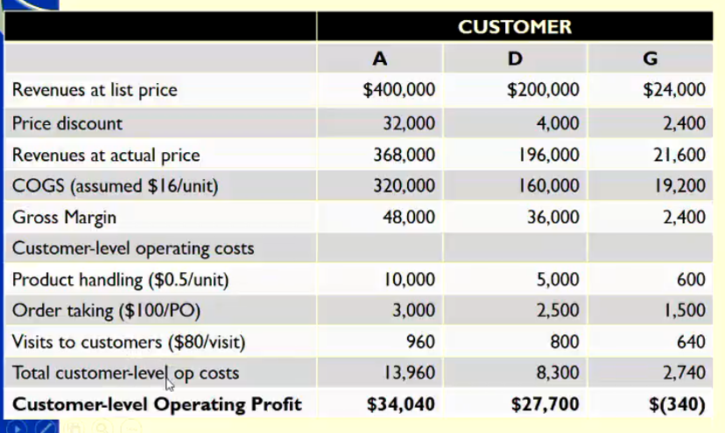

- Customer profitability report soften highlight that a small percentage of customers contribute a large percentage of operating income
- It is important that companies devote sufficient resources to maintaining and expanding relationships with these key contributors to profitability.

Sales Volume Variance Analysis – Levels of Analysis
- Level 1
  - Static Budget Variance
- Level 2
  - Flexible Budget Variance
  - Sales Volume Variance
- Level 3
  - Sales Mix Variance
  - Sales Quantity Variance
- Level 4
  - Market Share Variance
  - Market Size Variance

Lecture 7 Material Starts HERE
Lecture Overview
- Customer Profitability Analysis
- The FBV and SVV: a review
- Decompose the SVV
  - Sales mix
  - Sales Quantity
    - Market Share Variance
    - Market Size Variance
- Revenue and Bundled Products
  - Stand-alone
  - Incremental
Customer Profitability Analysis
- Customer-Revenue Analysis
  - Differences in Quantity purchased; price discounts
- Customer-Cost Analysis
  - Differences in customer costs because of different demands on company resources.
- Using ABC to determine the activities, costs and profit associated with serving particular customers
  - For various reasons some customers simply are less profitable than others
  - For e.g.
    - Customer makes frequent order changes
    - Customer needs special parts
    - Customer is difficult to please
- Profitable Customers
  - Small set vital to total profitability
    - Devote sufficient resources to maintain and expand relationship
- Least profitable customers
  - Modify our relationship to improve profitability
  - Assist them to improve their ordering patterns
  - Charge for extra services (orders)
  - Discontinue relationship

Revenue Allocation and Bundled Products
- Revenue allocation occurs when revenues are related to a particular revenue object but cannot be traced to it in an economically feasible way.
- Revenue objects
  - Products, customers and divisions
- Stand-alone
  - Revenue traced
- Bundled product
  - Revenue allocation issues
  - ∑ stand-alone prices > bundled price
Revenue Allocation methods
Two main revenue allocation. Methods are:
- Stand-alone method – uses product-specific information on the bundle of products to calculate the weights used to allocate the bundled revenues to the individual products.
  - Stand-alone referees to the product as a separate non-bundled item
  - Allocation weights: product specific information
    - Selling prices
    - Unit costs
    - Physical units
- The incremental method – rank the individual products in a bundle according to criteria determined by management.
  - Allocated based on rank
  - Primary product, first incremental product, second incremental product etc.
  - If bundle selling price > stand-alone price
    - Primary product allocated 100% stand-alone price
    - Based on?

Lecture 8: Strategy, Balanced Scorecard and Strategic Profitability Analysis
Learning Objectives
- Recognise the two generic strategic positioning strategies and consider the influences of that strategy choice
- Understand the purpose developing a Balanced Scorecard
- Describe the 4 perspectives of the Balanced scorecard, how they relate to each other and the organisation’s strategy, and provide examples of measures that could be used in each perspective.
- Analyse changes in operating income due to growth, price-recovery and productivity to evaluate strategy.

Pre-Lecture Material
Strategy
- Strategy decrisbe show an organisation matches its own capbiltieis with the opportunities in the market place to accomplish its overall objectives
  - Set of polices and procedures
  - Producing long-term growth and survival
- Part of Strategic Cost management/strategic performance measurement system
  - Uses financial and non-financial information
  - Used to develop and identify strategies to produce sustainable comepetitive advantage
- An organisation must create value for its customers but differentiate itself from its competitors
Strategic Analysis
- Internal anyslis
  - Product lines; management; R&D; production; marketing strategy.
- External/Industry analysis
- Competitors/competitive intensity (price/cost, quality and time)
- Potential market entrance
- Substitute/equivalent products
- Customer bargaining power
- Supplier pargaining power
Strategic Positioning
- Cost leadership
  - Producing products or services at lowest cost in the industry – through productivity and efficiency improvmeents, elimination of waste, redesign, reengineer processes, tight control -control
    - Leads to lower selling prices
- Product differentiation
  - Developing and maintain a unique and superior value for the product, as perceived by customer
  - Leads to brand loyalty and the willingness of customers to pay high prices
- Focus (niche)
  - Targeting its attention to a specific segment of a market
Why are strategies hard to implement?
- Source of value shifted from Tangible to Intangible assets
  - Patents, trademarks etc..
Strategy Implementation
- The challenge to any organisation is how to effectively implement chosen strategy.
- Balanced Scorecard – Translates an organisation’s mission and strategy into a comprehensive set of performance measure sthat provides the framework for implementing its strategy
  - Combination of measures, structured to express a cause and effect relationship between specific measures and overall organisation objectives
  - Measuring and managing all aspects of a company’s performance
  - Balances traditional financial measures of success with non-financial measures(the drivers of future financial performance)
  - Measures of organisational performance across 4 perspectives.

The Balanced Scorecard
- The Balanced Scorecard is a framework that translates and organisation’s mission and strategy into a set of performance measures to track progress and manage the implementation of the organisation’s strategies.
- The performance measures of the BSC focus on the objectives an organisation must achieve to sustain long-run financial performance.
- The BSC balances the use of financial and non-financial measures to evaluate short-run and long-run performance in a single report.

Balanced Scorecard: Four perspectives
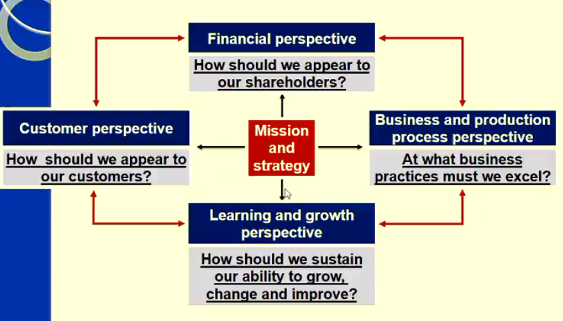

Steps in Implementing the Balanced Scorecard
- Clarify vision, core competencies and strategies
- Analyse perspectives to develop performance objectives and measures
- Construct a strategy map to reinforce the links between measures
- Communicate, link throughout organisation and refine
- Establish performance targets and action plans
- Collect and analyse scorecard data to monitor performance
- Investigate variances and reward employees
- Provide feedback and refine the balanced scorecard
- Note – these steps focus on the technical aspects of implementation – a range of behavioural aspects will also influence success of implementation (e.g. top management support, use of multiple champions, adequate communication throughout process, organisation-wide participation)
Good Balanced Scorecard features
- It tells the story of a company’s strategy by articulating a sequence of cause-and-effect relationships.
- It assists in communicating the strategy to all members of the organization by translating the strategy into a coherent and linked set of measurable operational targets.
- Motivates managers to take actions that will result in improvements in financial performance.
- The scorecard limits the number of measures used by identifying only the most critical ones.
- The scorecard highlights sub-optimal trade-offs that managers may make by forcing them to consider the operational and financial measures together.

Lecture Material
Financial perspective
- Evaluates the profitability of the strategy and the creation of shareholder value
- Uses the most objective measures in the scorecard
- The other three perspectives eventually feed back into this dimension
- Lag measures
Customer Perspective
- Identifies targeted customer and market segments (and products) and measures the company’s success in these segments.
- Organisation’s that better meet customers needs (creating value for customers) → are also more likely to generate desired financial results
- Usually evaluated using outcome measures
- Lead and lag
Internal Business Process Perspective
- Employees who do work are the best source of new ideas for better business processs
- Key measures
  - Innovation
    - # of new products manufacturing capabilities
  - Operations
    - Yield time to deliver
  - Post Sales Service
    - Time taken to repair shit
- Focuses on internal operations that create value for customers → furthers the fiancnial perspective by increasing shareholder value
- Goal
  - Improve processes will improve customer satisfaction
  - Improve efficiency of operations which contributes directly to financial results (analyse the value chain)
- Includes three sub processes
- Innovation (identify customer needs and design to meet those needs)
- Operations (quality, efficiency, consistency and on time delivery)
- Post-sales service (training, product users, warranty, handling returns, correcting defects, collecting and processing payments)

Learning and Growth Perspective
- Focuses on the capabilities of people
- Managers are responsible for developing employee capabilities
- Key measures
  - Employee satisfaction
  - Employee education/skill
  - Employee retention
  - Employee productivity
- Identifies the capabilities at which the organisation must excel to achieve superior internal processes that create value for customers and shareholders
- As managers focus on improving IBP they also identify opportunities for enhancing the capabilities of employees, information systems and operating procedures.
- Concerned with achieving future success by discovering new and better strategies

Common Balanced Scorecard Measures
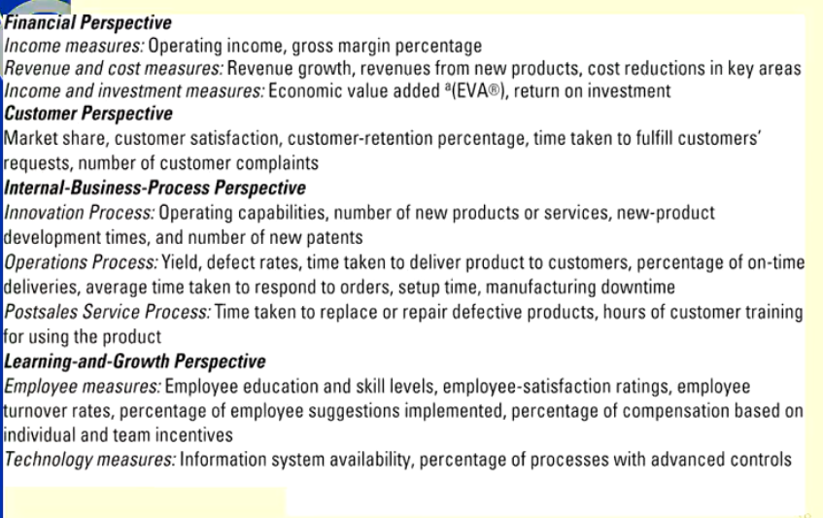
Performance Measures
- Balanced Between
  - Lag measures and lead measures
    - Outcomes of decisions and operations (effort)
    - Information – actionable and manageable (drivers)
  - Objective measures and subjective measures
    - Quantified and verifiable
    - Judgemental
  - External measures and internal measures
    - Customers and shareholders
    - Process and capabilities
  - Financial measure and non-financial measures
    - Monetary terms
    - Non-monetary terms
Non-financial performance measures
- Play key role in contemporary responsibility accounting system
- Operational control (& continuous improvement)
  - Before vs after fact
- Operational measures – increase employee involvement
  - Physical vs financial measure of activity
    - Efficiency, quality and time
- Advantages
  - Drivers of future financial performance
  - More actionable
  - More understandable/easier to relate to
- Disadvantages
  - Wide choice of measures
  - Development can be ad hoc and undirected
  - Trade-offs made
  - Lack integrity
  - May not easily translate into financial outcomes

Strategy Map
- A diagram that describes how an organisation creates value by connecting strategic objective sin explicit cause-and effect relationships with each other in the financial customer, internal business processes, and learning and growth perspectives
- A useful first step in designing a BSC
- It shows how a strategic objective affects other strategic objectives

Strategic Analysis: evaluating success of strategy
- Change in operating income
  - Growth
    - Revenue and cost effect
    - Increase in quatity of output sold
  - Price recovery
    - Revenue and cost effect
    - Change in price
    - Changes in input prices
  - Productivity
    - Comparison of cost decreases
    - Fewer quantity inputs
    - Better input mix
    - Less capacity
Evaluating Success of Strategy
- A company that has successfully pursued a product differentiation strategy will be able to increase its output prices faster than the increase in its input prices ie., it will show a positive price-recovery component.
- A company that has successfully pursued a cost leadership strategy will be able to produce a given quantity of output with a lower cost of inputs ie., it will show a large positive productivity component.
- A company that successfully pursued a product differentiation strategy or a cost leadership strategy will show a positive growth component.
Productivity Measured
- Relationship between output and inputs used to produce output
- Current Productivity
- Technically efficiency improvement
  - Less inputs, same output
  - Same inputs, more output
- Input trade-off efficiency
  - Least costly inputs, same output

Lecture 9: Balanced Scorecard (Competitive Tools): Quality, Time and The Theory of Constraints
Learning Objectives
- Two important strategic factors within the Balanced Scorecard: Quality and Time can be competitive Tools
- Explain what is meant by quality
- Explain the 4 categories of Cost of Quality, how they interact and how they can be analysed in a Cost of Quality Report
- Identify/develop financial and non-financial measures of quality
- Identify different methods to determine quality problems
- Describe customer response time and its components and explain why delays happen
- Explain the Theory of Constraints and how it can be used to improve ‘time’.

Pre-Lecture Material
Quality
- What do you think quality is?
- Why do you believe quality is important to organisations?
- Management recognise that pursuit of high quality is a fundamental organisation strategy for competing in a global economy
- Consumers desire a wide variety of product and service choices, but companies have resource constraints → make trade-offs (price, quality, service, promptness of delivery) … and continuously adopt more dynamic approaches to improve products, processes and customer service.

- Some quality facts:
  - Increased training of workers will build expertise, reduce scrap and rework costs, reduce time and cost to make
  - With reduced waste more product can be generated with the same equipment and workers
  - Narrower control limits (of acceptable quality) force improved processes and greater utilisation of capacity
  - “Designing-in” quality prevents production problems
  - Empowering employees through quality circles etc. to give them control over quality related production decisions increases total commitment and satisfaction
  - Higher quality products improve customer satisfaction and generate higher sales

Perspective on Quality
- Quality is:
  - The sum of all characteristics of a product or service that influence its ability to meet the needs of the acquirer.
  - Form a production viewpoint: is conformity with requirements and therefore can be improved by:
    - Increasing good output generated from a specific amount of input during a period
    - Reducing variability, often by adding automation in the process
    - Reducing the product’s (service’s) failure rate
  - Determining conformity to standards? Use Statistical Quality/Process Control techniques such as Control Charts (“Six Sigma” production view of quality)
- From a customer viewpoint: quality is the ability to meet and satisty all specified needs at a reasonable cost.
  - Relates to both performance and value
- Characteristics of quality from a customers view?
  - Performances
  - Features
  - Reliability
  - Conformance
  - Durability
  - Serviceability and responsiveness
  - Aesthetics
  - Perceived value
    - First 6 are more easily evaluated objectively → more subject to organisational control
Two Basic Aspects of Quality
- Design Quality
  - How closely the characteristics of a product or service meet the needs and wants of customers (at a reasonable cost)
- Conformance Quality
  - The performance of a product or service relative to its design and product specifications (its purpose).
The Evolution of Quality Management
- Inspection (reactive) – toleration of a certain level of defects → Quality Control (reactive) – determination of conformity by QC inspectors → Quality assurance (proactive) → Total quality Management (pro-active) a holistic approach (all internal processes); customer driven; continuous improvement.

Quality Certificaiton – ISO 9000 Standards
- Family of standards for Quality managmenet systems maintained by the International organisation fro standaridationsation (Iso) and administered by accreditation and certification bodies.
- Some requirements include
  - A set of procedures to cover all key processes in the business
  - Monitoring processes to ensure they are effective
  - Keeping adequate records
  - Checking output for defects, with appropriate and corrective action where necessary
  - Regularly reviewing individual processes and the quality system itself for effectiveness, and
  - Facilitating continuous improvement.

Costs of Quality (COQ)
- Total Quality Management (TQM) creates a new focus on costs and their incurrence
- Out of pocket costs associated with quality generally fall into two categories
  - Costs associated with activities to correct failure to control quality
  - Costs associated with controlling quality

COQ: Financial perspective
- Four Categories
  - Prevention costs – incurred to prevent the product of products that do not conform to specifications
  - Appraisal costs – incurred to detect units that do not conform to specifications
  - Internal Failure costs – incurred on defective products before they are shipped to customers
  - External failure costs – incurred on defective products after they are shipping to customers

Lecture Material
Quality and Failure
- Conformance Quality Failure
  - Relevant to Actual Performance of product and Design Specifications
- Design Quality Failure
  - Relevant to Design specifications and Customer satisfaction of product
Measuring COQ: Costs of Compliance
- Prevention
  - Activities that seek to prevent defect sin products or services being produced
    - Certifying suppliers
    - Designing for manufacturability
    - Quality training
    - Quality evaluations
    - Preventative maintenance
    - Process improvements
- Appraisal
  - Activities for inspecting inputs and attributes of individual units of product and service
    - Inspecting Materials
    - Inspecting Machines
    - Inspecting Processes
    - Statistical Process Control
    - Sampling and Testing
- Internal Failure
  - Costs associated with Defect sin processes and products that are found prior to delivery to customers
    - Disposing of Scrap
    - Spoilage
    - Rework
    - Re-inspecting/Retesting
    - Delaying Processes
- External Failure
  - Costs associated with defects in processes and products that are detected after delivery to customers
    - Warranty Repairs
    - Field Replacements
    - Product Liability
    - Restoring reputation
    - Customer Support
    - Lost Sales

TQM Cycle → Continuous Improvement
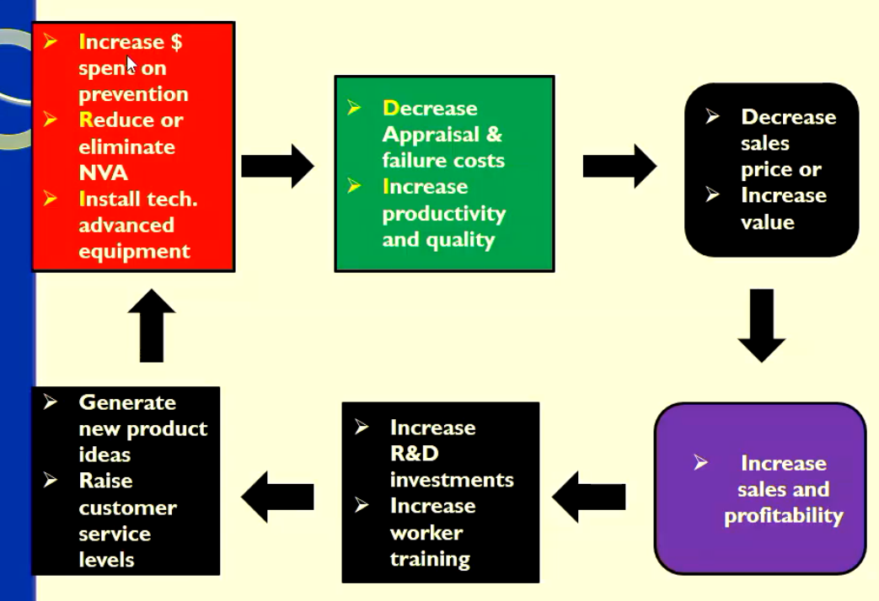

The Cost of Quality Report
- Identify the costs of quality
- Categorise as P, A, I or E
- Calculate total costs of quality
- Analyse
  - Calculate the ratio of each CoQ catergory to
    - Total quality costs
    - Revenues
- Evaluate changes and trends over time
- Identify opportunity costs: often result from poor quality – can be hard to measure but should be included if they can be

Usefulness of CoQ Reports
- Places a dollar figure on the costs of poor quality
- Helps prioritise quality improvement programs
- Helps managers monitor the effects of the ‘quality effort’
- Can help identify the optimal level of quality for the firm (Is there one?)
“There has been a lack of use of COQ reports”
- Costs outweigh the benefits?
- Information is difficult to extract from conventional costing systems
- Many of the quality costs are spread across the organisation

Financial and Non-Financial Measures of Quality
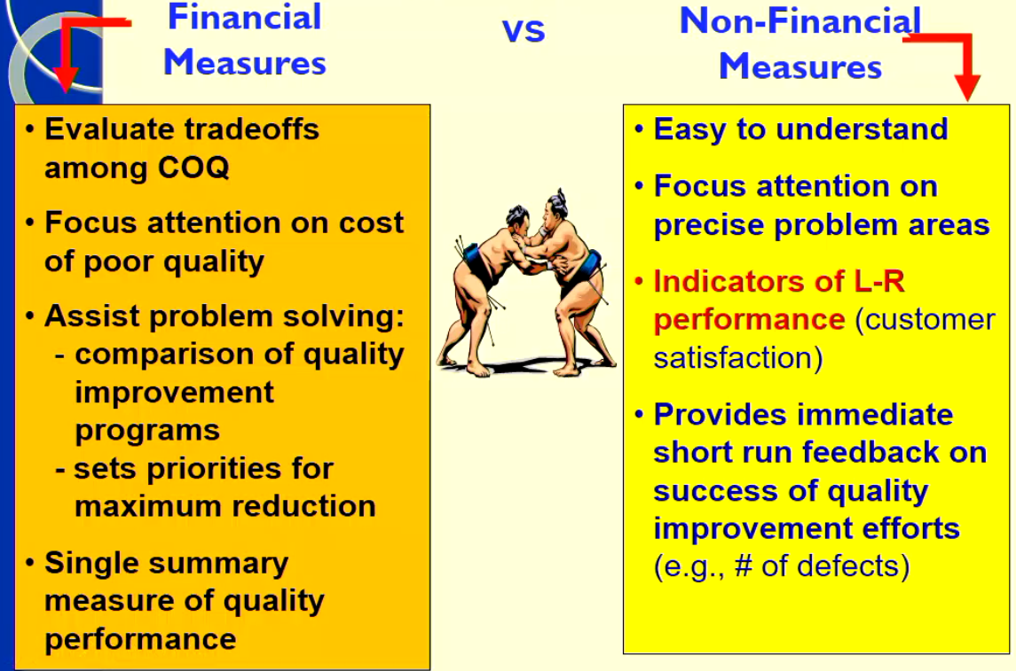
Non-financial measures of quality (can include design and conformance quality) → linked to the Balanced Scorecard
- Customer Satisfaction
  - Number of Customer Complaints
  - Defective units as a percentage of total units shipped to customers
  - Percentage of products with early or excessive failure
  - On-Time quality delivery
  - Market Share
  - Customer Satisfaction Ratings
- Internal performance
  - % of defective products
  - % of reworked products
  - Average time to repair at customer’s site
  - # of design changes made to improve design quality
  - Employee training in quality methods
  - Employee Turnover
Techniques used to Identify and Analyse quality problems
- Three Methods
- Control charts
- Pareto diagrams
- Cause-and-effect diagrams

Control Charts
- Statistical quality control (SQC), or statistical process control (SPC)
  - Formal means of distinguishing between random variation and non-random variation in an operating process
- Control chart
  - A graph of a series of successive observations of a particular step, procedure, or operation taken at regular intervals of time.
  - Each observation is plotted relative to specified ranges that represent the expected statistical distribution (e.g., m ± 2s)
  - Only observations outside control limits regarded as non-random and worth investigating
Pareto Diagrams (making diagrams not examined)
- Observations outside control limtis serve as inputs to Pareto diagrams – indicate show frequently each type of failure (defect) occurs
- Then analysed using a cause-effect diagram
Cause and effect Diagrams (Not examined)
- Identifies potential causes of the defects of the most frequently occurring failure - copies are fuzzy and unclear
- PC has identified four major categories of potential causes of failure:
  - Human factors
  - Methods and design factors
  - Machine related factors
  - Materials and components factors
What now?
- Develop solutions (engineers develop solutions)
- Management Accountants analyse and evaluate solutions using relevant cost analysis
- How will total costs and total revenues change under each proposed solution?
- May include
  - Estimating incremental costs of each alternative
  - Cost savings from reduced rework, customer support, repairs, liabilities
  - Incremental contribution margin from higher sales as a result of building a reputation for quality and performance
Another important strategic factor: Time
- Two operational measures of time:
- Customer response time
  - Time from receiving customer order → product or service delivery to customer = receipt time + manufacturing cycle (lead) time + delivery time
- On-Time performance
  - Delivering a product or service by the time it was scheduled to be delivered.
- Why is it important?
- Time management can:
  - Increase revenue and decrease costs
  - But how???
Time Drivers and Costs of Time
- Managing these 2 measures of tiem required understanding causes and costs of delays

- Time driver - any factor where a change in the factor causes a change in the speed with which an activity is undertaken.

- Two important drivers of time:

- Uncertainty about when customers will order products and services.
- Bottlenecks due to limited capacity
  - Work to be performed approaches or exceeds available capcity
- Delays → Lower revenue and increase inventory carrying costs

Time … Average Waiting Time
- Average time an roder waitis in line before being set up and processed
=
Average number of orders × (Manufacturing time)²
2 × [Annual machine capacity – (Avg no. of orders × Mfg time)]

- What are drivers of waiting time?
  - Numerator – the longer the manufacturing time
    - The greater chance machine in use when order arrives, and longer delays
  - Denominator measured unused capacity, or cushion
    - The small unused capacity … the greater the delays

Bottlenecks due to limited capacity
- The Theory of Constraints (TOC) is a systemic approach to improving throughput by identifying the bottleneck or constraint in the system.
- Throughputs reflect movement of input through processes to become outputs
  - A measure of productive activity
- Recall throughput costing?
  - Shouldn’t count units or services or work performed as throughput unless they are:
    - Acceptable for purchase
    - Actually sold (to earn income) (not inventory)
  - A bottleneck is a limiting constraint (recall constrained resources?)
  - By ‘breaking’ the bottleneck additional throughput can be obtained
  - An approach to continuous improvement

Three measures of system performance
- Throughput contribution
revenues minus direct material costs of the goods sold
- Investments
sum of material costs in direct materials inventory, work-in-process inventory, finished goods inventory; R&D costs; and costs of equipment and buildings
- Operating costs
all operating costs (other than direct materials) incurred to earn throughput contribution - assumed fixed eg., salaries, wages, rent, utilities, depreciation etc
- The objective of TOC is to increase throughput contribution while decreasing investments and operating costs.
- TOC considers a short-run time horizon and assumes operating costs to be fixed costs.
Four Steps to Manage
- Recognize bottleneck operations determine the throughput of the system
- Recognise bottleneck operations by identifying operations with large quantity of inventory waiting to be worked on
- Keep bottleneck busy and sub-ordinate all non-bottleneck operations to it
- Take action to increase efficiency and capacity of bottleneck operation (longer term)
Theory of Constraints
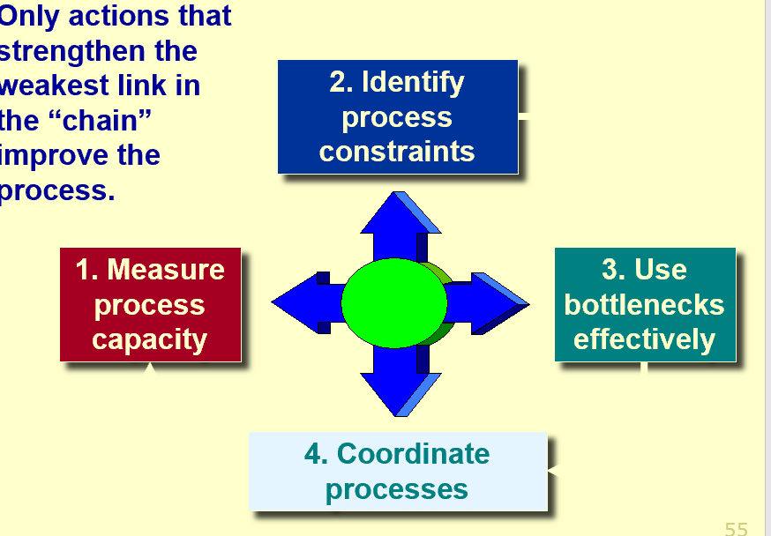
Balanced Scorecard Measures of time?
- Financial
  - Revenue loss or price discount due to delay
  - Carrying cost of inventory
  - Throughput contribution – operation costs
- Customer
  - Customer response time
  - On-time performance
- Internal Business Process
  - Avg manufacturing time for key product
  - Manufacturing cycle efficiency for key processes (VA processing time/total time)
  - Idle time at bottleneck operations
  - Defective units at bottleneck
- Learning and Growth
  - Employee satisfaction
  - Number of employees trained in managing bottlenecks

Lecture 10: Decentralisation, Management Control Systems and Transfer Pricing
Learning Objectives
- Be able to define Management Control Systems and their features and how to evaluate them.
- Understand what decentralisation means and the costs and benefits of decentralisation.
- Be able to explain the need for transfer prices and how a TP should be evaluated.
- Be able to use the market, cost-based and negotiated methods of transfer pricing.
- Be able to understand the behavioral consequences of different TP methods.
Pre-Lecture Material
Management Control Systems
- Definition: a management control system (MCS) is a means of gathering nad using information to aid and coordinate the process of making planning and control decisions throughout the organisation
- Goal: to improve the collective decisions within an organisation in an economically feasible manner (cost vs benefit)
- Key feature of MCS? Designed to fit the organisation’s structure and the decision-making responsibility of individual managers and is closely aligned with organisational strategy and goals.
- A management control system guides the behaviour of managers and employees through evaluation, motivation and reward.
Management Cotnrol Systems
- Contain some or all of the BSC perspectives
- Consist of:
  - Formal Control Systems – explicit rules, procedures, performance measures and incentive plans that guide behaviour
  - Informal control systems – shared values, loyalties, corporate culture, unwritten norms of acceptable behaviour…
Evaluating Management Control Systems
- Consider the following
  - Does it align tot eh organisation’s strategy and goals
  - Doe sthe system fit the organisation structure
  - Does the system fit the repsonsiblities of the indivual managers
  - Does it effectively motivate managers and their employees?
    - Motivation? Desire to attain a goal (goal congruence) and the pursuit of it (effort
      - Goal Congruence? Managers and individuals working in their own best interest take actions that align with organisational goals
      - Effort? Exertion toward goal
    - Incentives?
Organisational Structure – Decentralisation
What is decentralisation?
- Structural choice with respect to the organisation of a company
- Specifically: how long in the organisational structure decisions are made
  - Decentralisation is the freedom for managers at lower levels of the organisation to make decisions
  - Autonomy is the degree of freedom to make decisions. The greater the freedom, the greater the autonomy
- What is this a response to?
  - Organisation diversity, in a complex and uncertain environment
    - Type of diversity? Geographic; business; product; functional; technological
  - It is another cost v benefit decision
Centralisation Vs Decentralisations
- Centralisation
  - Maximum constraints; minimum freedom
  - Decisions made by top management
- Decentralised
  - Minimum cosntraints; maximum freedom
  - Decisions made at devisional and departmental levels
Decentralisation
- Benefits:
  - sub-unit managers are specialists – greater responsiveness to local needs
  - decision making autonomy - managerial training, development, learning
  - decision making authority - exhibit greater/increased motivation
  - delegating provides time
relief to top managers
  - empowering employees -
uses knowledge and expertise of those closest to operations (sharpens focus)
  - timely response to opportunities and problems..gains from faster decision making
  - top mgt freed to concentrate on strategy; lower level managers gain experience in decision making; decision making authority leads to job satisfaction; lower level decision often based on better information’; improves ability to evaluate managers.
- Costs
  - Suboptimal decision making if the manager DOES NOT have the necessary skills and
  - managers narrow their focus to their units’ performance rather than on the firm’s overall goals (incongruent or dysfunctional behaviour)
  - ignore consequences of their actions on other sub-units
  - duplication of tasks or services
  - information diseconomies across borders
  - need for monitoring costs etc
- Disadvantages
  - May be a lack of coordination among autonomous managers; lower level managers may make decisions without seeing the “big picture”; lower level managers objectives may not be those of the organisation; may be difficult to spread innovative ideas in the organisation.
Decentralisation – Issues:
- Degree of decentralisation
  - E.g. company may have centralisation on the operating level, but more centralised for the long-term financing
- Performance Measurement
  - A decentralised organisation must measure the performance of the decentralised sub-units
    - Choices about type of responsibility centres to use (responsibility = control/influence)
      - Performance measurement and evaluation
      - Management compensation
    - Setting transfer prices, when subunits transfer product or services between each other

Lecture Material
“Accounting” & Performance Measurement
- Recognise in decentralised structures – the role of accountability and accounting is heightened
- With the use of accounting information – need to consider
  - Which performance aspects to measure? Type of centre?
    - How accurately are they measured?
  - Weakness
    - Segment performance vs managerial ability
    - Externalities
    - Exclusion of non-financials
    - Short term emphasis
Measuring Management Performance – Using accounting measures
Type of Centre | Evaluation Tool
Revenue Centre | Revenue Standards
Cost Centre | Cost Standards
Profit Centre | Variable Costing  Income Statement
Investment Centre | ROI, RI or EVA

Transfer Pricing
Transfer pricing: the price one sub-unit charges for a product or service supplied to another sub-unit of the same organisation.
- Management control systems: use transfer prices to coordinate the actions of subunits and to evaluate their performance
- Affects outsourcing decision, marketing, finance, production, tax planning
- Involves trade-offs between firm-optimal outcomes and divisional autonomy
Transfer pricing results from the fact that internal transfers…
- Create a need for a pricing mechanism
- Should accurately reflect the costs and revenues of doing business
- Do affect profit of associated divisions
- Should not affect total profit overall
Issues (conflicts) arise when intermediate product (service) sold by one profit or investment centre to another profit or investment centre.

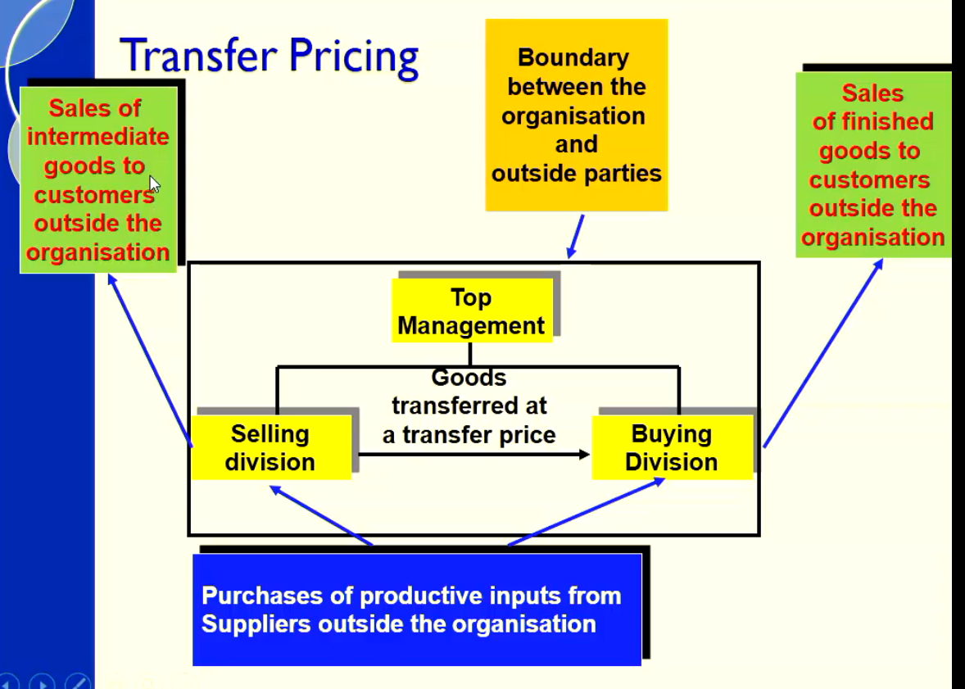

Purpose (role of TP)
- Allocative purpose:
  - Assist sub-unit *segment) managers in resource allocation decisions
    - How much of the intermediate product should be supplied? Purchased?
  - Performance evaluation purpose:
    - TP is an input to the calculation of profit for the seller (as revenue) and the buyer (as cost) within the firm.
      - Does the TP motivate managers, provide incentive for goal congruence, fairly reward managers?
  - The main objective for the firm?
    - To maximise its value, therefore there is a possible conflict between these 2 roles.
Transfer Pricing
- The transfer price affects the profit measure for both the selling division and the buying decision.
- E.g. A transfer between Division X to Division Y
  - Greater profits for Division X
  - Lower Profits for Division Y
- Goal
  - Encourage lowest total cost (or highest total benefit) decision making
  - From which perspective?
- Issue: transfer price imapcts on
  - Profit distribution
  - Accurate performance evaluation
- Solution?
  - Use market prices (if available)
  - Segments free to deal outside
  - But possible only if, external market exists for product
- Central management involvement?
  - Detracts from decentralisation motive
- Optimal TP = one in the best interests of the company as a whole

Criteria for Selecting (& Evaluating) TP
Transfer Price should
- provide signals that will guide or motivate sub-unit (divisional or segment) managers, while acting in their own best interests, to also make decisions that are also in the company’s best interests.
That is, it should provide:
  - Goal congruence
  - Promote management effort towards a goal
  - Sub-unit autonomy (motivation)
- Produce divisional measures of economic performance
- Support a fair evaluation of managers
- Provide reliable information for external reporting and contracting purposes

Approaches to Transfer Pricing
- There are 3 methods (approaches to) TP:
- Market-based
- Cost-Based
- Negotiated
Fourth?
- Administered

Market Based Transfer Prices
- Top management chooses to use the price of similar product or service that is publicly available. Sources of prices include trade associations, competitors, etc.
- Leads to optimal decision-making when three conditions are satisfied:
- The market for the intermediate product is perfectly competitive
- Interdependencies of subunits are minimal
- There are no additional costs or benefits to the company as a whole from buying or selling in the external market instead of transacting internally
Be aware of distress prices! When market prices temporarily drop below historical averages due to supply outstripping demand.
Cost-based Transfer Prices
- Top management chooses a transfer price based on the costs of producing the intermediate product.
- Examples include:
  - Variable production Costs
  - Variable and Fixed Production Costs (full Mfg Cost)
  - Full Costs (including life-cycle costs)
  - One of the above, plus some mark-up
- Useful when market prices are unavailable, inappropriate, or too costly to obtain
Cost Based TP Alternatives
- Transfer Price = Variable Cost (VC)
- Advantages
  - Can help fill internal capcity
  - Floor price when selling division has excess capacity
  - Focuses on relevant costs
  - But incentive for buying division to buy inside only
- Limitations
  - If seller is a profit centre, no return or coverage of fixed costs
  - Incentive for seller to control costs: efficiency not rewarded nor inefficiency penalised if actual cost
- If an external market exist it cannot be justified
Cost-Based Transfer Pricing Summary
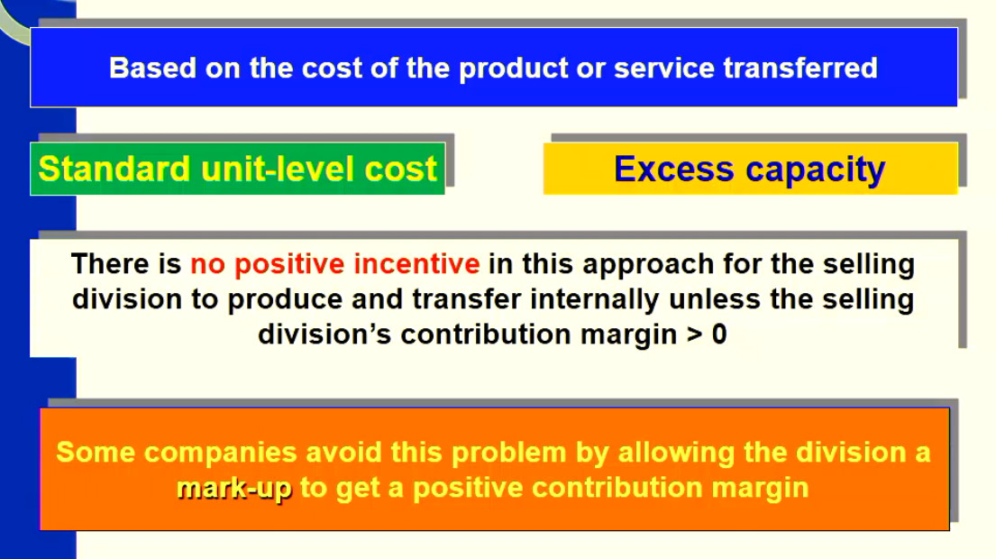

Negotiated Transfer Prices
- Used when subunits of a firm are free to negotiate the transfer price between themselves and to decide whether to buy and sell internally or deal with external parties
- May or may not bear any resemblance to cost or market data
- Often used when market prices are volatile
- Represent the outcome of a bargaining process between the selling and buying subunits

- Division managers actually negotiate the price at which trasnfers will be made
- Drawbacks
  - Negotations can lead to diviseness and competition between participating division managers
  - Althoguh neg. skill is a valuable managerial talent, it should not be the sole or dominant factor in evaluation a division manager
How a transfer price may be determined
- Minimum transfer price (floor price)
  - Selling division no worse off if the goodservice is sold to an internal division
    - Need to consider is there excess capcity? What can it sell for externally?
- Maximum transfer price (the ceiling price)
  - Buying division no worse off if an input is purchased from an internal division
    - Consider what can it buy the input for externally?
- General rule for establishing a minimum transfer price (floor price for the SELLER) =
  - Incremental costs per unit incurred up to transfer + opportunity costs per unit to the selling division
Minimum Transfer Price
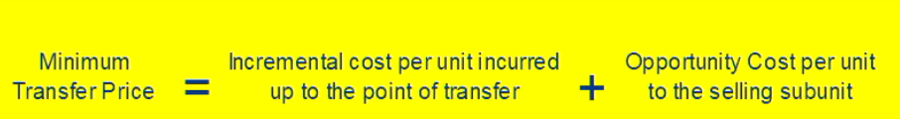

- Incremental Cost: Is the additional cost (of the seller) of producing and transferring the product or service
- Opportunity Cost: is the maximum contribution margin forgone by the seller if the product or service is transferred internally

Market Price and capacity in the producing (selling division)
- When producing division ahs no excess capacity and perfect competition prevails, the general tranfer-pricing guideline and market price yield the same transfer price
- Transfer price = Incremental cost + Opp. Cost
  - = Unit level cost of production and transport + Forgone Contrib. Margin of an external Sale
Difficulty implementing a general guideline?
- General transfer-pricing guideline will always promote goal-congruent decision making if it can be implemented
- Issue: Difficulty in measuring opportunity Cost
  - market may not be perfectly competitive
  - there may be no external market for the product
  - goods or services may be unique
  - special equipment may be needed to produce the transferred good
  - there may be interdependencies among several transferred goods or services
Multinational Transfer Pricing
- In international transactions, transfer prices may affect tax liabilities, royalties, and other payments because of different laws in different countries (or states)
- Companies have incentives to set transfer prices that will increase revenues (and profits) in low-tax countries and increase cost (thereby reducing profits) in high-tax countries

Lecture 11: Performance Measurement and Compensation
Learning Objectives
- Be able to explain the role of performance measures in a MCS – financial and non-financial
- Be able to measure performance for an investment centre calculating the ROI, RI and EVA and to understand the advantages and limitations of each method.
- What are the behavioural incentives associated with performance measured using ROI? RI? EVA?
- Explain how reward /compensation systems can be designed and used to enhance goal congruence
Pre-Lecture Material
Measurement & Evaluation of Performance
- In ACCT2102 and 3104, we have considered some accounting-based (financial) performance measures used in different responsibility centres, such as:
  - Cost and Revenue Centres use flexible budgets and variance analysis (Flexible Budget Variances and Sales Volume Variances)
  - Profit Centres use contribution margin income statements by segments (Segment Reporting), flexible budgets and variance analysis
  - Investment Centres (focus of L 11) use ROI, RI and EVA as summary financial performance measures
- Why not compare operating incomes (segment margins) of these divisions?
- Accounting based performance measures can be used as good indicators of progress the Company has made towards its goals and objectives.
Financial and Non-Financial Measures
- What have we learned to date about performance measures?
- Accounting based performance measures are only a subset of availabl measured used to evaluate subnits and subordinates
- Non-financial measures
  - Assist our interpretation of the financial measures
  - Provide leading indicators of future financial performance
  - Can be used to evaluate aspects of a business that are critical to its long term success
- Recall the “balanced scorecard” approach
  - Can be applied – from the entire company to subunits to individuals

Designing Accounting – Based Performance Measures
- Choose performance measures that align with management’s financial goals (best measure of a subunits performance?)
- Choose the time horizon of each performance measure
(Annual? Multi-year period?)
- Define components of the performance measure
- Choose a measurement alternative for the components of the performance measure
- Set the target level of performance (do all subunits have identical targets e.g., the same required rate of return on assets?)
- Determine the timing of the feedback (frequency of calculating & reporting the measure to top management? How critical is the info for success?)
Selection between alternative at each step? How do each alternative effect these:
- Promoting goal congruence
- Promoting management effort
- Promoting subunit performance evaluation
- Promoting subunit autonomy
Measurement and Evaluation of performance – Investment Centres
- Return on Investment (ROI)
  - Profit margin (ROS) x Investment (asset) turnover
  - Accounting rate of return
- Residual income (RI)
- Economic Value Added (EVA)
- The above are ‘investment’ measures
- Investment = resources or assets used to generate income
- Return on Sales (ROS) – does not include any ‘investment’
Efficacy of Financial Control?
- Criticisms:
  - delayed information
  - highly aggregated information
  - not actionable; limited guidance for future actions
  - narrow measures that emphasise only one aspect of performance and that do not evaluate how well the organisation is meeting shareholders’ requirements
  - too focused on short-term results
  - may encourage actions that decrease both shareholder and customer value
- Overcome This? Take a BSC approach
  - Use financial and non-financial measures
  - Select measures that support the strategic orientation
  - Use external benchmarks
  - Incorporate continuous improvement
Behavioural incentives and performance evaluation
Fundamental principles of Incentive compensation plan
- Basic idea behind incentive compensation plan is to “pay for performance”
- Two key elements of an incentive compensation plan re the:
  - Measures of performance
  - Method of compensation
The Trade-Off: creating Incentives vs. Imposing Risk
- Compensation may range from:
  - Flat salary with no performance based incentives to
  - No salary and full commission
  - (think spectrum of this)
- An inherent trade-off exists between creating incentives and imposing risk
  - An incentive should be some reward for performance
  - An incentive may create an environment in which suboptimal behaviour may occur (the goals of the firm are sacrificed in order to meet a manager’s personal goals)
- Managers do not like being subject to risk BUT lack of risk can create MORAL HAZARD
Moral Hazard
- When an employee prefers to exert less effort compared with the effort desired by the owner because the employee’s effort cannot be accurately monitored and enforced
Intensity of Incentives
- Intensity of Incentives – size of incentive component relative to the salary component

Elements of a typical Incentive Scheme
- Well defined variables used to measure, assess and reward performance
- Basis for determining the standard or target level of performance
- Rules for translating levels of performance into individual rewards
- Nature of rewards
  - Size of reward, type of reward
  - Basis for determining bonus pool size
  - Basis for determining participants in scheme

Preferred Performance Measures
- Are sensitive to or change significantly with the manager’s performance.
- Do not change much with changes in factors that are beyond the manager’s control
- Should motivate the manager as well as limit the manager’s exposure to risk
- Financial and non-financial benchmarks may be used to evaluate performance.
Aside: Merchant’s six criteria of an “ideal” motivational contract
- Performance measures that are congruent with
overall corporate goals of maximising shareholder value
- Controllable results measures
- Accurate results measures
- Preset and challenging performance standards
- Rewards that are meaningful, but at a minimum cost
- Simplicity
LECTURE MATERIAL
Return on Investment (ROI)
ROI = Income / Investment
Investment = resources or assets used to generate income
- Total assets employed, total assets available or a measure of net assets?
- Valued at cost, book value, current cost?
- Beginning, ending or average?

- The formula for computing ROI for an investment centres.
- The manager can improve ROI by either increasing controllable profit margin and/or reducing average operating assets. We will talk about this further shortly.
- Income - segment or operating; before tax or after tax?
- Assets – total assets utilised, total assets available or net assets; plant assets at original cost, book value or current value; beginning, ending or average assets.
- Total assets: Appropriate if the division manager has considerable authority in making decisions about all of the division’s assets, including nonproductive assets
- Total assets employed: Appropriate if the division manager has been directed by top level management to keep nonproductive assets in progress, making it appropriate to exclude nonproductive assets from the measure of invested capital
- Total assets – current liabilities: Appropriate if the division manager has authority to secure short-term bank loans and other short-term credit
Varied Definitions of Investment
- Total Assets (available
  - Appropriate if the division manager has considerable authority in making decisions about all of the division’s assets, including non-productive assets
- Total Assets employed
  - Appropriate if the division manager has been directed by top level management to keep non-productive assets, making it appropriate to exclude non-productive assets from the measure of invested capital
- Total assets less current liabilities
  - Appropriate if the division manager has authority to decide short-term bank loans and other short-term credit
Measurement Alternative?
- Current Cost
  - Cost of purchasing an identical (or similar) asset today
- Historical Cost
  - Can include Gross Book Value or Net Book Value
Controllable Assets
- Assets that the divisional manager has considerable authority in making decisions about
- Not controlled by Head Office.
- Example:
  - Total division assets are $1,500,00 of which $500,000 are controlled by Head Office
  - Operating Income $100,000 of which $20,000 relates to depreciation on assets controlled by Head Office
  - ROI including uncontrollable assets and depreciation: $100,000/$1,500,000 = 6.7%
  - ROI excluding uncontrollable assets and depreciation:
$120,000/$1,000,000 = 12%
Assessing ROI performance
- Analyse trends over time
- Compare to competitors (if you can)
  - Decompose and compare
- Compare to alternative ‘returns’
- Look for signals suggesting where there may be problems
- Use cautiously and in conjunction with other measures

Net Book Value vs Gross Book
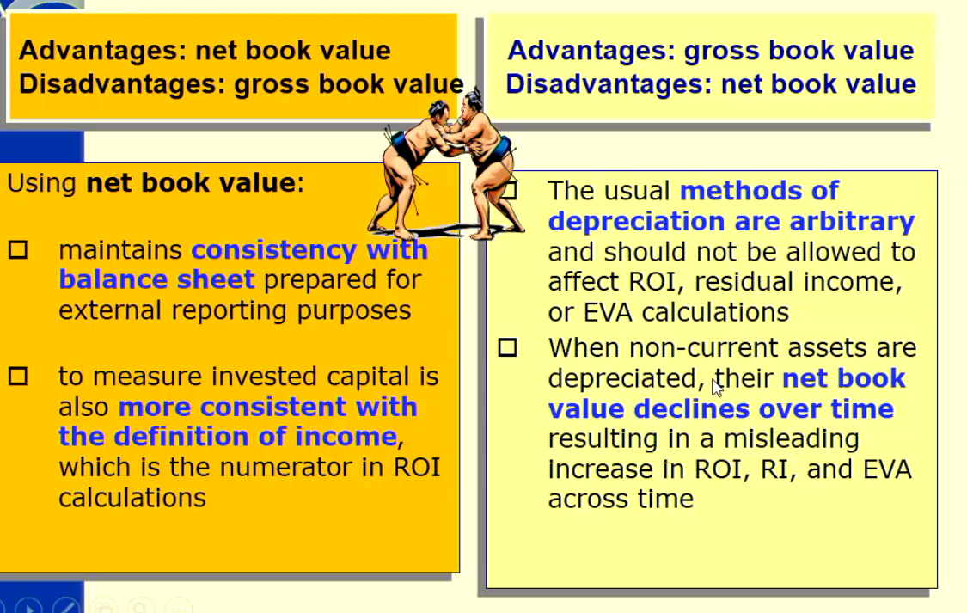
Factors Underlying ROI – The Du Pont Method
- Measures the percentage of each sales dollar that remains as profit after all expenses are covered – measure of efficiency
- Return on Investment =
  - Income/Investment = Income/Sales Revenue (AKA. Return on Sales) x Sales revenue/Investment (AKA Investment (Asset) Turnover)
- Note: Investment = Assets
- Overall Highlights the benefits of reducing investment in inventories, & spending carefully on fixed assets

Controlling ROI
- Three ways to improve ROI
  - Increases sales without a similar increase in costs
  - Reduce Expense
  - Reduce Assets
- Return on Sales x Investment Turnonver
  - ROS = Income/Sales
  - Investment Turnover = Sales/Investment
- Profit can be increased by increasing sales or by reducing variable and controllable fixed costs.
- An increase in sales benefits both the investment centre and the company if it results in new business. It would not benefit the company if the increase was achieved at the expense of other investment centres.
- If variable and fixed costs were decreased – this action is beneficial when waste and inefficiencies are eliminated. However a reduction in vital costs, such as required maintenance and inspections is not likely to be acceptable to top management.
Some Technical Problems of ROI
- ROI is too aggregated to give guidance about the trade-off that can be made between profit and investment
- The measure gives rise to inconsistent capital investment decisions across the company which lead to sub-optimal outcomes.
- NPV Calculation and evaluation of investment is inconsistent with ROI outcomes after the investment.
  - ROI encourages investment in fast payback assets
- What about the effect of transfer prices on Divisional ROI
  - Company profits are rarely optimised by optimising divisional profit
    - Solution? Remove the decision rights?
- ROI results may be misleading and decisions dysfunctional
  - Is comparison of different divisions appropriate?
  - Measuring the performance of the division rather than the performance of the manager?
- Be careful comparing the Roi’s of different business segments
  - Invalid comparisons between different work units can occur because:
    - Age of assets are different (GBV vs NBV)
    - Asset-intesive vs low-asset business types
    - Different national (and cultural contexts)
    - Different Legal restrictions
  - Multinational Companies
    - Comparing the performance of divisions of a multinational company creates additional difficulties
      - Difference sin the economic, legal, political, social and cultural environment
      - Governmental controls
      - Availability of materials and skilled labour
      - Currency differences
- THIS IS A BIG EXAM QUESTION, LECTURE 11. 41 MINUTES IN

ROI Advantages & Disadvantages
- Advantages
  - Single comprehensive figure that focuses managers on profit & assets needed to generate the profits
  - easily understood -comparable to interest rates and rates of return on alternative investments
  - Motivates managers to use assets optimally and only acquire when justified
  - widely used
  - improvement over evaluation based on dollar profit alone

- Disadvantages
  - high ROI units may be unwilling to invest in projects with ROI greater than minimum rate of return but less than unit’s current ROI
  - using investment based on historical costs, net of depreciation (NBV), managers may put off purchasing new equipment when assets fully depreciated
  - Aggregated measure –may lead to manipulation

Residual Income
- Evaluates profit relative to a minimum required ROI
- Residual Income = Income – Required Rate of return x Investment)
- Typically use Operating Income
- Uses an ‘imputed cost of the investment’ based on the minimum acceptable rate of return the company seeks on its investment. (typically measured by weighted average cost of capital (WACC))
- Measure is expressed in dollar terms → Motivates managers to maximise $$$ rather than %%%
- A potential solution to under/over investment → managers have incentive to accept all projects that more than cover the cost of capital → Goal congruent
Residual Income Advantages & Limitations
- Advantages
  - Supports incentive to accept all projects with an RI greater than the minimum rate of return
  - Can use the minimum rate of return to adjust for differences in risk
  - Can use a different minimum rate of return for different types of assets
  - positive dollar return projects adopted; is flexible, allowing different costs of capital to be incorporated to reflect varying risk factors; opportunistic behaviour is easier to control.

- Limitations
  - Favours large units when minimum rate of return is low
  - Not as intuitive as ROI
  - May be difficult to obtain a minimum rate of return
  - tends to favour large segments because easier for them to achieve a positive RI; determining cost of capital is both complex and coloured by arbitrariness; short term decision making will still dominate.
Economic Value Added (EVA)
- RI adjusted for “accounting distortions”
- EVA is the income “pie” available to creditors and shareholders less the required return on funds invested for the L-T by creditors and shareholders
- evaluates income relative to level of investment required to earn that income
- motivates managers to undertake economic value added activities

- EVA = A-T Profit – COST of Capital
  - A-T Profit = After-Tax Operating Income
  - Cost of capital = Weighted Average cost of Capital (WACC) x (Total Assets – Current Liabilities)
    - (Total Assets – Current Liabilities) = NCA + CA – Current Liabilities
    - OR
    - NCA + Working Capital
- Further Explained in diagram below
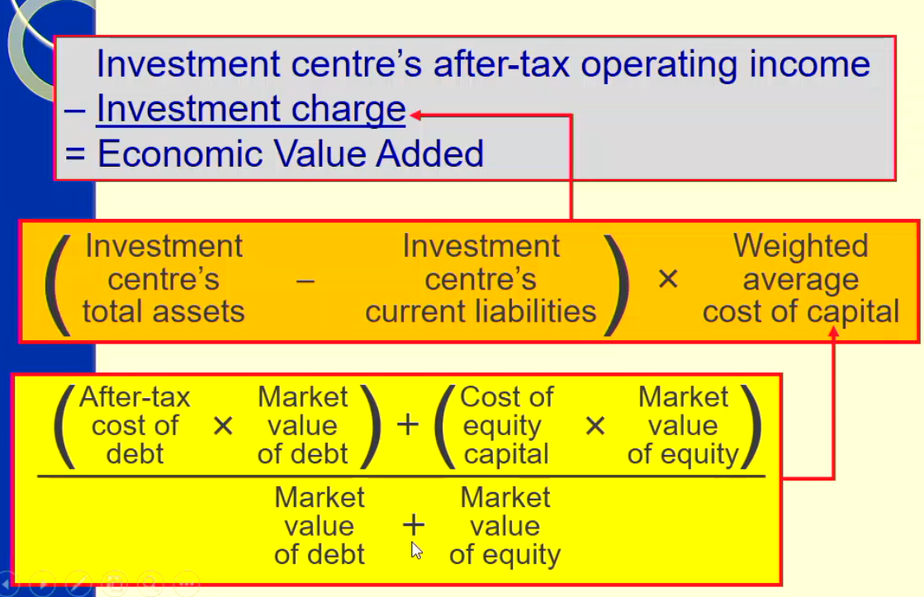

EVA Advantages & Limitations
Advantages
- Approximates real underlying increase in the value of shareholder’s wealth
- Makes management focus on optimising the company’s capital mix
- Studies? Show some closer correlation with share price than conventional profits
- positive dollar return projects adopted; is flexible, allowing different costs of capital to be incorporated to reflect varying risk factors; opportunistic bahviour is earlier to control.

Limitations
- Cost of capital imprecise
- Capital base may fluctuate from year to year distorting EVA
- May discourage long term investment
- Studies? Show some weak correlation with share price
- tends to favour large segments because easier for them to achieve a positive RI; determining cost of capital is both complex and coloured by arbitrariness; short term decision making will still dominate.
Overall Still a short term measure – invested capital increases before profits increase therefore may discourage long term investment.
Return on Sales (ROS)
- ROS = Operating Income (EBIT) / Sales

- Suitable for use in firms where the level of investment in assets is low, therefore the corresponding ROI would be extremely high
- Shows how effectively costs are managed
Time Horizon?
- ROI, RI, EVA (and ROS) represents results for a single period (Year)
- Managers may be inclined to take actions that improve short-run performance but that are detrimental to long-run interests of Company
- Many companies evaluate subunits on these measures over multiple years
Performance Evaluation and Behavioural Incentives
- Performance evaluation of a manger should be distinguished from the subunit
  - Managers should be evaluate don the profit margin they control
    - Exclude these costs:
      - Costs traceable to the division but not controlled by the division manager
      - Common costs incurred elsewhere and allocated to the division
  - Key issue is controllability
  - Comparisons between managers of different units on the basis of ROI are not necessarily valid:
    - different types of businesses deliver different levels of return
    - a good manager of a poor division may not appear to do as well as a poor manager of a good ROI division.
A manager’s performance is limited by the division’s profit potential.
    - the extent to which a manager can control an item is irrelevant to the division’s performance BUT is relevant to the managers performance.

Management Rewards
- Cash incentives are highly liquid and attractive (short term)
- Share incentives are usually not redeemable into cash until a future time (longer term, aligns interests more)
- Prizes, promotions (titles), location can be more attractive than money and more motivational

Prompting Incentives
- What behaviour should incentive compensation plans motivate?
  - This is dependent on the type. Either Current or FUTURE performance
- Current
  - Compensation awards are usually cash or shares that can be cashed soon afterwards, that are based on performance in the recent past
- Future
  - Compensation awards are based on future performance providing an incentive for workers to stay and for workers to focus on the long run
Rewards Divisional or company-wide performance?
Division
- Focuses managers attention on their own responsibility centre
- May be detrimental to other responsibility centres and performance of a company as a whole
- Fits more in a decentralised diverse organisation
Company-Wide
- Allows managers to consider the impact of their actions on the company as a whole
- May be difficult to see relationship between their actions and the company as a whole
- Fits more into a centralised organisation
In providing rewqards -? Use fixed formulae? Subjectivity?
Fixed Formulae
- Managers know precisely what is expected of them
  - Example: For each percentage point by which revenue growth exceeds 5% managers receive a bonus of 10% of their base salary
  - (used more for lower levels in organisations)
Subjective
- It is difficult to compare activities in a fixed formulae
  - Example: a manager’s ROI dipped because of research, employee training, and advertisting, expenses that will not pay off until the future. (used more for upper/top management)
Dow you measure absolute performance or relative performance?
Absolute
- Evaluation is on an absolute scale and does not depend on what other people do
  - Example: 90 – 100 = A, 80-89 = B, 70-79 = C etc…
Relative
- Your evaluation depends on how you perform in relation to everyone else
  - Example: comparing divisional performance to other divisions in the same industry
Base evaluation on share price, rather than accounting based measures
- Performance Evaluation based on share performance ?
  - Aligns managers’ incentives with those of shareholders
  - Division managers in big companies may see little relationship between their performance and the company’s shares
  - EVA focuses on creating value for shareholders, while relying on nonshared performance measures

