ACCT3101 Notes
Auditing and Public Practice
Vimal Singh

Tutorial 1:
Rudimentary information
The role of an auditor is not to prepare financial statements. It is the auditor’s responsibility to perform an audit & assurance engagement. Client’s responsibility to prepare financial statements.

Q1.23
b. The reason the element of quality control is 5(A) (Engagement persofrmance, direction, supervision & performance) is due to the fact that a standardised form -> gives direction
d. ethical requirements – independence, to eliminate bias and provide transparency
Q1.29 This has appeared in exams before.
Q4.28 Tough question
- Management Assertions:

  - Occurrence is when you look at the Trial Balance/Financial statements. You are testing to see whether or not that transaction has actually happened.
  - Completeness is when you have a transaction that has happened but may not have been recorded. -> Bank Statement reconciliation
    - Occurrence and completeness are often confused.
  - Accuracy –
  - Classification –
  - Timing/Cutoff – refers to end year date, everything is recorded in the correct period. In the exam be very specific
- Recorded Cash disbursements are for goods and services actually received – OCCURRENCE
- Existing cash disbursement transactions are recorded – COMPLETENESS
  - The difference here, is that in the first one they’ve happened and you’re checking that they actually happened. In the second, they’ve happened but you need to make sure they’re recorded.

Posting and summarisition – posting is when you take something from a sub-ledger, and you’re posting it to the trial balance. Summarisation is totalling (summarising) that list. From an audit perspective, it’s checking how well they added it up together.

Tutorial 2:
*Pervasive = Found Everywhere/Affects the business majorly
Non Pervasive = only affects a few accounts/ a smaller portion
Audit Reports
Adverse Opinion

Disagreement with Management

Disclaimer of Opinion
Scope Limitation
Material Misstatement
Unmodified (Fairly Stated)

Pervasive
Not Pervasive then Qualified opinion

Exam Answer Structure
- Issue/Problem
- 2. Material -> Yes -> Qualified if not pervasive
- Pervasive
Go over Slide 35 -> Google the cycles to understand the flow.
Revise Slides 45-47 (Important for the exam)
Tutorial Question 18.23 ALWAYS COMES UP ON THE EXAM
Tutorial Answers:
Question 18.21
C. (Comprehensive answer)
Provision for doubtful debts is incorrect.
Also a disagreement with management.

Tutorial 4:
Question 5.23
- 13) – This is an Analytical Procedure, due to the fact that it deals with ratios.
- 7) – This is Documentation, this is because a document is being inspected.

Question 5.25
- A) Because it is with a third party, less of an incentive to manipulate that information, management can easily forge their own records, however its much more difficult to forge documents that have been signed by customers (receipts).

- C) when as an auditor, you don’t have experience with what the inventory is, is when your knowledge as the auditor impacts the validity of the observation. E.g. if your client is Queensland gas, you would have no knowledge of how to measure gas and what is correct, thus causing a physical observation to become unreliable evidence. – in this case, because you don’t have the skills, you would confirm it with an external specialist.

- D) Re-performance tests, only tests accuracy, because you’re looking to replicate the same result as the original, Auditor’s do not usually only test for accuracy, therefore causing this be of relatively limited use.

- E) Relatively reliable documentation examples include: vendor statements, bank statements, and signed lease agreements. Relatively unreliable documentation examples may be: copies of customer invoices, internal memoranda and other communications, and a listing of fixed asset additions.

- G) they will direct us to see if there is a possible misstatement, does not give an actual misstatement, but will show us if something is actually wrong.

Question 5.29
- C) Procedure for accounts payable (tute answers show a/c recievable, so now you have the answer for how to do the procedure for A/P as well):
- Select a supplier, and sent out confirmation to them to make sure it was billed at the correct date.
- Confirmation: Send out external confirmation to suppliers (sample of suppliers) to confirm the amount outstanding

- Documentation/re-performance: obtain the clients a/c payable reconciliation and trace outstanding amounts to suppliers’ statements (documents). Will then reperform the reconciliation to check its accuracy.

- Inquiries of client: Sit with client and ask them if they have any knowledge of any a/c accruals to their knowledge that they have not raised yet.

- Analytical procedures – compare last years accruals and a/c payables to this years balance. Follow up regarding unusual patterns

Slide 12 – 13
- Audit risk model is not something you can calculate it is something you set the audit risk.
  - You understand the clients business and based on the risk you are exposed to you set the audit risk
  - The riskier the client the lower the audit risk = the more risk you have that your issued audit opinion could be incorrect.
- Read in textbooks what affects audit risk, and make a summary.

Lecture 1: Introductions and Functions of Auditing
Overview of course
- Concept & context of auditing
- Audit Planning
- Audit Testing
- Audit Report
Nature and Function of Auditing
- Nature and function of auditing
- Relationship between auditing & accounting
- Auditing in the accounting profession
- Types of audit
- Demand, benefits and limitations of audit
- Professional standards & Statutory requirements
- Financial report audit: management assertions
What is auditing?
- Obtaining and evaluating evidence … about assertions … to form an opinion about those assertions… and communicate that opinion to interested users.
- ASA 200 overall objective sof the independent auditor and the conduct of an audit in accordance with Australian Auditing Standards
- Financial report audit is most common
- When looking at a financial report audit, you should look at the auditor’s opinion firstly to evaluate whether or not the information being audited is of an appropriate quality.
Why we need independent financial report audits
- Financial statements need to be relevant, reliable, understandable & comparable to be useful -> decisions have economic consequences.
- Possible errors, fraud, manipulation & other illegal acts, e.g. due to agency conflict.
- Agency Theory -> Manager incentive to do well, thus giving air to reasons why a manager may skew results
Auditing – Who Cares?
- Shareholders / Members
- Creditors & Customers (e.g. HIH, One. Tel)
- Suppliers & Employees
- Government / Regulators
- The public (e.g.. Anseet, HIH)
- Parties involved in monitoring companies (e.g., directors: professional reputation, personal liability)
- Important Objectives:
  - Investor Protection (giving them confidence to make economic decisions)
  - Accountability and Credibility
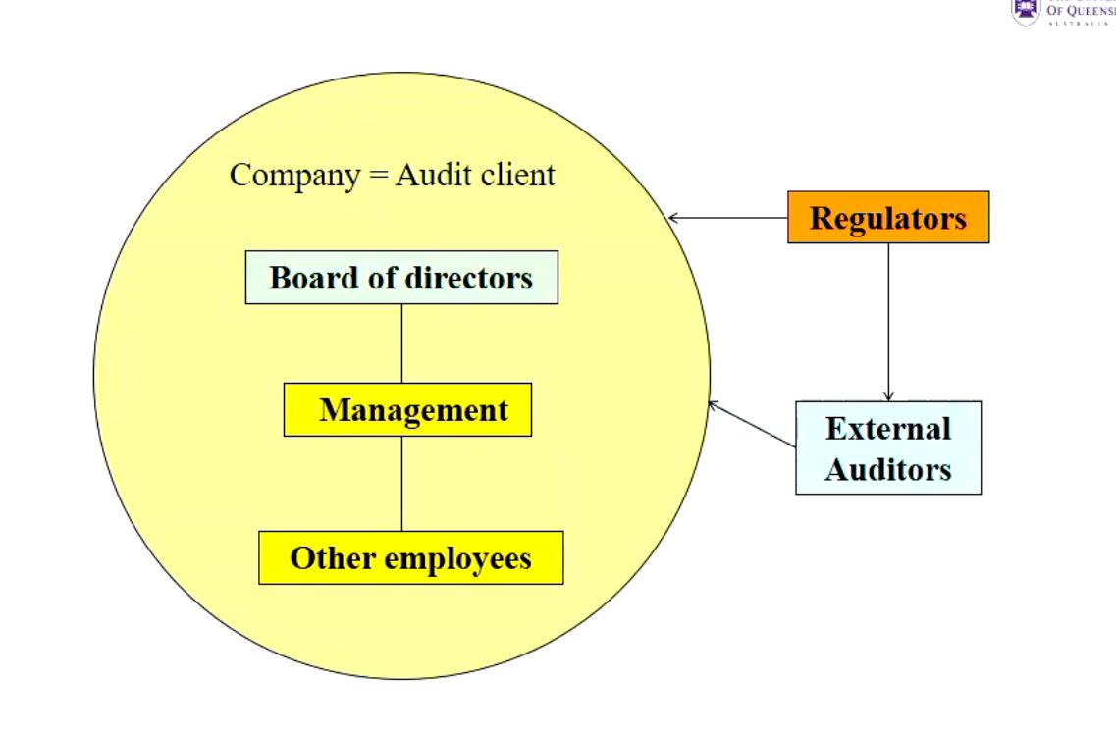

The relationship between accounting & auditing
- Accounting: Analyse events and transactions -> measure and record transaction data -> Classify and summarise recorded data -> Prepare financial statements and other reports in line with frameworks -> Distribute annual report including financial statements
- Auditing: Obtain and evaluate evidence concerning the financial statements -> verify that financial information has been presented in accordance with an identified financial reporting framework. -> Express an opinion in the audit report -> Deliver the audit report to the entity.
Relevant Terminology: Assurance Engagement
- Assurance Engagement:
  - An engagement in which a practitioner expresses a conclusion designed to enhance the degree of confidence of the intended users other than the responsible party about the outcome of the evaluation or measurement of a subject matter against criteria (Accounting Standard/Relevant corporations act)
    - E.g. an audit or a review engagement
- Listed companies are required to have their annual financial report to have their reports audited by auditors. Required by corporations law. Half-year reports are not required by corps act to get audited, however the ASX states that half-year reports need to be audited.
Different types of audit
- Financial statement audit
- Compliance audit
- Performance audit = Operations audit: efficiency, effectiveness & economy
- Comprehensive audit – combination of above
- Environmental audit – impact of environmental on financial statements
- Internal audit
Different types of auditor
- Independent Auditors = external auditors
- Internal auditors: employees of the auditee.
- Government auditors: Employed by the Commonwealth or state audit offices; headed by the Auditor General.
- Tax Auditors
Demand for Financial Statement Audits
- Agency Theory – monitoring performance of agents.
- Information hypothesis – reliability of information for decision-making
- Insurance hypothesis – provide insurance if audit fails to report material misstatements.
Economic benefits of an audit
- Reduce agency costs
- Lower cost of capital
- Access to a capital markets
- Deterrent to fraud and inefficiency
- Control and operational improvements
- Insurance

- Companies not audited, have a higher information risk. (people will not want to invest into a company that has not been audited, as the information in the statements are not ratified and may be false).

Limitations of Financial Report Audit
- Time lapse
- Audit testing on selective samples
- Assessment of materiality
  - People only care about decisions that will affect the overall health of the business (e.g. a $2 error for a billion-dollar company, is not a material misstatement).
  - However, this may be quantitatively unimportant, buy if it is recording (say multiple $$$ missing from a till over a period and there is consistency, this could be an indicator of fraud – e.g. qualitative)
- Forming professional judgements in highly specialised areas
- Report format limitations (New ASA701 – Key audit matters)

- Financial Audit reports are due 90 days after the end of the fiscal year, given this, it adds period for error as a lot can happen for a business in a 2 month period, and those records are not due for audit for another year thus causing a large limitation.
Auditing in the Accounting Profession
- Auditors are members of the accounting profession
- Company auditors must be registered by the Australian Securities and Investment Commission (ASIC). s1280
Auditing – Issues & Regulations
- Auditor’s responsibilities:
  - Audit quality
    - Competence
    - Ethics & Independence (Topic 3)
- Regulations
  - E.g. corps act, auditing standards
- Self-regulation by the accounting professions
  - Individual accounting firms
    - Professional accounting associations (e.g. CPA, CAANZ)
Statutory provisions (corporations act)
- Financial report audits:
  - Disclosing entities MUST have their annual financial report audited: s301
    - Public company – must appoint an auditor of the company within one month after the date of the company’s registration: s327A
    - A large proprietary company must have annual financial statements prepared and audited s292.
  - Appointment
    - An auditor can be (s324AA)
      - An individual (natural person)
      - A firm (partnership)
      - A company
    - Removal by special resolution at a general meeting s.329)
      - They cannot just be fired at will
    - Powers and duties (ss.307-309)
    - Independence requirements (topic 3)
Auditing Standards
- Basic principles and explanatory material
- With force of law (s307A)
- Important because:
  - They set a minimum standard of technical proficiency.
  - Users are informed that standards have been followed
  - Compliance is evidence against a malpractice lawsuit.
    - Protection for the auditor, if you can show that you complied with the auditing standards, it’s an amicable defence to prove that you were not negligible in your duties as an auditor.

- Standards are divided into:
  - Introductory matters
  - Principles & responsibilities
  - Risk assessment & response
  - Audit evidence
  - Specialised Areas
  - Conclusions/reporting
  - Using the work of others
Audit Quality
- ASA220 quality control for financial report audits
  - This standard establishes auditor’s responsibilities regarding quality control procedures for financial report audits
Elements of Quality Control (ASA 220)
- Leadership responsibilities for quality on audits – engagement partner & overall quality
  - Audit partner stays involved and overseas what the junior audit staff are doing. Ultimately responsible for the audit report.
- Ethical requirements, e.g. independence
- Client evaluation – Acceptance & continuance
- Assignment of engagement team
- Engagement performance
  - Direction, supervision & performance
  - Reviews
  - Consultation (e.g., difficult/contentious matters)
  - Engagement quality control review
  - Differences of Opinion
- Monitoring
- Documentation

Objective of a financial report audit (ASA200.11(A))
- The overall objective of an audit of a financial report to obtain reasonable assurance about whether the financial report as a whole is free from material misstatement, whether due to fraud or error, thereby enabling the auditor to express an opinion on whether the financial report is prepared, in all material respects, in accordance with an applicable financial reporting framework.
Responsibilities of Managers vs. Auditors
- Management is responsible for the financial statements and for internal controls.
- Auditors issue an opinion on compliance and/or fair presentation of the financial statements.
- The external auditor performing a financial report audit does NOT provide an opinion on the performance or profitability of the entity.
Financial Reporting Framework
Two types of Financial reporting Framework (ASA200.13):
- Fair presentation framework
  - Compliance & Fair presentation
- Compliance Framework
  - Compliance only
Financial Report Audit
- Annual Report
  - Financial report: including financial statements & notes to financial statements - Audited
  - Other information e.g. managers discussions -> Reviewed by auditor for consistency, but not ‘audited’
Audit Objectives
- Auditors need to test the accuracy of management assertions in order to assess whether the financial report is materially misstated.
Management Assertions:
5 main types of management assertions:
- Existence or occurrence
- Rights and obligations
- Valuation or allocation
- Completeness
- Presentations and disclosure

Lecture 2 – Audit reports & Audit Objectives:

Outline
- Responsibilities of management
- Responsibilities of auditor
- Unmodified and Modified audit reports
- Key audit matters
- Emphasis of matter/Other matter paragraphs
- The going-concern assumption
- Audit objectives, transaction cycles & management assertions
Responsibilities under Corporations Act: Managers & Directors:
- CEO & CFO Declaration (s.295A): Financial records properly maintained, compliance with accounting standards, true & fair view.
  - Does not need to be in the annual report, just given to the directors of the auditee
- The directors’ declaration (s.295): The financial statements and notes are in accordance with the law & Accounting Standards, give a true and fair view, able to pay debts when due.
  - This needs to be included in the annual report.
Responsibilities under corporations act: Auditor (s.307 & s.308)
- Statutory duty to form an opinion
- Auditor’s report on annual financial report:
  - Compliance with accounting standards.
  - True & fair view
  - Describe defect/irregularity in the financial report
  - Describe problems with audit independence
- Duty to report breaches of law to ASIC (s.311).
  - If a company is found to be in breach, auditors do not need to run to ASIC, but they do include their findings in the audit report and those are then published.
Auditor’s responsibility under ASA
- ASA 200.3; 200.5; 700.6; 700.10
- To enable the auditor to express an opinion, the auditor is required:
  - To obtain reasonable assurance about whether the financial report as a whole is free from material misstatement, whether due to fraud or error.

Auditor’s Responsibilities
- Reasonable assurance
- Material versus immaterial misstatements
- Errors versus fraud
- Professional scepticism

Reasonable Assurance
- Auditors can not guarantee that there are no material misstatements because of:
  - Sampling error.
  - Judgement error, e.g. accounting estimates, materiality.
  - Fraud is difficult to detect, especially if there is collusion

Material vs. Immaterial
- Misstatements are usually considered material if the combined uncorrected errors are fraud in the financial statements would influence a reasonable person using the statements.

Error vs. Fraud
- An audit should be designed to provide reasonable assurance of detecting both material errors and fraud in the financial statements.
- An error is an unintentional misstatement of the financial statements, whereas fraud is intentional.
- For fraud, there is a distinction between:
  - Misappropriation of assets, and
  - Fraudulent financial reporting

Professional Scepticisms
- Although an auditor should not assume that the audit client’s management & employees are dishonest, the possibility of dishonesty must be considered.

Auditor’s report Structure
- Title
- Addressee
- Auditor’s opinion
- Basis for opinion
- Going Concern (where applicable)
- Key audit matters
- Other information (where applicable)

Auditor’s Report: The Decision Process
- Determine whether any condition exists requiring a departure from a standard unmodified auditor’s report
- Decide the materiality for each condition
- Decide the appropriate type of report
- Prepare the audit report.

Auditor’s Report: Audit opinions
- Unmodified audit opinion
- Modified audit opinion
  - Qualified opinion
  - Adverse opinion
  - Disclaimer of Opinion
- “Key audit matter” section
- “Emphasis of matter” paragraph
- “Other matter” paragraph”
- “Material uncertainty” section

Unmodified Auditor’s Report 1
- An unmodified audit report is issued fi:
  - All required evidence was obtained
  - Proper accounting records were kept
  - The accountants are consistent with the Corps Act (e.g. true and fair view)
  - Applicable accounting standards have been adopted
  - Directors’ statement is consistent with the auditor’s knowledge of the client; and
  - Defects of irregularities have been disclosed
    - Usually by company management
  - ALL OF THESE MUST BE SATISFIED FOR AN UNMODIFIED REPORT

Unmodified Auditor’s Report 2
- For an Unmodified audit report use one of the following phrases (equivalent):
  - In our opinion, the accompanying financial report presents fairly, in all material respects, […] in accordance with [the applicable financial reporting framework]; or
  - In our opinion, the accompanying financial report gives a true and fair view of […] in accordance with [the applicable financial reporting framework].

Conditions requiring a modified opinion:
- Two Conditions:
- The financial report is materially misstated, e.g. due to:
- Disagreement with management, or/and
    - Company overstated assets/understated liabilities, did depreciation incorrectly e.g. (not in compliance with accounting statements) and managers refuse.
- Conflict between applicable financial reporting frameworks.
    - Companies in different locations, frameworks in different areas, companies can’t comply with both simultaneously, they become in breach in both areas, thus the financial reports would still be materially misstated on technicality.
- Scope limitation (Inability to obtain sufficient appropriate audit evidence).
    - Not given enough information to deliver an opinion.

Modified Opinions
Three types of modified opinions:
- Qualified
- Adverse
- Disclaimer of Opinion
- Explanations in “Basis for opinion” section.
- Use headings such:
  - “Basis for Qualified opinion”
  - “Basis for Adverse opinion”
  - “Basis for Disclaimer of opinion”

Qualified Opinion
- Due to: Disagreement with management, Conflict between reporting frameworks or Scope limitations
- Effects are not so fundamental as to require an adverse opinion or disclaimer (inability to form an opinion). i.e matters that affect the financial report are material but not pervasive.
- E.g. “Except for the provision for employee redundancy … the financial statements present fairly…”
Adverse Opinion
- Due to: Disagreement with management or Conflict between reporting frameworks
- Only happens when shit truly hits the fan
- Effects are so pervasive that the overall usefulness of the financial report has been materially impaired (i.e. financial report is misleading, uninformative, incomplete, or of little use).
- The financial statements do not present fairly in accordance with applicable financial reporting framework.
- E.g. “due to a disagreement regarding the application of the Accounting Standard relating to intangible assets, we believe the financials statements do not present fairly…”

Disclaimer of Opinion
- Due to:
- Scope Limitation (More common)
- Multiple uncertainties (rare) – can’t form an opinion despite having obtained sufficient appropriate evidence.
- Effects are so fundamental that the auditor is unable to express an opinion on the financial statements:
- Should not be used in relation to a normal case of a disagreement with management;
- E.g. “we have not been able to obtain sufficient appropriate evidence to provide a basis for an audit opinion. Accordingly, we do not express an opinion on the financial report”.
Exam Tips
- If you follow tute template for this lecture in exam, you’ll get full marks.
- Things you must cover
  - Is it material misstatement or scope limitation
  - If its material misstatenet, due to disagreement with management, or conflict with frameworks.
  - Irregardless of what you think, list the reasons for both situation (if it was pervasive or non-pervasive) TALK ABOUT ABOUT

Question: Materiality & Type of Audit Opinion
Materiality Level | Significance in terms of Reasonable Users’ Decisions | Type of Opinion
Immaterial | Decisions are unlikely to be affected. | Unmodified Opinion
Material but not pervasive | Some decisions are likely to be affected. | Qualified Opinion
Extreme (Material and Pervasive) | Most decisions are likely to be affected. | Adverse Opinion
Extreme Case of Scope Limitation |  | Disclaimer of Opinion

Key Audit Matters (ASA701)
Key audit matters section:
- A separate section in the audit report describing matters that were of the most significance in the audit of the current period financial report.
- Choose these from the matters communicated with those charged with governance that required significant auditor attention in performing the audit.
- This section NOT to be included in the audit report if a disclaimer of opinion is issued.
  - If you have disclaimer of opinion -> Do not put in a key audit matters section
Determine key audit matters: e.g.
- Areas of higher risk of material misstatement.
- Areas requiring significant auditor/management judgments, e.g. accounting estimates with high estimation uncertainty.
- Effect on the audit of significant events/ transactions.
Describe individual key audit matters;
  - Why this is a key audit matter.
  - How the matter was addressed in the audit

Emphasis of Matter (ASA706)
- Under certain circumstances, the auditor may want to draw user’s attention to a matter presented or disclosed in the financial report that is fundamental to users’ understanding of the financial report.
- Auditor must have obtained sufficient appropriate audit evidence that the matter is NOT MATERRIALLY MISSTATED IN THE FINANCIAL REPORT.
- Does NOT affect the audit opinion, can be issued with a modified or unmodified report.
Emphasis of Matter paragraph – circumstances
Examples:
- There is an uncertainty, adequately disclosed by management (e.g. litigation)
- The financial report is re-issued due to subsequent events;
- Early application of new accounting standards
- Major catastrophe with a significant effect
- There are additional disclosures with which the auditor concurs that make accounts true and fair.

Other Matter Paragraph (ASA706)
- The auditor considers it necessary to communicate a matter other than those presented or disclosed in the financial report that is relevant to users’ understanding of the audit, the auditor’s responsibilities or the auditor’s report.
- Does NOT affect the audit opinion. Can be issued with a modified or unmodified report.
- Example (ASA 706. A13-14): A special purpose financial report audit.

Going concern (ASA570)
- Auditor has a responsibility to assess audit clients’ going concern status over the relevant time period.
  - Generally 12 months, from audit report date to next report date
- Examples of factors affecting audit client’s ability to continue as a going concern:
  - Financial indications:
    - Ratios, borrowings, losses, bad debts, insolvency
      - Liquidity ratios, debt ratios, analysis required in report and findings reported in going concern
  - Operating indications:
    - Loss of management / labour / key markets
  - Other, e.g. litigation, uninsured disasters.
Going concern – Audit opinions 1
ASA 570 [Aus] Appendix 1 diagram:
- If the going concern assumption is appropriate:
- Are appropriate disclosures made by management in financial report?
  - Yes -> Unmodified audit opinion with Material Uncertainty section.
  - No -> Qualified or Adverse opinion (due to inadequate disclosure).
- If the going concern assumption is not appropriate:
  - Is the financial report still prepare don a going concern basis?
    - Yes -> Adverse opinion (inappropriate basis).
    - No -> Adequate disclosure of alternative basis used?
      - Yes -> Unmodified opinion with emphasis of matter paragraph.
      - No -> Qualified or Adverse opinion (due to inadequate disclosure)
Audit Opinion: Summary of Our Approach
- Identity the issue (e.g., material misstatement due to disagreement with management)
- Materiality – Immaterial? Material? Pervasive?
- Determine the audit opinion – e.g. Qualified? Adverse? Disclaimer? Need to add Emphasis of matter paragraph/ Other matter paragraph?
Basics for Financial Report Audits
- Audit objectives
- Transaction Cycles
- Management assertions
Steps to Develop audit objectives
- Understand objectives & responsibilities for the audit
- Divide financial statements into cycles
- Know management assertions about accounts
- Develop general audit objectives for classes of transactions and accounts
- Develop specific audit objectives for classes of transactions and accounts
Relationships amongst transaction cycles
- Accounts have impact on each other, for example, auditing sales revenue, will also be doing accounts receivable and cash simultaneously.
Audit Objectives
- Auditors need to test the accuracy of management assertions in order to assess whether the financial report is materially misstated.
- To test management assertions, auditors develop:
  - General audit objectives
    - Sometimes, sub-categories of assertions (that need to be checked more carefully).
  - Specific audit objectives (the processes for gathering evidence)
  - If you assertion is existence, your general objective is also existence, and your specific objective is to check that it exists.
Management Assertions:
- Management assertions – implied or expressed representations by management about:
  - Classes of transactions:
    - E.g. sales, purchases, cash receipts/payments
  - Account balances
    - E.g., asset/liability/equity accounts
  - Presentation & disclosure in financial statements.
5 main types of management assertions:
- Existence (or occurrence)
- Rights and obligations
- Valuation or allocation (or accuracy)
- Completeness
- Presentations and disclosure.

Existence or Occurrence
- Management represents:
  - Existence is concerned with whether assets, obligations, and equities include din the balance sheet actually existed on the balance sheet date.
  - Transactions recorded occurred during the accounting period.
- Auditor Tests:
  - Auditors tests for overstatement of items
Rights and obligations
- Management represents:
  - Audit client possesses ownership rights to recorded assets.
  - Client records show liabilities owed as of the balance sheet date.
- Auditor tests:
  - Auditor tests assets ownership and liability claims. (inherently checks overstatement)
Valuation or allocation (or accuracy)
- Management represents
  - All asset, liability, equity, revenue, and expense accounts have been included in the financial statements at appropriate amounts.
- Auditor tests
  - Auditor tests whether account balances are valued and allocated in accordance with accounting standards
Completeness
- Management Represents
  - All transactions and accounts that should be presented in the financial statements are included.
- Auditor Tests
  - Auditor tests for understatement of items
Presentations and Disclosure
- Management represents
  - Financial statement components are properly combined or separated, classified, described and disclosed.
- Auditor Tests
  - Auditor tests whether financial statements are presented in accordance with accounting standards.
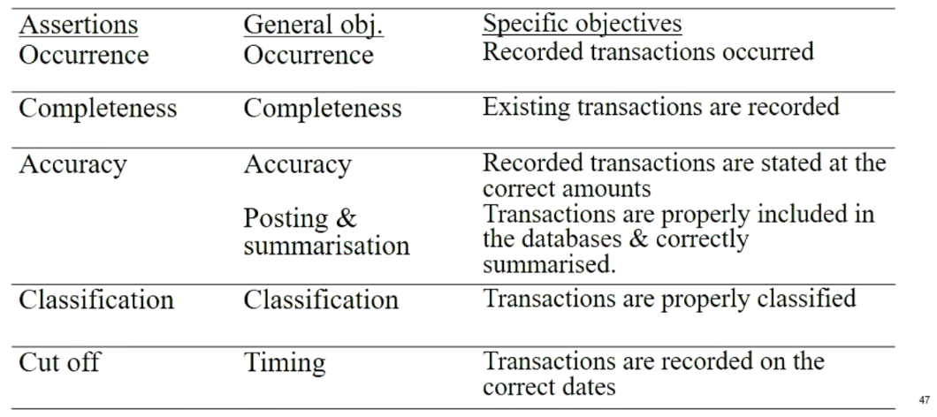
Transaction -related audit objectives

Balance-related audit objectives
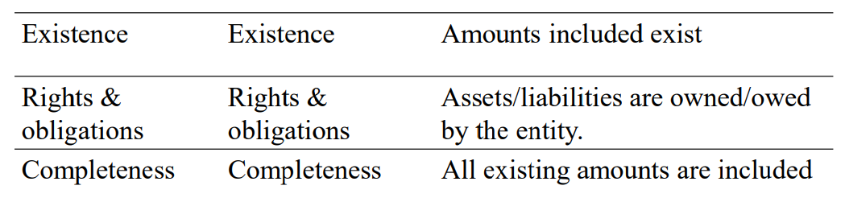

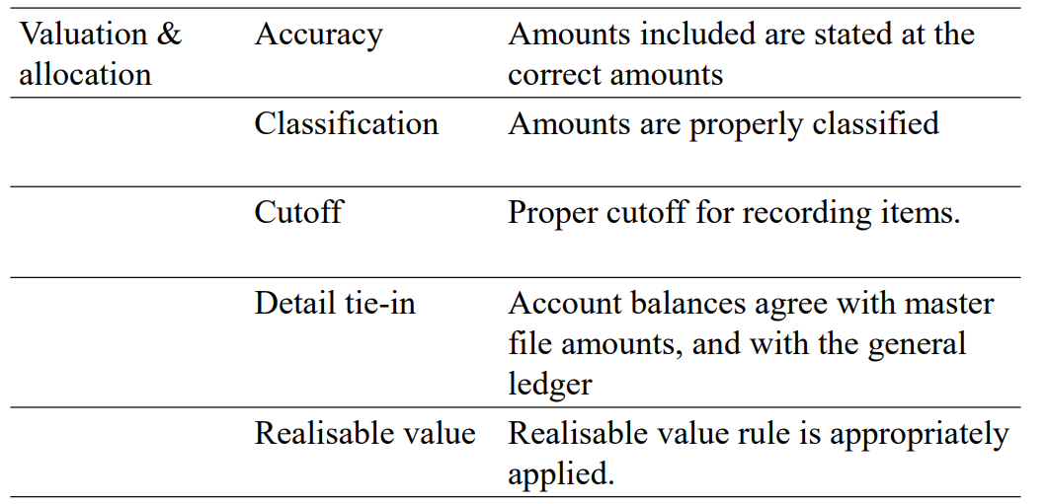

Summary
- Most audit reports are unmodified, in that the financial statements present fairly in accordance with accounting standards/laws & regulations.
- Modified reports are usually issued when there is a material misstatement or scope limitation. The nature and the materiality of the issue determine the type of audit opinion given.
- Auditor’s need to obtain reasonable evidence about the truthfulness of management assertions in the financial report.

Lecture 3: Corporate Governance, Audit Quality, Ethics & Independence
Outline
- Corporate Governance – External/internal audit & the audit committee
- Audit expectations gap
- Audit quality & Audit independence
- Independence: Ethical Standards
  - APES 110 Code of Ethics for Professional Accountants
    - Threats to independence & safeguards
Corporate Governance
- “The system by which companies are directed and controlled”
- Large corporate collapses have focused attention on weaknesses in corporate governance: Demand for greater accountability and transparaency.
- Boards, CEOs, Auditors, - all have faced strong criticism.
Corporate Governance: Serving client and public interests
- Corporate governance mechanisms:
  - Board of Directors
  - Audit Committee
  - Internal Auditors
  - External Auditors
Audit Committee
- The audit committee is an important function:
  - Monitors management
    - Has oversight responsibility for:
the outside reporting of the company;
    - Risk monitoring and control processes
    - Both internal and external audit functions
  - To operate effectively:
    - Ideally made up of independent directors;
    - Members with accounting and finance expertise
    - Meet frequently
  - Communication with auditors.
Internal Audit
- Can support and enhance the work of the audit committee.
- To help strengthen the independence of internal auditors:
  - The internal audit function should report directly to the audit committee.
  - The audit committee should be involved in hiring and firing the chief internal auditor.

Internal Audit & External Audit
- External auditors can rely on the work of internal auditors (with conditions). Before doing so, they should evaluate internal auditors’:
  - Organisational status
  - Scope of work
  - Technical competence
- External auditors should also test the work they plan to rely on to ensure that due professional care has been taken.
External audit & Audit failures
- Auditors are viewed by the public as trusted professionals in the provision of assurance services.
- Perceived audit failure due to problems with:
  - Audit independence
  - Audit quality
- Part of the problem is the expectations gap.
Audit Expectations Gap
- Auditors cannot guarantee that they can find all material misstatements / fraud
- Gap between auditor’s stated objectives and users’ perceptions as to the role of an audit.
- For example:
  - Belief that an unqualified audit report guarantees the accuracy of the financial report
  - There is no fraud or error
  - It is an opinion on the economy, efficiency and effectiveness of management
  - “true and fair” is not defined, hence public and professional expectations differ.
Components of the expectations gap
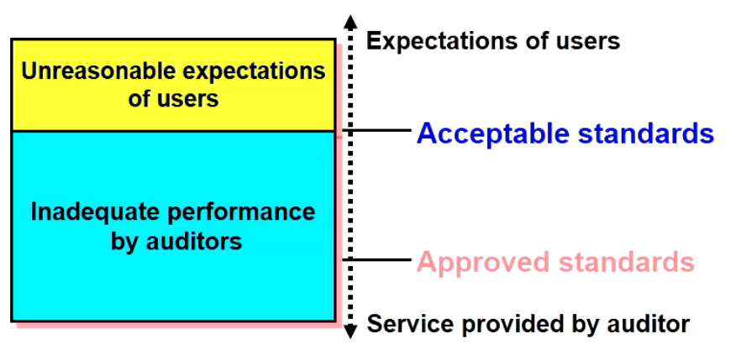

Audit Quality
- Audit quality is ensured through:
  - Certification/ continuing education
  - Auditing standards & regulations
  - Ethical requirements
  - Professional and firm standards
  - Quality reviews
  - Legal Liabilities
APES110 New Structure
- Part 1. Fundamental principles
- Part 2. Members in business
- Part 3. Members in public practice
- Part 4. Independence standards
  - Part 4A Independence for audit and review engagements
  - Part 4B Independence for assurance engagements other than audit and review engagements.
Ethics & professional independence
- Cornerstone of the auditing professions
- A distinguishing mark of the accountancy profession is its acceptance of the responsibility to act in the public interest
- I.e., responsibilities not only to the clients but to society at large.

Professional independence
- Sources of independence guidance
  - APESB – APES 110
  - AUASB/FRC
  - CLERP 9 (Corps law reform 2004)
  - ASX corporate governance principles & guidelines
  - International Ethics Standards Board of Accountants (IESBA)
General Standard of independence
- In all matters relating to the audit engagement, an indpeendnece in attitude is to be maintained by the auditor or auditors.
Independence of Mind
APES 110 s4300.5(a)
- Independence of Mind: the state of mind that permits the expression of a conclusion without being affected by influences that compromise professional judgement, thereby allowing an individual to act with integrity, and exercise objectivity and professional scepticism.
Independence in Appearance
APES 110 s4300.5 (b)
- Independence in appearance: The avoidance of facts and circumstances that are so significant that a reasonable and informed third party would be likely to conclude that a firm’s, or an audit team member’s, integrity, objectivity or professional scepticism has been compromised
APES110 Part 1 Fundamental principles
- Fundamental principles of ethics (Part A)
  - Section 111 – Integrity
    - Be straightforward & honest in all professional & business relationships
  - Section 112 – Objectivity
    - Not to compromise professional or business judgements because of bias, conflict of interest or undue influence of others.
  - Section 113- Professional Competence and Due Care
    - Attain and maintain professional knowledge and skill at the level required to ensure that a client or employing organisation receives competent professional activities, based on current technical and professional standards and relevant legislations and
    - Act diligently and in accordance with applicable technical & professional standards.
  - Section 114- Confidentiality
    - Respect the confidentiality of information acquired as a result of professional & business relationships
      - Be alert to the possibility of inadvertent disclosure … Including in a social environment
      - Not disclose confidential info. Without proper and specific authority, unless there is a legal or professional duty or right to disclose;
      - Not use confidential info. For the personal advantage of the member or a third party.
  - Section 115 – Professional Behaviour
    - Comply with relevant laws and regulations and avoid any conduct that might discredit the profession.
    - Shall not knowingly engage in any business, occupation or activity that impairs or might impair the integrity, objectivity or good reputation of the profession

Conceptual Framework (APES110 s.120)
APES 110 s120.2
The conceptual framework approach – 3 steps:
  - Identify threats to compliance with the fundamental principles
  - Evaluate the threats identified, and
  - Address the threats by eliminating or reducing them to an acceptable level
(the same framework applies to audit independence issues.)

Threats to Compliance/Independence APES110 s.120.6 A3)
  - Self-interest threat – the threat that a financial or other interest will inappropriately influence a Member’s judgement or behaviour
  - Self-review threat – the threat that a Member will not appropriately evaluate the results of a previous judgement made, or an activity performed by the Member, or by another individual within the Member’s Firm or employing organisation, on which the Member will rely when forming a judgement as part of performing a current activity.
    - E.g. if you worked on someone’s firm in an audit, and then revised their system, and came back the following year and found it was riddled with mistakes that you caused, you’d be less likely to own up to it
- Advocacy threat – the threat that a Member will promote a client’s or employing organisation’s position to the point that the Member’s objectivity is compromised
- Familiarity threat – the threat that due to a long or close relationship with a client, or employing organisation, a Member will be too sympathetic to their interests or too accepting of their work.
- Intimidation threat – the threat that a Member will be deterred from acting objectively because of actual or perceived pressures, including attempts to exercise undue influence over the Member.
Addressing the Threats (APES 110 s.R120.10)
- If the identified threats are not at an Acceptable Level, address the threats by eliminating them or reducing them to an Acceptable Level:
  - Eliminating the circumstances, including interests or relationships, that are creating the threats
  - Applying safeguards, where available and capable of being applied, to reduce the threats to an Acceptable level or
  - Declining or ending the specific Professional Activity

Safeguards – Examples
- Establish and enforce independence policies, e.g. identify threats/relationships between audit firm and assurance clients.
- Remove an individual from the assurance team.
- Rotation of senior personnel
- Prohibit individuals who are not members of an assurance team from influencing the outcome of the assurance engagement
- Additional quality review of audit work.
Independence for audit & review engagements APES 110 Part 4A
- Examples of specific independence issues:
  - Fees
  - Gifts & hospitality
  - Financial interests
  - Employment relationships
  - Business relationships
  - Family & personal relationships/long association
  - Non-assurance/non-audit services
Fees
- E.g. fee dependence
- Independence threats:
  - Self-interest, intimidation
- Apes 110.410: guidance & safeguards, e.g.
  - If audit fee > 15% of audit firm’s total fees for 2 consecutive years and the audit client is a public interest entity -> disclose to those charged with governance of the audit client and discuss the need for a pre-assurance/post-issuance engagement quality review by an auditor who is not a member of the audit firm or by a Professional Body.
    - Pre-issuance: before audit opinion is issued to client, this is issued to the client (regarded as more effective)
    - Post-issuance: you don’t do the review this year, you do it earlier next year, post this years audit
Gifts & hospitality
- Independence threats:
  - Self-interest, familiarity, intimidation
  - APES110. R420.3
    - A firm or an audit team member shall not accept gits and hospitality from an audit client, unless the value is trivial & inconsequential

Financial Interests
- E.g. equity/debt instruments
- Independence threat? Self interest threat
- Corps Act & APES110 (S.R510.4) ban audit firms, audit team members and their immediate family from having a direct financial interest or a material indirect interest in the audit client.
- Consider:
  - Role of the individual holding the financial interest?
  - Direct/Indirect Interest?
  - Materiality

Employment Relationships
- E.g. can an auditor be a director or officer of the audit client?
  - Independence threats:
    - Self interest, self-review, familiarity, intimidation
  - Corps act & APES (s.523, 524) prohibit an auditor form being a director/officer, or employee with significant influence over the preparation of accounting records/financial statements, of an audit client.
- Safeguards: Per legislation
  - Corporations Act:
    - Mandatory Cooling Off Period before former audit partner can be an officer of the client: -> 2 years for persons directly involve din the audit
Business relationships
- E.g. close business relationship between an auditor (and immediate family) and the audit client (including its management).
- Independence threats:
  - Self-interest, familiarity, intimidation
- Corps Act & APES110: Such relationships are prohibited unless insignificant to the auditor and the audit client.
- Safeguards = Rules in Legislation/Code of Ethics
Personal relationships/Long Association
- Family/personal relationships between the auditor & audit client’s director/officer/some employees;
- E.g. an immediate family member is a director/officer/key employee of an audit client:
- Independence threats:
  - Self-interest, familiarity, intimidation
- Safeguards:
  - Remove the auditor with the relationship from the team
  - Structure the affected auditor’s responsibilities to avoid dealings with the immediate family member. (APES 110.521.4. A4)
- Corps Act: Auditor rotation for listed companies (s.324DA-DD)
  - 5 years for individuals who play a significant role in the audit. 2 years cooling-off period for engagement partners.
- APES110.R540.5 and s.R540.11 For public interest entities:
  - Engagement partner: 7 cumulative years with 5-year cooling-off period.
- APES 110.R540.19.1 For listed entities where the law requires a 2 year cooling-off period, the cooling-off period shall be 3 years for periods beginning prior to 31/12/2023.
Non-audit services
- E.g. book-keeping, valuation/tax/internal audit services.
- Independence threats:
  - Self-interest, self-review, advocacy, familiarity, intimidation
- APES110.600: Detailed guidance for different types of services.
- Safeguards: Dependent on type of service
  - E.g., a separate division performs the work; extra engagement quality control reviews
- Corporations act:
  - Director’s declaration re. non-audit services & fees (s300.11A):
    - Disclose fees for non-audit services provided by the auditor, and
    - State whether the provision of non-audit services affected auditor independence.

Corps Act & CLERP 9: Other independence provisions
- Appointment & removal of auditors
- Duties, rights (access to info & assistance, reasonable fees) & qualified privilege
- Auditor’s independence declaration (s.307c)
- Obligation to report to ASIC s.311
- General independence requirements – conflict of interest situations
- Specific independence requirements – specific relationships.

Structure of answers for ethics questions
- State the Ethical issue, e.g. provision of non-audit services
- State the most important rules/regulations under Corps Act and/or APES 110
- Recommend Safeguards / the auditor’s course of action

Lecture 4 – Audit Evidence
Overview
- Audit procedures by purpose
- Audit risk model
- Sufficient pappropriate audit evidence
- Types of audit evidence
- Procedures to gain evidence
- Analytical Procedures

Audit Procedures & Evidence
The Auditor:
- Assesses the risks of the client company
  - ROMM (Risk of Material Misstatement)
- Perform audit procedures to collect audit evidence to test managerial assertions inherent in the financial statmeents
- In order to provide reasonable assurance/an opinion on whether there are material misstatement’s in the client’s financial statements
Internal Controls
Thing organisations do to
- Protect assets,
- Ensure accuracy of records/reports
- Help run operations effectively/efficiently
- Comply with rules/regulations
E.g physical/computer controls, separation of duties, proper authorisation.
Better Controls -> Lower ROMM.
Audit Procedures – by Purpose
- Risk assessment procedures – to obtain an understanding of the entity and its environment
- Test of controls – to test the effectiveness of internal controls in preventing, detecting or correcting material misstatements
- Substantive procedures – tests to detect material misstatements at the assertion level.:
    - Tests of transactions
    - Tests of details of balances
    - Substantive analytical procedures (not as effective as the former 2)

Audit Risk Model
AR = IR x CR x DR
- AR = Audit Risk = the risk of inappropriate audit opinion when financial report is materially misstatement
Risk Components
- IR = Inherent Risk = risk of misstatement in the absence of internal controls
- CR = Control risk = risk that internal control will not prevent or detect misstatement on a timely basis.
- DR = Detection risk = risk that audit testing will not detect misstatement

DR = AR/(IR x CR)

Audit Process: Assessing Risks
For each assertion of each transaction class/account balance:
- Set target AR
- Assess IR and CR (procedures to obtain an understanding/risk assessment procedures)
- Obtain DR allowed & determine audit strategy
- Choose appropriate audit procedures (tests of controls & substantive procedures) & prepare audit program
- Sample selection
- Perform audit procedures
- Evaluate evidence & form conclusions.

Audit Strategies
- From step 2: obtain preliminary assessment of control risk -> checking internal controls’ design effectiveness
- The assessed level of control risk affects the audit strategy & audit program (the design of the audit procedures to be carrier out)
- Predominantly Substantive Approach
  - If the preliminary assessment of CR is high
  - Design effectiveness of internal controls is poor
  - I.e. Internal controls cannot be relied upon
  - Perform tests of controls? No, waste of time. (no/very few testings of controls, due to their poor structure)
  - Extend of substantive tests to be performed: a large amount of
  - substantive testing is needed, as there is a high level of misstatement.

- Lower Assessed Level of Control Risk Approach
- If the preliminary assessment of CR is low:
- Design effectiveness of internal controls is good
- i.e. internal controls can be replied upon
- perform tests of controls: Yes, controls are good, so test them.
- Extent of substantive tests to be performed: depending on outcome of tests of control, if employees use the IC but make mistakes/ignore the IC, then more substantive testing will be needed. IF TOC (testing of controls) results confirm preliminary assessment of CR

Acceptable detection risk matrix
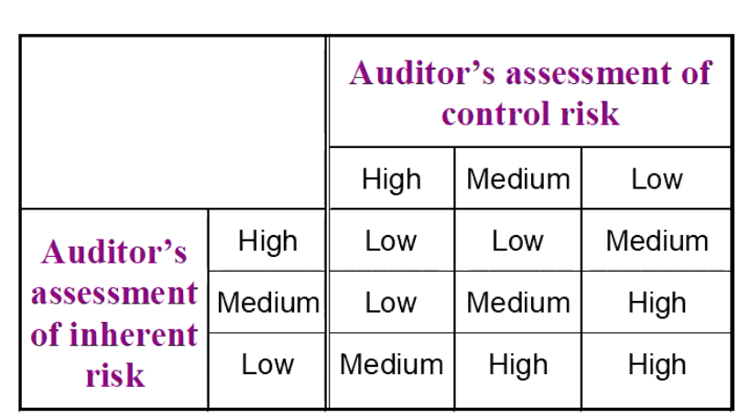
Audit Program
Example: Accounts payable
- General balance related objective -> completeness
- Specific balance related objective -> There are no unrecorded accounts payable
- Procedure -> Trace a sample of supplier’s invoices to the purchases/general journal & general ledger
- Type of evidence: -> Documentation

Audit evidence decisions
- Which audit procedures to use – Specific procedures (should be spelled out for instruction during the audit).
- Determine sample size for each procedure – Sample size (how many items should be tested for each audit procedure)
- Which items to select from the population – Items to select (determine which items in the population should be selected)
- When to perform the procedures? – Timing (can vary from early in the accounting to some time after it has ended)

Sufficient appropriate audit evidence (ASA500)
- Auditors are required to design and perform audit procedures obtain sufficient appropriate audit evidence to be able to draw reasonable conclusions on which to base the audit opinion
  - Sufficient = Quantity: how much information must be examined?
  - Appropriate = Quality: what type of information is used?
- The circumstances of the audit determine which evidence is sufficient and appropriate
- Need to obtain sufficient appropriate evidence for each assertion of each transaction class/account balance
- Generally, the auditor must rely on evidence which is persuasive rather than conclusive.
- Through professional judgement the auditor must determine what is sufficient and appropriate
- Constrained by time & cost
  - Usually less than 2 months after date, and budget constraints
Sufficiency of audit evidence
Affected by:
- Materiality of the account
- Risk of misstatement in the account
- Population size and characteristics
- Effectiveness of client’s internal controls
- Economic constraints
Appropriate of audit evidence
- Also called competence of evidence
- Competence is affected primarily by the relevance of the evidence and the reliability of its source
- This is broken down into 7 factors affecting competence
- It is a matter of the auditor’s judgement to weigh up these factors to determine how competent or reliable the evidence is.

Competence Considerations
- Relevance – must pertain to the audit objective being tested.
- Reliance:
      - Independence – evidence from outside the client is a stronger form of evidence.
      - Effectiveness of client internal controls – good internal controls can mean more reliable information
      - Auditor’s direct knowledge – auditor’s determinations are stronger than client’s comments
      - Qualifications – Qualifications of the source
      - Degree of objectivity – Objective evidence is stronger than subjective evidence.
      - Timeliness –
    - Balance sheet account evidence is better when it is collected around the date of the financial statement
    - Income statement evidence should sample the entire reporting period
Reliability of evidence
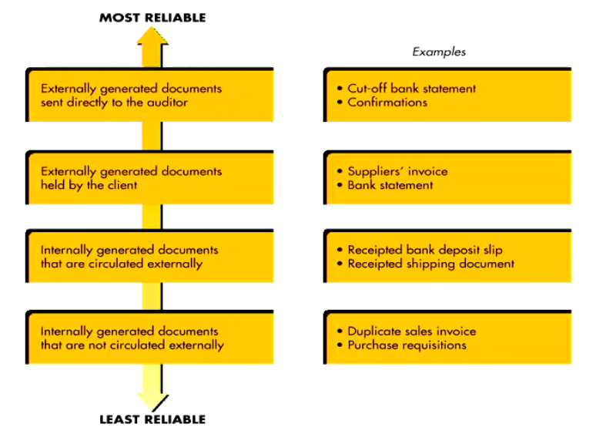

Audit Evidence – Overview
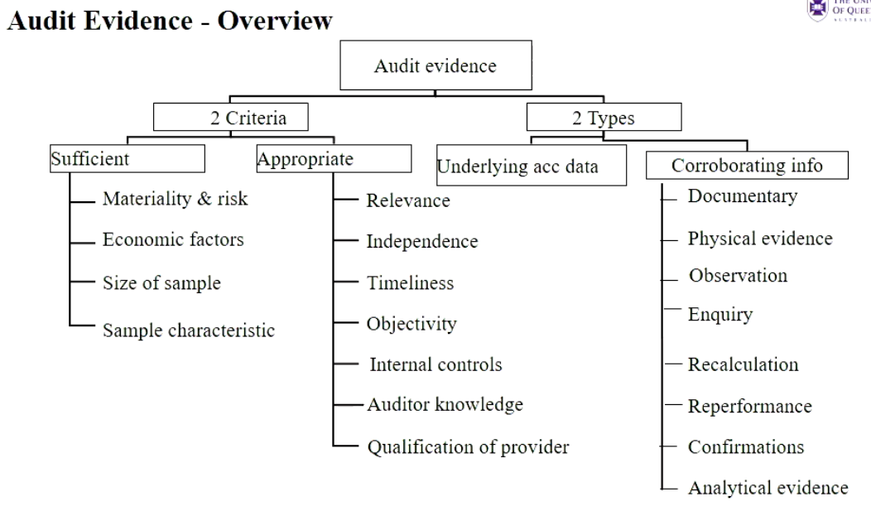

Types of audit procedures/evidence
Audit Procedures:
- Procedures to obtain an understanding of client.
- Tests of controls – Provide evidence about effectiveness of the design and operations of internal controls
- Substantive tests – provide evidence as to the substance of management’s financial statement assertions
Methods:
- Inspection – of documents
- Inspection – Physical examination
- Observation
- Enquiry
- External confirmation
- Re-calculation
- Re-performance
- Analytical procedures
Inspection – Documentation
- Auditor’s examination of the client’s documents and records to substantiate the information that is or should be included in the financial statements.
- Internal documents (e.g. duplicate sales invoices).
- External documents (e.g. bank statements).
Differences between tracing and vouching
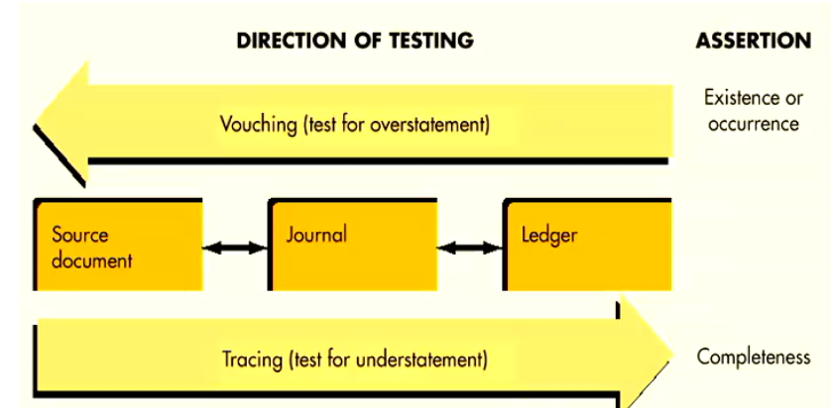
- Tracing is following the process of how it should’ve been recorded from source document to ledger
- Vouching is following the process in reverse, from ledger, to journal to source document.
Physical Inspection
- Inspection or count of a tangible asset.
- Usually associated with inventory and cash.
- Issues:
  - No help for rights and obligations.
  - Usually no real assistance for Valuation or NRV
  - Cannot be used if you don’t have training (e.g. valuating gems), for obvious things like fire/flood damage.

Observation
- The use of senses to assess certain activities
- Auditor may tour the premises.
- Observation is rarely sufficient – it is necessary to follow up initial observations with other kinds of corroborative evidence
- Issues:
  - Not reflective, if you’re observing someone do something, they’re more likely to do the right thing and comply with procedures. (you can try and do a surprise visit, but once they see the auditor, they’ll start doing the right thing)
Enquiries
- Enquiry consists of seeking information of knowledgeable persons, both financial and non-financial, within the entity or outside the entity.
- Range from formal written enquiries to informal oral enquiries
Enquiries of the client
- Enquiries of the client: obtain written or oral information from the client in response to questions from the auditor.
- Usually cannot be regarded as conclusive due to:
  - It is not from an independent source
  - May be biased in the client’s favour
- Highly useful, but low reliability.
External confirmations
- ASA500.A18: obtained as a direct written response to the auditor from a third party (the confirming party), in paper form or by electronic or other medium.
- Usually from an independent third party verifying the accuracy of information requested by the auditor
- Written confirmations are easier for supervisors to review.
- More costly to obtain
- Positive or negative confirmations
- Positive confirmations
  - Asks for response even if balance is correct
  - More reliable than negative confirmations
- Negative confirmations
  - Asks for a response only if the balance is incorrect
  - Uncertainty associated with no response.
- Need to specifiy whether it is a positive or negative confirmation
- More persuasive evidence is needed when there is a higher assessed risk of material misstatement.

Information often confirmed – Examples
- Cash in bank – Bank
- Accounts receivable – Customer
- Notes receivable – Maker
- Owned inventory on consignment – Consignee
- Inventory in public warehouses – warehouses
- Cash surrender value of life insurance – Insurance Company
- Accounts payable – creditor
- Notes payable – Lender
- Advances from customers – Customer
- Mortgages payable – Mortgagor
- Debentures payable – Debenture Holder
- Shares outstanding – Registrar and transfer agent
Re-calculation
- Checking the mathematical accuracy of documents or records.
- May be performed manually or electronically (audit software)
- Essentially just adding shit up to make sure it is accurate.
Re-performance
- Auditor’s independent execution of procedures or controls
- Example: Depreciation, ageing of accounts receivable, testing computer controls
- Used when it is more complex than Re-calculation and the activity needs to be redone to confirm the outcome
Analytical Procedures ASA 520
- Evaluations of financial information through analysis of plausible relationships among both financial and non-financial data
- Used at all stages of an audit.
Analytical procedures – Benchmarks
Compare client data with:
- Industry data
- Prior-period data
- Client determined expected results
- Auditor determined expected results
- Expected results, using non-financial data
Analytical procedures – Purposes
- Assist in understanding the client’s industry/business and in the going concern assessment.
- Help identify potential misstatements (help identify areas to concentrate audit investigation)
- Help reduce substantive tests of details
- Help assess going concern.

Purposes 2 & 3:
- Help detect areas with potential material misstatement, for example, if analytical procedures indicate unusual fluctuation/patterns
- If analytical procedures reveal no unusual fluctuations, the possibility of a misstatement is reduced and the auditor can reduce the amount of substantive testing.
Use of analytical procedures
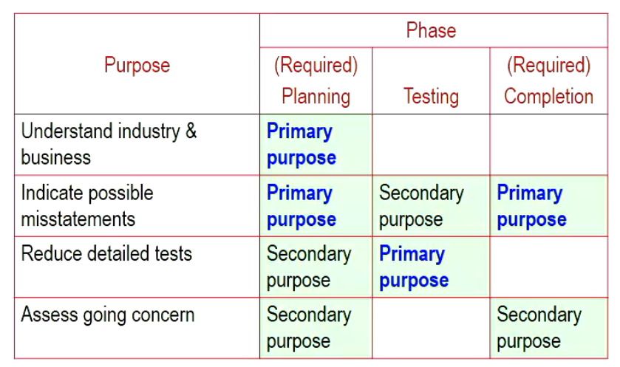
Summary
- The audit risk model is used to help the auditor develop audit strategies and design audit procedures.
- The auditor needs to use professional judgement to choose suitable audit procedures to obtain sufficient and appropriate audit evidence in order to form an opinion on the financial statements.
- Sufficiency relates to amount and appropriateness relates to relevance + reliability.
Terms and types of evidence
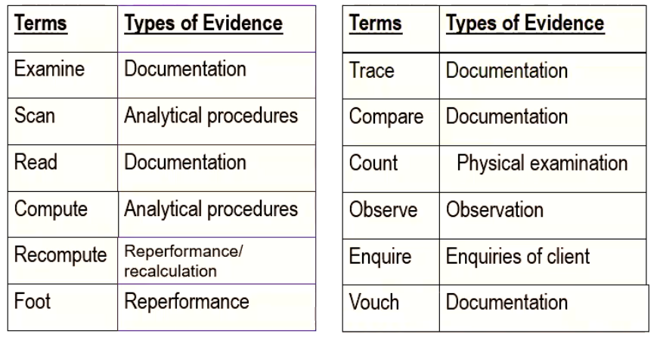
Profitability Ratios
Earnings per share:
- Net Income / Average commons shares outstanding
Gross Profit Percent:
- (Net Sales – COGS) / Net Sales
Profit Margin:
- Operating Income / Net Sales

Given Ratios in Exam, however need to know how to interpret them.

Lecture 5: Audit Planning
Overview
- Audit Planning – first 4 steps:
        - Accept the engagement
        - Obtain an understanding of the client’s business & industry
        - Assess client’s business risk
        - Perform preliminary analytical procedures
    - This is like, ratio analysis and shit
- Audit Documentation

Audit Planning: Introduction
- Auditors shall plan the audit so that it will be performed in an effective manner (ASA 300.4).
- Reasons for planning and audit properly:
- To gain a clear understanding of the client, to enable the auditor to obtain sufficient appropriate evidence;
- To ensure a cost-effective audit
- To avoid misunderstandings with client.

Audit Planning – Purpose
- Recall: AR = IR * CR * DR
- Main purpose of audit planning is to assess:
- Acceptable (desired) audit risk = how willing is the auditor to accept an inappropriate unmodified audit opinion after the audit is lone
    - Lower audit risk -> Lower risk of an inappropriate audit opinion
- Inherent risk = likelihood of material misstatements before internal controls are applied
- Also helps assess control risk

Planning an Audit and designing an approach
- Accept client and perform initial audit planning
- Understand the client’s industry and business
- Assess client business risk
- Perform preliminary analytical procedure
- Set materiality and assess acceptable audit risk and inherent risk
- Understand internal control and assess control risk
- Gather information to assess fraud risk
- Develop overall audit plan and audit program
Some of these steps may happen concurrently

Step 1: Accept client & perform initial planning
- Accept new client/continue with existing client – Acceptable audit risk
  - Quality control standard requires the engagement partner to be satisfied that engagement practices have been followed and documented.
  - Evaluate client – New or continuing engagements
  - Factors to Consider (ASA 220.A8):
  - Integrity of management
  - Auditor’s competence & capabilities
  - Ethics & independence
  - Significant matters arising from current/previous audit.
Step (1a) Evaluate integrity of management
- Communicate with previous auditor
- Investigate the client’s business & financial standing:
- If managers aren’t good, then litigation risk/overall risk goes up and therefore you do not want to engage with these clients -> AVOID them, you will be blamed by shareholders/creditors
  - Inside information – e.g. financial statements
  - Outsiders – e.g. bank, solicitor, industry peers.
  - Publicly available information - e.g. internet/database search
- Review previous experience (if it is a continuing appointment).
Step (1b & c) Competence & Independence
ASA 220, ASQC 1.A18
- Knowledge of relevant industries or subject matters
- Experience with relevant regulatory or reporting requirements, or ability to gain necessary skills/knowledge effectively;
- Sufficient personnel with necessary competence & capabilities;
- Experts are available, if needed:
- Personnel for quality review are available
- Able to complete the work within deadline.

- Identify the reasons for the audit
  - In most cases, the audit is conducted as it’s required by law for disclosing entities.
  - Identify users
    - Two major factors affecting acceptable audit risk are likely statement users and their intended uses of the statements. More evidence may be necessary when the statements are to be used extensively.
  - Discuss with management
    - The most likely uses can be determined from previous experience with the client and discussion with management.

- Obtain mutual understanding with the client about the terms of engagement (ASA 210 – Engagement letter)
  - Purpose
    - Confirm terms of the engagement
  - Effect
    - Legal contract between auditor and client
  - Content:
    - Identification of the entity and the financial report to be audited.
    - Objectives of the audit
    - Reference to professional standards and statutes.
    - Directors/Management’s responsibilities
    - Auditor’s responsibilities
    - Limitations of the audit
    - Advice that files may be subject to quality control review
    - Basis of fee
    - Acceptance by client

- Select staff for the engagement & evaluate need for outside specialists (ASA 62)
  - Staff competence & compliance with ethical requirements.
  - ASA 220 – the engagement partner takes responsibility for the team
  - May need to consult a specialist:
    - ASA620 The auditor isn’t an expert in anything, but should know enough about the business to know when expertise is required.
  - Auditor should evaluate the specialist’s qualifications and understand the objectives and scope of their work
  - Auditor should also consider specialist’s relationship to client that may impair objectivity.

Step 2: Understand the client & industry
- Industry and external environment
- Business operations and processes including related parties ASA 550
- Management and governance – i.e control environment
- Objectives and strategies
- Measurement and performance
ASA315.11 Auditor shall obtain an understanding of:
- Relevant industry, regulatory and other external factors & the applicable financial reporting framework.
- The nature of the entity (operations, ownership / governance structures, investments & financing)
- Entity’s selection & application of accounting policies (including reasons for changes).
- Entity’s objectives & strategies.
- Measurement & review of the entity’s financial performance.
Step 2(a) Industry and Environment
- Risks specific to a client & its industry.
- Effect of external factors/economic conditions on the client
- E.g.
  - Unique accounting requirements
  - Regulatory requirements
  - Competition
  - Recession/drought/flooding
Step 2(b) Business operations & processes
- Understand factors such as major sources of revenue; key customers & suppliers; sources of financing; areas with higher business risk.
- Tour the premises and offices to better understand client operations and meet key personnel.
- Identify related parties ASA550 – disclosure requirements & higher inherent risk of misstatements. The auditor must consider the risk that related party transactions are not identified/disclosed (para. 6 & 15)
Step 2(b) Related Parties
- Related parties include an affiliated company, a principal owner of client, and others who can influence the management or operating polciies of the client.
- “Related party” in Corps Act means
  - Director
  - Spouse, parents & children of directors
  - Entity that controls/ Entity controlled by client
- Related party transactions must be disclosed by the audit client in the financial statements.
Step 2(c) Management and Governance
- Also called the control environment
- Formal processes of governance and control:
- 7 Features (covered in Lecture 7)
- Integrity and values
- Commitment to competence
- Participation by those charged with governance
- Management’s philosophy & operating style
- Organisational structure
- Assignment of responsibilities
- HR policies and practices.

Step 2(d) Objectives and Strategies
- Objectives are the overall plans for the entity
- Strategies are managements approaches to achieve the objectives.
- The auditor needs to understand the objectives related to:
- Reliability of financial reporting
- Effectiveness & efficiency of operations
- Compliance with laws & regulations

Step 2(e) Measurement and Performance
- The auditor reviews performance of the entity, according to what management sees as the KPI’s
- Bear in mind that performance measures can create pressures on management & employees to achieve them – e.g., creating incentives to manipulate financial information to look like the performance goals have been achieved.

Step 3. Assess client business risk
- Client business risk is the risk that the client entity will fail to achieve its corporate objectives.
- Management is the primary source of info. About business risk.
- Understand client’s business and industry -> Assess Client business risk -> Assess risk of material misstatements

Step 4. Preliminary analytical procedures
- At the planning stage, analytical procedures assist in risk assessment when obtaining an understanding of the entity.
- Comparison of client ratios or data to benchmarks *e.g. prior periods, industry, competitors, management/auditor’s expectations) provides an indication of the client’s performance/liquidity/financial stability etc.
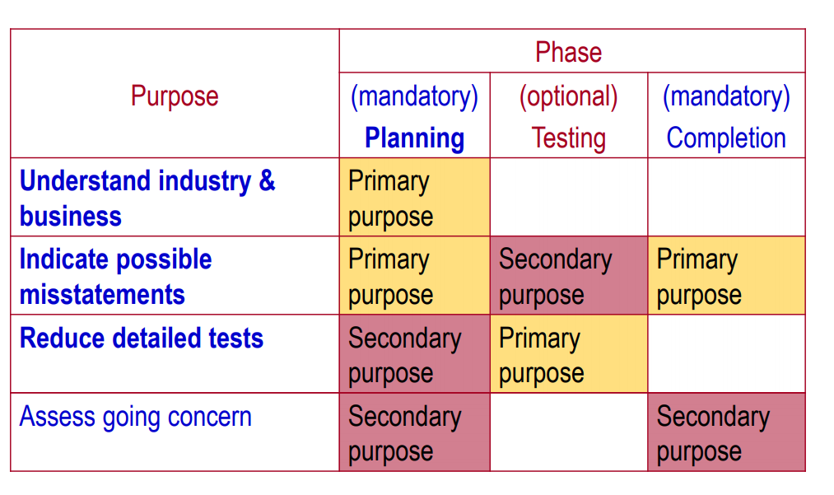
Recall – use of analytical procedures

Analytical Procedures
- Planning stage: mandatory -> Risk assessment – obtaining an understanding of the client.
- During the audit: optional -> As part of substantive procedures.
- End of the audit: Mandatory -> Overview & help form an overall conclusion as to whether the financial report is consistent with the auditor’s understanding of the entity.
Audit documentation (ASA 230)
- ASA230.8 – The auditor shall prepare audit documentation that is sufficient to enable an experienced auditor, having no previous connection with the audit, to understand:
  - The nature, timing & extend of audit procedures performed to comply with Auditing Standards & applicable legal/regulatory requirements;
  - The results of audit procedures & audit evidence obtained; and
  - Significant matters arising from the audit, conclusions reached, and significant professional judgements made.
Audit Documentation: Functions
- Basis for planning & performing the audit.
- Record of evidence accumulated.
- Evidence of work performed to support audit opinion.
- Basis for review by audit supervisors/partners & quality review
- Enable the engagement team to be accountable for its work
- Retain a record for of matters of continuing significance to future audits.
- Basis for preparing other records not related to audit, e.g. tax returns
Audit documentation: Contents and Organisation
- Two types of audit documentation:
- Permanent audit file – contains data of a historical or continuing nature pertinent to the current audit.
- Current audit file.
Permanent audit file
- Information in permanent file – Related to:
  - The client entity, e.g.
    - Extracts of key company documents
    - Description of activities, structure
  - The audit, e.g.,
    - Important analysis from previous years
    - Details of internal control systems and assessment of control risk
    - Results of previous analytical procedures

Current Audit file
- Including:
  - Audit program
  - General info & planning
  - Working trial balance
  - Schedules trial balance
  - Schedules and analyses
  - Adjusting and reclassifying entries
Audit Documentation: Ownership and custody
- Audit documentation is the property of the auditor
- At the completion of an engagement, the auditor retains the audit documentation and computer files for future reference (7 years)
- The auditor is responsible for adopting appropriate procedures for maintaining the confidentiality of working papers
- Ordinarily, the working papers can be provided to someone else only with the express permission of the audit client
- Exceptions to confidentiality restrictions: Quality reviews or legal requirements.

Lecture 6: Risk and Materiality
Overview
- The 5th and 6th stage of audit planning
- Set materiality levels
- Apply the Audit risk model:
  - Set AR, Assess IR & CR, Obtain DR → Determine the amount of work/evidence needed.
- Understand internal controls – Introduction
- Next topic – seventh and eight stage
  - More on internal control and assessment of control risk, fraud risk, overall audit plan and program
Materiality (5th stage of audit planning
- Stage 5. Set materiality and assess acceptable audit risk and inherent risk
- The important of “materiality”
- Auditor’s responsibility & in reports (ASA700)
  - To provide reasonable assurance whether the financial report is free of material misstatement

- Definitions
  - Information which if omitted, misstated or not disclosed separately has the potential to adversely affect decisions… made by users”
  - “Misstatements, including omissions, are considered to be material if they, individually or in the aggregate, could reasonably be expected to influence the economic decisions of users taken on the basis of the financial report”

- Asa320.4
  - A matter of professional judgement. Affected by auditor’s perception of financial statement users’ common information needs.
- Asa320.5&6 Materiality considered when:
  - Planning the nature, timing and extent of audit procedures;
  - Performing the audit & determinising whether further audit procedures are required;
  - Evaluating the effect of misstatements.

Quantitative factors
- Auditor selects benchmarks appropriate for an entity- either dollar amount or percentage.

Qualitative factors
- Significance of misstatement to the entity.
- Pervasiveness of the misstatement.
- Effect of misstatement on the financial report as a hole
- E.g. in a multimillion dollar company, they might have $5 losses regularly, on the face of it, it’s not material, however if it was the same cashier, this may be of significant as an indicator of fraud/incompetence

Materiality: Quantitative Guidelines
How to establish a preliminary estimate of materiality
- Use latest available financial information and knowledge of the client.
- Predict when accounts are likely to be misstated.
- Consider AASB 1031:
  - As per aasb1031: the follow applies
  - Amount >10% of base amount → It is Material
  - Amount <5% of base amount → it is NOT material
  - Between 5 and 10% of base amount → Requires individual judgement
  - THIS IS JUST A GUIDELINE, DOES NOT ALWAYS WORK.
    - Take for example Enron, the auditor’s that audited Enron did not report a $1billion discrepancy and argued that due to it being under 5% of the net companies assets, it was not relevant, however due to a reasonable and normal person. $1billion is still a large amount and was found to be material.

Quantitative Guidelines: Materiality at the Financial Statement Level
- The following are illustrative of some guidelines used in practice:
  - 5% to 10% of net income before taxes (10% for smaller incomes, 5% for larger ones)
  - ½% to 1% of total assets
  - 1% of equity
  - ½% to 1% of gross revenue
  - A variable percentage based on the greater of total assets or revenue
Materiality Levels
3 Levels of materiality (ASA320.9 & 14)
- Financial statement level (the financial report as a whole)
- Assertion Level (materiality levels for classes of transactions, account balances or disclosures)
- Performance materiality – the amount(s) set at less than materiality to reduce to an appropriately low level the probability that the aggregate of uncorrected & undetected misstatements exceeds the materiality determined for (1)or (2) above (ASA320.9).
- If margins for error are very close, additional tests can be conducted to provide certainty. (e.g. if benchmark is 50k, and you get 49k materiality)

Steps in applying materiality
- Set preliminary judgement about materiality (for financial statements as a whole)
- Allocate preliminary judgement about materiality to segments
Step 1 and 2 is Preliminary extend of tests
- Estimate total misstatement in segment
- Estimate the combined misstatement
- Compare combined assessment with preliminary or revised judgement about materiality
Step 3,4,5 is Evaluating Results
Step 1: Preliminary Judgement about materiality
Preliminary judgement about materiality (also called preliminary assessment of materiality):
- The maximum amount by which the auditor believes the financial statements could be misstated and STILL NOT affect the decisions of reasonable users
- This decision is made early in the audit
- May be revised during the audit →
  - Revised judgement of materiality?
Step 2: Allocate preliminary judgement of materiality to segments
- When the auditor’s preliminary judgements about financial statement materiality are quantified, a preliminary estimate of materiality for each account may be obtained by allocating financial statement materiality to the individual accounts.
- An allocation is necessary because evidence is accumulated by segments rather than the financial statements as a whole
- The materiality allocated to account balances is known as the tolerable misstatement (also called tolerable error)
- The allocation may be made to both balance sheet and income statement accounts (but be careful to avoid double-count)
- Most practitioners allocate materiality to balance sheet rather than income statement accounts because most income statement misstatements have an equal effect on the balance sheet due to the double-entry book keeping system.
- In making the allocation consider:
  - The likelihood of misstatements in the accounts.
    - Auditors expect certain accounts to have more misstatements than others.
    - Both overstatements and understatements must be considered
  - The account balance size
  - The probable cost and level of difficulty of verifying the account.

Materiality at the Assertion Level
- Account balance materiality is the maximum misstatement that can exist in an account balance before the account is considered materially misstated.
- Misstatement up to that level is known as tolerable misstatement (tolerable error)
- The concept of materiality at the account balance level should not be confused with the term material account balance - the two have opposite relations with the amount of audit evidence required.
Relationship between materiality and audit evidence
- It is generally correct to say that the lower the materiality level, the greater the amount of evidence needed
- It is also generally correct to say that the larger or more significant an account balance is, the greater the amount of evidence needed.
Step 3: Evaluate Results
- Auditor keeps a record of all errors found.
- In evaluating the financial report, consider errors individually and in aggregate.
  - Known misstatements – auditor can determine the amount of misstatement in the account.
  - Likely misstatements:
- Misstatements due to disagreement in judgement between auditor & management
- Projected misstatements (when sampling is used).
- Use materiality to evaluate audit findings:
  - Use actual errors to make a direct projection to estimate misstatement.
  - Estimated total error = Projected error (based on actual error) +/- sampling error
  - We can’t say that a single misstatement is immaterial → need to look at how many misstatements accumulate in the account.
Assessing Risks
- Need to assess the following risks when forming an audit strategy/program
  - Audit Risk
  - Inherent Risk
  - Control Risk
- Note: Risk factors may be pervasive/general or specific to certain assertions of certain accounts/transaction-classes.

Audit Risk
- Audit risk should be kept, low due to the following factors
  - Reliance by external users
    - When external users place heavy emphasis on the financial statements, acceptable audit risk should be kept low. The following generally results in more users of the financial statements:
      - Larger clients
      - Publicly held corporations
      - Extensive use of liabilities
  - Likelihood of financial failure
    - There is a greater chance of having to defend the quality of the audit when there is a financial failure. Failure indicators include:
      - Shortage of funds
      - Declining net income or continued losses
      - Risky industries such as technology
      - Management lacking competency to deal with financial difficulties
  - Integrity of management
    - If a client has questionable integrity, the auditor is likely to assess acceptable audit risk lower. Indications of integrity problems include:
      - Frequent disagreements with prior auditors & regulators
      - Frequent turnover of key financial and internal audit personnel.
      - ongoing conflicts with labour unions and employees.
Some factors affecting assessment of inherent risk
- Industry factors – economic and competitive conditions
  - If industry is doing well, lowers IR due to managers having no incentive to manipulate records to display good results
  - If industry is not, there is a higher IR due to the company wanting to do well, managers may manipulate records.
- Nature of the audit client’s business
- Integrity of management
- Audit client motivation – e.g., management incentives
- Results of previous audits – errors in previous audits likely again
  - Results from previous audit, tell you if company has a good/bad accounting system.
- Initial versus repeat engagement – inherent risk drops as experience grows
  - In initial year, IR and CR would be set at a higher level to be vigilant
  - In repeat years, it would be lower as you have familiarity with the client
- Related parties – possibility of transaction not at arms-length & not disclosed adequately.

- Non-routine transactions – transactions which are unusual in nature are more likely to be recorded incorrectly
  - Things that don’t happen often, have a higher IR associated with them
- Judgement required for correct recording, e.g. accounting estimates.
- Makeup of the population
  - If you have inventory with one type of inventory, very straightforward
  - With a company that sells 1000+ things it becomes much more complicated therefore higher IR
- Susceptibility to fraudulent financial reporting
- Susceptibility to misappropriation of assets
- Other factors, e.g., IT changes, Litigation, legal environment for the entity, country factors.
  - Any major changes that would affect pretty much anything about the company also affect the IR of the audit engagement.
Assess Control Risk
- Control risk is the risk that a material misstatement could occur in an assertion, and that it will not be prevented, or detected and corrected on a timely basis by the entity’s internal controls.
- Control risk directly affects the audit strategy and thus affects (1) the mix of TOC and substantive tests, and (2) the amount of evidence required.
- Control risk is inversely related to planned detection risk.
  - Like IR, CR is also inversely related to detection risk. Therefore, the higher the IR lower the allowable detection risk
Obtain allowable detection risk
- Planned detection risk is the risk the auditor is willing to take that audit evidence for a segment will fail to detect a misstatement that exists in an assertion that could be material
- It is dependent on the other three forms of risk and has an inverse effect on the amount of evidence required.
Control risk assessment & control related tests
- Risk assessment procedures (to evaluate control environment + design effectiveness)
- Form preliminary assessment of control risk
- Choose audit strategy:
  - Predominantly substantive approach
    - This means, everything is shit and just test everything
  - Lower assessed level of control risk approach
- Perform tests of control (TOC) (Operational effectiveness) if necessary.
- Control test results help determine the extent of substantive testing needed.

Control related tests vs substantive tests
Need to understand this bit very well
- Control related tests (risk assessment procedures + tests of control)
  - Only check that IC are designed well, give no info on financial statements (aka no direct evidence) never good enough by themselves
  - Provide evidence on control environment t& internal controls.
  - Not direct evidence on whether misstatements actually exists.
- Substantive procedures
- Provide direct evidence on financial statement misstatements
- Dual-purpose tests

Lecture 7: Internal Control & Fraud
Overview
- 6th to 8th stages of audit planning
- Step 6. Understanding internal control (IC)
- Components
- Procedures for obtaining an understanding of IC & documenting IC
- Preliminary assessment of control risk
- Tests of control
- Step 7. Assess Fraud Risk
- Step 8. Overall audit plan and program

Internal Controls – Control risk & Fraud Risk
- ASA315.3: The objective of the auditor is to identify and assess the risks of material misstatement, whether due to fraud or error, at the financial report and assertion levels, through understanding the entity and its environment, including the entity’s internal control, thereby providing a basis for designing & implementing responses to the assessed risks of material misstatement.
Definition of Internal Control
- A process, effected by an entity’s board of directors, management, and other personnel, designed to provide reasonable assurance regarding the achievement of objectives in the following categories:
- Reliability of financial reporting
- Compliance with applicable laws and regulations
- Effectiveness and efficiency of operations (also protection of assets)

Understanding Internal controls & Assessing control risk
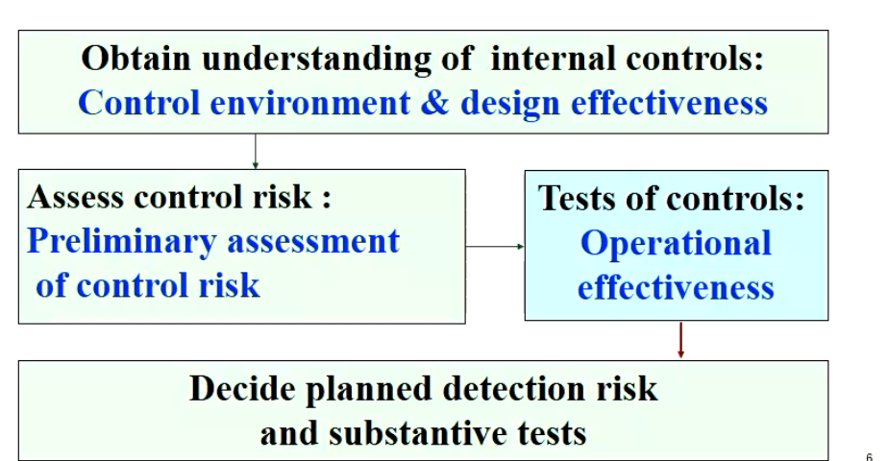

Audit Planning Step 6: Obtain and understanding of ICS
- Step 1. Components of ICS (Internal Control Structure)
- Step 2. Procedures for obtaining an understanding of IC & Documenting IC
- Step 3. Preliminary assessment of control risk
- Step 4. Test of Control
Internal Control Structure
5 Component so the ICS
- The control environment
- The entity’s risk assessment process
- The information system
- Control activities
- Monitoring of controls

Control Environment
ASA 315.A77
- Control environment includes the governance & management functions and the attitudes, awareness, and actions of those charged with governance and management concerning the entity’s internal control and its importance in the entity
- The control environments sets the tone of an organisation, influencing the control consciousness of its people
- Communication & enforcement of integrity & ethical values.
  - To enforce & communicate ethical values:
    - Communication of behavioural standards by codes of conduct and example:
      - E.g. let employees know that dishonesty or unprofessional behaviour will not be accepted
- Commitment to competence.
  - Management’s consideration of the competence levels for specific jobs and how those translate into requisite skills and knowledge
  - Effect on risk of misstatement due to errors
- Participation by those charged with governance.
  - The board/audit committee delegates responsibility for IC to management and is charged with regular independent assessments of manage-established IC
- Management’s philosophy and operating style.
  - Management, through its activities, provides clear signals to employees about the importance of IC, e.g., attitude toward risk management/financial reporting
    - E.g. Unrealistic sales targets.

- Organisation structure.
  - Understanding the client’s organisation structure provides the auditor with an understanding of the client’s business functions and the effectiveness of the IC system
    - E.g. Lines of reporting
- Assignment of authority & responsibility.
  - Clear definition of responsibility & accountability for staff.
    - E.g. Employee job descriptions
    - Clearly allocate responsibilities to each employee, so they cannot shirk/blame other people. If there is ambiguity, employees can state that they were unaware of what was required of them
- HR policies & practices.
  - Methods by which persons are hired, trained, promoted and compensated are important elements of IC
  - If employees are honest, trustworthy and competent, other controls can be absent and financial statements will still be reliable.
Entity’s Risk Assessment
- Risk assessment here is the audit client’s identification and analysis of risks in relation to the achievement of business objectives.
- It forms a basis for risk management by the audit client
  - e.g. financial reporting risks → affects ICS design & implementation
Understanding the information system
ASA315.18
The auditor shall obtain an understanding of the information system relevant to financial reporting, including the following areas:
- identify significant classes of transactions
- Procedures & records – how transactions are initiated, recorded, processed, corrected & reported
- How the info system captures significant events & conditions (other than transactions) relevant to the financial report.
- The financial reporting process. E.g. Accounting estimates & disclosures
- Controls surrounding journal entries, including for non-recurring, unusual transactions or adjustments
Control Activities
- Authorisation (= proper authorisation)
  - Transactions approved by people with the right authority
    - General authorisation is permissible for routine events for which there are policies to follow
    - For some transactions specific authorisation is needed on a case-by-case basis.
- Performance reviews (independent checks/proper supervision)
  - Supervision of operation by managers or senior/other staff
  - Personnel are likely to forget or intentionally fail to follow procedures, or they may become careless unless someone observes and evaluates their performance
- Information processing
  - General Controls – computer system as a whole, hardware systems, software acquisitions, security re. access, maintenance, backup and recover
  - Application controls – applies to the processing of specific types of transactions, e.g., invoicing customers, so application controls will differ for each transaction cycle
    - Input controls
      - E.g. pull-down list, reasonableness test, validation test (against master files)
    - Processing controls
      - E.g. validation test (correct master files), sequence test, arithmetic accuracy test, data reasonableness test, completeness test.
    - Output controls
      - E.g., manual review of exception reports.
- Physical controls (also documents & records)
  - Limit access to important assets and records
  - Physical control over assets: e.g., physical security and access.
  - Documents & records:
    - Pre-numbered documents so missing items are noticed (sales invoices, cheques etc...) – checking for completeness management assertion
    - Good design instructions and appropriate spaces
- Segregation of duties
  - Ensures that individuals do not perform incompatible duties.
    - Separation of the functions of authorisation, custody and recordkeeping.
    - Separating IT duties from User departments
    - Separate
      - Custody of assets from accounting
      - Authorisation of transactions from custody of related assets
      - Operational responsibility from record-keeping responsibility
      - It duties from user departments
    - This will help eliminate collusion and fraud

Monitoring
ASA315.A110
- The audit client needs to have a process to:
  - Assess effectiveness of internal controls on a timely basis
  - Take remedial action
Limitations of IC
- Internal controls can only provide reasonable assurance due to limitations such as:
  - Management override
  - Collusion amongst employees
  - Non-routine transactions
  - Breakdowns – carelessness, distractions
  - Mistakes in judgement
  - Changes in operations/conditions
  - Cost vs benefit – How much IC
Audit Planning: Obtain an understanding of client’s IC structure
Step 1 & 2 at the planning stage:
Obtain an understanding of the ICS & Form a preliminary assessment of control risk, which determines the audit strategy ify:
- CR is set to maximum → predominantly substantive approach → no/very few tests of controls
- CR is lower than maximum → lowered assessed level of control risk approach → perform test of controls
Step 3: Perform TOC (and revise control risk assessment if necessary) to determine planned level/nature of substantive testing. Greater reliance on IC → Less substantive testing.
- IF TOC results show control risk is the same or lower than the preliminary assessment → Can REDUCE substantive tests as planned
- If TOC results show CR is higher than the preliminary assessment → Need to INCREASE planned level of substantive testing
- Also consider the cost of substantive testing.

Assessment of CR: Steps
- Identify transaction -related audit objectives
- Identify specific controls
- Identify and evaluate weaknesses
  - Existing controls
  - Absence of key controls
  - Compensating controls
Documentation of ICS
- The auditor is required to document the understanding of internal control structure:
  - Questionnaires – series of questions about accounting and control policies and procedures
  - Flowcharts – schematic diagram using standardized symbols.
  - Narrative memoranda – supplementary summary of auditor’s understanding of the ICS.
Tests of Controls
- Provide evidence as to the operational effectiveness of internal controls.
- Auditors should report material weaknesses in IC to management
Design Tests of Controls
- Nature e.g.,
  - Enquiry of personnel,
  - Observing activities
  - Inspection of documents
  - Re-performance of control procedures.
- Extend
  - Lower assessed level of control risk → more extensive control testing required to confirm the assessment of control risk.
- Timing
  - Interim VS. End year
  - Responsibility to make control risk assessment for the whole period of the audit.
  - How much additional testing should be carried out close to year-end depends on:
    - Length of remaining period
    - Significant changes in controls
    - How much substantive testing was carried out before year-end
Evaluate Results
- Asses the rate (frequency) / cause / disposition of deviations.
- Consider both quantitative/qualitative aspects
- Revise audit program?
Fraud Defined ASA240.2-3
Step 7. Assess Fraud Risk
- Fraud – intentional act … involving the use of deception to obtain an unjust or illegal advantage.
- Two types of misstatements relevant to fraud
  - Fraudulent financial reporting
  - Misappropriation of assets.

Fraud Triangle
- In order for fraud to take place, all 3 elements of the triangle must take place.
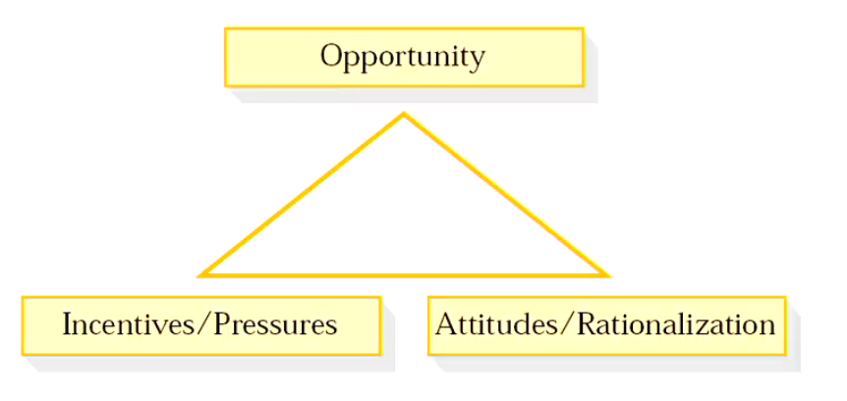
Auditing for Fraud ASA240
- Professional Scepticism ASA 240.12-14
- Discussions among the engagement team
  - Emphasis on how/where the financial report may be susceptible to material misstatement due to fraud (ASA240.15)
Risk assessment procedures (ASA 315 & ASA 240)
- Inquiries of Management
- Consider fraud risk factors, e.g.,
  - Need to meet 3rd party expectations, e.g., financing
  - Targets for bonuses
  - Ineffective control environment
- Consider unusual or unexpected relationships (ASA 240.22)
- Consider other information (ASA 240.23)
Responding to the risk of fraud
- Change the overall conduct of the audit to respond to identified fraud risks
- Design and perform audit procedures to address fraud risks
- Design and perform procedures to address the risk of management override of controls
- Update risk assessment process.
Summary
- The auditor assesses the effectiveness of the internal control system to se eif substantive testing can be reduced without sacrificing the level of audit assurance
- A good internal control system in the audit client decreases the risk of material misstatements in the accounting records
- CR assessment affects the audit strategy and thus the combination of TOC and substantive tests
- The auditor needs to assess the risk of fraud and change the conduct of the audit accordingly.
Lecture 8: Audit Testing Part 1
Overview of Lecture
- Audit phase; audit testing
- Types of audit tests
  - Control related
  - Substantive tests
- Evidence mix
- Specific Audit Areas
Summary of the Audit Phases
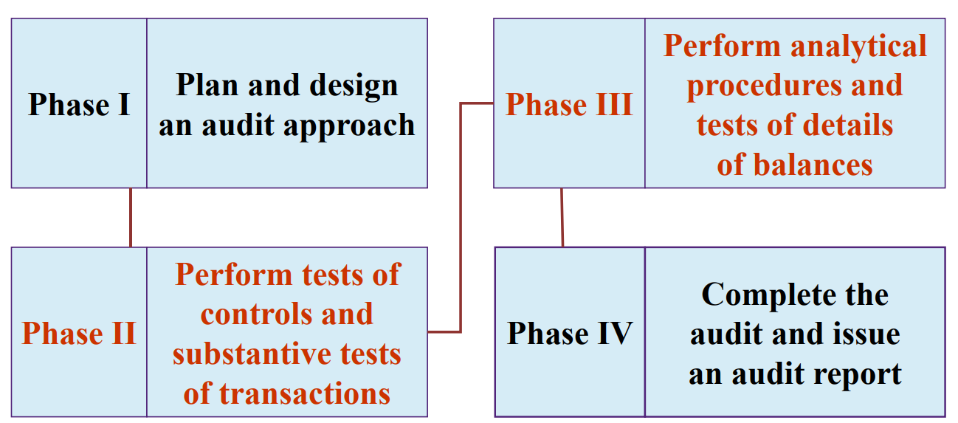

Audit Phases:
- Phase 1
  - When planning an audit, the auditor considers audit risk and materiality, performs preliminary assessment of inherent risk and control risk for management assertions, and obtains the allowable level of detection risk.
  - Appropriate audit strategy is then chosen and the auditor plans the audit program (i.e, the nature, timing & extend of audit testing to be performed to test each management assertion).
- Phase 2+3: Audit Testing
Types of Audit tests
- Use the 5 types of audit tests to determine whether financial statements are fairly stated
- Procedures to understand the entity (risk assessment procedures)
- Analytical procedures
- TOC
- Substantive tests of transactions
- Substantive tests of details of balances

Type of Audit tests – Control Related
Procedures to understand internal control system:
(Planning stage: Evaluate design effectiveness + control environment)
- Evaluate and update previous experience with the entity
- Make enquires of audit client personnel
- Read client’s policy, procedure and systems manual
- Examine documents, records and reports
- Observe entity activities and operations
Tests of controls
(At audit testing stage: checking operational effectiveness)
- Make enquiries of audit client personnel
- Examine documents, records and reports
- Observe entity activities and operations
- Re-perform client procedures
Substantive tests of Transactions
- Purpose is to determine whether all transactions-related audit objectives have been satisfied for each class of transaction.
- Tests to obtain evidence of a sample (or all) of the individual debits and credits that make up an account, to reach a conclusion about the account.
- Typically, tests include:
  - Documentation – especially tracing & vouching
  - Inquiries of the client
  - Re-performance
Analytical procedures
- Analytical procedures:
  - Must be used in planning the audit and in reviewing the aduit at the end
  - MAY be used as a substantive test during th testing stage
    - → Substantive analytical procedures.
Substantive Analytical Procedures
- When used as a substantive test:
  - If the results are reasonable
    - Can be used to reduce tests of details of balances (e.g. sample size)
    - Different to planning stage, as planning often involves preliminary data.
    - At substantive testing stage, expect to use full year data

Tests of details of balances
- Tests of details of balances focus on obtaining evidence directly about an ending account balance
  - Emphasis is on the balance sheet
- Extent of the test is dependent on the outcome of tests of controls and substantive tests of transactions (hence phase III).
- Typical tests of details of balances:
  - Physical examination
  - Confirmation
  - Documentation – especially tracing and vouching
  - Inquiries of the client
  - Re-performance
  - Recalculation
Relationship between types of tests and evidence
Below Table is not needed for the exam (or to put on cheat sheet), but good to help memorise what is needed in what situation
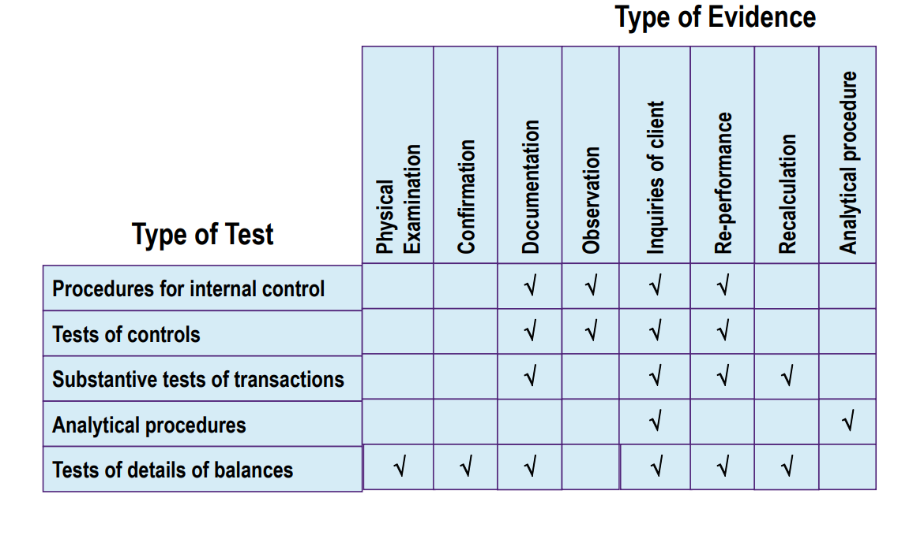
Audit Program – Design substantive procedures
Basic Steps
- Develop specific audit objectives
- Assess IR and CR to determine the acceptable DR for each assertion (taking into account AR and materiality level)
- Determine appropriate audit strategy
  - Predominatly substantive
  - Lower risk of control strategy
- Perform tests of control if using lower assessed level of control risk strategy
- Design substantive procedures
  - Substantive tests of transactions
  - Tests of details of balances
Nature, Timing & Extent
- Perform substantive procedures
- Evaluate results

Audit Risk Model & Audit Testing
- DR = the risk that substantive procedures will not detect a material misstatement
- Given the level of AR, DR is inversely related to the assessed levels of IR and CR
- If assessed DR is low, the auditor would need to use more effect and more costly substantive procedures
- If assessed DR is high, the auditor can use less effective and less costly substantive procedures
Nature & Extent of Substantive Procedures
- Nature- - more/less effective procedures
  - E.g., inquiry vs documentation vs. external confirmation
- Extent – test entire population or a sample? Sample size? (next lecture)
- When making such decisions and evaluating results, always keep in mind the risks and materiality for the assertion of this particular account balance/transaction class
Timing of Substantive procedures
- Interim vs year end
- Longer gap between interim testing and year-end, greater risk that the interim tests results are no longer applicable at year-end
- Incentives for client to manipulate accounting numbers often increase closer to the end of reporting period.
- Consider: Between interim testing & year end:
  - Internal controls still effective?
  - Incentives for manipulation
  - Year-end account balances are reasonably predictable? (analytical procedures)
  - Can get info. For significant unusual transactions/fluctuations
Findings/Exceptions
- An “exception” found in a test of control is an indication of possible misstatement (i.e., control test deviations)
- An “exception” found in a substantive test is a misstatement

Evaluate Results
- If the results indicate the existence of material misstatements or problems with internal controls, the auditor’s options include:
  - Evaluate results from other tests
  - Increase sample size or perform other tests
  - Expand testing in specific areas
  - Ask client to adjust account balance or correct records,
  - Communicate with audit committee or management
  - Modify audit opinion
Evaluate Results – Documentation
- Remember the auditor has to document the audit to allow an experienced auditor to review:
- Nature, timing and extent of audit procedures
- Results of audit procedures and evidence obtained
- Significant matters arising and conclusions reached.

Summary
- The nature, timing and extent of substantive testing are mainly determined by the assessment of inherent risk and control risk
- Assessed control risk determines audit strategy (i.e, the combination of control-related tests and substantive tests)
- The effectiveness of substantive procedures depends on the specific procedure used, the type of evidence obtained, the timing and the extent of the substantive testing.

Lecture 9: Audit Testings & Substantive Procedures: Sampling
Audit Sampling Introduction
- We know about the various audit procedures available
- TO be able to collect evidence, we first need to conduct audit sampling
  - Audit procedures require sample pool of items from which to collect Audit evidence to be able to make an audit conclusion
Why do we need sampling?
- Not practical to test every transaction – time/resources constraints
- Sampling increases efficiency.
- Select a sample representative of the population we want to examine to collect sufficient and appropriate evidence.
  - E.g., are credit sales correctly authorised by a senior manager (TOC)
  - E.g., how many dollars are misstated in the accounts receivable account (STOB)
Why do we need sampling?
- After performing audit procedures on a sample, we then extrapolate the sample results to the entire population of items.
  - E.g., all credit sales in the sample were correctly authorised, therefore, we may assume that credit sales in general are correctly authorised.
Definitions – ASA530.5
Sampling
- Application of audit procedures to less than 100% of items within a population of audit relevance such that all sampling units have a chance of selection in order to provide the auditor with a reasonable basis on which to draw conclusions about the entire population.
Population
- The entire set of data from which a sample is selected and about which the auditor wishes to draw conclusions
Population of audit relevance
- E.g., an account balance or a transaction class suitable for the assertion to be tested
Sampling unit
- The individual items constituting a population.
Representative Sample
- A representative sample is where the characteristics of the sample are approximately the samea s those of the population
- Two things cause a sample to be non-representative
  - Sampling risk
  - Non-sampling risk
Sampling Risk
- Sampling risk (ASA530.5(c))
  - The risk that the auditor’s conclusions based on a sample may be different from the conclusion if the entire population were subjected to the same audit procedure.
- Inherent to sampling
- Sample characteristics will never match the population exactly.
- Higher risk with a very small sample, no risk if the entire population is tested
- Difficulty for auditors – finding the correct balance .
- Easy way to eliminate sampling risk is to increase the sample → therefore getting closer to the population
- May lead to 2 types of wrong conclusions
- First type: wrongly conclude that
  - Internal controls are more effective than they actually are (risk of over-reliance)
  - There are no material misstatements when there are actually material misstatements (risk of incorrect acceptance)
- *Null hypothesis = no material misstatement.
→ Ineffective audit (more likely to result in an inappropriate audit opinion)
- 2nd type: wrongly conclude that
  - Internal controls are less effective than they actually are (risk of-under reliance)
  - There are material misstatements (risk of incorrect rejection)
→ Inefficient audit (additional work) but you’ll get to the right conclusion, you just have to do a fuck tonne more work and it’s annoying as shit

- First type of wrong conclusion is worse

To reduce sampling risk
- Can be controlled by:
- Increasing sample size
  - Larger sample, lower sampling risk
- Using an appropriate method of sample selection

Non-sampling risk
- Non sampling risk ASA 530.5(d))
- The risk that the auditor reaches a wrong conclusion for any reason not related to sampling risk e.g.
  - Failure to detect a material misstatement due to human error/incompetence
  - Inappropriate audit procedures
- This risk is not related to sample size.
- To minimise non-sampling risk:
  - Careful design of audit procedures,
  - Proper instruction/supervision/review.
Statistical vs Non-statistical sampling
- Two types of sampling method
- Statistical
- Non-statistical
- Similar process
  - Step 1. Plan the sample
  - Step 2. Select the sample
  - Step 3. Perform the tests
  - Step 4. Evaluate the results
- Different techniques
  - Statistical samplings allow the quantification of sampling risk in planning the sample and evaluating the results
  - In non-statistical sampling, those items that the auditor believes will provide the most useful information are selected
- Auditor’s choose non-statistical samples from professional judgement, no rigorous framework. (draw on past experience and knowledge to determine sample size)
- Audit standards encourage stastical sampling, as it is more objective

Statistical Sampling
- Mathematical rules allow quantification of sampling error
- Random selection, probability theory and statistical inference are used in combination with audit judgement and experience.
- Example:
  - 95% confidence level = 5 sample risk
- The purpose is to use a sample to compute a confidence interval that will contain the true population mean, a given % of the time.
- All samples must be chosen at random as to eliminate bias, any that are not chosen at random will corrupt the results → not objective.
- Must use a probabilistic sample selection method.
- Random sample selection
- Systematic Sample selection – calculated interval with a random starting point
- PPS (probability proportional to size) sample selection – also called monetary unit sampling. Probability of selection is proportional to recorded value of the item.

Non-Statistical Sampling
- Does not require quantification of sampling risk.
- Use judgement (not probability theory or statistical inference) to determine sample size and evaluate the results
- Use non-probabilistic methods to select the sample:
- Directed sample selection – Judgement
- Block sample selection – sequence
- Haphazard Sample selection – no structure, but no bias (supposedly)
Stratification
- The process of dividing a population into sub-populations. The sub populations (i.e., strata) contain items with similar characteristics
- Identifying characteristics. E.g.,
  - Often monetary value, so greater effort is directed at larger value items
  - Characteristics that indicate a higher risk of misstatement.
- The purpose is to reduce variability of items within each stratum and so allow a smaller sample size without increasing sampling risk
- Helps improve audit efficiency
- Strata must be defined so that each sampling unit can only be in one stratum
- Example:
- 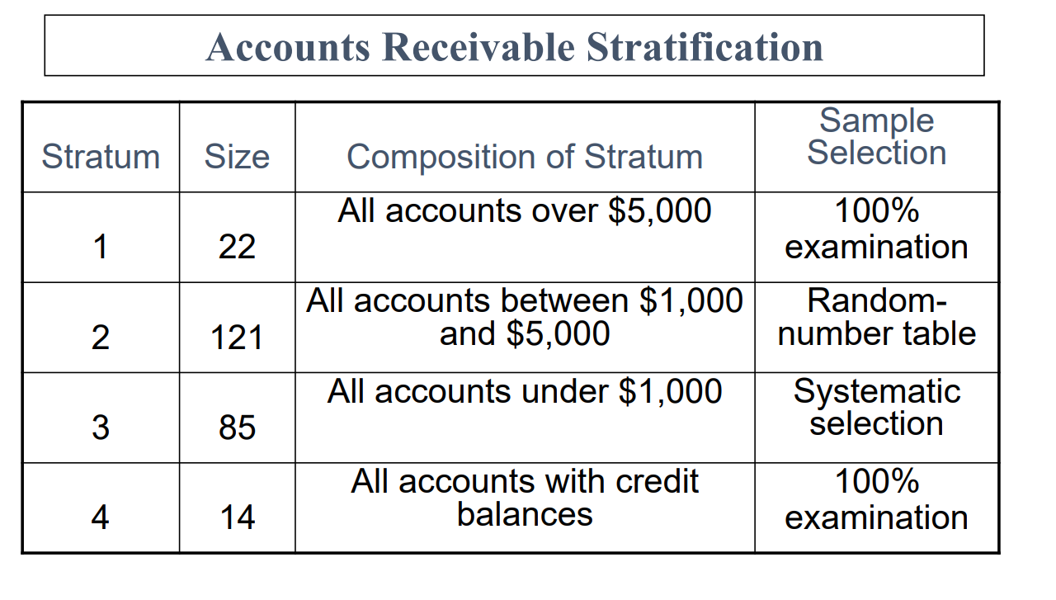

Sampling for Tests of Control
- When performing tests of controls, the auditor is concerned with evidence that controls are operating effectively.
- Auditor is interested in the frequency of the occurrence of problems in internal controls, ie., rate of deviation
- E.g., 5 out of a sample of 100 purchase invoices examined did not have a receiving report attached. The sample deviation rate (SDR) of 5% can then be projected to the population.
Sampling for Substantive Tests
- When performing tests of details of transactions, the auditor is interested in the misstatements in transaction data → occurrence rate (i.e, rate of deviation is again relevant)
- E.g., 7% of purchase invoices examined were not recorded in the accounting journal/ledger
  - Which assertion is breached?
    - Completeness was breached (transaction occurred, but was not recorded)
- With tests of details of balances, the auditor is interested in the monetary misstatements in account balances (dollar amounts, not deviation rates)
- Sample results can be used to estimate total dollar amount of misstatements in the population
- Example:
  - 9% of the value of inventory items sampled are misstated, therefore 9% of ending inventory value are estimated to be misstated
    - Then ask Is this amount material?
Sampling to estimate deviations/misstatements
- Consider two risks when making such judgements (recall slide on sampling risk):
  - Risk of incorrect acceptance/the risk of over-reliance → audit inappropriate opinion, therefore ineffective audit.
  - Risk of incorrect rejection/ the risk of under-reliance → inefficient audit
- We are more concerned about the risk of incorrect
  - The first type → affects whether the financial statements provide a ‘true and fair’ view
Using sampling in Audit testing
- Is sampling required?
- Determine the objectives of the audit test
- Choose appropriate sampling method
- Identify population and sampling unit
- Specify tolerable error, expected error, required confidence level
- Determine the sample size
- Determine appropriate sample selection method
- Perform audit procedure on the sample selected.
- Evaluate Results
Plan the Sample
- Is sampling Required?
- Alternatives to sampling:
  - Select all items in a population
  - Select specific items
    - High value or key items
    - All items over a certain amount
    - Items to obtain information
    - Items to test procedures

- Determine objectives of the Test
- Need to define the error/misstatement being tested for e.g,
  - To assess the occurrence rate of monetary errors in the recording of purchasing transactions
  - To assess monetary misstatement sin accounts receivable

- Choose appropriate sampling method
- Statistical vs Non-statistical sampling method

- Identify population & sampling unit
- Population – should be appropriate & complete
- Consider stratification of the population using an appropriate attribute, usually dollar amount
  - Advantage: Focus audit work on items of greater risk/interest

- Specify tolerable error, expected error, required confidence level
- Tolerable error means the maximum error in a population that the auditor is willing to accept. Also called tolerable misstatement/tolerable rate of deviation in ASA530
- Expected error rate – expected population deviation rate or expected $ misstatement
- Confidence interval – (Sampling risk)
  - Test of controls – the risk of over-reliance
  - Substantive Tests – the risk of incorrect acceptance

- Determine the Sample Size
- In determining an appropriate sample size, the auditor’s main concern is with reducing sampling risk to an acceptably low level (ASA530.7)
- The level of sampling risk that the auditor is willing to accept has an inverse relation with the sample size required (ASA530.A10).
- See ASA530 appendix 2 & 3 for factors that may affect sample size for tests of controls and substantive tests
- Select the sample
- All sampling units in the population must have a chance of being selected (ASA 530.8)
- Recall:
  - Probabilistic sample selection methods (for statistical sampling)
  - Non-probabilistic sample selection (for non-statistical sampling)

- Perform audit procedure on the sample selected

- Evaluate Results
- Consider qualitative aspects of the misstatements
- Investigate nature & cause of deviation/misstatements, and evaluate possible effect on the purpose of the audit procedure & on other areas of the audit
- Project sample result to the population
- Compare projected error & tolerable error
- E.g. for TOC, if the projected deviation rate exceeds the tolerable deviation rate, the preliminary assessment of control risk is confirmed or not? The control was not working effectively.
  - There increased (more) Substantive tests will be required
- Additional evidence/testing? Communication with client? Request to adjust/correct account balances?
- If internal controls are no good, just do more substantive tests

Summary
- Audit testing often required sampling so that inferences can be made about the population
- Sampling is associated with risks such as sampling risk and non-sampling risk
- Both statistical and non-statistical techniques can produce appropriate and sufficient evidence. Both methods require judgement by the auditor

Lecture 10: Completing the Audit
Completing the audit
- Additional testing of presentation- & disclosure – related audit objectives.
- Review for contingencies & commitments
- Enquire regarding litigation and claims
- Review for subsequent events
- Accumulate
  - Perform final analytical procedures
  - Evaluate going-concern assumption
  - Obtain a management representation letter
  - Read other information in the annual report re. material inconsistencies
- Evaluate results:
  - Final assessment of materiality, audit risk and sufficiency of evidence
  - Evaluate unadjusted misstatements – known & projected uncorrected misstatements
  - Technical review of financial report including adequacy of disclosures
  - Final review of working papers
  - Independent review by independent staff
- Form audit opinion
- Communicate with the client entity
Step 2 - Contingent Liabilities – ASA502
- Contingent liability = a potential future obligation to an outside party for an unknown amount resulting from past activities but the outcome is conditional on some future event.
- E.g, pending legal action, tax disputes, guarantees of obligations of others, native title claims.
- Usually required to be disclosed by the audit client in the notes to the financial statements.
- Management and not the auditor is responsible for identifying and deciding the appropriate accounting treatment
- Main assertions. General audit objectives of concern:
  - Disclosure/Classification and Completeness
- P.680 Arens – may be misleading → “To determine the existence of contingencies” is to check the completeness assertion (i.e, looking for contingencies that should be disclosed).
- Timing of audit procedures to find/very potential obligations/liabilities:
  - Throughout the audit process
  - At the end → Final check

Contingent Liabilities – audit procedures
- Inquiry of management of possibility of unrecorded contingencies
  - Just ask management, if there’s anything else we (auditors) need to know about
- Review of minutes of directors’ and shareholders’ meetings over indications of legal action
  - These meetings discuss major things (e.g. litigant, big company changes etc...)
- Review of ATO correspondence, e.g., disputes
- Analyse Legal Expenses and correspondence from legal firms for indications of liabilities, e.g, legal actions and pending tax assessments.
  - Big things/legal matters will be discussed with lawyers, so analyse direct correspondence for further clarity
- Obtain solicitor’s representation letter (to be sent directly to auditor)
  - Reliance on expert advice regarding the expected outcome of existing legal actions and probable $ amount of the liabilities including court costs.
  - This is a form of external confirmation.
- Review existing audit working papers for information indicating a potential contingency.
Commitments
- Audit client’s agreement to commit the company to a set of fixed confidtion in thef ture.
- E.g., sales commitments at specified prices, commitment to purchase raw materials or to lease facilities
  - Affects audit, because they will be significant in the future and affect future cash flow/investor interest
- Usually disclosed by audit client in a note to the financial statements
- Auditors should search for unknown commitments as part of normal audit process, e.g., examination of contracts or correspondence
Step 3 - Litigation and Claims – Legal/solicitor’s representation letter
- A legal representation letter is prepared by management and sent by the auditor to each of the client’s solicitors. The letter is to be sent directly back to the auditor
- Written representations are obtained from all lawyers with whom management has consulted for material legal matters.
- It is the auditor’s primary means of obtaining corroborating information about management’s assertions concerning the status of litigation, claims and unrecorded or contingent liabilities.
Step 4 - Review for Subsequent events
- Subsequent events are events that happen to the company after the balance date, they may or may not be related to the year you are auditing. Affects assets/liabilities etc. The financial report suffers from a timely bias, it is 2-3 months before the report can be issued, e.g., if something major happens 2 months after, the auditor needs to reflect that as well
- The auditor needs to obtain sufficient appropriate audit evidence to ensure subsequent events are appropriately reflected in the financial report in accordance with applicable financial reporting framework. (ASA560.4)
- Subsequent events include
  - Events occurring between the date of the financial report and the audit report date
  - Facts that become known to the auditor after the audit report date.

Audit procedures to identify subsequent events
Examples of procedures performed specifically to find subsequent events:
- Inquire of management
- Correspond with solicitors.
- Review internal/other statements prepared subsequent to balance date
- Examine minutes issued subsequent to balance date
- Obtain a management representation letter.

Review for Subsequent Events
- Two Steps:
- Auditor’s responsibility (depends on time period – see next slide.)
- Determine the appropriate accounting treatment (to see if amendment to the financial report is necessary) and the effect on audit report.
Subsequent Events – Step 1
- Auditor’s responsibility varies depending on time period:
  - Period 1 – From balance date to the date of auditor’s report (i.e, before the auditor’s report is issued).
  - Period 2 – From audit report date to the date of the financial report is issued
  - Period 3 – After the financial report is issued to the users.
- Note: the numbering of time periods is used here for convenience
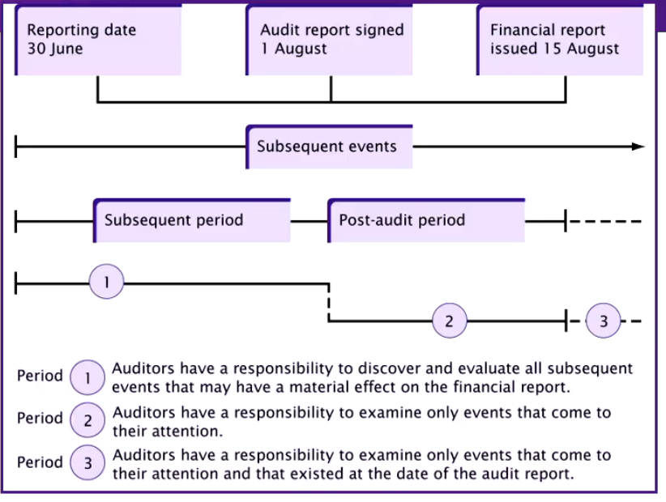

- Prior to the date of the audit report
  - Auditor has a responsibility to identify and evaluate all subsequent events that may have a material effect on the financial report.
- Between the date of the audit report and the issue of the financial report
  - Responsibility only extends to the evaluation of events which come to the auditor’s attention
- After the issue of the financial report
  - Only need to evaluate events which exist before the audit report date and which come to the auditor’s attention
Subsequent Events – Step 2
- Step 2: Assess effect of subsequent events on financial report (i.e, determine appropriate accounting treatment for them) and consider whether audit report is affected.
- 2 types of subsequent events for step 2:
- Subsequent events where the condition already existed on balance date
  - Require adjustment to financial report (i.e, apply normal accounting rules)
  - Arens describes these events that have a direct effect on the financial statements and require adjustment.
  - E.g., declaration of insolvency of an account receivable due to the ongoing losses, settlement of litigation of an amount different to that recorded in the books.
- Subsequent events where the condition did NOT exist on balance date
  - Do not require adjustment to financial report but need to be disclosed in the notes to the financial statements
  - Arens describes these events that have no direct effect on financial statements but for which disclosure is advisable.
  - E.g, after balance date: decline in market value of investments held for resale or temporary investment, issuing shares, uninsured loss of inventory as a result of fire, a merger or an acquisition/takeover.
  - Effect on audit report:
    - Periods 1 & 2 – Before audit/financial reports are issued:
      - A modified audit opinion is necessary if the financial report is not amended when the auditor believes it should be amended due to subsequent events.
      - Period 3: - If significant events are discovered after the financial report is issued and the events existed before the audit report date, the auditor needs to assess whether the auditor would have issued a different audit opinion had the events been known at the audit report date. If so, and if the auditor believes the financial report should be amended
      - Period 3 – If the auditor believes the financial report should be amended:
        - If management amends & re-issues the financial report, audit report should include an emphasis of matter paragraph referring to a note disclosure in the fin. Report which discusses the reason for the revision of the fin. Report.
        - If management refuses to amend/re-issue the financial report, auditor needs to act to prevent future reliance on the previous financial/audit reports.

There is an extra tutorial file that show you how to get full marks on this Q – becareful on what management and auditor repsonsibilitites are, don’t mistake what the auditor needs to change and what the auditor needs to change.

Step 5 - Accumulate Final Evidence
- Perform Final analytical procedures
- Obtain a management representation letter
- Evaluate going concern assumption
- Read other information in the annual report
Analytical Review (ASA 520)
- Auditor looks for inconsistencies between the client’s performance and financial position (may not be apparent from specific audit procedures).
- Analytical procedures are required at or near the end of the audit as part of an overall review for forming an overall conclusion.
- Procedures include:
  - Inter-temporal comparisons of financial data
  - Reconciliation of financial information with non-financial information
  - Consideration of economic conditions and impact of business risk.
Management representation letter
- Client representation letters provide evidence of responses to enquires made by the auditor during the course of the audit which the auditor, if necessary, can rely on in future disputes
- It details the auditor’s understanding of client representations on substantive points, allowing the client the opportunity to correct and misconception the auditor may have.
- Purpose of a management representation letter:
  - To impress on management its responsibility for the assertions in the financial report.
  - To document mngent. response to inquiries about various aspects of the audit. May acknowledge and confirm auditor’s understanding of issues
  - TO address matters material to the financial report when other sufficient and appropriate audit evidence cannot reasonably be expected to exist
Content of the Letter
Example:
- Financial reports (true and fair)
- Completeness of information (no unrecorded transactions)
- Recognition, measurement and disclosure, e.g., identification and disclosure of contingent liabilities or related parties
- Significant risks and uncertainties
- Subsequent events
Related Parties’ Disclosures
- Related parties’ Disclosures (ASA550)
- Auditor is required to obtain sufficient and appropriate evidence for the identification and disclosure of related parties.
- Use of management representation letter for completeness in identification of related parties
- Identification procedures include a review of: previous working papers, the entity’s procedures for identification or related parties, shareholders records to determine principal shareholdings, minutes of meetings of shareholders and Board of directors, tax returns, contracts and agreements and unusual transactions.
Going Concern (ASA 570)
- Auditor needs to assess the appropriateness of the going concern assumption over the relevant period, i.e, up to the expected date of the auditor’s report for the subsequent reporting period.
- Recall indications of going concern problems:
  - Financial, e.g. material operating losses; net liability position; adverse key financial ratios
  - Operational, e.g. loss of key personnel; loss of market share; lack of strategic direction
  - Other, e.g., changes in legislation
- Auditor also needs to consider mitigating factors
- Effect on audit opinion – Covered topic 2
Step 6 - Evaluate Audit Results
Consider:
- Sufficiency and appropriateness of audit evidence
- Evidence supports auditor’s opinion
- Financial report disclosures
- Working paper review
- Independent Review (recall: engagement quality control review)
Objectives
- Determine opinion as to fairness
- Determine compliance with applicable reporting framework (AASB)
Steps:
- Make final assessment of materiality and risk, sufficiency of evidence.
- Carry out technical review
- Conduct final review of working papers
- Formulate opinion & draft audit report
Review of audit risk
- Audit risk is the risk that the auditor may express an inappropriate opinion, comprised of inherent risk, control risk; and detection risk.
- The auditor should determine known & likely misstatements by considering:
  - Uncorrected errors specifically identified through substantive tests; and
  - Projected uncorrected errors identified through sampling.
Step 7 - Form an opinion
- Recall Leccie 2 – auditor’s report:
  - Unmodified opinion
  - Qualified opinion
  - Adverse opinion
  - Disclaimer of opinion
  - Emphasis of matter paragraph
  - Other matter paragraph
  - Key audit matters section
  - Other information section
Step 8 - Communicating with the client
- Communicate with management & those charged with governance
  - Auditor’s view about significant qualitative aspects of client’s accounting practices,
  - Significant difficulties encountered during the audit
  - IC weaknesses
  - Irregularities & fraud
  - Other matters
    - Independence sign off
    - Subsequent events review
Management Letter
- Letter of recommendation – prepared by the auditor & given to the client
- To inform client management of the auditor’s recommendations for improving the client’s business, e.g, efficiency of operations, IC weaknesses
- No standard format
- Not the same as a management representation letter or engagement letter
Summary
- The auditor has several key responsibilities at the conclusion of the audit
- Must consider impact of subsequent events
- Must assess the appropriateness of the going concern assumption
- Must communicate with the entity re. large matters such as IC weakness & fraud
Lecture 11: Auditor Liability
Overview
- The auditors’ regulatory environment, including:
  - Statutory liability – Corps act and the Australian Consumer law (ACL)
  - Common law liability
- Liability to clients – due care
- Liability to third parties under common law
- Defences
- Managing legal exposure & the expectations gap
The Legal Environment: Litigation Crisis
- Expectations gap - .e.g, auditor should detect fraud & errors
- The deep pockets theory
- Professional indemnity insurance
- Tendency to settle out of court
- Exposure to unlimited liability (but now can form companies)
- Hard insurance market – lack of availability, premium increases, larger excess payments, inadequate cover
Audit Liability: Regulatory Environment
- Statutory duties
  - Corps act
  - Australian consumer law (ACL)
- Common law responsibilities
  - Contract law
  - Tort of Negligence
  - Fraud
Statutory Duties
- Corps act s307-309 & CLERP 9
  - Ban on misleading and deceptive statements S1041h
  - Civil and criminal liabilities
- ACL in schedule 2 of the competition and consumer act 2010
  - A general ban on misleading & deceptive conduct in trade or commerce (s.18 of ACL)
Other Corps Acts Requirements
- Auditor’s responsibilities
  - E.g., duty to form opinion/to report to members
- Auditing standards – with force of law
- Auditor independence requirements
- Reporting obligations, e.g., breach of law

Common Law Responsibilities: Contract and Negligence
Auditory Liability: Contract & Negligence
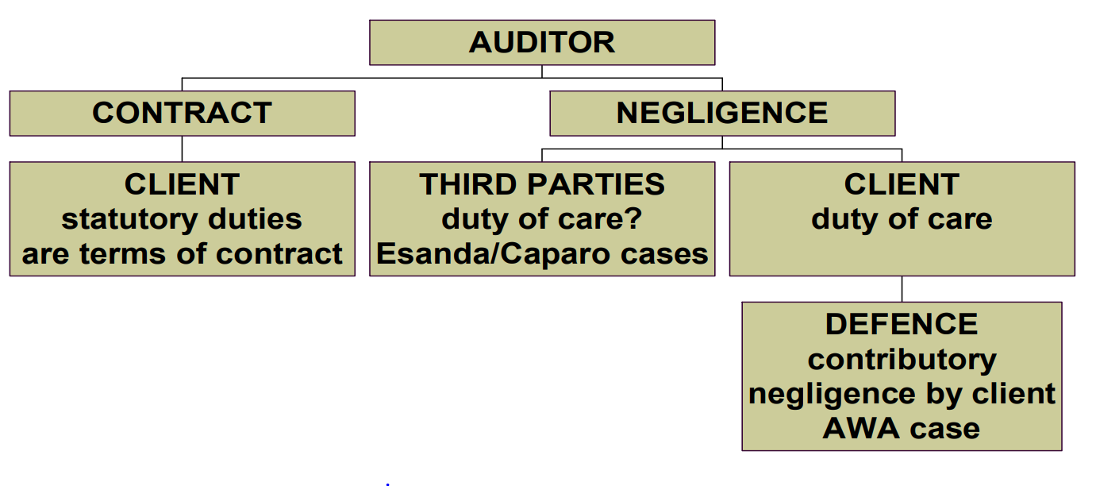
Liability in Contract
Contract Law:
Auditor → Client
- Terms of Retainer
  - Conduct the audit consistent with statutory duties
  - Express an opinion on the financial accounts
  - Exercise reasonable care & skill
Privity of Contract
- Law of contract- action can only be brought against the auditor by the company (privity of contract)
Liability of Auditors at one and two stages removed
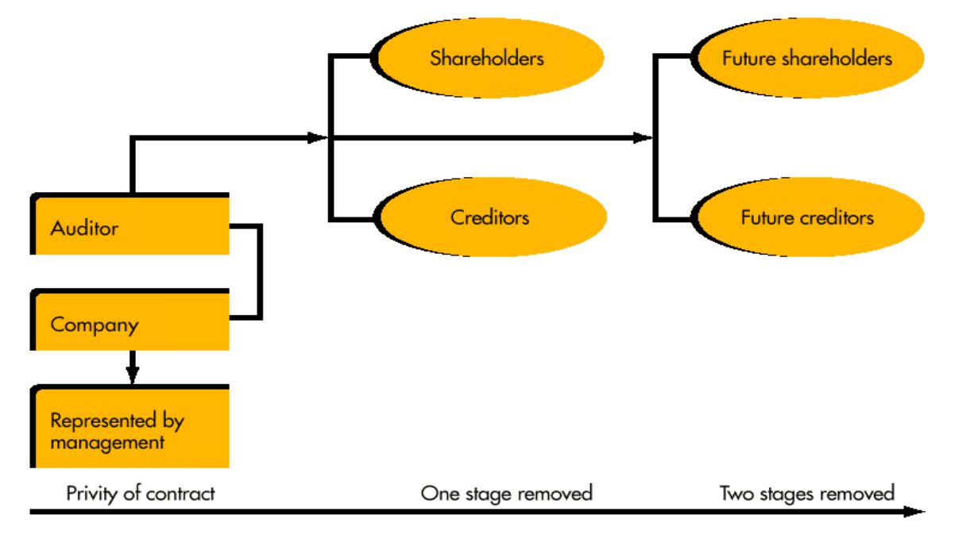
Liability in Negligence
Negligence 3 Steps
- Duty of care → To whom is the duty owed?
- Standard of care → what conduct is required?
- Damages → what loss is recoverable?
Negligence: Concept of due care
4 requirements to show negligence:
- Duty of care is owed to plaintiff;
- Breach of duty of care (standard of care)
- Loss is suffered by plaintiff
- Causation – Loss is foreseeable as a result of negligence

2- Standard of care: Due Care = Reasonable Care & Skill
- Kingston Cotton Mills:
  - Perform an audit like a reasonably competent, careful and cautious auditor. What is reasonable skill, care and caution must depend on the particular circumstances of each case.
  - Auditor is a watchdog, not a blood hound.
- London & General Bank:
  - Must take reasonable care and skill but is not bound to exercise more than reasonable care and skill
Pacific Acceptance v Forsyth (1970)
- An officer of pacific acceptance (audit client) defrauded the company by taking loans based on mortgages that either didn’t exist, or were not properly registered.
- Auditor was sued by pacific acceptance (audit client) for breach of contract – failure to detect fraud, over-reliance on management, inexperienced staff/inadequate supervision, auditor not independent, etc.
- Auditor’s claims in defence: reasonable reliance on the company’s management & solicitors; compliance with auditing practice (expert evidence).
- Held auditor liable; the judgement become a catalyst for promulgating tighter audit standards
- Main points covered about the duty to audit:
  - Includes a duty to warn, at any stage, of a suspicion of fraud
  - Design the audit with due regard to fraud or error: it is not to be regarded as a “mechanical” process
  - Not to rely on management assurances, but to check independently

WA Chip & pulp 1989
- First substantive Australian case to look at fraud detection.
- The auditor was negligent in not enquiring about an escalating unsecured debt owed to the company by a senior officer
- The matter should have referred to an officer senior to the officer who accruing the debt
Findings:
- Any suspicion of fraud ought to be reported. The court does not take a view on ‘materiality’ on this
- Duty to report to senior management
AWA Ltd. V Daniels 1995
- AWA’s FX trader Koval appeared to make profitable trades so he was left largely unsupervised, e.g.
  - No dealing limits imposed
  - No proper records kept
- In fact, Koval was able to hide his losses, through unauthorised borrowings.
- Auditor sued in negligence for AWA’s financial losses
Claims against auditor:
- Auditor failed to warn the board of Koval’s unsupervised activities & absence of internal controls
- Auditor was not independent; friend of G-M & internal auditor.
- Auditor claimed AWA was contributory negligent for management’s failure to supervise Koval.
Held:
- Auditor negligent, but AWA management 1/3 contributory negligent
- Executive director also liable in negligence
  - Now have the benefit of statutory proportionate liability (where the action is misleading and deceptive conduct, not for common law negligence).
Standard of Due Care
- Aspects of the standard of care discussed in common law cases have been incorporated into auditing standards
- A reasonable standard of care includes performing an audit in compliance with professional standards, eg.,
  - Verification & IC system – ASA315
  - Investigation: Fraud detection – ASA240
  - Relevance of professional standards – ASA220
  - Duty to report to management – ASA620

Due Care re. Internal Control
- Verification & internal control
  - Auditor cannot rely on IC unless:
    - Auditor ascertains the system by proper inquiry
    - Appraises the system’s reliability
    - Checks by samples that it operates as intended
      - Pacific acceptance v Forsyth
      - AWA ltd
Duty of Care to Third Parties
- Negligence: Duty of Care
- Auditory Liability in negligence to whom is the duty of care owed?
- Client
- Third parties
  - Investors
  - Financiers
Third Party Liability
- Caparo 1990 (UK): Limiting liability to third parties
- Audited accounts showed a profit. Caparo relied on these accounts. After the takeover, Caparo found a loss of $400,000 and sued the auditor.
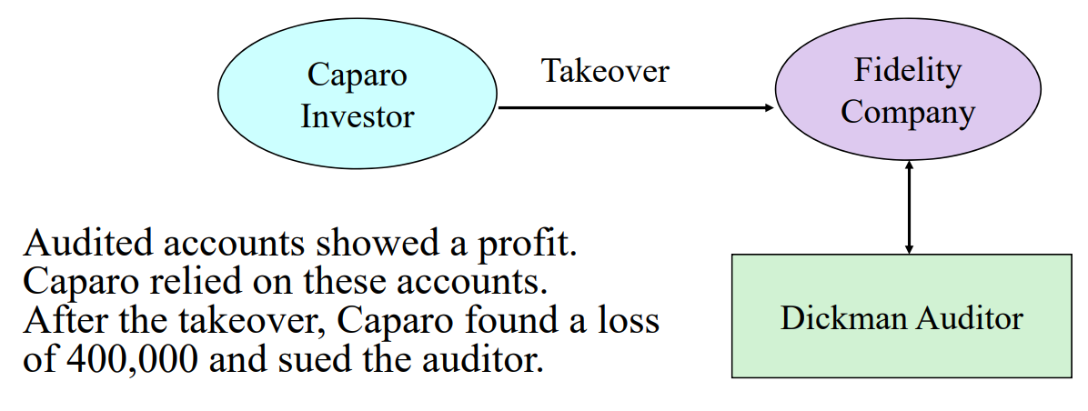

Caparo
- Held: Auditors do not owe a duty of care to:
  - Potential investors
  - Existing shareholders individually
- Mere foreseeability that the report would be relied upon by third party users does not establish a duty of care/relationship of reliance
- May have a duty of care to shareholders collectively as a group

Esanda
- Limiting liability to third parties
- Esanda v Peat Marwick 1997 (HC)
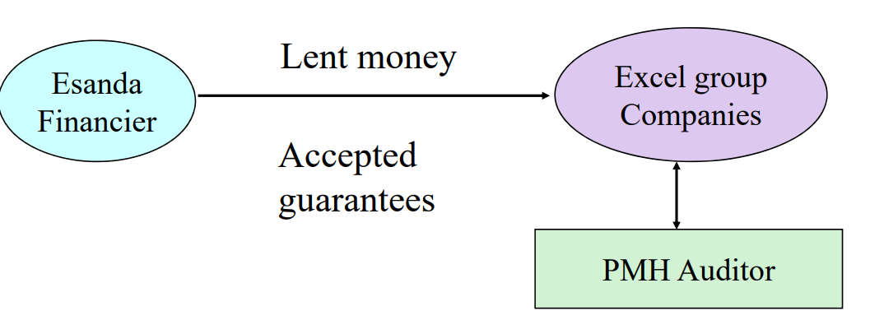

- Esanda relied on the accounts audited by PMH when deciding to finance the group’s activities.
- Excel subsequently defaulted, resulting in a loss to Esanda
- Esanda sued the auditor, but did not claim any direct relationship between it and the auditor
High Court Held:
- No duty of care
- There must be a relationship of reliance by
- Reasonable reliance;
- Assumption of responsibility
- Voluntary provision of information or advice

- Reasonable reliable & assumption of responsibility depends upon:
- Auditor knew the information would be communicated to the third party
- The third party individually or an identified class
- Intention by the auditor for the information to be relied upon by third party
- The information is for the purpose of the third party transacting with the company
Damage
- What loss is recoverable
- Damages put the party in the position they would have occupied if there was no breach of duty (“but for” test of causation)

Framework
- Distinguish the auditors statutory duties from civil.
- Common law duties to client (in contract or tort of negligence)
- The elements of negligence
  - Duty of care is owed to…
  - Negligent performance/opinion (i.e due care)
  - Loss is suffered
  - The loss is foreseeable result of the negligence
- What is the standard of care (ie due care) expected?
- What is the liability to third parties?
- What loss is recoverable
- Defences etc?
Examples of Defences & Liabilities
- No duty o care, e.g., to a third party
- Reasonable care was taken
- Contributory negligence: AWA case
- Loss was not directly caused by auditor’s negligence
Defences & Liabilities
- Proportionate Liability: THE CLERP 9 Act introduces proportionate liability for claims for damages for economic loss or property damage arising from misleading or deceptive conduct. Proportionate liability involves a defendant being liable only for that portion of the damage for which the defendant is judged to be responsible: S 1041(1)
- Liability Capping: All states and territories have enacted legislation enabling the establishment of a professional standards council to enable the creation of schemes to limit the civil liability of professionals and others, to facilitate the improvement of occupational standards and to protect consumers.
- Participants in the scheme can limit liability to a statutory cap.
- The cap varies depending on the practice’s nature and firm size
- For Audit firms, the highest cap is $75 million
To Minimise litigation Risk
- Use of engagement letters
- Investigate prospective clients thoroughly
- Regularly evaluate retention of current clients
- Comply fully with professional pronouncements
- Recognise eliminations of professional pronouncements
- Establish & Maintain high standards of quality control (inc. documentation)
- Maintain independence
- Maintain adequate professional indemnity cover
- Disclaimers
- The issue of privity letters

Disclaimers
- Corps act prevents the contracting out of liability and responsibilities
- However, AGS 1014 permits disclaimers for other parties
Privity Letters
- Privity (or comfort) letters – after Caparo, it became common for outsiders to seek a letter from the auditor acknowledging the outsider’s interests in the audit client. This was one way of trying to establish a relationship of reliance.
- Professional bodies responded with AGS 1014
  - Recommends that auditors respond negatively to such requests
  - Audit reports are only for shareholders
Summary
- Auditors have liabilities under statutory law and common law
- Statutory duties are usually from Corps Law and the ACL
- Common law duties are usually under contract law and the tort of negligence
- Auditors can reduce potential liabilities by exercising reasonable care, e.g, by complying with legal/ethical requirements including the Auditing standards, Corps law and the code of ethics

