TOPIC 0 – THE BASICS
A. Channelling funds: the role of financial instruments
Definitions:
Funds in the context of the financial system are exclusively transaction deposits in banks.
Term deposits and savings accounts are financial instruments.
When a financial instrument is created, funds flow towards the agent in need of money in exchange for a financial instrument.
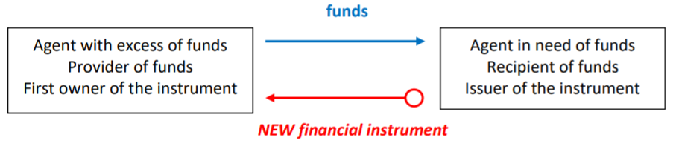
The issuance of a financial instrument is the only stage in the lifecycle of the product that actually ‘provides funds’. All subsequent transfers of funds related to the financial contract do not constitute channelling of funds from agents in surplus to agents in deficit of funds.
B. The lifecycle of a financial instrument in the flow-of-funds diagram
The process described in part A is the birth of the financial instrument. One issued, most financial instruments can change hands among investors. By buying the financial instrument from the previous investor, a new investor provides funds to the previous investor. This step in the lifecycle of the financial instrument is liquidation.
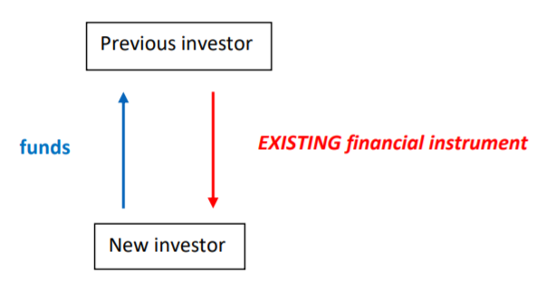
The amount of funds paid by the new investor to the previous investor is the price of that instrument as determined by demand and supply in the secondary market at the time of the exchange.
If the financial instrument has a maturity date, the last payment scheduled in the financial contract is made by the issuer to the current investor and this last payment destroys the contract.
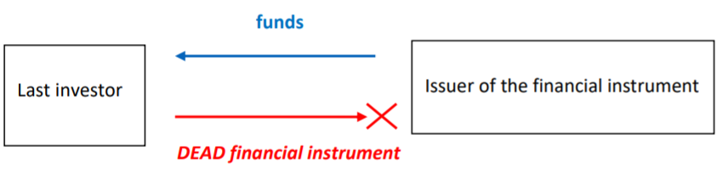
The liquidation of a financial instrument refers to the sale of the instrument by its owner in the secondary market.
C. Flow of funds for a bond, a share and a non-bank loan
$Coupon=\frac{Coupon Rate*FV}{Times Paid Annually}$

D. Balance sheet of a non-bank entity
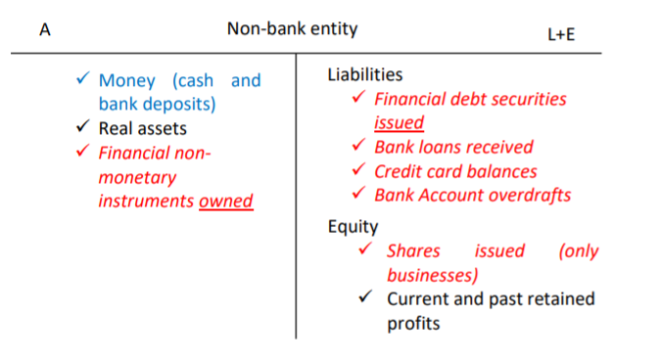
Assets
Non-monetary financial assets: Financial assets owned by the entity to which the balance sheet relates and were issued by other entities. One cannot list in financial assets a financial instrument that has been issued by the entity itself (e.g. a bond issued by Rio Tinto cannot be an asset in Rio Tinto’s balance sheet, even if it buys it back).
Liability and equity
This side of the balance sheet records the origin or the source of wealth.
Regardless of whether the financial instrument bought by the investor is a debt instrument or equity instrument, it appears as an asset in the balance sheet of the investor. The distinction between equity/debt is relevant for the balance sheet of the issuer only.
E. The lifecycle of a financial instrument in balance sheets
Issuance of a financial instrument
The receive of funds (company) issues a financial instrument that is exchanged for money. Because the financial instrument issued is a source of funding, it appears on the liability/equity side of the balance sheet of the issuer.
Liability if -form of debt (bonds, loans, commercial paper, credit card balance, etc).
Equity if -funds are raised through the issuance of shares.

TOPIC 1 – FINANCIAL INTERMEDIATION
A. Surplus spending units and deficit spending units
SSU: An entity that is giving funds to the financial system, funds which have been earned as an income that has not been spent on consumption or on real investment. The origin of the funds is the provider’s own income, not outsiders’ money.
DSU: An entity that receives funds from the financial system in order to consume or do real investment now, and not for the purpose of lending to others.
Financial intermediary: A provider of funds who raised these funds from others in the financial system (not a SSU). A recipient of funds that intends to lend funds instead of consuming or investing (not a DSU).
Examples:
-Perpetual Australia shares fund provides money to the financial system that comes from its customers when they buy its units. PPT is an intermediary.
-Unisuper invests in the financial market using contributions from its customers. Unisuper is an intermediary.
-A finance company like GE Money could be either a DDU or a financial intermediary. When the funds it lends have been borrowed from the financial market, it is a financial intermediary. When the funds the finance company lends come from its own profits, it is a SSU.

B. Direct finance
Direct finance is a one-contract process for funds to circulate from SSU to DSU in the financial system.
Definition: Direct finance occurs when the SSU holds as an asset the financial instrument that has been issued by the DSU.
Example: When an individual buys Rio Tinto shares and keeps this in their portfolio, this is direct finance. When an individual keeps money in their superannuation fund and this fund purchases Rio Tinto shares, this is not direct finance.

Representation of direct finance in balance sheets
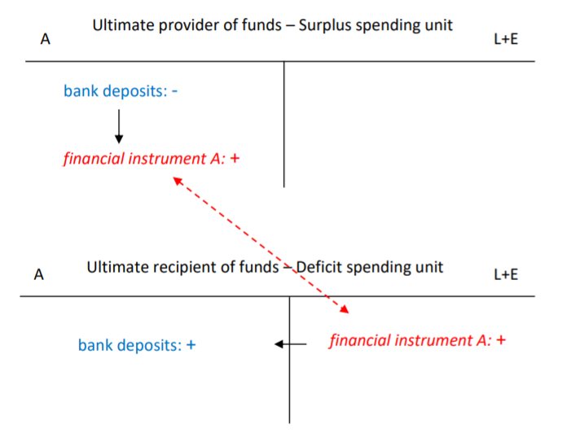
Only one single financial instrument is involved in linking the two ends of the financial system.

The use of financial markets and peer-to-peer platforms in direct finance
With peer-to-peer lending platforms, individuals and companies can now make loans even without a financial services license. Once the matching is completed, the lender and borrower have a loan contract between themselves, not with the platform.
Examples
- Mr Smith buys some Rio Tinto shares
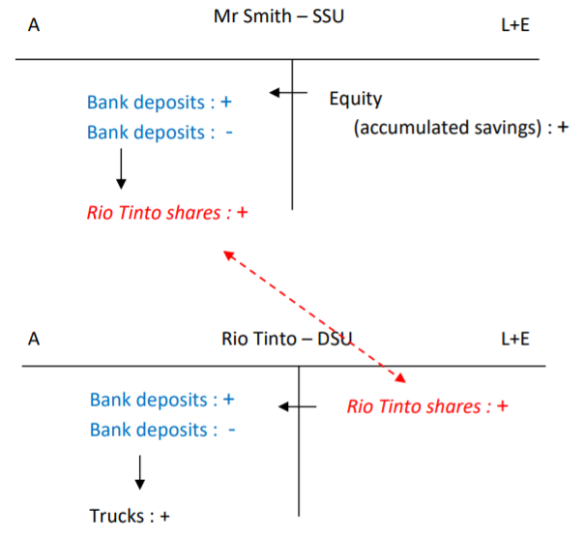

- The Australian government buys Rio Tinto corporate bonds
The government is in a financial surplus and is a SSU. Instead of keeping bank deposits, it decides to buy Rio Tinto bonds. Rio Tinto will buy trucks with the money raised by issuing bonds and therefore is a DSU.
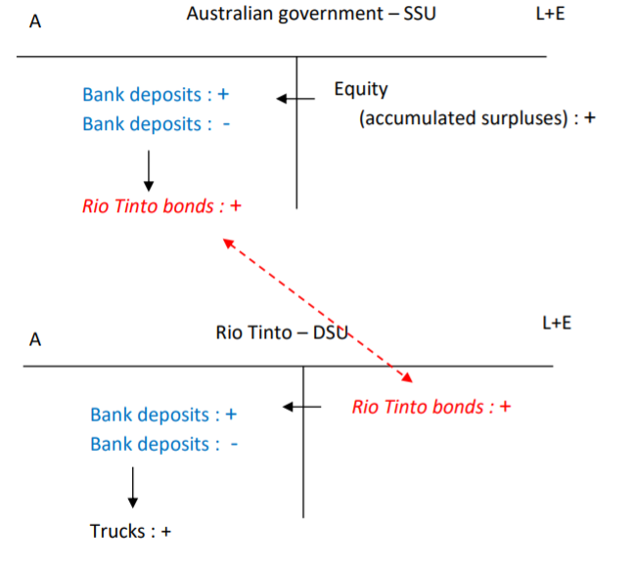

C. Financial intermediation by non-bank financial institutions
Definition: Financial intermediation (also called indirect finance or intermediated finance) means that the financial instrument issued by a deficit spending unit is held as an asset by an entity, usually a financial institution, that borrowed or raised funds from others rather than by using its own income. It is a two-contract process (raising funds and using funds in the financial system).
or
A financial intermediary is an entity that acts as the middleman between two parties in a financial transaction.
Simple:
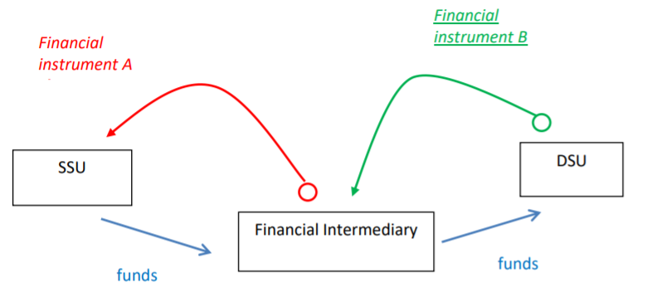
Complicated:
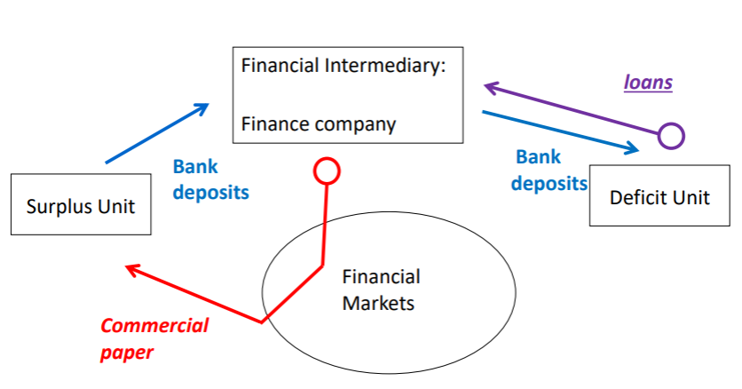
Bank deposits transit through the nonbank intermediary.
There is a CHANNELLING OF FUNDS:
- SSU lose bank deposits
- DSU gain bank deposits
There are TWO FINANCIAL INSTRUMENTS:
- One in the asset side of the intermediary (e.g. loan)
- One on its liability/equity side (e.g. commercial paper)
The bank deposits TRANSIT THROUGH the finance company:
- Bank deposits come in the intermediary’s assets
- Bank deposits come out of the intermediary’s assets

Representation of financial intermediation in balance sheets
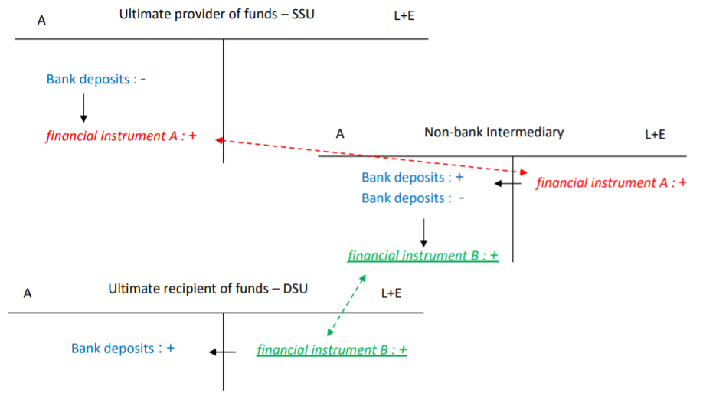

Examples
- Rio Tinto issues shares to Perpetual Australian shares fund
PPT is a provider of funds when it buys Rio Tinto shares. However, PPT is not the ultimate provider of funds as the funds invested are exclusively raised by issuing shares. The SSU may be households who buy shares in PPT.
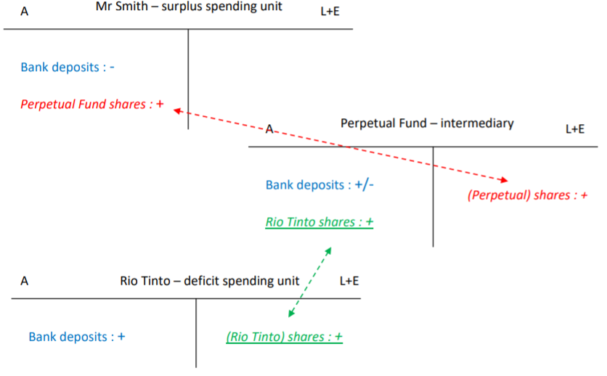
Households provide funds to Perpetual which uses the funds to provide funds to Rio Tinto. Perpetual has an obligation towards Mr Smith and has a claim over Rio Tinto.

- GE Money issues commercial paper and makes loans to households
GE Money is a provider of funds when it makes loans to households (Mr Smith). However, GE Money is not the ultimate provider of funds as the funds invested are exclusively raised by issuing commercial paper, which are short-term securities. The surplus spending unit may be Rio Tinto, which buys commercial paper when it has excess money.
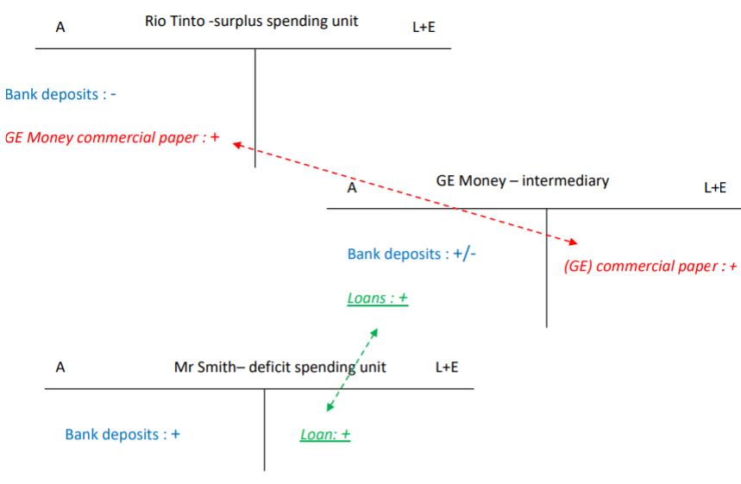
Rio Tinto provides funds to GE Money, which uses the funds to make a loan to Mr Smith. GE Money has an obligation towards Rio Tinto and has a claim over Mr Smith.

D. Reconciliation of opposite needs in direct finance and in financial intermediation
DSUs need large amounts of funds for a long period of time. SSUs usually have small amounts of money to invest and prefer to lock their money for short periods.
Financial markets provide some mechanisms to reconcile the opposite needs of the SSU and DSU, even though a single instrument is used. Primary markets allow deficit spending units to raise large amounts of funds through one issue of many securities that suit the need of surplus spending units. Secondary markets allow investors to get rid of securities before their maturity dates.
Benefits of financial intermediation
The pooling of the investments of man small SSUs on the liability/equity side allows the financial intermediary to operate at a much larger scale on the asset side than individual SSUs could do themselves if they invested in a direct way. The larger size reached permits economies of scale in terms of transaction costs. The fixed cost (broker fees, search costs, analysis costs) is spread over a larger volume of investment, thereby reducing the cost per $ invested for the financial intermediary compared to an individual SSU. Economies of scale also decrease the cost per $ invested for screening borrowers therefore reducing adverse selection and moral hazard issues in the credit markets.
The larger scale of the balance sheet finally allows a better diversification of the portfolio of the intermediary.
Tutorial notes
Securities are standardised and can be traded on the secondary market.
Shares and units are equity. Commercial paper and loans are debt.
There is no market for loans as it is not a security. We can say the creation of a loan is a primary transaction.
Liability -the face value is owed back to the investor.
Equity -no obligation for the entity.
An economic agent who provides funds to others in order to get income for future real investment is an SSU.
A unit is NOT a security: it is not traded in the secondary market.
In official direct finance (excluding peer-to-peer lending), households can only be on the SSU side. In intermediated finance they can be in the SSU or DSU side.

TOPIC 2 – THE ROLE OF ADTIs

A. Accounts at the central bank and ESA
All ADIs have an account with the central bank called an Exchange Settlement Account (ESA), which lies on the asset side of their balance sheets (they are essentially bank deposits but for the banks -the central bank is the bank of the commercial banks). The money held in ESAs are Exchange Settlement Funds (ESFs). ESFs are liabilities for the RBA because commercial banks can demand that the balances of their accounts be converted into notes at their discretion.
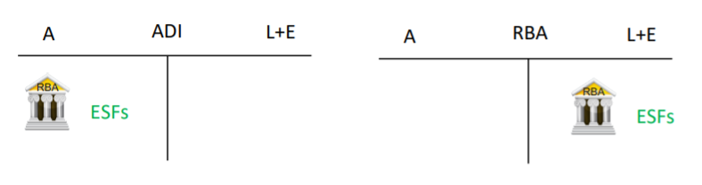
ESFs can be used to make/receive payments to/from another bank also with an ES. It is NOT possible for banks to transfer this money to a non-bank company or a household, as the latter do not have an account at the CB.
There are three types of money that exist in the economy: notes and coins, central bank money in ESAs, and private money in bank accounts.
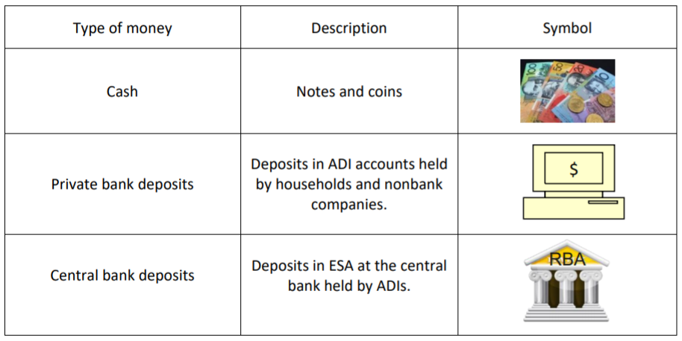

B. The role of ADIs in the payment system
Banks create the money they lend.
Because ADIs (mainly banks) manage the private means of payment of the economy, they are in charge of keeping the balances of the deposit accounts of their customers updated after the accounts have been used for commercial and financial transactions.
- Households and non-ADI companies make payments with their deposits at ADIs
- ADIs keep a record of transactions and update electronically the balances of their customer’s deposit accounts
- If the transaction involves deposit accounts in different ADIs a transfer of ESF occurs between banks
Examples:
(1) Will withdraws cash to buy coffee at a store.
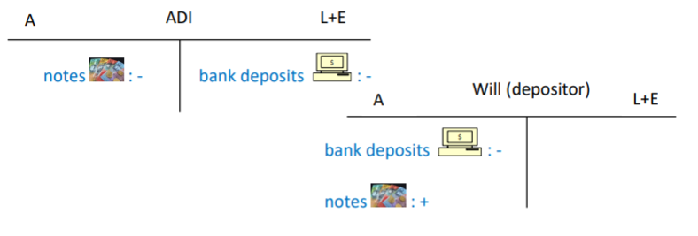
As coffee is a non-durable consumption good, Will’s equity decreases in the process as a result of the expense.
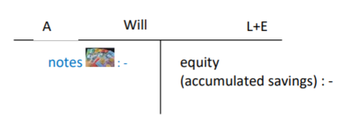
If we merge the two operations:
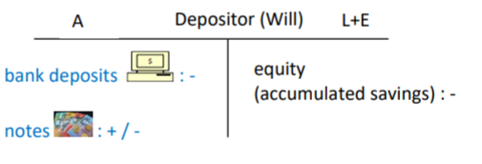
(2) Will pays his mobile phone bill through an internet transfer. Will has an account at the same bank as the mobile phone provider.
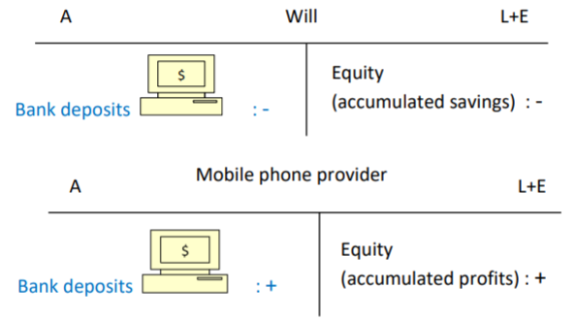

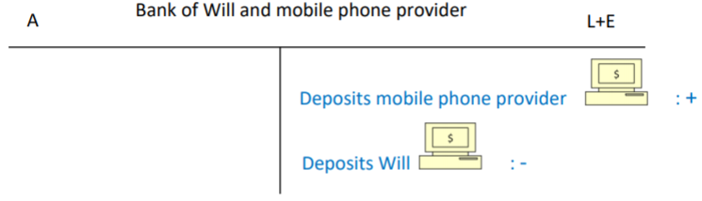

Assume now that Will and the mobile phone provider are customers of different banks. Will = Bank B, mobile phone provider = Bank C. Because the two parties are in different banks, there is the need to transfer central bank deposits between the two banks ESAs at the central bank.
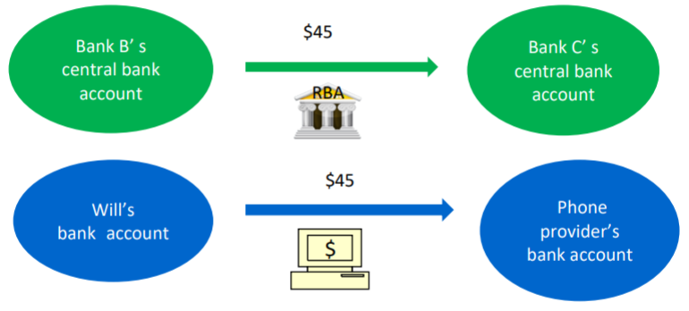
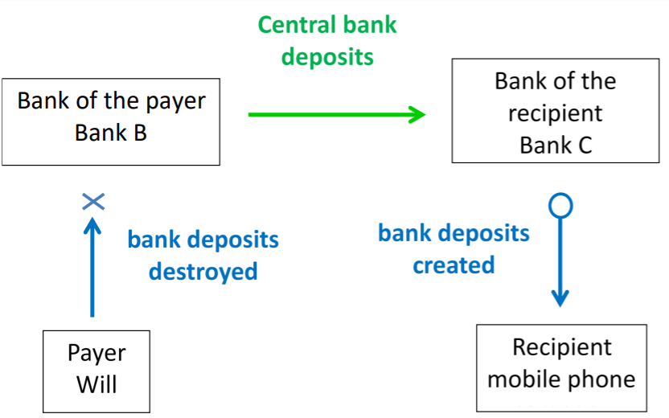
If they are new bank deposits for a person, bank deposits are created.
Getting additional ESF
When a bank is short of ESF, it can either borrow some from other banks or from the central bank. The interest rates for borrowing from another bank in the interbank market or from the central bank will be a key component of the implementation of monetary policy. The total amount of ESF is not affected by the loan in the interbank market, simply reallocated.
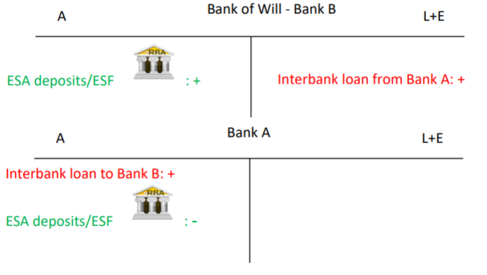

C. Transactions between an ADI and a non-ADI that is not a customer
Examples:
(1) Assume a bank is paid an income and the payer is not an ADI or a depositor in that bank. For example, a bank receives coupon payments on a bond issued by a company that is not a depositor.
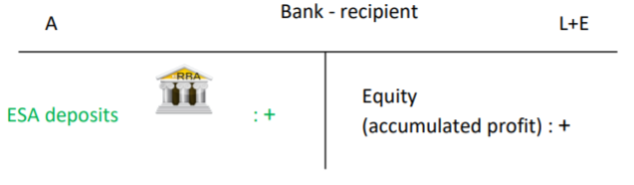
The stock of private money has decreased in the banking system: nobody has received bank deposits in return and deposits paid were therefore destroyed and not recreated. The stock of central bank deposits remain the same, and simply has been reallocated within the banking system to another bank.
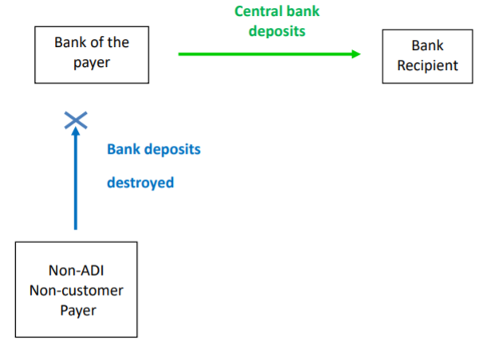

(2) An expense for the bank -the bank pays rent. The recipient of the funds is not a customer of the bank.
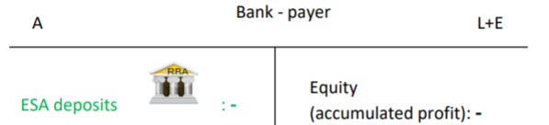
The stock of private money in the financial system has increased. The stock of central bank deposits remained the same.
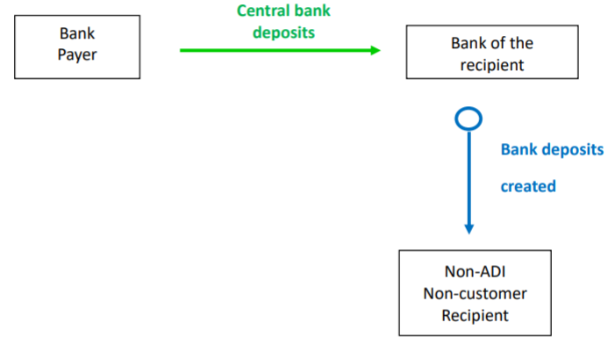
Issuing financial instruments and buying assets
When the bank issues a bond or a share to a non-customer depositor, this brings central bank money to the bank, while increasing the liabilities (bond) or equity (shares) of the bank:
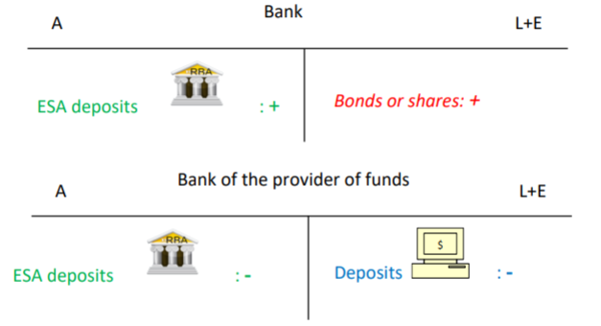
The total stock of private deposits has decreased, while the stock of central bank deposits remains unaffected.
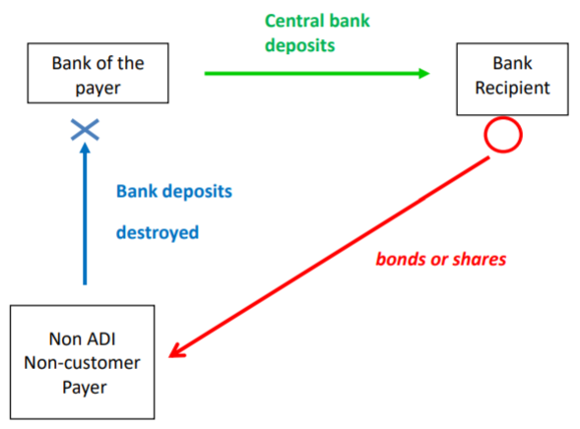
When the bank buys a bond or a building from a non-customer depositor, this removes central bank money from the bank while increasing the other assets of the bank.
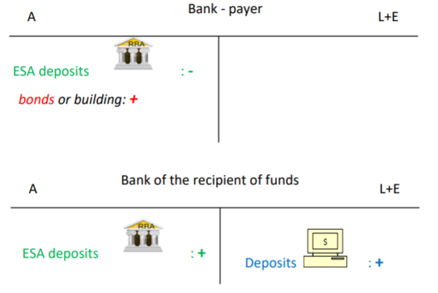
The stock of private money is increased while the stock of central money remains unaffected.
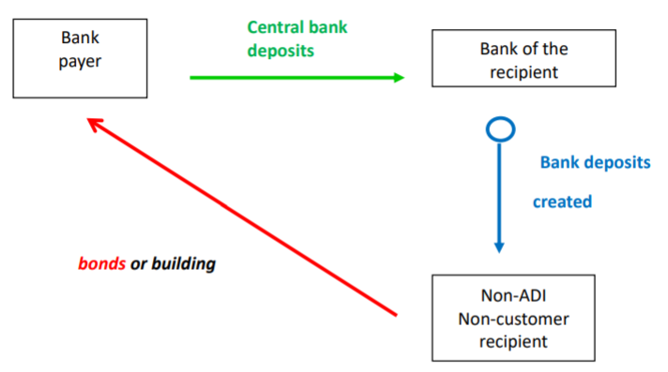

D. Transactions between an ADI and a non-ADI customer
When a bank engages in a transaction with its own depositor, there is no transfer of central bank money.
Income and expense
When the bank is paid an income and the payer is a customer of the bank:
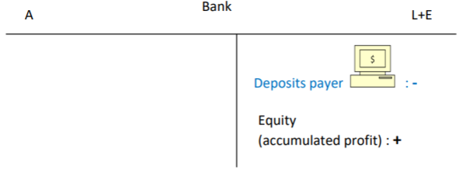
Bank deposits are destroyed (fewer liabilities).
When the bank pays rent and the recipients of the funds are customers of the bank:
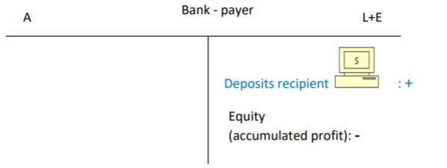
Deposits are created (less equity, more liabilities).
Issuing financial instruments and buying assets
When the bank issues a bond or a share to a customer depositor, this does NOT bring funds to the bank, not even central bank money.
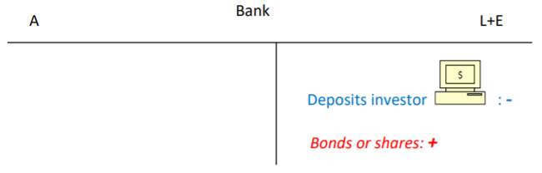
The bank does not receive any funds; it just records a decrease in its liabilities (deposits). The money is destroyed.
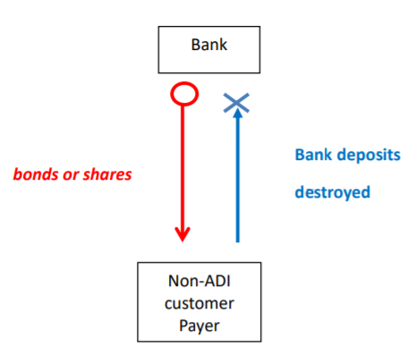
When the bank makes a loan to a customer depositor, or buys a bond from a customer depositor, this does not involve central bank money either.
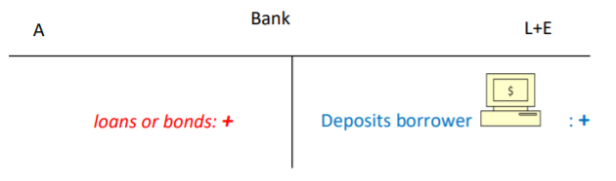
A bank creates the money that the loan provides.
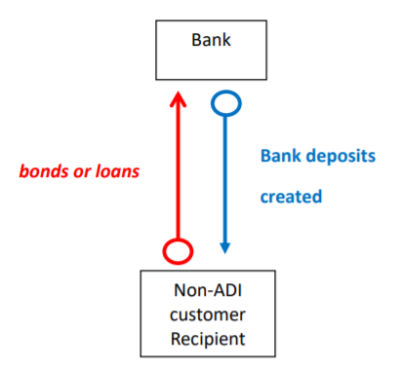
Quiz Notes
- ‘As part of their role as financial intermediaries, commercial banks collect funds from SSU and lend these funds to DSU.’
  - FALSE. The funds of the SSU cannot transit through a bank and then be given to a DSU as these funds (private money) are not from the same network as the funds for banks (central bank money).
- ‘A depositor in a commercial bank is an investor in a financial instrument issued by that bank.’
  - TRUE. Deposits are liabilities for banks but assets for the depositor. Investor means holding an asset.
- A bank issues a bond to a non-financial company that is NOT a depositor in that bank. The bank receives ESF and the nonfinancial company pays with bank deposits.
- Finance companies make their payments using their bank deposit accounts.

TOPIC 3 – THE BOND MARKET
Bonds
- Each bond has a face value (denomination) of $100 -however this is meaningless because a bond is never traded as a single entity
Plain vanilla bonds
- Simplest version of bonds
- Have a fixed coupon rate decided at issue
Floating rate bonds
- Coupon payment is variable -fluctuate with BBSW (bank bill swap rate; short-term interest rate used as a benchmark for the pricing of AUD securities)
- BBSW fluctuates coupon value is fixed agreed margin + new value
Index bonds
- Type of variable coupon -face value adjusted for inflation
Hybrid bonds
- Not compulsory to pay the fixed coupon
  - There is no legal consequence but company is not allowed to distribute dividends to shareholders
- These bonds can be turned into shares
Treasury bonds
- Issue:
  - Government decides the amount of bonds they want to issue
  - Variable price discriminatory tenders; aka bidders bid two things (1) price, and (2) quantity. Each winner pays the price in their bid
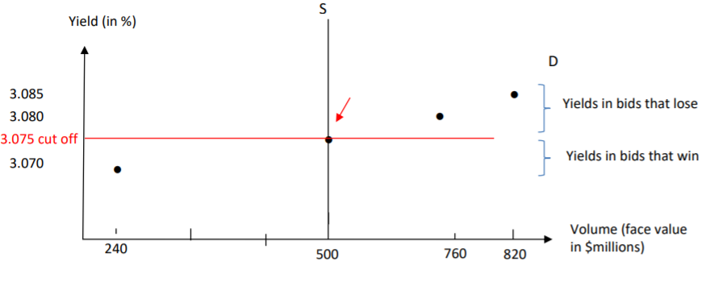
Corporate bonds
- Corporate bonds are debt contracts, requiring borrowers to make periodic payments of interest and to repay principal at the maturity date. They can be unsecured or debentures.
  - Unsecured = bond that has no security attached as collateral in the case of default
  - Debentures = (1) fixed debenture have the right to the proceeds of the sale of the assets specified in the debenture, should the bond default. (2) floating charge debenture holder has the right to the proceeds of the sale of assets specified in the debenture that are not already pledged against a fixed charge in any other debenture, should there be a default.
- Issue:
  - The corporation uses an investment bank for the marketing, preparation, etc. The investment bank can organize a fixed price tender

Securitisation
- Process in which certain types of assets are pooled so that they can be repackaged into interest-bearing securities
- Two steps:
- A company with loans or other income-producing assets -the originator- identifies the assets it wants to remove from its balance sheet and pools them into a reference portfolio. It sells this asset pool to the special purpose vehicle (SPV).
- The SPV finances the acquisition of the pooled assets my issuing tradable, interest-bearing securities that are sold to capital market investors. The investors receive payments from an account funded by the cash flows generated by the reference portfolio.
The liabilities of the SPV are sliced into tranches.
In most cases, the originator services the loans in the portfolio, collects payments from the original borrowers, and passes them on -less a servicing fee- directly to the SPV or the trustee.
- This process creates asset-backed securities (ABS), backed by the reference portfolio.
  - The amount issued is divided into tranches: senior, mezzanine, junior.
  - Investors in the senior tranche are paid first, the mezzanine tranche investors are paid second, the junior tranche investors are paid last. Therefore, the senior tranche holder bear less risk, and junior tranche holders bear more.
  - These tranches receive different interest rates.
Benefits for the originator:
- More stable income
  - The originator forgoes the interest paid on the underlying assets for an immediate lump sum of money (+ servicing payments).
- Transfer of credit risk
  - Credit risk is the default risk on the underlying assets.
- Cheaper source of funds
  - Securitisation involves raising funds by selling assets rather than issuing liabilities.
  - Issuing new liabilities would be at a cost reflecting the originator’s whole portfolio (all assets). Issuing ABS would be at a cost reflecting only the reference portfolio (sold to the SPV) not the whole portfolio of the originator. If the quality of the reference portfolio is higher than the quality of the originator’s overall portfolio, then the cost of raising cash through securitisation is lower.
- Reduced need for regulatory capital

Bank Capital Notes
- A capital note is an unsecured debt (unsecured = no specified security attached as collateral) generally issued by a company to pay short-term liabilities. Investors that purchase capital notes are loaning money to the issuer. They do not have a maturity date, and if not exchanged or redeemed could remain on issue indefinitely (in which case you do not receive your investment back).
- In ‘English’ = you’re loaning money to accompany for a fixed period of time in return for regular interest payments on a fixed interest rate. At the mandatory exchange date the notes may be converted into ordinary shares, usually at a discount to the market price. The number of shares given is calculated by looking at the minimum of ‘number of shares given’ or ‘maximum shares given’. This is so they don’t flood the market and existing shareholders are disadvantaged.
Features:
- $100 face value
- Distribution rate = (BBSW + fixed margin decided at bookbuild)*(1 – tax rate)
  - BBSW = bank bill swap rate
- Redeemable or resalable for $100 at a call date
- Conversion to ordinary shares at a mandatory exchange date for $101.01 if not redeemed at call date and if certain conditions met
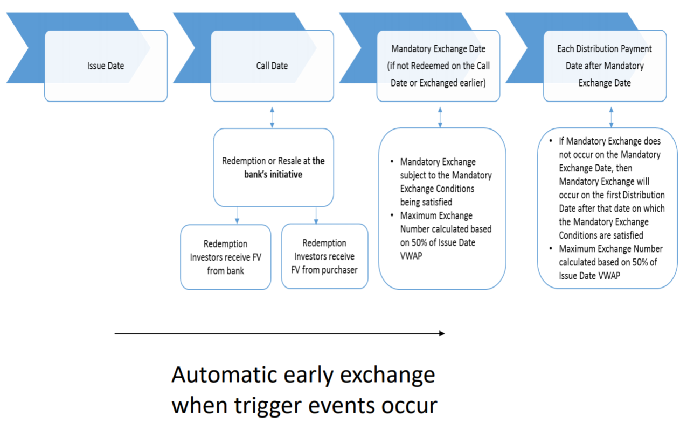
- Number of shares given = $\frac{Face Value}{0.99*exchange date VMAP}$
- Maximum shares given = $\frac{Face Value}{0.5*issue date VMAP}$
  - Take the minimum of the two!
- Condition for mandatory exchange = VMAP on the 25th day before ME > 56% of the issue day VMAP
Benefits for the banks:
- Banks may issue capital notes in order to cover short-term financing issues, such as being able to meet minimum capital requirements. Banking regulation requires banks to have a minimum amount of capital in their reserves in order to keep functioning. To satisfy regulatory demands regarding capital requirements under the Basel Accords, banks will issue capital notes classified as either Tier 1 or Tier 2 capital.
  - Can be converted into Common Equity Tier 1 capital at call date, mandatory exchange date or at any time if a trigger event occurs.
Risks for investor:
- Fluctuating BBSW means fluctuation of distribution
- Possibility that no distribution without having to justify

TOPIC 4 – MTM TRANSACTIONS
Held-to-Maturity/Investment Securities
- Income is the main purpose
- Meant to be held until redemption, only interested in income from the coupon payments
- Recorded at their amortised cost (historical value minus depreciation)/book value
Trading Securities
- Capital gain is the main purpose
- Bought with the hope the price will go up and then sell to make a gain
- Recorded at current market price change under ‘retained profits’
Available-for-Sale Securities
- Liquidity is the main purpose
- Bought with the purpose of selling them when cash is needed (important for banks, acts like a buffer)
- Recorded at current market price change under ‘capital reserve’
Unrealised capital gains -change in the value of securities that are still in the balance sheet because they have not been sold.
Realised capital gains -security is sold and finally disappears from the assets in the balance sheet.
Lending Provisions
- Loans on the asset side appear as net loans meaning that the lending provisions are deducted.
- Lending provisions are also called allowance for loan losses or provisions for bad and doubtful debt.

TOPIC 5 – CAPITAL REGULATIONS
RATIONALES FOR CAPITAL REGULATION
Role of Equity Capital
- The objective is to protect creditors (depositors and other lenders to the bank) and to maintain the stability of the financial system.
- Banks’ equity capital must be sufficient to absorb unanticipated losses.
- Unanticipated write-offs decrease retained profits.
Rationale for Regulation
- Banks underestimate the safety aspect (private cost of failure lower than social cost) and tend to choose a level of capital lower than what is socially desirable.
- Rules are usually same across countries to avoid banks going global to choose the less demanding countries.
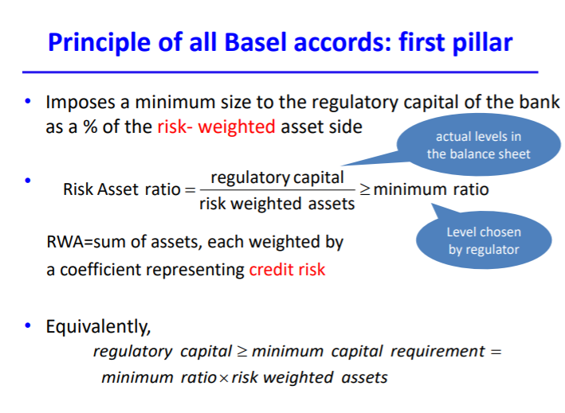
3 Minimum Ratios
- Common Equity Tier 1 minimum ratio is 4.5% (used to be 2% in Basel I and Basel II)
  - CET1 = best quality
  - Crisis showed 2% not enough
- Additional Tier1 minimum ratio is 6% (used to be 4% in Basel I and II)
  - Minimum includes CET1 + 1
- Tier 2 minimum ratio is 8% (in all Basel accords)
  - Minimum includes all
Increase in good quality capital with Basel III
- No change of the total capital requirement but increase in requirements of good quality equity

Other Pillars of Regulation (Since Basel III)
Second pillar: Supervisory review process where supervisors evaluate bank measurement techniques with respect to credit and operational risks and possibly impose a different (larger) minimum capital ratio.
- Not simply checking if ratio is met
- Banks need to provide information about how they assess their risk, how they consider the composition of their portfolio, etc.
- Regulator will examine and see if there are any trends that are worrying
- e.g. if bank has 80% of loans in housing not diversified enough too exposed to one part of the economy regulators can get the bank to either change this balance in portfolio or have more capital than minimum imposed
Third pillar: Market discipline by which banks are required to increase their information disclosure, especially on the measurement of credit and operational risks and on their regulatory ratios.
- Force banks to issue more info about their capital/equity
REGULATORY CAPITAL
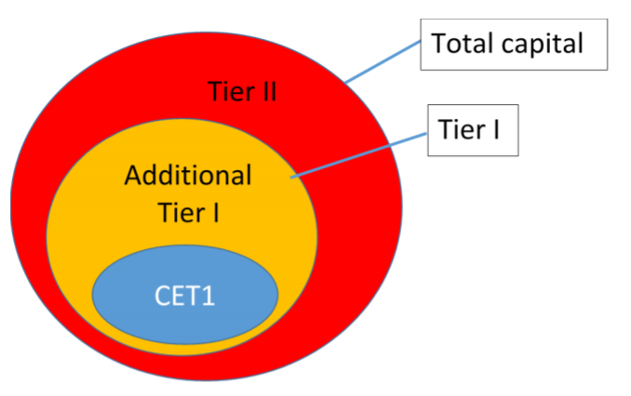
Definition
Tier I
- Common Equity Tier 1: ordinary shares, retained earnings, current year earnings, reserves from revaluation of securities, foreign conversion reserves (don’t owe it back)
- Additional Tier 1: perpetual non-cumulative preference shares, perpetual non-cumulative capital notes
Tier II
- Perpetual cumulative preference shares, term subordinated debt, life limited redeemable preference shares
Preference shares
- Pay fixed dividends
Cumulative preference shares
- Have to catch up previous dividends not paid
- Pay year after
Non-cumulative preference shares
- If company doesn’t have enough money/misses a dividend, they just don’t pay it
- Better from the point of view of equity because they don’t have to pay the year after
Subordinated debts
- Debt in regulatory capital are mostly hybrid bonds
  - Debt that can be transformed into equity/shares
  - If there is a problem required interest/coupon payment can disappear those holding this might not receive dividends at all boost equity (if company doesn’t have to pay, equity goes up with profit)
Risk-Weight in Basel I
- Weight according to recipient of funds
  - 0 for cash and loans to OECD governments
  - 0.2 for non-OECD government loans, local authority, lending and interbank lending
  - 0.5 for mortgages
  - 1 for commercial lending
- Basel I weight not risk-sensitive enough and there was not enough discrimination between each category
  - Greece and Aus both OECD countries
  - Subprime mortgage doesn’t require more capital mortgage
  - No discrimination between banks
- Not enough ranking
Risk-Weight in Basel II and III
Two approaches for risk weights:
(1) Standardised approach: the weights are imposed by the regulator per category of Basel I and differentiated on the basis of credit rating
(2) Internal ratings based approach: using bank home credit risk models
Standardised approach
- Rating grade risk weight
- Each borrower’s credit risk is given by the ratings of external credit assessment agencies
- Then for each type of rating agency and each type of borrower (sovereign, corporate, banks, etc) the supervisor provides a grid of conversion from the agency’s rating to a grade and then a risk weight
- Corporate debt are not recorded in one single risk category anymore – can be recorded in four possible credit risk categories
- Sovereign debt no longer 0% if OECD – ratings converted into five categories
IRB approach
- Banks can use their own credit risk models to estimate the risk of their borrowers. Then they must estimate risk components like probability of default, loss given default, exposure at default, effective maturity
- Instead of credit risk agency, banks rate themselves
- Then a risk-weight function (imposed by the regulator) converts these inputs into a risk weight
  - Used by sophisticated banks like the big four
Residential loans
- Residential mortgage loan weight depends on loan to valuation ratio (LVR)
  - LVR = value of loan/value of house they have bought
  - Higher valuation higher weight
Assessment of Minimum Capital Requirements in Basel III
Improvements of Basel III
- Increase risk sensitivity
- RWA better reflect real level of risk
- Flexibility
  - Small banks go for standardised
  - Sophisticated banks can go for IRB
- Incentive for banks to improve credit risk modelling
Adverse effects of higher requirements
- Not easy to issue new shares and expand their asset side, at the detriment of the economy
  - If you want more loans you need more CET1
  - If they issue more shares for a given profit, each share receives fewer dividends
  - Banks might forgo making new loans because they can’t back them up
- To increase retained profits, incentive to increase risk taking
Other issues
- Diversification ignored
- Excessive role for credit rating agencies
  - Ratings may be distorted due to conflicts of interest or renumeration structure
- IRB structure expensive – only big banks can do it
Procyclicality
- Write off asset lose equity only thing banks can do short notice is decrease RWA
- Don’t make new loans or sell assets/securitise make recession worse
- Unrealised loss on trading and afs securities can decrease the capital base
- Amplify economic cycle
Conservation buffer
- Requirement bank can breach but must pay some consequence
- 2.5% CET1
- Can be used but punishment = restrictions on dividends and bonus distribution
  - Punishment automatically makes equity go up
- If buffer is used it’s not a big deal simply restricted to what bank can distribute as dividends to shareholders don’t have to touch assets
Counter-cyclical buffer
- Banks are required to hold further capital during periods of high credit growth – between 0-2.5% made of CET1
- If breached, can’t distribute dividends
- When there is a problem coming, regulators can say to banks the buffer doesn’t exist anymore can be used without punishment
Check conservation buffer first, then countercyclical.
Upcoming Reforms
Effective 2021
- CET1 ratio will increase to 10.5%

Extras from tutorial:
Calculating an Open-Ended Fund’s Net Asset Value
Definition NAV: Total current value of the managed fund’s stocks, bonds, cash, and other assets minus any liabilities, divided by the number of units outstanding.
Unit price = $\frac{Assets-Liabilities}{Number of units}$
Units associated with sale orders counted in, as not paid back yet; units associated with purchase order not counted, as not issued yet.

TOPIC 6 – INTEREST RATES
THE BEHAVIOUR OF INTEREST RATES
Determinants of demand
- Higher the yield of the bond larger the demand
- Higher the risk of the bond lower the demand
- Higher the wealth larger the demand
- More liquid the bond larger the demand
- Higher the expected inflation lower the demand
Note: quantity demanded means amount investors want to hold (not buy)
Determinants of supply
- Higher the profitability of real investment opportunities larger the supply
- Higher the yield relative to other sources of funds smaller the supply
- Higher the expected inflation larger supply
THE TERM STRUCTURE OF INTEREST RATES/YIELDS
Term structure of interest rates
The relationship between yield and term to maturity
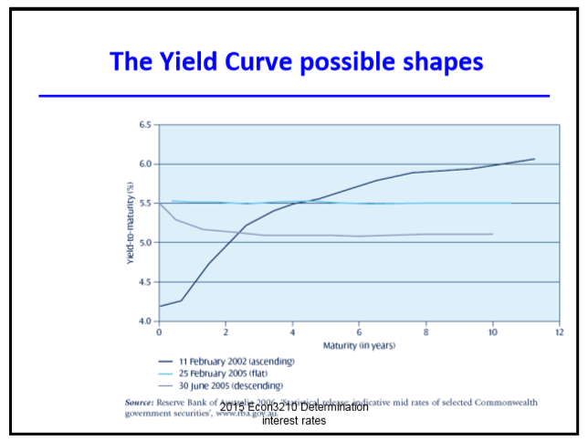
Flat – maturity has no effect on interest rate

Three empirical facts
Fact 1: The yields on bonds of different maturity move in the same direction
Fact 2: When short-term yields are low, the YC is more likely to be ascending, whereas when short-term yields are high the YC is more likely to be descending
Fact 3: YC almost always slopes upward
Expectation theory
- Suggests that the shape of the yield curve is determined by investors’ expectations of future interest rates
- Ascending investors expect interest rates to increase in the future
- Descending interest rates likely to fall (investors willing to accept a lower rate for longer maturities)
- Assumption: perfect substitutability among maturities (investors indifferent between investing in one n period maturity bond or investing in n consecutive one period bonds)
- Explains 1 and 2
Segmented markets theory
- Assumption: Bonds with different maturities are not substitutable
  - If you want to invest for 4 years, have to go for 4 year maturity
- One market for each maturity
  - Each yield depends only on the demand and supply for that maturity
  - Demand for a given maturity reflects the needed holding period
  - People prefer shorter maturities
- Explains 3
Liquidity premium theory
- Assumption: Bonds with different maturities are imperfectly substitutable
- Preference for short-term bonds as less interest-risk
- The long-term interest rate is an average of current and future short-term interest rates plus a liquidity premium
- All facts explained
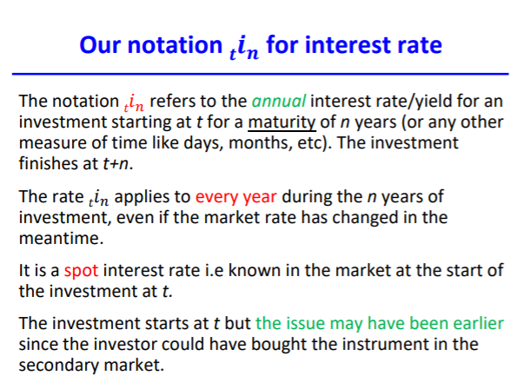
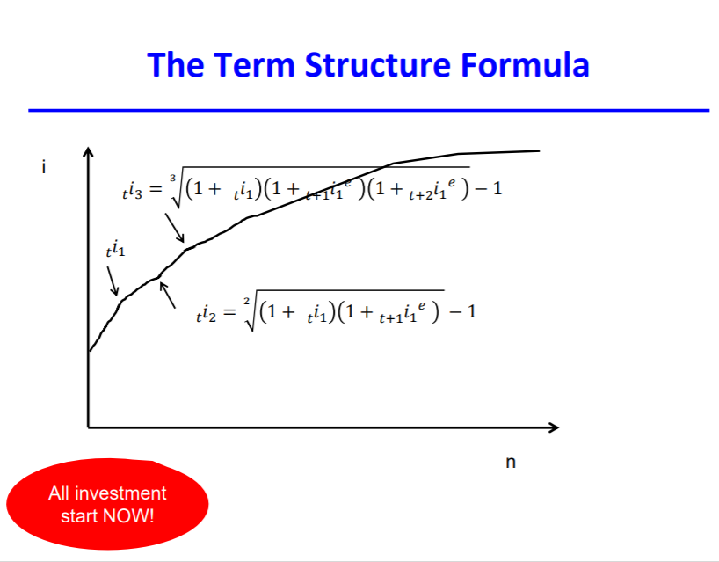
RISK STRUCTURE AND DEFAULT RISK
Default risk: possibility that a bond issuer will not pay back some or all of the interest or principal
- Investors are risk averse so they have to be compensated with a higher yield for investing in bonds with a higher default risk
Default risk premium: the premium over the (default) risk free yield if the default risk premium
- DRP = i – i_{rf}
Probability of default revealed to investors by bond ratings

MARKETABILITY/LIQUIDITY
Marketability/liquidity
- Refers to the cost and quickness that investors can resell a security
- The greater the marketability of a security, the greater the demand for it and the lower its yield will be
Assessing marketability
- Marketability is measured by the volume of the security’s secondary market
- In Australia, the most marketable securities are short-term bank accepted bills
- The spread between two bonds of the same maturity and same options, called the ‘risk premium’, is actually a combination of both risk and liquidity premium
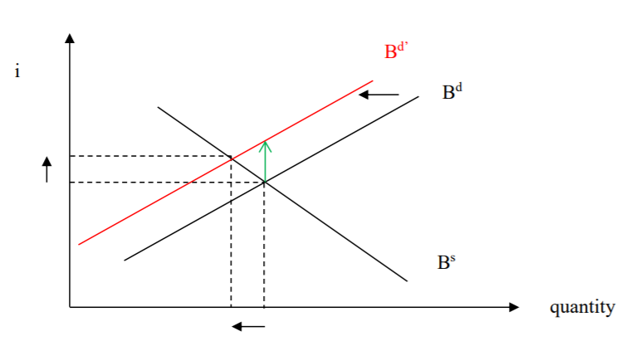
Remember: The supply is not the sale of bonds by investors in the secondary market but the stock of bonds that have been issued and are currently available in the financial system.

TOPIC 7 AND 8 – MONETARY POLICY

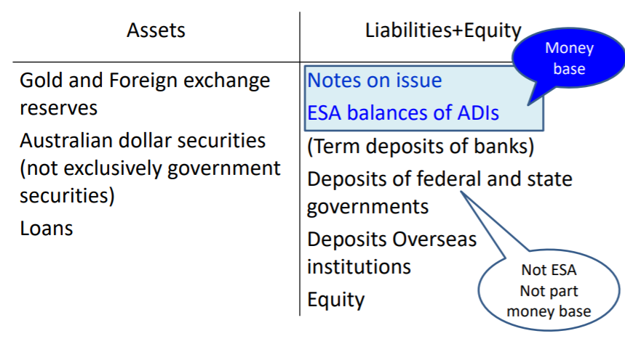
Monetary Policy

Assets
Australian dollar securities
CB provides reserves to the banking system by purchasing securities, thereby increasing its holdings of these assets.
Discount loans
The CB can provide reserves to the banking system by making discount loans to banks. An increase in discount loans can also be the source of an increase in the money supply.
Terms
Repurchase agreement (repo)
A form of short-term borrowing for dealers in government securities. The dealer sells the government securities to investors, usually on an overnight basis, and buys them back the following day.
Money base (M0)
- All notes in circulation in the economy
- ESA balances of ADIs
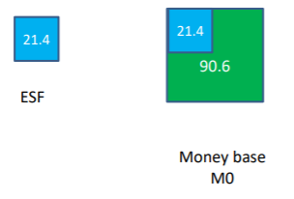
Creation of ESF
Involving assets
- Example 1a: The central bank makes a loan to a bank
- Example 2a: The central bank buys Treasury securities from the public or from the banks
- Example 3a: The central bank buys some foreign exchange from a local ADI
Involving liabilities
- Example 4a: Government makes payment to a bank or a customer of a bank
- Example 5a: Banks transfer funds from their term deposit at RBA to their ESA
- Example 6a: Banks bring notes to the RBA
Involving equity
- Example 7a: RBA pays interest to the ESA
- Example 8a: RBA buys stationary (bank of seller ESA) or pays employees (bank of employee ESA)
M1 (money supply) – things that can be used for transactions
- Notes and coins held by the private non-bank sector
- Current accounts of the private non-bank sector with banks
M3
- M1
- Term deposits and other savings accounts by the private non-bank sector with banks
- Certificates of deposits issues by banks to the private non-bank sector
- All current, term and savings deposit accounts and certificates of deposit issued by non-bank ADIs to the private sector minus notes and coins held by non-bank ADIs and deposits of non-bank ADIs in banks
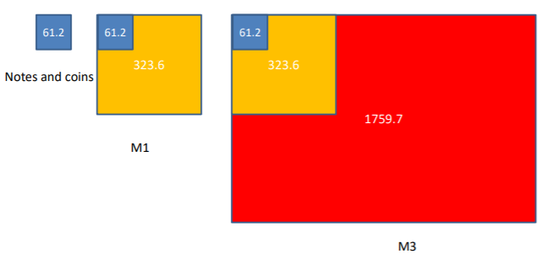
MB (monetary base) is cash held by the public (private non-bank sector), cash held by banks, and ES balances.
M1 is the bank deposits held by the public and the cash held by the public.
Money multiplier = M1/M0
MONETARY TOOLS
- OMO volume
- Interest rate for refinancing/lending facility and deposit facilities
- Reserve requirements
OMOs
The reserves acquired through OMOs do not give rise to a record of loan from the central bank. OMO purchases by the central bank involve the transfer of a security (government or private) from the commercial bank to the central bank. Therefore, the increase in the commercial bank’s reserves is through the reallocation of assets, not the creation of a liability. This is why reserves created through OMOs are called non-borrowed reserves.
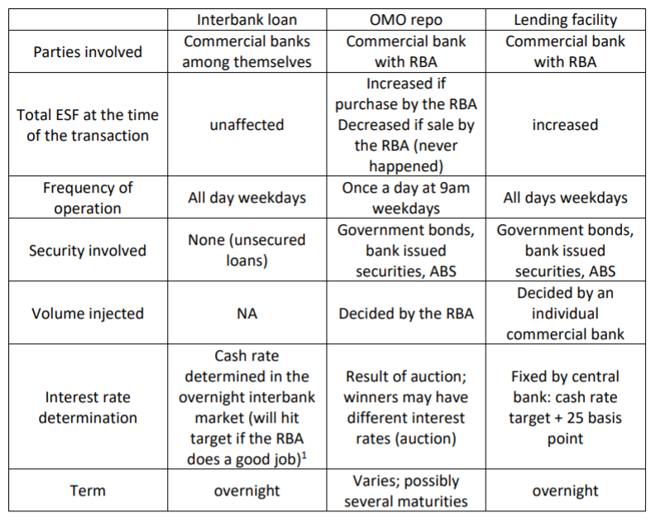

Actual and Theoretical Market For Reserves
Actual: Demand is the desire by banks to borrow reserves, supply is the desire by banks to lend reserves.
Theoretical: Demand is what banks would like to hold as reserves, supply is the existing stock of reserves in the banking system.
We use the theoretical as we do not need to take into account the initial allocation of reserves among banks. All that matters in the theoretical market is the aggregate stock, not the individual allocation of reserves.
The theoretical market and real market clear at the same rate.

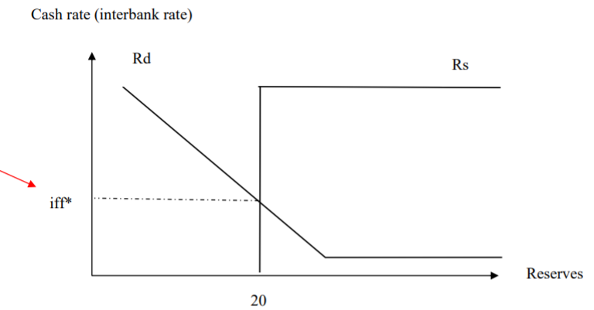

Note: The demand for reserves depends on the current and future interbank rate.
- The main purpose of holding reserves is for regulatory purposes and for the future payment to other banks or to customers.
- Banks prefer to lend the reserves in the interbank market at the current level of the interbank market rate (iff) as they generate a larger income than keeping their money at the ESA.
- The current interbank rate is therefore the opportunity cost for holding reserves: the higher the current interest rate, the lower the demand for reserves. This is shown as a negative sloped demand curve.
- However, if the bank does not keep enough reserves to meet future payment requirements it may have to borrow in the future. Therefore, the current demand for reserves depends positively on the future interbank rate. This is shown through a shift in the demand curve: if the future interbank rate is higher the demand shifts to the right; if the future interbank rate is lower the demand shifts to the left.
Demand curve = how much reserves banks WANT (/need) to hold

Operating Target: Interbank Market Interest Rate
Cash rate as an operating target:
- It is not a variable directly set by the RBA. It is determined by demand and supply in the private overnight interbank market.
- The objective is to influence the cash rate (via market forces) so that it stays close to a specified value.
  - The RBA manipulates the supply/stocks of ESF to manipulate the conditions in the market for overnight interbank loan and therefore cash rate.
  - That requires forecasting the demand curve (or the demand at the cash rate target) and the autonomous factors that affect the supply curve.
In Australia the system is such that the autonomous factors usually bring the supply down (red supply). So keeping the supply at the same location required an injection of reserves by the central bank (red arrow).
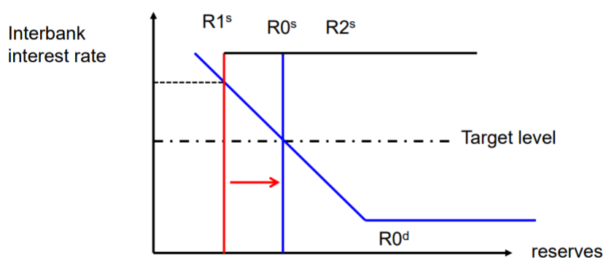
Transmission to the Real Economy
Interbank rate is a major cost for banks. When the RBA changes the cash rate banks need to adjust the rates on their loans (housing loans, business loans, personal loans, etc) in order to maintain their profit margins.
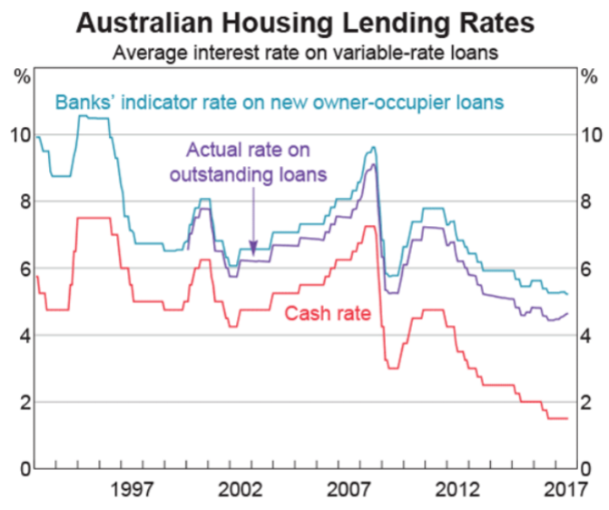
When the RBA changes the cash rate longer maturity interest rates adjust in the same direction. All interest rates tend to move in the same direction along the yield curve.
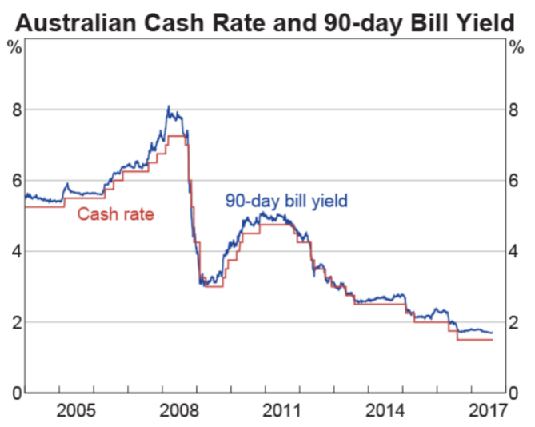
Sometimes there is no need for a change in the position of supply when there is a change in the target rate.
- Future level of the cash rate affects the demand for reserves
- A decrease in the future level of the cash rate decreases the demand for reserves now as there is less incentive to have precautionary reserves (will borrow in the interbank market if more reserves are needed)
- Shift of the demand curve so it crosses the old supply at the new target
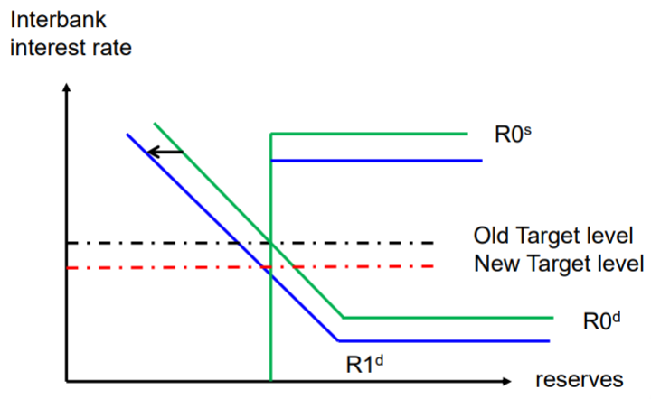
Interest Targeting During GFC
Main aspects:
- Action to overcome instability in the reserve market by providing liquidity to banks (focus)
- Action to fight recession
- Support credit markets and institutions to avoid their collapse
1. Short-term problems of liquidity and of targeting interbank interest rates
Just after the collapse of Bear Stearns and again after Lehman Brothers there was upward pressure on interbank short-term rates due to higher demand for reserves. Difficulties hit the interbank target due to the instability of demand for reserves.
1.1 Increase in demand for reserves by banks (frozen interbank market)
- Banks need reserves for possible deposit withdrawals by panicking investors bank loses ESF.
- Higher counterparty risk reluctance to lend to other banks as higher probability of default.
- More uncertainty about future access to interbank market future losses of reserves have to be met with holding reserves now.
This meant the interbank market rates increased above their targets.
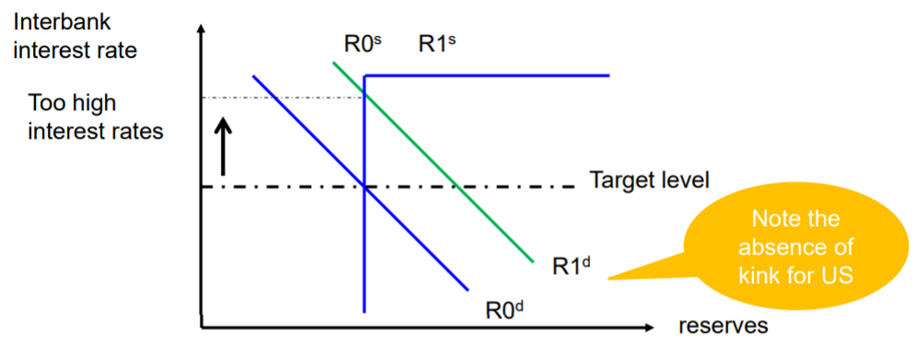
This meant the CB had to inject mass amounts of reserves to hit the target.
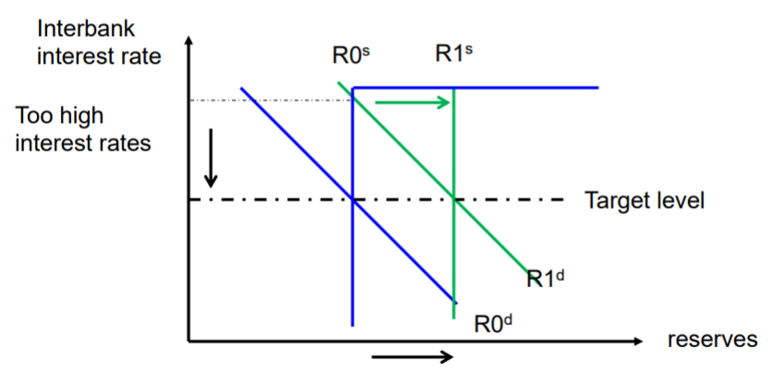
Lead to a massive expansion of the CBs balance sheet.
- Shifting the supply of reserves to meet the new demand on target rate required huge OMO purchases.
- A lot more securities on the asset side and a lot more reserves (ESF in Australia) on the liability side.
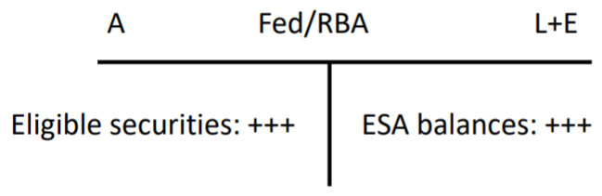

Required adjustment for OMO
There were not enough eligible securities to bring to the OMO for maintaining the large level of ESF.
- CB had to widen eligible collateral
- Increase the scope of securities for lending
  - Banks can get treasury securities by exchanging another security. Auctions where bids are the fees of the security lending and amount.
- Longer maturity in REPO to reduce uncertainty and avoid injecting large amounts too often
  - US introduced the Term Auction Facility for long term securities; Australia just used normal daily auctions but with a longer maturity
The demand curve changed location all the time, making the interbank rate move all the time. The central banks reacted by decreasing the corridor in which the interbank rate moves by decreasing the distance to the target rate for lending facility and deposit facility rates.
- In US – rate used to be +100 basis points above the fed funds rate -> since 2007 + 50 basis point -> since 2008 +25 basis points.
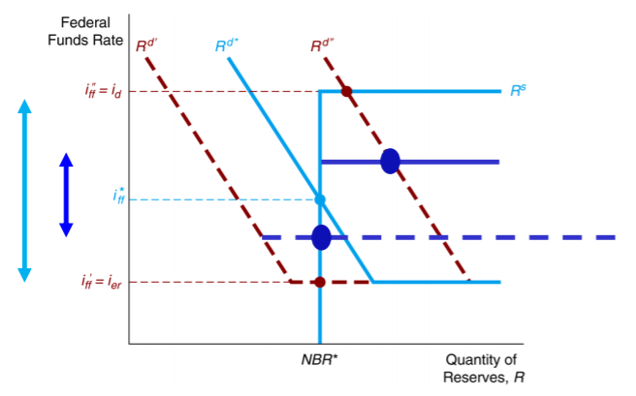

RBA term deposits in Australia
- RBA introduced term deposits to remove ESF when ESF had increased too much
- Contrary to overnight deposit facility, the funds disappear from the ESA balance but remain liabilities for the RBA
- Not used anymore
when demand goes back to normal, there will be reserves they don’t want anymore
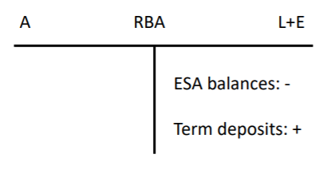
can’t wait for repo to reach maturity and decrease automatically
drain reserves that has been initially injected because of high demand

TOPIC 9 – MANAGED FUNDS
Managed Funds
- Legally considered corporations or trusts – financial intermediaries
- They are not operating companies as they have no employees and are managed externally by another company – most often an investment bank
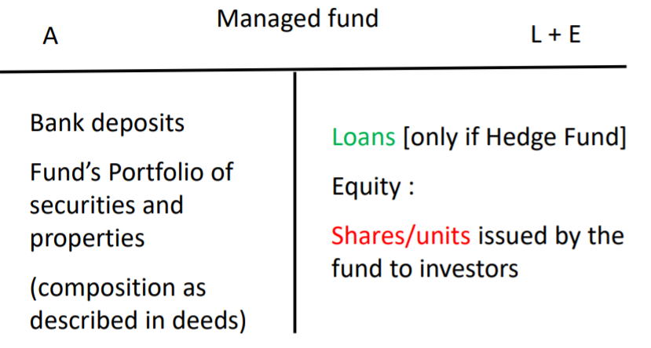
- MFs pool the resources of many investors by issuing shares/units use the money to invest in the assets specified in a trust deed (specifying the use of the money) investors pay a variety of fees in return for enjoying the opportunity to use investment products that might otherwise be unavailable to them
- Investors receive distributions (like dividends) from their shares/units. The distribution comes from the stream of income from the assets in the portfolio and realised (i.e. sold) capital gains on assets in their portfolio.
- Investors can make a capital gain/loss on the fund share/unit when they resell their shares in the secondary market (closed-end) or sell back their units to the fund (open-ended)
Benefits for Investors
- Liquidity – investors can quickly convert investments into cash (in the secondary market or from the fund) selling one product as opposed to selling the assets of the portfolio
- Reduced transaction costs – economies of scale decrease the search and brokerage fees
- Diversification – investors immediately realize the benefits of diversification even for small investments
- Managerial expertise – many investors prefer to rely on professional managers to select their investments
- Maturity/currency transformation – if you invest in AUD, you are paid in AUD even if the investment is foreign
- Access to financial assets not available to retail investors – e.g. corporate bonds
Types of Managed Funds
Closed ended
- Fixed number of nonredeemable shares are sold through an initial offering then traded among investors in the secondary market
- Price for the shares is determined by supply and demand forces in the secondary market
  - Usually below the NAV
Open ended
- Investors may buy or redeem units at any point by trading directly with the fund go to managed fund to get money back
- Price determined by NAV of the fund calculated once a day at 4pm
- Most common form
Exchange traded funds (ETF)
- Invest in an index (passive management)
- Shares can be traded in the secondary market or can be exchanged at the fund for the assets in the portfolio
Pricing of a Unit: Net Asset Value
Price of unit = NAV (per unit) = $\frac{portfolio value-liabilities}{number of units}$
Definition: Total current value (at 4pm that day) of the managed fund’s stocks, bonds, cash and other assets minus any liabilities, divided by the number of units outstanding
- Units associated with sale orders are counted in, as not paid back yet; units associated with purchase orders not counted, as not issued yet.
- All orders to buy or redeem a share in the open-ended fund recorded before 4pm will pay the NAV of the day evaluated at 4pm
- Any order received after 4pm will pay the NAV of the next day at 4pm
Late trading
- Allowing trades after 4pm to trade at today’s 4pm NAV instead of tomorrow’s price
- Illegal under SEC regulations

Managed Fund’s Organisation
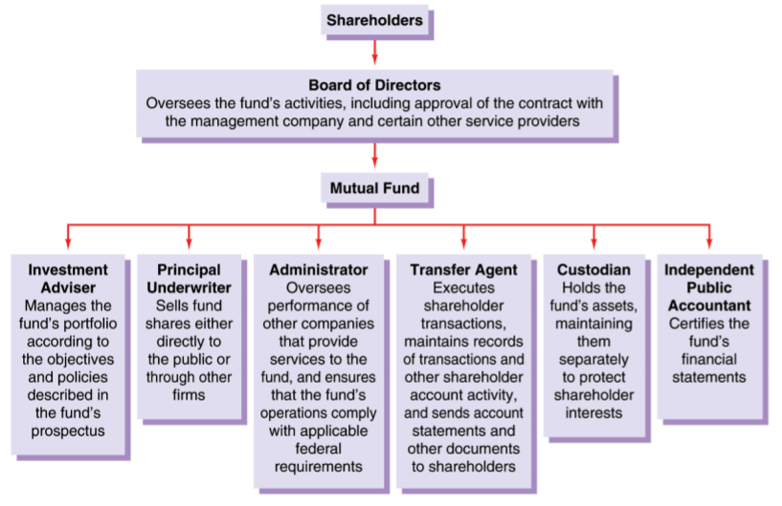
Fee Structure of Investment Funds
Banks only bother managing funds because it’s a source of fees.
People pay a fee when they join/leave and for hedges funds they pay for maintenance of the account and a performance fee.
- Load funds (class A shares/units) charge an upfront fee for buying the shares/units. No-load funds do not charge this fee.
- Deferred load (class B shares/units) funds charge a fee when the shares are redeemed.
- If the fund charges no front or back end fees, it is referred to as class C shares.
Hedged Fund
Distinction between MF and HF
- Traditional:
  - Exclusively invest the funds of the unit holders (no leverage/gearing)
  - Only take long positions in their asset portfolio (no short selling)
- Hedge:
  - Borrows funds (in addition to raising funds through units)
  - Take short and long positions
  - More risky
  - High minimum investment (average of $1 million)
  - Long-term commitment to funds is required
  - High fees: typically 2% of assets (annual fees) plus 20% of profits (performance fees – do not exist for mutual funds)
  - High leverage (margin loans from banks)
- In the US the two types are not subject to the same regulations; hedge funds are much less regulated. This results in HF being available only to high net worth investors and institutional investors.
- In Australia they are treated the same way by the regulator and units can be bought by any type of investors. The main distinction relies on the type of investment strategies/assets they invest in (true for the US as well).
Hedge funds are often trying to take advantage of unusual spreads between security prices.
Doesn’t depend on the direction of the market, just about the spread.
HF sells overvalued assets and buys undervalued assets then reverses the position.
This is a very risky strategy – if the spread becomes wider then the HF will lose money.
Abuse of the market
- Deliberately sell to make the price go down decrease in price triggers other investors to sell price decreases further HF buys back at a lower price than it sold when price goes back up, make a capital gain
Problems with HF
- Long Term Capital Management was a hedge fund with excellent returns for the first several years
  - In 1998 it lost $4.6 billion in less than four months following the Russian financial crisis
  - Its collapse was eminent, and regulators decided they had to develop a bailout by banks under the supervision of the Fed
  - LTCM had over $80 billion in equity positions and over $1 trillion in derivative positions. Its failure could have been devastating for the US economy
ETFs, XTBs and Mfunds
Exchange traded funds
- Invest in an index
- Shares can be traded in the secondary market for cash or can be exchanged at the fund for the assets in the portfolio
- Open ended feature only for authorized participants
  - Big institutional investors who can go to fund to buy product
  - Retail investors have to go to secondary market
Authorized participant goes to an ETF. AP gives securities. ETF gives creation unit (contains of ETF securities). This of the creation unit as a box containing a bunch of ETF securities. The AP can open the box and go to the secondary market and sell the securities.
OR
Can go back to the ETF and get equivalent securities to the ones the AP put in.
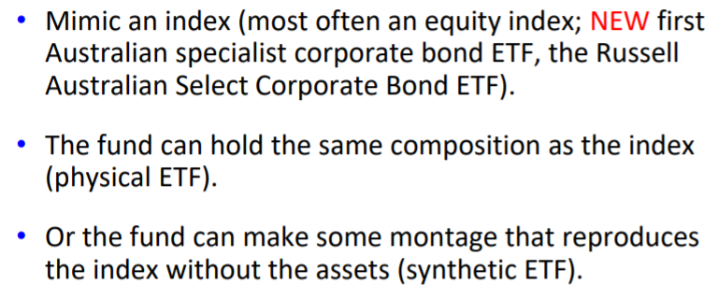
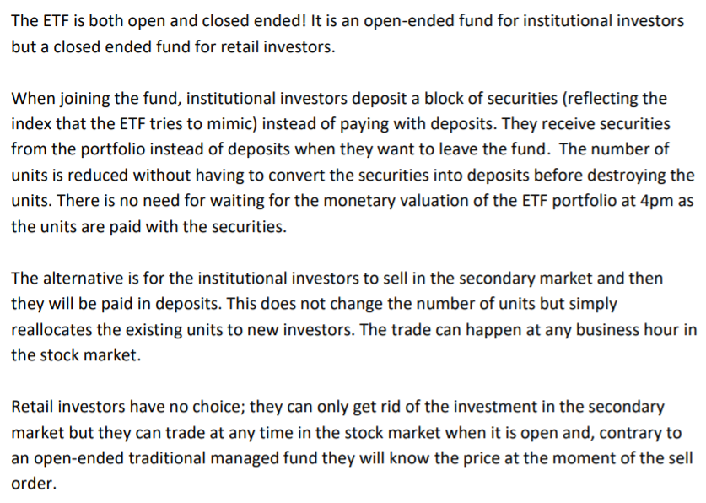
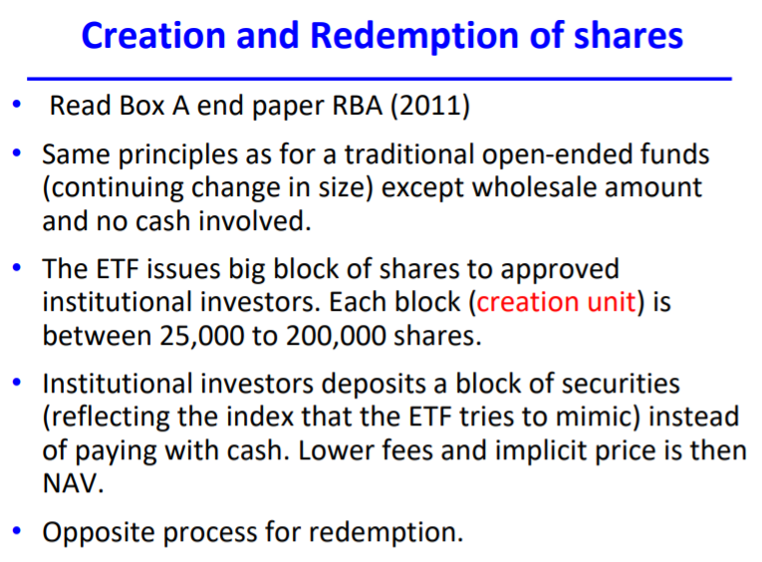
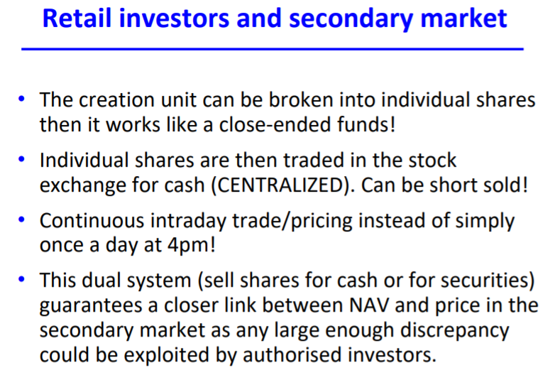
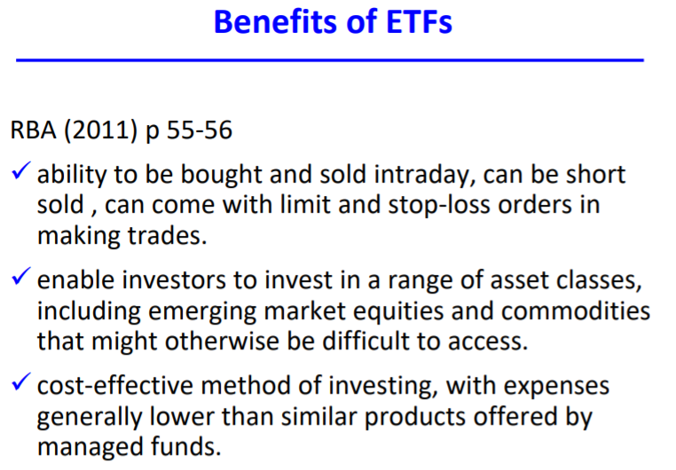
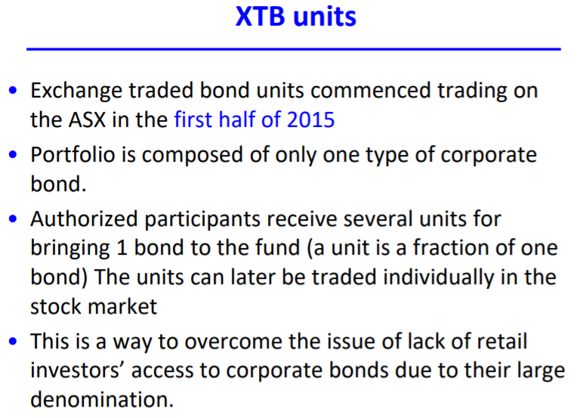
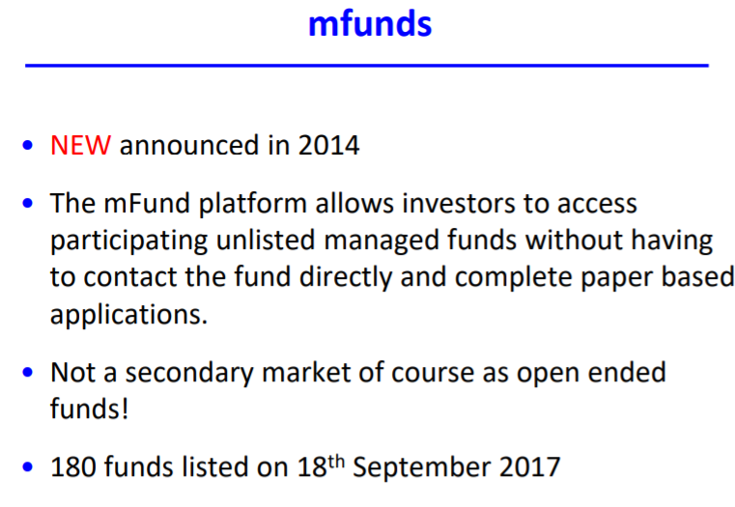
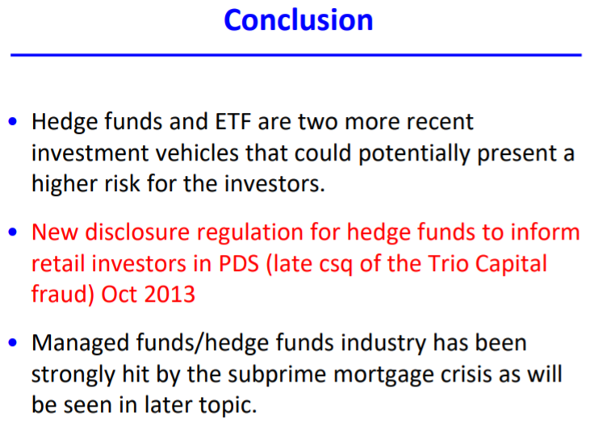

TOPIC 10 – SECURITY LENDING AND SHORT SELLING
Security Lending
= temporary transfer of legal title from lender to borrower for a fee and the repayment of equivalent cash flows
The lender temporarily transfers their legal title on a particular security to a borrower. This means the borrower is the new official/registered owner. Dividends, voting rights, and coupons go to the borrower (as long as the borrower hasn’t sold the security).
A similar security will usually be returned to the original owner. There is a fee paid by the borrower to the lender, as well as collateral.
Additionally, the borrower needs to substitute payment equivalent to the original cash flow of the security (e.g. if dividends were paid on the security while they were with the borrower, the borrower needs to return the equivalent of that dividend to the lender).
There is often no agreed date to return the security.
Market Arrangements
Lenders are usually custodian banks (really big banks with a lot of assets). Borrowers usually use prime brokers as a third party. This is mainly done through bilateral arrangements. It’s quite difficult to match borrowers/lenders.
Execution and settlement is arranged through CHESS.
Uncertain time for matching lenders and borrowers.
Settlement occurs T+2 days after execution change in legal title at time of settlement.
Short Selling
= putting in a sale order without officially owning the securities yet at the moment of the trade.
Definition in the Corporations Act (2001): the short-seller does not have a ‘presently exercisable and unconditional right to vest the products in the buyer’.
Occur on a T+2 sale basis (have 2 days to become the legal owner of the security). If the security is not delivered there is a daily default fine as a % of the trade value.
Covered short sell = the securities borrowing has been arranged prior to the short sell order (but ownership not yet transferred).
Naked short sell = where no lending arrangement to get the securities has been made at the time of the sell order. The seller will need to get the securities for the delivery date.
Corporations Act
Put a blanket ban on all short-selling. Then created five exceptions:
- Securities traded by a financial services licensee who is a participant in a licensed market and who specialises in dealing in odd lots (‘odd lot sales’ exemption)
  - Odd lots = small quantities
- Securities sold as part of a bona fide arbitrage transaction (‘arbitrage transaction’ exemption)
  - Professional arbitrager = someone whose job it is to watch changes in the market price and make a profit from it
  - Bona fide reason = not to manipulate price or exercise insider trading
- Securities sold by a person who has entered into a contract to buy the securities but is awaiting delivering (in T – T+2 period)
- Any time a person has a lending agreement in place prior (covered short sell)
- Short sales of approved securities as designated by ASIC (regulator of ASX) sold in accordance with the operating rules of the market (‘approved short sale’ exemption)
  - Approved securities = securities in abundance in the market (e.g. government bonds)
Why are these accepted?
- Odd lot sales
  - Heavily regulated and watched (can track you down if you don’t fulfil your end of the bargain)
  - Small quantities mean it is easy to find a lender on the same day as a naked short sale low settlement risk
- Bona fide arbitrage transaction
  - Helps to align prices in the market
  - Allows for smooth and efficient operation of financial markets
- Prior purchase agreement
  - Low settlement risk – there is an agreement in place to ensure delivery will occur
- Covered short sale
  - Low settlement risk – there is a lending agreement in place to ensure delivery
- Approved short sale
  - Low settlement risk – classes of approved securities are very abundant and easy to find a lender on the same day as the naked short sale
Note: 2018 Regulations
- covered short selling is allowed as a general rule
- naked short selling is prohibited BUT there are exceptions created by ASIC from time to time
- created a system of disclosure requirements for covered short sales (more transparency)
Difference: Previously said NO to covered short selling except under exemptions, now says YES to short selling in general. For naked short selling it is basically the same.

TOPIC 11 – SUBPRIME MORTGAGE CRISIS
Introduction
Causes of the crisis
- Fed funds rate was too low (consumer debt high, demand for houses high)
- Trade deficit (if US imports a lot, they give a lot of US dollars away international investors invest in securitised products)
- Complex financial securities (very hard to assess the risk)
- High levels of short-term debt (at every level: households, banks, companies)
- Weak regulation (investment banks with no minimum capital requirement, no regulation of credit rating agencies, lenient capital regulation)
What created the housing boom 1998-2005
- Clinton had a policy of lending to less qualified borrowers [1995]
  - Easier access for borrowers
- Low official interest rates
  - High demand of loans
- Securitisation
  - More funds available for lending: high supply of loans
- Poor lending standards by brokers
- Speculation
  - Purchase of houses for investment purposes
What caused the housing bubble to burst
- Increase in official interest rates
- Delinquency on mortgage payments
  - Involuntary delinquency because they could not afford the repayments
  - Voluntary delinquency because the mortgage was higher than the value of the house; better to default and give the house to the bank
- Foreclosure of mortgages led to the banks selling the houses which drove the house price even further down

